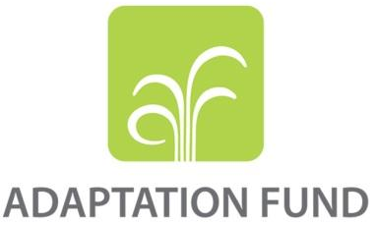

REQUEST FOR PROJECT/PROGRAMME
FUNDING FROM THE ADAPTATION FUND

The annexed form should be completed and transmitted to the Adaptation Fund Board Secretariat by email or fax.

Please type in the responses using the template provided. The instructions attached to the form provide guidance to filling out the template.

Please note that a project/programme must be fully prepared (i.e., fully appraised for feasibility) when the request is submitted. The final project/programme document resulting from the appraisal process should be attached to this request for funding.

Complete documentation should be sent to:

The Adaptation Fund Board Secretariat
1818 H Street NW
MSN P4-400
Washington, D.C., 20433
U.S.A
Fax: +1 (202) 522-3240/5
Email: afbsec@adaptation-fund.org

PROJECT/PROGRAMME PROPOSAL TO THE ADAPTATION FUND

PART I: PROJECT/PROGRAMME INFORMATION

Project/Programme Category: REGULAR Project/Programme
Country/ies: INDONESIA
Title of Project/Programme: Safekeeping-Surviving-Sustaining towards Resilience: 3S Approach to Build Coastal City Resilience to Climate Change Impacts and Natural Disasters in Pekalongan City, Central Java Province
Type of Implementing Entity: National Implementing Entity
Implementing Entity: Kemitraan (The Partnership for Governance Reform)
Executing Entity/ies: Kemitraan (The Partnership for Governance Reform)
Amount of Financing Requested: 5,972,670 (in U.S Dollars Equivalent)

Project / Programme Background and Context:

Provide brief information on the problem the proposed project/programme is aiming to solve. Outline the economic social, development and environmental context in which the project would operate.

Climate change is one of the significant factors contributing to severe flooding of Pekalongan City. There are many factors – human and natural – both are intertwined.
Thus we propose three pillars: 1. Adaptive Capacity [survival - sensing and knowing the problem collectively and largely, aligning with on-going government project/programme], 2. Ecological restoration [survival - social-ecological approach], 3. Sustainability [sustaining]

- Indonesia is among the largest archipelago in the world which constituted of over 18,000 islands (both populated and not populated islands) with around 230 million populations. Its vast coastline that stretches over 18,000 km (in total) is the home for almost 60% of Indonesian population. Scientists had observed changes in climate indicators in Indonesia over the past several decades, and concurrently made projection using AR-4 IPCC model to assess the future changes with results as below:
- Average surface temperature increases will reach 0.8°C-1°C until 2020-2050 relative to the final climate period in the 20th century.
- Sea surface temperature increases will reach 1-1.2°C by 2050 relative to 2000.
- In the period of 2001-2100, there will be significant changes (especially in 2080s period) with a tendency of rainfall increase in wet season and a decrease in transition months.
- Sea level rise (SLR) is projected to reach 35-40 cm in 2050 relative to the value of 2000. The maximum SLR may reach 175 cm in 2100.
- Considering its geographic traits as an archipelagic country that consists of not only large but also great numbers of small islands, changes in the above indicators could potentially bring a significant impact and affect diverse development sectors in Indonesia, and consequently affecting the area’s sustainability. The risks are higher for coastal areas and populations as a result of close exposure to coastal-related climate change impacts in the forms of climate-related disaster events, coupled with their low socio-economic capacity.
- In March 2015, Indonesian poverty rate reaches 11.22%. Poverty is claimed as rural phenomenon considering that 60% of the poor are living in rural areas; where most of the poor lives in Java Island. Research conducted by the Ministry of Marine and Fishery shows that from a total of around 41 million poor population of Indonesia, over 13.5% of them are living in coastal area; they live in poverty level with minimum services to basic infrastructure. Exposed to sea level rise, high tide, extreme weather and also the subsequent impact such as salt-water intrusion; the coastal population often does not have adequate resources to face those risks, leaving them highly vulnerable to climate change impacts.
- The North Coast of Java is one region that has repeatedly been affected by climate change impact. Sea level in this region is rising between 6-10 mm/year. Despite SLR projection in this region is not the highest in Indonesia, but its high population density and rapid urban development in comparison to other coastal area has placed North Coast of Java as highly vulnerable to climate change impact. As the major and busiest corridor for human and logistics mobilization in Java, as well as one of the largest rice producer regions in Indonesia, disruption to this region will hinder economic activity in the island. For instance, flash flood and coastal flooding in 2014 (in Central and East Java region of North Coast Java) had inundated over 40,000 Ha of paddy field and damaging thousands of hectares of brackish water fish pond, causing failed harvesting in those land; imposing significant economic cost to the farmers and fishermen. Another coastal flooding in mid-2016 (in Central Java area of North Coast Java) have caused 50-120 cm inundation in the major road access, leads to a significant delay in logistics distribution to several industrial area in central and eastern Java; crippling the industrial activity.
- The City of Pekalongan comprises of 4 sub-districts with a total administrative area of 45.25 km² and a total population of 296,533 people, where 31.3% of the population lives in Pekalongan Barat sub-district. In 2015, 8.09% of Pekalongan population lives below poverty level, which in this particular city is set at Rp. 352,717 (27.13 USD)/capita/month. This is a slight increase in comparison to 2014, where the poor population was accounted for 8.02% of the population. Geographically, the city is located in lowland plain with an average height of 1 m above sea level (a.s.l) and highest point within the city at 6.5 m a.s.l.

- Seven rivers flow through the city and disembogue into the Java Sea, with Pekalongan River as the main river. There are several rivers that often overflow during high intensity rain events, namely Pekalongan River, Bremi River and Bangger River; causing 50-100cm inundation in many communities, and at times forcing the population to be evacuated for several days. This flash flood is considered as a recurring disaster in Pekalongan City.

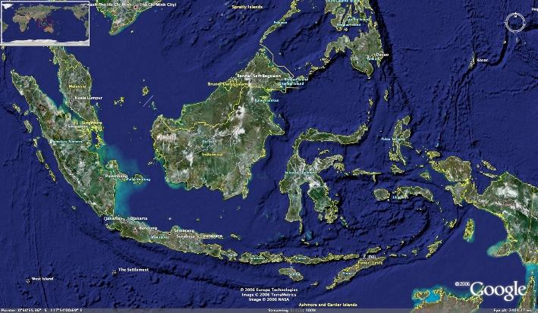 | 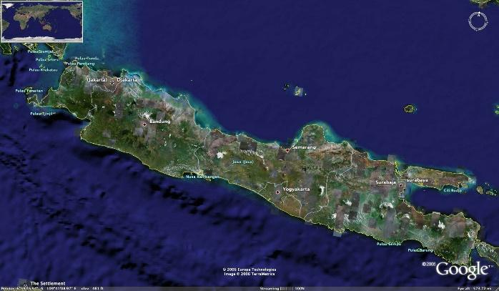
Figure 1. Map of Indonesia | Figure 2. Map of Java Island
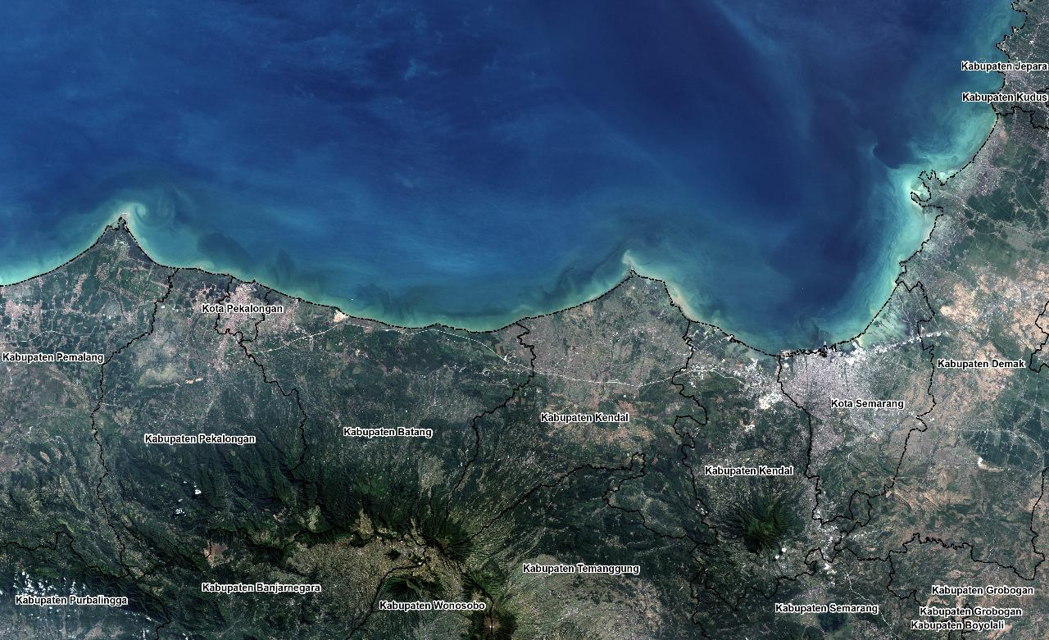
Figure 3. North coastal area of Central Java Province

THE PROBLEM

- From Creative City t o urban vulnerability

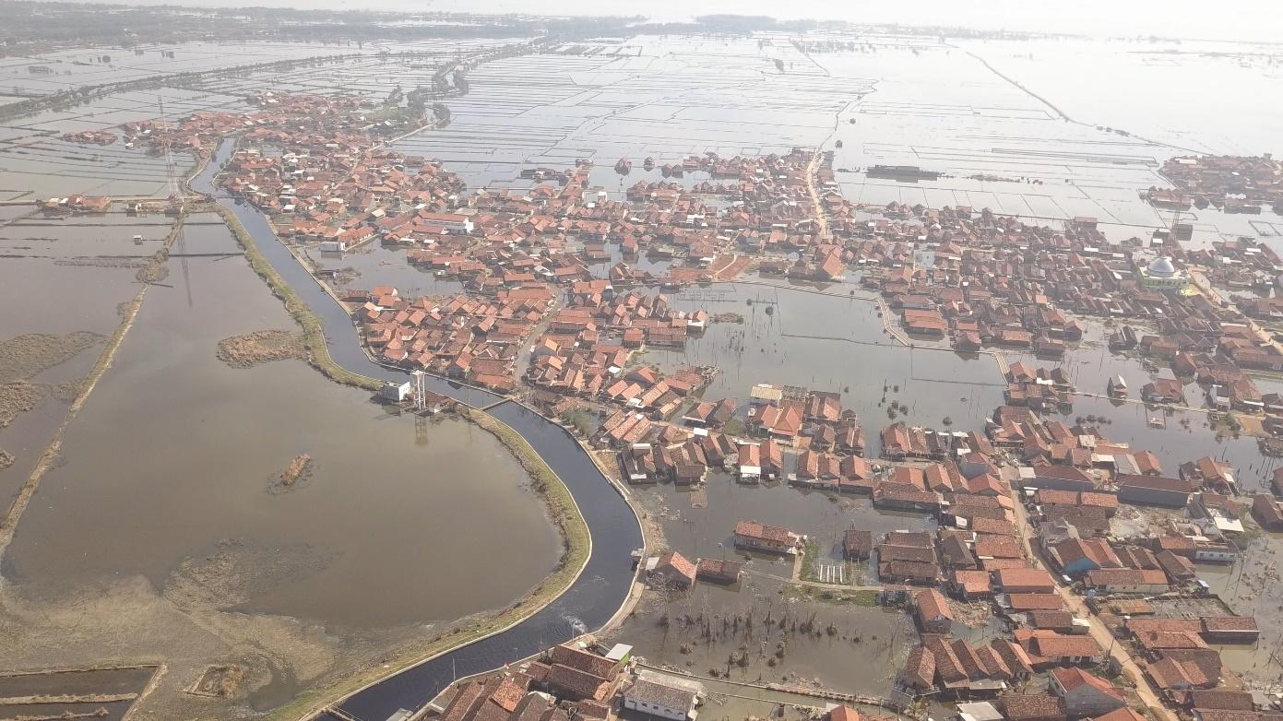
Figure 4. Severe Flooding in Pekalongan City

- Pekalongan City has been recognized by UNESCO (United Nations Educational, Scientific and Cultural Organization) as part of Creative City networks o n 1st December 2015. Pekalongan City is well-known in Indonesia and beyond as the city of “Batik”, the process of traditionally dyeing fabric, performed on cotton and silk using a resist technique, also recognized as World Intangible Cultural Heritage by UNESCO in 2nd October 2009.

- Considering its geographical and hydrological attributes, Pekalongan City is no stranger to climate change impact in the forms of climate-disaster events. The city has a history of recurring events of coastal flooding and flash flood. Added with extreme weather events and prolonged drought, Pekalongan population have suffered significant damage from this climate-disaster events that goes beyond physical structure damage and inundated productive land in the coastal area, but they also imposed by socio-economic cost.
- Climate Change Projection

- Historical trend shows that there is a 0.6-0.8 cm rise in sea level annually. In 2030, this number is projected to increase up to 22.5±1.5 cm annually; and in 2100, sea level rise in Pekalongan City is projected to reach 0.8 m and consequently affect 913.8 Ha area within 1.63-2.01 km distance from the city coastline. According to Pekalongan City Agriculture and Marine Agency, the city coastal vulnerability index is at 2.4 from a maximum scale of 3. The impact of coastal flooding will not only affect coastal-related sector such as fishery and tourism, but might also creating domino effect to other development sectors; posing an imminent threat to the sustainability of the city.
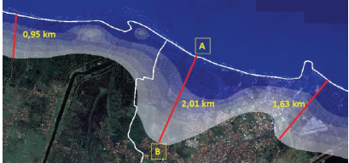
Figure 5. Projected Inundation in Pekalongan City Coastal Area in 100 Years Period (Pekalongan City Government, 2011)
- The same study also shows how the precipitation pattern and level in Pekalongan City have changed in a 40 years period. The peak rainy season is shifting and occuring in a shorter period but with an increasing intensity. In future time, the peak rainy period is projected to become shorter and occuring in November-January period, which could potentially lead to an increase in flooding intensity and frequency. Meanwhile dry season will occur in a longer period with a lower precipitation intensity that could cause prolonged drought and water scarcity subsequently.
- Other changes t assessed were surface and sea surface temperature in the North Coast of Java. Historically, there is only slight increase in the surface temperature, with 0.004-0.04ºC increase annually. Yet projection shows that in the next 100 years, there will be 0.4-4 ºC increases in surface temperature. This is believed to then affect the sea surface temperature at coastal area in a rate of 0.05-0.1ºC annually, prompting changes in the surrounding ecosystem.
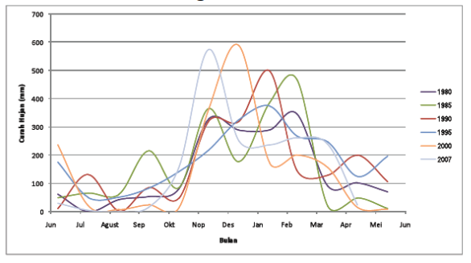
Figure 6. Precipitation Pattern in Pekalongan City in 1980-2007 Period (Pekalongan City Government, 2011)

- Expected Impacts

It was projected that in 2050, the maximum inundation water level could reach 135 cm. This could cover up to 1,295 Ha of residential area, 507 Ha of paddy field and 230 Ha of wetland and fish pond; covering 51% of the Pekalongan administrative area, where Pekalongan Utara will experience the most severe impact from this event because of its geographical location in the coastline of Pekalongan City. The previously mentioned sea level rise projection in 2100 that would affect area up to 2.01 km from the city coastline further highlights the vulnerability of Pekalongan Utara. Pekalongan Utara population that predominantly works in fishing industries will be highly affected economically from this; forcing them to alter their fishing practices (both those who fishes in the sea and cultivating fish-ponds) and adapting to recurring inundation in their neighbourhood. Overexploitation of groundwater further exacerbated the flood intensity and impacts by causing land subsidence in the coastal area. Salt water intrusion have been experienced by those who rely on ground water for their daily needs, for instance in Panjang Wetan community (Pekalongan Utara Sub-district).
- Flood risks and vulnerability in Pekalongan

- To validate and further emphasize the correlation between the aforementioned risks to climate change impact, a study was conducted in 2012 on Pekalongan City Climate Vulnerability by SMERU Research Institute. The study assesses the exposure of Pekalongan City to three types of climate-related disasters frequently occurred in the city (flash flood, coastal flooding and landslides), the area’s human and ecological sensitivity, and their adaptive capacity.
- The result shows that more than 25% and 10% of Pekalongan City population are exposed to flash flood and coastal flooding due to SLR in that order. With respective climate exposure index to flash flood and coastal flooding of 0.39 and 0.31, Pekalongan Utara sub-district is assessed as the most exposed area to both climate-related disaster events; putting this area at a total Climate Change Exposure Index of 1.
Sub-district | Flash Flood | Coastal Flooding from SLR | Landslide | Exposure Index
Pekalongan Barat | 0.2365 | 0.0067 | 0.0994 | 0.3426
Pekalongan Timur | 0.0851 | 0.0303 | 0 | 0.1154
Pekalongan Selatan | 0 | 0 | 0.2812 | 0.2812
Pekalongan Utara | 0.3900 | 0.3100 | 0.300 | 1
Table 1. Climate Change Exposure Index of Pekalongan City (SMERU, 2012)
- Pekalongan Selatan is the most sensitive sub-district with 0.60 sensitivity index, due to the fact that the area is the centre for batik industry and agricultural land in the city. Livelihood, ecology and population are three aspects that being considered in measuring Sensitivity Index. Based on the sensitivity assessment, being one of the major industries in Pekalongan, disruption to the sustainability of Batik industry could affect the economic condition of batik workers in particular and the city’s income in general. Climate-related disaster could affect batik industry either by flooding the industrial area or contamination of immersion water from flood water. Meanwhile inundation from flash flood in agricultural area could leads to a severe failed harvesting. The second most sensitive sub-district is Pekalongan Utara with 0.48 sensitivity index attributed to the fact that majority of the sub-district’s population works in fisheries sector, which at risk of economic losses from the loss of brackish water fish pond, damage to their house as well as changing fishing pattern and location.

Sub-district | Livelihood at Risk | Ecology at Risk | Population at Risk | Sensitivity Index
Pekalongan Barat | 0.06 | 0.00 | 0.16 | 0.21
Pekalongan Timur | 0.02 | 0.14 | 0.22 | 0.38
Pekalongan Selatan | 0.23 | 0.13 | 0.24 | 0.60
Pekalongan Utara | 0.18 | 0.05 | 0.25 | 0.48
Table 2. Climate Change Sensitivity Index of Pekalongan City (SMERU, 2012)
- Pekalongan Barat has the lowest Adaptive Capacity Index of 0.0010 which indicates the area is the most adaptive amongst other sub-districts. For adaptive capacity index, the calculation take account of aspects that are highly needed for dealing with and recovering from climate-related disaster events, comprising of infrastructure, technology, health facilities, institutions and economic conditions.

Sub-district | Infrastructure | Technological Information | Health | Institution | Economic | Adaptive Capacity Index
Pekalongan Barat | 0.2600 | 0.1389 | 0.1900 | 0.2000 | 0.2100 | 0.0010
Pekalongan Timur | 0 | 0.0883 | 0.0382 | 0.0363 | 0.0946 | 0.7426
Pekalongan Selatan | 0.0469 | 0.0073 | 0 | 0.0557 | 0.1409 | 0.7492
Pekalongan Utara | 0.2414 | 0.0315 | 0.0331 | 0.669 | 0 | 0.6270
Table 3. Climate Change Adaptive Capacity Index of Pekalongan City (SMERU, 2012)
- Pekalongan Utara is the most vulnerable sub-district to climate change with 0.72 index. The high vulnerability of Pekalongan Utara is due to the fact that the area is highly exposed to climate change impact, particularly coastal flooding; while also has a relatively high sensitivity and low adaptive capacity. Meanwhile its high sensitivity and low adaptive capacity is the major factor for Pekalongan Selatan’s vulnerability, despite the fact that the area has a relatively low exposure index.
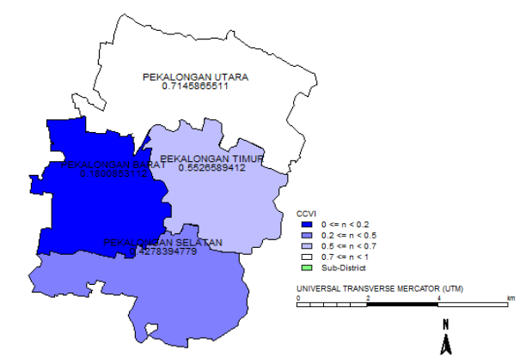

Figure 7. Climate Change Vulnerability Index of Pekalongan City (SMERU, 2012)

Economic Context
- Pekalongan City’s economic state in 2014 shows that Manufacturing Industry, Trading and Retail, and Construction are three economic sectors with the highest contribution for the city’s Gross Regional Domestic Product (GRDP), with GRDP growth for each sector ranging between 4-6% from 2013. Looking at the GRDP contributor, it is fair to conclude that 38.46% and 28.14% of the population works in Industrial and Trade sector respectively. This also attributed to the fact that Pekalongan City is one of the main ‘Batik’ producers in Indonesia that not only supply national but also international market. As part of the largest rice producer region, Agriculture, Forestry and Fisheries sector is also one of the main economic sectors in Pekalongan City; ranks 6th on the GRDP contribution in 2014 with over IDR 400 million of income, and attracts 4.65% of the population to work in the said sector.
- As mentioned above, these climate-related risks will not only damaging the settlement and infrastructure but also pose a severe threat to the area’s food security, as well as other area that depends on Pekalongan for their staple food supply. Losses from the inundation of the paddy field are predicted to extend between IDR 19.33 and 24.10 billion (USD 1.486.923 – 1.853.846) for a range of affected paddy field area between 945-1,339 Ha. Another study conducted on loss and damage due to coastal flooding in Bandengan Community (Pekalongan Utara Sub-district) shows that the said community experience over IDR 188 billion (USD 14.461.5380 loss and damage over the period of 2000-2016. This number encompasses the loss of agricultural land productivity, infrastructure damage as well as loss of income and increasing household expenses due to the flooding events.
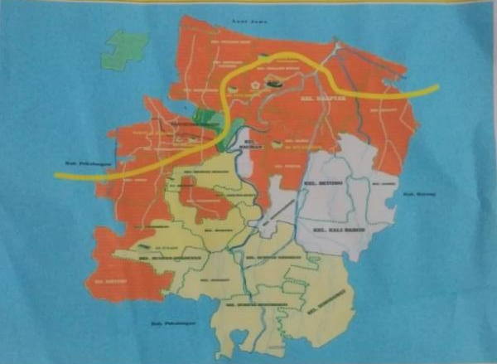
Figure 8. Pekalongan City Coastal Flooding-prone Map Year 2016 (Pekalongan City Government, 2017)

Social Context
- Considering the above climate-related risks and their domino effect faced by Pekalongan, addressing the risks become of importance to the city. Diverse measures have been taken by municipal government of Pekalongan City to address this issue; both conducted self-sufficiently as well as with the assistance from third party. Self-sufficiently, the municipal government has developed evacuation plan annually for the purpose of community mobilization during flooding. They have also implemented short-term measures by providing economic assistance in the form of fish seed and fish nets, as well as physical assistance such as raising embankments and build productive roads in the embankments area. The local community have also implementing voluntary adaptive measures, albeit a simple one due to economic restraints; such as: raising their floor levels, changing livelihood, river cleaning etc. Yet these measures were conducted partially, without a comprehensive planning that could relate the root cause of the issue to the implemented activities, so that the results are slightly ineffective, especially when considering long-term perspective.
- Pekalongan City had also cooperated with different local and international NGOs as well as development partners in this climate change issue. PAKLIM-GIZ had assisted the city in developing their GHG Emission Profile, Risk Profile and also deriving the relevant Integrated Climate Change Strategy (ICCS); in which the latter is claimed as successfully integrated to the existing Mid-Term Development Plan of Pekalongan City. However in actual, the integration is limited to inserting the actions into development plan matrix, without consideration of climate change as the strategic development issue for the city; losing the actual meaning of mainstreaming process. ACCCRN Indonesia (a programme under Mercy Corps Indonesia) further assist the city in managing the issue by providing capacity building for both the community and local government to enhance their awareness and knowledge on this matter. By doing so, the programme expected that the city could develop the corresponding adaptation activities.

Environmental Context
- During ACCCRN implementation period, a city climate working group was developed. The said group is a multi-stakeholder group, comprises of not only local government representative, but also academicians, community member and local NGOs. Throughout its lifetime, city climate working group had been able to provide the municipal government with sound input and recommendation particularly in providing climate perspective when discussing development issue. However, one glaring weakness of the group is that the member was appointed by name, instead of institution, thus their involvement in the group can somewhat diminish. These lessons learned are considered in developing the proposed programme; boosting its strengths and tackle its weaknesses.
- In 2014, the Government of Indonesia had published their National Action Plan on Climate Change Adaptation (RAN-API), a document outlining adaptation strategy and programme that will be implemented nationally by the country for a 5-year period. RAN API is expected to be mainstreamed into provincial and local level, in which adaptation plan made at both level should reflect and in harmony with the content of RAN API, while at the same time aiming to address climate-related risks in the respective area.
- At this moment, the RAN API Secretariat is in the process of tagging adaptation activities at national level, whereas the locus area for the said activities will be at city/district level. Ensuring a synchronize local-provincial-national adaptation plan would potentially assist the city in tapping adaptation-related funding that budgeted at the national level. Not to mention the fact that a synchronize activities will assist the national government in assessing the effectiveness of RAN API implementation. Planning can be made at national level, but the implementation would almost always be at local level, as the party that directly facing the risks. Hence developing an effective adaptation activity at local level is essential here.
- In relation to RAN API, Pekalongan City also has the benefit of being chosen as one among 15 pilot locations of RAN API; putting them at the forefront for adaptation-related activities. Pertinent to this matter, the mainstreaming process that will be conducted under this programme is expected to set an example on how to synchronise adaptation plan and programme at four government levels, as well as mainstream the said plan to the local development plan. Lessons learned from the mainstreaming process can be disseminated to other pilot locations.
- Coastal flooding is one of the most frequent risks faced by Pekalongan City. The coastal community experiences daily coastal flooding for the past 10 years. During high tide, the affected communities will be inundated for a period of 2-4 hours. Houses, public facilities, roads, paddyfield are all flooded by the flood. The flood intensity is deemed as increasing each year. In 2012, coastal flooding inundated 8 communities and caused significant damages to ports and settlement area (and the infrastructure within) with water level reaching 110 cm, while also affecting 100 Ha of paddy field; whilst in 2016 the affected area is increasing to 10 communities and 197,5 Ha of paddy fields. Historical record shows that the height of coastal flooding in 2016 is considerably higher compared to the previous years; prompted the Mayor of Pekalongan City to declare state of emergency due to coastal flooding.
- The inundated household has no access to adequate sanitation facilities since their latrine is also inundated. The municipal government of Pekalongan City has limited budget to provide this access to the affected community, which then prompted open defecation practices (often to water body) in some communities. These unhygienic practices coupled with high frequency of coastal flooding have increased the potential of water-borne disease; leaving the community susceptible to health issue.
- In addition, the dense coastal settlement area is not serviced by water piping from the state-owned water company, prompting the community to rely heavily on groundwater. The combination of this groundwater exploitation with land subsidence from significant coastal land use change over the years could exacerbate the impact of coastal flooding in coastal area. These aspects are among the identified non-climatic barrier for the programme achievement. The design of the proposed programme had considered this potential barrier by developing City Climate Risk Assessment and the subsequent action plan early in programme implementation; while also involving BAPPEDA as the leading sector for development plan within the programme. The Climate Risk Assessment and Action Plan will entail recommendation for climate-resilient development and spatial plan; to reduce massive land use change into built environment in coastal area. Meanwhile BAPPEDA and other relevant government institutions will be equipped with knowledge and information on the correlation between land use change, land subsidence and coastal flooding risk. At the moment, municipal government officials that are involved in the proposal development had understood the connection between land subsidence and coastal flooding.
PROJECT APPROACH

- Adaptation measures taken in Pekalongan City to address climate change issues are somewhat lacking in evaluation that derives from the non-existent of a comprehensive climate risk assessment. A such-complex issue such as climate change needs across-the-board measures to be able to address the issue effectively, and from its roots. Considering that most of the risks are deriving from changes in climate indicators, hence it is of importance to develop climate risk assessment prior to intervening with different projects, so that the project's results can be tracked back to the initial level of risk.
- It is this gap that this proposed programme tries to bridge, by implementing a comprehensive approach encompassing technical assessment, planning, intervention, and also monitoring and evaluation; which will be supported by framework and measures to fortify institutional mechanisms on climate adaptation and resilience issues. In practical the programme components will be started with identifying the roots of the problem (climate risk assessment) and followed by developing and implementing the adaptation plan (in the form of intervention projects) which results can be tracked back to the problem; while simultaneously building stakeholders’ capacity and advocating climate resilience policy along the course of the programme.
- This programme will focus on building resilience to climate change impacts in Pekalongan City, one of the coastal cities in Central Java Province (in North Coast of Java region), by employing interventions in the form of not only hard structure, in the form of coastal protection construction/installation, but also soft structure; touching not only physical interventions but also building their socio-economic and institutional capacity. Due to increased frequency and dimension of coastal or tidal flooding, the Municipal Government of Pekalongan City received assistance from the Central Government and Central Java Provincial Government to construct a polder dyke and to extend the coastal parapet. The parapet was constructed up to the eastern part of the Pekalongan City’s coast, leaving a gap of 300m exposed directly to the sea and still a threat for the community in the said area during tidal flood occurrence. This 300m gap was requested to be filled by KEMITRAAN during the initial phase of the development of this proposal. In addition to the parapet, the Municipal Government of Pekalongan City has installed geotube within the length of its coastline, indeed leaving some gaps in different spots, both in the western and eastern part of the city’s coast. The geotubes are installed to protect the coast from further abrasion and, in some parts, the existing mangrove ecosystem, as well as to enforce the coastal sediments KEMITRAAN was also requested to fill the gaps with new installation of geotubes during the initial phase of this proposal development.
- Indeed, during the socialisation of the proposal approval, the Municipal Government of Pekalongan City have informed KEMITRAAN that the initially requested 300 parapet construction have been taken over by the provincial government, which was to be covered by the state budget. The Municipal Government has therefore requested KEMITRAAN to reallocate the budget for parapet construction to alternative solution with the similar output, which is to protect the community from the impact of sea level rise and to mitigate abrasion. Moreover, the Municipal Government also informed KEMITRAAN to reconsider the enhancement of the geotube incl. replacement of the damaged once as initially planned. This request for consideration was based on consultation with coastal experts from different universities and also on the facts that most of the geotubes did not sustain the expected maximum durability of 20 years.
- This approach will be taken at 4 governance level; starting from community (kelurahan) level, city level, provincial level up to the national level; to ensure the interlink of plan and actions across those different level. Capacity building and developing adaptation plan as well as implementing the corresponding plan will be the fundamental of the approach. Meanwhile at provincial and national level, mainstreaming and advocacy will be the primary component. Synchronization of adaptation plan will be at the core of the approach at every level.
- Climate risk assessment process will be done at Pekalongan City utilizing Vulnerability Index Data Information System (Sistem Informasi Data Indeks Kerentanan/SIDIK), a vulnerability assessment tool developed by the Ministry of Environment and Forestry. SIDIK is a web-based data and information system that can be used to assess the vulnerability level of an area and/or sector to climate change impact. SIDIK has a standardized data and methodology which enable the user to compare vulnerability level across different areas in Indonesia. Despite its standardized character, SIDIK acknowledge that every region has different level of data, type and accuracy; thus the system provides space for adjustment. SIDIK user could use a more accurate data and indicator for the system that is available in their region.
- For the purpose of this programme, given that the system is initially built for land-based region, adjustment will be made to SIDIK. To be able to capture the vulnerability of Pekalongan City with its coastal characteristics, vulnerability indicator within SIDIK system need to incorporate coastal-related data. The adjustment will then provide input for SIDIK developer to improve their system by including coastal attributes. This future improvement will be essential seeing how coastal cities/districts are spread out across Indonesian coastline.
- Furthermore, a Participatory Climate Risk Assessment will also be applied. The initial step of the programme will be establishing community working groups delivering some series of trainings to build their knowledge on climate change adaptation and coastal resilience. This is expected to assist them in developing much sounder climate risk assessment. This two-tier risk assessment at community and city level will be done to ensure a synchronized adaptation planning at both level, which does not happen often in the past; the city government project at times did not fully serve the actual community needs.
- Having taken into account the existing Climate Change Vulnerability Index, climate risks faced by the area, as well as losses imposed to the respective community, hence this programme will specifically address the risks of coastal flooding (and its secondary impact such as loss of livelihood, health disease etc.) in the coastal area of Pekalongan City which historically imposed by climate-related risk in the form of coastal flooding and abrasion. The coastal area falls under the administrative area of Pekalongan Utara sub-district. Pekalongan Utara is the largest sub-district in Pekalongan City with a total administrative area of 14.88 km2 that inhabited by 78,470 population (in 2014), the second highest population number amongst sub-districts in Pekalongan City. From that number, 50.2% are women.
- Pekalongan Utara constitutes of 7 kelurahan (an administrative area similar to Kampongs); in which kelurahan Panjang Wetan is the most vulnerable to flash flood, while Krapyak Lor is the most vulnerable to coastal flooding. In addition to 7 communities within Pekalongan Utara Sub-district, the community level scope for this programme will also include kelurahan Pasirkraton Kramat Kampong in Pekalongan Barat Sub-district that assessed as prone to coastal flooding. The significance of addressing coastal flooding risks in these communities further underlined by the city government publication of Pekalongan City Coastal Flooding-prone Map 2016 (Figure 5) which shows how the all of the kelurahan targeted in this particular programme are categorized as highly prone to coastal flooding.
- Seeing these risks faced by the area, resilience building process in this proposed programme will be focusing its work in strengthening food security, enhancing community livelihood while simultaneously preserving the environment; touching not only practical aspect but also promoting policy. Sustainable development principle will be held at core here to ensure efforts being done at one sector will not create negative impact and incremental losses in the other.
- In view of this multifaceted issue, the proposed programme framework will be instilled by multidisciplinary and iterative process, with a series of assessment, study and activities to be derived from. Accordingly, the programme will not only emphasizing on building hard structure, but also strengthen soft structure (institutional realms, including capacity building) in addressing the issue; creating a paradigm shift from the conventional approach that mostly revolving around building infrastructure that could only serve short-term purposes to newer perspective that allow for continual development and evaluation. At the core of this framework is participatory and collaborative approach by fostering multi-stakeholder involvement, to bring about different interest on the issue and resolve it amicably to achieve common goals.

TARGET COMMUNITIES
Overall, the target communities within the municipality of Pekalongan City consist of 8 kelurahan:

Area 1 – Degayu
Area 2 – Krapyak
Area 3 – Panjang Wetan
Area 4 – Panjang Baru
Area 5 – Kandang Panjang
Area 6 – Padukuhan Kraton
Area 7 – Bandengan, and
Area 8 – Pasirkraton Kramat

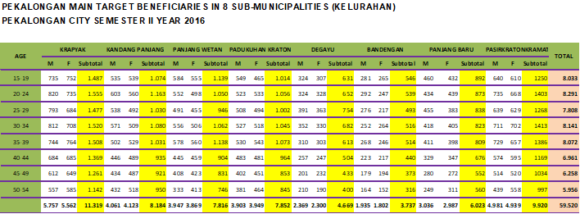

Project / Programme Objectives
Goals
- This project is specifically designed to Building Coastal City Resilience to Climate Change Impacts and Natural Disasters, with a particular focus on pro-poor adaptation actions that involve and benefit the most vulnerable communities in the city. We believe that the key to do so is to enhance the capacity of coastal community in implementing climate change adaptation actions. This will be achieved through three important actions namely: (1) safekeeping actions, (2) surviving actions and (3) sustaining actions with the objectives as follows:

Objectives
- Restoring natural protection to increase resilience from flood hazards and risk exposure and vulnerability by restoring mangrove ecosystem and enhancing coastal protection where there is still gap. – [Safekeeping Actions].
- Developing Climate Change Information System based on the various datasets related to climate change indicators at various areas in Pekalongan City. The aim is to develop resilient livelihood strategies, by combining formal scientific data and relevant local knowledge and wisdoms. – [Surviving Actions]
- Involving and engaging local government and city stakeholders in developing Local Climate Adaptation Action Plan and implementing climate smart actions. The proposed programme will conduct capacity building activities for local government and city stakeholders to develop the Plan and to implement climate smart actions. – [Surviving Actions].
- Mainstreaming climate change adaptation and resilience into Central Java Province development plan, which in turn could foster better climate-related policy on climate financing and bottom-up planning. – [Sustaining Actions]
- Strengthening vertical coordination and collaboration between national and local government in climate adaptation context and enriching knowledge, toolkits and methodologies coastal resilience for the national government. [Sustaining Actions]

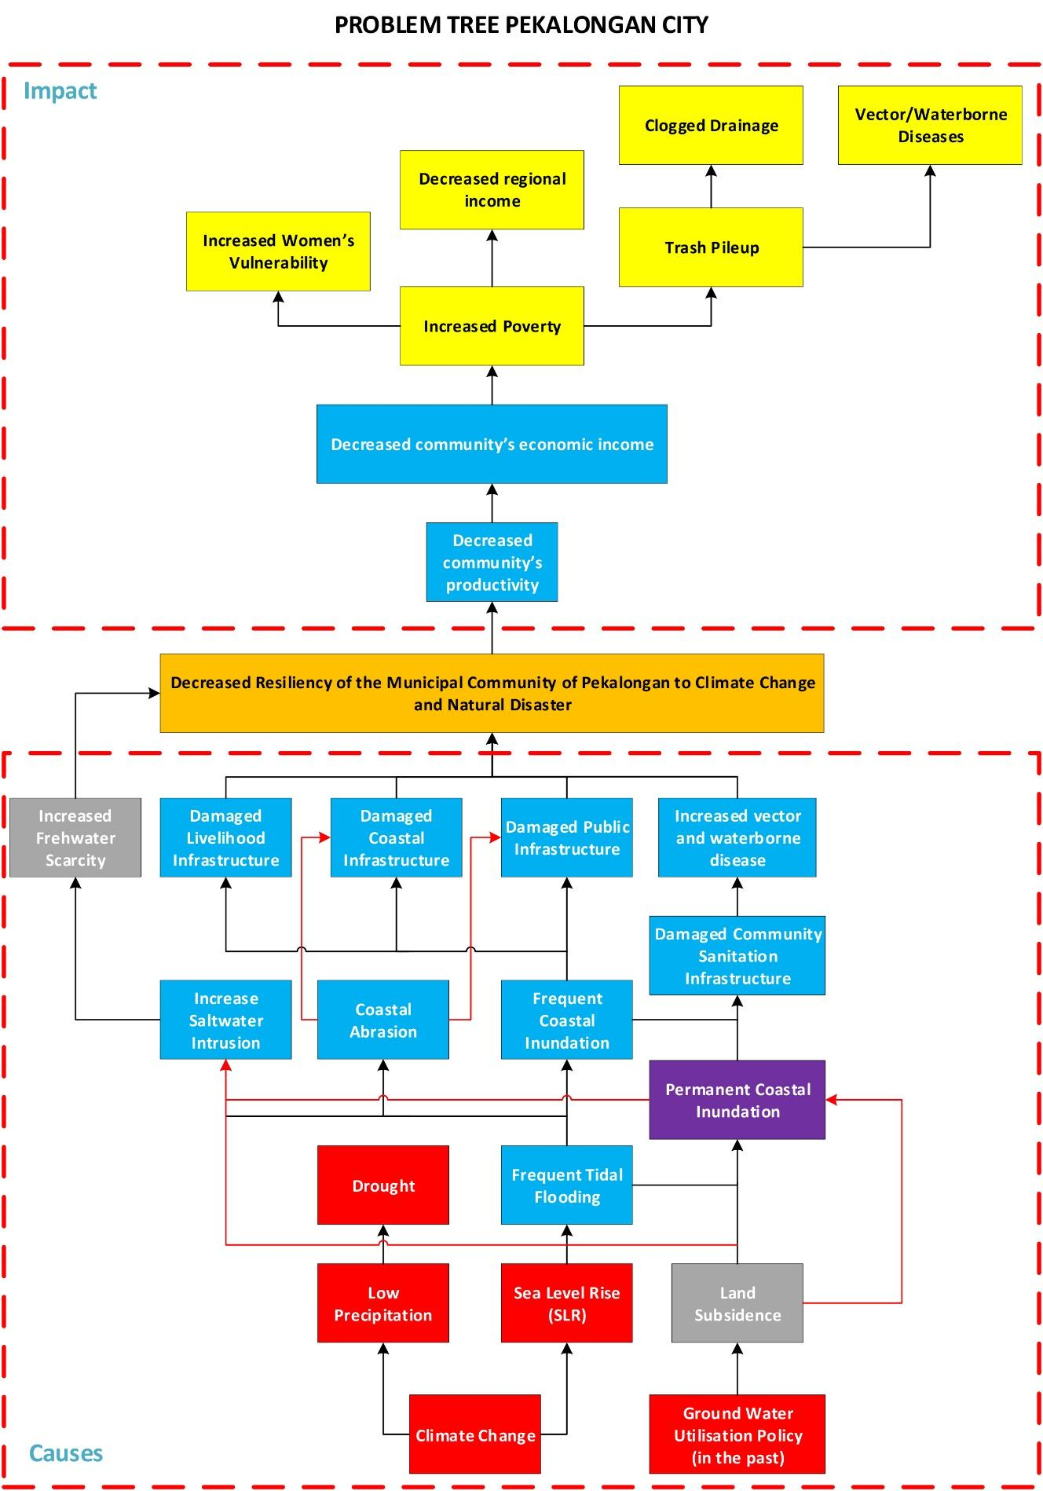
Figure 9. Problem Tree Pekalongan
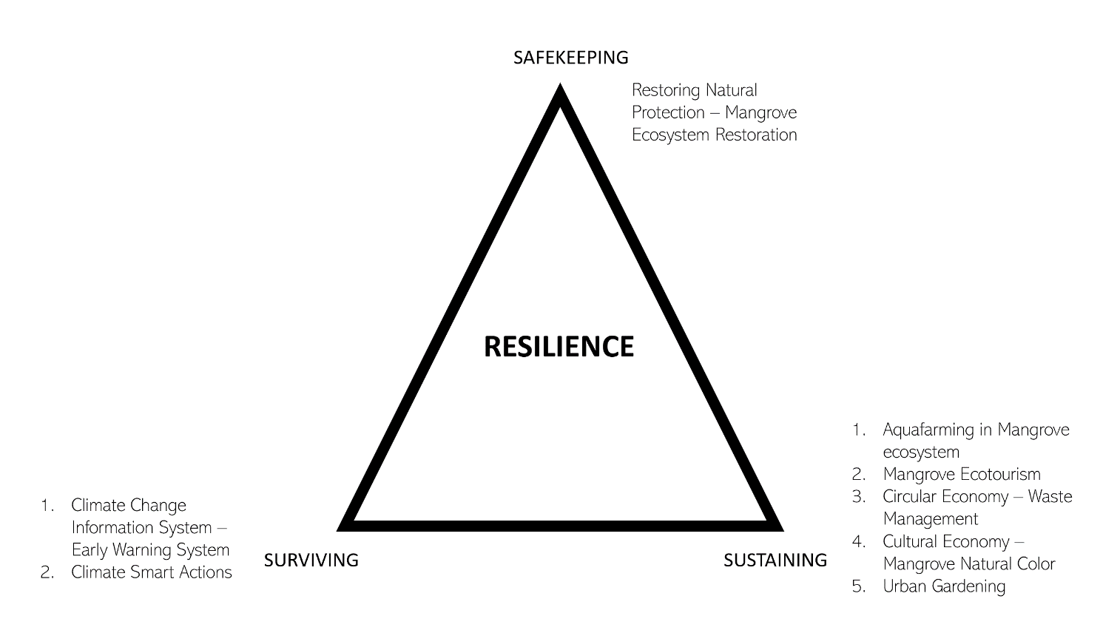
Figure 10. 3S for Resilience Approach: Safekeeping-Surviving-Sustaining

Project Component and Financing

Project/Programme Components | Expected Outputs | Expected Outcomes | Amount (US$)
SAFEKEEPING
- Enhancing protection along the coastal line of Pekalongan City | - 3 ha of Mangrove Ecosystem established | - Increased coastal community resilience in Pekalongan City | $ 1.329.480
 | - Breakwater (rubble mound) covering the coast of Kandang Panjang in the area of Mangrove Information Centre (PIM) constructed, | - Increased coastal community resilience in Pekalongan City | $ 1.329.480
SURVIVING
- Enhancing coastal community capacity in developing and implementing Local Climate Change Adaptation Action Plan (RAD API), climate change information system, Climate Smart Initiative | - Pekalongan City Climate Working Group reactivated | - Enhanced capacity of local actors in identifying, initiating, strengthening, and escalating community-based actions to address climate risk and natural disaster; including capacity in integrating the actions to kelurahan development plan | $ 620.511
 | - Climate working group established and functioning in each of the 8 target kelurahan |  | $ 620.511
 | - Enhancing coastal community capacity in developing kelurahan’s information system and implementing the ensuing climate change adaptation actions |  | $ 620.511
 | - Engaging youth groups and building their capacity to become Agents of Change in climate change adaptation actions of Pekalongan City |  | $ 620.511
 | - RAD API developed based on Pekalongan City Climate Risk Assessment and Climate Coastal Impact | - Enhanced capacity of local government and other city stakeholders’ in developing climate risk assessment and utilizing the results to develop local climate change adaptation action plan (RAD API) | $117.222
 | - Strategy to integrate CCA into local government planning processes (annual work plan or mid-term development plan of city) is developed |  | $117.222
 | - Innovative and collaboration adaptation actions are implemented in collaboration with private sector, Government bodies and NGO (i.e. technology for main productive sectors, model on collaborative CCA programme across coastal kelurahans/ upstream and downstream kelurahans, collaborative action to protect the affected coastal area); and also evaluated for future reference | - Enhanced resilience of coastal community through the implementation of Climate Smart Initiatives, including fostered sustainable utilization of natural resources, with implementation scheme that can be replicated and disseminated to broader audience | $ 68.148
 | - Climate change training and knowledge sharing conducted | - Established knowledge management network at municipality level | $ 262.259
 | - Knowledge product, Advocacy materials (i.e. lessons learned, research paper, newsletter) published and shared |  | $ 262.259
 | - Local knowledge sharing network established |  | $ 262.259
3. Strengthening vertical coordination by enhancing provincial government’s capacity in mainstreaming climate change adaptation and resilience into Central Java Province development plan which in turn could foster better climate-related policy on climate financing and bottom-up planning | - Enhanced provincial capacity to develop RAD API | - Enhanced provincial government’s capacity in mainstreaming climate change adaptation and resilience into Central Java Province development plan | $ 194.815
 | - Appropriate strategy to integrate CCA into Provincial government planning processes (annual work plan or mid-term development plan of city) is developed |  | $ 194.815
4. Strengthening vertical coordination and collaboration between national and local government in climate adaptation context and Enriching knowledge, toolkits and methodologies coastal resilience for the national government | - Knowledge product in the form Handbook on how to use SIDIK for risk assessment at coastal city is published and shared. This handbook is targeted to be used by local government, NGOs and civil society organizations | - SIDIK as risk assessment tools for coastal area based on local experience enriched | $ 284.370
 | - Strengthened vertical coordination and collaboration between national and local government in climate adaptation context |  | $ 284.370
SUSTAINING
5. Improving community’s resilience through initiation of alternative livelihood and improvement of sanitation facility | - Aquafarming in mangrove ecosystem developed and implemented by community | - Increased economic income and improved community’s health in 8 target kelurahan of Pekalongan City | $ 2.545.388
 | - Mangrove ecotourism improved and involving wider participation of affected coastal community of Pekalongan City |  | $ 2.545.388
 | - Improved cultural economy through application of ecological batik using mangrove based colouring product |  | $ 2.545.388
 | - Improved food security through the application of urban farming as alternative to conventional agriculture practices |  | $ 2.545.388
 | - Developed circular economy through initiation integrated waste management system and processing |  | $ 2.545.388
 | - Improved sanitation facility in 8 target kelurahan to mitigate risks of waterborne disease |  | $ 2.545.388
 | 5.1.7. Flood Relief for Pekalongan City
- Total Project/Programme Cost |  |  | $ 5.422.194
- Project/Programme Execution cost and ME cost Improved sanitation facility in 8 target kelurahan for better and healthier living condition |  |  | $ 82.571
- Project/Programme Cycle Management Fee charged by the Implementing Entity |  |  | $ 467.905
Amount of Financing Requested |  |  | $ 5.972.670

Projected Calendar

Project Duration: 3 years (36 months)

Indicate the dates of the following milestones for the proposed project/programme
Milestones | Expected Dates
Start of Project/Programme Implementation | April 2020
Mid-term Review (if planned) | November 2022
Project/Programme Closing | March 2023
Terminal Evaluation | April 2023

PART ii: Project / programme JUSTIFICATION

Describe the project / programme components, particularly focusing on the concrete adaptation activities of the project, and how these activities contribute to climate resilience. For the case of a programme, show how the combination of individual projects will contribute to the overall increase in resilience.

- Climate change has led to the rise of sea level and changes in rainfall patterns in Pekalongan City. The rainfall pattern in recent years has become more intense and occurs in a shorter period, which then leads to flooding. Flooding in northern part of Pekalongan City, either those caused by increased rainfall or sea level rise, have contributed to a large number of various interconnected problems. Extreme climate events like heavy rains, combined with sea-level rise have resulted in more frequent and more unpredictable floods that threaten populations’ security and goods. Climate change is thus impeding Pekalongan City development. One example of this impediment is the decrease of agricultural land area in nine communities of Pekalongan City that reaches 73% between the period 2007-2016 due to the land being submerged in sea water and also high salinity level of the irrigation water. This condition has threatened Pekalongan City food security by reducing rice and other agricultural production.
- This programme is specifically designed to Building Coastal City Resilience to Climate Change Impacts and Natural Disasters through 3S Actions: [safekeeping-surviving-sustaining], with a particular focus on economic/livelihood, food security and environmental issues. The development of local climate change adaptation plans required scientific basis to corroborate and better understand the pattern of current and future of climate risk. This information is essential to create and develop an effective adaptation. Effective adaptation action should also be built on existing actions; adjusting and leveraging practices that are socially- and environmentally-friendly, while leaving practices that potentially cause adverse impact.
- Another key to effective adaptation is that it needs to be locally driven and to involve those most at risk. This notion thus highlights the importance of two key actors, the local government and community-based organizations (Satterthwaite, 2010). Having considered the above, employing a combined bottom-up and top-down approach, while simultaneously taking into account the current and future climate risk pattern, is considered as important for this programme in developing an effective local adaptation action plan.
- Bottom-up approach means that the development of local action plan should meet local needs and involve diverse actors by taking into account the local condition (human capacity, resource availability, local knowledge and practices, etc.). Top-down approach means that national actors play role in providing direction, guidance and resources for supporting local government in developing adaptation action plan that is in line with national development goals. This programme will combine two approaches and facilitate interaction between national and local actors, in order to achieve better overall results. Combined approach is expected to become best practice and set out example on how to synergize national policies (RAN API) into all level of government (Province, City and Community/Kelurahan). Following this approach, activities under this project will then be designed and implemented at four governance level (National, Province, City and Community/Kelurahan).
- Building city’s and community’s resilience is not merely equipping them with hard structure and soft structure to address climate impact, but also by building their awareness and capacity in responding to the impact. Collaborative and participatory approach is the core of this programme. Participatory approach is not only going to be implemented during programme implementation phase, but also in programme design, where the said approach is already applied during the development process of this full proposal. All the interventions to be implemented in this proposal are the result of Focus Group Discussions and Consultation with Local Stakeholders including communities and municipal government of Pekalongan City. The process of these activities could be seen in the Annex 3.
- The interventions approach to different levels of government administration are meant to be in-line with the Law No.23 Year 2014 about Regional Government. This is the sustainability approach on adapting to climate change through local livelihood and economic improvement. This proposed programme will be focusing its work on economic/livelihood, food security and environmental issues. From legal perspective, these 3 issues are in line with resilience sectors in RAN API (specifically Cluster 1, 2 and 3) and with the direction for improvement of communities’ resilience in 2015-2019 National Mid-Term Development Plan (RPJMN). As mentioned above, the combined approach at four governance level is in line with Law Number 23/ 2014 on Regional Government. Activities to be implemented at each level are explained below.
- The main focus at community level is to strengthen the capacity of coastal community in developing community profile/climate-change information system and adaptation action plan, on top of implementing the derived climate change adaptation action. The profile itself will be built upon participatory climate risk assessment conducted by the community. The project in community level will also stimulate the implementation of community-based adaptation actions that will be focusing mostly on livelihood context; how the community can adjust their conventional livelihood practices to be able to face climate change impact. The other focus will be on impact from climate-related disaster faced by the community, namely coastal flooding and erosion and sea level rise.
- At municipal level, more emphasis is placed on increasing the capacity of local government bodies, universities and local NGOs to have the ability to develop local climate-change adaptation action plan (RAD API). The development process will be facilitated by the Project Management Unit (PMU). The core steps in developing RAD API document will be translation and adjustment of RAN API content into local context. To provide scientific basis to the document, training on utilizing SIDIK to assess climate vulnerability and risk of the city will be conducted. The assessment result will then be a part of local context in RAD API and among the key considerations to develop the list of adaptation actions. Training will also be given on mainstreaming process of adaptation plan to local development plan. The training participants at city level will also involve community representatives. This is to ensure that all stakeholders will have the ability to evaluate and find synergy between RAD API and other relevant regional/local development plans. Furthermore, approach at city level would not only encourage community, but also private sector participation in implementing adaptation action, by exploring the potential of private sector cooperation in supporting local adaptation action. Promoting collaborative climate change adaptation actions, not only within programme timeframe, but also in future time.
- The collaborative adaptation actions that will be implemented at city level will be designed with implementation and financing scheme for selected actions that will allow for replication and wider implementation, so that benefit derived from the programme can be further shared after the programme is ended, not only relying from programme funding. It is this existence of such financing scheme that will be the main difference between adaptation actions at community level and city level. Whilst in community level the activities will be conducted in an area with one-off AF grant specifically for aquaculture and innovative latrine will be introduced.
- Adaptation actions that will be implemented at city level will be focusing on:
- Concentrating mangrove enrichment and planting in and around the area of Mangrove Information Centre (PIM), as well as in some part of Kelurahan Degayu, that accumulatively covers an area of around 3 ha (based on the conversion of the initial 6km with 5m thickness). The adjustment to 3 ha is because the possibility to develop mangrove belt east from PIM area is no longer existing. This is the result of municipal city’s parapet construction along the coast up to Degayu. Mangrove Planting in this coastal area is therefore not feasible (See Annex 14).
- Enhancing the resilience of main productive sectors through (i) development of aquafarming in mangrove ecosystem as an alternative income generation for the affected community (ii) construction of coastal embankment with breakwater construction. Aside from financial resources, one of the biggest challenges for aquafarming implementation in the targeted area is coastal and tidal flooding. To this, KEMITRAAN received the request to explore options of breakwater construction to protect Pekalongan City’s coast in Kandang Panjang.
Following the above request, a series of FGDs involving respective experts have been conducted to find the best solution for the protection of the coastline in Kandang Panjang within the month of August 2021. The solution was including both the substitute to the parapet and alternative to geotube.

Therefore, KEMITRAAN sought assistance from coastal experts to develop alternative solutions for coastal protection structures. Based on the options proposed by experts during the FGD, the chosen form of coastal safety building is a rubble mound breakwater. This form of coastal protection construction was chosen considering the real impact caused by climate change is the massive coastal abrasion and the increasing destructive power of waves against infrastructure in the coastal area, which results in, among others, damage to mangrove ecosystems around the Mangrove Information Center (PIM) area, which is an asset of Pekalongan City. Rubble mound breakwater has proven ability to reduce wave destructive power in terms of minimizing coastal damage, as well as to restore lost coastal sedimentation that is necessary to support mangrove ecosystem rehabilitation. Therefore, with the design of these breakwater structures protecting the coastline of Kelurahan Kandang Panjang in the Mangrove Information Center (PIM) area, it can reduce the energy of ocean currents, thus causing tidal waves to return sedimentation and increase land for mangrove planting areas previously degraded from 9.2 ha to 2.3 ha (see the picture below).
- 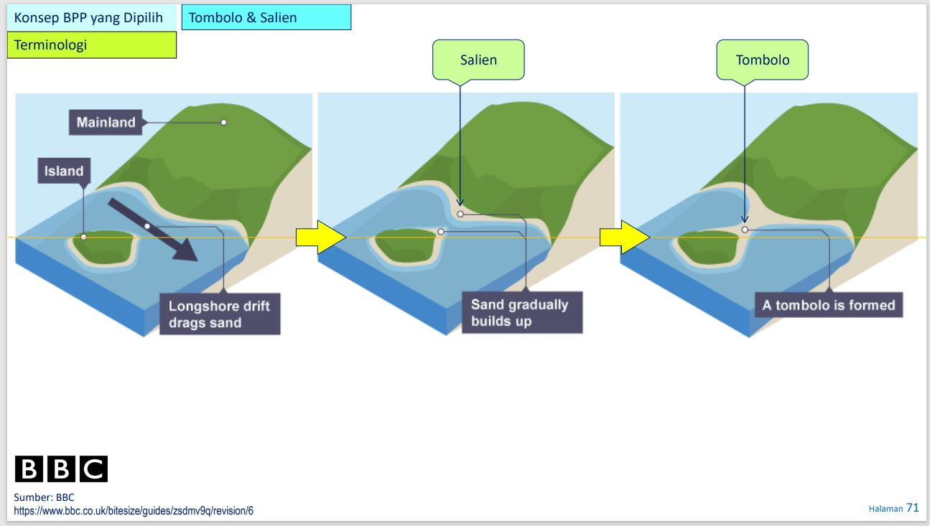
Figure 11 Tombolo and salient concept for the rubble mound breakwater

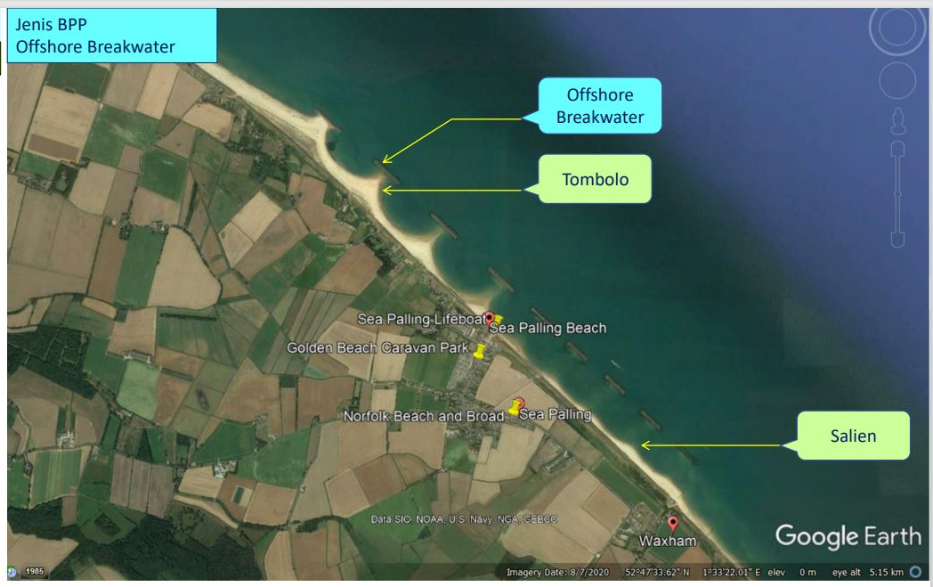
Figure 12 Example of separated offshore breakwater construction
As a follow-up to these coastal experts, KEMITRAAN has conducted a study to determine the appropriate location and design for the construction of the breakwater building in the Kelurahan Kandang Panjang, precisely on the beach in front of the Mangrove Information Center (PIM) of Pekalongan City, considering the available budget. Field studies were conducted for 6 months at the PIM area location to determine the exact location for the construction of the breakwater structure using methodologies such as current surveys, wave surveys, tidal surveys, bathymetric surveys, geotechnical surveys, material availability surveys, and hydro & sediment computational simulations on the breakwater building model based on the obtained data. The methodology used in preparing the study resulted in data consistent with field conditions, ultimately resulting in the design of breakwater structures consisting of natural stone piles ranging from 200 kg to a maximum size of 1.5 tons, with a total required volume of 2,578.5 m3 for natural stones ranging in size from 200 – 1000kg, then 1,567.5 m3 for natural stones sized 1000kg, and 7,059 m3 for natural stones sized 1.5 tons.
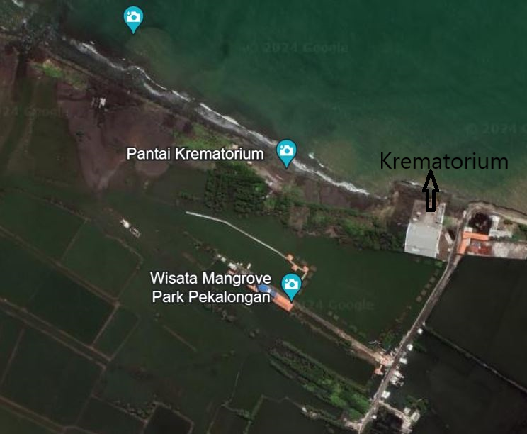
Figure 13 Bird view of the breakwater construction site in front of “Pantai Krematorium”

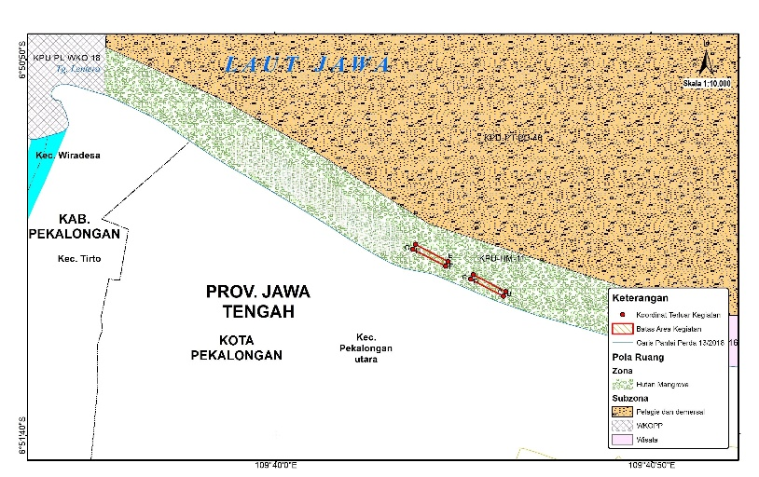
Figure 14 Digitised version of Figure 13 with two breakwater offshore

Based on the results of the above study and considering the budget availability, it was decided to build 2 units of rubble mound breakwater using natural stones. These natural stones will then be arranged into 2 structures, each 150 meters long with a distance of 100 meters between each structure (Annex 13). The decision to build 2 separate breakwater units is to keep ocean currents conducive and not adversely affect the coastal areas around the site (see figures 13 and 14).

This construction does not require groins because based on the results of oceanographic and bathymetric studies, the presence of groins will lead to a backflow of ocean waves opposite to the natural flow of currents in the area. Coastal protection structures in the form of groins, mostly function as longshore capture and transport. Therefore, groins are not effective in stopping erosion on muddy beaches and are not effective in changing the character of the surf zone which will not change the wave height along the coast.

Supporting the construction plan of the rubble mound breakwater, an Environmental and Social Impact Assessment (ESIA) has also been prepared.
- Introducing innovative communal latrine (permanent construction with floating septic tank) in flood prone area to reduce impact from water-borne disease.
- Developing and promoting community-based ecotourism. Despite its nature being community-based, this ecotourism activity will fall under the responsibility of Pekalongan City Government considering that the community does not have jurisdictional authority in the city administrative area. Yet the community will be the main actor in implementation and will work closely with city government officials on this matter,
- Improving Pekalongan City’s cultural economy into a more resilient and environmentally friendly production method through the application of mangrove based colouring material. This way, not only innovative production method is developed, but another economic opportunity through the production and sales of the natural batik colour can be developed,
- Increasing food security through the introduction of urban farming that offers affected local community with possibility to enhance its food source to meet their daily needs of nutrition on the one hand, and to generate income on the other hand,
- Creating income opportunity through support to the Municipal Government of Pekalongan City with an integrated waste processing facility that separates organic and inorganic waste, offering income opportunity through organic fertilisers and recycling process of inorganic waste. This way, the Municipal Government of Pekalongan City can release affected communities from the monthly waste disposal fee, thus creating a cleaner and healthier environment.
- Additionally, knowledge management networks will be established at municipal level; enabling information sharing between stakeholders and creating a transparent programme implementation. Among knowledge products that will be produced are documentation of lessons learned, training materials, research paper, and advocacy materials.
- Activities at provincial level are more focused in assisting the provincial team to develop climate risk assessment with community or kelurahan level as the smallest level of analysis, in which the assessment results will be the basis to develop RAD API. The province will undergo a series of training to equip them with the following technical skill and knowledge: SIDIK utilisation, RAD API development by considering RAN API and city adaptation plan, translation and integrating RAD API into provincial development plan. These will be the basis to build a synchronised adaptation action at city, province and national level. A total of 6 trainings (3 trainings for RAD API development, and 3 trainings for its integration into provincial development plan) will be received by provincial government officials on the aforementioned aspects. From this training, Central Java Province RAD API document and strategic document outlining its integration into Provincial Development Plan will be generated.

- At national level, the team will be focusing in strengthening vertical coordination and advocacy process by working closely with 2 national government bodies and secretariats in issue that will be elaborated as follows:
- The Ministry of Environment and Forestry (MoEF) has developed a free web-based tool to calculate the climate risk index known as SIDIK. This tool is highly beneficial for local governments to assess the risk index of their administrative area in an easy and user-friendly manner. Yet the tool has a drawback in its inability to accurately calculate climate risks in coastal areas. Therefore, this programme will support the MoEF in refining the tool in order to improve its effectiveness and accuracy of its utilisation in coastal areas. Building upon experience of using SIDIK at city level, a handbook will be developed on how to use SIDIK for risk assessment at coastal city areas, where it will contain coastal-related criteria to generate a more appropriate vulnerability index for coastal cities. This handbook will be communicated to MoEF and broader audiences through dissemination activity. Concurrently, 300 handbooks will be produced and made available for local government, NGOs and civil society organisations.
- The Secretariat of RAN API had developed gap analysis of RAN API documents. Building upon experience in translating RAN API at provincial and city level, the team will provide input to the secretariat on gaps identified during the translation process. This input will be beneficial for the RAN API review process that is planned to be conducted in 2017-2018. Cooperation with Secretariat of RAN API will also be done to explore potential synergy between the national (RAN API) and regional adaptation actions (RAD API), that could prompt vertical collaboration between line ministries/government agencies and local governments for implementing adaptation actions that can be implemented at the provincial, city or community level. Seeing Pekalongan City position as one of the pilot areas of RAN API, this synergy and collaboration is seen as highly potential to be implemented.
- In order to explore the potential vertical collaboration in implementing adaptation action, there will be a series of national dialogue (Musrembang, 3 events) as a consultative meeting/forum among national, province and city representatives. In the national dialogue, based on the existing national dialogue method and scheme, community representatives might not be involved. However, lessons learned from community implementation will be shared and communicated by PMU during the event. Furthermore, Pekalongan City representatives will represent communities' (as well as wider city stakeholders’) voice and interests during the dialogue. To further strengthen the need for collaboration as well as highlighting the role of local level in climate adaptation context, a set of policy advocacy materials (including 3 policy papers on: gaps in national policy, fiscal, regulatory and legal framework that built upon experience and findings at local level; 1 lessons learned documentation, research paper) will be developed and communicated to relevant stakeholders. This communication can be done through the programme's regular involvement in national knowledge network meetings (at least 9 meetings). Engagement with a national network that advocates the same interest is believed to provide assistance to this advocacy process, and thus the team will actively engage and communicate with Indonesia Climate Alliance (ICA); a national network of different national institutions, research institutes and NGOs with interest on climate resilience issues. Policy advocacy will be a continuous and interconnected activity at 4 governance levels; and it will be the main content of the vertical approach. Lessons learned obtained at community and city level will be utilised to build research papers and policy brief as bottom-up advocacy material that will also be communicated at province and national level.
Interconnection of Programme Implementation at 4 Governance Level

- Combination of bottom-up and top-down approach will be implemented within the proposed programme to ensure a cohesive climate adaptation plan/programme/policy and its implementation at all governance level. In general, the programme will focus on 4 aspects, which are capacity development, adaptation action, knowledge management and policy advocacy. Figure 11 below shows the interconnection between actions at different governance level within the programme, with brief information on each aspect.

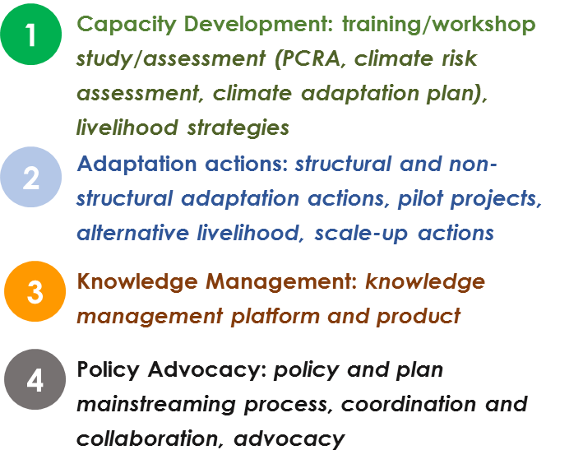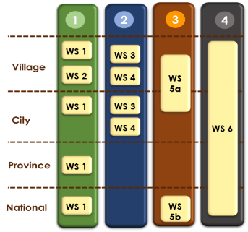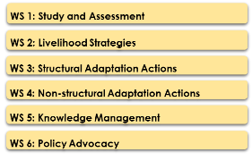

Figure 15. Interconnection of 4 Aspects at 4 Governance Level

Capacity Development
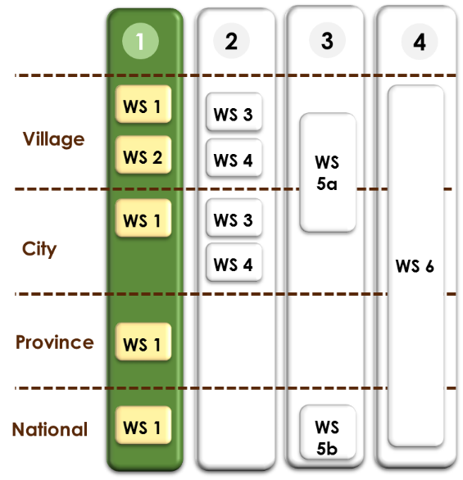
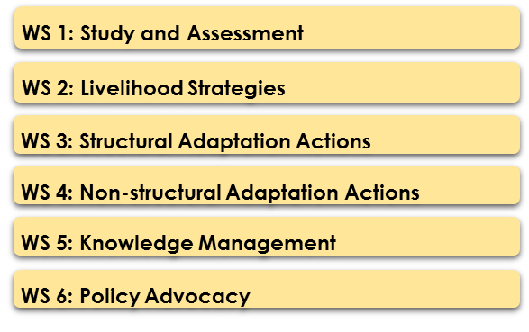
- Focusing in equipping implementer and beneficiaries with sufficient knowledge and skill to address climate-related issue. Capacity development activities will be done at all governance level, with materials including how to develop, use and integrate climate risk assessment at lower governance level into risk assessment process at higher governance level and its relevant policy-making process. At community (kelurahan) level, capacity development process will also include participatory assessment in determining the most suitable and appropriate alternative livelihood strategies for their area. This particular strategy will also be advocated to the municipal government of Pekalongan City for broader replication that complemented with financing scheme.

Adaptation Actions
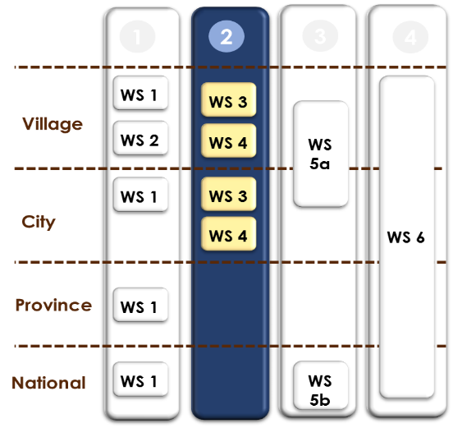
- Focusing in implementing physical and non-physical interventions that are expected to assist Pekalongan City in reducing coastal-related climate risk. Considering the scope of programme implementation as well as the fact that local autonomy in Indonesia falls under city government (instead of province/state government) and its lower governance level, hence adaptation actions for this proposed programme will only be implemented at community and city level. Adaptation actions that will be implemented at both level will be depending on the corresponding climate risk assessment results. At city level, the content of climate adaptation plan (and subsequent adaptation actions) will not only consider city climate risk assessment results, but also input from participatory climate risk assessment at community level.

Knowledge Management
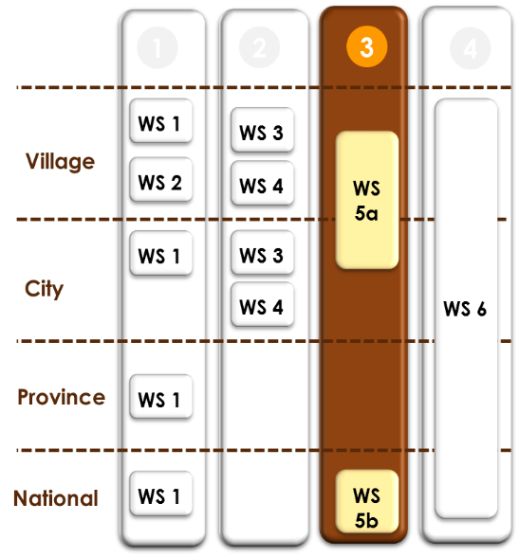
- Focusing in network development for information dissemination and knowledge products development. This aspect is aiming to ensure an effective horizontal and vertical information sharing on climate-related issue. For the purpose of this programme, knowledge management aspect is embedded in each of 4 governance level. Hence the relevant knowledge management activities are located scattered in each level.

- At community level, knowledge management aspect will be focusing on collecting and documenting lessons learned at local level and also two-way vertical communication with city government on climate-related issue. Knowledge management network will be developed at city level with information coming also from lessons learned at community level, in which the network allows a more effective information sharing process. Among knowledge products that will be developed at city level are research paper and policy brief that will support policy-making process at city and higher governance level. At national level, knowledge management activities will be focusing on refinement of SIDIK as risk assessment tools that can be utilized by coastal area. The refinement itself will be utilizing lessons learned obtained from activities conducted at community (kelurahan) and city level. Knowledge management activities will not be implemented at province level since province government role in Indonesia governance system is mostly as the extension of national government, with no actual administrative area, since autonomy falls under the hand of city/district government. Yet, city government will continually feed climate-related information and the relevant adaptation plan to province government as key information for them to develop Central Java Province Climate Adaptation Plan which obligated to be developed by the national government.
Policy Advocacy
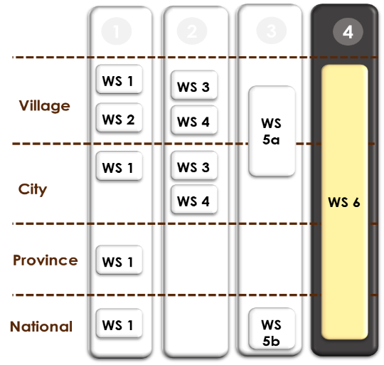
- Focusing in ensuring the integration of climate-related issue into government plan/programme/policy. Policy advocacy will be a continuous and interconnected activity at 4 governance level within this particular programme. Adaptation plan at community level will be mainstreamed to community development plan, and then submitted and advocated during development plan meeting at sub-district level. This plan will continue to be advocated during the succeeding development meeting at city level. Furthermore, the results will also be synchronized with adaptation and development plan at province and national level. Aside from the plan, lessons learned obtained at community (kelurahan) and city level will be utilized to build research paper and policy brief as bottom-up advocacy material.
- To better illustrate how the advocacy process can be done throughout the programme, figure 12 below shows the applicable National Development Planning System in Indonesia. In this figure, it can be seen that community (kelurahan) level is not formally included in the framework of National Development Planning System. However, the deliberation to formulate city development plan is started at community level. The agreed Community Adaptation and Development Plan will be discussed at deliberation meeting at sub-district level. The results then will provide an input to local adaptation plan at city level which will then be integrated to city development plan. Moving vertically, city adaptation plan and development plan will subsequently feed information to shape province adaptation and development plan. Considering their role as national government extension, provincial adaptation and development plan will also be influenced by policy at national level. On the other hand, city government also has the ability to directly feed information to national government by providing sound lessons learned in the form of policy brief. For this particular programme, the city government will provide policy brief which showcasing lessons learned from development and implementation process of coastal adaptation plan that at the moment still lacking in Indonesia, including outlining how coastal characteristics can be integrated into SIDIK.
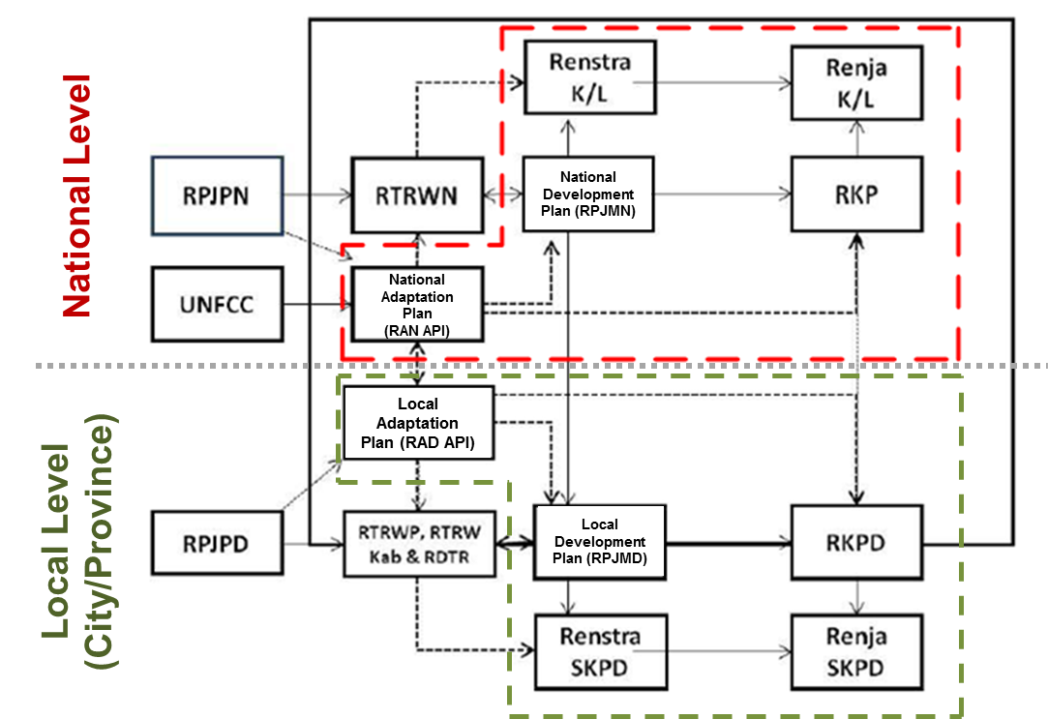

Figure 16. National Development Planning System
- Meanwhile figure 13 shows how the local government (community (kelurahan), city and province government) could incorporate climate adaptation plan into their development plan. This scheme would inform the PMU on how to design the best approach for advocacy. Climate adaptation strategy and plan would provide different perspective to local government in formulating their local development strategy and plan, in addition to the conventional approach which often only considering local and regional economic perspective.
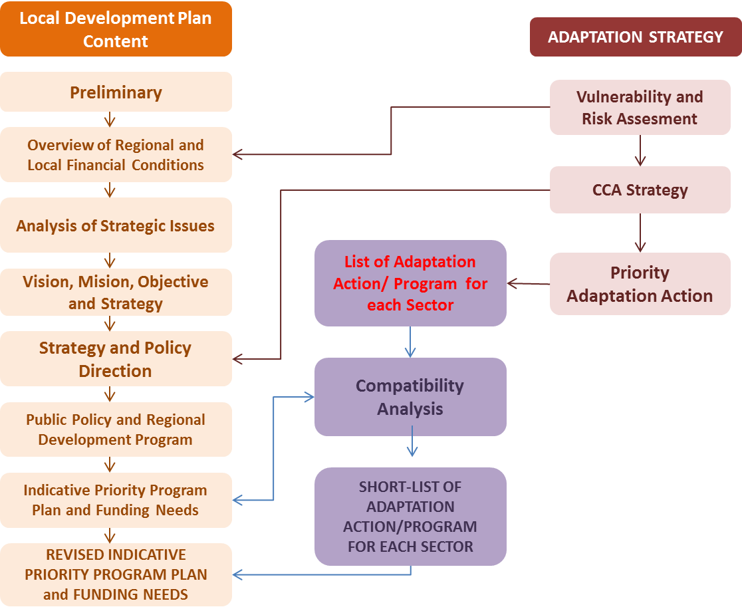
Figure 17. Potential Scheme to Integrate Climate Change Adaptation into Local Development Plan

Describe how the project/programme provides economic, social and environmental benefits, with particular reference to the most vulnerable communities, and vulnerable groups within communities, including gender considerations. Describe how the project / programme will avoid or mitigate negative impacts, in compliance with the Environmental and Social Policy of the Adaptation Fund.

- The programme implementation will generate economic, social and environmental benefits and contribute in improving gender equality, women's empowerment, engagement of youth groups and meet the targeted adaptation needs of women and men. This is marked by the implementation of various consultations with stakeholders at all stages of the project / programme cycle in a gender responsive manner and paying attention to gender equality. Therefore, these benefits came not only from introducing alternative livelihoods and implementing adaptation actions, but also from implementing the whole course of the programme and from various actions mainstreaming gender at every stage of programme implementation. It will bring about and promote a set of innovations that will help improve the lives of the most vulnerable communities and encourage the empowerment of women and engagement of youth. In general, benefits that can be obtained from this programme including protection of the livelihood assets of coastal communities, sustainability of ecotourism and reducing impact from waterborne disease.
- Target beneficiaries of this project through 3S (Safekeeping-Surviving-Sustaining) Approach to Build Coastal City Resilience to Climate Change Impacts and Natural Disasters in Pekalongan City, Central Java Province in 8 Kelurahan comproses 2 different types, direct beneficiaries of 10,477 people consisting of 6,289 (60%) male, 3,145 (30%) female and 1,043 (10%) of vulnerable groups, and also 109,011 both direct and indirect beneficiaries (please refer to Annex 12).

- Direct beneficiaries are those directly involved either in strategic activities (policy planning and development) or in general activities (awareness raising, construction works and planting). Meanwhile, vulnerable groups consist among others of elderly, children, poor, pregnant women and people with disability.

- From a total of 82 planned activities, 50 activities will involve direct beneficiaries. In the activities involving youth groups, the options can still be applied based on gender and vulnerable definition. The percentage of women’s involvement in each important action component is described as follows:
Important Action | Output | Male (Persons) | Female  (Persons) | Vulnerable  (Persons)
Safekeeping | - Establishment of 3 ha of Mangrove Ecosystem (equivalent to 6 km with 5m thickness);  - Breakwater (rubble mound) covering the coast of Kandang Panjang in the area of Mangrove Information Centre (PIM) constructed ; (planning and preparation phase, i.e. engagement of consultant, site survey, development of construction design (DED)) | 128 | 64 | 21
Surviving | - Pekalongan City Climate Working Group reactivated;  - Climate working group established and functioning in each of the 8 target kelurahan;  - Enhancing coastal community capacity in developing kelurahan’s information system and implementing the ensuing climate change adaptation actions;  - Engaging youth groups and building their capacity to become Agents of Change in climate change adaptation actions of Pekalongan City;  - RAD API developed based on Pekalongan City Climate Risk Assessment and Climate Coastal Impact;  - Strategy to integrate CCA into local government planning processes (annual work plan or mid-term development plan of city) is developed;  - Innovative and collaboration adaptation actions are implemented in collaboration with private sector, Government bodies and NGO (i.e. technology for main productive sectors, model on collaborative CCA programme across coastal kelurahans/ upstream and donstream kelurahan, collaborative action to protect the affected coastal area); and also evaluated for future reference  - Climate change training and knowledge sharing conducted;  - Local knowledge sharing network established;  - Enhanced provincial capacity to develop RAD API;  - Appropriate strategy to integrate CCA into Provincial government planning processes (annual work plan or mid-term development plan of city) is developed;  - Strengthened vertical coordination and collaboration between national and local government in climate adaptation context | 4.863 | 2.432 | 806
Sustaining | - Aquafarming in mangrove ecosystem developed and implemented by community;  - Mangrove ecotourism improved and involving wider participation of affected coastal community of Pekalongan City;  - Improved cultural economy through application of ecological batik using mangrove based colouring product;  - Improved food security through the application of urban farming as alternative to conventional agriculture practices;  - Developing a circular economy through initiation of integrated waste management systems and processing. | 1.395 | 697 | 232

- Types and estimated number of target beneficiaries to be involved in the 50 different activities is listed below, with general description of interventions at community and at Kelurahan level:
Capacity building
Activity | Beneficiaries |  |  | Total
Activity | Male | Female | Vulnerable Gr. | Total
Training | 869 | 434 | 140 | 1.443
Focus Group Discussion | 912 | 456 | 152 | 1.520
Workshop | 1.431 | 716 | 239 | 315
Seminar | 180 | 90 | 30 | 300
Awareness raising | 617 | 308 | 103 | 1.028

Economic empowerment
Activity | Beneficiaries |  |  | Total
Activity | Male | Female | Vulnerable Gr. | Total
Manpower for planting and construction. In construction include planning, construction/supervision and operational/maintenance during post construction. | 97 | 48 | 16 | 161
Economic assistance (production means) | 336 | 168 | 56 | 560

- Meanwhile, the types of activities and estimated number of municipal, provincial and national governmental, as well as multi-stakeholders beneficiaries are as follows:

Capacity building for Govt. (municipal, provincial, national)
Activity | Beneficiaries |  |  | Total
Activity | Male | Female | Vulnerable Gr. | Total
Focus Group Discussion | 360 | 180 | 60 | 600
Training | 186 | 93 | 31 | 310
Workshop | 1.062 | 531 | 177 | 1.770

Multi-stakeholders Capacity building
Activity | Beneficiaries |  |  | Total
Activity | Male | Female | Vulnerable Gr. | Total
Focus Group Discussion/Multi-stakeholder | 48 | 24 | 8 | 80
Training/ Multi-stakeholder | 132 | 66 | 22 | 220
Workshop/ Multi-stakeholder | 72 | 36 | 12 | 120
Seminar/ Multi-stakeholder | 84 | 42 | 14 | 140

Tidal flood, abrasion and siltation of rivers
- Climate change impacts include the occurrence of tidal flooding, abrasion and siltation of rivers at the programme location. The following table details some of the causes and their impact on the environment and the communities around the programme locations identified from the results of the discussion with the communities.
Causes | Impact
- Many development activities don’t comply with the “AMDAL” [Environmental Impact Assessment]  - Lots of artesian excavation  - Many companies make water drill wells  - There are still people who throw litter  - Trash piles up and burns  - Over capacity TPA (lack of waste management)  - Many rice fields turn into houses  - The amount of disposal of industrial waste into rivers (pollution)  - There is no green land  - The drainage channel is reduced | - Damaged roads  - The difficulties of the transportation  - Daily activities are disturbed (ponds)  - Home industry is paralyzed  - economic downturn  - Many ships cannot dock, so raw material supply is disrupted  - Slums (dirty and unhealthy)  - Water quickly enters the settlement  - The wind hit the settlement  - Health issues (skin, tuberculosis, vomiting, dysentery, filariasis, leprosy, increased stress and emotions, mental disorders)  - Disrupted sanitation  - Decreasing groundwater level  - Disrupted education (children don’t want to go to school, the school/study location were moved)  - Increasing living costs (repairing motorbikes, houses, etc.)  - Damaged/destroyed properties  - Need more energy and people to clean the house affected by tidal flood  - Disappearing beach (loss of tourist spot/recreation area)  - Plants died  - Loss of children's playground (open land is flooded)  - Domestic violence

Community proposal/suggestions
- From a series of programme preparation discussions, the Partnership team also explored community proposals/suggestions, especially among women, so that their problems could be resolved immediately as follows:
- Grombyang Kali (river’s dredging) in Degayu Community
- Provision of pumps for Degayu Community, because currently there is only one large suction pipe
- Dredging of Kupang River and construction of Parapet (Tebing) and sluice gates in Panjang Wetan Community
- Controlling settlements (there are 11 houses) on the Kali Kupang side of Panjang Wetan Community
- Dredging of city rinse channel repair in the kelurahan of Panjang Wetan, Padukuhan Kraton, Kandang Panjang
- Repair of public toilets for Panjang Wetan Community on the river bank (there are 4 locations)
- Elevation of roads and normalisation of channels in Panjang Baru Community
- Normalisation of Kali Bremi (dredging, cleaning of water hyacinth, raising of senderan) in Pasir Kraton Kramat Community
- Elevation of the talud and repair of the channel (so that water can come out) in Kandang Panjang Community
- Improvement of public channels and household channels in the Padukuhan Kraton ex-Pabean community
- Normalisation of the channel in Pasir Kraton Kramat Community because the sediment is already high.
- Repair of ‘MCK’ in Pasir Sari, Kelurahan Pasir Kraton Kramat
- Elevation of the road in Kramat Sari (‘angkatan 66’). It is because the water overflows into the area.
- Training and provision of capital for residents whose jobs are affected by rob. Giving capital should be direct to individuals (not per group, because often it doesn't work if per group).
- Training: selling, convection and sewing, food (processed fish such as shredded meat), dressing
- Training on waste recycling to reduce waste generation while increasing income
- Socialisation regarding waste management
- Optimization of waste banks, currently many garbage banks are flooded due to tidal flood

Barriers / challenges faced by women in programme participation:
- To ensure women's participation in the entire programme process, it is important to recognize the various potential barriers that hinder their participation. From various discussions with them, the barriers/challenges encountered and need to be anticipated are:
- Generally, in everyday life, women and children suffer from the effects of tidal flood, from waking up until they sleep at night.
- Women must do extra work caused by the tidal flood. Among others: cleaning the house (sweeping, mopping), clearing household items, maintaining and saving children, helping to provide consumption for those cleaning the environment after the tidal flood.
- Female rest periods (including sleep) are much less. The average woman in the beneficiary area wakes up at 2:30 in the morning and sleeps at night at 12.00 a.m. This has an impact on women's health conditions and prevents them from participating in programmes.
- Meeting activities in the community are often held during the evening, but as mothers it is rather difficult to leave children at this particular time.
- Climate change adaptation interventions focus more on road elevation, whereas according to them what is considered should be not only roads, but also waterways. In fact, if the road is elevated but the channel is not repaired, water will still be difficult to get out of the inundation area.
- Even if women submit proposals, the proposal is usually only recorded, but it is not realised because it is not considered a priority scale. The priority is generally based on areas that are considered more severe.
- NUSP funds are directed to ‘SK Kumuh (slum)’. But this ‘SK Kumuh (slum)’ is not in accordance with his visual condition. So that the really slum areas cannot be handled, even though the NUSP funds are quite high in value. Merged communities and non-demergers, obtaining the same amount of funds for handling, even though the extent of the environment and the severity are different.
- Due to limited funds while the location and need for handling is very high. Some women's proposals tend not to be prioritised.

- Participatory approach being employed in the programme will ensure the fulfilment of representatives of both women and men in consultation at all stages of the project / programme cycle and community’s opinion and interests are taken into account. The community working group will be composed of representatives from women groups, most vulnerable groups (included here are community members that could represent the voice of elderly, children and disable groups) and community representatives from different socio-economic levels. The planned adaptation actions, including alternative livelihood, will be designed by considering their needs and interests. Community Working Groups at kelurahan level (CWG) act as institutions that select those beneficiaries of the project at the community level. The criteria for beneficiaries are affected communities, the poor and vulnerable people, for farmer groups, VWG must ensure that at least 30% of the group members are women.
- While at city level, the programme tries to provide a broader impact by not only targeting direct beneficiaries in the forms of people that are involved in target implementation sites, but also indirect beneficiaries which are the wider Pekalongan City community through advocating and fostering a climate-resilient development plan and action plan. The programme will also focus on strengthening local government’s capacity in developing and mainstreaming climate change adaptation plan to local development plan and spatial plan by paying attention to the gender aspects in it.
Capacity Building
- Capacity development activity at community level in the 8 target kelurahan will be mostly done in the form of training and awareness building that are focusing on strengthening coastal communities' capacity in climate-related knowledge as well as planning, implementing and monitoring community adaptation plan. These activities will introduce new knowledge that intends to stimulate behaviour changes. For the local environment this would mean less adverse environmental impact from anthropogenic activity as well as an opportunity for promoting new ecosystem services (e.g. coastal conservation activity) and increasing social capital. The community thus will obtain social benefit in the form of improved knowledge and capacity to better address climate-related issues which in turn will increase their adaptive capacity to climate risks; and also environmental benefit that is derived from behavioural changes. Meanwhile the economic benefit comes as an indirect impact of capacity development at community level, particularly from alternative livelihood training that is aimed to increase the coastal population income. The training and awareness building will also raise some gender issues related to climate change such as gender mainstreaming of climate action into community development plans, including the impacts of climate change on women. Accordingly, the vulnerable groups (including women) will be trained and equipped with new skills; and open up new employment opportunities for them. The total target of training and workshop participants at the community level will be attended by 360 participants where 100 participants are women. Furthermore, women representatives will also be the members of community climate working group (20% of community working groups are women champions in all communities).
- Further, this programme will also provide social benefit to the local government, both the Municipal Government of Pekalongan City and the Provincial Government of Central Java, by enhancing their capacity to develop a participatory gender responsive and sustainable local development plan that incorporate climate change context; fostering a better institutional framework for climate-related planning and thus creating a ripple effect in building a more resilient coastal city. The existence and implementation of this plan will assist them in better allocating resources (both in terms of monetary, physical and human resources), including improving public services to vulnerable people. Often, resources allocation done by the local government was not on target due to minimal information, especially when trying to synergize vertical planning between city and provincial government; resulting in an ineffective not on-target resource allocation. Implementation of this programme is expected to remedy these previous practices, fostering a better and more synergized planning, and also a more effective and on-target resource allocation.
- At city level, social benefit will also be obtained from the establishment of local knowledge management network that enable information sharing (including technical information and gender issues) between stakeholders. As one of the member of the knowledge network, local NGO and community-based organizations will also gain social benefit from this programme since they will receive technical training that will be useful for their future operational activity in the area. Local knowledge management network will ensure the diversity of knowledge regardless of gender and age to add to the robustness of the knowledge constructed and insights gained.
Advocacy
- Advocacy conducted at national level has the potential to promote economic benefit for the city by synergizing city adaptation plan (that built upon community adaptation and development plan), provincial adaptation plan and national adaptation plan; open-up opportunity for Pekalongan City to tap funding access from the national government budget. The municipal government of Pekalongan City will then be able to allocate the needed funding for implementation at community level. For national government itself, this synergy would enrich their existing information on climate-related issues at local level and also set example for vertical coordination mechanism to other RAN API pilot areas.
Potential Adaptation Actions
- Potential adaptation actions at community level in the target kelurahan will be focusing on addressing impact from climate-related disaster faced by the community, namely coastal flooding, erosion, sea level rise and changes in sea water properties. Among the potential actions and their corresponding benefits are:
- Extending the existing mangrove belt to increase the resilience of the coastline community with natural and local-based structure. Intervention will be done in the targeted communities that are prone to coastal flooding, mainly the community of Panjang Wetan, Kandang Panjang and Bandengan. Mangrove in this design will generate environmental benefit by acting as sediment trap for coastal erosion protection (from prevailing wind) and water purifier; hence creating a more suitable environment for fish pond that will be located behind the mangrove layer. Additionally, mangrove will also act as a natural barrier to protect coastal environment and community from coastal flooding. All of these environmental benefits would in turn create economic benefit for the coastal community by increasing fish population from better water quality and provision of complex food web that supports different kind of numerous commercial valuable species. Mangrove ecosystem is known as natural habitat of a number of fish species, among others milkfish, white snapper, mudskipper and mullet; shrimps and prawns, as well as fiddler crab and mud crab.
- Construction of breakwater covering the coast of Kandang Panjang in the area of Mangrove Information Centre (PIM) constructed . The breakwater is intended to reduce tidal force that leads to extensive coastal abrasion. The breakwater is also aimed to strengthen the coast through sediment building (sediment trap), that will allow mangrove to grow, especially in the area of the municipal Mangrove Park. This way, the condition of the coastal ecosystem will be improved and settlement area adjacent to the coast and directly affected by sea level rise can be protected.
- Installing communal latrine to address sanitary issue, including reducing the risk of water-borne disease. Due to permanent inundation, some household are suffering from inoperable latrine, hence open defecation in body of water can be found in some area. The open defecation habit also driven by the community’s economic condition which majority at low level, and thus often do not have individual latrine. The community had indeed provided with communal latrine in the past. However these facilities were inoperable due to inundation as well as low level of maintenance. To overcome problems with water and sanitation, 3 communal latrines will be installed in each of the 8 targeted communities (total 24 communal latrines in total). To complement these latrines, a communal waste water management installation will also be built to prevent water pollution from latrine effluent. Both the latrine and waste water installation will be designed to suit with the area’s characteristics that at risk from inundation, but still takes the ease of access and maintenance for the community into account, so that the facilities will be well maintained throughout the time and continually benefit the community. Consultation with the community has been conducted on the design of the communal latrine. Yayasan Bintari (Bintari Foundation) has built upon this consultation with the community a pilot communal latrine for the community of Bandengan (see Annex 11 for the design and construction). This programme will continue the construction of the communal latrines in the target kelurahan based on the result of consultation conducted by, also in collaboration with, Yayasan Bintari including the provided design and construction.

Alternative Livelihood
- Alternative livelihood will be introduced in this programme to reduce coastal community’s high reliance to their existing livelihood which has the potential to be highly affected by climate change impact, and also to provide additional income for those who currently live in low level economic income. Eco-tourism is the alternative livelihood that will be fostered by this programme and will be implemented at city level.
- This new livelihood relies heavily on the existence of mangrove belt, which for city level has a high environmental value by providing coastal protection. Environmental benefit for Pekalongan City could also be obtained from the introduction and management of eco-tourism. To ensure the site is attractive enough for eco-tourism, protection of its condition is of essential; and hence the management will be driven to preserve environmental condition of the eco-tourism site and its surroundings. At the moment, the existing site can be considered as unkempt despite its potential as tourism site. Having the site dedicated for eco-tourism will drive the community and government officials to preserve its environmental condition. Other benefit arising from these new livelihoods is its potential to contribute in increasing Pekalongan City’s income from fisheries and tourism sector as well as provide job opportunity for the community.
- Being the habitat for various kinds of species with commercial value, healthy and well conserved mangrove ecosystem can serve not only as alternative source of livelihood for capture fishermen but also a destination for recreational fishing, both for local community or for visiting tourists.
- In addition to the above, the Municipal Government of Pekalongan City has raised the issue on waste management in Pekalongan City in the affected area of the 8 target kelurahan, especially in the community of Bandengan, Panjang Wetan and Kandang Panjang, which are severely affected by tidal flooding and in some part permanently inundated. The main issue is that the poverty has led to insufficient income of the community and they therefore struggle to even pay the monthly rate for waste disposal. This issue causes the community to pileup their trash, which than washed away once another coming flood. Existing drainage systems are often clogged because of this issue and thus exacerbates the condition of the flood.
- The Municipal Government of Pekalongan City, led directly by the Mayor, is developing a solution of an integrated waste processing centre, in which the trash is separated and processed to income generating waste products, such as organic fertilizer and recycled plastic. A study has been conducted to neighbouring city of Purwokerto that is successfully managing its waste, becoming a zero-waste community, in which trash are collected and processed in rapid manner without having to end at the landfill. Innovative trash separating machine is applied here that can separate organic and light-weight non organic waste (plastic, paper) automatically. Based on the study, the government asked for assistance to develop the waste processing facility that can also offer job opportunity to the surrounding community. The idea was to build one facility in each kelurahan, but before that, a pilot needs to be established. The request is to assist with the establishment of this pilot facility in one of the target kelurahan, which is Krapyak.
- With a total population of approx. 302,000, with around 109,011 people occupying the 8 target kelurahan, and between 0.4 to 0.6 kg of trash per person per day, the whole Pekalongan City produces up to 180 tons of domestic waste, of which around 54 tons come from the 8 target kelurahan. Based on the study, 1 kg organic fertilizer and 1 kg recycled plastic can reach an average turnover of approx. IDR 35,000.- (around USD 2.5.-). 50 tons of domestic waste has therefore the value of IDR 1.75 billion (around USD 125,000.-). Properly processed, domestic waste can therefore contribute quite significant to local economy.
- From the abovementioned activities and benefits, the vulnerable groups that will gain benefits from this programme are encompassing:
    - Flood-prone household
Data recorded in 2017 shows that 12,573 households located in the targeted 8 communities are categorized as prone to coastal flooding. These households will receive direct socio-economic and environmental benefit from the programme since they will be the core subject for project interventions; not to mention how they will receive knowledge enhancement from their involvement in series of trainings and workshops.
    - Fishermen, farmers, aquaculture farmers and batik entrepreneur
In 2017, 4.65% Pekalongan City population works in Agriculture, Forestry and Fishery sector and around 5% are involved in the industry, mainly the batik industry. This percentage represents over 28,800 people out of approx. 300,000 population. For these people whose works are highly influenced by climate variability, this programme will assist them in creating a livelihood strategy that is more resilient and sustainable; fostering a potential economic benefit for them. This programme provide not only opportunity for fishermen and aquaculture farmers to increase their income through capture fisheries, but also with innovative, ecological solution to the city’s batik industry through the development of mangrove based natural batik colouring products.
Well maintained mangrove environment can be beneficial for small scale capture fishery, providing source of protein for local community and additional income through the marketing. A collaborative study conducted by Wetlands International and The Nature Conservancy (TNC) indicated an economic potential of up to USD 1394 /ha/year.
    - Women-headed household, women, children and elderly
From approximately 109,011 population of 8 communities that become the geographical scope of the programme, around 49.1% of the population are women, including women who act as the head of their household. This programme will assist this specific women group by providing alternative livelihood to increase their income as well as possible adaptation actions they are able to implement themselves. Meanwhile children and elderly are accounted for around 29% of the total population of Pekalongan City. As vulnerable group with limited capacity, children and elderly will be benefited by the creation of a coastal resilient. This programme will build 16 communal latrines, 2 in each of the 8 target kelurahan.

Programme Benefits
Type of Benefit | Baseline | With/at the project completion
Social | - Poor adaptive capacities  - Lack of mechanism for disseminating proven strategies to adapt to risks has led to relatively high fatality rates, disease incidence and food security, especially for vulnerable people (child, elderly and women-headed household)  - High exposure to hazards can be considered as co-drivers of poverty and compounded social problems such as disease, sanitation and food security issues.  - Slow onset event such as sea level rise and droughts have affected the social well-being and cohesion of local communities and reduce their ability to cope climate change impacts. | - New capacities acquired by populations on coastal protection and aquaculture  - Improved food security  - Leverage on lessons learnt on coastal management and adaptation to climate change  - Improved adaptive capacity through a greater awareness of climate risks and adaptation options at the community and city level.  - Strengthening social capital and capacity development to protect the community and surrounding area from disasters, fatality rates, diseases and food security threat  - Increased resilience of coastal city and its communities, ecosystems and livelihood  - Coastal city resilient planning, infrastructure and services contribute to social well-being
Economic | - Economic losses, physical infrastructure loss and also loss or disruption to livelihood options  - Low cost-effectiveness of investments in the main productive sectors  - Continuous decline in populations’ revenue | - Improved institutional framework and aspect, improved communities and physical and natural assets, and also more resilient ecosystems and livelihoods  - Revival of the economic activity  - Improved food security and promotion of urban agriculture, changes to resource management, and identification of alternative livelihoods.  - Capacity development of urban poor / women to gain new skills and employment opportunities.
Environment | - Abrasion/coastal erosion  - Mangrove degradation  - Degradation of the vegetation  - Land salinization/salt water intrusion  - Ecosystem degradation and increased waste production lead to health issues especially in poor urban communities | - Decreases in climate-induced environmental degradation and losses, and improved planning and preparation for disasters  - Promotion of ecosystem-based adaptation in the urban environment, leading to environmental benefits  - Rebuilding of coastal belt and protection against coastal erosion by sediment trap method  - Rebuilding the vegetation  - Protection of fishpond fields against salinity and flood by sediment trap method  - Reduced adverse impact from anthropogenic activity through changes to coastal zoning and waste management e.g. community-based waste reduction and recycling schemes and energy efficient building construction techniques.  - Enhanced resilience of urban poor communities

Describe or provide an analysis of the cost-effectiveness of the proposed project/ programme.

- As described under project objectives, the goal of the programme are to be achieved through safekeeping (component 1), surviving (component 2, 3 and 4) and sustaining (component 5) actions. Following table describe the cost-effectiveness of each component of this programme:
Expected result | Output | Cost-effectiveness  (assessment of alternative approaches)
SAFE KEEPING
- Enhancing protection along the coastal line of Pekalongan City  - Increased coastal community resilience in Pekalongan City | - Multilevel stakeholder engagement in the establishment of 3 ha Mangrove Ecosystem (equivalent to 6km with 5m thickness)  - Breakwater (rubble mound) covering the coast of Kandang Panjang in the area of Mangrove Information Centre (PIM) constructed | Building natural coastal protection with mangrove belt is not only cost effective but can also give economic benefit both for the community and for the City of Pekalongan.  While serving as ecological tourist destination and/or recreation site, well-maintained and conserved mangrove ecosystem also provides source of protein and offers income opportunities for the affected community through capture fishery.  Reducing risk of coastal abrasion through breakwater can be costly in construction, but in the long term, breakwater construction can prevent damage to existing coastal facilities and protect vegetation behind it from the force of the wave. In the case of mangrove rehabilitation and conservation, the breakwater construction can provide a more conducive environment for mangrove to grow and enable the development of silvoculture. To ensure long-term cost effectiveness, the choice of breakwater construction is a decisive factor. Therefore, engagement of coastal expert and construction is necessary to determine the feasibility and the right choice of the construction.  The combination of breakwater construction and mangrove also provides stronger protection of existing facilities behind them, including settlement areas, improving community living conditions and reducing possible wave runoff that can damage or inundate public facilities.  Based on the ESIA document, of rubble mound breakwater has a minimum lifetime of 20 years.
SURVIVING
- Enhancing coastal community capacity in developing and implementing Local Climate Change Adaptation Action Plan (RAD API), climate change information system, Climate Smart Initiative  - Enhanced capacity of local actors in identifying, initiating, strengthening, and escalating community-based actions to address climate risk and natural disaster; including capacity in integrating the actions to community development plan | - Pekalongan City Climate Working Group reactivated  - Climate working group established and functioning in each of the 8 target kelurahan  - Enhancing coastal community capacity in developing the kelurahan’s information system and implementing the ensuing climate change adaptation actions  - Engaging youth groups and building their capacity to become Agents of Change in climate change adaptation actions of Pekalongan City | Project Management Unit (PMU) of this programme will work closely with Pekalongan city team in programme implementation at community level, in which the city team will play a major role at this level. As part of the city team, the local NGO that has been working in the targeted area will act as the spearhead for establishing community working group and delivering the series of training/workshop. This division of responsibility will ensure effective allocation of financial and human resources  Drawing community support and involvement (in the form of community working group) in arranging community adaptation plan and development plan will reduce the costs since the proposed actions will be on-target and as needed. Thus, this will ensure the ownership of all planning document developed and implemented adaptation actions  Alternatively, if actions are implemented without calculating risk assessment and the implementer is not equipped with training, the end result can be more costly; unnecessary actions may be implemented which may be ineffective in addressing the targeted risk.  Planning arrangement without involving local community will only result in low level of community participation in implementing climate adaptation actions.  Drawing community support and involvement in selecting the adaptation actions will be a cost-effective mechanism since the proposed actions and its corresponding budget and man power allocation will be on-target and as needed. This approach, along with assigning the spearhead role to the local NGO will also ensure programme ownership and subsequently the maintenance of the interventions after the programme ended.  Alternatively, actions that based solely on local climate wisdom or typical development may be selected and implemented as the actions, however it will not target the most vulnerable areas and people. Not to mention that the particular action will not be sustainable
- Enhanced capacity of local government and other city stakeholders’ in developing climate risk assessment and utilizing the results to develop local climate change adaptation action plan (RAD API) | - RAD API developed based on City Climate Risk Assessment and Climate Coastal Impact  - Strategy to integrate CCA into local government planning processes (annual work plan or mid-term development plan of city) is developed | The project pursues a participatory and integrated approach where community, local government, university, NGO, and private sector work together to develop adaptation action plan (RAD API) and integrate it into local development. This approach reflects a more sustainable way and will be more cost-effective especially if considering long-term time scale. A city climate working group that comprises of the abovementioned city stakeholders had previously formed in Pekalongan City, yet the said team is not active in the past year. The first action that will be conducted at city level under this programme is reactivating the working group.  Activating and optimizing the role of city team in this programme is deemed as cost-effective since they already have basic knowledge on climate change and the relevant issues and assessment, so that the team does not has to be trained rigorously on basic matter.  As part of the city team, local government will be equipped with skills to integrate adaptation action and planning to their city development plan (RPJMD/RKP). This integration is considered to be cost-effective measures since it will ensure that there will be budget allocation for adaptation actions that will not be funded under the programme but included in the RPJMD /RKP (including integration of city-wide replication/scaling up of adaptation actions funded by the programme); the programme thus can focus in the most prioritized actions in the prioritized area. Furthermore, the integration would also allow M&E activity for actions undertaken under the programme to be included in the city development plan. Hence this city-level engagement will ensure that local adaptation action will be adequately supported in long-term.  From their experience and acquired knowledge and skill during risk assessment development process, the local government officials can use this approach for periodical M&E activity of the city development  During proposal development process, by employing collaborative and participatory approach (on top of observation, interview and assessment), adaptation actions that will be implemented in the targeted area had been selected.  Technical support will ensure that options with the highest resilience impact will be selected, as well as options that foster sustainable utilization of natural resources. The selected options should be complemented with implementation and financing scheme that can be replicated and disseminated to broader audience. This process of selecting on-target actions that have the highest impact will ensure the effectiveness of the selected actions in addressing climate change impact.  The type of adaptation actions conducted in community level are similar to those that will be implemented at city level, particularly on aquaculture/farm pond, mangrove restoration and construction of sanitation facilities. This similarity is due to the fact that actions implemented at the targeted community will be treated as pilot measures for city-wide replication, allowing for evaluation on the implemented pilot scheme. This piloting approach is seen as cost-effective approach rather than implementing city-wide scale directly. This approach will assist in identifying weaknesses and strengths arise from the pilot process; where the weaknesses can be addressed and the strengths can be amplified for the purpose of city-wide replication.  Alternatively, climate change adaptation and DRR planning activity can be implemented but in an unsustainable way and with a limited vulnerable target group (where the activity may not be suitable in future time since calculation will only be made on current risk)
- Enhanced resilience of coastal community from the Implementing Climate smart initiatives, including those fostering sustainable utilization of natural resources, with implementation and financing scheme that can be replicated and disseminated to broader audience | - Innovative and collaboration adaptation actions are implemented in collaboration with private sector, Government bodies and NGO (i.e. technology for main productive sectors, model on collaborative CCA programme across coastal communities/ upstream and downstream communities); and also evaluated for future reference
- Established knowledge management network at city-level | - Climate change training and knowledge sharing conducted  - Knowledge product, Advocacy material (i.e. lessons learned, research paper, newsletter) published and shared  - Local knowledge sharing network established
- Strengthening vertical coordination by enhancing provincial government’s capacity in mainstreaming climate change adaptation and resilience into Central Java Province development plan which in turn could foster better climate-related policy on climate financing and bottom-up planning  - Enhancing provincial government’s capacity in mainstreaming climate change adaptation and resilience into Central Java Province development plan | - Enhanced provincial capacity to develop RAD API  - Appropriate strategy to integrate CCA into Provinciall government planning processes (annual work plan or mid-term development plan of city) is developed | Provincial government have limited authority on activities conducted at city level, yet they play significant role in vertical coordination and conveying national budget allocation for climate-related programme/activity (provincial government responsible for one national budgeting channel to city). Considering this role, the programme will not touch physical development at this level, merely capacity development and advocacy process. Thus activity at this level will be focusing on building provincial officials’ knowledge on climate risk assessment so that they could develop risk assessment at province scale.  This assessment and the corresponding RAD API will be the basis to build a synchronize adaptation action between city, province and national. Mainstreaming climate change adaptation and resilience into Central Java Province development plan could in turn foster better climate-related policy at provincial level and bottom-up planning. This approach is deemed as a cost-effective and resource-effective approach at provincial level to achieve the targeted objectives of the programme  Alternatively, climate change adaptation and DRR [Disaster Risk Reduction] planning can be implemented without considering the city’s/district’s characteristics and needs, however the results will be most likely unsustainable
- Strengthening vertical coordination and collaboration between national and local government in climate adaptation context and enriching knowledge, toolkits and methodologies coastal resilience for the national government  - Enriching SIDIK as risk assessment tools for coastal area based on local experience | - Knowledge product in the form Handbook on how to use SIDIK for risk assessment at coastal city is published and shared. This handbook is targeted to be used by local government, NGOs and civil society organizations  - Strengthened vertical coordination and collaboration between national and local government in climate adaptation context | SIDIK has significantly help cities and regencies in developing climate risk assessment. However, SIDIK has drawbacks when being used to asses coastal city, resulting in an inaccurate assessment, which could consequently lead to the implementation of action that considered as maladaptation  Since SIDIK cannot accurately assess the vulnerability and risk area with coastal characteristics, hence adjustment is needed when using SIDIK in Pekalongan City so as appropriate coastal resilience/adaptation actions are developed  SIDIK adjustment for coastal area based on experience from Pekalongan City is expected to provide valuable lessons learned for other Indonesian coastal cities that intending to use SIDIK. Dissemination of this lessons learned is deemed as more efficient and cost-effective by developing SIDIK Handbook specifically for coastal city that accessible for coastal cities throughout Indonesia, rather than through knowledge sharing forum or training solely which often only attended by limited cities/representatives.  Yet this handbook development does not necessarily mean that the materials will not be shared in such forum and trainings. This programme will collaborate with national level network in advocating climate resilience issue (ICA), including advocating lessons learned drawn from local experience, in which the handbook is amongst them.  To date, adaptation action often implemented in silo manner by each level of government, so that the adaptation actions are not synchronized. At national level, the project is aiming to foster a stronger vertical coordination and collaboration between national and local government in climate adaptation context to make the local adaptation action synchronized with adaptation plan at the higher level of government. This objective is in sync with the line of work of the national network that always thriving to foster bottom-up planning process in climate change context; connecting local experience with policy at different level of government.  Having considered the similar objective, thus advocacy through national network engine is deemed as the most cost-effective approach to foster vertical coordination. To date, the national network itself is an active network and had provided different climate resilience-related input to different line ministries in Indonesia. Riding on this network is believed to more cost-effective in comparison to conducting the advocacy process on our own.
SUSTAINING
- Improving community’s resilience through initiation of alternative livelihood and improvement of sanitation facility  - Increased economic income and improved community’s health in 8 target kelurahan of Pekalongan City | - Capture fishery in mangrove ecosystem developed and implemented by community  - Mangrove ecotourism improved and involving wider participation of affected coastal community of Pekalongan City  - Improved cultural economy through application of ecological batik using mangrove based colouring product  - Improved food resiliency through the application of urban farming as alternative to conventional agriculture practices  - Developed circular economy through initiation integrated waste management system and processing  - Improved sanitation facility in 8 target kelurahan to mitigate risks of waterborne disease through establishment of communal latrine and water supply | Vast areas of agriculture and aquafarming were lost or severely damaged due to sea level rise causing frequent tidal flood that frequently hit the coastal area of Pekalongan City. To date, many families have lost their regular income and thus fell into poverty. Many have to do irregular jobs to survive, including women that still have to take care of the household at the same time.  One possibility to restore the loss livelihood facilities is to relocate to other areas, which can be very costly and might not cover all those affected. Not to mention the needs to develop new settlement areas in the case of relocation to other part of the city or even to the rural suburbs.  Capture fishery and eco-tourism through mangrove restoration and expansion provide less costly solution of alternative livelihood, while at the same time improve coastal protection and can contribute to recovery of the frequently or even permanently inundated areas in the long term.  Well maintained and vast area of mangrove can even apply to improve local batik industry and reduce environmental impact through its utilisation as a natural colouring product.  Replacing lost agricultural land, especially bound with the relocation of community, can also be as costly as replacing damaged aquaculture facility. Urban farming can be more cost efficient and suitable for promoting urban style agriculture that can cover daily nutrition and eventually be commercially beneficial, even if it is not in the same dimension as land intensive agriculture activity.  Poverty in the affected target community has also led to other issues related to hygiene condition, which is the pileup of domestic waste that exacerbates the impact of tidal flood, and can also lead to rain flooding, due to clogged drainage, causing prolong inundation. Improvement of sanitation condition and proper waste management plan can provide better living conditions, help reduce risks of waterborne disease and increase the community’s adaptive capacity to climate change impact at coastal areas, and thus prevent further social and economic damage to the affected communities. This model provides a financially win-win-solution for the Municipality of Pekalongan City through improvement of health and hygiene conditions by generating income from waste processing at the same time. This approach is also more cost effective compared with relocation and/or provision of land for agriculture/aquaculture to communities in other areas.  Waterborne disease can easily spread to a wide area, especially during floods and poor sanitation are involved. Without a proper solution to the latter, waterborne disease can evolve to an epidemic condition that could affect the economic situation in Pekalongan City. Improvement of individual sanitation facilities has proven to be difficult and expensive, especially once different expectations of individual households arise. Providing communal water and sanitation facilities has, in many cases, been efficient not only to improve the health quality of communities but also to stimulate them to improve their own sanitation facility in the household when possible. Provision of communal water and sanitation facilities is obviously more cost effective instead of providing improvement for individual population.

Proposed adaptive actions cost-effectiveness rationale
Adaptation Actions | Detailed activity | Alternative interventions and rationale why priority interventions/activities have been selected from a cost-effectiveness perspective
Improvement of water and sanitation condition to reduce risks of waterborne disease | Communal Latrine | The alternative would be to construct drainage pipes in 8 communities in North. However, because of lower densities and other situations (i.e. land ownership) would not be cost effective. Moreover, possible drainage pipes channels considered would be less effective in addressing flash flood and sea level rise situations in North Pekalongan.  Another alternative is to construct a sewerage system, but this is both not in the scope of the project and way too expensive.  Moreover, with this approach, the most vulnerable / poor people will benefit.
Protection of coastal areas and mangrove restoration activity | Coastal protection with breakwater | Hard infrastructure embankment is too expensive.  With the right choice of the right type of breakwater construction, less e cosystem disruption from mobilization and construction process will occur. The concept of sediment building/enhancement through breakwater construction is part of natural development. We will also ensure to choose breakwater construction that is a risk-free solution. In comparison to geotube, breakwater construction is more long-lasting in the long run and in the example of rubble mound that does not need concrete construction, it offers low cost maintenance. Geotube only last for a maximum of approx. 20 years. In the case of Pekalongan City, most of the installed breakwater only last for less than 10 years. As for protection function, breakwater construction breaks and therefore reduces the force of tidal wave, thus avoids further abrasion of the coast. Breakwater’s ability to also trap sediment can enforce the remaining coastline and provide enabling condition fort the manifestation of coastal vegetation .
Establishment of mangrove belt and enhancement of the mangrove information sites | Integrated Mangrove plantation with capture fishery and ecotourism | Planting mangroves along the coast is very good, but the main challenge is land ownership issue. More than 80% of the land is private land. Indeed, the Municipal Government of Pekalongan City has declared its support for mangroves development  The integration model of mangrove restoration with ecotourism becomes attractive for private landowners to join the project based on the opportunity to be involved in ecotourism business.

- Bintari Foundation had conducted loss and damage studies by taking a sample of North Bandengan Community in North Pekalongan, concluding that loss and damage per household in the Bandengan Community is USD 1,800 / year. The indicators for the losses are: the loss of paddy field, disable toilets, unoccupied houses, disable wells and indicators for damage are decreased income, increased domestic and services expenditure, fragile houses. There are 11,065 households in the 8 target kelurahan, so the potential loss if not doing anything can reach up to 19,917.00 / years. The expected benefits after the end of this project is to prevent loss and damage or decrease in income of no more than 10%.
- Activities proposed are expected to be completed in three-year period. The first year will be programme preparation stage with activities that are mostly intended to strengthen local stakeholders’ (including community) awareness and understanding on climate-related issue and also build their ownership on the programme. Key studies and assessment conducted on this stage, not only will serve the purpose of building stakeholders’ knowledge and awareness, but also ensuring that the proposed actions will not leads to mal-adaptation and further jeopardizing Pekalongan City sustainability. The studies and assessment is expected to be completed within a time frame of 6-months. Afterwards, the programme will focus o n implementation actions. This arrangement is aimed to ensure that the programme is completed in a timely manner.

Describe how the project / programme is consistent with national or sub-national sustainable development strategies, including, where appropriate, national or sub-national development plans, poverty reduction strategies, national communications, or national adaptation programmes of action, or other relevant instruments, where they exist.

- This proposed programme is consistent with the following institutional and policy framework and commitment at National Level:
- First Nationally Determined Contributions (NDC) Republic of Indonesia

- The document stated how the Government of Indonesia (GoI) will implement enhanced actions to study and map regional vulnerabilities as the basis of adaptation information system, and to strengthen institutional capacity and promulgation of climate change sensitive policies and regulations. It further emphasized the need for local capacity strengthening, improved knowledge management, convergent policy on climate change adaptation and disaster risks reduction, and also application of adaptive technology; in order to achieve the medium-term goal of Indonesia’s climate change adaptation strategy which aiming to reduce risks on all development sectors. The proposed approach of this programme is in line with the NDC document by focusing on mapping area vulnerability and risk, fostering public and institutional capacity building and also advocating relevant policy. Climate Risk Assessment and Climate Impact Assessment that will be conducted at community and city level will provide vulnerability and risk map that will subsequently utilized to develop adaptation plan. This adaptation plan will then be integrated into local development plan and advocated to the higher governance level to ensure synergize climate-sensitive development plan from local to national. This sequence is in consistent with the First NDC of GoI where they see regional vulnerabilities as the basis of adaptation information system and foster climate-responsive policies.
- National Action Plan for Climate Change Adaptation (RAN-API)

- Action Plan in RAN API is divided into 5 sectors with Resilience of Special Areas as one of the sectors. This particular sector is further divided into 2 sub-sectors, one of which is Sub-sector of Coastal Area and Small Islands. There are 5 strategies developed for this sub-sector, which are:
- Life stability of coastal and small islands communities against climate change threat;
- Improvement of environmental quality of coastal areas and small islands;
- Development of adaptation structures in coastal areas and small islands;
- Adjustment of urban spatial plan by taking into account the risk of climate change;
- Development and optimization of research and information system on climate change in coastal areas and small islands.
- This proposed programme aimed at delivering the above mentioned strategies in the form of different project components and outputs, including developing and implementing adaptation plan, mainstreaming process into local development plan and spatial plan, and also developing knowledge management network. Pekalongan City is named as one of the pilot locations of RAN API. A successful implementation of vertical approach within the programme will set an example of synchronize planning to the other RAN API pilot area; in which RAN API also promote this vertical approach as part of their framework.
- Law No. 32 Year 2009 on Environmental Protection and Management

- Climate change issue was taken into account in 2 articles in Chapter 3 on The Development of Environmental Protection and Management Plan (RPPLH), which are:
- Article 10 clause (2); which stating that climate change is one of the factors that need to be considered during the development of RPPLH
- Article 10 clause (4); which stating that climate change adaptation and mitigation plan is among the contents of RPPLH
- Considering that city and provincial governments are obligated to develop their Environmental Protection and Management Plan, hence the proposed programme will assist the development process by providing and advocating the integration of climate risk assessment results and the proposed adaptation actions into the plan.
- Law No. 16 Year 2016 on Ratification of Paris Agreement to The United Nations Framework Convention on Climate Change
- The ratification shows GOI commitment to its people as well as international community to address climate change issue, particularly considering Indonesia’s characteristics as an archipelagic country that is vulnerable to climate change impact. Based on the global agreement, adaptation is aimed to increase adaptive capacity, strengthen resilience and reduce vulnerability to climate change. This proposed programme supports the ratification by aiming to address climate change issue at city level while at the same time aiming to foster a better institutional framework for climate change realm. Activities implemented under the programme are aiming to build and strengthen coastal community resilience; by not only reducing their vulnerability (such as through mangrove restoration and breakwater construction), but also increase their adaptive capacity (for instance by building latrine as sanitation facilities, developing capture fishery, and also developing ecotourism site and activities).
- Government Regulation No. 2 Year 2015 on The National Midterm Development Plan (RPJMN) 2015 – 2019
- In section 1.2.2-Climate Change and sub-section 1.2.2.1-Problems and strategic issues of the RPJMN, the decrease of Greenhouse Gas (GHG) emission (climate change mitigation) and improvement of communities’ resilience (climate change adaptation) were stated. The development of resilience coastal communities and communities that are aiming to be done by this programme is in line with the RPJMN content. Furthermore, in RPJMN 2015-2019, the national government also set a target of Universal Access of Sanitation facilities in 2019; where the term Universal Access here means every population will be served with adequate sanitation facilities. Construction of individual and communal latrine for coastal communities with no adequate access to sanitation facilities that will be done under the programme will surely support the aforementioned government target.
- Presidential Decree No. 60 Year 2015 on Government Work Plan Year 2016
- The general objective for the 2016 Work Plan is to “Accelerate Infrastructure Development to Strengthen the Qualitative Development” by focusing on 6 leading sectors, which are: food sovereignty, energy and electrical sovereignty, maritime, industry, tourism, and also innovation and technology. The development of eco-tourism that complemented with breakwater construction and mangrove restoration are amongst hard and soft structures that will be developed during this programme. Not only contribute in the acceleration of infrastructure development in tourism sectors, the aforementioned actions will also assist in increasing the quality of life of the targeted coastal population in specific and Pekalongan City population in general.
- Ministry of Environment and Forestry Regulation No. 33 Year 2016 on Guidance for the Development of Climate Change Adaptation Action
- This regulation is the reference for national and local governments to develop their climate change adaptation action plan and subsequently mainstreaming the plan into the corresponding development plan. The regulation states that identification of area/sector that will be the subject should be followed by climate vulnerability and risk assessment, prior to developing climate change adaptation actions and its implementation priorities. The actions then should be mainstreamed to the corresponding development plan, programme and policy. As described i n this proposal, general approach and activities that are outlined for this programme are referring to and in line with the abovementioned steps; ensuring programme compliance to the said regulation.
- Ministry of Marine and Fisheries Regulation No. 23 Year 2016 on Management Plan of Coastal Area and Small Islands
- This particular regulation was developed as a means to foster cross-level and cross-sector synergy in managing coastal areas and small islands. The regulation states that the relevant strategic plan should consist of a cross-sector policy directive for the dedicated development plan area through the development of objectives, targets, and broader strategy, as well as implementation targets that are equipped with appropriate indicators to monitor the plan. It further states that the management plan should contain policy framework, procedure and responsibilities in the event of decision-making process among stakeholders regarding agreement on resource use or development activity in the designated zone. The proposed programme supports the regulation by fostering cross-level and cross-sector coordination in its approach; involving not only government actors but also non-government institutions including lay public, driving multi-stakeholder involvement and coordination at any steps possible. Formation and operationalization of community and city climate working group as well as implementation of the arranged coordination line under the programme is the example of this cross-level and cross-sector synergy. The development process of city development plan that takes account of the programme’s vertical approach and results further demonstrate how the city policy directive are made with a synergized process across different levels and different sectors.
- Vulnerability Index Data Information System (2015) developed by Adaptation Directorate, Directorate General of Climate Change Control, Ministry of Environment and Forestry
- Preliminary assessment by utilizing standardized data in SIDIK shows that there are 15 vulnerable communities located in the coastal area of Central Java Province (including Pekalongan City); where some of them are severely affected by sea level rise. The selection of Pekalongan City coastal area as the geographical scope is in line with this preliminary assessment. However at the moment, SIDIK is not compatible to be utilized by coastal area to assess their vulnerability, since coastal characteristics had not been fully considered in SIDIK method. Hence this programme is aiming to refine SIDIK with recommendations on coastal indicator that can be included in SIDIK to better illustrate the vulnerability of coastal area, so that local government of coastal city/district could utilize SIDIK results for their local plan and policy.
- This proposed programme is also consistent with the following institutional and policy framework and commitment at Provincial and City Level:
- Central Java Province Local Regulation No. 9 Year 2009 on Management of Coastal Area and Small Islands
- Central Java Province Local Regulation No. 4 Year 2014 on 2014-2034 Zoning Plan of Central Java Province Coastal Area and Small Islands (RZWP3K)
- Central Java Province Local Regulation No. 5 Year 2014 on 2013-2018 Mid-term Development Plan (RPJMD) of Central Java Province
- Central Java Governor Regulation No. 1 Year 2011 on Strategic Plan of Central Java Province Coastal Area and Small Islands

- Pekalongan City Local Regulation No. 4 Year 2010 on Zoning Plan of Pekalongan City Coastal Area (RZWP)
- RZWP document is a long-term planning document that is aiming to create a balance between development needs and conservation efforts by creating a sound planning, management and development of coastal area. Capacity building and community-based planning are amongst fundamental principle for this document. The geographical scope of this RZWP is 6 communities located within Pekalongan Utara sub-district that directly interfacing Java Sea or affected by activities conducted at coastal area and the sea. These 6 communities are among 9 communities that are selected as the geographical scope for this proposed programme, and thus the programme is consistent with the aforementioned Local Regulation.
- Pekalongan City Local Regulation No. 4 Year 2016 on 2016-2021 Mid-Term Development Plan (RPJMD) of Pekalongan City
- Improvement of environmental carrying capacity and infrastructure is among strategic issues stated in the RPJMD document, in which flash flood and coastal flood were acknowledged as issues that driven the need for the improvement. The local government is targeting a reduction of inundated area to 37.57% in 2018 by building and strengthening flood (both flash and coastal flood) prevention and control infrastructure. In the same year, the government is also targeting 37% of the generated solid waste to be managed at 3R facilities; reducing the volume that being disposed at drainage channel and/or river. The proposed programme will support this inundation reduction target by constructing breakwater to protect coastal areas from further abrasion and coastal flooding. In addition to that, mangrove restoration is also deemed as the most suitable and feasible flood prevention action that can be implemented under the programme.

- Pekalongan City Local Regulation No. 7 Year 2012 on The Border
- Articles 16 of city local regulation no 7/2012 states that the building boundary line to the coast is 100 meters from the highest tide point to the land and on article, and then articles 26 states that Reservoir, river and coast border areas can be utilized by the community / agency / institution / agency for the following activities: a. agricultural cultivation with types of perennials that function as protected; b. limited tourism activities; c. construction of water traffic infrastructure and water collection buildings; d. installation of billboards, extension boards and warnings, and job signs; e. utility network placement; f. the road to the location.; The utilization of the border area may not reduce its protected function and must obtain permission from the Mayor through the Office in accordance with the applicable laws and regulations. This is in line with the project for mangrove restoration and aquaculture activities.

Describe how the project / programme meets relevant national technical standards, where applicable, such as standards for environmental assessment, building codes, etc., and complies with the Environmental and Social Policy of the Adaptation Fund.
- Ministry of Environment and Forestry Regulation No. 33 Year 2016 on Guidance for the Development of Climate Change Adaptation Action
- Approach for the proposed programme is designed by following steps elaborated in the particular regulation; from area and sector identification, developing climate risk assessment up to developing the corresponding adaptation plan and mainstreaming process to the relevant development and spatial plan, programme and policy. Assessment during the full proposal development process shows that no adjustment will be made to the steps provided in the guideline since the local characteristics are in accordance with conditions that had been stated in the guidance.
- Ministry of Marine and Fisheries Regulation No. 16 Year 2008 on Management Plan of Coastal Area and Small Islands
- According to Chapter 2 Article 2 of the regulation, this particular regulation is the norm, standard, and guidance for local governments (provincial and district levels) to develop their areas management plan of coastal area and small islands. Steps taken in this proposed programme have considered and been in line with the planning principle elaborated in the regulation, including:
- In accordance with and/or complementing the local development plan system
- Integrate different activities of diverse stakeholders, including private sector and community; as well as activities relevant to both land and sea ecosystem
- Undertaken in accordance with the area’s characteristics and potential
- Involvement of local community and other stakeholders
- The approach and methodology for this proposed programme are also designed by taking into consideration the abovementioned principles. Activities and planning process will be undertaken in line with the applied development planning system at local, provincial and national level; with multi-stakeholders involvement at the core by involving lay public in the planning process and private sector in the future stage to create public-private partnership in implementing adaptation actions.
- Strategic Environmental Assessment as Compulsory Assessment in Spatial Plan and Development Plan
- Climate vulnerability and risk assessment is one of 6 analysis options needed for the development of Strategic Environmental Assessment (SEA); in which the SEA itself is a compulsory assessment in the development and/or evaluation process of Spatial Plan and Development Plan. To date, there is no standardized step in specific manner (only general approach available) to develop the SEA; the proponent could use only the CRA result to develop SEA and subsequently benchmark the contents of the proposed plan with the CRA. Relevant to this programme, to advocate the integration of CRA into SEA process, the proposed programme will follow the nationally standardized steps of SEA; from issue identification to adjustment recommendation for the benchmarked plan:
- Ministry of Environment Regulation No. 5 Year 2012 on Types of Activities that Require AMDAL
- Ministry of Environment Regulation No. 16 Year 2012 on Guidance to Develop Environmental Document (AMDAL, UKL-UPL and SPPL)
- Ministry of Environment Regulation No. 8 Year 2013 on Procedure for Assessment and Checking of Environmental Document, as well as Environmental Permit Issuance
- Ministry of Environment and Forestry Regulation No. 4 Year 2021 on The List of Bussines and/or Activity that require EIA (AMDAL), UKL-UPL or SPPL
- Ministry of Public Works Regulation No. 10 Year 2008 on Types of Activities under Public Works Sector that Require UKL/UPL
- For Environmental Impact Assessment (EIA), Appendix 1 of the Ministry of Environment and Forestry Regulation No. 38 Year 2019 (PermenLHK P.38/MENLHK/SETJEN/KUM.1/7/2019) and No.4 Year 2021 (PermenLHK 4/2021) listed types of activities that require AMDAL/EIA prior to its construction. Hence for this programme, EIA will only need to be done for adaptation actions that included in the list; otherwise EIA is not compulsory to be undertaken and will be replaced by Environmental Management Measures and Environmental Monitoring Measures (UKL-UPL) document. Referring to PermenLHK P.38/MENLHK/SETJEN/KUM.1/7/2019 and PermenLHK 4/2021 content, figure 11 illustrates environmental document screening process need to be done to any projects that will be implemented in Indonesia, including adaptation actions under the programme.
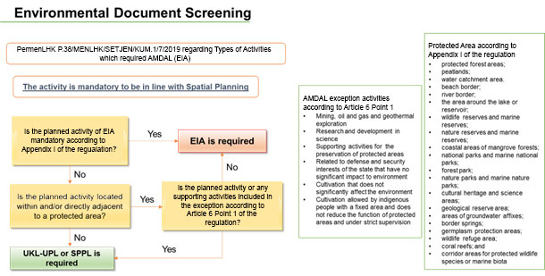
Figure 18. Environmental Document Screening Process
- Each of the selected adaptation action has been screened against the EIA-compulsory activities list and the results show that the actions are not categorized as activities that need to be complemented by EIA. The next process then identified whether the actions are located within and/or directly adjacent to a protected area; where the term protected area here is define as different areas listed in Figure 11. Results from this screening process are;
- Individual and communal latrine; not included in the EIA compulsory list and not located within and/or directly adjacent to a protected area. Further benchmarking utilizing Ministry of Public Works Regulation 10/2008, the construction of individual and communal toilet is not categorized as project/activity that needs to develop UKL/UPL. Accordingly, the programme implementer only needs to submit Environmental Management Statement Letter (SPPL).
- Eco-tourism; not included in the EIA compulsory list, but located within and/or directly adjacent to a protected area (coastal border). However, seeing how the eco-tourism site is aiming to protect the environment while at the same time provide natural tourism for the community, the activity is included in the exception listed in Article 6 Point 1c of PermenLHK P.38/MENLHK/SETJEN/KUM.1/7/2019 (preservation of protected area). Accordingly, the programme implementer should submit UKL-UPL.
- Breakwater construction; covering the coast of Kandang Panjang in the area of Mangrove Information Centre (PIM) constructed. However, this total length will not be constructed continuously along the coastal line of Bandengan and Kandang Panjang, since some coastline sections had been protected by geotubes and a watercourse in between that disembogues to the sea. Considering this non continuous manner, the particular option is thus not categorized as requiring EIA. Conducting further process under the screening diagram show that the construction will be located within a protected area (coastal border), however the activity is included in the exception listed in Article 6 Point 1c of PermenLHK P.38/MENLHK/SETJEN/KUM.1/7/2019 and PermenLHK 4/2021 (supporting activities for the preservation of the protected areas); and thus according to the screening diagram, it should be followed by UKL-UPL. To date, the UKL-UPL document has been submitted to provincial authority in charge, reviewed and principally approved. Indeed, for the breakwater construction activity to proceed, it needs clearance from the Ministry of Marine and Fishery Affairs. This clearance, stipulated under the Marine and Fishery Affairs Ministerial Decree No. 6/2023, is an official document confirming the suitability of marine space utilisation (KKPRL). Once the KKPRL document issued by the said Ministry, the provincial authority can officially approve the UKL-UPL document.
- Mangrove restoration: the proposed action is not categorized as requiring EIA, but instead supports the preservation of protected area.
- To conclude:
- Eco-tourism and breakwater construction is located within and/or directly adjacent to protected areas but those activities are classified as EIA exception activities as per article 3 point 4 since they are considered as supporting activities to the preservation of protected area. As such, they do not need to submit EIA, instead replaced by UKL/UPL as outlined in PermenLHK P.38/MENLHK/SETJEN/KUM.1/7/2019 and PermenLHK 4/2021.
- The size of individual and communal latrine proposed in the programme is not categorized as activities that need to be complemented by EIA.
- Mangrove restoration with a size that is proposed in this programme is not included in Environment Ministry Regulation PermenLHK P.38/MENLHK/SETJEN/KUM.1/7/2019 as activities that are required to have EIA.
- Despite the adaptation actions are not categorized as requiring EIA, PMU will assure that all activities will not pose adverse impacts to the surrounding environment by implementing the needed mitigation measures; including implementing environmental rehabilitation if the activities contaminate the area. As an initial assessment, this proposal document also contains initial findings on environmental and social risks from the programme, which elaborated on Part II - Section K as well as on the Environmental and Social Management Plan (ESMP). PMU will also continue to monitor any potential risks that had not been identified at this moment and might arise during programme implementation, and will carry out the necessary mitigation measures. The development of climate risk assessment, UKL-UPL, SPPL and ESMP within the programme will ensure that environmental and social impacts and risks are being considered, assessed and addressed throughout the project.
- Indonesia National Standard on Design Procedure for Septic Tank with Infiltration System and Latrine
- Housing Construction and Development Standard from Ministry of Public Works

- Hard structure that will be constructed as part of the proposed programme in future time will be ensured to conform to building codes, especially since conformity to the codes is the primary requirements for granting the building license. For hard structure that serve as public facility, the construction and development will be ensured to follow infrastructure construction and development standard from Ministry of Public Works and Housing as well as Indonesia National Standard. Construction of sanitation facilities will be among the selected adaptation actions under this programme. The facilities’ design and construction process will adhere to the aforementioned applicable standard to prevent negative impacts to the surrounding environment.
- The construction of latrine and septic tank (on-site waste water treatment system), both individual and communal facilities, will follow the requirements stated in Indonesia National Standard on Design Procedure for Septic Tank with Infiltration System (SNI 03-2398-2002) and Indonesia National Standard on Design Procedure for Latrine (SNI 03-2399-2002). Design approval and the corresponding environmental permit will be issued by the agency prior to facilities construction.

- In comparison to the previous version of proposal, there are two regulatory frameworks/standards that omitted from this latest proposal version, which are the Water Supply Regulatory Framework and Building Codes. For Water Supply Regulatory Framework, the omission is due to the fact that based on discussion with city stakeholders (including local community), water supply facility will not be included as the selected adaptation actions; and thus this particular regulatory framework has no relevancy to the programme. Meanwhile for building codes, the omission is due to its irrelevancy with the selected adaptation actions under this programme. Indonesia National Standard (SNI) is more relevant to the actions in comparison to building codes standard. At the moment, Indonesia Building Codes and Indonesia National Standard only apply to some activities; and the proposed activities within the programme (with the exception of latrines) are not among the activities that are regulated by building codes and national standard. The submission of UKL/UPL and SPPL are adequate to obtain relevant environmental permit
- Furthermore, in relation to land-ownership issue mentioned in the earlier part of the proposal document, land tenure policy (Presidential Regulation No. 71 Year 2012 on Land Procurement for Development Purposes) will not take effect in this programme since awareness building approach that will be taken under the programme is expected to create land-owner willingness to allocate their land for mangrove restoration site. This decision for not conducting land procurement process had been discussed and agreed by the city government.

Describe if there is duplication of project / programme with other funding sources, if any.

National Urban Development Project (NUDP)
- NUDP is a World Bank project applying loan mechanism aiming to increase capacity of selected cities in terms of assisting the spatial climate change adaptation planning. This project is still active and runs until 2024. The difference between this project and NUDP is that NUDP assist only up to the spatial plan, while Kemitraan proposes implementation up to grassroots level, especially to improve livelihood. NUDP also targets cities with population number over 500,000, which exclude cities like Pekalongan which only have less than 300,000 population. More detail on NUDP can be seen here.

PAKLIM GIZ-ICLEI Oceania
- Pekalongan City had collaborated with external parties in climate change issue. In 2010, this city was among 8 pilot cities in Central and East Java Province that implement Integrated Climate Action approach that was developed by PAKLIM GIZ and ICLEI Oceania. Based on this approach, the city was able to develop Climate Risk and Greenhouse Gas Emission Profile; in which the risk profile methodology employs a more qualitative approach, with participants perception became the basis for the profile. Following the profile, the city with assistance from PAKLIM GIZ thus developed Integrated City Climate Strategy which outlining climate mitigation and adaptation strategy that detailed into corresponding actions. Several actions in ICCS had been inserted into RPJMD of Pekalongan City, receiving funding from local government budget. PAKLIM GIZ does not provide further funding assistance for the city after ICCS development and their intervention in Pekalongan City had ended in 2014.
ACCCRN-Mercy Corps Indonesia
- Other external party that works closely in Pekalongan City is Mercy Corps Indonesia (MCI), where one of the organization’s programmes is run in the said city, which is Asian Cities Climate Change Resilience Network (ACCCRN). This programme is aiming to build climate change resilience knowledge in the city. Pekalongan City was selected as ACCCRN Replication City, and the programme was commenced in 2013. ACCCRN in Pekalongan City was focusing on capacity building for community and local government on climate change issue. This capacity building process includes not only series of training and discussion in the city, but also involving Pekalongan City local officials and practitioners in different knowledge sharing event outside Pekalongan. Yet the trainings and discussions conducted were none on the topic of quantitative climate risk assessment. Starting last year, ACCCRN is in its closing phase and the programme finished its implementation by the end of 2017, hence there is no more funding assistance given to the city. Pekalongan City Team was established as part of ACCCRN programme with member comprises of representative from local government officials, academics, practitioners and local NGOs. This team’s main role is building climate change awareness in the city and fostering the implementation of adaptation actions under the umbrella ACCCRN programme. This programme will reactivate the working group that will work closely with the programme’s PMU. Aside from the city team, this particular programme will also draw upon lessons from the implementation of adaptation actions under ACCCRN programme; where it fails and where it succeeded, including reflecting on the sustainability of the implemented actions.
JICA
- At a higher government level, Central Java Province had work closely with Japan International Cooperation Agency (JICA), specifically in implementing Project of Capacity Development for Climate Change Strategies in Indonesia (2010-2015). The main activity from the collaboration was mainstreaming adaptation/mitigation of climate change in National Development Planning, with Central Java as part of the scope. JICA had also developed study on Integrating Climate Change Adaptation into Spatial Planning Policies at 2 pilot sites which are 1) Java Island and 2) South Sulawesi (West & South coastal area, Selayar). Among the output of the study is recommendation on integration mechanism of adaptation plan into spatial planning. The JICA programme is completed in 2015, hence the proposed programme will not overlap with JICA funding. Seeing that the mechanism is developed at a higher government level that has to cater to different city/regency characteristics in tis planning proves, but on the other hand considering the fact that Pekalongan City is part of Central Java Province that will somewhat affected by planning conducted at provincial level, hence this programme will learn from JICA study on mainstreaming and integration mechanism, and assess whether the proposed mechanism can be applied in Pekalongan City context and how to adjust the mechanism.
Central River Region Pemali Juana (Directorate Generale Water Resources, Ministry of Public Works
- Earlier this year, the Central River Region Pemali Juana (BBWS Pemali Juana) start the construction of cross-boundary dam that intended to protect Pekalongan City and Pekalongan District from coastal flooding; where the construction process is expected to be completed in 2019. This project is done in collaboration between BBWS Pemali Juana, Central Java Province, Pekalongan District and Pekalongan City. In Pekalongan City, the dam is constructed in Bandengan Community which located in the western part of Pekalongan. In addition, this BBWS project will also close the gap of 300 meters parapet in the eastern of Pekalongan City (Degayu). Considering this information, thus coastal protection (Breakwater) planned in Kandang Panjang will complement this BBWS project (see Annex 14).

If applicable, describe the learning and knowledge management component to capture and disseminate lessons learned.
- The knowledge management component will contain activities that capture and disseminate both tacit and intrinsic knowledge. For tacit knowledge, climate change training and knowledge exchange activities will serve as information and experience sharing media. These such forums will facilitate learning and co-creation of opportunities for various stakeholders. The intrinsic knowledge will be captured through more traditional methods, by conducting research that can be disseminated to government, practitioners, academic community and also general public. The output of the research could be both in form of knowledge product or advocacy material.
- The overall knowledge transfer process is under component 3 and component 4. Component 3 provides the cornerstone for capturing and disseminating lessons learned, other project components / activities directly contributing to knowledge management and dissemination mechanisms from community to city and inter-regional levels, while component 4 focuses more on share learning from the local to the national level.
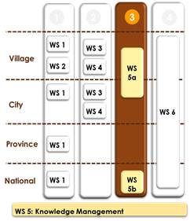
Figure 19. Knowledge Management Component is Embedded at Different Level of Governance
- At community level, a participatory approach (involving communities and local authorities in conduct community based risk assessment, planning and implementation activities) will lead to increased local knowledge on climate change adaptation. Project demonstration sites will contribute, from the start and in an ongoing way, to share lessons and training through local disseminators and tools and guidelines. Knowledge dissemination tools that will be utilized in the proposed programme encompassing regular newsletter, social media network and knowledge board (contain information on climate-related issue as well as programme progress) in community centre or community office. Lessons learned obtain at this level will also be communicated to stakeholders at city level.
- At city level, transfer of results and lessons learned to other communities across community and broader city area will be promoted. The programme’s knowledge management product will be disseminated not only to Pekalongan City and Central Java Province area, but also broader community. For Pekalongan City dissemination, the project management team will collaborate with the existing knowledge sharing network, the Mangrove Information Centre (Pusat Informasi Mangrove/PIM). At the moment, PIM is focusing only on mangrove issue, however preliminary discussion with PIM shows that the organization is highly willing to broaden their scope to incorporate climate change resilience issue. In this project PIM will play a major role at city level in disseminating knowledge product and programme benefit to wider city stakeholders, thus will be facilitated through an online knowledge hub that will include capacity-building webinars, technical documents, multi-media knowledge products thus will be developed as an information and training centre for climate adaptation action.
- At national level, we will use two approaches, First approach is supporting the Ministry of Environment and Forestry (MoEF) to make improvements SIDIK to suitable for coastal risk assessment based on pilot in pekalongan city. One knowledge product that will be the output for the proposed programme is Handbook on SIDIK for Coastal Risk Assessment that can be used by local government, NGOs and Civil Society Organizations. The handbook development will be based on climate risk assessment process conducted at city level. Related to advocacy material, the research will be the basis for developing policy briefs that highlight the shortcomings in national policy, fiscal and other institutional framework in developing a resilience coastal city. A direct linkage will be established, through the partnering MoEF, ICA and Apeksi facilitating countrywide dissemination to other cities/regencies, NGOs and Civil Society Organizations.
- Second approach is that the project management team will actively engage with the existing national climate change network, the Indonesia Climate Alliance (ICA). ICA member consists of different national level organizations that share the same interest in climate change issue. This collaboration will assist the team to share experience from local context and elevate the issue at national level, as well as advocating the developed policy brief. Throughout the course of the programme, an active communication and discussion will be conducted with the network to advocate lessons learned from local experience in Pekalongan City as well as on common interests. During the programme period, the programme will apply as the network member.
- Additionally, the proposed programme also has Monitoring and Evaluation Unit as part of the project management team. This unit responsible for knowledge management and sharing within project team member, organizing knowledge sharing event and outreach, and conducting pre and post-test survey on given interventions for evaluation purpose. All those activities will be documented, reported and made available.
- Knowledge management in this programme tries to link science, implementation, management and policy both horizontally (between different sector) and vertically (between different government level). Changes in science could affect implementation strategy and subsequently alter how the project being managed, and consequently affecting the advocacy process. Considering the dynamics of this link, adaptive management approach thus became an important factor here. PMU will exercise adaptive management approach in programme implementation, by emphasizing ‘learning and adapting’ context, through partnerships with diverse community and city stakeholders; allowing them to work and learn together with the stakeholders in building a sustainable Pekalongan City. Adaptive management approach will allow PMU to acknowledge the existence of uncertainty and provide them with flexibility to work around the emerging issue; giving them space for adjustment in order to achieve the targeted objectives.
- Involvement of diverse stakeholders within the working group, as well as building knowledge management network are considered as the two main factors that could decide upon the sustainability of knowledge management strategy outcomes after the programme period is ended. These efforts enable the generated knowledge to be disseminated to wider stakeholders, and not only those directly involved in the programme; creating a potential for replication in other area by other actors. During the course of the programme, the knowledge management network will be used effectively and regularly to disseminate information as measure to build stakeholders need on climate-related information, open up their perspective on the benefit that can be obtained by interacting with the network as well as nurturing knowledge sharing habit. It is expected that by creating this need on information and realizing on benefit that they could get, the stakeholders will have a sense of ownership to the network and work together to maintain its operation in future time, after the programme is ended.
- Furthermore, building upon this sense of need and ownership, PMU will work with city working group to search for a host for the network and integrate network management into local development plan. The host is needed to allow government funding stream to flow to the network. The proposed host for the network is Pekalongan City BAPPEDA as the leading sector for development planning. This particular institution does not have a specific work focus, instead they deals with diverse development issue. Climate change and coastal resilience are considered as development issue, and thus BAPPEDA will be the most appropriate host for the network. A successful integration into local development plan will ensure that the network will get continual budget allocation from the local government. To successfully advocate this integration, community working group will prepare a case study that will show the positive correlation between network existence and successful implementation of adaptation action.
- PIM is a local network in Pekalongan City that specifically works in mangrove-related issue. Despite the programme also touch mangrove context, however the network that will be developed at city level will not be focusing on mangrove, instead on climate change and coastal resilience. Thus PIM and the future network will complement each other and could implement cross-learning mechanism.
- Meanwhile ICA is a national level network that works around general resilience issue. The proposed city-scale network will not overlap and duplicate ICA efforts since both have a different scale (local vs national level network). Moreover, during its implementation period, the proposed programme will join ICA and use ICA as a vehicle for national advocacy process. This advocacy collaboration is feasible since ICA also has common interest in coastal resilience issue. Information and lessons learned at community and city level will be communicated by PMU in regular ICA meeting as a part of advocacy material to the national government. Hence ICA and the future local network complement each other by drawing upon common interest for advocacy. Without the existence of a nationally-known advocacy partners, such ICA, it will be difficult to get traction for advocacy process at national level.

Provide justification for funding requested, focusing on the full cost of adaptation reasoning

Component | Baseline | Additional (with AF)
Enhancing the coastal resilience through construction of coastal protection in the form of breakwater | - Rising sea level has increased abrasion at the coast line of Kandang Panjang  - Rising sea level has increased tidal run off to PIM area and adjacent residential area  - Potential of degraded coastline around PIM area | - Abrasion in can be reduced through the breakwater construction  - Reduced tidal run off to PIM area and adjacent residential area  - New sedimentation can be develop to enhance the degraded coastline around PIM area  - Increased opportunity of mangrove development
Enhancing coastal community capacity in developing and implementing Climate change adaptation actions and community information system | - Local actors have limited capacity to prepare for and respond to climate change and natural hazards  - The most vulnerable areas and groups receive limited infrastructure support and no targeted object to receive resilience building support because of limited capacity and resources.  - Detailed/specific climate change threat and hazard information / evidence is not available at community scale in Pekalongan City, which means the local government and communities can’t plan for appropriate adaptation actions | - Local actors and communities are enabled to prepare for and respond to climate change and natural hazards  - The vulnerable groups in coastal areas are targeted and appropriate resilience measures  - Participatory Climate risk assessment by community will enhance community awareness and capacity to develop community adaptation actions thus how to mainstreaming into community development plan
Enhancing local government and other city stakeholders’ capacity in developing local climate change adaptation action plan (RAD API) and implement Climate smart | - Lack of capacity of the local governments officer and related stakeholders to lead climate change adaptation and disaster risk reduction plan  - Any interventions in the proposed intervention areas will continue as small-scale and stand-alone projects that lack integration and miss important opportunities for synergies. They also will not consider the impact of future climate change and the need to include consideration in the design of community level interventions.  - The most vulnerable communities are not targeted/reached | - Local governments and related stakeholders can lead climate change adaptation action and disaster risk reduction plan thus mainstreaming into city development plan  - City government and climate stakeholders will have ability to develop a climate-smart approach that builds resilience to current climate variability and future climate change and specifically tackles the gendered inequalities around climate change. The integrated approach, grounded in local community development plans and a gender responsive approach, will enable interventions that are consistent with the National Action Plan on Climate Adaptation Actions (RAN API) to be implemented at the local level  - The most vulnerable communities are the main beneficiaries of the project
Strengthening vertical coordination by enhancing provincial government’s capacity in mainstreaming climate change adaptation and resilience into Central Java Province development plan, which in turn could foster better climate-related policy on climate financing and bottom-up planning | - Lacking capacity of provincial government officer to put forward climate change adaptation issue in development plan as well as incapability to lead by example in mainstreaming the issue | - Provincial government officers have the capacity to promote climate change adaptation action plan and mainstream the said plan into development plan, setting out example and support all cities and regencies within its administrative region to do the same
Strengthening vertical coordination and collaboration between national and local government in climate adaptation context and Enriching knowledge, toolkits and methodologies coastal resilience for the national government | - SIDIK unable to appropriately and accurately assess the vulnerability and risk of coastal region  - Adaptation programmes planned at ministry level (national level) often incompatible with the needs of adaptation actions at city/local level | - SIDIK is improved and able to appropriately assess vulnerability and risk of area that has coastal characteristics  - Ministries and local government collaborate and cooperate to implement the appropriate adaptation actions

- In addition to gender assessment done during the preliminary assessment for this proposal, Kemitraan’s has also conducted additional gender assessment in Pekalongan City within the period of 2017 to 2018. The result of this gender assessment is added on the last page of Annex 3 of this document.
- Based on the result of the assessment, Kemitraan has seen the importance to engage a number of woman and youth organisations in the activities in Pekalongan, especially in the capacity building related to climate change adaptation measures. Following table lists the mapping of existing CSO and community groups to be involved in the project:

No | Community | Active Member | Registered Member
No | Community | Active Member | Offline | Online
1 | Bintari Foundation
2 | Insta Pekalongan (Pekalongan Instagram Community) | 50 | 100 | 73.000
2 | PEKKA (Women as Leader of Familly) | 200 | 500 | -
3 | Doodle Art | 51 | 100 | -
4 | Great of Pekalongan | 44 | 30 | 3.467
5 | Pekalongan Photography Community | 150 | 100 | 700
6 | Mahakarya (College Students of Pekalongan) | 350 | 60 | 1.100
7 | Pekalongan Blogger Community | 40 | 302 | 1.304
8 | Drone Pekalongan Community | 20 | 20 | 500
9 | Bara Air Activist | 50 | 60 | -
10 | Pekalongan River Lover Community (Kali Lodji) | 1.400 | 1.400 | 1.800
11 | Painting Community (PERUPA) | 100 | 400 | 700
12 | Batik Kauman Community | 100 | 300 | 1.000
13 | Akademi Berbagi Pekalongan (Knowledge Sharing Community) | 35 | 35 | 1.137
14 | Boys scout of Pekalongan | 100 | 166 | 256
15 | Explore Pekalongan (tourism, ecotourism) | 35 | 60 | 56.000
16 | Generasi Pariwisata Pekalongan (Pekalongan Youth Generation for Tourism) | 25 | 25 | 60
17 | Pekalongan Info (Ecotourism) | 4 | 3 | 222.000
Total |  | 2.754 | 3.661 | 363.024
Table 4. Partners & Beneficiaries of Pekalongan Project
- The above listed CSO and community organisations have been actively involved in various activities in Pekalongan, such as establishment of Climate Change Forum (Bara Air Activist), assistance to women headed household (PEKKA), empowerment in batik industry (Batik Kauman Community), mangrove planting (Great of Pekalongan), photography and knowledge & communication (Doodle, Pekalongan Photography Community, Pekalongan Blogger Community, Insta Pekalongan) and ecotourism (Pekalongan Info, Explore Pekalongan). More on consultative process can be seen in Annex 8 of this document.

Describe the consultative process, including the list of stakeholders consulted, undertaken during project preparation, with particular reference to vulnerable groups, including gender considerations, in compliance with the Environmental and Social Policy of the Adaptation Fund

We have conducted consultations with different stakeholders at various levels to ensure that we are able to build a proposal which represent the needs and the interests of all stakeholders related to the climate-change adaptation in Pekalongan City. As for the construction of breakwater, consultation process has been also conducted involving the community in Kandang Panjang to make sure that the respective community is aware about the construction plan. Below are descriptions of some of the consultation processes. We summarize the consultations processes in a table that can be accessed in Annex 8 and Minutes of Consultation in Annex 18 related to coastal protection and breakwater.

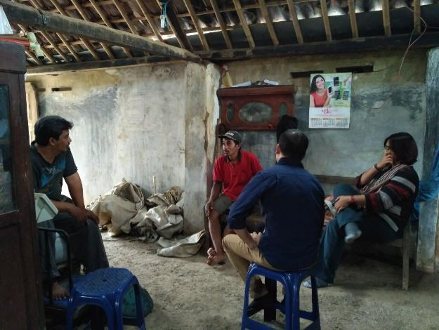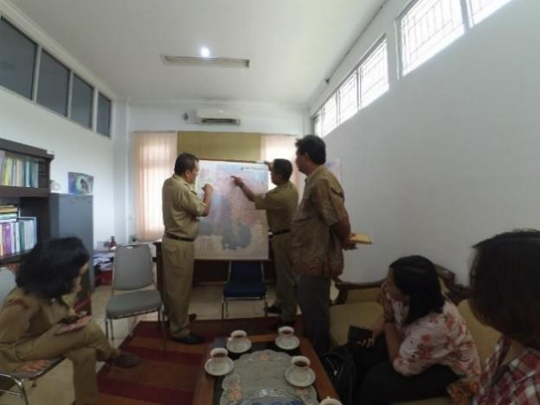

Consultation with community members and Planning Bureau of Pekalongan City

- Mobility constraint and lack of involvement in decision-making process are two main barriers for women participation regarding CCA activities. In this programme, women representative, both full-time working and housewife, will be included as working group member. The meetings will be scheduled to be taken place in days and times that are feasible for them, and the other member, to attend; for instance during weekend morning or afternoon. The regular meeting will not only allow them to voice relevant information, thoughts and experiences on that matter but also act as a consultation room to share the related problems. In a more informal setting, these women representative will be urged to approach their women ‘colleagues’ that are not involved as working group member, gather their opinion and share it during the meetings as appropriate.
- To follow up initial consultation, individual consultations were conducted with Bandengan, Kandang Panjang and Degayu community representatives. So in total, 4 communities were consulted individually in concept and proposal development process, which are: Tirto, Bandengan, Kandang Panjang and Degayu Community; meanwhile the representatives of other communities were unable to be met individually. However they, -including the women group representative-, attended and actively participated in the 3 (three) separate Focus Group Discussion events discussing:
- Potential Adaptation Activities at Community and City Level;
- Gender Aspect; and
- Framework and Potential Implementation of the Proposed Programme. ]
- One issue being raised by the former Pekalongan City Mayor during consultation process is on land ownership issue. Except from breakwater and ecotourism locations, as well as some are for mangrove restoration which had been confirmed as government land, the decision upon which specific area for activities’ implementation will be discussed during early in programme implementation stage. From consultation process (interview and FGD), the local community are very welcome and support the proposed activities. They believe latrine construction and improvement of aquaculture activities could enhance their quality of life, and thus there will be no issue on land ownership. They will not oppose to programme implementation in their land. During proposal development stage, identification has been made on potential mangrove restoration area that are owned by the government, such as in the vicinity of eco-tourism site, PIM, breakwater area etc. If during discussion process (early in programme implementation stage), there are private land that will be suitable for mangrove restoration, the following measures will be undertaken: (1) Building community perspective and awareness through Free Prior Informed Consent (FPIC) on the benefit of turning unproductive land into something that benefit them as a whole community, and not merely individual benefit. As part of the FPIC, workshops and / or FGDs will be conducted on climate adaptation action and coastal resilience, where among the workshop material will be the importance of mangrove restoration for coastal protection, including for protection their dwelling and neighbourhood. The workshop is expected to build their knowledge and awareness on mangrove function. (2) Informed the community that not all of their land will be utilized for mangrove restoration activity; only selected one. Furthermore, considering its current condition as unproductive land, utilizing the land as mangrove restoration site will not result in economic loss for the community, instead benefit them by protecting their area. The workshop itself will be done by the PMU in collaboration with community working group. Aside from their involvement in the workshop process, community working group will also be tasked to conduct a more personal and informal approach to the land owner that identified as hesitant to ‘donate’ their land for mangrove restoration; persuade and build their awareness on the issue at hand, and how they can support in addressing the issue.

- Indeed, during preparation of full proposal, the Municipal Government of Pekalongan City through its BAPPEDA has declared its endorsement for this project and its plan and readiness to compensate land use for green open areas incl. for mangrove restoration purpose (Annex 4).

Describe how the sustainability of the project / programme outcomes has been taken into account when designing the project / programme.

- As mentioned in the previous section of this proposal, this programme is aiming to address multifaceted issue in coastal area, specifically those related to climate change impact; fostering coastal resilience building in the area. Seeing the considerable benefit trying to be achieved by the programme, it is thus important to ensure the sustainability of the programme in order to spread out the benefit to wider community. Approach taken for this programme rely heavily on stakeholders involvement and collaboration, hence the derived activities for those two aspects are designed to ensure the programme’s sustainability.

Building Sense of Ownership in the Municipality of Pekalongan
- At community level in the 8 target kelurahan, benefit arises from the existence of adaptation actions and the alternative livelihood will directly affect community’s life in tangible manner. Their financial capital will be strengthened from the combination of increases of income and decreases of disaster-related expenses. Their income will increase from the alternative livelihood and better management of the fishing practices, while their physical environment will be better protected from coastal hazards such as coastal flooding, and thus reducing their household expenses in dealing with this such hazard. Further, development of urban farming provide substitute, although in a smaller scale, to the loss agriculture land, accommodating farmers who have lost their possibility to cultivate. Involving existing farmer community can ensure the sustainability of this alternative solution, especially if it is combined with a financial mechanism such as farmer cooperative. To further ensure the sense of ownership will always be maintained, local CSOs will continue to work closely with community working group to share their knowledge on the issue, including on matters relevant to new alternative livelihood. These CSOs are member of city team and have been working with the targeted local community for a period of time, and thus they will be committed to maintain the programme’s outcome in the targeted area. Moreover, engagement of the Municipal Fishery and Agricultural Office will ensure that the Municipal Government is involved in providing assistance to the farmers and solution to any occurring administrative and/or cultivation issues.
- Sense of ownership can also be built up amongst community members through provision of communal facility applying community participatory approach. Community involvement in the establishment of the communal water and sanitation facility, not only through public consultation but also through community’s direct involvement in the construction, will provide better understanding in the importance of community’s health and hygiene in the whole aspect of their life. This will increase public awareness and strengthen public’s sense of ownership of the facility. More over, the project will ensure the mainstreaming of the overall intervention and allocated budget especially for the Operation & Maintenance of the infrastructure as well as communal facility. Communal facility can also be used to socialise issues related to health and hygiene to broader community of different age groups. Since clean water scarcity occur in the affected coastal area, not only caused by damaged water supply infrastructure but also saltwater intrusion affecting community wells, is covered by the communal water supply system, it will also strengthen public ownership of the facility and ensure its sustainability.
- Meanwhile for Pekalongan City, these actions and livelihood will increase their GDP from fisheries and tourism sector as well as reduce their expenses in infrastructure repair/rehabilitation due to coastal-related hazard. Seeing how the activities positively affect their GDP, the local government will be driven to maintain the existing activities and further replicate/scale-up the activities in other location within their administration area. Regarding fisheries and tourism sector programmes, the regional government has also allocated a budget for the 2016-2021 midterm development plan. Allocation for the development of aquaculture is set for IDR 6,155,000,000, coastal rehabilitation for IDR 1,075,000,000, conservation for IDR 205,000,000 and the development of a tourism partnership, including ecotourism for IDR 2,625,000,000
Introduction of circular economy to Pekalongan City
- Assisting the Municipality of Pekalongan City with the establishment of integrated waste management facility provide tangible solution to improve both the city and community’s income. While the City owned Enterprise can benefit from the products generated through the facility, a public-people-private partnership model can also develop to engage broader stakeholder generate profit from the facility, not only financially but also in terms of improved living environment of affected community through regular, cost-free waste collection.

Knowledge Network Establishment and Engagement
- Multi-stakeholder involvement and knowledge network engagement within the programme is also designed to allow programme sustainability. It enables knowledge to be disseminated to diverse actors, and not only one single entity. Allowing projects and lessons learned to be disseminated, replicated and even expanded. The existence and operationalization of this network will support the effort in building a sense of ownership to the programme and its benefit. The more people take ownership, the more sustainable the programme will be. Concurrently, the sustainability of this network will be maintained. Facilitating and optimizing the existing network of multistakeholder i.e. green forum or sanitation working groups will garner more knowledge.
City Level
- The local knowledge network (PIM) will play a major role at city level in disseminating knowledge product and programme benefit to wider city stakeholders. This role will support in building a sense of ownership to the actions and alternative livelihood produced under the programme. During the implementation stage, particularly the workshop series, the programme will build the sense of need and importance of this network as a knowledge sharing media by emphasizing the significance of regular multi-stakeholder discussion in addressing climate change impact in their area. The stakeholders will also be trained to share their relevant achievement and issues in this network. Having built their sense of need and issue/knowledge sharing habit, it is expected that in future time, they will turn to this network if they encounter opportunities and/or threat to the adaptation actions and alternative livelihood.

National Level
- National knowledge sharing network (ICA) has been established and actively operationalized prior to the programme development. Throughout the course of the programme, an active communication and discussion will be conducted with the network to advocate lessons learned from local experience in Pekalongan City as well as on common interests. During the programme period, the programme will apply as the network member. This membership will end after the programme ended, and the advocacy for Pekalongan City lessons learned and interest will be taken over by APEKSI who is also ICA member. APEKSI is the national association for city government in Indonesia, where Pekalongan City is among the member.
Programme Mainstreaming at City Level
- Aside from community, this programme place government institutions as the core subject. Hence, other means to ensure programme sustainability relies on government involvement. During the programme period, the adaptation actions will still be conducted under the programme umbrella but in parallel, PMU will advocate the actions to the city government to enhance their awareness on the benefit of the action; driving them to preserve and replicate the action. City government institution that will be the advocacy target might be different for each action, depending on the work area of the said institution. Coastal embankment will be advocated to BAPPEDA, Mangrove restoration, aquaculture and farm pond will be advocated to Agriculture and Marine Agency; sanitation facilities will be advocated to Public Works Agency and Environmental Agency; while eco-tourism will be advocated to BAPPEDA and Tourism Agency.
- This advocacy process has one major aim, which is to mainstream the actions into city government’s development plan and spatial plan. This mainstreaming process (including M&E activities and climate risk assessment) is believed as the most effective sustainability strategy at city level. Facilitating the government officials to properly develop and mainstream climate strategy and adaptation action into local development plan is part of the sustainability design. The term mainstreaming here means that climate related context and the adaptation actions are included in the city development plan. In Indonesia governance context, city development plan is the legal and formal direction for city government officials in delivering their works. The plan is developed in deliberative manner by the city government agencies, and its legalization by the City Mayor indicates city government commitment to implement the plan, Programmes and activities included in the plan has their own budget allocation and must be implemented according to the schedule. For the programme case, a successful advocacy and mainstreaming process will see the inclusion of adaptation actions into city government’s programmes and activities under the city development plan; automatically provide the adaptation actions (as well as the related M&E and risk assessment updating activities) with budget allocation, especially for Operation & Maintenance (O&M) for the overall infrastructure, not only funding for initial construction in other area (replication), but also regular functional trouble shooting(for actions implemented under the programme and replication). It will also show government commitment to continue and replicate the actions in future time even after the AF-funded programme period ended. This will further ensure the programme sustainability in long term.
Financial Sustainability
- Some Adaptation actions must be profitable, the action that do not pay for themselves are unlikely to be sustainable. Therefore, some adaptation action in this project is designed to include strong income generation and entrepreneurial aspect which will make the project outcomes financially sustainable. Selected adaptation actions are locally viable and good profitable such as capture fishery, ecotourism etc. notes for adaptation actions that profit generally require large capital so that it is difficult to do by poor people affected by climate change. Another strategy that will be done is by linking and involving the private sector from the beginning to seek potentiality of link and match between the supply and demand side.
Sustainability of applied technology
- Implementation of climate change adaptation measures and actions cannot be fully separated from applying technological support. Indeed, application of the supporting technology will be adjusted with local context and the local ability/capacity to maintain and to sustain this. This project will definitely not intended to invent new technology in its innovative approach, but will certainly look at simple and low cost, easy-to-maintain available solution. Based on Kemitraan’s national wide connection with universities and academicians, any technological application to be utilized in this project will also be applied in connection and communication with its academic network at municipal and/or provincial, even at national level in order for them to involve in the supervision and monitoring of the adopted technology in the long term. This way, this project does not only increase wider ownership to sustain its overall results element, but also opens opportunities for possible development both at municipal and at provincial level.
- The application of the above mentioned technology will also be conducted as early as possible in the respective stage of each project component to allow the users to be sufficiently trained and also to be able to monitor and evaluate users’ development during the remaining project timeframe. Therefore, the emphasis on low-cost, simple and available technology become necessary. Moreover, all online application intended to be integrated in this project, such as Climate Smart Agriculture, will be applied in connection with the already existing platform under Pekalongan Smart City Programme (http://smartcity.pekalongankab.go.id/).
Exit Strategy Development
- All in all, this programme believed that maintaining the programme sustainability cannot rely solely on funding allocation, but also involving stakeholders to take part in the maintenance and dissemination stage. Pursuing funding allocation is somewhat a futile effort if not complemented by the existence of someone who protects and preserves the results. Combination of the above efforts at different government level will ensure the sustainability of the programme output and outcome in long-term period. These efforts will be combined and translated into an exit strategy plan which will be included in the M&E documents of the programme.
Sustainability Plan
Key issue | Description | Opportunity | Plan | Remarks
Institutional
Community Level | - Existing and/or new established Fishermen Groups (include women group and vulnerable group) acknowledged, fostered and supported by the municipal govt. through the respective Kelurahan;  - Established Farmers Groups (include women group and vulnerable group)acknowledged, fostered and supported by the municipal govt. through the respective Kelurahan;  - Engaged youth groups (include women group and vulnerable group) and build their capacity to become Agents of Change in climate change adaptation actions of Pekalongan City.  - Community groups (include women group and vulnerable group) involved in ecotourism institutionalized, assisted and fostered by the municipal govt. | Kelurahan and The Municipal Govt. acknowledge the existence of each community groups and their activity in the municipal CCA strategy policy to sustain coastal protection against CC impact. | - Strengthening formation of existing groups, through Kelurahan decrees  - Engage Kelurahan and/or the Municipal Govt. in the activities related to the establishment, development and empowerment of each group to strengthen connection and to build mutuality between each other | To be arranged and conducted throughout the project cycle in order to foster communication and trust between local community, Kelurahan authority and the Municipal Govt.
Kelurahan Level | Constructed communal facility adopted and maintained by respective Kelurahan as a public facility; | The respective Kelurahan authority acknowledge each constructed communal facility as part of its public infrastructure and adopt it in the maintenance plan | Identification and selection process selecting of the locations for communal facility through Free, Prior and Informed Consent (FPIC) The selected location has to be government or community land free from disputes;  Engage the Kelurahan authority and related local government offices (Public Works, Environment and Health) in the development of the facility and communicate the message of the necessity of the facility within CC adaptation action for the welfare of the community | To engage the Kelurahan authority,the Municipal Office of Health and Municipal office of Public Work during preparation, awareness raising and inauguration of the facilities
 | Established Kelurahan Climate Working Groups (KCWG) supported and facilitated by Kelurahan to regularly oversee and monitor the community based adaptation actions | Respective Kelurahan adopts the KCWG into its development policy and arranges annual budget to support the activities of the working group | Engage the Kelurahan authority and related local government offices in the dialogue, discussions and communication during the development of KCWG to increase Kelurahan authority’s awareness and comprehensive understanding on the importance of a robust and sound community based CCA action;  Involving the KCWG in meetings and coordinating the preparation of RAN API | To communicate with and engage the Kelurahan authority and local government office from the early phase of the development of the Working Group
Municipal Level | - Municipal Govt. through its Office of Tourism and Office of Environment provides continuous assistance and maintenance of the enhanced mangrove belt as part of the city owned Mangrove Information Centre;  - Municipal Govt. take responsibility to maintain the constructed breakwater as part of its public infrastructure and for enhanced coastal protection | The Municipal Govt. acknowledge the improved mangrove belt, Mangrove Information Centre and the constructed breakwater as part of public infrastructure and include these in the maintenance plan of the city.  Moreover, the Municipal Govt. also acknowledge the mangrove belt and Mangrove Information Centre as income generating facility not only for the city, but also for its community that need to be well managed and kept sustainable. | Identifying process and selecting locations (demplot and construction) through FPIC, the location has to be government or community land free from disputes;  Intensive engagement of the Municipal Govt. (Bappeda and Public Works) in each development phase progress evaluation of the activities.  Declare from the beginning that all constructed facilities will be under the responsibility of the Municipal Govt. once those are finally constructed and handed over.  Assist the Municipal Govt. in the integration of the constructed facility in its annual maintenance plan. | To engage the Municipal Govt. in the development and/or construction process right from the early phase.  Engage the Municipal Govt. to lead the development process in terms of developing sense of ownership of the Municipal Govt. to the project and its results.  Maintain intensive communication with the Municipal Government at all stages of the development and/or construction activities.
 | Municipal Climate Working Group (MCWG) supported and facilitated by the Municipal Govt. to oversee and monitor the Municipal CC Adaptation Action Plan. | The Municipal Govt. adopts the MCWG into its development policy and arranges annual budget to support the activities of the working group | Engage the Municipal Govt. in the dialogue, discussions and communication during the development of KCWG to increase Municipal Govt. awareness and comprehensive understanding on the importance of a robust and sound CCA action | To communicate with and engage the Municipal Govt. in the reactivation of the MCWG from the early phase
Economic
Community Level | - Community involved in ecotourism acknowledged, supported and continuously facilitated by the Municipal Govt.;  - Fishermen groups are supported with fish, crab and shrimp seeds to enrich and/or maintain the health of the mangrove ecosystem for capture fishery and other production means;  - Farmers groups are supported with seeds and other production means to improve productivity;  - Groups of trained batik makers facilitated by the Municipal Govt. and endorsed in the promotion of modern and innovative batik culture that in return enrich Pekalongan to be the leading city in sustainable batik industry. | The Municipal Govt. acknowledge the importance of sustaining the community based economic activity through intensive assistance and empowerment, and through protecting and supporting policy | Engage the Municipal Govt. (Bappeda, Office of Tourism, Office of Education and Culture) in the development of community based economic empowerment right from the early phase and involved the Municipal Govt. in all events related to community based economic empowerment | Organize a kick-off FGD in the beginning of the process involving the Municipal Govt.
Municipal Level | Waste management facility become a sustainable municipal business entity that provides jobs and business opportunity to the community of Pekalongan City and replicated in the other Kelurahan | The Municipal Govt. run the facility through a municipal business entity and involved surrounding community in the operationalization of the facility applying gender mainstreamed policy | To assist the Municipal Govt. to lead all process of the development of the facilities and discuss on the form of the management entity in charge;  Encourage the Pekalongan City Government to improve the planning, operational budgeting and maintenance of sanitation facilities related to climate change adaptation actions | Conduct intensive discussion during planning and development process with the Municipal Govt. and propose options of management entity form
Technological
Kelurahan Level | Each target Kelurahan maintain sustainably the developed community based CC Information System  Establishment of the citizen-data group at each kelurahan to maintain sustainability of CC related knowledge production at the local level. | Each Kelurahan takes over the maintenance of the provided equipment and the sustaining of the system supporting infrastructure, and adopts this in its annual budget line to sustain the provision of CC related information to the community | To intensively engage and provide training to the Kelurahan authority in the development of the system right from the beginning and assist in the planning for the maintenance through Kelurahan’s budget arrangement  Encourage Pekalongan government to assist and increase the capacity of climate change information system group at kelurahan level | Conduct intensive communication with the community, Kelurahan authority and Municipal Govt. during each development process

Provide an overview of the environmental and social impacts and risks identified as being relevant to the project / programme.
- Environmental and Social Impact Assessment has been conducted for the programme to assess potential risks arising from programme implementation. The assessment was carried out by considering nationally applicable standard in risk assessment as well as compliance to AF Environmental and Social Principles. The assessment results are as below.
Checklist of environmental and social principles | No further assessment required for compliance | Potential impacts and risks – further assessment and management required for compliance
Compliance with the Law | - | The programme is designed in compliance with all applicable national, regional and local law, including:  - Law Number 5 of 1960 concerning Basic Regulations on Agrarian Principles  - Law Number 18 of 2008 concerning Waste Management;  - Law 32/2009 on Environmental Protection and Management.  - Law Number 2 of 2012 concerning Land Acquisition for Development in the Public Interest;  - Law Number 27 of 2007 concerning Management of Coastal Areas and Small Islands;  - Law Number 23 of 2014 concerning Regional Government;  - Law Number 1 of 2014 concerning Amendments to Law Number 27 of 2007 concerning Management of Coastal Areas and Small Islands;  - Law Number 6 of 2023 concerning the Stipulation of Government Regulations in Lieu of Law Number 2 of 2022 concerning Job Creation into Law  - Government Regulation 27/2012 on Environmental Permit and Environmental Impact Assessment  - Government Regulation Number 18 of 2012 concerning Management of Household Waste and Similar Household Waste;  - Government Regulation Number 5 of 2021 concerning Implementation of Risk-Based Business Licensing;  - Government Regulation Number 22 of 2021 concerning the Implementation of Environmental Protection and Management;  - Government Regulation Number 21 of 2021 concerning the Implementation of Spatial Planning;  - Government Regulation Number 19 of 2021 concerning Implementation of Land Acquisition for Development in the Public Interest.  - Minister of Environment Regulation Number 5 of 2014 concerning Waste Water Quality Standards;  - Ministry of Environment and Forestry Regulations PermenLHK P.38/MENLHK/SETJEN/KUM.1/7/2019 on Types of Activities that Needs to be Equipped with Environmental Impact Assessment  - Ministry of Environment Regulations 16/2012 on Guidance to Develop Environmental Document (AMDAL, UKL-UPL and SPPL)  - Ministry of Environment Regulation 8/2013 on Procedure for Assessment and Checking of Environmental Document, as well as Environmental Permit Issuance  - Ministry of Environment and Forestry Regulation No. 4 Year 2021 on The List of Bussines and/or Activity that require EIA (AMDAL), UKL-UPL or SPPL  - Ministry of Public Works Regulation 10/2008 on Types of Activities under Public Works Sector that Require UKL/UPL  - Minister of Maritime Affairs and Fisheries Regulation Number 31/PERMEN-KP/2020 concerning Conservation Area Management;  - Minister of Environment and Forestry Regulation Number 4 of 2021 concerning List of Businesses and/or Activities Required to Have Environmental Impact Analysis, Environmental Management Efforts and Environmental Monitoring Efforts or a Statement of Capability for Environmental Management and Monitoring;  - Minister of Environment and Forestry Regulation Number 5 of 2021 concerning Procedures for Issuing Technical Approvals and Operational Feasibility Documents in the Field of Environmental Pollution Control;  - Minister of Environment and Forestry Regulation Number 6 of 2021 concerning Procedures and Requirements for Management of Hazardous and Toxic Waste;  - Regulation of the Minister of Maritime Affairs and Fisheries Number 26 of 2021 concerning Prevention of Pollution, Prevention of Damage, Rehabilitation and Improvement of Fish Resources and the Environment;  - Minister of Maritime Affairs and Fisheries Regulation Number 28 of 2021 concerning Implementation of Marine Spatial Planning;  - Minister of Public Works and Public Housing Regulation Number 10 of 2021 concerning Guidelines for Construction Safety Management Systems;  - Minister of Environment Decree Number Kep-48/MENLH/11/1996 concerning Noise Level Standards.  - Pekalongan City Regional Regulation (PERDA) Number 7 of 2020 in Amendment to Pekalongan City Regional Regulation Number 16 of 2012 concerning Waste Management;  - Pekalongan City Regional Regulation Number 3 of 2010 concerning Environmental Protection and Management of Pekalongan City;  - Pekalongan City Regional Regulation Number 9 of 2015 concerning Waste Water Management;  - Pekalongan City Regional Spatial Planning for 2018-2038 (Pekalongan City Regional Gazette 2020 Number 9).  - Pekalongan City Regional Regulation 13 of 2022 Concerning Boundary Lines (Pekalongan City Regional Gazette 2022 Number 13, Supplement to Pekalongan City Regional Gazette Number 13)  - Pekalongan City Regional Regulation Number 17 of 2017 concerning Amendments to Pekalongan City Regional Regulation Number 3 of 2010 concerning Protection and Management of the Environment of Pekalongan City.  According to the above mentioned regulations, EIA is not compulsory for the selected adaptation actions under the programme; however the following environmental documents should be submitted prior to the implementation of specific adaptation actions so that environmental permit can be issued by the city government:  - Individual and communal sanitation facilities (latrine): SPPL document  - Aquaculture: UKL-UPL document  - Breakwater construction: UKL-UPL document  - Eco-tourism: UKL-UPL document  Every 6 months, regular monitoring will be required for activities that need UKL-UPL, and the report will be submitted to the City’s Environmental Agency. The report content itself is outlined in Ministry of Environment Regulation No. 16/2012.  Meanwhile based on the abovementioned regulations, mangrove restoration activity does not need to be equipped with environmental document Yet, the PMU will ensure mangrove restoration activity and other activities under the programme will prevent negative impacts to the surrounding environment by implementing is ESMP and adhering to the applicable regulations.  In addition, the Indonesia coastal engineering practices is also heavily adopting the US Army Corps of Engineers’ venerable Coastal Engineering Manual.  Potential risks:  Disruption of physical environment from mobilization, construction and implementation of adaptation actions  Requirements and Managements:  - Prepare the required environmental documents prior to the implementation of adaptation actions  - The environmental document will be in coherent with the programme’s ESMP  - Prepare the necessary environmental management plan for each activity listed in ESMP.  - Mitigation measures for the impacts are stated in the Environmental and Social Management Plan (Annex 7).  Based on the current status, the UKL-UPL study has been completed and is awaiting approval from the Central Java Provincial Environment Office, which can only be obtained after approval for the KKPRL license from the Ministry of Marine Affairs and Fisheries. In principle, the UKL-UPL document has been acknowledged and agreed upon by the Province, but since the KKPRL document is still in process, official approval of the UKL-UPL is still pending. In addition, the UKL-UPL is the basis for the preparation of the ESIA document. Given that most of the social and environmental studies have been carried out in the UKL-UPL, the ESIA document complements the UKL-UPL document. The latest status of KKPRL licensing development is that a technical assessment has been carried out on the proposed KKPRL clearance and is currently waiting for the KKPRL license to be issued by the Ministry of Marine and Fishery affairs (KKP).
Access and Equity | - | The programme is designed to ensure fair allocation of access to the community, including in information dissemination. To further disseminate knowledge related to the programme, knowledge board will be built in community centre or community office; making it accessible to all community.  Participatory approach employed by the programme will further ensure access and equity principle being undertaken during programme implementation.  One issue being raised during FGD on Gender Issue conducted during the proposal development stage is workshops’ and meetings’ timing that should be done at night time to ensure women’s group participation in the process. This issue will be taken into account when designing the relevant activities to ensure all groups have similar access to programme information and implementation process.  Despite the effort in ensuring access and equity principle being carried out within the programme, there still a minor potential social risk that could arise during programme implementation.  Further there is the potential of the emergence of local community jealousy regarding the utilization of local labor as construction workers. Opening of Business Opportunities and Increasing Community Income  Potential risks:  - Social conflict arising from selection of community member that will be the implementer of adaptation actions, breakwater construction and alternative livelihood at community and city level implementation.  - Related to the breakwater construction in the kelurahan Kandang Panjang, potential conflict could arise from the community who are afraid that their land would be taken over because of the construction.  Requirements and Managements:  - Stakeholder mapping as the basis for assessment on implementer selection, fair role and responsibilities among stakeholders, and also activities site location (including knowledge board location) that could benefit wider community  - Mitigation measures for the impacts are stated in the Environmental and Social Management Plan (Annex 7).
Marginalized and Vulnerable Groups | - | Vulnerable groups are the targeted beneficiaries of the programme. They will not only act as the passive actor within the programme, but also actively involved in the programme implementation.  Meanwhile marginalized group was identified as not residing in the programme area. They live in the central and southern part of the city. So that they will not be the main focus under the programme, yet they will be the indirect beneficiaries of the programme.  The proposed programme will employ participatory approach, particularly at local level, by involving women groups, most vulnerable groups and community representative from different socio-economic level during training, discussion forum and risk assessment process. The planned adaptation actions, breakwater construction and alternative livelihood also designed by taking into account their interests.  However, there still a minor potential social risks that could arise during programme implementation.  Potential risks:  - Social conflict arising from selection of priority activities site and design (at community and city level implementation) which could raise envy from other community member that will not directly exposed to the programme  Requirements:  - Social impact assessment and management plan for the adaptation options will be integrated under UKL-UPL and SPPL document and will be submitted to the city agency.  - Social impact assessment and management plan will be in coherent with the Programme’s ESMP  - Adaptation action design (the site location and structural design for hard structure) that take account the needs and suitability for elderly, children groups, and disable groups; to ensure they can experience the benefit  - Mitigation measures for the impacts are stated in the Environmental and Social Management Plan (Annex 7).
Human Rights | The proposed programme is intended to elevate the quality of life of the beneficiaries (including marginalized and vulnerable groups) by creating a better environment for them (physical, social and economic environment).  Furthermore, The Republic of Indonesia has ratified The International Covenant on Economic, Social, and Cultural Rights into Law Number 11/2005 and International Covenant on Civil and Political Rights into Law Number 12/2005. The proposed programme will adhere to these laws and ensure that Human Rights principles are being carried out throughout the course of the programme. | None
Gender Equity and Women’s Empowerment | - The Republic of Indonesia has ratified the Convention on the Elimination of All Forms against Women/CEDAW into Law Number 7/1984. Hence the proposed programme will comply with this law and also other applicable national law on Gender Equity and Justice.  - Gender analysis had been done during proposal development stage and outlined this particular document  - Women groups will be an active participant in the programme, where their representative will be selected as Community Working Group member.  - The programme is designed so that trainings on economic livelihood will involve female participant; to ensure they will receive economic benefits from the actions  - There is no risk that the husbands will object their wives new livelihood since it will support their household economy | - Gender assessment has been conducted independently by KEMITRAAN in 2017 in three provinces: Central Java [ Pekalongan City & Kebumen], Central Kalimantan [Pulang Pisau] and Central Sulawesi [Donggala District].  - The gender assessment result has been done with the four kabupaten/district in terms of enabling environment for gender equality, Pekalongan has the highest score 6.8 out of 10.  - Gender score was particularly measured to budget commitment for women’s empowerment, women’s capacity building programs, and the number of women officials in the local civil service. These aspects are crucial to pursue climate resilience mechanism in the local development plan with gender sensitivity.  - The programme will mainstream gender specialist to ensure the design and implementation covers all essential elements of gender equality. In the implementation, we will mainstream gender training to all partners to ensure adequate understanding of gender equality in all stages of implementation.  - In terms of grievances for gender equality, we will establish the grievance mechanism in the program management policy
Core Labour Rights | Relevant to labour rights, the nationally applicable regulations are as below:  - Law No. 80 of 1957 concerning Ratification of ILO Convention No. 100 on Equal Remuneration for Men and Women Workers for Work of Equal Value  - Law No. 7 of 1984 concerning Ratification of the Convention on the Elimination of All Forms of  Discrimination Against Women;  - Law No. 21 of 1999 concerning Ratification of ILO Convention No. 111 regarding Discrimination in Employment and Occupation.  - Law No. 13 of 2003 on Manpower  Accordingly, labour works done under this programme will adhere to the above laws, including payment issue. Additionally, the programme will also ensure that it will comply with ILO Convention No. 138 and 182 on Child Labour, by assuring that there will be no child labour involved in the programme.  The programme will not pose any risk on labour rights since it will equip the community member with additional skills | Potential risks:  Related to the breakwater construction, following risk might occur in the surrounding area:  1. Emergence of social conflict between construction workers and the surrounding community.  2. Emergence of local community jealousy regarding the utilization of local labor as construction workers.  3. Work Health and Safety Disturbances  Requirements and Managements:  - Prioritize project workforce from local residents  - Carry out a social approach to the community in the Kandang Panjang sub-district, North Pekalongan sub-district, Pekalongan City and surrounding areas to accommodate the aspirations and opinions accommodated by representatives of the affected communities  - Provide Operational Safety and Health (OSH) SOP Construction complies with OSH Construction standards  - Provide complete and adequate PPE to serve all workers and guests who have an interest in construction activities
Indigenous Peoples | Community resides within the geographical scope of the proposed programme came from similar ethnicity, and has a well-established social norm. Accordingly, there is no risk related to indigenous people for this proposed programme | None
Involuntary Resettlement | Resettlement for community who resides in permanently inundated area is issue that had been raised in the past, but put on hold due to local government budget constraint.  During the full proposal development stage it has been agreed with the city stakeholders (including government and community) that resettlement will not be a part of the proposed adaptation actions. Hence there is no risk of involuntary resettlement for the programme. | No involuntary resettlements are expected, since the breakwater is far from settlement areas
Protection of Natural Habitats | - | As a coastal area, protection of natural habitat is essential to be taken throughout the course of the programme. Mangrove, the natural habitat for fish and shell fish, has been the green belt for Pekalongan City shoreline for the past decade, protecting the area to a certain extent from sea-related risk. However, mangrove condition in the area has been degraded in the past years.  Risks posed to natural habitats from the implementation of the breakwater will be among the content of potential impacts outlined in the UKL-UPL and SPPL document of each action.  Maintaining the Preservation of Natural Resources and Sustainability and Protection of Pekalongan City Coastal Areas  Recovery of Coastal Ecosystems and Mangrove Forests  Potential risks:  Minor natural habitat disruption from aquaculture preparation activity, mangrove restoration process, as well as mobilization and construction process of breakwater, eco-tourism site and communal sanitation facilities  Requirements:  - Submitting the relevant environmental document for each adaptation action to obtain environmental permit for its implementation. The needed documents are:  - Individual and communal sanitation facilities (latrine): SPPL document  - Aquaculture: UKL-UPL document  - Breakwater construction: UKL-UPL document  - Eco-tourism: UKL-UPL document  - The environmental document will be in coherent with the programme’s ESMP  - Prepare the necessary environmental management plan for each activity listed in ESMP.  - Mitigation measures for the impacts are stated in the Environmental and Social Management Plan (Annex 7).  - carry out prevention activities against forest disturbances, including theft/illegal logging, forest encroachment, pest and disease control and protection of protected species of natural animals and plants and their habitats  - Maintaining the amount planted and encouraging the growth of mangrove vegetation  - Improving the physical properties of the soil by hydrating or loosening the soil.  - Replant dead plants and replace them with similar plants
Conservation of Biological Diversity | - | Coastal resilience aimed by this proposed programme is not only focusing on human resilience, but also considering the corresponding biodiversity.  Potential risks:  - Minor environmental and ecological disruption from the construction of breakwater, mangrove belt, eco-tourism site and communal sanitation facilities; and alteration of resource management (introduction of shrimp and fish species to body of water and introduction of new mangrove species to the environment)  Requirements:  - Submitting the relevant environmental document for each adaptation action to obtain environmental permit for its implementation. The needed documents are  - Individual and communal sanitation facilities (latrine): SPPL document  - Aquaculture: UKL-UPL document. The document content will include the potential impact from the introduction of Bandeng fish to a new environment and how it will interact.  - Breakwater construction: UKL-UPL document  - Eco-tourism: UKL-UPL document  - The environmental document will be in coherent with the programme’s ESMP  - Prepare the necessary environmental management plan for each activity listed in ESMP, including the impact from mangrove restoration activity.  - Mitigation measures for the impacts are stated in the Environmental and Social Management Plan (Annex 7).  - The programme will ensure the compliance to applicable laws and regulations on biodiversity conservation, including Ministry of Marine and Fisheries Regulation No. 16 Year 2008 on Management Plan of Coastal Area and Small Islands and other  - Identification of land-ownership in the targeted mangrove restoration site. Involvement of the private land owners in relevant workshops at community level
Climate Change | Activities under the proposed programme will not significantly contribute to the increase of greenhouse gas emission or other climate change drivers | Potential risk:  - Increased levels of SOx, NOx, CO, COx, and Pb Emissions and dust particles  Requirements:  - Regularly sprinkling equipment and/or material transportation routes with water, especially during the dry season around residential areas people passing through,  - Using a vehicle fit for operation;  - Cover the vehicle bed with a tarpaulin to cover cargo that is at risk of falling when transporting equipment and/or materials
Pollution Prevention and Resource Efficiency | - | Potential risks:  - Water pollution from the construction and implementation of breakwater, eco-tourism site, mangrove belt and sanitation facilities and sanitation facilities’ effluent (both floating and non-floating design)  - Decreased Ambient Air Quality and increased dust  - Increased effects of noise exposure from vehicles transporting equipment & materials > 55 dBA  - Increased Waste Generation  - Solid waste generation in small/medium cities is estimated at 0.3 -0.4 kg/person/day. Thus, the generation of solid waste during breakwater construction activities is 4 kg/day  Benchmark: SNI 19-3964-1995  - Generation of hazardous waste  - Wastewater generation is equal to  Requirements:  - Submitting the relevant environmental document for each adaptation action to obtain environmental permit for its implementation. The needed documents are  - Individual and communal sanitation facilities (latrine): SPPL document  - Aquaculture: UKL-UPL document  - Breakwater construction: UKL-UPL document  - Eco-tourism: UKL-UPL document  - The environmental document will be in coherent with the programme’s ESMP  - Prepare the necessary environmental management plan for each activity listed in ESMP.  - Mitigation measures for the impacts are stated in the Measures for Environmental and Social Risk Management (Annex 7).  - Regularly sprinkling equipment and/or material transportation routes with water, especially during the dry season around residential areas people passing through  - Providing a place to dispose of waste materials and waste  - equipment so that waste does not scatter and endanger workers  - Providing adequate and safe containers for hazardous waste;  - Deposit hazardous waste to third party/vendor for disposal  - Providing portable toilets at the basecamp location  - Maintaining the cleanliness of the basecamp environment  - Suctioning black water waste in collaboration with a third party
Public Health | There is no risk to public health from the programme. The programme activities will continually be ensured for not placing community’s health and safety in dangerous state by adhering to the relevant applicable laws and regulations | None
Physical and Cultural Heritage | There is no risk to physical and cultural heritage from the programme since there is no physical and cultural heritage located within the geographical scope of the proposed programme. | None
Lands and Soil Conservation | - | Inundation from coastal flooding in the targeted programme area has resulted in adverse impact, transforming productive land into unproductive one. This proposed programme aims to reduce the inundated area, preventing them from turning into unproductive land by implementing diverse adaptation measures.  Potential risks:  - Soil pollution the construction of breakwater, eco-tourism site, and sanitation facilities and effluent of sanitation facilities that apply non-floating design  - The noise level for the Green Open Space designation is based on Minister of Environment Decree No. KEP- 48/MENLH/11/1996 concerning Noise Level Standards does not exceed 55dBA  Requirements:  - Submitting the relevant environmental document for each adaptation action to obtain environmental permit for its implementation. The needed documents are  - Individual and communal sanitation facilities (latrine): SPPL document  - Breakwater construction: UKL-UPL document  - Eco-tourism: UKL-UPL document  - The environmental document will be coherent with the programme’s ESMP  - Prepare the necessary environmental management plan for each activity listed in ESMP.  - Mitigation measures for the impacts are stated in the Measures for Environmental and Social Risk Management (Annex 7).  - Equipment and material mobilization vehicles do not use units that produce high noise.  - The location plan uses land that is already available so there is not much land clearing.  - Land cleaning does not use units that produce high noise.  - Organize and supervise workers so as not to create noise with limited working hours from 08.00 to 16.00.  - Benchmark: Minister of Environment Decree No. 48 1996 concerning Standard Levels Noise.  Quality Standard is 55 dBA

- Based on the assessment above, it can be seen that the programme implementation has several potential risks that are considered as minor, small scale (limited impacts and not widely spread) and easily mitigated. These risks can be avoided by implementing adequate mitigation measures. With regards to Risk Categorization of AF, the programme can be categorized as “Category B” where it has potential adverse impacts but in small number, small scale, not widespread and easily mitigated. Annex 7 describes the risk management measures of this project in detail.

- In this proposal, the mitigating measures has been incorporated into Environmental and Social and Management Plan (Annex 1) that will be implemented and utilised by the programme to mitigate the potential risks and also ensure the compliance of programme implementation to AF Environmental and Social Policy.

PART iiI: IMPLEMENTATION ARRANGEMENT

Describe the arrangements for project / programme implementation
- Institutional structure and arrangement for the program is developed by considering that it will be implemented in an interconnected manner at 4 (four) different government levels (kelurahan, municipality, provincial and national). Accordingly, the institutional structure should allow an effective coordination and communication.

- KEMITRAAN as the National Implementing Entity will act as the Executing Entity in this program, and will be responsible in developing the PMU and assisting them in managing and implementing the program, some parts in partnership with local stakeholders as listed below. To implement the program, adequate arrangements have been made to provide for clear separation of implementing and executing functions and responsibilities through the establishment of a Project Management Unit (PMU), including those of monitoring and evaluation, supervision and reporting. The PMU has the main responsibility of managing and implementing different components under the proposed program and ensuring the implementation is in line with the program frameworks, including its targeted goal and objectives. Accordingly, the PMU will be located under KEMITRAAN.

- KEMITRAAN will ensure that detailed and specific steps will be in place to involve Pekalongan City’s goverment as co-executing entities for the execution of the components of the adaptation project to ensure that national ownership is achieved, and that those detailed and specific steps shall be described in the cooperative agreements between KEMITRAAN and related offices (9 municipal offices).

- KEMITRAAN demonstrates that it has the capacity to execute all the components of the Pekalongan City project based on its fiduciary eligibility. KEMITRAAN applies robust financial control mechanisms and procedures that are acknowledge by various international organisations.

- The key programme partners to be involved in Pekalongan City include the following:
- Bappeda (Municipal Development Planning Office);
- Municipal Office of Environment;
- Municipal Office of Marine and Fishery;
- Municipal Office of Public Works and Spatial Planning;
- Municipal Office of Sanitary;
- Municipal Office of Tourism;
- Municipal Office of Education and Culture;
- University of Pekalongan;
- Polytechnics of Pekalongan (Batik and Islamic Polytechnics of Pekalongan);
- Various CSOs as listed in the above table 4.

- Following diagram describe the structure of the PMU for the implementation of the project:
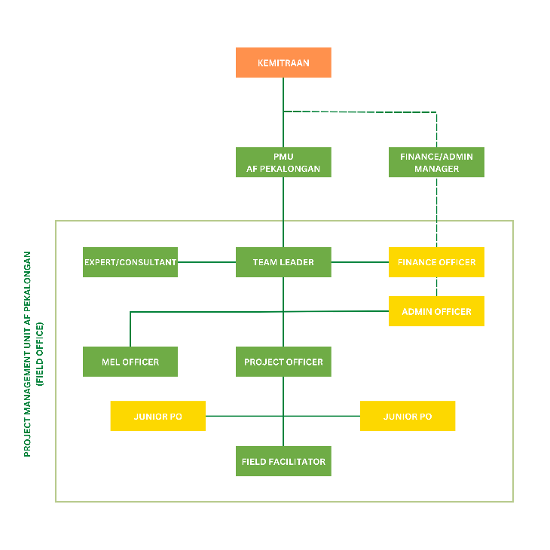

Figure 20. Institutional Structure of the Programme
- The Steering Committee (SC) will oversee the whole program implementation to ensure that the means and mechanisms are in place to run the program effectively to be able to achieve the desired outcomes, while also representing the voice of stakeholders that do not directly sit on the committee. They will provide high level technical and management guidance to the NIE and PMU for program implementation, including guidance on policy advocacy process at national level. Member of the SC will encompass representatives from National government, Province, Government, City Government, Kelurahan Government, Academicians and Civil Society Organizations.

- The Project Team Leader will have the authority to run the project on a day-to-day basis on behalf of Kemitraan, reporting to the Director and Executive Director, within the constraints laid down by the SC. The Team Leader’s prime responsibility will be to ensure that the project produces the results specified in the project document, to the required standard of quality and within the specified constraints of time and cost. The Project Support role includes project officer, finance/admin officer, ME & Learning Officer, and technical support to the Project Leader, as and when required.

Describe the measures for financial and project / programme risk management

- Kemitraan has managed financial measures through on-going refinement of financial management policies. Several financial risks have been anticipated such as misuse of funds in Fraud Anti-Corruption, Fraud and Whistle Blower Policy 2015, Conflict of Interest in the Employee Handbook, and asset lost and damages in Chapter 4.11 SOP General Service Asset lost and Damage, while there is no measures for poor investment since Kemitraan has no investment funds.
- Our internal control system has used online Project Tracking System through integrated Monitoring & Evaluation Learning system. While at the organization level, the internal control system has been managed through existing Internal Auditor that directly reports to Executive Board that oversees the use of finance and operations.

- Besides that, all risks in project implementation are analyzed during the design phase with the participation of all relevant stakeholders. A mitigation strategy is established to ensure that the risk is well managed. The table below presents the types of risks, description of risk and risk level and the strategies that have been and will be done to minimize them. Potential risks are identified below, along with proposed countermeasures.

Type of Risk | Description of Risk | Risk category (H/M/L) | Risk Mitigation Strategy
Institutional | Weak commitment built by project implementers with central/provincial/local government due to changes in government structure and lack of coordination and communication. | Medium | This project has a specific work component of community strengthening for groups that have been strengthened by Partnership since 2017 at the city level.  The change of government structure has been anticipated by strong communication with regional secretariat (Sekda) and Planning Agency (Bappeda).  To ensure project achievement will be achieved, the PMU will continue to build active coordination and communication with the provincial and central government.
Institutional | Changes in project personnel can affect the availability of qualified staff | Low | In establishing working relationships with the PMU, the Consortium implements a recruitment system with output of work contracts during the project. With this mechanism, the personnel is attached with the project goal.
Financial | Delays in disbursement of funds, procurement and institutional efficiency (long approval process and others) that delay project implementation. | Medium | Building active communication with AF and fulfilling all forms of financial procedures in budget disbursement.
Social | Lack of community (direct beneficiaries) support to the project | Medium | - Building good relationships with local government (kelurahan level), community and the community leaders (direct beneficiaries) before the project starts  - The formation of groups at the kelurahan level can gather all people/levels that are in target community  - Utilization of activities in the form of training/workshops/group discussions to provide understanding of the project
Social | Communities are less aware of climate change and have lack of enthusiasm to respond to disasters. If beneficiaries are not fully aware of the impacts of climate change, it is difficult to gain their commitment in urban farming development and climate change adaptation | Low | This project will implement and introduce participatory methods to the communities so that they can be provided with understanding on the impacts of climate change. In addition, the mentoring process will be undertaken at the kelurahan level by utilizing field facilitators in each of the project target kelurahan.
Social | Conflict of community interest in selection of location | Medium | This project will build trust with stakeholders in the utilization of land to be used for urban farming, latrines and eco-tourism.
Social | Low technical knowledge of urban farming and eco-tourism | Low | This project will provide technical support to project beneficiaries in urban farming and eco-tourism.

Describe the measures for environmental and social risk management, in line with the Environmental and Social Policy of the Adaptation Fund
- Please refer to Annex 7 of this document, in which a table summarizes the potential environmental and social risks that could arise from the program and the corresponding mitigation measures.

- From the beginning of the program period, the stakeholders will be informed on the potential risks associated with the program and the corresponding mitigation measures in place. The program’s Environmental and Social Management Plan/ESMP (described in a more detailed manner in Annex 1) will be communicated to them; not only during the program preparation phase, but also throughout the course of the program, to ensure all parties involved are aware of the risks and the appropriate mitigation measures.

- As part of the program implementation, the PMU will also set up grievance mechanism for the stakeholders involved. This mechanism is needed to ensure the program always in line with AF’s ESMP that promote environmental and social safeguard and also ensure that it always in line with community’s interest and met their expectations. Steps that will be taken for setting up the mechanism are as follow:
- Initial orientation for the PMU will include materials on ESMP and grievance mechanism so that the staff will understand their roles and responsibilities on this matter
- Assign staff/team of staff that will be responsible for receiving and processing the grievance
- Develop procedures for accepting/logged-in grievance, grievance assessment process, providing feedback for the grievance, and monitoring the feedbacks
- Create internal communication procedures for the mechanism
- Communicating the ESMP and grievance mechanism at the beginning of program implementation to the stakeholders
- The grievance mechanism procedure that will be set up will follow these following general guidelines:
- Logged-in Grievance
Stakeholder should formally communicate grievance in a written manner, and sent it to the appointed staff through email, fax or hand-delivered the text to the PMU office. Once it’s being logged, the particular stakeholder will receive receipt that acknowledging the complaint is being accepted and will be processed
- Grievance Assessment
Once the complaint is logged-in and recorded, an assessment process will be done by a specific team by considering the complainants, issues, mitigation measures in place, rating the grievance and exploring options to address the grievance. The team leader will continually updated on the process
- Providing and Communicating Feedback
Once the option is selected, the team will prepare a response for the grievance and communicate the response formally in written text to the complainant
- Monitoring Feedback
To ensure the feedback is well received by the complainant or to maintain in case there will be follow up response, the responsible staff will continually monitor the grievance cases logged-in, its feedback and how it being dealt in practise.

- A more detailed grievance mechanism and the responsible staff has been developed at the beginning of program implementation (see Annex 15 and www.kemitraan.or.id/complaint-handling).

Describe the monitoring and evaluation arrangements and provide a budgeted M&E plan
- Through a project management system which blend M&E system and Knowledge Management & Learning, Kemitraan ensures early detection of any changes, both positive and negative throughout project implementation. Hence, knowledge and lessons throughout project implementation are well identified, well responded and documented so that can be learned and widely informed to and by key stakeholders.

- To ensure the quality of project deliverables Kemitraan operates an IT based project tracking system (called TRACY) to monitor the programmatic achievement and Sun System to monitor the project financial performance. The TRACY and Sun System work based on the Kemitraan Manual of Policy and Procedure which covers every stages of the project cycles (planning, monitoring and evaluation). All data and project documents are required to be stored in the system and enable the organization to elaborate the lesson learnt into the knowledge. Kemitraan applies project comprehensive quality control system. The quality assurance comprises of 3 tiers, i.e. Programme Unit and Project Management Unit (PMU) as 1st tier of defense, Organization’s Planning, Monitoring & Evaluation Unit (PME), Finance & Grants Unit (FG) and People Office Management (POM) as 2nd tier of defense and Internal Auditor as 3rd tier of defense.

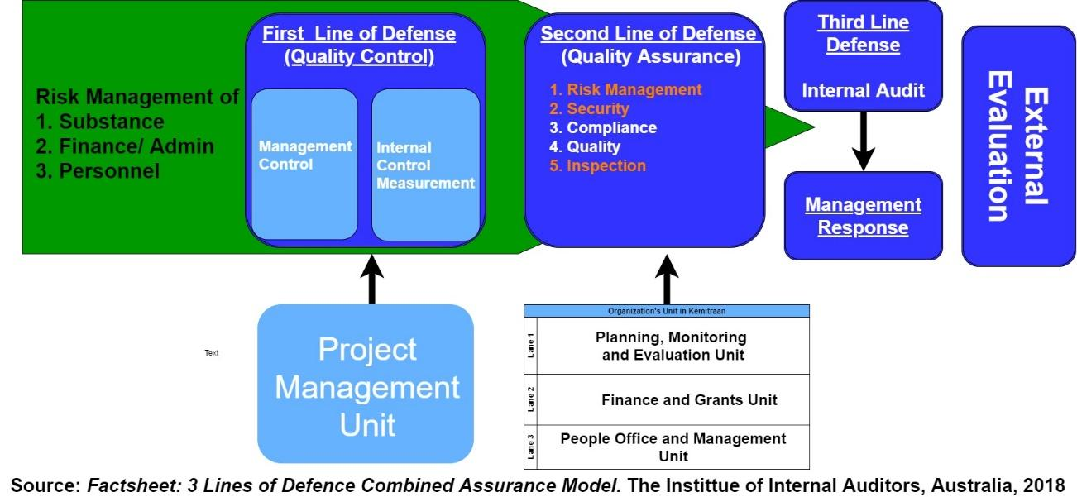
Figure 21. Quality Assurance Mechanism in Kemitraan

- TRACY system also provides dashboard for easy access of the Management Level to monitor the progress of the project. Any challenges throughout project implementation will be reported and consulted to the Management through a Management Meeting to review project performance and further seek management response for any identified risks.

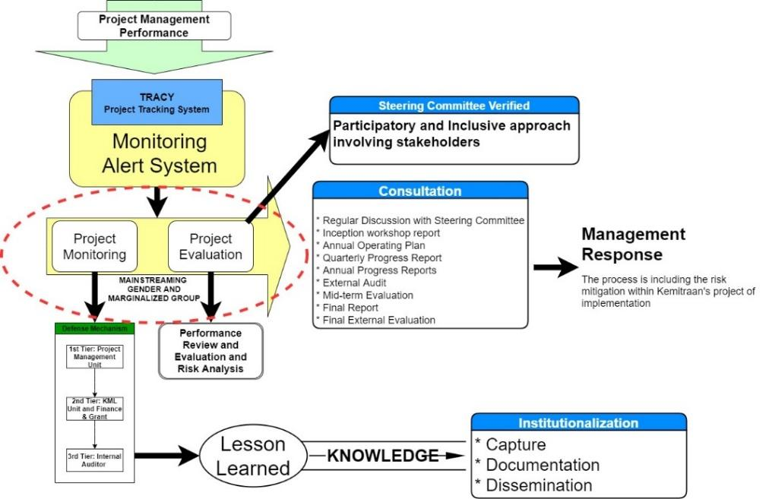
Figure 22. Project Monitoring Mechanism in Kemitraan

- In the 1st tier of defense mechanism, PMU is established to implement and ensure the quality of deliveries and conduct project monitoring progress through a tailor-made monitoring tool which will be developed based on an Inception workshop. This workshop is designed to capture as follows:
- Assist all participants to fully understand the project objectives and activities and take ownership of the project
- Discuss the organizational structure of the project
- discuss the roles and responsibilities of all agencies involved in the project including decision making, reporting, and lines of communication
- Discuss conflict resolution mechanisms.
- Review and agree on the indicators, targets and their means of verification, and recheck assumptions and risks.
- Ensuring the mainstreaming of gender and marginalized group in each level the implementation of project and output of projects.
- Prepare and framework finalize the annual work plan for year one.
- Discuss project monitoring, evaluation and reporting requirements
- Discuss financial procedures.

- Progress of project performance is monitored based on the set result framework as stated in the below E section. PMU with the support of PME Unit will be responsible for monitoring the progress guided by Annual Operating Plan (AOP). Annual Operation Plan displays all necessary activities for current year and its milestone of performance indicators based on the set project results framework. The results of the monitoring will be in the form of Quarterly Status Reports presenting monitoring process on executed activities and its progress towards the intended outputs. AOP’s will be agreed and scheduled annually during Steering committee meetings.
- All progresses and results are documented through the below reporting tools:

- Inception Workshop Report - will be prepared after inception workshop, which will detail about roles, responsibilities, actions, and functions of all stakeholders. Furthermore, it will include first AOP and monitoring plan for the first year.
- Annual Operating Plan (AOP) - Annual plan should be approved by the steering committee before starting each operating period, and it will detail all activities to be executed, all milestones and goals which will be reached during the year, and dates for each indicator to be executed. AOP will include all the necessary financial activities relevant to the first period.
- Quarterly Progress Reports (QPR) - project management unit should submit QSRs to steering committee at the end of each operating quarter. QSRs will present how the indicators identified in project results framework are executed, what challenges PMU faces during the execution process and identify any constraints. Quarterly Status Reports will present monitoring process on executed activities.
- Annual Progress Reports (AMR) - Annual Progress Report will cover last AOP, it will compare the actual results with the targets and milestones listed in AOP, and if necessary it will come up with improvements and corrective measures for the upcoming AOP.
- External Audit Reports - with the periodic financial statements, external annual audit report will be prepared. Audit reports are made in accordance to Financial Regulations set by the government.
- Mid-term Evaluation - Halfway through the project implementation the project will undergo an external mid-term evaluation, which will assess the project’s progress of achieving outcomes. Effectiveness and efficiency of the projects will be taken into consideration, and if needed any corrective mechanisms will be applied after the mid-term evaluation.
- Final Report - Final report will be presented three months prior to the end of the project. The main focus of the evaluation is to assess project’s results with planned results. Moreover, the final evaluation will look to impacts of the projects and to the sustainability of the project.
- Final External Evaluation - The main focus of the evaluation is the project impacts, project’s sustainability and long-term effects. Final evaluation will also suggest any further actions to be implemented for project’s sustainability.

Monitoring and Evaluation Activities and Budget
Type of M&E Activities | Responsible Parties | Budget (US$) | Time Frame | Year 1 | Year 2 | Year 3
Type of M&E Activities | Responsible Parties | (does not include staff time)
Inception workshop | Team Leader | 4,000 | Y1; 2nd month | 4,000
(30 participants, 2days)
Inception report | Team Leader | Part of Execution Cost | Y1: 2nd month | 4,000
Develop the performance management plan and reported quarterly | Team Leader | Part of Execution Cost | Y1 (quarterly), Y2, Y3
Develop base line data | M&E Specialist | 35,000 | 2nd-3rd month Y1 | 35,000
(4 month, 1 team researcher)
Regular monitoring to the field | Team Leader | 13,500.00 | Y1: bimonthly | 4,500 | 4,500 | 4,500
· 1x BImonthly, 4 days, 2 persons | Team Leader | (Travel cost of Steering committee to be charged to IE Fees) | Y2 and Y3 | 4,500 | 4,500 | 4,500
Spot check monitoring the measure the progress output | PME Unit and Internal Audit | 15,000 | Y1: quarterly | 5,000 | 5,000 | 5,000
· 1x/quartile, 4 days, 2 person | PME Unit and Internal Audit | 15,000 | Y2, Y3 | 5,000 | 5,000 | 5,000
Quarterly report | Team Leader | Part of Executon Cost | Y1 (quarterly), Y2, Y3
Coordination meeting of the project management unit with the steering committee in the national and district level | Team Leader |  | Y1, 3rd Year | 4,500 | 4,500 | 4,500
· National level: 10 persons | Team Leader | 13,500 | Y1, 3rd Year
· City level: 10 persons | Team Leader |  | Y1, 3rd Year
PMU coordination meeting including the field staff | Team Leader | 16,500 | Y1, Y2, Y3 | 5,500 | 5,500 | 5,500
· 2x/year, 3 days, 10 persons | Team Leader | (Travel cost of Steering committee to be charged to IE Fees)
End line survey | Researcher | 35,000 |  | 0 | 35,000
· Team research
· 4 month
· Field visit
Documentation of achievements from program's indicators and targets |  | 9,000 |  | 3,000 | 3,000 | 3,000
Annual Review | External consultant | 7,800 | Y2 6th month | 2600 | 2,600 | 2600
Final evaluation | External consultant | 10,000 | Y3, 3rd quartile | 0 |  | 10,000
Grand Total |  | 159,300.00 |  | 64,100.00 | 60,100.00 | 35,100.00

Include a results framework for the project proposal, including milestones, targets and indicators.

Project Objective(s) | Project Objective Indicator(s) | Baseline | Target |  |  | Risk & Assumptions | Operational Definition
Project Objective(s) | Project Objective Indicator(s) | Baseline | 1st year | 2nd year | 3rd year | Risk & Assumptions | Operational Definition
Goal. Building coastal City Resilience to Climate Change Impacts and Natural Disasters, with a particular focus on pro-poor adaptation actions that involve and benefit the most vulnerable communities in the City
Objective 1. Enhancing protection along the coastal line of Pekalongan City | 50% of the total households or equal to 12,573 households has gained impact from protection along coast line from sea level rise causing tidal flood and inundation |  |  | 6.200 | 6.373
Outcome 1.1  Increased coastal community resilience in Pekalongan City | Approx. 75% of targeted coastal areas is protected through a combination of mangrove ecosystem and breakwater  At least, the coastal areas in 3 kelurahan is protected through mangrove ecosystem |  |  | 3 ha |  | Social conflict arising from selection of priority activities site and design | Increasing community’s resilience towards CC impact through coastal protection
Output 1.1.1  3 ha of Mangrove Ecosystem established | 3 hectares of targeted coastal areas is protected through established mangrove ecosystem  At least, the coastal areas in 3 kelurahan is protected through mangrove ecosystem |  |  | 3 ha |  | Social conflict arising from selection of priority activities site and design (at community and city level implementation) which could raise envy from other community member that will not directly exposed to the programme | extending coastal mangrove coverage by planting, restoring and maintaining approx. 3 ha mangrove ecosystem, as well as nursery establishement/extension
Output 1.1.1  3 ha of Mangrove Ecosystem established | 60 persons are involved in expanding mangrove cover in coastal areas by planting, restoring, and maintaining. Approximately. Male : 36 persons, Female: 18 Persons and vulnerable : 6 Persons |  |  | 60 persons
Output 1.1.2  Breakwater (rubble mound) covering the coast of Kandang Panjang in the area of Mangrove Information Centre (PIM) constructed | coastline in Kandang Panjang rehabilitated through the construction of breakwater (rubble mound)  1 of Kelurahan is protected through breakwater construction Kandang Panjang. |  |  |  | 300 meter breakwater constructed | Disruption of physical environment from mobilization, construction and implementation of adaptation actions | Improvement of environmental infrastructure of community settlements in climate change adaptation Kelurahan Kandang Panjang through the construction of breakwater
 | 56 local people were socialized about livable and healthy settlements and were involved in the construction of breakwater infrastructure in both kelurahan Kandang Panjang.  Approximately Male : 34 persons, Female: 17 Persons and vulnerable : 5 Persons |  |  | 56 persons
Objective 2. Enhancing coastal community capacity in developing and implementing local climate change adaptation actions (RAD API), climate change information system, climate smart initiative | 160 community members from 8 kelurahan has targeted to become agent of change in coping better with climate-change through adaptation and actions. The targets will be counted from the achievement in each outcome. |  |  | 60 | 100 | There is support from stakeholders; A forum is initiated and attended by stakeholders and the community; Increased public awareness and knowledge, especially on the issues of adaptation to changing environmental condition
 | 8 (eight) CCA-specific activities with allocated budget are included in City Developmet Plan  Regional Development Planning (Bappeda): Regional Action Plan on CC, Supervising each CC-A specific activities in Municipal Technical Offices  Office of Marine and Fisheries: Ensuring the sustainability of coastal livelihood, ensuring fisheries infrastructure are maintained  Office of Environment: Monitoring and implementing the environmental prerequisite  Public Work and Spatial Planning: Ensuring the sustainability and maintenance of build infrastructure from the Project, increasing access to public facilities in water and sanitation in collaboration with Office of Sanitary and Health  Office of Tourism: Strengthening community enterpreneurship such as Kelurahan-owned enterprise and/or cooperative improvement |  |  | 4 | 4
 |  |  |  | 3 | 4
Outcome 2.1  Enhanced capacity of local actors in identifying, initiating, strengthening, and escalating community-based actions to address climate risk and natural disaster; including capacity in integrating the actions to sub-district development plan | 160 community members from 8 kelurahan become agent of change in coping better with climate-change through adaptation and actions. The targets will be counted from the achievement in each outcome. |  |  | 60 | 100 | - | Encouraging local community to be Agents of Change in CCA action through capacity building activity
Output 2.1.1  Pekalongan City Climate Working Group reactivated | The existing City Climate Working Group reactivated and actively involved in the planning of adaptation action at municipal level, both community based and government led. |  | 1 |  |  |  | reactivate existing CCWG through approach to and re-engagement of involved key stakeholders
 | 80% of the members of the Pekalongan City climate working group, representatives of regional stakeholders and / or program cadres that they are active in FGD forums, workshops and meetings organized by the program |  |  |  | 80% of the members of the Pekalongan City climate working group, representatives of regional stakeholders and / or program cadres
 | 30% of climate working group members in Pekalongan city, representations of women groups and vulnerable groups |  |  | 30% of climate working group members in Pekalongan city
Output 2.1.2  Climate working group established and functioning in each of the 8 target kelurahan | 8 climate working group established in each kelurahan and actively involved in the development of community based adaptation action plan |  | 4 | 4 |  |  | Increased awareness and participation of the community and local governance service through climate working groups, in kelurahan level (8 Kelurahan) and municipal level
 | 80% of the members of the Kelurahan climate working group in 8 Kelurahan, representatives of program cadres that they are active in FGD forums, workshops and meetings organized by the program |  |  | 80% of the members of the Kelurahan climate working group in 8 Kelurahan, representatives of program cadres
 | 30% of climate working group members in Kelurahan leve, representations of women groups and vulnerable groups |  |  | 30% of climate working group members in Kelurahan leve, representations of women groups and vulnerable groups
 | There is a document of lesson learned or best practice about women and vulnerable groups related to climate change adaptation |  |  |  | 1 dokumen lesson learn
Output 2.1.3  Enhancing coastal community capacity in developing kelurahan’s information system and implementing the ensuing climate change adaptation actions | Climate change information system (CCIS) developed and ensuing climate change adaptation actions implemented |  |  | 1 |  |  | strengthening community based climate information systems (including women groups and vulnerable groups), to help make decision on the ensuring adaptation action
Output 2.1.4  Engaging youth groups and building their capacity to become Agents of Change in climate change adaptation actions of Pekalongan City | At least 3 (three) youth groups established across 8 targeted Kelurahan with developed action plan agreed upon |  | 1 | 2 |  |  | Establishment of Young Agents of Change the 8 kelurahan that become influential to further the effort of CC adaptation in Pekalongan City
Outcome 2.2  Enhanced local government and other city stakeholders’ capacity in developing climate risk assessment and utilizing the results to develop local climate change adaptation action plan (RAD API), | Increased capacity of local government and city’s key stakeholders in the development of climate risk assessment and utilizing the results to develop local climate change adaptation action plan that is mainstreamed in the Municipal Development Plan with regards to gender equity |  |  |  | 1 document of RAD API (CC Adaptation Action Plan) incorporated within annual work-plan or mid-term development plan at municipal level | Changes in government structure and lack of coordination and communication so the mainstreaming budget will take longer than expected | This outcome looks at the improvement of the municipal CCA action plan (RAD API), which development involves the municipal govt. and other key stakeholders. To do this, local capacity needs to be enhanced
Output 2.2.1  RAD API developed based on Pekalongan City Climate Risk Assessment and Climate Coastal Impact | Climate change adaptation action plan adopted and developed to RAD API documents and incorporated within annual work-plan or mid-term development plan at municipal level |  |  | 1 draft document of RAD API incorporated CC-Adaptation within annual work-plan or mid-term development plan at municipal level |  |  | Increased awareness and participation of youth groups (including vulnerable groups) and women's groups in supporting climate change adaptation actions through social media, socialization and as an agent for climate change issue
 | Mainstreaming gender and marginalized groups adopted and developed to RAD API documents and incorporated within annual work-plan or mid-term development plan at municipal level |  |  |  | 1 document on mainstreaming gender and marginalized group incorporated within RAD API and annual work-plan or mid-term development plan at municipal level |  | Strengthening climate change actions in the regional level through proposing Regional Action Plans for climate change action (RAD API) to the Pekalongan municipal government of Pekalongan City
Output 2.2.2  Strategy to integrate CCA into local government planning processes (annual work plan or mid-term development plan of city) is developed | At least, 5 municipal offices (Regional Development Planning (Bappeda),  Office of Marine and Fisherie, Office of Environment, Public Work and Spatial Planning in collaboration Office of Sanitary and Health, and Office of Tourism) have actively involved in governing Climate-change adaptation and involved in the development of a strategy to integrate CCA into local government planning |  |  | 5 |  |  | Efforts to accelerate climate change adaptation actions to be integrated into local government development planning
Outcome 2.3  Enhanced resilience of coastal community through the Implementation of Climate Smart Initiatives, including fostered sustainable utilization of natural resources, with implementation scheme that can be replicated and disseminated to broader audience | Improved livelihoods and ecosystem resilience, as well as developed social behavioural changes in community through applied Climate Smart Initiative.  Adoption and application of developed online technology systems in collaboration with local governments |  |  |  | 1 | Low technical knowledge of internet and technology | Adoption and application of online technology to develop Climate Smart Initiative to encourage social behavioural changes in the community towards CC issues
Output 2.3.1  Innovative and collaboration adaptation actions are implemented in collaboration with private sector, Government bodies and NGO ( i.e. technology for main productive sectors, model on collaborative CCA programme across coastal kelurahan’s upstream and downstream, collaborative action to protect the affected coastal area); and also evaluated for future reference | Established community-led climate network, that consists at least 30% of Women |  |  | 8 kelurahan |  |  | Improved multi-stakeholder participation and engagement (local governments, NGOs, academics, Community incl. women groups and vulnerable groups, and the private sector) in the development of new innovations and collaborative actions
 | Developed smart-phone based climate warning systems across 8 Kelurahan.
Outcome 2.4  Established knowledge management network at municipality level | The knowledge management network established in each target kelurahan that are actively engage and communicate with each other. |  |  | 4 | 4 | Lack of community (direct beneficiaries) support to the project | Increase community knowledge on CCA based on own experience and the applied assistance through this project
Output 2.4.1  Climate change training and knowledge sharing conducted | Training and knowledge sharing conducted across 8 target kelurahan involving different community groups |  | 1 | 1 | 1 |  | Increased capacity, skills and knowledge management as needed by the community (including women groups and vulnerable groups) and government staff (municipal level and provincial level)
Output 2.4.2  Knowledge product, Advocacy materials (i.e. lessons learned, research paper, newsletter) published and shared | Publications related to climate change adaptation produced by each group during the course of the project |  | 1 | 3 | 4 |  | Dissemination and publication of program activities and products (i.e lessons learned, research papers, newsletters) through socialization, seminar, roadshow, mass media, social media, short movie, and research publications.
Output 2.4.3  Local knowledge sharing network established | Knowledge management network established and consists at least of 5 different community groups in each target kelurahan (i.e youth group, women group, farmers and fishermen groups, local enterpreneurs, other marginalized group, and academician or urban planners) that are actively engage and communicate with each other. |  |  | 16 | 24 |  | Establishment of local knowledge sharing network in level community and goverment level to enable knowledge exchange amongst stakeholders and Community (including woment groups & vulnerable groups) in Pekalongan City
Objective 3. Strengthening vertical coordination by enhancing provincial government’s capacity in mainstreaming climate change adaptation and resilience into Central Java Province development plan | Climate change and adaptation context included in Central Java Province Development Plan (RPJMD/RKP)  The definition is approved by the documents of Regional Regulation on RPJMD and RKP (Regional Development Planning, and Annual Development Plan) at Central Java Province. The RPJMD and RKP documents has integrated the climate change and adaptation context into the provincial policy. |  |  |  | 1
 | Increased contribution of the number of women and marginalized community that contribute in policy making and in implementation at municipal level. |  |  |  | 30%
Outcome 3. 1  Enhanced provincial government’s capacity in mainstreaming climate change adaptation and resilience into Central Java Province development plan | Increased capacity of local governments and key city stakeholders (at least 7 municipal offices) in developing climate risk assessments and utilize the results to develop local climate change adaptation action plans that are mainstreamed in the Provincial Development Plans with regards to gender equality (Environmental Office, Bappeda, Maritime and Fisheries Office, agriculture Office, public works Office, women empowerment, Health Office) |  |  |  | 7 | Weak commitment built by project implementers with central/provincial/local government due to changes in government structure and lack of coordination and communication | This outcome looks at the improvement of the provincial development plan, in which CCA and CC resilience are mainstreamed. To realize this, improvement of prov. Govt. needs to be improved and enhanced
Output 3.1.1  Enhanced provincial capacity to develop RAD API | Climate change adaptation action plan adopted and developed to RAD API documents and incorporated within annual work-plan or mid-term development plan at provincial level |  |  |  | 1 document of RAD API incorporated CC-Adaptation within annual work-plan or mid-term development plan at provincial level. |  | Increasing the capacity of the provincial govt. to develop RAD-API involving key-stakeholders in the consultation and development process
 | Mainstreaming gender and marginalized groups adopted and developed to RAD API documents and incorporated within annual work-plan or mid-term development plan at province level |  |  |  | 1 document on mainstreaming gender and marginalized group incorporated within RAD API and annual work-plan or mid-term development plan at provincial level |  | Efforts to accelerate climate change adaptation actions to be integrated into local government development planning in Province level
Output 3.1.2  Appropriate strategy to integrate CCA into Provincial government planning processes (annual work plan or mid-term development plan of city) is developed | At least, 5 provincial offices (Regional Development Planning (Bappeda),  Office of Marine and Fisherie, Office of Environment, Public Work and Spatial Planning in collaboration Office of Sanitary and Health, and Office of Tourism) have actively involved in governing Climate-change adaptation and involved in the development of a strategy to integrate CCA into local government planning |  |  |  | 5 |  | Appointed staff of the 5 offices have good knowledge and understanding on CCA, its strategy and its integration to provincial development plan
Objective 4. Strengthening vertical coordination and collaboration between national and local government in climate adaptation context and Enriching knowledge, toolkits and methodologies coastal resilience for the national government | Establishing knowledge management network between national and local government in climate adaptation context  At least, one knowledge product is produced in each output |  | 5 | 8 | 10
Outcome 4.1  SIDIK as risk assessment tools for coastal area based on local experience enriched | SIDIK Handbook developed, introduced and disseminated to broader stakeholder at all governmental level (local, provincial and national) with input from multi-stakeholders (i.e civic society, local government, private sectors and national government) in the re-formulation of SIDIK indicators.  Introducing SIDIK as risk assessment tools for coastal area based on local experience at two ministries which include Ministry of Marine and Fisheries, and Ministry of Environment and Forestry  Two technical ministries on forestry and coastal management is actively involved in governing Climate Change Adaptation through SIDIK system. |  |  |  | 1 | Lack of coordination across ministries due to same level of authority | SIDIK enhancement with risk assessment tools for coastal area. Local experience and knowledge from this project will be added into SIDIK documentation
Output 4.1.1  Knowledge product in the form Handbook on how to use SIDIK for risk assessment at coastal city is published and shared. This handbook is targeted to be used by local government, NGOs and civil society organizations | Input from multi-stakeholders (i.e civic society, local government, private sectors and national government) in re-formulation of SIDIK indicators collected and integrated in the handbook. |  | 2 (workshops, FGDs) | 2 (workshops, FGDs) | 4 (workshops, FGDs) |  | SIDIK operational handbook (manual) for risk assessment in coastal cities is made available, published and distributed, which content is enhanced with knowledge, toolkits and methodologies related to coastal resilience
 | SIDIK as risk assessment tools for coastal area based on local experience at two ministries which include Ministry of Marine and Fisheries, and Ministry of Environment and Forestry introduced and disseminated |  |  |  | 1 handbook (7000 expl.)
Output 4.1.2  Strengthened vertical coordination and collaboration between national and local government in climate adaptation context | Two technical ministries on forestry and coastal management respectively are actively involved in governing Climate Change Adaptation through SIDIK system. |  | 1 | 2 | 2 |  | To develop common knowledge, understanding, and similarities between planning and actions among municipal, provincial and national governments. in the context of climate change adaptation (CCA)
Objective 5. Improving community’s resilience through initiation of alternative livelihood and improvement of sanitation facility | Established livelihood alternatives and circular economy. The indicator of the objective include:  - developed of capture fisheries (number of group developed);  - urban farming introduced and applied by community (yields and number of plots applied urban farming)  - developed and improved community-based ecotourism (number of group developed and improved ;  - constructed integrated-waste management facility (number of facility constructed and number of community members trained and gained service of water and sanitation) |  |  |  | 3
Outcome 5.1  Increased economic income and improved community’s health in 8 target kelurahan of Pekalongan City | At least 4 (four) sustainable livelihood are adopted and applied as climate change adaptation strategies by communities in each kelurahan through inclusive approach, by involving women and other marginalized group. The sustainable livelihood includes community fisheries at coastal areas, urban farming strategies, community-based ecotourism and integrated-waste management in communities.  Institutionalization of circular economics to improve average income in each Kelurahan, both in normal seasonal condition and in the mid of increasing of climate change consequences (i.e. El-Nino, La-Nina, Long drought, or wet-dry seasons). Furthermore, decreasing the health problems and risk in 8 Kelurahan. |  |  | 2 | 2 | Communities are less aware of climate change and have lack of enthusiasm to respond to disasters. If beneficiaries are not fully aware of the impacts of climate change, it is difficult to gain their commitment in urban farming development and climate change adaptation | assistance to community and the municipal govt. of Pekalongan in the development of sustainable alternative livelihood with strong inclusion of women and marginalized groups
 | Income or health level of beneficiaries of sustainable economic empowerment as well as improved watsan facilities at the program location,  Male = 1.394 persons or 60%  Female = 697 persons or 30%, include women headed family  Vulnerable = 232 persons or 10% |  |  |  | 2.324 | There is support from the local government;  Beneficiaries depend on their income in the batik sector, eco-tourism, fishermen or as breadwinners in their families;
Output 5.1.1  Aquafarming in mangrove ecosystem developed and implemented by community | Capture fisheries (number of group developed) developed and applied |  | 1 Kelurahan | 7 Kelurahan |  |  | introduce and apply capture fishery to community (including women groups and vulnerable groups) through enrichment of mangrove ecosystem with consumable fish and other sea species, such as shrimps and crabs (integrated aquaculture)
Output 5.1.2  Mangrove ecotourism improved and involving wider participation of affected coastal community of Pekalongan City | Community-based ecotourism (number of group developed and improved) developed and/or improved |  | 1 Kelurahan | 7 Kelurahan |  |  | Development of community based ecotourism, that includes women and vulnerability groups with full support of the municipal govt.
 | There is a journal about livelihood women and vulnerable groups related lo climate change adaptation |  |  |  | 1 Journal
Output 5.1.3  Improved cultural economy through application of ecological batik using mangrove based colouring product | ecological batik using mangrove based colouring product applied and cultural economy improved |  | 1 Kelurahan | 7 Kelurahan |  |  | Introducing ecological batik colouring technic to the batik craftsmen community incl. women and vulnerability groups, and increase capacity of batik maker to improve designs
Output 5.1.4  Improved food security through the application of urban farming as alternative to conventional agriculture practices | urban farming introduced and applied by community (yields and number of plots applied urban farming) |  | 1 Kelurahan | 7 Kelurahan |  |  | introducing and implementing urban farming based on local seeds to community (including women groups and vulnerable groups) as an alternative agriculture practices to strengthen local food security
Output 5.1.5  Developed circular economy through initiation integrated waste management system and processing | integrated-waste management facility constructed and running |  | 1 Kelurahan | 7 Kelurahan |  |  | establishment of a functioning waste management facility that can offer jobs and business opportunities both for the city and for the community that also gender mainstreamed in the development of employment opportunity
Output 5.1.6  Improved sanitation facility in 8 target kelurahan to mitigate risks of waterborne disease | Water and sanitation condition in 8 target kelurahan improved through construction of communal facilities |  | 16 | 8 |  |  | Improvement of domestic public sanitation and / or waste water facilities in 8 villages by involving the community (including women groups and vulnerable groups) and local governments from the start of planning, development and maintenance
Output 5.1.7 Flood Relief for Pekalongan City

Demonstrate how the project / programme aligns with the Results Framework of the Adaptation Fund
Project Objective Components | Expected Outcomes | AF Outcomes
- Enhancing coastal community capacity in developing and implementing climate change adaptation actions and information system in each of the 8 target kelurahan | Enhanced capacity of local actors in identifying, initiating, strengthening and escalating community-based actions to address climate risk and natural disaster; including capacity in integrating the actions to kelurahan development plan | Outcome 3
 | Enhancing local community adaptive capacity, including developing livelihood strategies to face climate change impacts and natural disasters | Outcome 3, Outcome 6
- Enhancing municipal government and other stakeholders’ capacity in developing local climate change adaptation action plan (RAD API) and implementing climate smart initiative | Enhancing local government and other city stakeholders’ capacity in developing climate risk assessment and utilizing the results to develop local climate change adaptation action plan (RAD API), | Outcome 2
 | Implementing climate smart initiatives, including those fostering sustainable utilization of natural resources and development of circular economy | Outcome 4, Outcome 6
 | Establishing knowledge management network at municipal level | Outcome 3
- Strengthening vertical coordination by enhancing provincial government’s capacity in mainstreaming climate change adaptation and resilience into Central Java Province development plan, which in turn could foster better climate-related policy on climate financing and bottom-up planning | Enhancing provincial government’s capacity in mainstreaming climate change adaptation and resilience into Central Java Province development plan | Outcome 2
- Strengthening vertical coordination and collaboration between national and local government in climate adaptation context and Enriching knowledge, toolkits and methodologies coastal resilience for the national government | Enriching SIDIK as risk assessment tools for coastal area based on local experience | Outcome1
 | Strengthening vertical coordination and collaboration between national and local government in climate adaptation context | Outcome 7

Include a detailed budget with budget notes, a budget on the Implementing Entity management fee use, and an explanation and a breakdown of the execution costs

Description Item |  |  | MODIFIED BUDGET | BUDGET NOTES
SAFEKEEPING |  |  | $1.329.480
1. Enhancing protection along the coastal line of Pekalongan City | 1.1 | Increased coastal community resilience in Pekalongan City | $ 1.329.480
 | 1.1.1 | 3 ha of Mangrove Ecosystem established | $ 37.037 | Changing output 1.1.1 to 3 ha of Mangrove Ecosystem established
 | 1.1.2 | Breakwater (rubble mound) covering the coast of Kandang Panjang in the area of Mangrove Information Centre (PIM) constructed | $ 1.292.443 | Changing output 1.1.2 to Breakwater (rubble mound) covering the coast of Kandang Panjang in the area of Mangrove Information Centre (PIM) constructed
SURVIVING |  |  | $1.547.326
2. Enhancing coastal community capacity in developing and implementing Local Climate Change Adaptation Action Plan (RAD API), climate change information system, Climate Smart Initiative | 2.1 | Enhanced capacity of local actors in identifying, initiating, strengthening, and escalating community-based actions to address climate risk and natural disaster; including capacity in integrating the actions to community development plan | $620.511
 | 2.1.1 | Pekalongan City Climate Working Group reactivated | $102.222
 | Activity:
 | 2.1.1.1 | Kick off meeting for city & village working group | $ 22.222
 | 2.1.1.2 | FGD (CWG & VWG) | $ 13.333
 | 2.1.1.3 | Workshop (CWG & VWG) | $ 33.333
 | 2.1.1.4 | Seminar (CWG & VWG) | $ 33.333
 | 2.1.2 | Climate working group established and functioning in each of the 8 target kelurahan | $233.474
 | Activity:
 | 2.1.2.1 | Workshop VWG | $70.511
 | 2.1.2.2 | Workshop CWG | $ 71.111
 | 2.1.2.3 | Office set up | $ 14.815
 | 2.1.2.4 | Overhead (office, car rent, utility) | $66.667
 | 2.1.2.5 | Equipment | $10.370
 | 2.1.3 | Enhancing coastal community capacity in developing kelurahan’s information system and implementing the ensuing climate change adaptation actions | $59.630
 | Activity:
 | 2.1.3.1 | Infrastructure (computer, internet connection) | $ 7.407
 | 2.1.3.2 | Maintenance | $ 3.704
 | 2.1.3.3 | Infosis Development | $ 5.185
 | 2.1.3.4 | Apps Development | $ 1.852
 | 2.1.3.5 | Series Training | $ 35.556
 | 2.1.3.6 | Technical Assistant (Data Specialist) | $5.926
 | 2.1.4 | Engaging youth groups and building their capacity to become Agents of Change in climate change adaptation actions of Pekalongan City | $ 225.185
 | Activity:
 | 2.1.4.1 | Youth Camp | $ 66.667
 | 2.1.4.2 | Essay of climate change and impact at coastal | $ 13.889
 | 2.1.4.3 | Poster competition | $ 13.889
 | 2.1.4.4 | Short movie competition | $ 13.889
 | 2.1.4.5 | Speech of climate change contest | $ 13.889
 | 2.1.4.6 | Focus group screeening 'Semesta' movie | $ 102.963 | Reallocation for emergency response needed
 | 2.2 | Enhanced capacity of local government and other city stakeholders’ in developing climate risk assessment and utilizing the results to develop local climate change adaptation action plan (RAD API) | $117.222
 | 2.2.1 | RAD API developed based on Pekalongan City Climate Risk Assessment and Climate Coastal Impact | $58.778
 | Activity:
 | 2.2.1.1 | Training RAD API | $32.111
 | 2.2.1.2 | Workshop | $ 8.889
 | 2.2.1.3 | Development of RAD API document | $ 17.778
 | 2.2.2 | Strategy to integrate CCA into local government planning processes (annual work plan or mid-term development plan of city) is developed | $ 58.444
 | Activity:
 | 2.2.2.1 | Assessment on government commitment to the implementation of climate change budget
 | 2.2.2.1.1 | Consultant | $ 11.111
 | 2.2.2.1.2 | Assistant | $ 6.667
 | 2.2.2.1.3 | Travel | $ 14.000
 | 2.2.2.2 | FGD | $ 8.889
 | 2.2.2.3 | Workshop | $ 17.778
 | 2.3 | Enhanced resilience of coastal community from the Implementing Climate smart initiatives, including those fostering sustainable utilization of natural resources, with implementation and financing scheme that can be replicated and disseminated to broader audience | $ 68.148
 | 2.3.1 | Innovative and collaboration adaptation actions are implemented in collaboration with private sector, Government bodies and NGO ( i.e. technology for main productive sectors, model on collaborative CCA programme across coastal villages/ upstream and downstream villages); and also evaluated for future reference | $ 68.148
 | Activity:
 | 2.3.1.1 | FGD | $ 8.889
 | 2.3.1.2 | Workshop | $ 14.815
 | 2.3.1.3 | National Seminar 2nd year | $ 22.222
 | 2.3.1.4 | National Seminar 3rd year | $ 22.222
 | 2.4 | Established knowledge management network at city-level | $262.259
 | 2.4.1 | Climate change training and knowledge sharing conducted | $56.778
 | Activity:
 | 2.4.1.1 | Community Training | $23.444
 | 2.4.1.2 | Training for Municipal Staffs | $ 16.667
 | 2.4.1.3 | Training for Provincial Staffs | $ 16.667
 | 2.4.2 | Knowledge product, Advocacy materials (i.e. lessons learned, research paper, newsletter) published and shared | $ 81.481
 | Activity:
 | 2.4.2.1 | talkshow & media gathering | $ 14.815
 | 2.4.2.2 | Media outreach on climate change adaptation | $ 44.444
 | 2.4.2.3 | Printing of knowledge product (booklets, reports) | $ 7.407
 | 2.4.2.4 | Short movie production | $ 14.815
 | 2.4.3 | Local knowledge sharing platform established | $ 124.000
 | Activity:
 | 2.4.3.1 | FGD with all related stakeholders at Kelurahan Level | $ 64.000
 | 2.4.3.2 | FGD at provincial and municipal level | $ 26.667
 | 2.4.3.3 | Workshop involving all of level community | $ 33.333
3. Strengthening vertical coordination by enhancing provincial government’s capacity in mainstreaming climate change adaptation and resilience into Central Java Province development plan which in turn could foster better climate-related policy on climate financing and bottom-up planning | 3.1 | Enhancing provincial government’s capacity in mainstreaming climate change adaptation and resilience into Central Java Province development plan | $ 194.815
 | 3.1.1 | Enhanced provincial capacity to develop RAD API | $ 125.926
 | Activity:
 | 3.1.1.1 | Training RAD API | $ 7.407
 | 3.1.1.2 | Refresher course RAD API | $ 7.407
 | 3.1.1.3 | Climate change adaptation RAD API short course ' | $ 111.111
 | 3.1.2 | Appropriate strategy to integrate CCA into Provincial government planning processes (annual work plan or mid-term development plan of city) is developed | $ 68.889
 | Activity:
 | 3.1.2.1 | Assessment to what extent climate change budget has been committed by city government
 | 3.1.2.1.1 | Consultant | $ 7.778
 | 3.1.2.1.2 | Assistant | $ 6.667
 | 3.1.2.1.3 | Travel | $ 10.000
 | 3.1.2.2 | FGD | $ 8.889
 | 3.1.2.3 | Workshop | $ 35.556
4.Strengthening vertical coordination and collaboration between national and local government in climate adaptation context and Enriching knowledge, toolkits and methodologies coastal resilience for the national government | 4.1 | Enriching SIDIK as risk assessment tools for coastal area based on local experience | $ 290.370
 | 4.1.1 | Knowledge product in the form Handbook on how to use SIDIK for risk assessment at coastal city is published and shared. This handbook is targeted to be used by local government, NGOs and civil society organizations | $ 138.519
 | Activity:
 | 4.1.1.1 | Consultant | $ 13.333
 | 4.1.1.2 | Travel consultant | $ 13.333
 | 4.1.1.3 | Printing | $ 77.778
 | 4.1.1.4 | Design layout | $ 2.222
 | 4.1.1.5 | Courier | $ 5.185
 | 4.1.1.6 | Gender Specialist | $ 13.333
 | 4.1.1.7 | Adaptation Specialist | $ 13.333
 | 4.1.2 | Strengthened vertical coordination and collaboration between national and local government in climate adaptation context | $ 145.852
 | Activity:
 | 4.1.2.1 | Workshop with central government agency | $68.074
 | 4.1.2.2 | Pekalongan adaptation intervention workshop ( Musrembang municipal) | $11.111
 | 4.1.2.3 | Participating in Musrembang (national & provincial) | $ 7.407
 | 4.1.2.4 | National Level Meeting | $ 59.259
SUSTAINING |  |  | $2.545.388
5. Improving community’s resilience through initiation of alternative livelihood and improvement of sanitation facility | 5.1 | Increased economic income and improved community’s health in 8 target kelurahan of Pekalongan City | $ 2.545.388
 | 5.1.1 | Aquafarming in mangrove ecosystem developed and implemented by community | $ 409.500
 | Activity:
 | 5.1.1.1 | Consultant (include travel) | $ 13.333
 | 5.1.1.2 | Aquafarming
 | 5.1.1.2.1 | Trainings | $ 20.000
 | 5.1.1.2.2 | Net for crab breeding | $ 20.000
 | 5.1.1.2.3 | Mud crab seedlings | $ 160.000
 | 5.1.1.2.4 | Crab feed | $ 53.333
 | 5.1.1.2.5 | Cultivation equipment | $ 85.333
 | 5.1.1.2.6 | Manpower | $57.500
 | 5.1.2 | Mangrove ecotourism improved and involving wider participation of affected coastal community of Pekalongan City | $ 440.876
 | Activity:
 | 5.1.2.1 | Mangrove enrichment | $ 133.333
 | 5.1.2.2 | capacity building untuk enterpreneurship ecoutourism
 | 5.1.2.2.1 | TOT for ecoutourism | $ 11.111
 | 5.1.2.2.2 | training bumdes improvement (institutional development) | $ 11.111
 | 5.1.2.2.3 | Architect | $ 13.333
 | 5.1.2.2.4 | Establishment of resort facility | $ 113.926
 | 5.1.2.2.5 | Mangrove tracking construction | $ 10.654
 | 5.1.2.2.6 | Public toilet & waste disposal | $ 4.444
 | 5.1.2.2.7 | speedboat | $ 7.778
 | 5.1.2.2.8 | Speedboat maintenance & fuel | $ 11.111
 | 5.1.2.2.9 | Resort maintenance | $ 44.444
 | 5.1.2.2.10 | Resort (staff & maintenance. Ticket , brochure) | $ 53.333
 | 5.1.2.2.11 | Business development consultant | $ 3.704
 | 5.1.2.2.12 | Culinary Consultant | $ 2.222
 | 5.1.2.2.13 | Ecotourism Consultant | $ 3.704
 | 5.1.2.2.14 | Staff coordination | $ 5.556
 | 5.1.2.2.15 | Resort management & Gender mainstreaming training for community | $ 11.111
 | 5.1.3 | Improved cultural economy through application of ecological batik using mangrove based colouring product | $ 512.593
 | Activity:
 | 5.1.3.1 | Training for 400 batik makers at Pekalongan | $117.048
 | 5.1.3.2 | Batik Design Expert | $ 44.444
 | 5.1.3.3 | Expert Assistant | $ 17.778
 | 5.1.3.4 | Travel | $ 26.667
 | 5.1.3.5 | Mangrove natural dyes
 | 5.1.3.5.1 | Expert | $ 31.111
 | 5.1.3.5.2 | Expert Assistant | $ 17.778
 | 5.1.3.5.3 | Travel | $ 26.667
 | 5.1.3.6 | Batik's equipment | $ 148.148
 | 5.1.3.7 | Revisit expert | $ 66.667
 | 5.1.3.8 | Staff Admin | $16.285
 | 5.1.4 | Improved food security through the application of urban farming as alternative to conventional agriculture practices | $ 245.926
 | Activity:
 | 5.1.4.1 | Application Development | $ 14.815
 | 5.1.4.2 | Survey | $ 59.259
 | 5.1.4.3 | Data input | $ 17.778
 | 5.1.4.4 | Trainings | $ 35.556
 | 5.1.4.5 | Infrastructure (computer, internet connection) | $ 29.630
 | 5.1.4.6 | Maintenance | $ 88.889
 | 5.1.5 | Developed circular economy through initiation integrated waste management system and processing | $ 330.370
 | Activity:
 | 5.1.5.1 | Survey | $ 59.259
 | 5.1.5.2 | Waste management FGD at Kelurahan level | $ 17.778
 | 5.1.5.3 | Waste management FGD at municipal level | $ 8.889
 | 5.1.5.4 | Waste management infrastructure & equipments | $ 222.222
 | 5.1.5.5 | Institutional Development for waste management business units | $ 22.222
 | 5.1.6 | Improve sanitation and clean water facility in 8 targets Kelurahan to mitigate risk of waterborne diseases | $606.123
 | Activity:
 | 5.1.6.1 | Communal latrine (include maintenance) | $307.770 | Reallocation for emergency response needed
 | 5.1.6.2 | Local facilitator | $264.509
 | 5.1.6.3 | Junior Project Officers | $30.140
 | 5.1.6.4 | Flood Relief for Pekalongan City | $3.704 | Emergency response on project location
6. Total Project/Programme Cost |  |  | $ 5.422.194
7. Project/Programme Execution cost and ME cost Improved sanitation facility in 8 target kelurahan for better and healthier living condition |  |  | $ 82.571
8. Project/Programme Cycle Management Fee charged by the Implementing Entity |  |  | $ 467.905
Amount of Financing Requested |  |  | $ 5.972.670

Include a disbursement schedule with time-bound milestones.

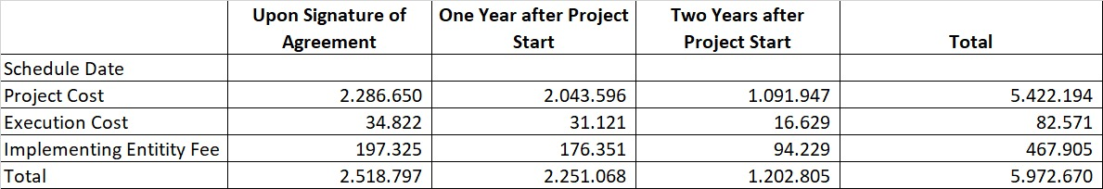

part iV: endorsement by government and certification by the Implementing Entity

- Record of endorsement on behalf of the government Provide the name and position of the government official and indicate date of endorsement. If this is a regional project/programme, list the endorsing officials all the participating countries. The endorsement letter(s) should be attached as an annex to the project/programme proposal. Please attach the endorsement letter(s) with this template; add as many participating governments if a regional project/programme:

Dr. Ruandha Agung Sugardiman  Director General for Control of Climate Change | Date: January, 17, 2020

B. Implementing Entity certification Provide the name and signature of the Implementing Entity Coordinator and the date of signature. Provide also the project/programme contact person’s name, telephone number and email address
I certify that this proposal has been prepared in accordance with guidelines provided by the Adaptation Fund Board, and prevailing National Development and Adaptation Plans (President Decree No. 16 year 2015; P.13/Menlhk/Setjen/OTL.0/1/2016; P.33/Menlhk/Setjen/Kum.1/3/2016; Indonesia Intended Nationally Determined Contribution/INDC; COP 21 Paris Agreement signed by Government of Indonesia; Book and Map of Information System of Vulnerability Index Data (SIDIK); Permen-KP No. 2 year 2013; Climate Change Adaptation National Action Plan) and subject to the approval by the Adaptation Fund Board, commit to implementing the project/programme in compliance with the Environmental and Social Policy of the Adaptation Fund and on the understanding that the Implementing Entity will be fully (legally and financially) responsible for the implementation of this project/programme.


Laode M. Syarif
Executive Director Kemitraan
Implementing Entity Coordinator
Date: 17th Jan 2020 | Tel. and email: +62-21-7279 9566;  Inda.Loekman@kemitraan.or.id
Project Contact Person: Dewi Rizki
Tel. and Email: +62-21-7279 9566; Dewi.Rizki@kemitraan.or.id

Akhmadi et.al., 2012, Impact of Climate Change on Households in the Indonesia CBMS Area, SMERU Research Institute
Bappenas, 2010, Indonesia Climate Change Sectoral Roadmap
Indonesia Central Bureau of Statistics, 2015
Akhmadi et.al., 2012
Secretariat of Republic of Indonesia Vice President, 2011, Presentation on Inventory on Poor Household in Coastal Area/Fishermen
Suhelmi, 2012, Assessment on the Vulnerability of Semarang Coastal Area to Sea Level Rise by Utilizing Composite Vulnerability Index
Kompas, 2014, Food Production is At Risk (online-reading)
Kompas, 2016, When Nature Responds to Human Greed (online-reading)
Pekalongan Bureau of Statistics, 2015
Pekalongan Bureau of Statistics, 2015
DKP, 2008 in Pekalongan City Government, 2011, Pekalongan City Risk Profile
DKP, 2008 in Pekalongan City Government, 2011, Pekalongan City Risk Profile
DKP, 2008 in Pekalongan City Government, 2011, Pekalongan City Risk Profile
Marfai et.al., 2013, Spatial Modelling of Coastal Flooding Inundation Based on Climate Scenario and Its Impact on Pekalongan Coastal Area
DKP, 2008 in Pekalongan City Government, 2011, Pekalongan City Risk Profile
Akhmadi et.al., 2012
Akhmadi et.al., 2012
Akhmadi et.al., 2012
Akhmadi et.al., 2012
Pekalongan Bureau of Statistics, 2015
Kasbullah&Marfai, 2014, Spatial Modelling of Coastal Flooding Inundation and Assessment on Potential Loss on Paddy Field Agricultural Land, Case Study: Coastal Area of Pekalongan District
Bintari, 2016, Loss and Damage – Climate Change Impact in Coastal Area of Pekalongan City
Marfai et.al., 2013, Spatial Modelling of Coastal Flooding Inundation Based on Climate Scenario and Its Impact on Pekalongan Coastal Area
Pekalongan Bureau of Statistics, 2014
Akhmadi et.al., 2012
BPS Kota Pekalongan 2018, Kota Pekalongan dalam Angka 2018
Hutchinson, Spalding and zu Ermgassen, 2014, The Role of Mangrove in Fisheries Enhancement
^{6.} Each Party shall designate and communicate to the secretariat the authority that will endorse on behalf of the national government the projects and programmes proposed by the implementing entities.

