Enhancing resilience of Coastal Communities of Samoa to Climate Change

Inception Workshop Report

Prepared by the Ministry of Natural Resources and Environment
February 2013

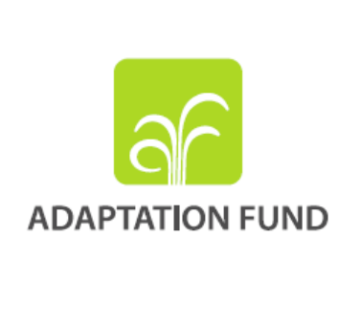


Contents
1 Introduction 2
1.1 Background 2
1.2 Objectives 3
2 Inception phase discussions and activities 3
3 Changes in project environment 4
4 The Inception Workshop 4
4.1 Project Linkages 6
4.2 Workplan for 2013 7
5 Strategic Result Framework 7
5.1 Implementation Arrangements: 8
5.2 Sector/Stakeholder Involvement: 9
5.3 Personnel 11
6 Risk Management 12
7 Conclusion and Recommendation 12
Annex 1: LPAC Meeting Minutes 13
Annex 2: Participants 17
Annex 3: 2013 Annual Workplan 18
Annex 4: Logical Framework 23

Figures
Figure 1: AF/PPCR Districts 3
Figure 2: Commencement 5
Figure 3: Meeting progress 5
Figure 4: Group Presentations 6

Introduction
This report identifies and documents mutual agreements reached on institutional arrangements amongst stakeholders and project approach, goals and objectives as well as project activities, as discussed in preparation for and at the Inception Workshop.

The Inception Workshop was conducted on the 28th January 2013 with the aim of gauging stakeholder perspective and input to project components and activities as identified in the Project Document.

The stakeholders invited included the Ministry of Finance (MoF), Ministry of Health (MOH), Ministry of Works Transport and Infrastructure (MWTI), Ministry of Women Communities and Social Development (MWCSD), Ministry of Agriculture and Fisheries (MAF), Chamber of Commerce (COC), Samoa Tourism Authority (STA), Samoa Water Authority (SWA), Land Transport Authority (LTA), Electric Power Corporation (EPC), and the Samoa Umbrella for Non Governmental Organizations (SUNGO). See Annex 2.

Background
The Adaptation Fund project is an initiative by the Government of Samoa through the Ministry of Natural Resources and Environment (MNRE) as executing agency, in partnership with the United Nations Development Programme (UNDP) as implementing entity.
This project is key to implementing the approved Coastal Infrastructure Management (CIM) Plans in a climate resilient way. Coastal management at a nationwide scale is the anticipated result of this program with a strong preference for ‘soft’ adaptation actions.

It is important to note the programmatic linkage this project has with the concurrently planned Coastal Resilience Investment Programme (CRIP) funded through the Pilot Programme for Climate Resilience (PPCR), funded by the World Bank. Both projects share similar objectives.

The 41 district CIM Plans of the country have been divided between the two projects. The identified districts to be covered upon completion of these two programmes are shown in Figure 1.

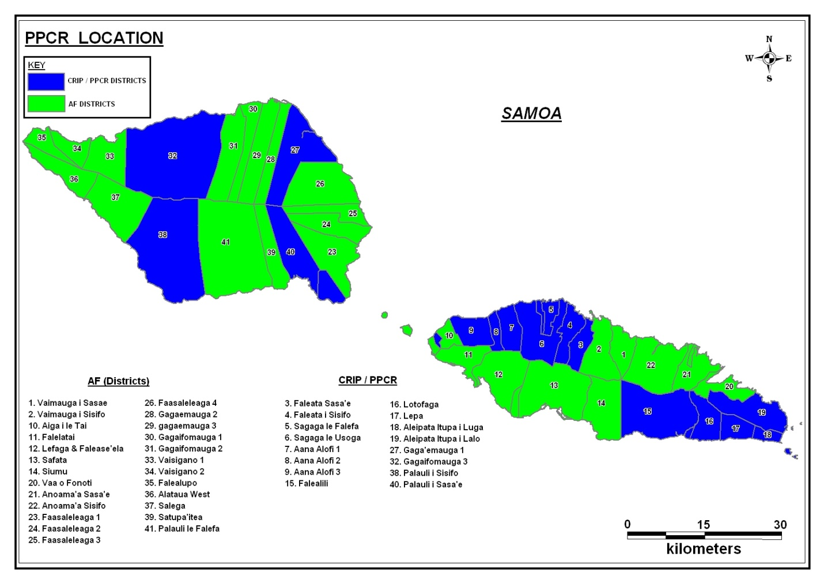
Figure 1: AF/PPCR Districts

Objectives
The primary objectives of this project are as follows;

Objective 1: Reduce vulnerability to the adverse impacts of climate change, including variability at local and national levels

Objective 2: Increase adaptive capacity to respond to the impacts of climate change, including variability at local and national levels

Inception phase discussions and activities
A Local Project Appraisal Committee (LPAC) meeting was held on 18 September 2012 with participation of MNRE, MoF and UNDP, and served as an overview and discussion of key project components, alignment with PPCR, underlying management arrangements and defining the 2012 Annual Work Plan (See LPAC meetingnotes in Annex 1)
Various exchanges and meetings have taken place between MNRE, MoF and World Bank in order to align programme processes and activities with the PPCR. To this effect, deliverables and context information of the AF-funded programme have been incorporated into a ToR aiming at establishing a project preparation and implementation plan for PPCR. This assignment also aims at establishing a method for the review process of the CIM Plans that can be followed jointly by the AF and PPCR programmes in the respective designated districts of the country.
The establishment of the Project Management Unit under the MNRE’s Planning and Urban Management AgencyStrategic Planning Section is scheduled to be completed by the end of the second quarter of 2013 with the recruitment of the Programme Coordinator and Programme Assistant (currently being advertised).

Changes in project environment
In December 2012 Cyclone Evan hit Samoa, causing an estimated value of total damage of ST$480million (or USD$210.7 million), including coastal assets and environment the AF-funded programme intends to address. The cyclone also interrupted usual government functions and delivery of development programmes and projects in general. The results of the Post-Disaster National Assessment and the Recovery Plan will be fully aligned with the programme implementation process.

The Inception Workshop
The project proposal was officially approved by the Adaptation Fund in December of 2011 with the agreement between the AF and UNDP being signed in February 2012. The project document which was the main focus of the Inception Workshop, was officially endorsed and signed between the Government of Samoa and UNDP in November 2012.

The Inception Workshop was conducted on Monday 28th January 2013. The purpose of this workshop was to provide an opportunity to review the approved Project Document and seek stakeholder contribution to the overall approach, components and activities that incorporates any new information.

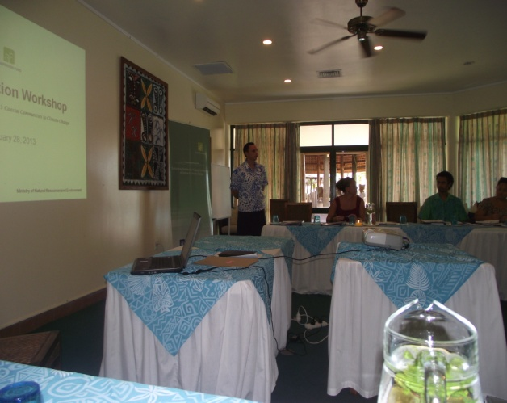
Figure 2: Commencement

The Inception Workshop started with welcome remarks delivered by the Assistant Chief Executive Officer (ACEO) of PUMA on behalf of the CEO and Minister.
A presentation on the overview of the project was delivered by Marta Moneo (UNDP) and ACEO-PUMA.
The discussions and suggestions put forward will be assessed and relevant matters incorporated into the Project Document.

As a result of the inception phase a Ministerial briefing will also be programmed for the Second Quarter of the project Workplan to demonstrate the high level commitment by MNRE.

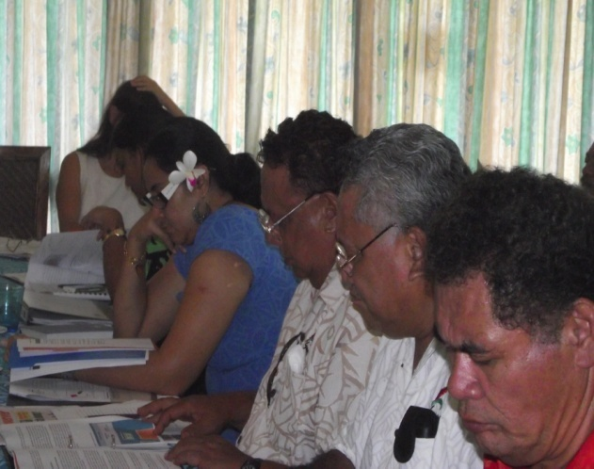
Figure 3: Meeting progress

The matters raised are highlighted under Section 5 of this report.

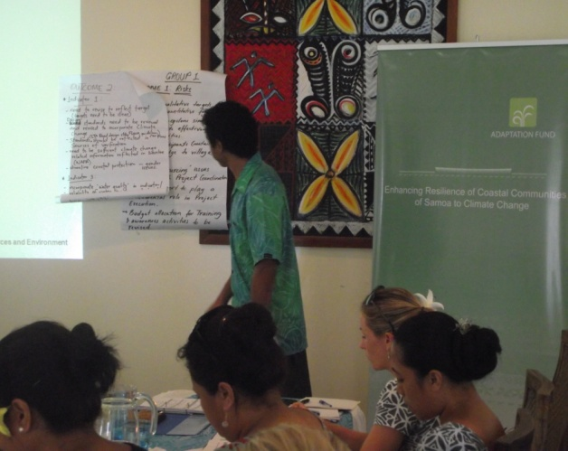
Figure 4: Group Presentations

Project Linkages
One of the key concerns raised during the Inception Workshop takes into account the alignment of the project activities for the AF programme with that of the PPCR. The concern lies with the approach taken by two different projects in trying to achieve similar objectives. However, the project team firmly reassured the participating group that the TOR’s for all contracted specialists in both projects will be carefully designed to reflect similar activities and scope of works for the two projects. In addition, the participation and support from MoF with regards to the alignment of the AF with the PPCR project has been an important aspect of the Inception Phase of the project.

Another identified key issue looks at the coordination of all implementing partners to ensure an efficient and coordinated approach during project implementation. It was recommended that a Memorandum of Understanding (MOU) be drafted for each of the partner agencies to avoid duplication of works and inefficient use of resources.In this regard, there will be a joint Project Management Unit set up for AF and PPCR under the PUMA Strategic Planning Section.

With respect to the approach taken by the project, it was recommended that a sector-wide approach be adopted. As recommended by Cabinet, this approach has been taken by most projects to ensure all relevant corporations, agencies, Ministries and organizations are taken account of.

Workplan for 2013
Key project activities that have been identified for the first few months of the project include the procurement of the Project Management Unit who will be tasked with project activity administration and coordination. However, due to the events of Cyclone Evan some major delays have been consequently adopted with these identified activities being pushed back. Other activities to be implemented during 2013 have been identified and itemized in the annual workplan for 2013as shown in Annex 3.

StrategicResultFramework
The majority of the stakeholder comment and feedback focused on the implementation approach and the identified activities.

The discussions also targeted the similarities between the AF programme and the PPCR projects and the potential for harmonization where appropriate.

The comments given for each of the three outputs are summarized below.
Outcome 1:
- Project team to ensure proper and coherent coordination of all Climate Change projects to ensure effectiveness of outcomes
- Logical framework to identify qualitative targets to complement identified quantitative figures
- Recommendation given to conduct pre-cyclone simulations to assess/evaluate effectiveness of awareness activities carried out within the villages/districts
- Highlight the importance of having training participants from Districts to disperse knowledge to all village members for increased awareness
- Highlight the importance of identifying ‘Resourcing” issues associated with Project Coordination prior to project commencement
- The project team to identify how political support plays a fundamental role in Project Execution
- Identified budget allocation for Training and Awareness activities to be revised as these will be extensive and costly if all identified districts are to be covered

Outcome 2:
- Some of the identified Indicators need to be revised in order to better reflect Targets
- Design standards within the Infrastructure Sector to incorporate Climate Change aspects and be in line with the CIM Plans
- Have sufficient Climate Change related information reflected in baseline information to support implementation
- Incorporate ‘water quality’ into identified targets/indicators
- Reliability of water supply to be ensured
- ‘Water quality’ to comply with MOH standards
- Identify gender issues associated with shoreline coastal protection

Outcome 3:
- Use existing government structures in channeling communications and networking
- Disaster Risk Reduction (DRR) Plans from DMO to align with targets identified in CIM Plans
- Identify more options to accommodate relocation plan
- Update hazard zones to reflect more recent conditions
- Improve collaboration with LTA and other utility providers in carrying our infrastructure works
- Water Sector Coordination group identified as the structure to be adopted by PMU to oversee all project activities and coordinate more effectively
- Revise the sources of verification for identified indicators
- Offer technical support for LTA to include Climate Change in activities
- Identify target for drainage improvement
- Include on-going research as an output
- Develop a tsunami risk zone using the 2009 event as a case study
- Draw in SUNGO involvement for coverage of NGOs
- Highlight the importance of awareness and the importance of the maintenance of infrastructure

The revised logical framework is attached as Annex 4.

Implementation Arrangements:
The following underlying implementation structure has been presented and discussed at the workshop:
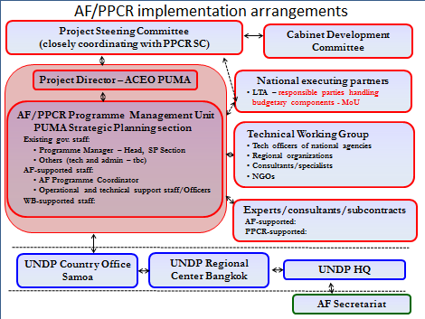
Figure 5: Implementation Arrangements

It was highlighted in the discussions the importance of all relevant stakeholders playing their part in the implementation of the identified project activities. Comments put forward regarding this part of the Project Document have been highlighted below.
- Draft MOUs between different Ministries/Corporations involved in project implementation
- Use a Sector-wide approach to address different stakeholder involvement
- Take into account two different forms of water supply: SWA and IWSA
- Take into consideration coverage of Environmental Impact Assessment (EIA) for infrastructure implementation
- Incorporate Gender issue resolutions

Sector/Stakeholder Involvement:
All stakeholders present were asked to identify each of the target outputs with which they were particularly involved with and to highlight some of their activities which were in line with the project activities identified in the project document. The response given is summarized as follows;
Disaster Management Office
- Identified relevance of the current DRR Survey conducted in Lalovaea as of relevance to the project
- DMO Hazard Zone mapping as a relevant component to be considered
- There are DRR Trainings conducted by DMO that could help greatly with creating awareness in communities
- A Coastal Area study is currently in the pipeline and is seen as relevant to project objectives and activities
- Currently reviewing the National DRR Management Plan
- DRR Plans in place at community level in association with MWCSD

Land Transport Authority
- The Capital Works Programme currently undertaken by LTA needs to be taken into account when identifying project activities to avoid duplication of works
- Improvement works on Eight (8) Access Roads (3 Upolu, 5 Savaii) to be reflected in identifying project activities
- Cyclone Packages incorporated into all works tendered to ensure consideration is given to possible impacts of natural disasters
- Continuing drainage improvement works seen as relevant to identified project activities

Ministry of Health
- Incorporated Adaptation Resilience measures to all trainings and awareness activities conducted by the Ministry
- Recommended that social services be incorporated in the relocation plans
- The Ministry currently has a GIS system in place for diseases
- There has been greater attention given to environmental health and sanitation and water quality standards within the Ministry
- They are currently looking into revising health procedures
- There have been continuous technical trainings for conducted within the Ministry for their resilience team

Chamber of Commerce
- Currently involvement in PPCR committee identifies them as a committee member in the AF Steering Committee
- Recommendation was given on the involvement of COC in community/business consultations
- Their involvement can be used to draw in micro-businesses to the project
- Sees the importance of taking into consideration the water supply for businesses
- Identified the importance of using lessons learnt to build on for improvement in future projects

Meteorology Services
- Met Office mainly identified their involvement and role in awareness raising (Outcome 1)
- Identified their role in developing hazard zone maps and having the capacity to conduct trainings regarding these hazard zones
- Met Office to offer information on tide fluctuation maps and storm predictions to assist with project activities and awareness raising

Samoa Water Authority
- Identified relocation as being a challenge in terms of finding water inland
- Issues associated with growing population in some areas has been a major concerns in trying to accommodate for water supply
- Changes in land use has been one of the factors affecting water supply in some areas
- Many plans already in place within many government Ministries/Corporations have taken a sectoral approach and this project should also adopt the same approach

Ministry of Natural Resources and Environment
- Land Management Division to be directly involved in terms of compensation
- The task of Surveying of land parcels and all related project activities to be the responsibility of the LMD
- LMD should be the focal point for mapping of utilities and other infrastructure
- Concern raised in terms of the social aspects of the project and food security not been included/highlighted in project outputs and targets
- Sector adaptation strategies are important to be taken into account

Personnel
Apart from the Programme Coordinator and Assistant being recruited, the following additional project support needs have been identified as:
- Communications Specialist
- GIS Specialist
- Civil Engineer technical adviser
- Contract Manager for CIM Plan implementation
- Coastal Management specialist

Detailed terms of reference will be prepared subsequently.

Risk Management
The Project Risks and mitigation Measures matrix was not discussed at the Inception workshop. The risks and mitigation measures already identified within the Project Document are seen as relevant and have therefore remained unaltered.

Conclusion and Recommendation
The Inception workshop was a success with comments and recommendations given being incorporated into the Project Document to ensure better coordination and implementation of project activities.
It is recommended that both the Executing Entity and the Implementing Agency work closely together to ensure that identified project activities are executed at a timely manner to avoid delay.

Annex 1: LPAC Meeting Minutes
Preliminary LPAC meeting for the Samoa Adaptation Fund Project
18 September 2012, UNDP Situation Room at 10.00am

Initial note
The Local Project Appraisal Committee (LPAC) meeting is the leading step to the signature of the project Document and outlines recommendations for the project set up.
The signature of the Project Document, therefore, implies the acceptance and commitment to comply with the recommendations captured in these notes.

- Introduction

The Adaptation Fund (AF) full project entitled “Enhancing resilience of coastal communities of Samoa to Climate Change” was approved in March 2012 by the Adaptation Fund Board with a total budget of US$ 8,048,250.
The objective of this programme is to strengthen the ability of Samoan communities and the public service to make informed decisions and manage climate change driven pressures in a pro-active, integrated and strategic manner.
UNDP called for a Local Project Appraisal Committee (LPAC) meeting on the 18th of September with the following objectives:
- gather key stakeholders in order to confirm on key elements of the project strategy and underlying management arrangements
- Review the objective and contents of the Project Document to enable signature by all relevant partners
- Define options for coordination with the World Bank PPCR initiative

After the signature of the project Document, the inception workshop will allow for a broader stakeholder participation, and more in-depth discussions to revise as needed the Strategic Results Framework, Budget items and Workplan, the Multi-Year activity schedule, institutional and management arrangements, and make any relevantrevisions to the Annual Work Plan.
- Meeting Participants
The meeting participants for the Preliminary LPAC meeting consisted of the following;
- Ms Nileema Noble – Chair Person/ UNDP RR
- Mr Jude Kohlhase – ACEO PUMA/MNRE
- Ms. Litara Tauleaalo – PPCR Coordinator/ MoF
- Ms Jean Viliamu – MoF
- Mr Gabor Vereczi – RTA, UNDP
- Yvette Kerslake – PO, UNDP

- Discussions and Agreed Outcomes
3.1) Briefing from stakeholders on update and progress of the AF and PPCR projects.
The key components of the AF project were highlighted by PUMA. They noted the delayed state and the need to move the project forward. The focus for the next quarter would be the set up and recruitment of the project management unit and office equipment. This would be followed by reviews and revisions of the CIM plans and the project activities in 2013 that would be implemented parallel to the PPCR. In November 2012, a consultancy would start to define a concise methodology for the revision of CIM plans under PPCR and this method would also be applied for the Adaptation Fund project in all districts of the country. The government would implement CIM plans as a component of the AF. Other components of the project deal with institutional strengthening, the EIA process and the implementation of adaptation options on the ground. The bulk of project funds imply implementation of activities on the ground for 25 districts. The 8 million USD fund would not be sufficient to implement all actions identified in the CIM Plans, and hence sites and actions would need to be prioritized in the respective districts. The PPCR and AF projects would be implemented in a whole-of-country approach, the methodology and technical aspects would need to be harmonized. The project management set up would also need to be aligned between PPCR and the Adaptation Fund Project.
Key outcomes and follow up action for 3.1
- The 4th quarter activities for the AF would be for PMU set up.
- A concise methodology for CIM plan revision under PPCR and framework could be replicated for AF and share benefits.
- Need to align the PPCR and AF projects.

3.2 Alignment of AF and PPCR project set up.
The PPCR and the AF Project are mirror images. The first phase of the PPCR focuses on strengthening and creating an enabling environment to implement the PPCR. At the time of the LPAC, MoF was undertaking a situation analysis similar to the CPEIR but with additional components added by the World Bank. This process would result on a final report in November 2012. The design of a trust fund and a mainstreaming exercise should be completed by November 2012.
The assessment of mainstreaming activities at the national and sectoral level and for key ministries for phase one of the PPCR was being implemented and for phase two it would include the selection of teams for the revision and implementation of CIM plans. For the PPCR, the reporting mechanism is the full responsibility of the PUMA staff, this would be run as an operational activity and align with the Adaptation fund but an overall project manager would still need to be recruited under the AF.

Further discussions at the UNDP RR and MNRE and MoF CEO level would be needed regarding the alignment of the PPCR and AF projects, especially in the functions of the National Steering Committee. The PPCR project activities would be exactly the same for AF at a national level and there would be a joint PMU set up under the PUMA Strategic Planning Division, where AF and PPCR support teams would be working closely together.
On the issue of coordination, it was also important for UNDP to respond to the explicit request from the Government of Samoa to adopt a sector wide approach to programme management. This request was sent to UNDP from the Ministry of Finance with the objective of maximizing the coordination with ongoing initiatives.
UNDP is currently not a member of the PPCR board. It is only represented in the AF board. The different options for project steering committee arrangements to align PPCR and AF implementation would need to be discussed. The existence of two different steering committees does not respond to the government’s sector wide and programmatic approach.
The situation analysis and capacity building review for sectors and community awareness were being implemented. The implementation of the PPCR CIM plans was delayed due to procurement processes. The PPCR would design the methodology for the review of the CIM plans which would also be applied for the AF project. A feedback advisory approach would be implemented in order to reflect the communities’ expectations from the project. A formal planning process would be put in place together with a regulatory framework to support the scale-up process for the CIM plans.
There was a need for the AF programme to take advantage of preparatory work already done under the PPCR and the need to address the barriers e.g. institutional strengthening and how to align existing mechanisms for the PPCR and AF.
For PPCR and AF project alignment, the review of the CIM plans should also include the Land Transport Authority (LTA) for climate proofing of road infrastructure. This integration would require the participation of the CEO for LTA. The AF project has a specific output on road CC proofing where LTA role is specified, and this would also need to be aligned with PPCR Investment Project 1 (airport road) in terms of methods and processes.

Key outcomes and follow up action for 3.2
- Discussions to take place at the CEO level for alignment of PPCR and AF implementation mechanism and processes.
- Definition of options for alignment of project steering boards for PPCR and AF.

3.4 Annual Work Plan
After the Project Document signature, the Annual Work Plan AWP 2012 would be finalized including the activities identified in the project document for project set up and recruitment. During the inception workshop the Multi Year Work Plan and project document would be discussed and finalized. The design of the PMU would need to support institutional strengthening and sustainability of project personnel after the end of the project.
Key outcomes and follow up action for 3.4
- UNDP to share and prepare draft ToR for Project Coordinator and Assistant. MNRE-PUMA to initiate recruitment process aiming at having PMU key staff on-board for the Inception Workshop.

3.5 Inception Workshop
The tentative date for the inception workshop would be the last week of October 2012 aligned with a PPCR WB mission (info from MoF). The operational and management issues and details would be expected to be discussed in the inception workshop.
The AWP for PPCR and AF would need to be aligned and operational efficiencies determined in the context of “combined” resources. The inception phase discussions (including the workshop) would serve to incorporate any needed changes in the project strategy (at output and activity level), results framework, institutional and M&E arrangements, links with related initiatives, definition of multi-year and annual work plans etc.
Key Outcomes and Follow Up action for 3.5
- Inception workshop would take place in October 2012 to coincide with the World Bank/PPCR mission. It would include discussions on operational and management issues and details of PPCR and AF projects. The main output of the Inception workshop would be the revision of prodoc elements.
- The AWP for PPCR to be shared with UNDP for implementation and approval of AF activities.

The meeting closed at 12.15pm

Signed by LPAC Chair: 25th September 2012

Nileema Noble
UN Resident Representative MCO
Cook Islands, Niue, Samoa & Tokelau

Annex 2: Participants
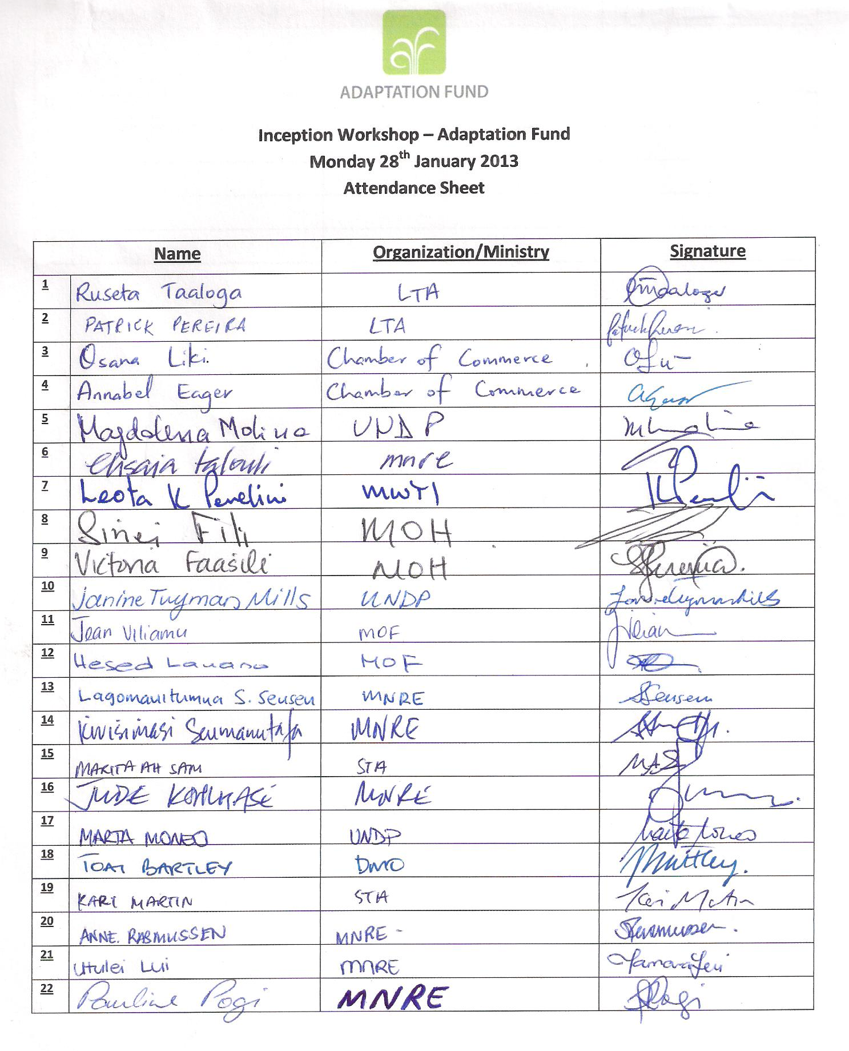

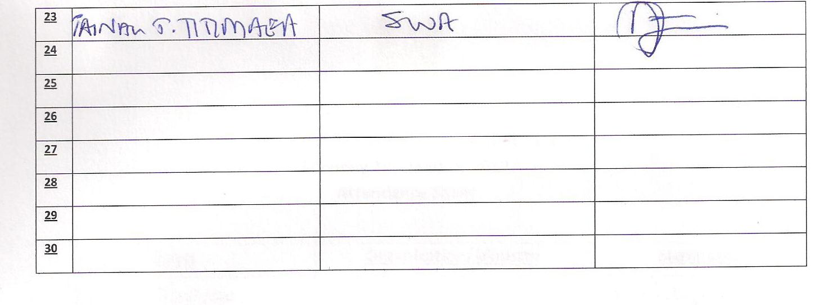

Annex 3: 2013 Annual Workplan
Enhancing resilience of Coastal Communities of Samoa to Climate Change |  |  |  |  |  |  |  |  |  |  |  |  |  |  | Year 2013 |  | Exch. Rate:2.5
Expected Outputs | Planned Activities | Timeframe |  |  |  |  |  |  |  |  |  |  |  | Responsible Party | Planned Budget
Expected Outputs | Planned Activities | 2013 |  |  |  |  |  |  |  |  |  |  |  | Responsible Party | Sources of funds | Budget Descripton | Amount (USD)
Expected Outputs | Planned Activities | Q1 |  |  | Q2 |  |  | Q3 |  |  | Q4
Expected Outputs | Planned Activities | J | F | M | A | M | J | J | A | S | O | N | D | Responsible Party | Sources of funds | Budget Descripton | 2013
Outcome 1: Strengthened awareness and ownership of coastal adaptation and climate risk reduction processes at community and national levels in 25 districts and 139 villages
Output 1.1 | Conduct Introductory workshop with the 25 districts representatives(Sui o Nuu) on the review CIM Plans |  |  |  |  |  |  |  |  |  |  |  |  |  |  | Venue Hire and others | 5,000.00
Output 1.2 | Prepare selection criteria for target relocation villages |  |  |  |  |  |  |  |  |  |  |  |  | PM
Output 1.2 | Hold workshop with MWCSD and Sui o le Nuu to identify eligible villages |  |  |  |  |  |  |  |  |  |  |  |  |  |  | Hire facilities (venue & others) | 5,000.00
Output 1.2 | Consultation preparation for Group 1 (5 villages) |  |  |  |  |  |  |  |  |  |  |  |  |  |  | Training Workshop & Conference | 5,000.00
Output 1.2 | Identify 5 districts and develop Village Hazard Zone Relocation Plans |  |  |  |  |  |  |  |  |  |  |  |  |  |  |  | 5,000.00
Output 1.3 | Develop training materials and translate |  |  |  |  |  |  |  |  |  |  |  |  |  |  | Training Workshop & Conference | 5,000.00
Output 1.3 | Hold initial assessment workshop with Sui o Nuu |  |  |  |  |  |  |  |  |  |  |  |  |  |  |  | 8,000.00
Output 1.3 | Review CIM Plans for eight (8) identified disctricts |  |  |  |  |  |  |  |  |  |  |  |  |  |  |  | 10,000.00
Outcome 2: Increased adaptive capacity of coastal communities to adapt to coastal hazards and risks induced by climate change in 25 Districts and 139 villages
Output 2.1 | Technical Assessment of all Coastal Infrastructure |  |  |  |  |  |  |  |  |  |  |  |  |  |  |  | 2,500.00
Output 2.1 | Review CIM Plan database to specify roading projects |  |  |  |  |  |  |  |  |  |  |  |  | NPM/PT
Output 2.1 | Prepare TOR for Design Consultant and carry out procurement |  |  |  |  |  |  |  |  |  |  |  |  |  |  |  | 2,500.00
Output 2.1 | Prepare site specific designs and cost estimates for selected projects
Output 2.1 | Carry out fieldvisits to identified sites (5 villages) |  |  |  |  |  |  |  |  |  |  |  |  | NPM |  |  | 2,000.00
Output 2.1 | Implementation of revised CIM Plans in ten (10) villages |  |  |  |  |  |  |  |  |  |  |  |  |  |  |  | 80,000.00
Output 2.2 | Review CIM Plan project database to specify shoreline protection projects
Output 2.2 | Prepare TOR for Design Consultant and carry out procurement |  |  |  |  |  |  |  |  |  |  |  |  |  |  |  | 5,000.00
Output 2.2 | Carry out fieldvisits to identified sites (5 villages) |  |  |  |  |  |  |  |  |  |  |  |  |  |  |  | 2,000.00
Output 2.2 | Preparation of site specific designs and cost estimates for selected projects
Output 2.2 | Implementation of shoreline protection measures identified in revised CIM Plans for ten (10) identified villages |  |  |  |  |  |  |  |  |  |  |  |  |  |  |  | 80,000.00
Output 2.3 | Review CIM Plan project database to specify water supply enhancement projects
Output 2.3 | Procure Design Consultant |  |  |  |  |  |  |  |  |  |  |  |  |  |  |  | 30,000.00
Output 2.3 | Carry out fieldvisits to identified sites (3 villages) |  |  |  |  |  |  |  |  |  |  |  |  |  |  |  | 1,500.00
Output 2.3 | * Prepare site specific designs and cost estimates for selected projects
Output 2.3 | Implementation of identified water supply enhancement projects for three (3) identified villages |  |  |  |  |  |  |  |  |  |  |  |  |  |  |  | 30,000.00
Output 2.4 | Initial assesment to specify water supply enhancement projects |  |  |  |  |  |  |  |  |  |  |  |  |  |  |  | 2,000.00
Output 2.4 | Procure Project Design |  |  |  |  |  |  |  |  |  |  |  |  |  |  |  | 1,500.00
Output 2.4 | Undertake field visits to selected sites (3 villages) |  |  |  |  |  |  |  |  |  |  |  |  |  |  |  | 1,000.00
Output 2.4 | Impelementation of flood protection measures identified in revised CIM Plans for three (3) identified villages |  |  |  |  |  |  |  |  |  |  |  |  |  |  |  | 30,000.00
Outcome 3: Strengthened institutional capacity of government sectors to integrate climate and siaster risk and resilience into coastal management related policy frameworks, processes and responses
Output 3.1 | Assess and review current organisation and structures
Output 3.1 | Develop revised arrangements and suggested method of implementation
Output 3.2 | Preparation of draft village relocation handbook |  |  |  |  |  |  |  |  |  |  |  |  |  |  |  | 2,000.00
Output 3.2 | Preparations for consultations with key stakeholders to develop Handbook |  |  |  |  |  |  |  |  |  |  |  |  |  |  |  | 5,000.00
Output 3.3 | Assess and review Contracts and procurement procedures
Output 3.4 | Conduct introductory workshop and training needs analysis of the relevant Ministries and Authorities |  |  |  |  |  |  |  |  |  |  |  |  |  |  |  | 3,000.00
Output 3.4 | Conduct training workshops for community awareness |  |  |  |  |  |  |  |  |  |  |  |  |  |  |  | 5,000.00
Output 3.5 | Initiate development of communication strategy and plan and procure Marketing and Communications Personnel |  |  |  |  |  |  |  |  |  |  |  |  |  |  |  | 25,000.00
Output 3.5 | Set up project website and procure webmaster |  |  |  |  |  |  |  |  |  |  |  |  |  |  |  | 20,000.00
Output 3.5 | Prepare and publish programme communications |  |  |  |  |  |  |  |  |  |  |  |  |  |  |  | 15,000.00
Output 3.5 | Prepare awareness materials for the National Environment Week |  |  |  |  |  |  |  |  |  |  |  |  |  |  | Printing and Resource materials | 4,000.00
Outcome 4: Project Execution
Output 4.1 | Set up project management unit within the MNRE/PUMA |  |  |  |  |  |  |  |  |  |  |  |  | PD
Output 4.1 | Recruit Project Management Unit Personnel |  |  |  |  |  |  |  |  |  |  |  |  | PD |  |  | 15,000.00
Output 4.1 | * Technical Advisor (??) |  |  |  |  |  |  |  |  |  |  |  |  |  |  |  | 50,000.00
Output 4.1 | * National Project Manager |  |  |  |  |  |  |  |  |  |  |  |  |  | 71400 |  | 40,500.00
Output 4.1 | * Administrative Assistant |  |  |  |  |  |  |  |  |  |  |  |  |  | 71400 |  | 26,250.00
Output 4.1 | * Technical Planners |  |  |  |  |  |  |  |  |  |  |  |  |  | 71400
Output 4.1 | * Works Supervisor |  |  |  |  |  |  |  |  |  |  |  |  |  | 71400
Output 4.1 | * Procurement Engineer
Output 4.1 | Procure office equipment: |  |  |  |  |  |  |  |  |  |  |  |  | PT |  | Maint. of equipment
Output 4.1 | * 1 heavy duty photocopier machine |  |  |  |  |  |  |  |  |  |  |  |  |  |  | Maint. of equipment | 20,000.00
Output 4.1 | * project vehicle |  |  |  |  |  |  |  |  |  |  |  |  |  |  | Maint. of equipment | 40,000.00
Output 4.1 | * Professional Digital Camera |  |  |  |  |  |  |  |  |  |  |  |  |  |  | Maint. of equipment | 2,000.00
Output 4.1 | * Notebook Computer |  |  |  |  |  |  |  |  |  |  |  |  |  |  | Maint. of equipment | 800.00
Output 4.1 | * Graphics Software |  |  |  |  |  |  |  |  |  |  |  |  |  |  | Maint. of equipment | 45,000.00
Output 4.1 | * 2 laptop computers |  |  |  |  |  |  |  |  |  |  |  |  |  |  | Maint. of equipment | 3,000.00
Output 4.1 | Maintenance of project unit |  |  |  |  |  |  |  |  |  |  |  |  |  |  | Stationery | 10,000.00
Output 4.1 | PB reports to the PUM Board as needed |  |  |  |  |  |  |  |  |  |  |  |  | PB
Output 4.1 | Monthly meeting with UNDP |  |  |  |  |  |  |  |  |  |  |  |  | PD & UNDP |  |  | 2,500.00
Output 4.1 | Timely and quality response & support is provided by UNDP to IA as necessary |  |  |  |  |  |  |  |  |  |  |  |  | UNDP
 | Total |  |  |  |  |  |  |  |  |  |  |  |  |  |  |  | 647,050.00

Annex 4: Logical Framework
 | Indicator | Baseline | Targets | Source of verification | Risks and Assumptions
Objective  Strengthened ability of coastal communities to make informed decisions about climate-change induced hazards and undertake concrete adaptation actions | Number of risk-exposed coastal communities protected through coastal adaptation measures based on climate-sensitive Coastal Infrastructure Management Plans (CIMP) | In the lack of systematic implementation of CIM Plans, the target villages and districts are highly exposed to climate-induced hazards | By the end of the programme 139 villages in 25 districts are protected from climate-induced risks as a result of coastal adaptation measures implemented guided by revised CIM Plans | Project progress reports  Technical reports  Mid-term and Final Evaluations | Linkages between national institutional coordination and local development processes facilitate the timely review of CIM Plans and the implementation of community-level coastal adaptation measures
Outcome 1  Strengthened awareness and ownership of coastal adaptation and climate risk reduction processes at community and national levels in 25 Districts and 139 villages through gender-sensitive processes | No. of Districts covered by reviewed and updated CIM Plans with climate change risks fully integrated | The 6 CIM Plans prepared under IAMP1 have no DRM component.  The 19 CIM Plans prepared under SIAM2 require review. | By the end of year one at least 8, year two 18 and by the completion of the programme at least 25 districts will have their CIM Plans reviewed and updated with climate change risks fully integrated, through balanced involvement of man, women and youth population | Project progress reports.  Annual workplans | Political stability is maintained  Strong coordination amongst climate change stakeholders in the country  Strong community leadership, cooperation and support for project activities.  Resourcing issues identified and addressed prior to project commencement.
 | No. of Districts with village hazard zone relocation plans competed | There are currently no village relocation plans available to guide relocation activities for households to move out from coastal hazard zones. | By the end of year one 5, year two 10 and by the completion of the programme at least 15 districts will have at least one village hazard zone relocation plan completed through balanced involvement of man, women and youth population.  Trainees to disperse this knowledge to wider community for greater awareness | Project progress reports.  Annual workplans
 | No. of community representatives trained on coastal risk assessment and adaptation and numbers of individuals engaged in those sessions | Currently there has been no training for village leaders in coastal adaptation and climate risk reduction processes including village relocation planning. | By the end of the project at least 300 village representatives (including matais, women and youth groups) trained (year 1- 50, year 2- 100, year 3-200), involving traditional leaders, women and youth group representatives | Sui o le Nuu training session minutes and attendance registers

Outcome 2  Increased adaptive capacity of coastal communities to adapt to coastal hazards and risks induced by climate change in 25 Districts and 139 villages | Km of coastal roads and related infrastructure improved to withstand climate change and variability-induced stress | There has been road reconstructions and upgrading undertaken in response to past hazards, such as the 2009 tsunami, but without integrating systematically climate change related risks in the process | By the end of the programme at least 80km of coastal roads and related infrastructure is improved to withstand climate change and variability-induced stress | Project progress reports.  Annual workplans | Low staff turnover resulting in sustained capacity of government and partner institutions.  Communities are willing and committed to actively participate in the project  No political interference in selection of districts and village works sites  Design standards within the Infrastructure Sector to be incorporate Climate Change aspects.
 | Km of coastline with climate resilient shoreline and flood protection measures introduced, including vegetation planting along the coast and riparian streams and beach replenishment | There are only a few villages, where shoreline adaptation measures have been introduced through the PACC and CBDAMPIC projects, but only in a pilot fashion | By the completion of the programme climate resilient shoreline and flood protection measures are introduced in at least 140km coastline and riparian streams, including vegetation planting in at least 60 km coast and 50 km of riparian streams, and beach replenishment techniques applied in at least 2 sites and 10 Km coastline | Project progress reports.  Annual workplans
 | N. of population and communities accessing improved water sector services and infrastructure to manage impacts on water supply induced by climate change and variability | The target villages lack robust water supply system to withstand climate-induced impacts in water supply | By the end of the programme at least 9,000 inhabitants in 15 villages have their water supply and associated infrastructure improved to manage climate-induced impacts on water supply | Project progress reports.  Annual workplans
 | Perception of coastal communities on changes in climate-induced risks as a result of interventions | Baseline to be set at the beginning of the project | By the end of the project at least 80% of the coastal communities involved perceive risk reduction to climate-induced hazards | Community consultations and surveys
 | Water quality and water supply improved and in compliance with the Ministry of Health standards. | Baseline to be set at the beginning of the project | By the end of the programme, all villages will have access to clean treated water. | Project progress reports

Outcome 3  Strengthened institutional capacity of government sectors to integrate climate and disaster risk and resilience into coastal management-related policy frameworks, processes and responses | Revised national organization and institutional structures to implement CIM Plans | There is currently no organization specifically identified to co-ordinate the implementation of CIM Plan recommended works at the village and district level. | A revised CIM Plan management institutional structure is set up by end of year one of the project | Project progress reports.  Annual workplans | Government and NGOs provide on-going funding support to units responsible for information management and dissemination  Strong strategic leadership and management within government and NGO agencies and national institutions.  Senior officials and technical officers have the time to commit to planning and training activities.  Government senior officials committed to incorporating climate change considerations in annual and strategic plans and budgeting processes
 | A blueprint established and tested for Village relocation processes | There are currently no guidelines or procedures in place as to how to undertake village relocations in Samoa. | A completed and operationally tested village relocation handbook is developed by the end of the project to guide future relocation planning exercises | Village relocation handbook completed and approved by the PSC by the end of the programme.
 | Improved regulatory procedures for physical works implementation with climate change and disaster risk considerations incorporated. | Current regulatory procedures for physical works are incomplete and do not have consistent references to either climate change or disaster risk considerations. | Revised regulatory procedures for CIM Plan works is prepared by the end of year 3 of the programme | Programme progress report
 | Number of policy makers and technical officers trained on climate risk assessment and planning processes for coastal adaptation. | Policymakers and technical officers have low to moderate levels of understanding of climate risk assessment and planning processes for coastal adaptation. | By the end of the programme at least 100 policymakers and technical officers exhibit improved levels of understanding of climate risk assessment and planning processes for coastal adaptation. | Records of training events and registers of attendees.  Training notes prepared and delivered.
 | Capitalize on existing natural waterways for drainage improvement | Improved drainage and reduced flooding by the end of programme. | Programme progress report | Improved drainage infrastructure
 | Number of knowledge management products and South-South exchange events carried out | Absence of a communication strategy and lack of information management system to support adaptation of coastal villages and districts to climate change risks. | By the end of the programme a communication strategy is developed and information and lessons learnt are compiled and disseminated to local, regional and international stakeholders through at least 4 different mediums  By the end of Year 1 the project web site is operational and not fewer than 5 project communications have been published.  By the end of Year 2 not fewer than 10 further project communications have been published | Web-sites  Fact sheets  Radio programs  Television programs  Project Technical reports  Project monitoring and evaluation reports
 | Hazard Zone maps updated to include tsunami risk zone | Use existing data to identify/update existing maps and using 2009 tsunami event as case study for tsunami risk zone development | By the end of the programme all villages to have in place updated hazard zone maps to reflect existing conditions. | Programme progress report

