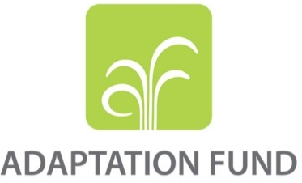

Project Completion Summary

In accordance with the project agreement, implementing entities are required to submit a project completion report within six (6) months after Project completion, and the final project progress report (PPR) is considered as a project completion report. While the PPRs meet technical requirements, the information is reported by year and its format is not ideal to convey the overall information and knowledge to wider and more general audiences. To supplement this, implementing entities are requested to prepare a project completion summary.
A project completion summary is intended to cover an entire project life in a reader friendly format by compiling submitted single-year PPRs. It also gives implementing entities an opportunity to express and share insights from project implementation, findings, challenges etc. which may not be presented by PPRs and captured by a final evaluation report.
A project completion summary consists of narrative information (Section A) and financial information (Section B). Any other information (Section C) can be added to the report as an option. Most of the contents can be filled in by copy-and-paste from the submitted PPRs. The completion report should be no more than 20 pages (excluding annexes).

Project Completion Summary
Section A: Project result and performance
- Basic information
Title of project/programme | Increasing the resilience of poor and vulnerable communities to climate change
Project/Programme category | Regular Size Project
Project period (if the project was granted an extension, include the original as well as the revised completion date) | 13-7-2016 to 13-7-2020 (4 Years), the revised completion date is 17-1-2026
Country(ies) | Jordan
Sector(s) | Multi-sector
Implementing entity name | Ministry of Planning and International Cooperation
Type of implementing entity (MIE, NIE or RIE) | NIE
Executing entity(ies) | Water Authority Jordan  Petra Development Tourism Region Authority (PDTRA)  National Center for Agricultural Research (NARC)  The Hashemite Fund for Development of Jordan Badia (HFDJB)  The Royal Scientific Society (RSS)  Ministry of Water And Irrigation (MWI)  Ministry of Environment
Amount of financing approved (USD) | US$ 9,226,000
Project contact(s) | Raed Badwan
Date of report | 18 January 2026

- Key milestones – Please refer to the overview tab in the latest PPR. For the delay in project implementation and related reasons refer to the lessons learned tab, section on “implementation and adaptive management”
Project inception | 13-7-2016
Mid-term review (if applicable) | October 2020
Project completion | 13-7-2020
Terminal evaluation | March 2026
If any, delay in implementation and reasons for delay | The project experienced implementation delays primarily due to the COVID-19 pandemic and regulatory and procurement-related constraints. Strict national procurement regulations and lengthy bidding procedures (often exceeding 60 days per cycle) contributed to slow progress. In addition, significant fluctuations in material prices (e.g., energy and iron) required re-bidding processes in several instances, further extending timelines.  As a result, a total of six separate no-cost extension requests were submitted by the Ministry of Planning and International Cooperation (MOPIC) and subsequently approved by the Adaptation Fund Board, as detailed below:  - Eighteen-month no-cost extension from 13 July 2020 to 13 January 2022 (Decision B.35.a-35.b/1), following MOPIC’s request for extension of the project completion date for “Increasing the resilience of poor and vulnerable communities to climate change.”  - Twelve-month no-cost extension from 13 January 2023 to 13 January 2024, approved in line with Decision B.35.b/16 on the Fund’s response to the COVID-19 pandemic, allowing temporary blanket extensions for projects affected by COVID-19.  - Six-month no-additional-cost extension from 13 January 2025 to 17 July 2025 (Decision AFB/B.43-44/9), following secretariat review and Board approval.  - Six-month no-cost extension from 17 July 2025 to 17 January 2026 (Decision B.44-45/12), as approved by the Board.  - 5–6. Two additional extension requests were submitted and approved during the project lifecycle in response to continued implementation constraints, including COVID-19 impacts and procurement-related delays, as reflected in official Board decisions and related correspondence.  Each extension was formally reviewed and approved in accordance with the Adaptation Fund’s Operational Policies and Guidelines and relevant Board decisions, ensuring continued alignment with project objectives while addressing unforeseen external challenges.

- Project overview and description
Jordan is experiencing severe water scarcity, a challenge expected to intensify as climate change increases aridity and reduces water availability. These pressures pose serious risks to food security, particularly as agriculture accounts for approximately 67% of total water withdrawals. Improving water efficiency in agriculture is therefore essential to enhancing climate resilience, safeguarding rural livelihoods, and sustaining food production.

The proposed programme aims to strengthen the adaptive capacity of Jordan’s agricultural sector to climate change–induced water stress through the introduction of affordable and innovative technologies, complemented by supportive policies and institutional measures. By reducing water losses and promoting the use of non-conventional water resources—such as treated wastewater reuse and rainwater harvesting—the programme will improve agricultural water productivity while easing pressure on limited freshwater resources. Farmers will also be encouraged to adopt higher-value crops and improve on-farm irrigation operation and maintenance practices.

The programme is structured around two complementary components and includes six interrelated projects. Component 1: Climate Change Adaptation of the Agricultural and Water Sectors through Technology Transfer focuses on implementing practical adaptation solutions in vulnerable and arid regions. It promotes efficient irrigation technologies, integrated water management approaches, and the reuse of treated wastewater and harvested rainwater to reduce groundwater abstraction, enhance irrigation efficiency, and support rural livelihoods.

Component 2: Capacity Building, Knowledge Dissemination, and Policy Mainstreaming strengthens climate change adaptation at both national and community levels through training, awareness raising, and participatory approaches to water and agricultural management. It supports the integration of climate change adaptation into policies and legislation, reduces health risks associated with irrigation practices, and contributes to improved food security, community resilience, and sustainable agribusiness development.

- Results and key outcomes (Alignment with the Adaptation Fund core impact indicators – Number of Direct Beneficiaries reached including women; Trainings conducted including women trained, Early Warning Systems (EWS); Assets Produced, Developed, Improved, or Strengthened; Natural Assets Protected or Rehabilitated i.e. hectares of natural habitats/ meters of coastlines)

Impact: Increased resiliency at the community, national and regional levels to climate variability and change
Core Indicator: No. of beneficiaries
 |  | * Total | * % of female beneficiaries | * % of Youth beneficiaries
Baseline information | Direct beneficiaries supported by the project | 3,692 | 26.00 | 34.00
Baseline information | Indirect beneficiaries supported by the project | 0 | 0 | 0
Baseline information | Total (direct + indirect beneficiaries) | 3,692 | 13.00 | 17.00
Target performance at completion | Direct beneficiaries supported by the project | 22,428 | 33.00 | 34.00
Target performance at completion | Indirect beneficiaries supported by the project | 50,000 | 33.00 | 34.00
Target performance at completion | Total (direct + indirect beneficiaries) | 72,428 | 33.00 | 34.00
Performance at mid-term | Direct beneficiaries supported by the project | Around 6000 (to be confirmed by final evaluation) | 33.00 | 34.00
Performance at mid-term | Indirect beneficiaries supported by the project | Around 12000 (to be confirmed by final evaluation) | 33.00 | 34.00
Performance at mid-term | Total (direct + indirect beneficiaries) | Around 18000 (to be confirmed by final evaluation) | 33.00 | 34.00
Performance at completion | Direct beneficiaries supported by the project | Around 14000 (to be confirmed by final evaluation) | 33.00 | 34.00
Performance at completion | Indirect beneficiaries supported by the project | Around 28000 (to be confirmed by final evaluation) | 33.00 | 34.00
Performance at completion | Total (direct + indirect beneficiaries) | Around 42000 (to be confirmed by final evaluation) | 33.00 | 34.00

Outcome 1: Reduced exposure to climate-related hazards and threats
Indicator 1: Relevant threat and hazard information generated and disseminated to stakeholders on a timely basis
 | Number of targeted stakeholders - Total | Number of targeted stakeholders - % of females targeted | Hazards information generated and disseminated | Overall effectiveness
Baseline information | 24 | 17.00 | Drought | Ineffective
Target performance at completion | 48 | 17.00 | Drought | Effective
Performance at mid-term | 32 | 17.00 | Drought | Moderately effective
Performance at completion | 32 | 17.00 | Drought | Effective

Output 1.1 Risk and vulnerability assessments conducted and updated
Indicator 1.1: No. of projects/programmes that conduct and update risk and vulnerability assessments
 | No. of projects/programmes that conduct and update risk and vulnerability assessments | Sector | Scale | Status
Baseline information | 0 | Multi-sector | National | No plans conducted or updated
Target performance at completion | 5 | Multi-sector | National | Risk and vulnerability assessments completed or updated
Performance at mid-term | 3 | Multi-sector | National | Undertaking or updating of assessments in progress
Performance at completion | 3 | Multi-sector | National | Undertaking or updating of assessments in progress

Output 1.2 Targeted population groups covered by adequate risk reduction systems
Core Indicator 1.2: No. of Early Warning Systems
 | No. of adopted Early Warning Systems | Category targeted | Hazard | Geographical coverage | Number of municipalities
Baseline information | 0 | Monitoring and warning service | Drought | National | 0
Target performance at completion | 3 | Monitoring and warning service | Drought | National | 16
Performance at mid-term | 1 | Monitoring and warning service | Drought | National | 16
Performance at completion | 1 | Monitoring and warning service | Drought | National | 16

Outcome 2: Strengthened institutional capacity to reduce risks associated with climate-induced socioeconomic and environmental losses
Indicator 2: Capacity of staff to respond to, and mitigate impacts of, climate-related events from targeted institutions increased
 | Number of staff targeted - Total | Number of staff targeted - % of female targeted | Sector | Capacity level
Baseline information | 0 | 0 | Agriculture | No Capacity
Target performance at completion | 150 | 20 | Agriculture | High Capacity
Performance at mid-term | 150 | 30 | Agriculture | Medium Capacity
Performance at completion | 150 | 30 | Agriculture | Medium Capacity

Output 2.1 Strengthened capacity of national and sub-national centres and networks to respond rapidly to extreme weather events
Indicator 2.1.1: No. of staff trained to respond to, and mitigate impacts of, climate-related events
 | Total staff trained | % of female staff trained | Type
Baseline information | 0 | 20 | Public
Target performance at completion | 150 | 20 | Public
Performance at mid-term | 120 | 25 | Public
Performance at completion | 150 | 30.00 | Public

Indicator 2.1.2: No. of targeted institutions with increased capacity to minimize exposure to climate variability risks
 | Type | Scale | Sector | Capacity Level
Baseline information | Public | National | Multi-sector | No Capacity
Target performance at completion | Public | National | Multi-sector | High Capacity
Performance at mid-term | Public | National | Multi-sector | Medium Capacity
Performance at completion | Public | National | Multi-sector | Medium Capacity

Output 2.2. Increased readiness and capacity of national and sub-national entities to directly access and program adaptation finance
Indicator 2.2.1: No. of targeted institutions benefitting from the direct access and enhanced direct access modality
 | Number of beneficiaries | Scale | Sector | Capacity Level
Baseline information | 0 | National | Multi-sector | No capacity
Target performance at completion | 5 | National | Multi-sector | High capacity
Performance at mid-term | 5 | National | Multi-sector | Medium capacity
Performance at completion | 5 | National | Multi-sector | Medium capacity

Outcome 3: Strengthened awareness and ownership of adaptation and climate risk reduction processes
Indicator 3.1: Increase in application of appropriate adaptation responses
 | Percentage of the targeted population applying adaptation measures | Sector
Baseline information | 0 | Multi-sector
Target performance at completion | 60 | Multi-sector
Performance at mid-term | 45 | Multi-sector
Performance at completion | 50 | Multi-sector

Output 3.1: Targeted population groups participating in adaptation and risk reduction awareness activities
Indicator 3.1.1: Percentage of targeted population awareness of predicted adverse impacts of climate change, and of appropriate responses
 | No. of targeted beneficiaries | % of female participants targeted | Level of awareness
Baseline information | 0 | 0 | Aware of neither
Target performance at completion | 3840 | 17 | Mostly aware
Performance at mid-term | 3200 | 17 | Partially aware
Performance at completion | 3400 | 17 | Mostly aware

Indicator 3.1.2: No. of news outlets in the local press and media that have covered the topic
 | No. of outlets in local press and media | Scale
Baseline information | 0 | Local
Target performance at completion | 10 | Local
Performance at mid-term | 30 | Local
Performance at completion | 30 | Local

Output 3.2: Strengthened capacity of national and subnational stakeholders and entities to capture and disseminate knowledge and learning
Indicator 3.2.1: No. of technical committees/associations formed to ensure transfer of knowledge
 | No. of technical committees/associations | % of women represented in committes/associations | Level of awareness
Baseline information | 0 | 20% to 39% | Aware of neither
Target performance at completion | 3 | 20% to 39% | Mostly aware
Performance at mid-term | 2 | 20% to 39% | Partially aware
Performance at completion | 3 | 40% to 60% | Mostly aware

Indicator 3.2.2: No. of tools and guidelines developed (thematic, sectoral, institutional) and shared with relevant stakeholders
 | No. of tools and guidelines | Type | Scale
Baseline information | 0 | Training manuals | National
Target performance at completion | 5 | Training manuals | National
Performance at mid-term | 3 | Training manuals | National
Performance at completion | 5 | Training manuals | National

Outcome 4: Increased adaptive capacity within relevant development sector services and infrastructure assets
Indicator 4.1: Increased responsiveness of development sector services to evolving needs from changing and variable climate
 | Project/programme sector | Geographical scale | Response level
Baseline information | Agriculture | Sub-National | Partially responsive (lacks most elements)
Target performance at completion | Agriculture | Sub-National | Mostly responsive (most defined elements)
Performance at mid-term | Agriculture | Sub-National | Moderately responsive (some defined elements)
Performance at completion | Agriculture | Sub-National | Mostly responsive (most defined elements)

Core Indicator 4.2: Assets produced, developed, improved or strengthened
 | Sector | Targeted asset | Changes in assets (quantitative or qualitative)
Baseline information | Water management | Physical asset (produced/improved/strengthened) | Not improved
Target performance at completion | Water management | Physical asset (produced/improved/strengthened | Mostly improved
Performance at mid-term | Water management | Physical asset (produced/improved/strengthened | Moderately improved
Performance at completion | Water management | Physical asset (produced/improved/strengthened | Mostly improved
Indicator 4.1.1: Vulnerable development sector services and infrastructure assets strengthened in response to climate change impacts, including variability
Indicator 4.1.1: No. and type of development sector services to respond to new conditions resulting from climate variability and change
 | Number of services | Type | Sector
Baseline information | 0 | Community | Water management
Target performance at completion | 3 | Community | Water management
Performance at mid-term | 2 | Community | Water management
Performance at completion | 3 | Community | Water management

Outcome 5: Increased ecosystem resilience in response to climate change and variability-induced stress
Indicator 5: Ecosystem services and natural resource assets maintained or improved under climate change and variability-induced stress
 | Natural resource improvement level | Sector | Type
Baseline information | Partially effective | Water Management | Water areas
Target performance at completion | Moderately effective | Water Management | Water areas
Performance at mid-term | Moderately effective | Water Management | Water areas
Performance at completion | Effective | Water Management | Water areas

Output 5: Vulnerable ecosystem services and natural resource assets strengthned in response to climate change impacts, including variability
Core Indicator 5.1: Natural Assets protected or rehabilitated
 | Natural asset or Ecosystem (type) | Total number of natural assets or ecosystems protected/rehabilitated | Unit | Effectiveness of protection/rehabilitation
Baseline information | Cultivated land/Agricultural land | 0 | Ha rehabilitated | Ineffective
Target performance at completion | Cultivated land/Agricultural land | 50 | Ha rehabilitated | Moderately effective
Performance at mid-term | Cultivated land/Agricultural land | 20 | Ha rehabilitated | Moderately effective
Performance at completion | Cultivated land/Agricultural land | 40 | Ha rehabilitated | Moderately effective

Outcome 6: Diversified and strengthened livelihoods and sources of income for vulnerable people in targeted areas
Indicator 6.1: Increase in households and communities having more secure access to livelihood assets
 | No. of targeted households | % of female headed households | Improvement level
Baseline information | 56 | 18 | No improvement
Target performance at completion | 1030 | 18 | High improvement
Performance at mid-term | 410 | 18 | Moderate improvement
Performance at completion | 750 | 18 | Moderate improvement

Indicator 6.2: Increase in targeted population's sustained climate-resilient alternative livelihoods
 | No. of targeted households | % of female headed households | % increase in income level vis-à-vis baseline | Alternate Source
Baseline information | 0 | 0 | From 0 to 0.5% | agriculture
Target performance at completion | 1030 | 15 | From 30% to 40% | agriculture
Performance at mid-term | 410 | 18 | From 10% to 20% | agriculture
Performance at completion | 750 | 18 | From 30% to 40% | agriculture

Output 6 Targeted individual and community livelihood strategies strengthened in relation to climate change impacts, including variability
Indicator 6.1.1: No. and type of adaptation assets created or strengthened in support of individual or community livelihood strategies
 | Number of Assets | Type of Assets | Sector | Adaptation strategy
Baseline information | 0 | Physical capital | Agriculture | Supporting livelihoods
Target performance at completion | 1008 | Physical capital | Agriculture | Supporting livelihoods
Performance at mid-term | 410 | Physical capital | Agriculture | Supporting livelihoods
Performance at completion | 750 | Physical capital | Agriculture | Supporting livelihoods

Core Indicator 6.1.2: Increased income, or avoided decrease in income
 | Number of households (total number in the project area) | Income source | Income level (USD)
Baseline information | 295 | Agriculture | 170
Target performance at completion | 1088 | Agriculture | 300
Performance at mid-term | 410 | Agriculture | 200
Performance at completion * | 750 | Agriculture | 245

Outcome 7: Improved policies and regulations that promote and enforce resilience measures
Indicator 7: Climate change priorities are integrated into national development strategy
 | Integration level
Baseline information | Some
Target performance at completion | Most
Performance at mid-term | Most
Performance at completion | Most

Output 7:Improved integration of climate-resilience strategies into country development plans
Indicator 7.1: No. of policies introduced or adjusted to address climate change risks
 | No. of Policies introduced or adjusted | Sector | Scale | Type
Baseline information | 0 | Multi-sector | National | Environmental policy
Target performance at completion | 3 | Multi-sector | National | Environmental policy
Performance at mid-term | 1 | Multi-sector | National | Environmental policy
Performance at completion | 1 | Multi-sector | National | Environmental policy

Indicator 7.2: No. of targeted development strategies with incorporated climate change priorities enforced
 | No. of Development strategies | Regulation | Effectiveness
Baseline information | 0 | Not enforced (No elements implemented) | Ineffective
Target performance at completion | 2 | Fully enforced (all elements implemented) | Effective
Performance at mid-term | 1 | Partially enforced (some elements implemented) | Moderately effective
Performance at completion | 1 | Partially enforced (some elements implemented) | Moderately effective

Outcome 8: support the development and diffusion of innovative adaptation practices, tools, and technologies
Indicator 8: Innovative adaptation practices are rolled out, scaled up, encouraged and/or accelerated at regional, national and/or subnational level
 | Sector of innovative practice | Geographic Scale | Type
Baseline information | Nature-based solutions | Sub National | Innovation replicated
Target performance at completion | Nature-based solutions | National | Innovation rolled out
Performance at mid-term | Nature-based solutions | Sub National | Innovation rolled out
Performance at completion | Nature-based solutions | National | Innovation rolled out

Output 8: Viable innovations are rolled out, scaled up, encourages and/or accelerated
Indicator 8.1: No. of innovative adaptation practices, tools and technologies accelerated, scaled-up and/or replicated
 | No. of innovative practices/ tools technologies | Sector | Status | Effectiveness
Baseline information | 0 | Water management | No innovative | Ineffective
Target performance at completion | 3 | Water management | Completed innovation | Effective
Performance at mid-term | 1 | Water management | Undertaking innovative practices | Moderately effective
Performance at completion | 1 | Water management | Undertaking innovative practices | Moderately effective

Indicator 8.2: No. of key findings on effective, efficient adaptation practices, products and technologies generated
 | No. of key findings generated | Type | Effectiveness
Baseline information | 0 | Innovative | ineffective
Target performance at completion | 5 | Innovative | Moderately effective
Performance at mid-term | 2 | Innovative practice | Moderately effective
Performance at completion | 5 | Innovative | Effective

Type of Indicator | Indicator | Baseline | Progress Since Inception | Target for Project End
Outcome | Quantity (m³) of supplementary water available for agriculture / number of families benefiting | Subproject 1.1: 1,022,000 m³  Subproject 1.2: 17 MCM  Subproject 1.3: 0  Subproject 1.4: 0 | Subproject 1.1: 1,317,200 m³/yr  Subproject 1.2: Project commissioned, using alternative water source  Subproject 1.3: 260,000 m³/yr  Subproject 1.4: 25,000 m³/yr | Subproject 1.1: 1,317,200 m³/yr  Subproject 1.2: 20,000,000 m³/yr  Subproject 1.3: 438,000 m³/yr  Subproject 1.4: 438,000 m³/yr
Outcome | Increased income / avoided decrease in income ($/household/month) | Subproject 1.1: 398 $  Subproject 1.2: 170 $  Subproject 1.3: 0  Subproject 1.4: 0 | Subproject 1.1:806$  Subproject 1.2: 330 $  Subproject 1.3: 300 $  Subproject 1.4: 300 | Subproject 1.1: 806 $  Subproject 1.2: 330 $  Subproject 1.3: 300 $  Subproject 1.4: 300 $
Outcome | Number of beneficiaries (average family size = 6; 2 females, 4 males) | Subproject 1.1: 40  Subproject 1.2: 16  Subproject 1.3: 0  Subproject 1.4: 0 | Subproject 1.1: 70 families  Subproject 1.2: 30 families  Subproject 1.3: more than 70 families  Subproject 1.4: 71 families | Subproject 1.1: 70 family  Subproject 1.2: 30 family  Subproject 1.3: 70 family  Subproject 1.4: 70 family
Outcome | Quantity (m³) of supplementary fresh water available for agriculture | 0 | Subproject 1.5: 302,000 m³/year | 300,000 m³/year
Outcome | Natural assets protected or rehabilitated | 0 | Subproject 1.6: 35 farms | 48 farms
Outcome | Increased income / avoided decrease in income per farm | 0 | Subproject 1.5: $1,500/farm/year  Subproject 1.6: $2,000/farm/year | Subproject 1.5: $2,000/farm/year  Subproject 1.6: $5,000/farm/year
Outcome | Number of beneficiaries participating in project activities | 0 | Subproject 1.5: 102 families  Subproject 1.6: 250 families | Subproject 1.5: 410 families (2,460 persons)Subproject 1.6: 380 families (2,280 persons)
Outcome | Number of targeted population groups aware of climate change risks | Subproject 2.1: 0 | Subproject 2.1: 21 WUA -189 Farmers (57% males,43 %females) | 48 WUAs – 3,840 persons (3187 Males, 653 Females)
Outcome | Number of registered farmers in Jordan Valley registered in the system database | Subproject 2.2: 16 WUAs, 26 farmer families | Subproject 2.2: 21 WUA -189 Farmers (57% males,43 %females) JV and Wadi Musa | 30 WUAs – 2,400 persons & 40 farmer families – 240 persons  1710
Outcome | Early warning systems installed | Subproject 2.2: 0 | 1 system | 3 system
Outcome | Number of new micro-enterprises created linked to agribusiness industries | Subproject 2.3: 0 | 200 New micro-enterprises | 300 New micro-enterprises
Outcome | Number of new direct & indirect jobs related to agribusiness in Jordan Valley | Subproject 2.3: 0 | 1,200 person | 19,800 (5,400 Females, 14,400 Males)

- Issues, challenges and mitigation measures (Environmental and social risks, gender considerations and other risks)
Environmental and social risks were proactively managed throughout implementation. For sub-project 1.1, an Environmental and Social Impact Assessment (ESIA) was conducted to address potential impacts related to installing treated wastewater–based drip irrigation systems in the sensitive Petra heritage area. The ESIA recommendations were integrated into project design, ensuring compliance with environmental and social safeguards and avoiding negative impacts.
Gender considerations were systematically integrated into programme implementation. Women are represented as focal points within executing entities, as well as in administrative, financial, and technical roles. Gender balance was ensured in decision-making structures, including equal representation in the Special Tendering Committee and the inclusion of female engineers in technical evaluation committees. Training activities targeted farmers and field workers, with a focus on health and safety, hygiene, gender integration, and social welfare. Lessons learned indicate that inclusive and gender-balanced participation enhances implementation quality, capacity building, and equitable access to project benefits.
Implementation faced delays due to institutional bureaucracy, re-tendering caused by weak technical specifications, insufficient early land-use assessments, cost escalation, and lengthy procurement procedures. To mitigate these challenges, the Project Management Unit maintained continuous coordination with implementing entities, revised technical and work plans, strengthened early environmental and site screening, and closely monitored progress to minimize delays. Adaptive management and strong institutional coordination were key to addressing risks and sustaining implementation progress.

- Lessons learned (Best practices, adaptive management, what worked during the implementation and what did not, what corrective actions were taken during implementation, what are the ways to improve the intervention)

Given the relatively long duration of the project and the diversity of activities implemented across different sites and institutional settings, the implementation process generated a wide range of lessons. These lessons relate not only to technical delivery, but also to environmental and social safeguards, gender inclusion, coordination with national institutions, procurement systems, and the importance of adaptive management in complex contexts. Reflecting on these experiences provides valuable insights for improving future interventions.
From an environmental and social safeguards perspective, one of the most important achievements was the early conduct of an Environmental and Social Impact Assessment (ESIA) for Sub-project 1.1. This proved particularly critical due to the sensitivity of the intervention area, especially its proximity to the Petra heritage site. The ESIA process helped identify potential environmental and cultural risks at an early stage and ensured that mitigation measures were embedded directly into the project design. This proactive approach prevented negative impacts in sensitive areas and strengthened compliance with both national regulations and donor requirements. The experience clearly demonstrated that safeguards are not merely procedural obligations; they are practical risk management tools. Where assessments are conducted early and their recommendations are genuinely integrated into technical plans, they significantly enhance project quality and sustainability. Conversely, had these assessments been delayed or overlooked, the project could have faced environmental risks, reputational damage, or costly redesigns. A key lesson is therefore the importance of conducting environmental and land-use screenings during the conceptual phase of all sub-projects, even those initially perceived as low risk.
In terms of gender and social inclusion, the project made tangible progress in ensuring that women were not only beneficiaries but also active contributors to implementation and decision-making. Women were engaged as focal points, committee members, and engineers, and targeted training sessions addressed health, safety, and gender-related considerations. Participatory planning processes were used to engage local communities in identifying priorities and shaping interventions. This approach strengthened ownership, increased transparency, and enhanced trust between implementing institutions and communities. However, the project also revealed that inclusion is not a one-time achievement; it requires continuous reinforcement. Balanced participation does not sustain itself automatically. Without deliberate follow-up, traditional power structures may reassert themselves. In response, the project ensured female representation in technical and decision-making committees and adopted facilitation techniques that encouraged equal participation during consultations. The main lesson is that gender-sensitive approaches must be embedded structurally within project governance and monitoring systems, with clear indicators and accountability mechanisms to sustain progress over time.
Regarding implementation and project management, strong coordination among national institutions emerged as a central success factor. Effective collaboration enhanced institutional ownership and increased the likelihood that project outcomes would be sustained beyond the funding period. Participatory planning at the local level further reinforced engagement and reduced resistance during implementation. At the same time, the project encountered operational challenges typical of large-scale, multi-stakeholder interventions. Bureaucratic procedures, slow procurement processes, re-tendering requirements, and weaknesses in initial technical specifications contributed to delays. Cost escalations and unforeseen site conditions required revisions to budgets and timelines. These challenges highlighted the importance of thorough feasibility assessments and clear technical documentation from the outset.
To address these issues, the Project Management Unit (PMU) adopted a proactive monitoring approach. Work plans were revised when necessary, technical specifications were strengthened, and early environmental and site screenings were reinforced to reduce uncertainty. Continuous communication with contractors and institutional partners helped mitigate further delays. The experience underscored that while procedural constraints may not always be avoidable, their impact can be minimized through strong oversight, timely decision-making, and transparent coordination mechanisms.
Perhaps the most overarching lesson relates to adaptive management. Over the course of implementation, several activities required adjustments due to unforeseen circumstances or contextual changes. Rather than treating these adjustments as failures, the project embraced flexibility as a management principle. Risks were identified early, corrective actions were taken, and work plans were modified in response to evolving realities. This adaptive approach allowed the project to maintain momentum and improve overall outcomes despite challenges. It demonstrated that resilience in project management depends not only on strong planning, but also on the capacity to respond quickly and pragmatically to emerging issues.
Moving forward, it is essential to institutionalize adaptive management frameworks within future interventions. This includes building contingency time and budget buffers, strengthening real-time monitoring systems, and empowering project teams to make timely adjustments within clear governance structures. Proactive risk assessment, combined with participatory engagement and inclusive planning, can significantly reduce downstream challenges and enhance sustainability.
Overall, the project reaffirmed that environmental safeguards, inclusive participation, institutional coordination, and adaptive management are deeply interconnected. When these elements are addressed comprehensively and early in the project cycle, they reinforce one another and contribute to more sustainable, efficient, and socially responsive outcomes.

- Innovation: description of any innovative practices or technologies that figured prominently in this project
Developing a technology-based early warning system through the Climate Smart Community apps: A key innovative aspect of this project was the introduction and use of the “تكيّف” system, a smart and interactive platform designed to enhance farmers’ adaptive capacity to climate change impacts in Jordan’s agricultural sector. Recognizing that climate variability—including extreme heat, droughts, flash floods, and frost events—directly affects crop production and livelihoods, the project leveraged technology to provide timely, actionable information to farmers, experts, and relevant government stakeholders.
The تكيّف system operates through multiple channels, a dedicated smartphone application, and SMS-based notifications, ensuring accessibility for different user groups. The platform is designed as a multi-level communication hub, connecting farmers directly with experts from the Ministry of Environment and other specialized institutions, as well as with peer farmers, to facilitate knowledge exchange, awareness-raising, and best practice dissemination.
From a functional perspective, the system incorporates several innovative features:
- User-specific dashboards: Farmers, experts, meteorological department users, and system administrators each have tailored interfaces that provide relevant alerts, information, and management tools.
- Early warning alerts: The platform delivers real-time notifications about extreme weather events such as heatwaves, droughts, flash floods, and frost events, enabling farmers to take preventive measures to protect crops and livestock.
- Knowledge dissemination: The system provides access to scientific resources, agricultural best practices, climate change adaptation strategies, and summaries of ongoing projects. It also offers a “Tip of the Day” feature to deliver concise, practical advice.
- Interactive forums: Farmers can share experiences, discuss local challenges, and exchange solutions through an integrated online community platform, fostering peer-to-peer learning and strengthening social networks.
- Event and training updates: Users receive information on upcoming workshops, lectures, and training opportunities, supporting continuous learning and capacity building.
The تكيّف system significantly enhanced the project’s innovative capacity by bridging technology, knowledge, and action. It allowed for rapid, context-specific responses to climate risks, supporting more resilient agricultural practices. Importantly, the platform was designed to integrate with existing national services, ensuring alignment with broader environmental and agricultural policies.
The innovative use of this system illustrates the potential for technology-driven adaptive management in climate-sensitive sectors. By combining real-time weather data, expert guidance, participatory learning, and interactive communication channels, the project created a scalable model for enhancing farmer resilience. Future interventions can build on this innovation by expanding coverage to additional regions, integrating more advanced predictive analytics, and linking the system to market and resource management information to further support agricultural decision-making in a changing climate.
In summary, the تكيّف system represents a forward-looking approach to climate adaptation: it not only informs and empowers farmers in real-time but also strengthens connections between communities, experts, and government institutions, creating a sustainable knowledge ecosystem for climate-resilient agriculture.

- Description of the vulnerable communities and social groups affected by the project, and how they have been engaged and empowered
The programme targeted vulnerable communities in arid regions of Jordan, including smallholder farmers, women, youth, and households with limited access to water and agricultural resources, who are directly affected by climate change.
Communities were actively involved in planning, implementing, and monitoring adaptation measures. Training and capacity-building focused on climate-resilient agriculture, irrigation management, health, and gender integration. Women and vulnerable groups were included as focal points and participants in local pilot groups and associations, ensuring gender-sensitive decision-making and active participation.
Communities gained skills, knowledge, and opportunities to adopt resilient agricultural practices. Demonstration sites provided replicable models for scaling up, and institutionalized local working groups ensure sustainability and continued engagement in climate adaptation initiatives.
Community Participation:
- Wadi Musa: 25 participants
- Southern Jordan Valley: 29 participants
- Northern Jordan Valley: 72 participants
- Women’s Associations in Deir Alla: 27 participants
- Central Jordan Valley: 36 participants
Capacity Building and Training:
- 189 community members trained in climate adaptation, sustainable agriculture, and resource management
- 30 researchers earned the Permaculture Design Certificate (PDC) from the Australian Permaculture Institute
- 8 National Center researchers participated in an international permaculture training course
- 60 farmers trained in resilient crop cultivation, including 8 farmers experimenting with tropical crops
- School-based workshops conducted across five governorates to integrate climate-smart practices into education
Workshops and Knowledge Dissemination:
- 40 workshops conducted covering climate-smart irrigation, sustainable crops, organic farming, post-harvest handling, and market analysis
- Notable workshops included:
  - Jordan Valley Workshop: Organic fertilizer and compost production for vegetable and fruit producers
  - Ghor Safi Workshop: Water management challenges with local water users’ associations
  - Agricultural Engineers Syndicate Training, Al-Karama: Technical and market skills for farmers and agricultural professionals
  - Northern Jordan Valley Farmer Training: Good agricultural practices, organic farming, post-harvest handling, and communication skills
- Description of how long-term institutional and technical capacity for effective adaptation has been strengthened
.
The project significantly enhanced both institutional and technical capacity of government counterparts, local organizations, and communities to sustain climate change adaptation outcomes.

Institutional Capacity: Government officials at the local level were actively engaged in project implementation, monitoring, and community trainings, strengthening their ability to integrate climate change considerations into policies and practices. Technical Working Group meetings promoted learning and experience-sharing among government counterparts, implementing partners, and the project team, facilitating joint monitoring, cross-learning, and informed decision-making. Community groups and local NGOs/CBOs were supported to manage critical project assets and infrastructure, including water storage systems, community infrastructure, and livelihood initiatives, ensuring long-term governance and sustainability of project outcomes.

Technical Capacity: Community members, local officers, and project staff received practical training in climate risk monitoring, early warning systems, sustainable agriculture, water resource management, and diversified livelihood practices. Key interventions included establishing Early Warning Systems in disaster-prone areas, rehabilitating village tanks and irrigation canals, promoting drought-tolerant crops and polytunnel innovations, and forming women’s microfinance groups. Technical skills were further reinforced through joint field monitoring, hands-on training, and policy-oriented capacity-building activities, enabling stakeholders to respond effectively to climate impacts and replicate adaptive practices.

Through these combined institutional and technical capacity-building efforts, the project ensured the sustainability of adaptation interventions, strengthened local governance structures, and mainstreamed climate change adaptation strategies into policy and development planning.

- An overview of complementarity and/or coherence of with other climate finance sources in the context of this project (synergies with other projects, national plans etc.) – Please refer to the lessons learned tab, section on “complementarity and coherence”.
This project is neither scaled up from nor build upon any other climate finance initiative.

- Sustainability, scalability and replicability
The project strengthened resilience and adaptive capacity at the institutional, technical, and community levels by implementing an integrated set of climate-smart, nature-based, and livelihood-focused interventions. From the outset, the project embedded a sustainability lens by working with national institutions, line ministries, and local organizations to align activities with national frameworks, including the National Climate Change Adaptation Strategy, National Agricultural Policy, National Water Management Policy, and National Disaster Management Policy. This approach not only strengthened the capacities of key stakeholders to replicate adaptation practices but also created an enabling environment for scaling up successful interventions beyond the project period.

To enhance ecosystem services and environmental resilience, the project expanded the area under intervention by 350 dunums, planted native trees along roads leading to the WWTP, and established a nursery for native plants. Eco-friendly and water-efficient demonstration areas for picnicking and strolling were designed and implemented in Al-Hisha Forest, promoting nature-based tourism while serving as demonstration sites for sustainable land and water management. Catchment conservation and agroforestry measures were also introduced along tank bunds and cultivation areas to reduce soil erosion, absorb salinity, and maintain water storage capacity, ensuring long-term productivity of agricultural lands.

Water management and irrigation infrastructure were a core focus, with the rehabilitation of 3,000 meters of uncovered irrigation canals, establishment of an additional 1,000 meters of new canals, and rehabilitation of watermills in Mousa’s Spring area. Twelve kilometers of roadside drip irrigation systems were installed, on-farm irrigation infrastructure was upgraded, and real-time water quality monitoring was initiated. Wastewater reuse was promoted to support farmers’ adaptation measures, while critical infrastructure, including the WWTP and Khnizerah earthen dam, was designed, constructed, and supervised with technical guidance, ensuring sustainability and operational continuity. All rehabilitated agricultural infrastructure has been formally handed over to government agencies, who maintain these assets at their own cost, guaranteeing the long-term functionality and replicability of project investments.

Climate-smart agriculture and livelihood diversification interventions were implemented to strengthen technical capacity and community resilience. Demonstration farms, permaculture pilot sites, greenhouses, livestock barns, and beekeeping facilities were established, complemented by tractors, flocks of sheep, and other necessary inputs for local farmers and CBOs. Trainings in agribusiness, composting, grading, packaging, cooling centers, and advanced irrigation techniques further enhanced practical skills. Cooperative societies, such as the Green Community Entrepreneurs’ Cooperative Society, were formed to institutionalize local knowledge, maintain market linkages, and ensure that project outputs continue to be applied and scaled after the project period.

Institutional and technical capacity were reinforced through situation and stakeholder analyses, learning seminars, ICT tools, database and web portal development, and joint monitoring of infrastructure and field activities. Government technical staff acted as resource persons, transferring expertise to farmers, community groups, and CBOs. Disaster management committees and Early Warning Systems were established, ensuring communities are informed of hazards and prepared to respond. These interventions collectively strengthened local governance, knowledge transfer, and technical expertise, creating conditions for long-term sustainability, scalability, and replicability. By integrating infrastructure rehabilitation, ecosystem restoration, climate-smart livelihoods, and capacity-building, the project has embedded climate adaptation practices into national and local development frameworks, empowering communities and institutions to continue implementing and expanding successful adaptation strategies well beyond the project’s duration.
Section B: Project expenditure
(The use of spreadsheet is recommended to avoid numerical errors.)
Total Cost of Project Components/Activities | Approved budget $
Project (1.1) Wadi Musa WasteWater Reuse Project | $ 1,732,461.60
Project (1.2) North Jordan Valley WW Reuse Project | $ 1,170,000.00
Project (1.3) Tal El Mantah WWTP Reuse | $ 840,421
Project (1.4) WW Reuse of North Shouneh WWTP Treated Effluent | $ 530,000
Project (1.5) Rain Water Harvesting Shouneh WWTP Treated Effluent | $ 627,118
Project (1.6) Building Resilient Food Security Systems through Extending Permaculture Design and Technologies in The Jordan Valley and Beyond | $ 1,000,000
Total (Component 1) | $ 5,900,000
Project (2.1) National Policy Capacity Building Needs for Climate Change Adaptation of Jordan‟s Agriculture | $ 200,000
Project (2.2) Using ICT as an enabling tool for more effective climate change adaptation and development programmes | $ 550,000
Project (2.3) Jordan Valley Water Forum Competitiveness Project | $ 1,150,000
Total (Component 2) | $ 1,900,000
Project/Programme Execution cost | $ 703,000
Entity (8.5%) | $ 723,000
Amount of Financing Requested | $ 9,226,000

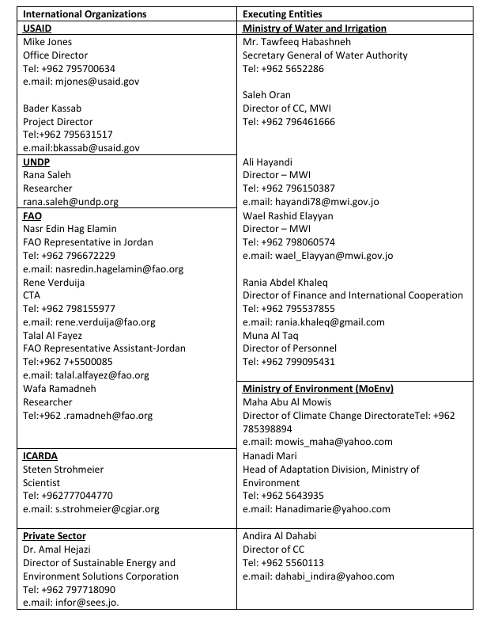
Section C: Appendices (optional)
- Participants list of an inception workshop (Wednesday 13 July 2016 in Ministry of Planning and International Cooperation (MOPIC), Amman, Jordan)
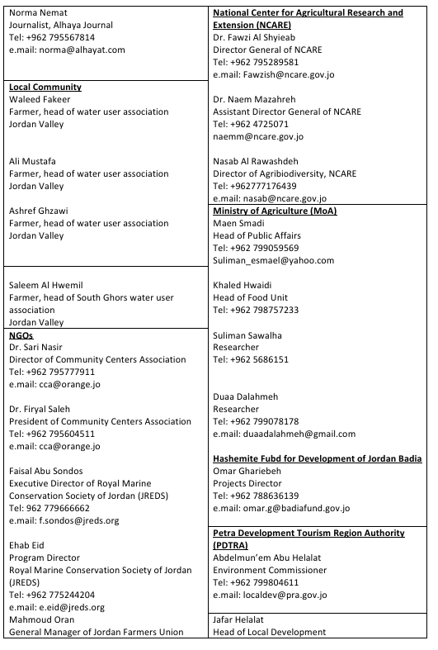
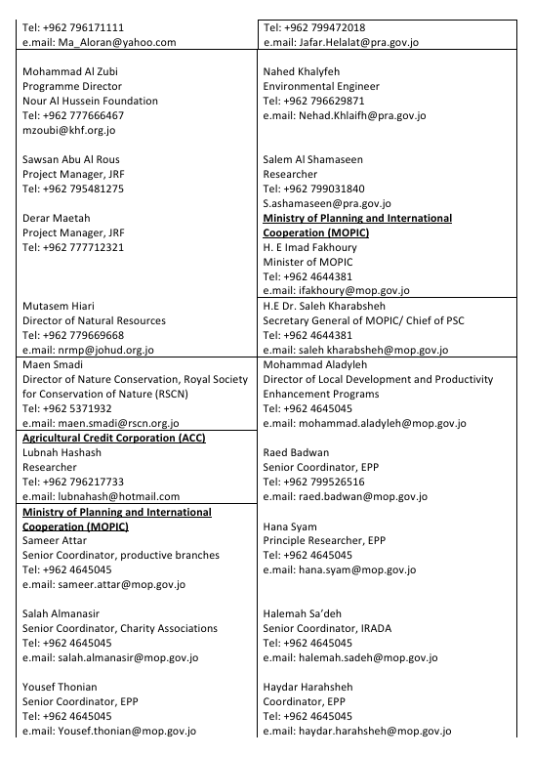

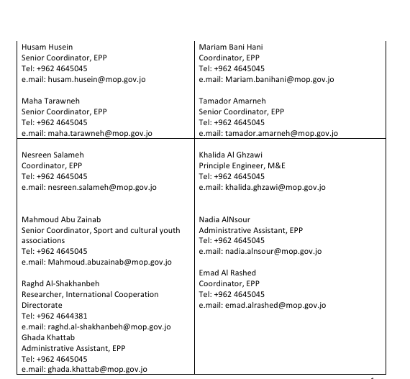

- Key project staff list
- Eng. Raed Badwan – MOPIC
- Dr. Issa Al Nsour - Project Manager
- Eng. Anas Atyat - Monitoring and Evaluation Specialist
- Mr. Ali Talafha – Financial Specialist
- Ms. Einas Masha’al – Administrative Assistant
- Reports and other publications
  - Newsletter:
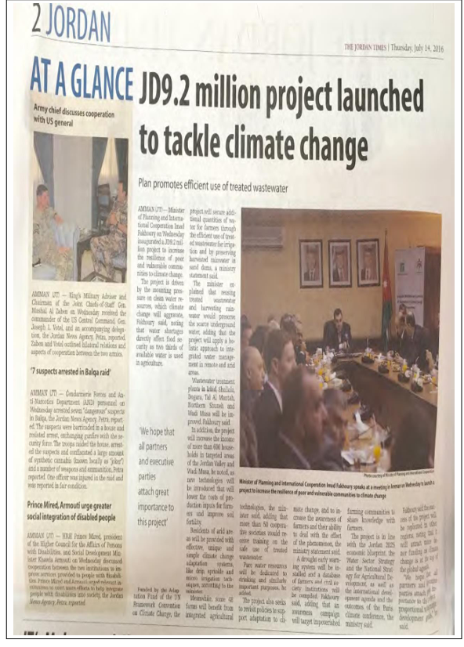

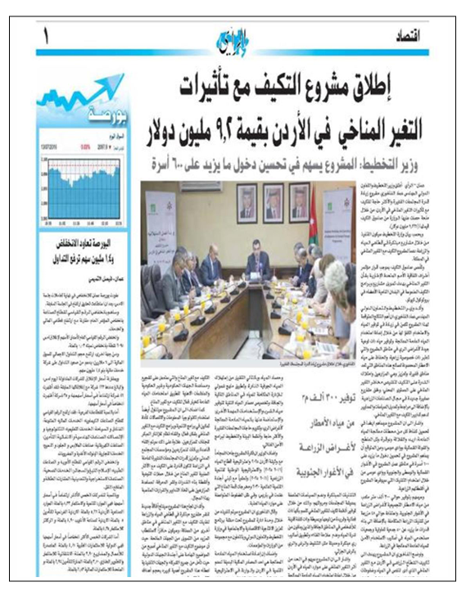

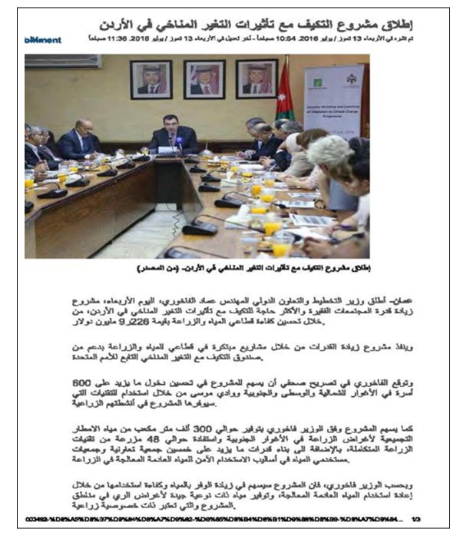

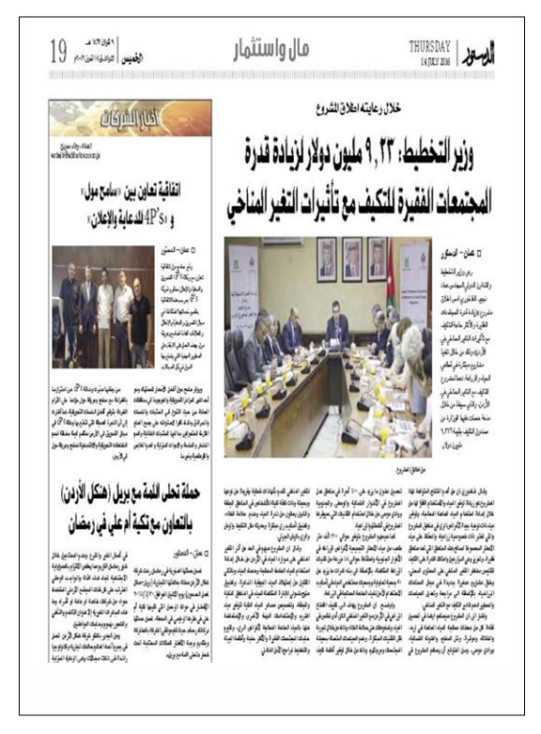

.

  - Reports:
- 2 Drafts ESMP reports in Arabic and English for project (1.1)
- 2 Drafts ESMP reports in Arabic and English for project (1.4)
- 2 Drafts ESMP reports in Arabic and English for project (1.6)
- Financial and management reports for the physical years started from 2019 2023 for the external auditing
- 5th PPR submitted to AF on (14/9/2021) and approval by AF on (1/12/2022)
- 6th PPR submitted to AF on (14/9/2022) and approval by AF on (14/5/2023)
- 7th PPR submitted to AF on (8/13/2023) and approval by AF on (8/11/2023)
- 8th PPR submitted to AF on (8/3/2025) and approval by AF on (12/09/2025)
- 9th PPR submitted to AF on (17/12/2025) and approval by AF on (8/01/2026)
- 10th PPR submitted to AF on (0000) and approval by AF on (0000)

  - Announcement
- Press release to kickoff project number 1.6 (Establishment of two (2) pilot sites for Permaculture in the northern Jordan Valley and Ghor Al Safi region, Shayyar Group : https://ddei5-0-ctp.trendmicro.com:443/wis/clicktime/v1/query?url=https%3a%2f%2fjordandaily.net%2f%25d8%25a7%25d9%2584%25d8%25a8%25d8%25ad%25d9%2588%25d8%25ab%2d%25d8%25a7%25d9%2584%25d8%25b2%25d8%25b1%25d8%25a7%25d8%25b9%25d9%258a%25d8%25a9%2d%25d8%25a7%25d8%25aa%25d9%2581%25d8%25a7%25d9%2582%25d9%258a%25d8%25a9%2d%25d9%2584%25d8%25a5%25d9%2586%25d8%25b4%25d8%25a7%25d8%25a1%2d%25d9%2585%25d9%2588%25d8%25a7%25d9%2582%25d8%25b9%2f&umid=28DFEBB7-E30D-0505-B526-FE8DDB76605D&auth=666b4d04c70a4d4d238b7c594c194870d0b0cd5c-a4a0e82845d2ebf2a94a009e09580936a4cd2a40
- Press release to sing agreement between Jordan Valley Authority and National Center for Agricultural Research for the supervision by NARC for demonstration farm for using unmixed treated wastewater in northern shouneh :https://www.petra.gov.jo/Include/InnerPage.jsp?ID=185290&lang=ar&name=news
- Press release to sign agreement between Ministry of Environment, National Center for Agricultural Research and Meteorological Department for the lunch Early warning system within projects number (2.1 and 2.2): https://www.petra.gov.jo/Include/InnerPage.jsp?ID=209797&lang=ar&name=news.
- Websites
  - Climate Change Adaptation Program - Ministry of Planning and International Cooperation( https://www.mop.gov.jo/EN/List/Climate_Change_Adaptation_Program1)
  - Jordan TV: Building Climate Resilience for Water and Agriculture (https://www.youtube.com/watch?v=y9Thk9EwUYs)
  - Case Study Cost and Benefit Analysis for Wicking Beds
  - Case Study Value Chain and Marketing Assessment and Livelihood of Farmers in the Jordan Valley/ Agriculture Products at the Airport
  - Economic Feasibility Study for Establishing an Agricultural Services, Marketing, and Cold Storage Company in the Jordan Valley
  - Avocado Tree Brochure – Activity Budget to Measure the Profitability of One Dunum of Avocado Production in Jordan Valley
  - Guava Tree Brochure – Activity Budget to Measure the Profitability of One Dunum of Guava Production
  - Mango Tree Brochure – Activity Budget to Measure the Profitability of One Dunum of Mango Production
  - Compost Brochure – Revenues and Costs for Producing Organic Fertilizer (Compost)

