


Mid-Term Evaluation Report for Adaptation Fund supported Project
“Conservation and Management of Coastal Resources as a Potential Adaptation Strategy for Sea Level Rise”

Implementing Country: INDIA

Implementing Entity: NATIONAL BANK FOR AGRICULTURE AND RURAL DEVELOPMENT (NABARD)

Executing Entity: M. S. SWAMINATHAN RESEARCH FOUNDATION
(MSSRF)

Period of Assessment: 2016/17 – 2018/19
Time of Evaluation: SEPTEMBER 2019
Report Submission: DECEMBER 2019

Evaluator: Dr. Saudamini Das, Institute of Economic Growth, Delhi Email: saudamini@iegindia.org; Phone: +919899066456, 01127667424
(ext-255)

Acknowledgement

This evaluation work was undertaken under the Research and Development Project Grant funding of the Department of Economic Analysis and Research (DEAR) of the National Bank for Agriculture and Rural Development, Mumbai HO. I sincerely thank DEAR, NABARD for giving this opportunity to evaluate this project and for providing logistical help to meet the executors, stakeholders and beneficiaries of the project. Special words of thanks go to K. L. Prabhakar and B. Suri Babu for their continuous support during the evaluation process. Sincere thanks goes to Dr Ramasubramanian of M.S. Swaminathan Research Foundation and Mr. Rao of Praja Pragati Seva Sangram for facilitating the field visit and arranging stakeholders meeting at different project sites. Ms Ananya Iyengar and Ms Sanju Yadav provided efficient research assistance.
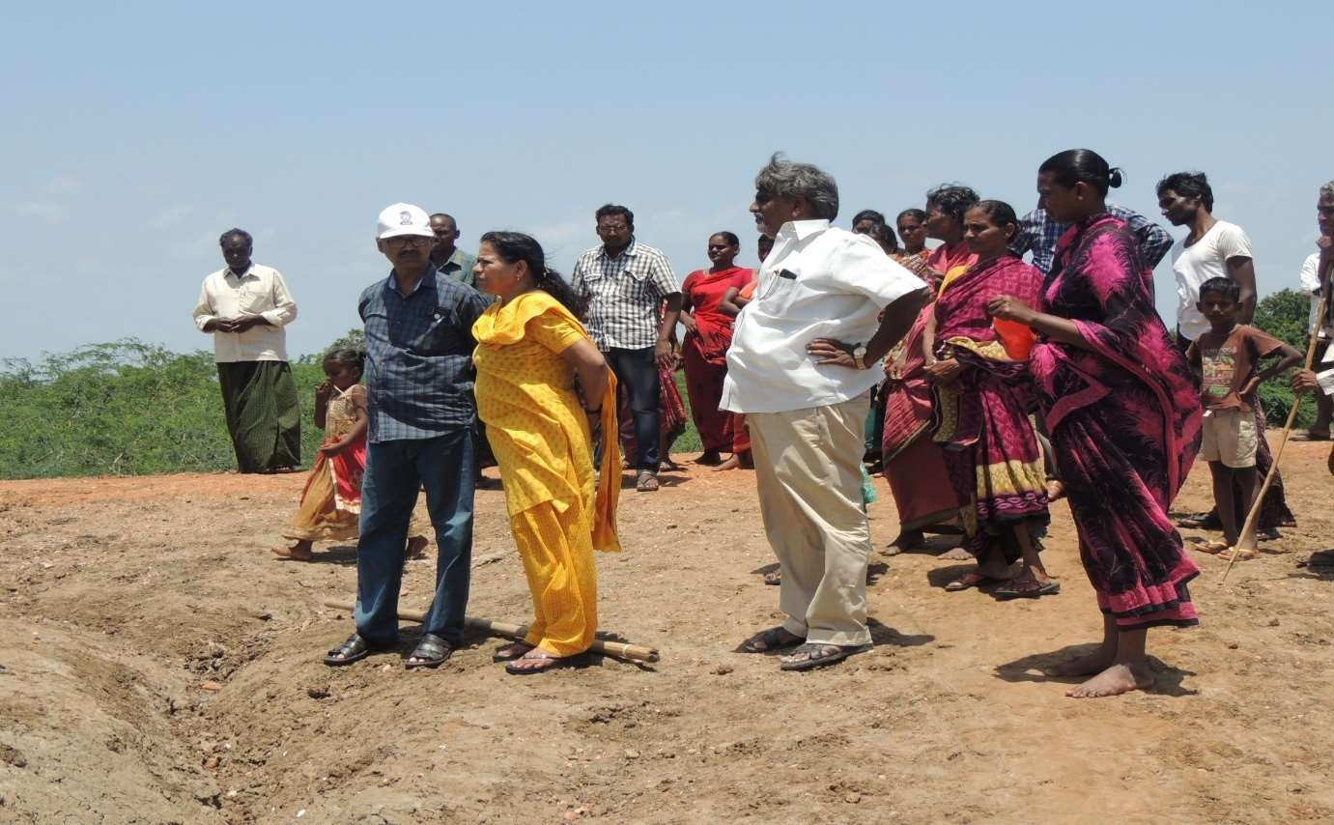

Inspecting mangrove plantation sites at village Basavanipalem, Krishna district, Andhra Pradesh on 9th September 2019.

Contents
Executive Summary 4
Acronyms & Abbreviations 8
List of Tables 9
List of Figures 10
Section 1: Introduction 11
  - Problem Context 11
  - Project Area 12
  - Project components 13
  - Project Logic Diagram 14
Section 2: Objectives of evaluation 15
Section 3: Methodology of evaluation 16
Section 4: Progress of the Project 18
Section 5: Results and Analysis 22
  - Women representation 22
  - Stakeholders responsibility and opinion on success and replication of the project 24
  - Economic and Social impact of the Project 26
    - Occupational Comparison 27
    - Income and Expenditure Comparison 28
    - Meeting attendance awareness and general 30
    - Awareness about role & importance of mangroves 30
    - Comparison of attitude related to Children’s education 31
Section 6: Summary 32
  - Sustainability Issues 33
  - Recommendations 34
APPENDIX: Survey Questionnaire for Stakeholders 35
APPNDIX: Household Survey Questionnaire 46
APPENDIX: Table 1 56

Midterm Evaluation Report for Adaptation Fund Project “Conservation and Management of Coastal Resources as a Potential Adaptation Strategy for Sea Level Rise”

Executive Summary

This study does a partial impact evaluation of the Adaptation Fund Project “Conservation and Management of Coastal Resources as a Potential Adaptation Strategy for Sea Level Rise”, which was implemented in three villages, namely Sorlagondi, Nalli and Basavanipalem, located in Krishna delta estuary region of the state of Andhra Pradesh in eastern India. This area is highly vulnerable to cyclones, high storm surges, coastal erosion, frequent sea water intrusion, etc. and had witnessed 10, 000 human deaths during the very severe cyclone (Diviseema cyclone) in year 1977. With climate change and associated increase in storm frequency and sea level rise, the situation have further aggravated and worsened vulnerability of people. The project aimed at empowering the coastal communities against climate change by developing a mangrove buffer and introducing sustainable fishery/aquaculture based livelihoods, which are conducive for the region. Along with awareness generation regarding climate change and women empowerment, the project’s main interventions were the following:

Project interventions
- Training and development of Mangrove nursery,
- Mangrove Plantation in 200 hectares area
- Introduction and demonstration of Integrated Mangrove Fishery Farming Systems (IMFFS) and
- Introduction and demonstration of Cage and Pen Culture Fishing

The first two activities were to provide synergies to the existing 22000 hectares of mangroves raised by the state government by extending the mangrove cover in another 200 ha of adjoining land and training local people in raising, maintaining and protecting the mangroves to get

protection from storms. Of the other two activities, IMFFS is rehabilitation of abandoned aquaculture ponds or establishment of new aquaculture ponds with mangrove plantation on the embankment and use of organic fish feed. IMFFS has its rationale on the ‘mangrove increases fishery’ ecosystem service argument and has been proved to be a sustainable aquaculture practice in many parts of the world. Cage culture fishing is organic feed based aquaculture in floating cages. Thus, the Project interventions tried to address mitigation, adaptation, sustainable livelihood and poverty eradication together.

Village level Activities

Different villages had different activities - Sorlagondi village developed mangrove nursery and three cage culture fishery; the activities in village Nalli were 30 IMFFS farms and three cage culture fishery and Basavanipalem had mangrove plantation in 200 hectares of coastal land and IMFFS farms in 20 hectares. Along with these, awareness on climate change, adaptation options, usefulness of mangrove for costal population, etc. was generated through meetings, distribution of pamphlets, brochures, and posters and Village Level Institutions (VLI) were formed in each village to better use the resources and plan, monitor and help upscale the project activities. Though each VLI was mandated to have at least 33% women representation, it was nearly 50% in all project villages. Though limited numbers of households were the direct beneficiaries, indirect beneficiaries were much larger because of the employment generation, learning from the demonstration activities, awareness generation, etc.

Status of Activities
The project duration was 2016-17 to 2019-20 and evaluation was undertaken during first and second week of September 2019. By this time, the mangrove plantation and construction of IMFFS in 40 hectares had been completed and the structures for cage and pen culture were completed and were waiting to be fixed once the water level in the river reaches the appropriate level. The mangrove nursery was successfully developed as observed from the survival rate of the plantation. Of the 40 IMFFS farms, only 15 were completed during 2017-18 and have had two rounds of harvest by the time of evaluation. The first harvest was very satisfactory, but the second suffered to some extent due to infection from neighbouring aquaculture farms that use chemical based intensive methods. Thus, all project activities, as promised, have been nearly completed.

Evaluation Methods
As mangrove plantations take a minimum of 5-6 years to stabilize and provide the ecosystem benefits, the present study did a partial impact evaluation of the project using multiple methods

like (i) detailed inspection of the field, (ii) stakeholders’ interview and (iii) evaluation of the beneficiaries’ perception and knowledge gain by conducting a questionnaire survey of households chosen randomly from both project and control villages. The questionnaire survey was conducted in six villages, the three project villages and three control villages. The location feature (distance from sea) was used as the main criteria to select the control villages. All control villages were from the same Krishna delta region. Each project village had a control village with similar location features. A comparison with control villages was attempted to separate out the impacts of the AF project from those of other developmental programs, if any, by the government in the area. Both program and control villages have received the government programs, whereas only the project villages had the AF project. Thus, a combination of both qualitative and quantitative approaches was used to evaluate the project’s implementation and impacts.

Stakeholders Perception
The stakeholders of the project were NABARD Regional Office, Forest Department of Government of Andhra Pradesh, M.S. Swaminathan Research Foundation (MSSRF), NGO Praja Pragati Seva Sangam (PPSS), village Self Help Groups (SHG), village Panchayats, farm owners, and landless local communities. A qualitative survey of stakeholders was conducted to know their level of satisfaction with respect to project implementation, the loopholes of the project, anything that needed to have been done differently, any lessons learned, etc. The project implementation seemed to have been very good as each of the stakeholders were highly satisfied and gave a high score (4.5 out of 5) to the implementation process and wanted the project to be scaled up. There were some delays in implementation and other than this no other dissatisfaction was reported from anyone. Though no cyclone has hit the area after the project implementation, protection from cyclones and erosion prevention were cited as the most important gain/contribution of the project by villagers and other stakeholders based on their previous experiences.

Socio-economic Impacts
Though project impacts are yet to be realized fully, training and project activities seemed to have resulted in high economic gain in project villages. The project activities have been women centric with 67% of the employments generated during 2015 to 2019, gone to women on average. In some years, the share of women have been as high as 90%. Compared to control villages, program village households showed a significant increase in their annual income during the project period. During 2015-19, households earning less than Rs60000 annually showed a decrease of 38% and those earning Rs60000 to 100000 per annum an increase of

300% in project villages, whereas such percentages were 18% and 38% respectively in control villages. Level of awareness on climate change, importance of mangroves, attitude towards girl child, precautionary behaviour to avoid climate impacts, etc. was seen to be comparatively much higher in project villages than the control villages.

Limitations/Sustainability concerns
Mangrove plantation seemed to have been successfully carried with very high survival rate and seemed to provide synergy to adjoining mangrove areas planted by the state government in future. However, the success and sustainability of IMFFS and cage fishing has to be accessed in future, though these activities were very well executed as evidenced from field visit to all project sites. The IMFFS farms are surrounded by conventional intensive aquaculture farms and all are connected through creeks and canals and chances of fish infection from these farms can’t be ruled out in future. Extra precaution need to be taken, at least for few years till the mangroves stabilize, grow and start providing ecosystem services.

Recommendations:
- Newly planted mangroves take more than 5-6 years to stabilize and supply ecosystem services and it is recommended that a final evaluation of the project effects be undertaken around the year 2024-25.
- The project area is surrounded by intensive aquaculture firms and these are the limiting factors for the sustainability of IMFFS as seepage of chemicals from these farms infect the shrimps/crabs in IMFFS. Seepage from these farms need to be checked till mangroves of the IMFFS farms grow and stabilize.
- If IMFFS become successful and conventional aquaculture farms learn from it and replace their farms by IMFFS, the entire area will be green and will gain tremendous ecological benefit.
- In awareness generation and training manuals for IMFFS, a comparative picture of IMFFS vs. conventional intensive aquaculture farms be included so that people learn about the future sustainability of this profession.
- Knowledge generation regarding mangroves benefits are limited to few ecosystem benefits of mangroves and people need to get more information on all direct and indirect benefits of mangroves. Knowledge sharing with neighbouring villages should also be encouraged.

 | ACRONYMS & ABBREVIATIONS USED:
AF | Adaptation Fund
BPL | Below Poverty Line
CC | Climate Change
DEAR | Department of Economic Analysis and Research
ha | Hectares
HH | Household
HO | Head Office
IE | Impact Evaluation
IMFFS | Integrated Mangrove Fishery Farming Systems
km | Kilometers
MSSRF | M.S. Swaminathan Research Foundation
NA | Not Applicable
NABARD | National Bank for Agriculture and Rural Development
NAFCC | National Adaptation Fund for Climate Change
NIE | National Implementing Entity
NGO | Non-Government Organizations
OBC | Other Backward Castes
PPSS | Praja Pragati Seva Sangam
SHG | Self Help Group
SLR | Sea Level Rise
VLI | Village Level Institutions

List of Tables

Table Page number

Table 1: Logic Diagram of Adaptation Fund Project in Krishna 14
Estuary, Andhra Pradesh, India
Table 2: Project and control villages 17
Table 3: Village wise Interventions and Status by September 2019 19
Table 4: Score given by stakeholders to different aspect of the project 25
Table 5: Basic Features of Program and Control Villages 27
Table 6: Comparison of Livelihood options between control and 28
program village
Table 7: Comparison of Income and Expenditure 29
Appendix Table 1: Role and involvement of stakeholders in AF 56
project in Krishna Delta

List of Figures

Figures Page

number

Figure 1: Project location in East coast of India 12

Figure 2: Field with planted mangroves (both a & b) near Basavanipalem 20
village
Figure 3: IMFFS (a and b are completed in 2017-18 and c and d, in March & 21
July 2019.
Figure 4: Preparation of Cage and Pen culture fishery structures (both a and b) 21
under AF project, AP
Figure 5: Number of males and females in Village level Executive Committees 22
for AF project
Figure 6: Village Stakeholders meeting: Basavanipalem (a & b), Nalli (c) & 23
Sorlagondi (d)
Figure 7: Employment offered and share of female work days 24
Figure 8: Change in annual economic indicators of project and control villages 29
Figure 9: Attendance in village meeting and general awareness 30
Figure 10: Awareness about the role and importance of mangroves 31
Figure 11: Comparison of children’s education and attitude towards girl child 32

Midterm Evaluation Report for Adaptation Fund Project “Conservation and Management of Coastal Resources as a Potential Adaptation Strategy for Sea Level Rise”

Section 1: Introduction

India is one of the most adversely affected countries from climate change, especially the agricultural and natural resource sectors of the country. Indian people who are most vulnerable are poor and have low adaptive capacity and thus, state intervention is urgently needed to help them adapt to the changed scenario. At the same time state intervention can create enabling environment for sustainable management and use of the natural resources so that both agricultural sustainability, livelihood sustainability and food security is ensured. NABARD is the NIE for both climate Adaptation Fund (AF) and National Adaptation Fund for Climate Change (NAFCC) of India and have undertaken many projects in different parts of the country to enable vulnerable population to adapt to the adverse impacts of climate change. Many of these projects are either completed or nearing completion and it is essential to evaluate the impact, outcome as well as the process of some of these projects so that decision regarding their replication elsewhere can be taken up. Impact evaluation is an important policy guidance tool to take a decision for either replicating or up-scaling a project.

Problem Context

The East coast of India is a core region of cyclogenesis and witnesses frequent cyclonic storms almost regularly, few times in a year. Krishna river delta in the state of Andhra Pradesh is one of the most vulnerable area of East coast of India and have been battered by many severe cyclonic storms. The 1977 Andhra Pradesh cyclone (Diviseema cyclone), which was a super cyclone with 250 kmh-1 wind speed, had severely damaged this region killing more than 10000 people. Along with cyclone, coastal erosion and saline water intrusion are the other natural

threats affecting the life and livelihood of this area and all these have got aggravated due to climate change. This region is also one of the densely populated area with high poverty ratio. Such low socio-economic profile with high intensity frequent natural disasters have pushed the region up in the vulnerability chart of the country. To improve the adaptation capacity and resilience of the people to climate change, the Adaptation Fund Project “Conservation and management of coastal resources as a potential adaptation strategy for sea level rise” was implemented in this region by National Bank for Agriculture and Rural Development (NABARD) with M. S. Swaminathan Research Foundation as the Executive Entity. The project was implemented in three different villages of the Machhlipatnam mandal of Krishna district of the state of Andhra Pradesh.

Project Area

The project villages were Sorlagondi, Nalli and Basavanipalem located within the Krishna river Delta region, 2 to 5 km from the coast and had suffered tremendously during the 1977 Andhra Pradesh cyclone. These villages were also poorer compared to their neighbouring villages. Figure 1 shows the location of these project villages in Krishna river delta region.

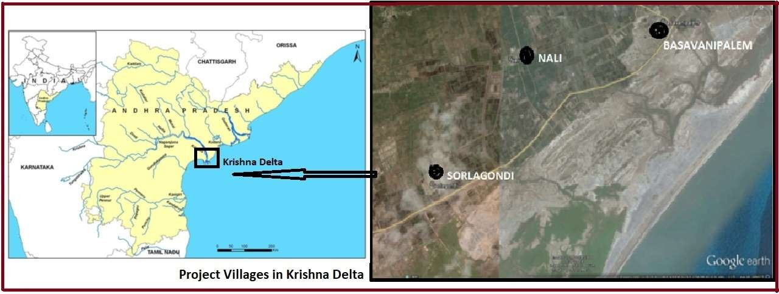

Figure 1: Project location in East coast of India

The choice of the project location, along with the objectives of equipping the vulnerable coastal population to adapt to climate change and to control the coastal erosion process, had the additional objective of establishing synergy with the 22,000 hectares of existing mangroves in the region.

Project components

The project had five components, i.e. (i) Community mobilization and organization, (ii) Capacity building for coastal protection and livelihoods, (iii) Restoration of degraded mangroves in 200 ha along the Krishna estuary for coastal protection, (iv) Demonstration of Integrated mangrove based fishery livelihoods and (v) Knowledge Management.
Different activities were undertaken under these components. Some of the notable ones are:
    - Forming gender balanced village level institutions (VLIs) in project villages,
    - Organizing orientation meetings on Climate Change, Sea Level Rise and Adaptive Capacity and measures involving mangroves,
    - Preparing and implementing annual micro plan for VLIs to ensure optimal utilization of resources,
    - Training people on mangrove restoration (training to develop and nurture mangrove nursery, restoration and rehabilitation of mangroves in both degraded and barren lands),
    - Developing one central mangrove nursery to serve the three villages,
    - Replanting mangroves on 200 ha of area close to two villages for future coastal protection (conducting biophysical inventory, preparing degraded mangroves for restoration, planting mangrove saplings, monitoring and care),
    - Training 50 farmers (including at least 20 women) in Integrated Mangrove Fishery Farming System (IMFFS) and fish culture,
    - Development of two models of IMFFS demonstrated with the participation of local community and stakeholders (one with inner bunds and one with inner mounds),
    - Raising mangrove plantation in the IMFFS farms, training on how to cultivate two culture of fish or prawn or both in the IMFFS farms per year,
    - Establishing cage and pen culture for crabs, fish, clams and cockles,
    - Preparation of resource materials in local language for dissemination among various stakeholders and distribution,

    - Bringing together the stakeholders and sharing the knowledge on CC, SLR, vulnerability and measures to improve adaptive capacity etc.
After implementation, project activities/interventions lead to initial outcomes called project ‘output’ and then the final outcome called ‘impacts’ in course of time. The likely output and impacts of the above activities of AF project are described below through a logic diagram.

Project Logic Diagram

Table 1 describes the likely outputs and impacts on the beneficiaries. This logic chart has been used to select impact indicators to undertake the evaluation exercise.

Table 1: Logic Diagram of Adaptation Fund Project in Krishna Estuary, Andhra Pradesh, India
Project component/activities | OUTPUT | IMPACT Indicators
A. Set up Village Level Institutions (VLIs) to plan adaptation strategies with equal representation of women and marginalized groups. | - Increased assertiveness of women and marginalized people in project related decision making.  - Increased participation and regular conduct of VLI meetings with quorum.  - Increased recognition of role or importance of women in the society. | - Increase in the proportion of women involvement in project activities.  - High Frequency of VLI meeting per village per year with quorum.  - Increased participation of women and landless people in all village level meetings.
B. Set up mangrove nurseries to grow organic mangrove saplings and transfer and plant them over the barren and degraded soil owned by the state Revenue Department for coastal protection. | - Growth and survival of healthy mangrove saplings in the nursery.  - Increase in land area under mangrove plantation.  - Good employment opportunity for villagers  - Additional skill for villagers to develop mangrove nursery for other agencies | - High survival rate of nursery-grown saplings.  - Increase in the hectares of land under healthy mangrove cover.  - Decrease in the community’s perception of their vulnerability to coastal soil erosion.  - Reduction in the loss of lives and assets during disasters like cyclones and floods.  - Villagers develop mangrove nurseries  for other agencies.
C. Building Integrated Mangrove Fishery Farming System  (IMFFS) on | C.1 More people trained in IMFFS in the 3 villages and more adoption of IMFFS. | C.1 Increase in number of IMFFS aquaculture farms in project villages.

abandoned shrimp farm land. | - Aquaculture farms have mangroves over the farm bunds.  - Less or no use of chemical feeds in aquaculture farming  - Increased production of healthy fishes and shrimps from the IMFFS farms, with an expected output of 300 kg of shrimp per year. | - More production of shrimps/prawns per year per hectare of IMFFS farms compared to normal aquaculture ponds.  - Decrease in annual expenditure on farm inputs by IMFFS households.  - Less infection/fish diseases in IMFFS farms.  - Life of IMFFS farms much longer than the normal aquaculture ponds.  C.4 Increase in income and expenditure of households owning IMFFS farms.
D. Engaging landless laborers in cage and pen culture for shrimp, oysters, clams, and cockles. | - Training of landless households in cage culture fishery.  - Increase in number of floating cages and pen  fishery in project area. | D.1 More landless laborers engaged in cage and pen culture fishery.  E.2 Increased wellbeing and less migration of landless laborers from the project area.
E. Distributing pamphlets and organizing orientation meetings to create awareness about climate change, sea level rise, sustainable aquaculture and mangroves among stakeholders. | - Printing and distribution of posters and pamphlets in local languages in project villages  - Increase in awareness about the impact of climate change and sea level rise among stakeholders. | - Large numbers of households per village are aware about climate change issues and willing to take up adaptation options.  - Households understand the role and importance of mangroves and cooperate to protect the planted mangrove areas.

Section 2: Objectives of evaluation

India has a vast coastline and bears a constant threat from sea level rise, erosion and extreme events like cyclone and storm surges. The AF project implemented in Krishna estuary empowers coastal community to face such challenges and it is essential to understand its’ impacts to consider similar intervention in other coastal areas. Keeping this urgency in mind, the present study intended to go for an impact evaluation of the project, however the full financial impacts are yet to be visible due to the large gestation period of the project as mangroves take 4-6 years to stabilize and give returns. Hence this study did a process and output evaluation of the project. The following questions were examined carefully in the study.
- How successfully the promised activities were implemented in the project villages?
- Has the promised acreage under mangrove plantation and IMFFS been completed?
- Has women participation and attitude towards women improved in project villages?
- What has been the project impact on Employment generation?
- Are people aware of climate change, threats to coastal areas and role of mangroves?

- Are there any areas of concern or any activity that should have been done differently?
- What are the opinions of stakeholders for replicating such projects elsewhere?
- What are the lessons learnt or scope of doing project activity differently (scope for cost minimization, more inclusiveness, broadening the scope, etc.)?

Section 3: Methodology of evaluation

This study uses a combination of both qualitative and quantitative methods to evaluate the project impacts.
- Quantitative method included questionnaire survey of households from project and control villages and explained the project impacts with the help of numerical data that are analysed using statistical methods. A cross section data set and a ‘with and without’ approach has been used to bring out the program effect.
- Qualitative method seeks to answer questions about why and how people consider the results in the way that they do. It provides in-person information about the benefits of the project interventions. Qualitative methods like focus group discussions, stakeholders’ interview, field visit and interaction with beneficiaries, meeting with village committees, their perception and expectations from the project were some of the qualitative data and assessment methods used in this study.

Quantitative Methods

    - Field visit

Surveyor visited all the 3 project villages and personally checked the progress of the project interventions during second week of September 2019. The visit was very extensive and intensive in terms of covering all the project sites, all villages, all stakeholders, all activities and judging the quality of activities and perception of people as well.
    - Household survey
There being no detailed baseline data for the village community where project was implemented, a detailed questionnaire survey was conducted to know their level of awareness on climate change impacts, role of mangroves, women’s participation, and economic benefits received during the project period. In absence of base line data, three other villages were selected to be the control villages and the same questionnaire survey was conducted over there.

The results from project villages were compared to findings from control villages to infer project impact.
    - Selection of Control Villages and Sample size
The selection criteria for choosing control villages were (a) similar distances from coast, (b) located in Krishna Delta facing similar threats and (c) have mangroves in their coastal distance. Keeping the budget in mind, the sample size was decided to be around 300 households that constituted approximately 12% of the total number of households of the six villages. Though same number of households were to be studied from each of the villages, the sample size from the project villages could not be same as the household size, occupational distribution and proportion of project beneficiaries varied widely in these villages. Basavanipalem was oversampled because of the wide economic disparity and scattered settlements of the village and the other two project villages had 12% of their households taken as sample households. Simple random sampling was followed to choose the sample households from each village. Table 2 below shows the list of project and control villages surveyed with their location and sample size. Villages were in very close proximity to each other and close to coast facing similar threats.
The questionnaire used for household survey is attached at the end of the report.

Table 2: Project and control villages

Name | of | the | Status of | Name | of | the | Name | of | the | Nu. of | Approximate
villages |  |  | the | panchayat |  |  | mandal |  |  | households | distance from
 |  |  | village |  |  |  |  |  |  | surveyed | coast (km)
Nalli |  |  | Project | Nalli |  |  | Nagayalanka |  |  | 60 | 4
Sorlagondi |  |  | Project | Sorlagondi |  |  | Nagayalanka |  |  | 70 | 5
Basavanipalem |  |  | Project | Ramakrishna Puram |  |  | Koduru |  |  | 20 | 2.1
Sangameswaram |  |  | Control | Sangameswaram |  |  | Nagayalanka |  |  | 52 | 4
Pathauppukali |  |  | Control | Sangameswaram |  |  | Nagayalanka |  |  | 52 | 3
Uttagundam |  |  | Control | Ramakrishna Puram |  |  | Koduru |  |  | 51 | 3

  - Stakeholders’ Identification and Consultation

From the project document, the stakeholders were identified and their activities and responsibilities towards projects were documented carefully. The following were the identified stakeholders of the project:
    - NABARD Regional Office,
    - Forest Department of Government of Andhra Pradesh,
    - M.S. Swaminathan Research Foundation (MSSRF),
    - NGO Praja Pragati Seva Sangam (PPSS),
    - Village Self Help Groups (SHG),
    - Village Panchayats, and
    - Farm owners
Next few descriptive and qualitative questions were prepared for each stakeholder and their opinion on project success was assessed on a Likert scale. They were asked to rank the quality of project activities, timeline, their level of satisfaction, lessons learnt and if anything should have been done differently. The questionnaire used for each of the stakeholder are appended at the end of the report.

  - Data Analysis

Data collected from household questionnaire survey was analysed with the help of STATA software. Comparison of mean and rate of growth are used to compare the differences in socio- economic characteristics between the project villages and control villages and their knowledge regarding project objectives. Results are presented using both tabular and graphical methods.

Section 4: Progress of the Project

First, the village wise activities and their status at the time of the field visit for evaluation are shown in Table 3. Of the three project villages, different villages had different activities and different completion dates. All activities, except the phase 2 of developing 15 hectare of IMFFS in Nalli village, had been completed. Mangrove nursery was successfully developed and all saplings have been planted. Mangrove plantation in 200 hectares has been completed and the survival rate is very high. Figure 2 below shows the images from the plantation field.
IMFFS farms were undertaken in Nalli (30 ha) and Basavanipalem (20 ha) villages and in two phases. In Basavanepalem, both the phases are completed and the first return is expected by

December 2020. Figure 3 below shows these farms. In Nalli, the first phase was completed in 2017-18 and the farm owners have already received two harvests, the first one being good and the second one had infection from the nearby intensive aquaculture farms using chemical feeds. The construction work for second phase of IMFFS in Nalli would be starting soon as the land has already been identified.
Because of high flood in rivers, the launch of cage culture fishery had to be delayed as these cages are to be floated in river banks. But the structures were all ready and to be floated by November 2019. Figure 4 below shows these completed structures. Thus, findings from the field made it very clear that the project has been successfully implemented and almost all activities have been completed except one part of IMFFS and the stocking and floating of the cages.

Table 3: Village wise Interventions and Status by September 2019

Name of the village (HH  size) | Type of intervention | Number of direct beneficia ry househol ds | Starting period | Status by September 2019 | Expected year to start getting return | Expected Life time of the activity
Sorlaga ndi (645 HHs) | Mangrove nursery | 16-17  HHs | 2015-16 | Completed | All sold | NA
Sorlaga ndi (645 HHs) | Cage culture fishery (3 cages) | 9 HHs | 2018-19 | Structure is completed and operation will start in November 2019 | March 2020, and then every six months | 20 years
Nalli (404 HHs) | IMFFS  (Integrated Mangrove Fish Farming System) in two phase | Phase1.  15HHs (15 ha.)  Phase 2. 15HHs (15 ha.) | 2016-17  2019-20 | Completed  Land identified for farm development | 2017-18 two harvests (one harvest had infection)  ----- | 20 years  -----
Nalli (404 HHs) | Cage culture (3 cages) | 9 HHs | 2018-19 | Structure is completed and operation will start in November 2019 | March 2020, and then every six months | 20 years

Basavan ipalem (55 HHs) | 200 hectares mangrove plantation (100  ha. in 2017-18 and 100 ha. in 2018-19) | Whole village | 2016-17  and 2017-18 | Completed | Indirect benefits, may be starting from 2024-25
Basavan ipalem (55 HHs) | IMFFS  (Integrated Mangrove Fish Farming System) in two phase | 20 HHs | Phase 1.  10 ha complete d in March 2019  Phase 2.  10 ha complete d in July 2019 | Completed | 2019-20 (4 - 5  months after completion) | 20 years

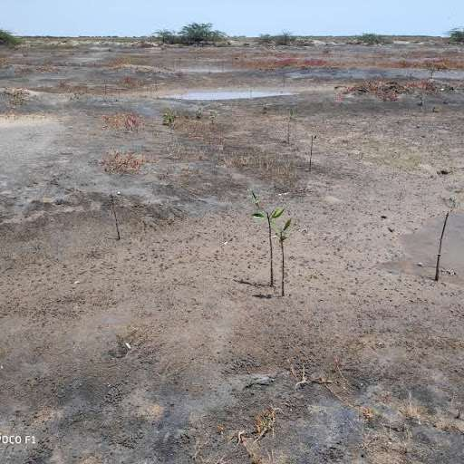
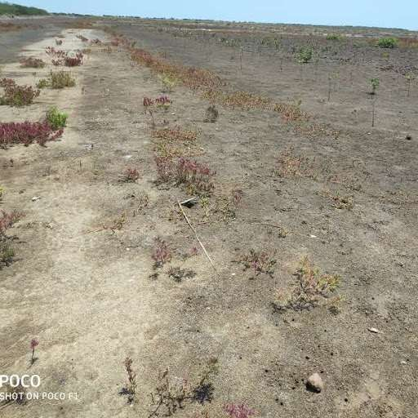

    - (b)

Figure 2: Field with planted mangroves (both a & b) near Basavanipalem village

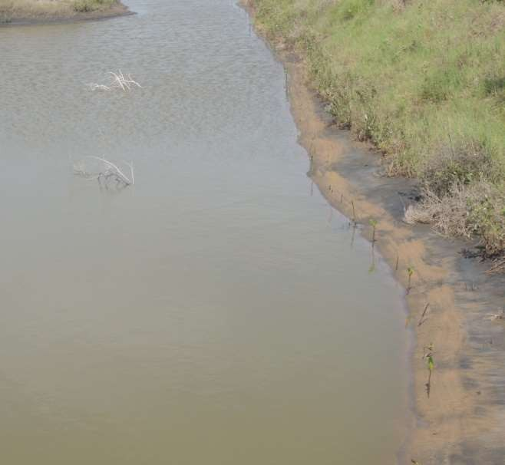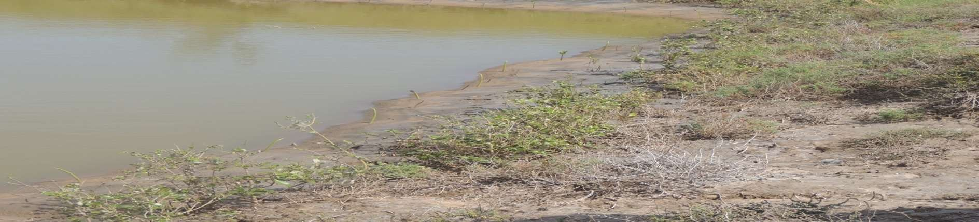
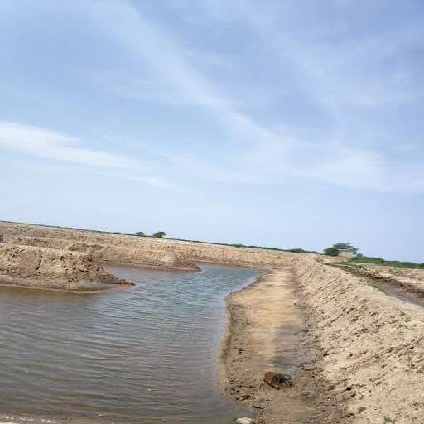
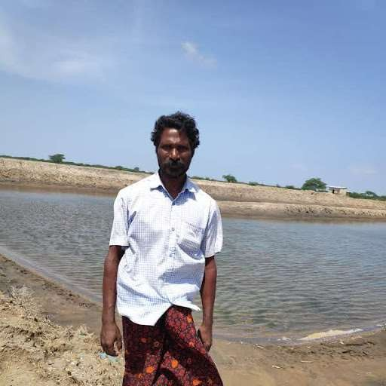
(a) (b)
- (d)

Figure 3: IMFFS (a and b are completed in 2017-18 and c and d, in March & July 2019.
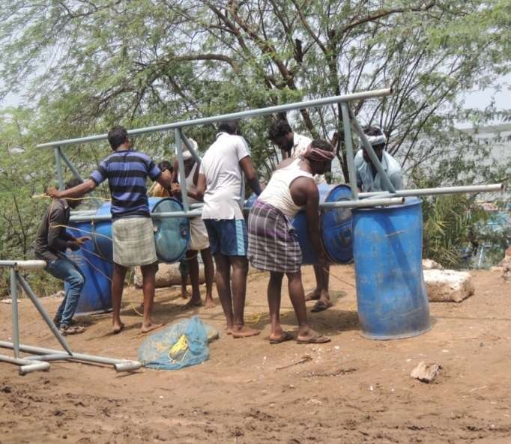
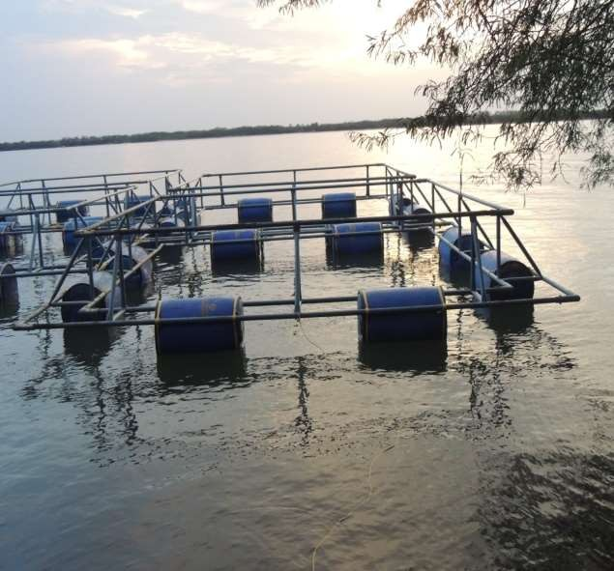
  - (b)

Figure 4: Preparation of Cage and Pen culture fishery structures (both a and b) under AF project, AP

Section 5: Results and Analysis

Women representation

Women representation in Village Level Institutions (VLIs) and attitute of villagers towards girl child were examined. All the three villages had VLI and the composition of the Executive Committee of the villages for AF project is shown in Figure 5, which shows a proper maintenance of gender balance in committee formation.:
9
8
8

7

6

5

4

3

2

1

0
Basavanipalem
Nali
Sorlagondi
Males Females
7
6
6
6
5

Figure 5: Number of males and females in Village level Executive Committees for AF project

Women participation in village meetings was very high and women participated in all coversations with enthusiasm. However, the stakeholders meeting in village Nalli was thinly attended by women and the reason given was that the day of the visit was an important festival day of the region (last day of “Vinayak Chaturthi”festival) and difficult for women to come out of home, especially during day time. Figure 6 shows the meetings with village level stakeholders during field trip and the women participants are seen to outnumber the men participants in two villages. The no-show of women in Nalli (Fig 6 ©) was due to the festival day, as explained above.

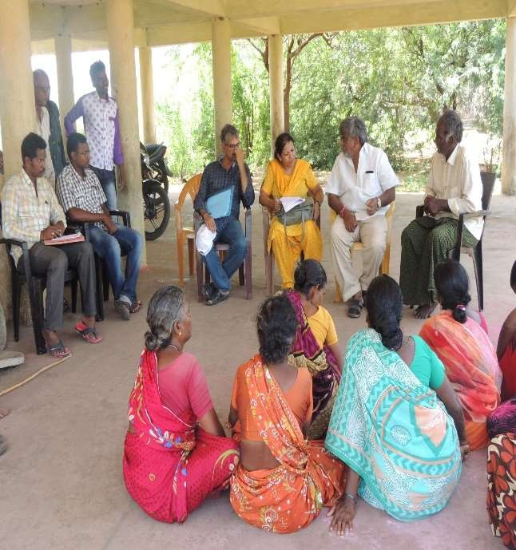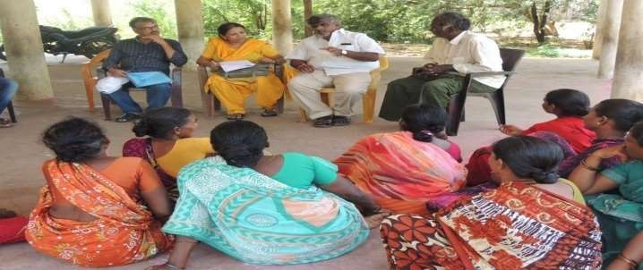

(b)
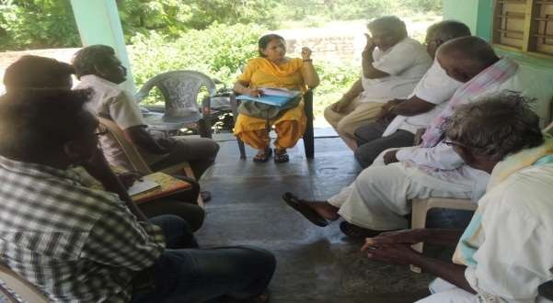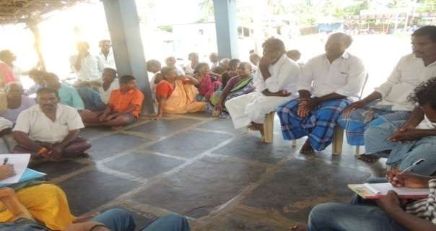

(c) (d)

Figure 6: Village Stakeholders meeting: Basavanipalem (a & b), Nalli (c) & Sorlagondi (d)

5.1.2 Women share in Direct Employment Generated
The project provided employment to villagers and as per the project stakeholders, unless necessary, most of the project work was given to women. Whenever, the work needed use of heavy machinery or trained manpower, which women could not handle, job was offered to

male workers. Figure 7 below shows the total employment generated by the project during the last five years and the share of women employees.
8209
7677
0.86
.9
0.69
0.47
0.44
1887
1412
1025
0

9000
8000
7000
6000
5000
4000
3000
2000
1000
0
1
0.9
0.8
0.7
0.6
0.5
0.4
0.3
0.2
0.1
0
2015-16 2016-17 2017-18 2018-19 2019-20
Total employment days
Share of female work days
Figure 7: Employment offered and share of female work days

The project has created 20,210 days of employment and on average, 67% of the work has gone to women. In some years, their share has been as high as 90% compared to men.

Stakeholders responsibility and opinion on success and replication of the project

The project was implemented by M.S.Swaminathan Research Foundation (MSSRF) in association with Praja Pragati Seva Sangam (PPPS) and other stakeholders were NABARD regional office, Forest Department of Government of Andhra Pradesh, Village Panchayats, farm owners, Self Help Groups, landless local community, etc. The role of different stakeholders in project implementation is described in Appendix table 1 at the end. Keeping their role and involvement in mind, a small questionnaire was given to each stakeholder to share their views on different aspects of the project and responses included both descriptive replies and choices in Likart scale. The questionnaires are attached in the apendix section as Stakeholder Questionnaires. Descriptive replies were sought for questions like:
- How often the VLIs meet in a month, general attendance, attendance of women, youth and landless people,
- Type of grievance redressal mechanism,
- Major obstacles faced in project implementation,
- Whether and how any synergy been established between the project and MGNREGA funds/activities,

- Immediate and future benefits from project,
- Issues in sustainability of project activities in future,
- Whether should be replicated elsewhere similarly or with modifications, if any,
- Type and number of awareness activities,
- Issues regarding diversity, protection, survival, back-up plan for mangroves planted
- Knowledge of villagers regarding ecosystem benefits of mangroves, SR and LR benefits,
- Visible and invisible indicators of people’s well being after the project, etc.

All stakeholders including villagers gave strong positive responses to all questions suggesting that project implementation has gone well. Except some delay at the beginning due to funds release and land acquisition, no other hurdle has been faced. Regarding replicability, no additional suggestion was given. Most of these replies were also verified from villagers, women groups and landless people through the household survey, which are described later.
MSSRF and PPPS being the actual implementers, opinion of other stakeholders was solicited on the Likert scale to judge the implementation success and broad impact of the project on climate and environmental stress. Table 4 shows their opinion in a scale of 0 to 5 (5 being the highest).

Table 4: Score given by stakeholders to different aspect of the project

Project impact | NABARD RO | Forest dept. Govt. of AP | Village Gram Panchayat |  |  | Average score (out of 5)
Project impact | NABARD RO | Forest dept. Govt. of AP | Nalli | Sorlago ndi | Basavanip alem | Average score (out of 5)
Implementation success | 4.5 | 4 | 5 | 3 | 5 | 4.3
Direct contribution to reduce poverty | 4 | 2 | 2 | 1 | 2 | 2.2
Indirect contribution to reduce poverty | 5 | 4.5 | 3.5 | 4.5 | 4.5 | 4.4
Help in reducing salinity intrusion | 3 | 0 | 2 | 0 | 3 | 1.6
Erosion prevention | 3.5 | 4 | 4 | 5 | 5 | 4.3
Adapting to sea level rise | 3 | 4 | 4 | 4 | 4 | 3.8
Should be replicated | 5 | 5 | 4 | 4 | 4 | 4.4

As per table 4, the project seems to have been well completed, the overall satisfaction rate being 4.3 out of five and two of the three villages giving highest score. Stakeholders perceive the project to play strong role in helping them to adapt to cyclones, coastal erosion and sea level rise, which are persistent threats in the project area. According to the panchayat members of Basavanipalem village, “the sea has marched more than a kilometre inland in recent years due to coastal erosion and we are very lucky to have the mangroves planted in the coast. Our village will not be eaten away by the sea any more”.
Most of the stakeholders’ visualized limited direct impact of the project interventions on poverty reduction as mangrove plantation, which generated massive employment is a onetime activity and other interventions are capital intensive. However, indirect impact on poverty reduction was seen to be very high because of work opportunities in IMFFS, availability of fish, crabs, etc. in mangrove areas for collection, more livelihood opportunities from more and sustainable production of fish, etc. They also visualized less impact from storms and thus, less property loss from disasters like cyclone due to the presence of mangrove buffers in future. Stakeholders visualised a low impact of the project on reducing salinity intrusion, and this may be due to the less understanding of the scientific role of mangroves in reducing salinity intrusion. Probably, the science behind this ecosystem service of the mangroves was not clear to people. However, all stakeholders were of the strong opinion that such project needs to be replicated in other areas as well.

Economic and Social impact of the Project

As mentioned before, such impacts were assessed with the help of a household questionnaire survey. In absence of detailed baseline data, control villages were surveyed to have a comparison group. Table 2 in the methodology section shows these control villages and the number of households surveyed from each village. First of all, the general features of the households in control and project villages are compared to see whether these villages are different from each other or not. To qualify as control village, the basic features should be as similar as the features of the program villages.
The average values of some of the main household characteristics of the villages are shown in table 5. It is very clear that the average values are quite similar across these two types of villages for many of the household features. Most of the features, except two, i.e. gender of the respondent and share of children in the household, are similar for the villages.

Table 5: Basic Features of Program and Control Villages

Village Features | Program villages | Control Villages
Gender of respondent_male | 0.54 | 0.66
HH head_male | 0.99 | 0.95
Age of respondent (years) | 39.7 | 42.7
Age of HH head (years) | 42 | 45
Approximate distance of village from sea (in  km) | 4.2 | 3.3
Do you have mangrove in coastal distance | 1 | 0.66
Approx distance of village from mangrove area (in km) | 1.8 | 1.5
Share_children in household | 0.28 | 0.18
Average education of adult member of HH | 8th standard | 10th standard
Religion_Hindu | 0.99 | 1
Social class_OBC | 0.99 | 0.99
HH having BPL ration card | 1 | 0.97
Hectares of land owned per household | 2 | 2
Crops planted | rice | rice
No of cropping seasons | 1 | 1
Hectares of land used for shrimp farming | 1.8 | 2.2
Whether children going to school | 0.57 | 0.49
Whether children go to Govt school | 0.94 | 0.95
Has increased expenditure on children’s  education in the last five years | 0.21 | 0.26
Whether children attend private tuition | 0.18 | 0.15
Next, the households were compared on the basis of their occupational shift, income and expenditure, women’s participation in village meetings, general awareness on role of mangroves and climate change and children’s education. Tables 6, and 7 and Figures 8, 9, 10 and 11 report these results.

Occupational Comparison

Table 6 provides livelihood comparison between the program villages (Nalli, Sorlagondi and Basavipalem) and control villages (Sangameswaram, PathaUppukali and Uttagundam). The program villages seem to be occupationally bit more stable compared to the control villages. In the last 5 years, people engaged in farming and marine fishing have shifted away from these occupations and have gone for aquaculture, but this is more prominent in control villages. People working as regular daily wage labourers have decreased in both the areas and it has become a subsidiary occupation. Again this is more prominent in control villages. The interventions of the project seem to have improved the employment scenario as time employed

has increased by nearly 20% [0.13 – (- 0.06)] in program villages compared to control villages in the last 5 yrs. This employment effect is attributed to the project as all other policies are same in both the areas except for this project.

Table 6: Comparison of Livelihood options between control and program village (%)

FEATURES |  | PROGRAM VILLAGE |  |  | CONTROL VILLAGE
 |  | current | 5 yrs ago | %change | current | 5 yrs  ago | %change
Main occupation(% of HH) | Farming | 0.34 | 0.38 | -0.11 | 0.24 | 0.31 | -0.22
Main occupation(% of HH) | Aquaculture | 0.28 | 0.21 | 0.33 | 0.49 | 0.21 | 1.33
Main occupation(% of HH) | Daily wage  labor | 0.05 | 0.09 | -0.04 | 0.06 | 0.31 | -0.80
Main occupation(% of HH) | Marine  fishing | 0.26 | 0.28 | -0.07 | 0.13 | 0.15 | -0.13
Main occupation(% of HH) | Others | 0.07 | 0.03 | 1.33 | 0.08 | 0.03 | 1.66
Population going for subsidiary  occupation |  | 0.93 | 0.85 | 0.09 | 0.92 | 0.67 | 0.37
Subsidiary occupation_daily wage  labour |  | 0.74 | 0.70 | 0.06 | 0.84 | 0.62 | 0.35
Employed for how many months in  a year |  | 5.1 | 4.5 | 0.13 | 4.5 | 4.8 | -0.06

Income and Expenditure Comparison

Table 7 shows the trends in income and expenditure by households in program and control villages. One striking finding is that over the last 5 years, there is significant upward mobility in annual income of households, particularly in project villages. Households earning less than Rs60000 annually have decreased by 38% and those earning Rs60000 to 100000 have increased by 300% in program villages, whereas such percentages are much lower (18% and 48% respectively) in control villages. Thus, project has played a significant role in uplifting the population of these areas economically. Both production and revenue from agriculture, aquaculture and marine fishing has increased at a much higher rate in program villages compared to control villages. Thus, project interventions have increased productivity and income of people engaged in various occupations. People in program villages received training (at least 42%) related to their occupations which may have contributed positively in influencing their productivity and income as compared to control villages who received nearly no training. These relative changes are shown in Figure 8, which clearly depicts the improvement in project villages over the control villages. Figure 8 shows significant increase in number of households earning high income in project villages compared to control villages (300% vs.48%) and so in revenue from agriculture and fishery.

Table 7: Comparison of Income and Expenditure

Features |  | Program village |  |  | Control village
 |  | Current | 5 yrs  ago | % change | Current | 5 yrs  ago | % change
Average annual income(Rs.) | <60000 | 0.56 | 0.89 | -0.37 | 0.6 | 0.73 | -0.18
Average annual income(Rs.) | 60,000 -  100,000 | 0.44 | 0.11 | 3.00 | 0.4 | 0.27 | 0.48
Approx HH monthly exp  (Rs.) |  | 4179 | 3879 | 0.08 | 4581 | 3974 | 0.15
Revenue from selling  crops (Rs.) |  | 46,407 | 39,440 | 0.18 | 49,317 | 45,878 | 0.07
Annual prod of fish/shrimp_aquaculture  (kg) |  | 199 | 148 | 0.34 | 191.4 | 156 | 0.23
Annual revenue from selling fish_aquaculture  (Rs.) |  | 40,000 | 28,096 | 0.42 | 38,539 | 29,898 | 0.29
Daily catch_marine (kg) |  | 5.4 | 5 | 0.08 | 9.8 | 11 | -0.11
Annual revenue from  fishing_marine (Rs.) |  | 18,444 | 15,130 | 0.22 | 36,260 | 35,565 | 0.02
Daily wage (Rs.) |  | 433 | 284 | 0.52 | 407 | 248 | 0.64

%change in economic indicators
Daily wage (INR)
0.64
0.
52
Annual revenue from marine fishing (INR)
0.02
0.22
Daily catch_mar-i0n.e1(1kg)
0.08
Annual revenue from selling fish (INR)
0.29
0.42
Annual prod_acquaculture (kg)
0.23
0.34
Annual revenue from selling crops (INR)
0.07
0.18
HH monthly exp. (INR)
0.15
0
.08
No of HH earning 60k - 100k(INR)
0.48
3
No. Of HH earnin-g0.<36-00k.1(8INR)
7
-1
-0.5
0
0.5
1
1.5
2
2.5
3
3.5
Control villages Project villages

Figure 8: Change in annual economic indicators of project and control villages

Meeting attendance and general awareness

Households of program villages are seen to be giving due importance to village meetings. This is observed from Figure 9, which shows village meeting attendance to be more in program villages (86%) than in control villages (54%). Though female participation seems to be similar in the area, daily wage laborers’ seem to participate in meetings and discussions more freely in program villages (nearly 87%) as compared to control villages (around 52%). Females in these areas do not face any discrimination and take part in meetings and discussions actively as observed from their high participation rates in both types of villages.
0.01
0.42
0.86
0.52
0.87
0.9
0.
0.95
0.
0.86
0.54
0.52

Attendance and participation in village meeting
Training received related to occupation Daily wage laborers participation in Village meeting
discussion
Daily wage laborers attendance in Village meeting

Female participation in village meeting discussion
99
Female attendance in village meeting
7

99
Attendance in Village meeting
0
0.2
0.4
0.6
0.8
1
1.2
Control village
Program village

Figure 9: Attendance in village meeting and general awareness (%)

Awareness about role & importance of mangroves

Awareness related interventions of the project have increased the knowledge regarding the role of mangroves in agriculture, fishing and protection from storms among population of the program villages as compared to control villages. These information, as shown in Figure 10, shows wide difference in the level of awareness of program and control villagers. Wide gap is also visible in knowledge regarding other ecosystem services of mangroves like controlling soil erosion, salinity or improving marine fishing. Control villagers seem to be having no such knowledge in spite of the fact that many of them (67% table 5) do have mangroves in their coastal distance. Thus, we can conclude that interventions related to mangrove awareness have been well received by villagers.
Though trainings seem to have improved the awareness, one important observation is that people in project villages are not equally aware of all the ecosystem services of mangroves. Mangroves functions like role in reducing salinity, soil erosion or on marine fishery are less understood by people compared to functions like protection from storm and role in agriculture or coastal fishery.

Awareness about the role and importance of mangrove
1

0.9

0.8

0.7

0.6

0.5

0.4

0.3

0.2

0.1

0
Knowledge of Importance of Importance of Mangroves can Mangroves can Role of
mangrove plantation scheme
mangroves to mangroves for control speed of control sea mangroves in
agriculture and protection from
the storm water flooding reducing soil
Benefits of Training
mangrove received on plantation to integrated
fishing
storms
erosion/salinity marine fishing mangrove fish
farming system
Program village Control village

Figure 10: Awareness about the role and importance of mangroves (%)
0.98
0.97
0.92
0.87
0.78
0.32
0.23
0.25
0.18
0.15
0.09
0.050.05
0.01
0.01
0

Comparison of attitude related to Children’s education

Figure 11 shows that, in general, children in both the program and control villages are not encouraged much to attend school as nearly half of the households send their children to school. However, the situation is relatively better in program villages. More households in program villages plan to give higher general education to their children. More discrimination between male and female child can also be seen in the control villages where 33% households think of giving technical education to their male children, but when it comes to female children such households are only 8% whereas such percentages are 13% and 5% for program villages. More households in control villages involve their children in family occupation and so are the households who involve them for at least 4 hours or more on daily basis. Similar situation exists in program village as well, but such discrimination is much less indicating a change in mind set towards children, particularly girl child in project area.

0.6

0.5

0.4

0.3

0.2

0.1

0
Children attend school
Children attend
Have increased
government expenditure school on education
Attend private tuition
Will educateWill provideWill educateWill provide
sons till graduation or above
sons with technical education
daughters till graduation or above
daughters with technical education
Children 4 hrs. or helping in more time
HH devoted to occupation household
occupation by children
Program village
Control village



Figure 11: Comparison of children’s education and attitude towards girl child (% of HH)
0.57
0.54
0.49
0.47
0.46
0.38
0.33
0.29
0.26
0.21
0.27
0.29
0.18
0.15
0.16
0.17
0.13
0.14
0.08
0.05

Section 6: Summary

Though full impact of the project are yet to be realised, there are many indicators showing program villagers have been greatly benefited and doing better both economically and socially compared to the control villagers. As the project villagers are compared to control villagers who are similar to them except for the project being implemented in their villages, such well- being of project villagers can be attributed to the interventions of the project, especially to the training, awareness, employment opportunities generated, investment opportunities and better work environment being provided to them from the project.

To summarize, the followings are the broad findings of this study.

      - Project has been implemented well and all activities have been successfully completed except 10 hectares of IMFFS in Nalli village and the stocking and floating of the cage fishery. The delay in cage fishery was due to excessive flood in river, though everything else had been completed and the stocking and floating of the cages were to start from November 2019. The delay in IMFFS implementation in village Nalli was due to delay in land acquisition and that was also completed when the evaluation took place.
      - The stakeholders give a score of 4.5 out of 5 to the implementation success of the project and a similar high score for providing enabling environment to villagers for climate change adaptation, especially to cyclones and coastal erosion which are getting aggravated due to sea level rise.

      - All stakeholders agree that villagers’ vulnerability to cyclones and coastal erosion has been reduced substantially after mangrove plantation. Basavanipalem village panchayat members commented, “The Sea has marched more than a kilometre inland in recent years due to coastal erosion and we are very lucky to have the mangroves planted in our coast. Our village will not be eaten away by the sea any more”.
      - The stakeholders feel the indirect effect of the project on poverty reduction is very strong and gave a score of 4.4 out of 5, whereas the direct effect on poverty reduction was perceived to be low (a score of 2.2) due to capital intensive nature of livelihood interventions.
      - It seems the effect of mangrove plantation in reducing soil salinity have not been comprehended by stakeholders (a score of 1.6 out of 5) and this may be due to their lack of scientific knowledge on ecosystem services of mangroves.
      - Both control and program areas have witnessed upward mobility in household annual income during the project period (last five years), but the upward mobility is 300% in program village compared to 48% in control villages. Probably livelihood trainings, employment opportunities and awareness have helped people to do well in their occupations.
      - Sorlagondi village, where IMFFS were established in 2016-17, had two rounds of harvest from IMFFS by the time of evaluation in 2019. The first round had very good harvest whereas the second round harvest showed infection due to seepage of chemicals from intensive aquaculture farms as farms are connected through water channels.
      - Female participation in village meetings seem to be similar in both the program and control villages, but participation of daily wage labourers seem to be very high in project villages compared to control villages. They have participated in meetings and discussions more freely and in large numbers in program villages (nearly 87%) as compared to control villages (around 52%) indicating the prevalence of a more equitable atmosphere and empowerment of marginalized classes due to the project.
      - The project villagers are more sensitive to women empowerment, especially girl child. Compared to 25% households who discriminate against girl child’s technical education in control villages, such households are only 8% in program villages.
      - The project has made the program villagers aware of climate change, role and importance of mangroves in adaptation and its complementary roles to agriculture and fishery. There is wide gap between the awareness levels of project villagers compared to control villagers and this is one of the strongest achievement of the project.

Sustainability Issues
      - Sustainability remains a concern, especially for IMFFS and planted mangroves. Survival, threat of grazing, cutting of grown up trees, etc. are a concern as the planted area is far off, but people being aware of the importance of mangroves may reduce the threat of grazing. Though there is replacement planting and Forest Department of the Government of Andhra Pradesh is providing protection to planted mangroves, these activities need to continue beyond the project period.

      - In case of IMFFS, fear of infection from nearby intensive chemical aquaculture farms is high, and care has to be taken till mangroves planted on the embankment of farms grow, stabilize and help reduce the risk. IMFFS are more sustainable than normal aquaculture farms as has been seen in other areas.

Recommendations

      - Newly planted mangroves take more than 5-6 years to stabilize and supply ecosystem services and it is recommended that a final evaluation of the project effects be undertaken around the year 2024-25.
      - The project area is surrounded by intensive aquaculture firms and these are the limiting factors for the sustainability of IMFFS as seepage of chemicals from these farms infect the shrimps/crabs in IMFFS. Seepage from these farms need to be checked till mangroves of the IMFFS farms grow and stabilize.
      - If IMFFS become successful and conventional aquaculture farms learn from it and replace their farms by IMFFS, the entire area will be green and will gain tremendous ecological benefit. Thus IMFFS training and knowledge sharing should be taken up for the area.
      - In awareness generation and training manuals for IMFFS, a comparative picture of IMFFS vs. conventional intensive aquaculture farms be included so that people learn about the future sustainability of this profession.
      - Knowledge generation regarding mangroves benefits are limited to few ecosystem benefits of mangroves and people need to get more information on all direct and indirect benefits of mangroves. Knowledge sharing with neighbouring villages should also be encouraged.

APPENDIX

Survey Questionnaire for Stakeholders: AF Project in the Krishna Delta, Andhra Pradesh

STAKEHOLDERS TO BE SURVEYED
STAKEHOLDER | PAGE  NO.
The M S Swaminathan Research Foundation (MSSRF) | 3-4
NABARD, Andhra Pradesh Branch | 5-6
Village Panchayats in each of the three project villages Nali, Sorlagondi and Basavanipalem  - Village 1 Questionnaire on pages 7 and 8  - Village 2 Questionnaire on pages 9 and 10  - Villages 3 Questionnaire on pages 11 and 12 | 7-12
NGO Praja Pragati Seva Sangam (PPSS) | 13-14
Revenue Department, Government of Andhra Pradesh | 15-16
Forest Department, Government of Andhra Pradesh | 17-18

STAKEHOLDER 1: M S Swaminathan Research Foundation (MSSRF)

Date of Interview (DD/MM/YYYY) __ __ / / __ Name of Interviewer Place of Interview Name(s) of Participants of the Interview with Designation
NAME DESIGNATION
(1)
(2)
(3)
(4)
(5)

Signature of Representative

QUESTIONS:
(Q1) Whether all three project villages have Village Level Institution (VLI), how many are there and how often the meetings occur in the project villages, and how does the VLI frame policies of implementation, keeping the concerns, suggestions, and problems of the stakeholders in mind?

(Q2) Tell us something about the grievance redressal and empowerment of women and people from marginalised groups (like landless labourers) in the VLI meetings. How do they voice their opinions in the meetings? Give some examples of policies taken to resolve their grievances.

(Q3) Has each village made annual micro plans in each one of the project years? Explain these plans briefly. Up to what extent have these micro plans been implemented in each of the three project villages?

(Q4) How many hectares of mangroves have been restored? Comment on the diversity, species composition, growth and benefits of mangroves. Have the mangroves helped in reducing the impact of Cyclone Titli on the project region? If yes, how?

(Q5) In your opinion, what will be the immediate benefits of the restoration of mangroves and the IMFFS activities on the project region? What are the long-term benefits?

(Q6) What has been the success rate of mangrove plantation, any lessons to be kept in mind for such projects in future?

(Q7) In a scale of 5, how will you rank the success of this project in implementation: ------------

(Q8) In a scale of 5, how will you rank the contribution of this project towards poverty eradication: -- Directly ----------
Indirectly ---------
(Q9) In a scale of 5, how will you rank the contribution of this project in disaster management & climate change adaptation?
Cyclone:----------
Salinity intrusion:-----------
Erosion prevention: ------------
Adapting to sea level rise: ------------
0=no contribution; 5= very large contribution Thank you very much taking out time for this survey
STAKEHOLDER 2: NABARD, Andhra Pradesh
Date of Interview (DD/MM/YYYY) / __ / Name of Interviewer Place of Interview _ Name(s) of Participants of the Interview with Designation
NAME DESIGNATION
(1)
(2)
(3)
(4)

Signature of Representative
QUESTIONS:
(Q1) Tell us something about the different awareness programmes carried out regarding climate change, the benefits of the project, etc. conducted for the various stakeholders of the project. What were the impacts of these programmes?

(Q2) Has the overall awareness of the villagers in the target villages increased over the project period? If yes, in what way?

(Q3) Please comment of the overall efficiency in the implementation of the project activities in the target villages.

(Q4) Were there any roadblocks/constraints, physical or financial, faced in implementation? What caused these roadblocks?

(Q5) If there were roadblocks, how were they resolved?

(Q6) Do you have any suggestions, advices, precautions etc. to keep in mind for such projects in future or to do anything differently?

(Q7) In a scale of 5, how strongly you feel that such projects should be replicated in other sites?------
(Q8) In a scale of 5, how will you rank the success of this project in implementation: ------------
(Q9) In a scale of 5, how will you rank the contribution of this project towards poverty eradication: -- Directly ----------
Indirectly ---------
(Q10) In a scale of 5, how will you rank the contribution of this project in disaster management & climate change adaptation?
Cyclone:
Salinity intrusion:
Erosion prevention: ------------
Adapting to sea level rise: ------------
0=no contribution; 5= very large contribution

STAKEHOLDER 3: Village Panchayats in each of the three villages: Nali, Sorlagondi, and Basavanipalem

VILLAGE 1
Name of Village

Date (DD/MM/YYYY) / / __

Name of Interviewer Place of Interview _ Name(s) of Participants of the Interview with Designation
NAME DESIGNATION
(1)
(2)
(3)
(4)
(5)

Signature of Representative
QUESTIONS:
(Q1) How many villagers (%) participate regularly in the Village Level Institution (VLI) meetings? Comment on the participation of women, youth, and households from SC/ST communities. What is their representation in village communities?

(Q2) How many hectares of land have been brought under mangrove cover? Which type of land has been used for re-plantation, and how many hectares? Tell us about the success rate of each type.

(Q3) What have been the immediate benefits of the project in your village?

(Q4) Do you receive funds from the MGNREGS Programme to pay for the employment of labourers associated with this project? If yes, do you receive the funds promptly? What is the proportion of MGNERGS funds used in the project?

(Q5) Have the overall incomes and living standards in the village increased over the last 5 years? If yes, in what way? Give all examples.

(Q6) Comparing the damage caused to the village by Cyclone Titli in 2018 and Cyclone Hudhud in 2014, how will you describe the impact of mangroves? Did the growth of mangroves reduce the damage caused during Titli? If yes, how?

(Q6) In a scale of 5, how satisfied are you with this project in your village: ------------
(Q7) In a scale of 5, how will you rank the contribution of this project towards poverty eradication: -- Directly ----------
Indirectly --------
(Q8) In a scale of 5, how will you rank the contribution of this project in disaster management: Cyclone:
Salinity intrusion:
Erosion prevention: ------------
Adapting to sea level rise 0=no contribution; 5= very large contribution

VILLAGE 2
Name of Village

Date (DD/MM/YYYY) / / __

Name of Interviewer Place of Interview _ Name(s) of Participants of the Interview with Designation
NAME DESIGNATION
(1)
(2)
(3)
(4)
(5)

Signature of Representative
QUESTIONS:
(Q1) How many villagers (%) participate regularly in the Village Level Institution (VLI) meetings? Comment on the participation of women, youth, and households from SC/ST communities. What is their representation in village communities?

(Q2) How many hectares of land have been brought under mangrove cover? Which type of land has been used for re-plantation, and how many hectares? Tell us about the success rate of each type.

(Q3) What have been the immediate benefits of the project in your village?

(Q4) Do you receive funds from the MGNREGS Programme to pay for the employment of labourers associated with this project? If yes, do you receive the funds promptly? What is the proportion of MGNERGS funds used in the project?

(Q5) Have the overall incomes and living standards in the village increased over the last 5 years? If yes, in what way? Give all examples.

(Q6) Comparing the damage caused to the village by Cyclone Titli in 2018 and Cyclone Hudhud in 2014, how will you describe the impact of mangroves? Did the growth of mangroves reduce the damage caused during Titli? If yes, how?

(Q6) In a scale of 5, how satisfied are you with this project in your village: ------------
(Q7) In a scale of 5, how will you rank the contribution of this project towards poverty eradication: -- Directly ----------
Indirectly ------
(Q8) In a scale of 5, how will you rank the contribution of this project in disaster management: Cyclone:
Salinity intrusion:
Erosion prevention: ------------
Adapting to sea level rise: ------------
0=no contribution; 5= very large contribution

VILLAGE 3
Name of Village

Date (DD/MM/YYYY) / / __

Name of Interviewer Place of Interview _ Name(s) of Participants of the Interview with Designation
NAME DESIGNATION
(1)
(2)
(3)
(4)
(5)

Signature of Representative
QUESTIONS:
(Q1) How many villagers (%) participate regularly in the Village Level Institution (VLI) meetings? Comment on the participation of women, youth, and households from SC/ST communities. What is their representation in village communities?

(Q2) How many hectares of land have been brought under mangrove cover? Which type of land has been used for re-plantation, and how many hectares? Tell us about the success rate of each type.

(Q3) What have been the immediate benefits of the project in your village?

(Q4) Do you receive funds from the MGNREGS Programme to pay for the employment of labourers associated with this project? If yes, do you receive the funds promptly? What is the proportion of MGNERGS funds used in the project?

(Q5) Have the overall incomes and living standards in the village increased over the last 5 years? If yes, in what way? Give all examples.

(Q6) Comparing the damage caused to the village by Cyclone Titli in 2018 and Cyclone Hudhud in 2014, how will you describe the impact of mangroves? Did the growth of mangroves reduce the damage caused during Titli? If yes, how?

(Q6) In a scale of 5, how satisfied are you with this project in your village: ------------
(Q7) In a scale of 5, how will you rank the contribution of this project towards poverty eradication: -- Directly ----------
Indirectly -------
(Q8) In a scale of 5, how will you rank the contribution of this project in disaster management: Cyclone:
Salinity intrusion:
Erosion prevention: ------------
Adapting to sea level rise: ------------
0=no contribution; 5= very large contribution

STAKEHOLDER 4: Praja Pragati Seva Sangam (PPSS)
Date of Interview (DD/MM/YYYY) __ / __ / Name of Interviewer Place of Interview _ Name(s) of Participants of the Interview with Designation
NAME DESIGNATION
(1)

(2)
(3)
(4)
(5)

Signature of Representative
QUESTIONS:
(Q1) How many mangrove seedlings have been received from the Forest Department for the mangrove nursery? Tell us about the quality and diversity of seedlings. Was there any delay in receiving these seedlings? If yes, what management strategies did you undertake to solve the problem?

(Q2) What is the survival rate of nursery seedlings? What could be the different factors affecting the survival rate?

(Q3) Have you faced any bureaucratic delays in implementing any part of the project?

(Q4) Have people become more aware about the importance of mangroves in adapting to climate change due to the project? If yes, in what ways? Give all examples.

(Q5) Are all activities in each of the project villages carried out in an inclusive manner? Are the views of women and marginalised groups heard? Describe giving examples.

(Q6) In a scale of 5, how will you rank the success of this project in implementation: ------------
(Q7) In a scale of 5, how will you rank the contribution of this project towards poverty eradication: -- Directly ----------
Indirectly --------

(Q8) In a scale of 5, how will you rank the contribution of this project in disaster management & Climate Change adaptation?
Cyclone:
Salinity intrusion:
Erosion prevention: ------------
Adapting to sea level rise: ------------
0=no contribution; 5= very large contribution

STAKEHOLDER 6: Forest Department, Government of Andhra Pradesh
Date of Interview (DD/MM/YYYY) / __ / Name of Interviewer Place of Interview _ Name(s) of Participants of the Interview with Designation
NAME DESIGNATION
(1)
(2)
(3)
(4)
(5)

Signature of Representative
QUESTIONS:
(Q1) How many mangrove seedlings have been given for the mangrove nursery planned in the project? Give some data year wise and village wise.

(Q2) What steps will be taken to preserve the newly planted mangroves?

(Q3) Have members of the field staff of the Forest Department attended training programmes in mangrove restoration? If yes, by whom were these training programmes conducted? What percent of the field staff is trained in mangrove restoration?

(Q4) What will be the role of the Forest Department in maintaining the mangrove cover in Andhra Pradesh and adapting to climate change in the future?

(Q5) According to you, how will this project affect the target villages and surrounding areas? Describe the positive and negative impacts of the interventions carried out in this project. Under your supervision

(Q6) In a scale of 5, how will you rank the success of this project in implementation: ------------
(Q7) In a scale of 5, how likely will you suggest such a project elsewhere in the state? ------------
(Q8) In a scale of 5, how will you rank the contribution of this project towards poverty eradication: -- Directly ----------
Indirectly ---------
(Q9) In a scale of 5, how will you rank the contribution of this project in disaster management? Cyclone:
Salinity intrusion:
Erosion prevention: ------------
Adapting to sea level rise: ------------
0=no contribution; 5= very large contribution Thank you very much taking out time for this survey

Household Survey Questionnaire for the Adaptation Fund’s project on Climate Change Adaptability in the Krishna Delta, Andhra Pradesh

INTRODUCTION OF THE SURVEY

Namaste! We are conducting a survey in many villages in Andhra Pradesh about aquaculture and agriculture activities and the benefits from those activities in recent years. We will use this data for research on the impact of climate change in these areas of Andhra Pradesh. The survey will take approximately 30 minutes. Your household has been picked randomly and your participation in this survey is voluntary. To have a successful survey, we would highly appreciate if you participate and give your replies until the very end of the survey. Please note that all your information will be strictly confidential and only average statistics of all respondents will be used in our analysis. All such information will be used only for the purpose of research.

f you have any questions about the survey, you may ask me.

(Answer any questions about the survey)

Do you agree to take part in this survey? (YES / NO)

If YES, CONTINUE SURVEY
If NO, END SURVEY AND MOVE TO NEXT HOUSEHOLD

Thank you for taking time out to participate in this survey.

The Survey Team

Signature/Thumb Impression of the Respondent with date _

Date of Interview DD/MM/YYYY Name of Enumerator Enumerator ID
Name of Supervisor/Editor

Village names: Nali =01, Sorlagondi = 02, Basavanipalem =03, Sangameshwaram = 04, Padhauppkali = 05, and Utagundam = 06

HOUSEHOLD IDENTIFICATION CODE

ENUMERATOR CODE VILLAGE CODE HOUSEHOLD CODE

SECTION 1: HOUSEHOLD IDENTIFICATION

IDENTIFICATION PARAMETER | RESPONSE
1.1 Name of the Respondent
1.2 Contact number of the respondent
1.3 Relationship of Respondent to Household Head
(1=Self, 2=Spouse, 3=Child, 4=Grandchild, 5=Parent,6=Other, specify)
1.4 If Not 1, Name of the Household Head
1.5 Contact number of the head
1.6 Gender of Respondent (1=Male, 2=Female)
1.7 Gender of HH Head (1=Male, 2=Female)
1.8 Age of Respondent
1.9 Age of Household head
1.10 Name of the village (village code)
1.12 Name of the Gram Panchayat
1.13 Name of the Tehsil/Block
1.14 Approximate distance of village from sea (in
km)
1.15 Do you have mangrove area between the village
and coast (Yes = 1/No = 0)
1.16 If Yes, approximate distance of village from
mangrove area (km)
1.17 Is the Household a member or office bearer of Village Committee (Member = 1, Executive
Committee = 2)
1.18 If reply is 2, type of association (President = 1,
Member of EC = 2)

1.19. Is your household a beneficiary of the AF
NABARD project (Yes = 1/No = 0)
1.20 If Yes, since when (1916-17 = 3; 17-18=2; 18-
19=1)
1.20 If Yes, which component of the project?
(nursery=1; plantation=2; IMFFS=3; cage culture=4; any other =5)

Signature of Enumerator Signature of Supervisor

SECTION 2: HOUSEHOLD CHARACTERISTICS AND GENERAL DETAILS

IDENTIFICATION PARAMETER | RESPONSE
2.1 Number of adult members in the HH (age > 14)
2.2 Number of adult males
2.3 Number of children in the HH (age < = 14)
2.4 Number of male Children
2.5 Highest education among the adult members of the family (1=Illiterate, 2=up to Class 5, 3=up to Class 8, 4=up to Class 10, 5=up to Class 12, 6=Graduate and above, 7=Technical)
2.6 Annual Income of HH (1=Below 60k, 2=60k to 1 lakh, 3=1 lakh to 1.5lakh, 4=Above 1.5 lakh)
2.7 Approximate annual income before 5 years(1=Below 60k, 2=60k to 1 lakh, 3=1 lakh to 1.5lakh, 4=Above 1.5 lakh)
2.8 Approximate Monthly expenditure of HH:
2.9 Approximate Monthly expenditure five years before?
2.10 How much does the HH save in a year from their income?
2.11 Religion (1=Hinduism, 2=Islam, 3=Christianity, 4=Jainism, 5=Buddhism, 6=Zoroastrianism, 7=Sikhism, 8=Other, specify)
2.12 Social class of the household (1 = SC, 2 = ST, 3 = OBC, 4 = General)

2.13 Do you have a ration card? (1=Antyodaya annapurna, 2=BPL, 3=Other)
2.14 Do you have an electricity connection? (1=Yes, 2=No)
2.15 Current main occupation of HH (1=Farming (agriculture), 2=Aquaculture, 3=Daily Wage Labour, 4=Marine Fishing, 5 = Government Service, 6 = Private Service)
2.16 Does the HH currently engage in any subsidiary occupation?
(1=Yes, 0=No)
2.17 If Yes, name the Current subsidiary occupations (Refer codes for 2.15). Record all mentioned
2.18 Main occupation of HH 5 years ago Refer codes for 2.15
2.14 Did the HH engage in any subsidiary occupation 5 years ago?
(1=Yes, 0=No)
2.15If Yes, name the Subsidiary occupations of HH 5 years ago
(Refer codes for 2.15)
2.16 Do you collect any materials from the mangrove forest?
(1=Yes, 0=No)
2.17 If YES, what materials do you collect? (1=Firewood, 2=Fodder, 3=Shrimp/Fish/Crab, 4=Other, specify) Record all mentioned
2.18 What are the main food items consumed by your family now?
2.19 How much quantity is consumed in a month? |  | Rice: Dal:  Vegetables: Fish: Chicken: Curd: Fruits:  Any other:
2.20 What were the main food items consumed by your family 5 years ago?
2.21 How much quantity was being consumed in a month then? |  | Rice: Dal:  Vegetables: Fish: Chicken: Curd: Fruits:

Any other:
2.22 How have the quality and quantity of food changed now compared to previous years (1 = improved, 2 = worse off, 3 = no
change)
2.23 If improved, in what sense?
2.24 What is the source of water for HH activities? (1=Water body like pond or lake within the village, 2=Water body like pond or lake outside the village, 3=Water tap connecting to house, 4=Water tap shared by HHs, 5=Well, 6=Other) Record all mentioned.
2.25 Do your children go to school? (1=Yes, 0=No)
2.26 If Yes, What type of School (1 = Government, 2 = Private)
2.27 If NO, why do they not go to school? (1=No means of transport, 2=Child required at home for work, 3=Cost too much, 4=Lack of toilet facilities, 5=Repeated failure, 6=Teacher absenteeism,
7=Other, specify) Record all mentioned
2.28 Have you increased the expenditure on your children’s
education now compared to earlier years? (1 = Yes, 0 = No)
2.29 Do your children attend any private tuition class? (1=Yes,
0=No)
2.30 How much do you plan to educate your male children? Refer
codes for 2.5
2.31 How much do you plan to educate your female children? Refer codes for 2.5
2.32 Do your children help in your occupation? (1=Yes, 0=No)
2.33 If YES, how many hours in a day do your children help you in your occupation? (1=Up to two hours, 2=Two to four hours, 3=Four to six hours, 4=Above 6 hours)
2.34 Have you taken any loan? (1=Yes, 0=No)
2.35 If yes, from whom? (Government source =1, private =2,
relatives=3, any other=4)
2.36 For what purpose have you taken the loan? (1=For occupation, 2=Purchase of vehicle, 3=Purchase of land/property, 4=Education of family member, 5=Marriage of family member, 6=Medical needs
of family member, 7=Other, specify)
2.37 Do you attend village meetings (1 = Yes, 0 = No)
2.38 Do the women in your household attend village meetings?
(1=Yes, 0=No)

2.39 If No, Why don’t they?
2.40 If YES, do they participate in the discussions? (1=Yes, 0=No)
2.41 In No, why don’t they participate in the discussions? (1=They belong to poorer class, 2=They feel intimidated, 3=They are not
listened to, 4=Other, specify)
2.42 How many Occupation related training you have attended in last 5 years?
2.43Are you aware of any mangrove plantation scheme being implemented in your area (1 = Yes, 0 = No)
2.44 Do you think that mangroves are important to activities like agriculture and fishing? (1=Yes, 0=No)
2.45 Did you face any natural disaster in the past 5 years? (1=Yes, 0=No)
2.46 Can you describe them year wise? | 2014:  2015:  2016:  2017:  2018:
2.47 Did mangrove help you/your village during these disaster (Yes=1, No=0)
2.48 Was the crop damage in the village higher or lower after the mangroves were planted? (1=Higher, 2=Lower)
2.49 Do you think that the mangroves protect you from the storms?
(1 = Yes, 0 = No)
2.50 If Yes, please describe:

SECTION 3: BENEFITS FROM OCCUPATION 3.1 FARMING
Q  NO. | QUESTION | RESPONSE
3.1.1 | How many hectares of land do you own?
3.1.2 | On how many hectares of land do you carry out agriculture?
3.1.3 | What crops do you grow on your land? (1=Vegetables,  2=Millets like Jowar, Bajra, Ragi, 3=Rice, 4=Other, specify)
3.1.4 | How many cropping seasons do you have in a year?
3.1.5 | What is the total approximate crop-wise production of the HH, currently, in a year? | Vegetables:
3.1.5 |  | Millets:
3.1.5 |  | Rice:
3.1.5 |  | Other crops:

3.1.6 | Compared to that, what was the total approximate crop- wise production of the HH, 5 years ago? | Vegetables:
3.1.6 |  | Millets:
3.1.6 |  | Rice:
3.1.6 |  | Other crops:
3.1.7 | What is your total revenue from selling crops, currently?
3.1.8 | Compared to that, what was your total revenue from selling crops, 5 years ago?
3.1.9 | Do you use fertilisers/pesticides in your farms? (1=Yes, 0=No)
3.1.10 | If YES, for what crops do you use fertilisers/pesticides?  Refer codes for 4.1.3
3.1.11 | Do you use organic fertilisers? (1=Yes, 0=No)
3.1.12 | If YES, why do you use organic fertilisers? (1=Less cost, 2=Helps remove pests, 3=Better crop quality, 4=Other, specify)
3.1.13 | If NO, why do you not use organic fertilisers) (1=Too expensive, 2=Not available easily, 3=Feel it is ineffective, 4=Other, specify)
3.1.14 | Do you feel that there is a current problem of soil salinity, which reduces your yield? (1=Yes, 0=No)
3.1.15 | If YES, what, according to you, is the likely cause of soil salinity? (1=Degradation of mangroves, 2=Pumping water  for irrigation, 3=Sea water entering the land, 4=Other, specify) Record all mentioned
3.1.16 | If NO, did you face the problem of soil salinity 5 years ago? (1=Yes, 0=No)
3.1.17 | If YES, do you think that mangrove plantation has reduced the problem? (1=Yes, 0=No)
3.1.18 | According to you, have there been any visible benefits in farming in the past 5 years? (1=Yes, 0=No)
3.1.19 | If YES, what benefits have you experienced?  (1=Reduction in pest attacks, 2=Higher crop yield, 3=Better quality of output, 4=Other, specify)

  - AQUACULTURE

Q NO. | QUESTION | RESPONSE
3.2.1 | On how many hectares of land (or number of ponds) do you carry out fish/shrimp farming?
3.2.2 | Were any of your shrimp ponds lying abandoned at least 5 years ago? (1=Yes, 0=No)
3.2.3 | If YES, how many were abandoned?

3.2.4 | Why was it abandoned? (1=Low yield, 2=Moved to another activity, 3=Pest attacks, 4=Other, specify)
3.2.5 | Has any of the abandoned land been reclaimed in the last 5 years? (1=Yes, 0=No)
3.2.6 | If YES, how has it been reclaimed? (1=Growing mangroves, 2=Other, specify)
3.2.7 | What is your current approximate production of fish/shrimp in a year?
3.2.8 | Compared to that, what was your approximate annual production of fish/shrimp, 5 years ago?
3.2.9 | What is your annual revenue, currently, from selling fish and shrimp?
3.2.10 | Compared to that, what was your annual revenue 5 years ago from selling fish and shrimp?
3.2.11 | How much do you spend on farm inputs in a year?
3.2.12 | Did you spend more or less of farm inputs 5 years ago?  (1=More, 2=Less)
3.2.13 | To whom do you sell your produce? (1=Self consumption, 2=Directly in the village, 3=Markets in nearby towns, 4=Shrimp processing companies, 5=Other, specify) Record all mentioned
3.2.14 | Has the size of the species increased? (1=Yes, 0=No)
3.2.15 | If YES, why has the size increased? (1=Mangrove growth, 2=Better quality of feed, 3=Efficient management of aquaculture activities, 4=Other, specify)  Record all mentioned.
3.2.16 | If you use feed, what kind of feed do you use?  (1=Organic feed, 2=Inorganic feed)
3.2.17 | If NO, what could be the possible reasons? (1=Degradation of mangroves, 2=Lack of required feed, 3=Other, specify)
3.2.18 | Do you use any chemicals for preserving your catch?  (1=Yes, 0=No)
3.2.19 | What is the price at which you currently sell your catch?
3.2.20 | How much (%) does the price of your catch fluctuate over the year?
3.2.21 | These fluctuations are increase or decrease (1= increase, 2=decrease)

  - MARINE FISHING

Q  NO. | QUESTION | RESPONSE
3.3.1 | What types of fishing do you do? (1=Offshore, 2=Onshore,  3 = both) Record all mentioned.
3.3.2 | What is your role in the fishery (1 = owner of boat, 2 =  worker/helper)
3.3.3 | If OFFSHORE fishery, what kind of fishing do you  undertake? (1=Hookline, 2=Trawler, 3=Mechanized)
3.3.4 | How much is your daily catch currently?
3.3.5 | Compared to that, how much was your catch per day, 5 years ago?
3.3.6 | What is your current annual revenue from fishing?
3.3.7 | Compared to that, what was your annual revenue from fishing 5 years ago?
3.3.8 | Over the years, how has the size of the species changed? (1  = increased, 2 = decreased, 3 = no change)
3.3.9 | Do you think the mangrove plantation is helping you (1 = Yes, 0=No)

  - DAILY WAGE LABOURERS

Q NO. | QUESTION | RESPONSE
3.4.1 | What activity do you carry out for a living? (1=Agricultural labour, 2=Collecting products from mangroves, 3=Shrimp  farm construction, 4=Cage and pen culture, 5=Mangrove plantation/nursery activities, 6=Other, specify)
3.4.2 | What is your current daily wage?
3.4.3 | Compared to that, what was your daily wage 5 years ago?
3.4.5 | For how many months are you employed in a year?
3.4.6 | Compared to that, for how many months in a year were you employed, 5 years ago?
3.4.7 | Have you received any training on integrated mangrove fish farming system? (1 = Yes, 0 = No)

3.4.8 | Have any other members of your family received it? (1 = Yes, 0 = No)
3.4.9 | Do you attend community meetings in the village? (1=Yes, 0=No)
3.4.10 | If YES, do you participate in the discussions in the meeting?  (1=Yes, 0=No)
3.4.11 | If NO, why do you not participate in the meetings and discussions? (1=Our community is not accepted in the village, 2=We are not listened to, 3=We do not have  anything to say, 4=Other, specify)Record all mentioned
3.4.12 | Do you feel that you are more settled and comfortable in life now, as compared to 5 years ago? (1=Yes, 0=No) If 1, go to  4.3.10; If 2, go to 4.3.11
3.4.13 | If YES, why do you feel so? (1=Regular source of income, 2=Better quality of life, 3=Family is settled, 4=Other, specify) Record all mentioned
3.4.14 | If NO, why do you feel so? (1=No regular source of income,  2=Not able to carry out daily activities conveniently, 3=Other, specify) Record all mentioned

Appendix Table 1: Role and involvement of stakeholders in AF project in Krishna Delta

M S Swaminathan Research Foundation (MSSRF) | - The Programme Director of MSSRF is responsible for the implementation of the project.  - MSSRF shall facilitate the formation of the Village Level Institutions (VLIs), and establish links between the VLIs and government agencies.  - It shall aid in the formation of the annual micro plans for the project.  - It shall provide training to the stakeholders on mangrove restoration.  - MSSRF shall prepare the annual financial reports and submit them to NABARD, as well as ensure compliance with NABARD regulations.
NABARD (Andhra Pradesh) | - The Andhra Pradesh Regional Office of NABARD in Hyderabad will be closely involved in the project.  - NABARD will be responsible for the overall management and finances of the project.  - It shall monitor the project, both on-site and off-site, and report to the Adaptation Fund.  - It shall create a platform for dissemination of knowledge about the project at regional and national levels.
Local Panchayats of the three villages (Nalli, Sorlagondi and Basavanipalem) | - The Panchayats (local self-government) of the three target villages will be instrumental in the setting up and working of the Village Level Institutions (VLIs).  - They shall aid in the preparation of the annual micro plans.  - The Panchayats shall provide resources for IMFFS  activities through MGNREGA funds.

 | - The Panchayats shall identify areas for restoration of mangroves and shall play a role in the implementation of the restoration process.
Praja Pragati Seva Sangam (PPSS) | - The PPSS is a local NGO partnering the MSSRF in the project.  - The PPSS shall work towards social mobilisation and monitoring of the project activities.  - The PPSS shall conduct regular meetings for monitoring of project activities.  - It shall be responsible for raising the mangrove nursery and for re-plantation of the nursery raised seedlings in the ground.
Village Level Institutions (VLIs) in the three villages | - The VLIs shall play a role in preparing the annual micro plans.  - The VLIs shall approach the local government for resources required in the project.  - Members of the VLI shall be an instrumental part of the orientation meetings organised by the MSSRF and shall receive training in IMFFS farming and cage and pen culture.  - The VLI shall play a role in preparing the plan for mangrove restoration.  - They shall provide, by resolution, equal opportunities for women and landless labourers in all activities of the project.
Women’s Self-Help-Groups | - Members of the Women’s Self Help Groups shall participate in the meetings, orientations and training programmes organised as equal members.
Forestry and Fisheries Departments of Andhra Pradesh | - The Forest Department of Andhra Pradesh shall grant access to mangrove seedlings for the centralised mangrove nursery.  - The Forest Department shall grant long-term protection to the mangroves under the Forest Act.  - 10% field staff of the Forest Department shall be trained in mangrove restoration.  - Officials of the Forest Department and the Fisheries Department shall participate in district level meetings and training.

Owners of abandoned shrimp farms | - Fishermen owning the abandoned shrimp farms shall give their farms for the IMFFS project.  - They shall carry out aquaculture activities on those farms after IMFFS is set up.
Local community, especially the landless and marginalised community | - The landless and marginalised community shall be a part of the VLIs and shall have an equal say in decisions made by the VLI.  - People from the landless community shall be trained to work as labourers on the IMFFS farms.  - Special focus will be given to people from landless and marginalised communities in providing training for cage and pen culture or oysters, crabs, shrimp, clams and cockles.

