Funding Proposal Template for Adaptation Fund Climate Innovation Accelerator (AFCIA) fully-developed programme proposals

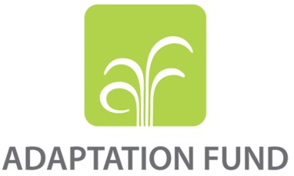

PROGRAMME ON INNOVATION:
AFCIA PROGRAMMES

REQUEST FOR PROJECT FUNDING FROM THE ADAPTATION FUND

The annexed form should be completed and transmitted to the Adaptation Fund Board Secretariat by email.

Please type in the responses using the template provided. The instructions attached to the form provide guidance to filling out the template.

Please note that a project must be fully prepared when the request is submitted.

Complete documentation should be sent to:

The Adaptation Fund Board Secretariat
1818 H Street NW
MSN N7-700
Washington, D.C., 20433
U.S.A
Fax: +1 (202) 522-3240/5
Email: afbsec@adaptation-fund.org

Contents
PART I: PROJECT/PROGRAMME INFORMATION 3
Project / Programme Background and Context: 4
Project / Programme Objectives: 7
Project / Programme Components and Financing: 9
Projected Calendar: 10
PART II: PROJECT / PROGRAMME JUSTIFICATION 11
PART III: IMPLEMENTATION ARRANGEMENTS 26
PART IV: ENDORSEMENT BY GOVERNMENTS AND CERTIFICATION BY THE IMPLEMENTING ENTITY 2

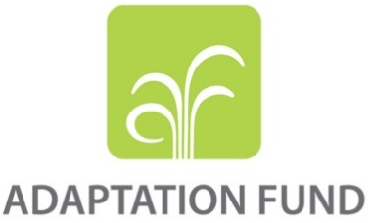
MULTI/ REGIONAL INNOVATION PROJECT/PROGRAMME PROPOSAL

PART I: PROJECT/PROGRAMME INFORMATION

Title of Project/Programme: Accelerating effective innovative adaptation actions, and learnings in the Pacific
Geographic Scope (Multi/Regional): Regional (14 Pacific SIDS) – Cook Islands, Fiji, Federated States of Micronesia, Kiribati, Marshall Islands, Nauru, Niue, Palau, Papua New Guinea, Samoa, Solomon Islands, Tonga, Tuvalu & Vanuatu.
Thematic Focal Area: Innovative adaptation measures
Type of Implementing Entity: Regional
Implementing Entity: Secretariat of the Pacific Regional Environment Programme (SPREP)
Executing Entities: participating SPREP & AF member Pacific SIDS
Amount of Financing Requested: 4,929,546.00 (in U.S Dollars Equivalent)

Project / Programme Background and Context
- Securing Climate Financing to build Resilience to Climate Change in the Pacific Region, a SPREP discussion paper (2021) highlighted the low levels of funding accessed by the Pacific under the three UNFCCC funding mechanisms – the Adaptation Fund (AF), Green Climate Fund (GCF), and the Global Environment Facility (GEF).

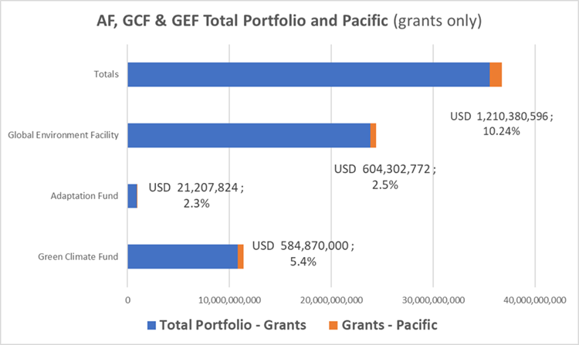
- As of May 2024, funding (grants only) received from the three mechanisms for the Pacific summed up to 10.24% percent of the total funding envelope – Figure 1.

- External finance is critical to the Pacific SIDS to supplement governments’ own expenditures through the national budget process, and it is expected to remain so. However, the evidence suggests there remains an ever-increasing gap between the current levels of adaptation and levels needed to respond to impacts and reduce climate risks – with the estimated adaptation costs and likely adaptation financing needs in developing countries where about five to ten times greater than current international public adaptation finance flows.
Figure 1. An overview of climate finance, grants only, in the Pacific (USD)
Source: SPREP calculations November 2023. Data sources from the AF, GCF and GEF databases.

- On the basis of available estimates, in the Pacific subregion of Melanesia the cost of adapting to climate change could vary from USD 30 million to at least USD 4.5 billion across the subregion over a 5- to 10-year period, while the cost of mitigating climate change could vary from USD 170 million to at least USD 2.9 billion. The World Bank estimated coastal adaptation costs by 2040 ranging from USD 3-11 million for Palau to USD 97-347 million for the Solomon Islands. To have climate resilient infrastructure, average annual costs range from USD 0.3 million for Tuvalu to USD 20.2 million for Fiji. Protection against tropical cyclone damage, losses in the agriculture sector (5% of GDP by 2100), changes in fish catch and destruction of coral reefs, and possible relocation due to climate change will add to these costs. For Kiribati alone, the cost of mitigating sea level rise will reach 4-17% of GDP by 2040.

- At the regional level there are declarations and frameworks such as the 2050 Strategy for the Blue Pacific Continent, the Small Islands Developing States Accelerated Modalities of Action (SAMOA) Pathway, the Framework for Resilience Development in the Pacific (FRDP) and the Boe Declaration on Regional Security to ensure a safe and secure future for the Pacific in the face of climate change.

- Pacific SIDS have progressed adaptation planning, institutional and systems improvement, national processes, and review of national frameworks to align to climate finance criteria in anticipation of improving access to financing.

- The small grants programme will be implemented in 14 Pacific SIDS and SPREP anticipates that the small grants programme will have far reaching benefits on populations especially those who are most vulnerable to impacts of climate change. According to 2022 information published by the Pacific Data Hub, the estimated total population for the targeted countries is 11,906,895. Table 1 demonstrates the proportions in percentage of this total number for each country, from highest to lowest.
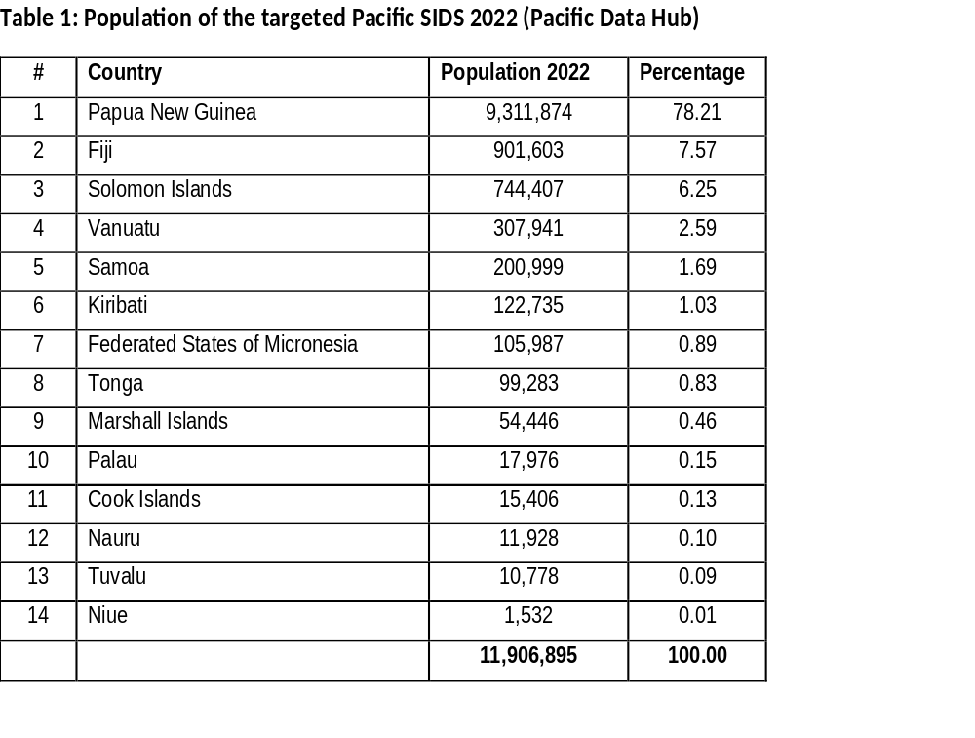

- Pacific communities have already begun to respond to these climate change challenges by leading adaptation actions which integrate traditional knowledge and practices with modern sciences to improve their resilience. However, there is limited systematic information on the large-scale effects of these adaptation actions for building resilience to climate change. For this reason and the increasing severity of climate change impacts, there is an urgent call on scaling adaptation through national policies, research, scientific assessments of the effectiveness of adaptation projects, combining traditional and more recently introduced governance systems, cross-regional exchanges and capacity building, and innovative financing.

- The livelihoods and economies of Pacific SIDS depend heavily on the ocean and climate-sensitive sectors. Changes in precipitation and cyclone patterns are already having devastating effects on water security, agricultural yields and availability of arable land. Fisheries are under threat owing to loss of coral reef, mangrove and sea grass habitats because of destructive climate-related events and warming of the sea significantly affecting the blue economy which is key in the Pacific. Lives, livelihoods, assets and infrastructure are threatened by several climate-related hazards, which are projected to increase in intensity and frequency due to climate change.

- The concept of a small grants programme to focus on incubation and an accelerator to up scaling and or replication of innovative adaptation measures in climate sensitive sectors such as agriculture, fisheries and food security, disaster risk management, energy, health, water and tourism would be a game changer and a transformational change in Pacific SIDS. The opportunity to have a say on what is required to cope with climate change impacts further stresses the need for inclusiveness as the region forges forward to bridge the gap between adaptation needs and available financing. The small grants programme will foster partnerships with small and medium enterprises (SMEs), researchers and AF national designated authorities in the above-mentioned climate sensitive sectors..

- This programme will provide the financing support to coordinate and achieve accelerated innovative adaptation measures and draw on innovative elements of adaptation projects already funded by the AF. An analysis found that these elements targeted the strengthening of governance and coordination processes, applying innovative financial systems (e.g., insurance) for recovery, enforcing ecosystem sustainability, maintaining food and water security, and building capacity. Given the circumstances of the Pacific, such elements will most likely target these same areas.

- Innovation in the context of this programme is foremost the use of small grants as a new form of financing modality to increase the region’s access to adaptation financing and to facilitate support for Pacific SIDS in their responses to climate change. In support of the UNFCCC, the programme recognises the importance of innovation including technology transfer for effective and durable responses to climate change.

- While there are various definitions of innovation, it is commonly understood as the application of a new technology, tool or practice that adds value. It also includes the diffusion and deployment to a new place or sector and is a systematic process. The criteria and procedures for assessing proposed interventions and awarding small grants under this programme will be based on these aspects of innovation, while emphasising the region’s access to adaptation financing as well as scaling up effective and sustainable responses to climate change.

Project / Programme Objectives
- The primary objective is to incubate and accelerate the upscaling, and replication of innovative adaptation measures in the targeted Pacific SIDS.

- Climate change challenges and effects on the Pacific have been well documented over the years. There have been initiatives prior to this programme that emphasised access to climate financing and on adaptation efforts to respond to the effects of climate change. The main aspects which have been discussed in the previous subsection are the needs to improve access to adaptation financing as well as the capability to incubate, upscale and replicate innovative adaptation measures.

- This programme’s objective and components demonstrated by the Theory of Change in Figure 2, stresses the significance of the following areas in response to such aspects:

- Accessing funds through a targeted small grants programme that recognises the significance of locally designed and incubated innovative adaptation measures to respond to climate change impacts.
- Learning from and knowledge sharing on the incubated innovative adaptation measures for upscaling, replication, measuring of the impact of interventions and financing at different levels/scales, as well as promoting efforts in the Pacific for innovative adaptation to enhance climate resilience.
- Accessing resources to build capacity, strengthen processes and coordination, as well as learning and awareness on innovation for sustainable adaptative responses to climate change.

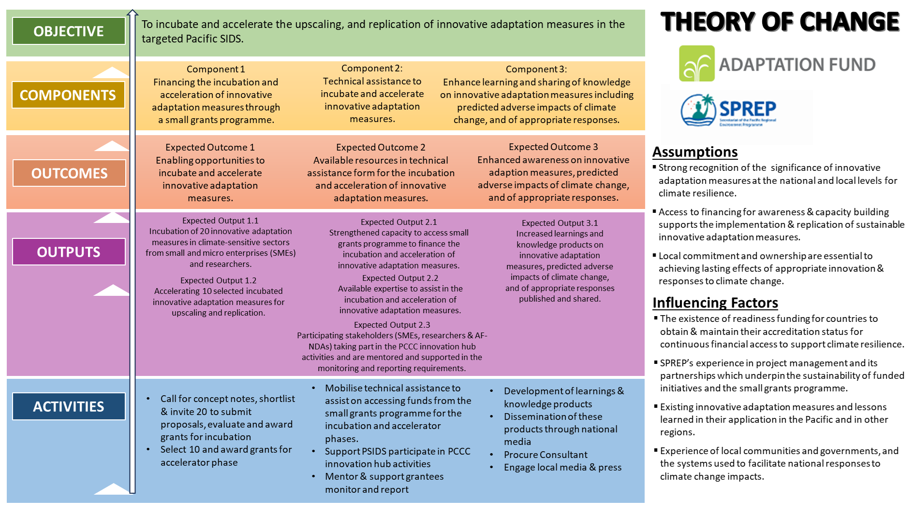
Figure 2. Theory of Change, SPREP-AF Small Grants Programme

- The three components of the programme as reflected in Figure 2 and provided with details in Table 2 (next subsection), portray the above areas. The outputs have been designed to engage SMEs, researches and AF national designated authorities in the 14 Pacific SIDS who will have key roles in achieving the programme’s objectives. The detailed explanation of each component, outcome and output is provided in Part II Project/Programme Justification, (A).

- As the programme advances in its implementation with Call for concept notes and proposals on innovative adaptation measures in climate-sensitive sectors, more specific results are expected and aligned to the wider strategic results framework of the Adaptation Fund such as on Outcome 1 reduced exposure to climate-related hazards and threats, and Outcome 3 strengthened awareness and ownership of adaptation and climate risk reduction processes at local level.

Project / Programme Components and Financing

Table 1: Programme Components & Financing
Project/Programme Components | Expected Outcomes | Expected Outputs | Countries |  | Amount (US$)
Component 1  Financing the incubation and acceleration of innovative adaptation measures through a small grants programme. | Expected Outcome 1  Enabling opportunities to incubate and accelerate innovative adaptation measures. | Expected Output 1.1  Incubation of 20 innovative adaptation measures in climate-sensitive sectors from small and micro enterprises (SMEs), researchers and AF national designated authorities. | Cook Islands, Fiji, FSM, Kiribati, Marshall Islands, Nauru, Niue, Palau, PNG, Samoa, Solomon Islands, Tonga, Tuvalu and Vanuatu. |  | 1,139,000
 |  | Expected Output 1.2  Accelerating 10 selected incubated innovative adaptation measures for upscaling and replication. |  |  | 2,107,000
Component 2:  Technical assistance to incubate and accelerate innovative adaptation measures. | Expected Outcome 2  Available resources in technical assistance form for the incubation and acceleration of innovative adaptation measures. | Expected Output 2.1  Strengthened capacity to access small grants programme to finance the incubation and acceleration of innovative adaptation measures. | Cook Islands, Fiji, FSM, Kiribati, Marshall Islands, Nauru, Niue, Palau, PNG, Samoa, Solomon Islands, Tonga, Tuvalu and Vanuatu. |  | 340,000
 |  | Expected Output 2.2  Available expertise to assist in the execution of activities in the incubation and acceleration of innovative adaptation measures. |  |  | 340,000
 |  | Expected Output 2.3  Participating stakeholders (SMEs, researchers & AF-NDAs) taking part in the PCCC innovation hub activities; and are mentored and supported in the monitoring and reporting requirements. |  |  | 137,000
Component 3:  Enhance learning and sharing of knowledge on innovative adaptation measures including predicted adverse impacts of climate change, and of appropriate responses. | Expected Outcome 3  Enhanced awareness on innovative adaption measures, predicted adverse impacts of climate change, and of appropriate responses. | Expected Output 3.1  Increased learnings and knowledge products on innovative adaptation measures, predicted adverse impacts of climate change, and of appropriate responses published and shared. | Cook Islands, FSM, Fiji, Kiribati, Marshall Islands, Nauru, Niue, Palau, PNG, Samoa, Solomon Islands, Tonga, Tuvalu, and Vanuatu |  | 466,000
4. Project/Programme Execution cost (with PSIDS)  5. IE part Executing Entity  6. Total Project/Programme Cost  7. Project/Programme Cycle Management Fee charged by the Implementing Entity (SPREP) – 8% |  |  |  |  | 340,000
 |  |  |  |  | 14,360
 |  |  |  |  | 4,543,360
 |  |  |  |  | 386,186
Amount of Financing Requested |  |  |  | USD | 4,929,546

Projected Calendar:
Table 2: Programme Milestones & Dates
Milestones | Expected Dates
Start of Project/Programme Implementation | Q2 2025
Mid-term Review (if planned) | Q3 2027
Project/Programme Closing | Q1 2030
Terminal Evaluation | Q1 2030

PART II: PROJECT / PROGRAMME JUSTIFICATION

- Describe the project / programme components, particularly focusing on the concrete adaptation activities, how these activities would contribute to climate resilience. Describe also how they would build added value through the regional or multi-regional approach, compared to implementing similar activities in each country individually. Furthermoe, show how the combination of individual projects would contribute to the overall increase in resilience.

- The programme, accelerating effective innovative adaptation actions, and learnings in the Pacific, focuses on three key interlinked components to support Pacific SIDS on innovative adaptation measures – reference Figure 3.

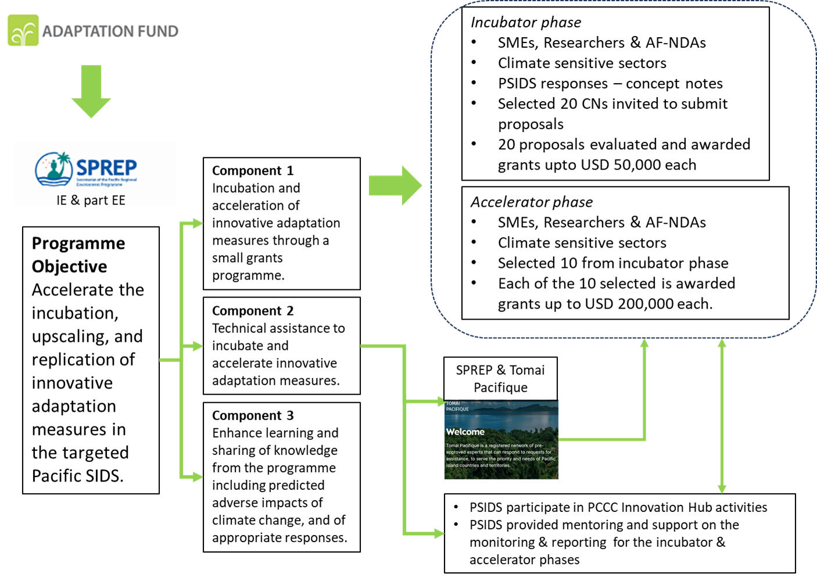

Figure 3: SPREP-Adaptation Fund AFCIA programme design

- The programme has been designed to provide the opportunity for SMEs, researchers and the Adaptation Fund national designated authorities (AF-NDAs) to incubate and accelerate innovative adaptation measures towards upscaling and replication, the innovative adaptation measures are to focus on climate sensitive sectors such as agriculture and water. The inclusion of AF-NDAs is to enable PSIDS that do not have formal set-up /registered SMEs and or Researchers – hence all donor funded activities are executed through government ministries /departments.

- Component 1 focuses on small grants which allows small and micro enterprises (SMEs), researchers and AF-NDAs in participating Pacific SIDS to nurture/incubate and accelerate innovative adaptation measures in climate-sensitive sectors (e.g., agriculture and water) including measures that will assist the most vulnerable groups to respond to climate change impacts.

- Expected Output 1.1 will incubate 20 innovative adaptation measures in climate-sensitive sectors from small and micro enterprises (SMEs), researchers and AF-NDAs. There will be a call for concept notes from the 14 Pacific SIDS. 20 responses to the call for concept notes will be shortlisted. The 20 shortlisted concept notes will be invited for proposals following which they will be awarded grants up to USD 50,000 each – the selection of the 20 concept notes and subsequently to 20 proposals will be on a competitive basis. The selected 20 grantees will have 12-18 months to incubate /nurture /ground-truth the innovative adaptation measures.

- Expected Output 1.2: Following the incubator phase (Expected Output 1.1), 10 incubators will be selected for upscaling and or replication. A grant of up to USD 200,000 will be available for each selected 10 to graduate to the accelerator phase – this will be on a competitive basis. The accelerator phase will have up to 24 months to execute. In addition to the USD 200,000, each of the selected 10 will be entitled to a project execution cost of up to 8.5% of total activities costs – that is, cost of all activities plus execution costs will be up to USD 200,000.

- COMPONENT 2: will address the current limited human resource capacity at the regional and national levels to provide technical assistance to Component 1. The technical assistance will be two-tiered: (i) Specialists/expertise from SPREP and the Tomai Pacifique to assist Pacific SIDS access finance to realise Expected Outputs 1.1 and 1.2 – e.g., technical assistance to develop concept notes and proposals – total budget of USD 340,000; and (ii) provide resources to assist participating Pacific SIDS access activities offered through the Pacific Climate Change Centre (PCCC) innovation hub and SPREP assistance on mentoring and support to report on the execution of the grant activities – total budget at USD 137,000.

- COMPONENT 3: will enhance outreach, learning and knowledge management on innovative adaptation measures including predicted adverse impacts of climate change, and of appropriate responses. There will be specific attention on the experiences from Component 1 and the participation of the local media and press in the awareness activities. A total of USD 466,000 has been budgeted. SPREP will procure a Communications /Information Services consultant to lead activities in Component 3 and support the SPREP Small Grants Coordinator.

- Describe how the project /programme would contribute meaningfully to the Expected Results under the Innovation Pillar (i.e. (i) New innovations and risk-taking encouraged and accelerated; (ii) Successful innovations replicated and scaled up; (iii) Access and capacities enhanced for designing and implementing innovation and (iv) Evidence base generated and shared)

- New innovations and risk-taking encouraged and accelerated.
Component 1 will provide the opportunity for SMEs, researchers and AF-NDAs to incubate 20 innovative adaptation measures and cushion selected risk elements that could be associated with the trial-demonstration and ground-truthing with the USD 50,000 available to each grantee.

- Successful innovations replicated and scaled up.
10 successful and outstanding innovative adaptation measures of the 20 incubated or showcased innovative adaptation measure(s) from Output 1.1 will be selected and provided the opportunity to accelerate for upscaling and replication. Each of the 10 selected will be provided a grant up to USD 200,000.

- Access and capacities enhanced for designing and implementing innovation.
Component 2 provides the SMEs, researchers and AF-NDAs access to experts/specialists from SPREP including Tomai Pacifique register on cost recovery basis to supplement the limited capacities to design and implement innovative adaptation measures. USD 200,000 have been budgeted for 400 working days at USD 500/day for technical assistance to enable participating PSIDS to access these experts/specialists.

- Additionally, grantees will have access to specific activities such as trainings provided by the Pacific Climate Change Centre (PCCC) Innovation Hub and, SPREP mentoring and support to report on the execution of grant activities.

- The accelerating effective innovative adaptation actions, and learnings in the Pacific programme has tremendous potential to enhance the work that PCCC has already started in the innovation space. In October 2022, PCCC hosted the first Pacific Virtual Innovative Exhibition which featured nine main exhibitors and other organisations. There was extensive interest and participation to learn about potential innovative solutions to climate change challenges in the region. The virtual space enabled people to connect and find out about both Pacific and global innovative solutions that have helped in responses to climate risks.

- Evidence base generated and shared.
Component 1 has an incubation phase to trial and showcase innovative adaptation measures such as technology transformation, techniques, innovative finance, practices, and mechanisms. There will be 20 selected concept notes and proposals to be funded for the incubation phase which will form the evidence and basis to select 10 for upscaling and replication as part of the accelerator phase. These results will be documented, shared across the region, and inform further upscaling and replication efforts. Component 3 is dedicated to ensuring that the learnings are documented, and knowledge and experience shared across the region through regional and local media and press. Component 3 budget includes a consultancy of an information services consultant over 600 w/days.

- Describe how the project/programme will source innovation small grant proposals, and screen them for the potential to support concrete adaptation actions to assist the participating countries in addressing the adverse effects of climate change and build in climate resilience.
The programme will administer small grants which should not exceed US$ 250,000. The proposal should provide details on the planned outreach effort and sourcing of innovation proposals, such that it would be ensured that innovation would not be restricted, and that the initiative would allow for various types of innovation (technologies, techniques, innovative finance for adaptation, practices, mechanisms and other.) Innovation may include the involvement of new or non-conventional stakeholders in the innovation process and/or the project develops incorporate new ideas “ways of doing things”, create or enhance social relationships or form new collaborations/ partnerships to address the adaptation challenge etc. (i.e. social innovation.) The proposals should include details on the process for awarding small grants, such as the approach, criteria, and timeline. Details on the proposed monitoring and evaluation arrangements of the small grants, results management, and, very importantly, the learning and sharing aspect of the programme. Provision of technical assistance should also be detailed in the design.

- To access the accelerating effective innovative adaptation actions, and learnings in the Pacific programme, the IE through its part EE functions will administer the following:

- Component 1: Incubator phase, there will be a call for concept notes from small and micro enterprises (SMEs), researchers and AF-NDAs to propose innovative adaptation measures in climate-sensitive sectors such as agriculture and water from the 14 Pacific SIDS. 20 concept notes will be shortlisted and invited to submit proposals and awarded grants up to USD 50,000 each and 12-18 months to demonstrate, incubate and ground-truth the proposed innovative adaptation measures on a competitive basis.

- Component 1: Accelerator phase – 10 projects from incubator phase will be selected and awarded grants up to USD 200,000 each for scaling up and replication.

- Technical assistance through Component 2 will be available on as-needs-basis for the incubator and accelerator phases. As required and requested by the PSIDS (SMEs, researchers and AF-NDAs), the technical assistance will be mobilised from SPREP and Tomai Pacifique register of experts/specialists on a cost recovery basis.

- Component 2 further enables participating grantees (SMEs, Researchers and AF-NDAs) to access specific activities such as training through the Pacific Climate Change Centre (PCCC) innovation hub and mentoring and support from SPREP to report on the execution of grant activities – a budget of USD 137,000 is available for these purposes.

- Component 3, outreach, learning and knowledge management including predicted adverse impacts of climate change, and of appropriate responses for the accelerating effective innovative adaptation actions, and learnings in the Pacific programme will be directly executed by the SPREP with a dedicated Consultant to support the Small Grants Coordinator.

- Describe how the project / programme would screen innovation small grant proposals for their potential to provide economic, social and environmental benefits, particularly to vulnerable communities, including gender considerations, while avoiding or mitigating negative impacts, in compliance with the Environmental and Social Policy and Gender Policy of the Fund.

- All responses to the call for concept notes and proposals (Component 1 Incubator phase) will be subject to an assessment process to shortlist 20 that will be required to submit proposals and subsequently awarded with a USD 50,000 each to participate in the incubator phase.

- More specifically, the shortlisted 20 concept notes will then be invited to submit proposals which will be evaluated by SPREP (the PRMG technical working group).

- The evaluation results will identify proposals to be considered for grant award. Following the evaluation, a due diligence assessment will be conducted on the 20 grantees. A list of the successful 20 proposals will be recommended to the SPREP PRMG Leadership Group for endorsement.

- Once endorsed by PRMG, the SPREP Small Grants Coordinator will proceed to finalising and signing of financing agreements with the 20 grantees.

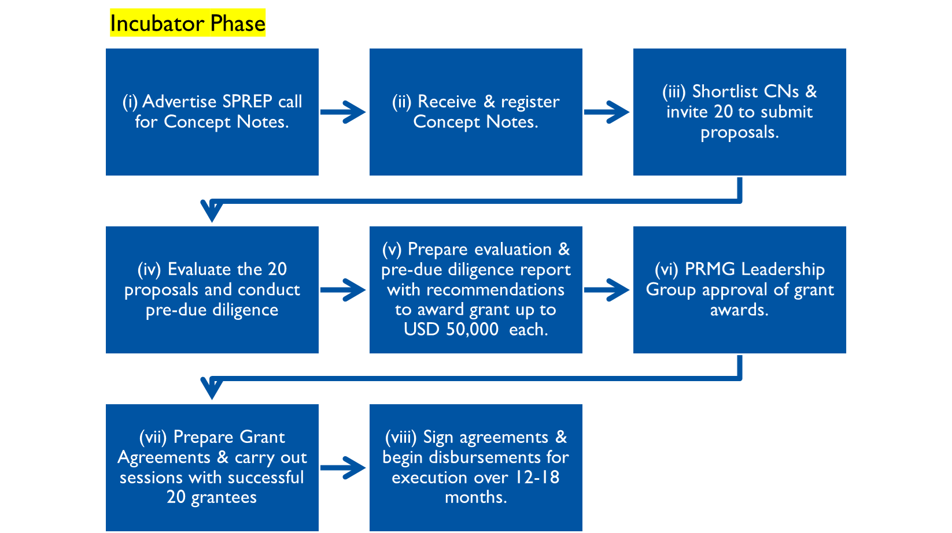

Figure 4. Process flow in the selection of 20 concept notes and proposals for the incubator phase

- The incubator phase is 12-18 months in timeframe following which the accelerator phase will be administered.

- There will be 10 selected proposals /projects from the incubator phase to be accelerated for upscaling and or replication.

- Conduct site inspection and review progress reports of the 20 proposals /projects in the incubator phase.

- Evaluate and select 10 proposals /projects to be considered for the accelerator phase. Invite the 10 selected from the incubator phase to review their proposals with the view to be accelerated for upscaling and replication – technical assistance to review the proposals are available through Component 2.

- Have PRMG LG to approve the 10 proposals and prepare grant agreements for signing and execution.

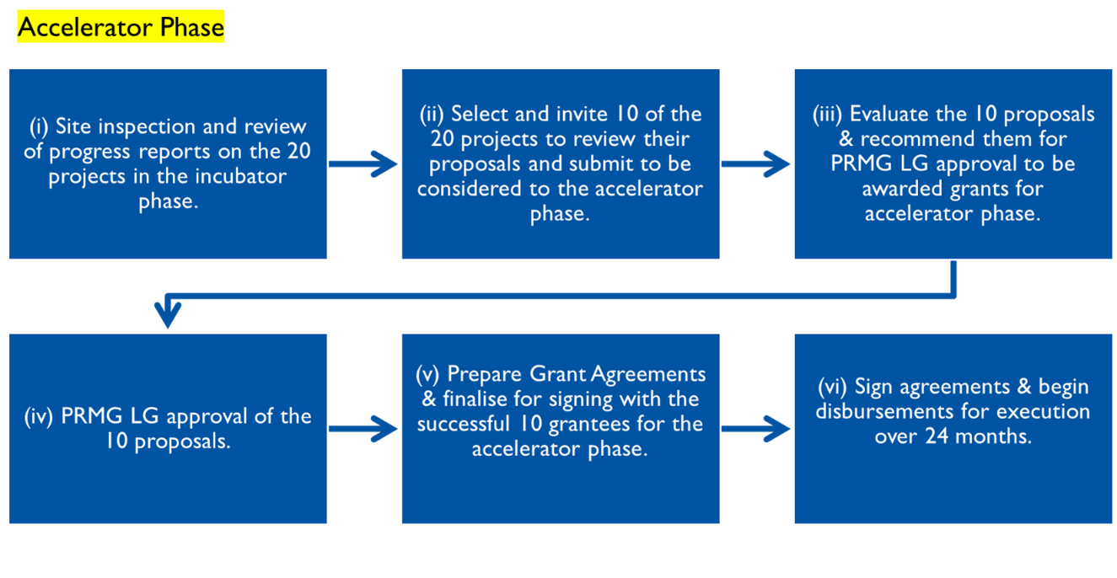

Figure 5. Process flow in the selection of 10 proposals /projects for the accelerator phase

- Describe or provide an analysis of the cost-effectiveness of the proposed project / programme and explain how the regional or multi-regional approach would support cost-effectiveness.

- The investment through the accelerating effective adaptation actions, innovation and learning in the Pacific will directly cushion financial, technical, capacity and coordination barriers to the effective absorbance of innovative adaptation measures with Pacific SIDS. This builds on ongoing similar interventions and existing mechanisms such as small grants presence at the national level, and the pooled register of experts /specialists with SPREP and the Tomai Pacifique at the regional level.

- Although direct revenue will not be realised of all components of this investment, this programme is expected to explore and develop innovative adaptation measures that will reduce costs associated with climate change impacts. The knowledge and learnings from these will inform the upscaling and replication of such measures at the national and regional levels.

- A full cost benefit analysis will be conducted once specific projects are selected into the accelerator phase. This will be organised by SPREP Small Grants Coordinator with the outcome of this analysis informing similar programmes in the future.

- Describe how the project / programme is consistent with national or sub-national sustainable development strategies, adaptation planning processes, national or sub-national development plans, poverty reduction strategies, national communications and adaptation programs of action, national adaptation plans (NAPs), nationally determined contributions (NDCs), adaptation communications, and other voluntary adaptation reports, where they exist, as well as with the UNFCCC technology framework, and other relevant instruments.

- Part I of this proposal has described in detail the relevant regional frameworks and strategies which underpin the relevance of this programme. The justifications provided of the programme’s objective and components highlight clear linkages to the UNFCCC technology framework and the Paris Agreement.

- The Pacific SIDS responses to the call for concept notes and proposals will have the requirement(s) to be aligned to the applicable national or sub-national sustainable development strategies, adaptation planning processes, national or sub-national development plans, poverty reduction strategies, national communications and adaptation programs of action, national adaptation plans (NAPs), nationally determined contributions (NDCs), adaptation communications, and other voluntary adaptation reports. The same alignment must be made to the key priorities of this programme, particularly in the context of innovative adaptation measures that are inclusive, sustainable, and beneficial for a wide range of beneficiaries, especially the most vulnerable people in communities.

- The implementation arrangements in Part III of this proposal outlines the requirement of government participation /endorsement in all the funded projects. Such arrangements will ensure that the innovative adaptation measures proposed are pre-screened and aligned to country priorities – also, will signify the participating country’s endorsement.

- Describe how the project / programme would screen innovation small grant proposals for meeting the relevant national technical standards, where applicable, in compliance with the Environmental and Social Policy of the Fund.

- The Pacific SIDS responses to the call for concept notes and proposals will have each concept note state the national technical standard requirements (e.g., national building standards; energy efficiency standards, etc) that the innovative adaptation intervention is aligned to, as applicable, among other specifications. This information will be verified during the evaluation process.

- On compliance with the Environmental and Social Policy of the Fund, the selected 20 proposals will be subject to an ESS screening during the evaluation process by SPREP. The screening process will be conducted in line with the Environmental and Social Policy of the Fund and SPREP Environment and Social Safeguards Policy, noting the checklist/framework presented in N (Table 4) below.

- Describe if there is duplication of project / programme with other funding sources, if any.

- The modality of small grants programme in the Pacific is not new however the respective scope and focuses differ. This programme objective underscores the introduction of innovative adaptation measures, incubating and ground-truthing these and upscale and or replicate as applicable. The definition criteria of what is innovative provides the uniqueness including a modular structure for future expansion in terms of funding. There is a due diligence process as part of the evaluation of proposals that will also identify duplication if any. As such, the possible duplication in terms of programme scope including the modular structure will be at minimum to none.

- For proposed interventions to be funded under this programme, the call for concept notes and proposals have a requirement in the criteria that activities proposed by SMEs, researchers and AF-NDAs are not already funded by another programme. The evaluation process, ESS screening and the due diligence processes will verify that prospective grantees are not double dipping and interventions are not duplicated.

- Describe the learning and knowledge management system to capture and disseminate evidence, particularly of effective, efficient adaptation practices, products or technologies generated, as a basis for potential scaling up.

The learning and sharing knowledge management mechanism developed should be useful, accessible, sustainable, and, to the extent possible, minimize inefficiencies and duplication. The AFCIA MIEs and RIEs are expected to coordinate closely to help bring about the optimal solution that would best serve the eligible recipient countries’ innovation-for-adaptation knowledge needs, including knowledge already generated under AFCIA so far.

- Component 3 is dedicated to ensuring that the learnings and knowledge from the programme is captured, documented, and disseminated across the region. This component will be coupled with the functions of the Pacific Climate Change Centre (PCCC) Innovation Hub at SPREP and the SPREP presence across the region with its sub-regional offices in Majuro, RMI and Suva Fiji and the present partnership arrangements with sister organisations in the Pacific and other regions such as the Caribbean further strengthens the dissemination avenues.

- Describe the consultative process that would take place, and how will it involve all key stakeholders, and vulnerable groups, including gender considerations.

- Consultative processes will be a crucial part of the procedures when rolling out this programme from its initiation to its conclusion. Inclusivity and engagement of a wide range of relevant stakeholders will be encouraged through SPREP’s partnership with its member countries. For promoting the programme and its activities, key channels of communication will be the SPREP official website and accounts on social media platforms, email notices, letter notifications, as well as publications via newspaper where appropriate will be highlighted in promotional materials for the programme and the call for concept notes and proposals. At the country level, SMEs, researchers and AF national designated authorities are encouraged to ensure that the beneficiaries of the proposed innovative measures are consulted when developing the concept notes and proposals – 14 national consultations /workshops at a budget of USD 14,000 has been allocated for the incubation phase and an additional 10 workshops /consultations at a budget of USD 20,000 for the accelerator phase. Each participating PSIDS to organise these consultations. These consultation funds are in addition to the USD 50,000 per Pacific SIDS during the incubator phase and USD 200,000 per Pacific SIDS during the accelerator phase.

- To access funds from this initiative, consultations will be held to promote the launching of the programme, including awareness raising workshops in Pacific SIDS for the call for concept notes and subsequently proposals. There will also be meetings and other forms of communications between SPREP and the Pacific SIDS. Besides these government agencies, opportunities for one-to-one meetings with prospective grantees will also be provided for guidance and support on the procedures and requirements. These consultations with key stakeholders including identified beneficiaries form the basis for the development of concept notes and proposals to be submitted. This is further enhanced with the provision of technical assistance to potential grantees that include funding allocation for stakeholder consultations in the development of concept notes and proposals.

- Furthermore, there will be a requirement for grant recipients (grantees) to keep registers and other evidence of the beneficiaries’ involvement in consultative processes to measure the engagement of stakeholders and vulnerable groups (disaggregated by gender, age, and persons living with disability). The same information is anticipated when tracking implementation and results for monitoring and reporting purposes.

- Describe how the project/programme draws on multiple perspectives on innovation from e.g., communities that are vulnerable to climate change, research organizations, or other partners in the innovation space, in the context in which the project/programme would take place.

- The programme is targeting SMEs, researchers and AF-NDAs in the 14 Pacific SIDS to participate and focus on the climate sensitive sectors such as agriculture and water. The innovative measures that will be proposed for incubation will have multiple and various beneficiaries. The budget allows for these beneficiaries to provide their respective perspectives on the proposed innovative adaptation measures at the incubation phase and the accelerator phase. Additionally, there will be the organisation/entity (SMEs, researchers & AF-NDAs) and the sector perspectives (participating climate sensitive sectors) to be considered.

- Provide justification for funding requested, focusing on the full cost of adaptation reasoning.

Neither the programme, nor the individual small grant projects will be required to provide co-financing, in line with the Fund’s mandate to finance the full cost of adaptation. However, co-financing would be considered a positive addition to the initiative, including top-ups of the programme.

- In the context of the programme, there is opportunity for participating countries to develop new /innovative measures on adaptation through SMEs, researchers and the AF-NDA to demonstrate, incubate and ground-truth some innovative adaptation measures that are often not possible to be trialled in large adaptation initiatives. There is also the opportunity to have the beneficiaries have a direct say to the design and implement initiatives that are tailored and manageable to suit their circumstances and subsequently protect them from the impacts of climate change. These small interventions are usually not considered in large adaptation initiatives given the economics and the matrix of investment.

- External finance is critical to the Pacific particularly for targeted beneficiaries at the forefront of being impacted by climate change to supplement governments’ own expenditures through the national budget process, and it is expected to remain so. More importantly, this programme has the provision for the targeted beneficiaries to have a say in the design and implementation of the proposed measures.

- Co-financing will not be required for this inaugural small grant programme, however, there will be opportunity for the SMEs, researchers and AF-NDAs including the participating climate sensitive sector of interest to record and report on cash and/or in-kind contributions.

- The approved funding for individual small grant projects may not entirely cover the activities which are expected to occur on the ground, particularly for logistics such as local travel, natural resources, etc. Therefore, the grant recipients will have to contribute to these costs for the successful completion of interventions. Such expectation for the grant recipients would encourage ownership of the projects and the innovative adaptive measures which will be born out of the interventions.

- Describe how the sustainability of the programme outcomes has been taken into account when designing the programme, including in the screening of the innovation small grants projects. Describe the pathways to scale up successful small grants projects.

The programme should include, in its design, pathways for scaling up, i.e. the process by which successful or promising innovations will be directed towards replication and/or scaling up, including for Adaptation Fund’s financing window Large Innovation Projects/Programmes for the exceptionally promising small grants.

- This programme has been designed to have an incubator phase where innovative adaptation measures will be nurtured and ground-truth before a selection of successful and outstanding incubators to progress to the accelerator phase to scale-up and or replicate. The innovative adaptation measures are to be for the climate-sensitive sectors such as agriculture and water.

- The sustainability aspects of the proposed innovative adaptation measures involve consideration of approaches that the beneficiaries can manage and use locally available resources including traditional knowledge to adapt to the impacts of climate change. Where feasible, beneficiaries will also access tools and technologies together with capacity building support to strengthen their innovative adaptation responses. There is evidence that AF-funded projects in other countries with innovative elements were successful and sustainable because of the capacity building component.

- Provide an overview of the environmental and social impact and risk screening process that will be put in place for the subgrant project.

- Within the existing SPREP institutional arrangements for projects portfolio, the Projects Review and Monitoring Group (PRMG) Leadership Group will be responsible for the approval /endorsement of recommended proposals to grant award. Prior to this approval process all proposals will be subject to a technical evaluation that includes ESS assessments/screenings and due diligence on potential grantees.

- The ESS screening exercise will have the following checklist (Table 4) noting that the yet-to-be identified projects will undergo the process during technical evaluation, ESS screening and a due diligence assessment on the potential grantee prior to grants-award.

Table 3: Environmental & Social Safeguards Checklist
Checklist of environmental and social principles | No further assessment required for compliance | Potential impacts and risks – further assessment and management required for compliance
Compliance with the Law | Project(s) supported shall follow all applicable domestic and international law. | Relevant national and local authorities are consulted during the development of applications to the incubator phase to ensure compliance with all relevant laws and national standards. Proposed activities will be implemented in alignment and compliance with national and international regulatory and policy frameworks.
Access and Equity | Project(s) supported shall provide fair and equitable access to benefits in a manner that is inclusive and does not impede access to basic health services, clean water and sanitation, energy, education, housing, safe and decent working conditions, and land rights.  Projects should not exacerbate existing inequities, particularly with respect to marginalised or vulnerable groups. | The sites for activities – there is a risk of inequitable or restricted access. To avoid this risk the ESMP for each project considered for grant-ward to provide mitigation measures including and requires ongoing screening during site selection.  The programme design understands this risk and is developed on the basis of equitable access and will be a crucial guiding principle for the selection of all sites and the process of allocating access to these project benefits will be fair and impartial. A fair process treats people equally without favouritism or discrimination, and an impartial process treats all rivals or disputants equally.  Equitable access requirements of the activities will be clearly and transparently communicated with beneficiaries.  Ongoing environmental and social screening during incubator and accelerator phases will ensure ongoing compliance with this Principle.
Marginalised and Vulnerable Groups | Project(s) supported shall avoid imposing any disproportionate adverse impacts on marginalised and vulnerable groups including children, women and girls, the elderly, indigenous people, tribal groups, displaced people, refugees, people living with disabilities, and people living with HIV/AIDS.  In screening any proposed activities shall assess and consider particular impacts on marginalised and vulnerable groups. | Through its equitable access approach, the programme focuses on marginalised and vulnerable groups (women, youth, elderly, people with disabilities, etc.) and aims to assist them to improve their resilience to climate change impacts through innovative measures. In this way, all vulnerable groups are expected to be positively impacted.
Human Rights | Project(s) shall respect and where applicable promote international human rights. | The following will trigger further assessment if:  - the programme leads to adverse impacts on enjoyment of the human rights of the affected population and particularly of marginalised groups.  - local communities or individuals are not given the opportunity to raise concerns regarding the project during the stakeholder engagement process.  - there is the risk of exacerbating conflicts among and/or the risk of violence to affected communities or individuals.
Gender Equity and Women’s Empowerment | Project(s) supported shall be designed and implemented in such a way that both women and men  - can participate fully and equitably  - receive comparable social and economic benefits  - do not suffer disproportionate adverse effects during the development process. | The below will trigger further assessment.  - Likelihood that the programme would have adverse impacts on gender equality, and/or the situation of women and girls.  - Women’s groups/leaders not given the opportunity to raise gender equality concerns regarding the project during the stakeholder engagement process.  - Activities potentially limit women’s ability to access or use natural resources upon which they depend for a livelihood.
Core Labour Rights | Project(s) supported shall meet the core labour standards as identified by the International Labor Organisation. | 11 Pacific SIDS (Cook Islands, Fiji, Kiribati, Marshall Islands, Palau, PNG, Samoa, Solomon Islands, Tonga, Tuvalu and Vanuatu) are ILO member states. The programme will be implemented in compliance with legislation – no child labour nor forced labour is expected to result from the innovative adaptation measures to be incubated and accelerated for replication and scaling up.
Indigenous Peoples | Project(s) are consistent with the rights and responsibilities set forth in the UN Declaration on the Rights of Indigenous Peoples and other applicable international instruments relating to indigenous peoples. | The below will trigger further assessment:  - Located on or commercially develop natural resources on lands traditionally owned by Indigenous Peoples.  - Activities require the relocation of Indigenous Peoples from lands and natural resources subject to traditional ownership or customary use.  - Significantly impact critical cultural heritage for indigenous peoples.  - Use such cultural heritage for commercial purposes.
Involuntary Resettlement | Project(s) supported shall be designed and implemented in a way that avoids or minimises the need for involuntary resettlement. | When limited involuntary resettlement is unavoidable, due process should be observed so that displaced persons shall be informed of their rights, consulted on their options, and offered technically, economically, and socially feasible resettlement alternatives or fair and adequate compensation.
Protection of Natural Habitats | The Fund shall not support project(s) that would involve unjustified conversion or degradation of critical natural habitats, including those that are  - legally protected  - officially proposed for protection  - recognised by authoritative sources for their high conservation value, including as critical habitat  - recognised as protected by traditional or indigenous local communities | Further assessment is required if the project is expected to impact natural habitats but there are no plans in place to ensure no net loss of biodiversity.
Conservation of Biological Diversity | Project(s) shall be designed and implemented in a way that avoids any significant or unjustified reduction or loss of biological diversity or the introduction of known invasive species. | Further assessment is required if  - the project is likely to affect biodiversity or ecosystem services.  - the project is in a legally protected area or internationally recognised area.  - the project is likely to introduce invasive alien species to the project area.
Climate Change | Projects can adapt to climate change. | The main drivers of climate change that are considered by the AF under this principle are the emission of carbon dioxide gas from the use of fossil fuel and from changes in land use, methane and nitrous oxide emissions from agriculture, emission of hydrofluorocarbons, perfluorocarbons, sulphur hexafluoride, other halocarbons, aerosols, and ozone.  This is not anticipated to be applicable to the proposed activities of the programme.
Pollution Prevention and Resource Efficiency | There are no significant waste generation from the projects. | Further assessment needed if:  - there are adverse impacts associated with waste generation or disposal from the activities.  - there is insufficient management and human and financial resources available on an ongoing basis to achieve effective and continuous environmental and social performance.  - relevant government agencies not fully involved in assisting SPREP to assess the environmental and social risks and potential impacts.
Public Health | Activities supported shall be designed and implemented in a way that avoids potentially significant negative impacts on public health. | Having an innovative adaptation measure will result into a positive impact and could be expected on the public health of targeted communities, e.g. an innovative measure in the water sector can address water-related diseases and vectors.
Physical and Cultural Heritage | Activities supported shall be designed and implemented in a way that avoids the alteration, damage, or removal of any physical cultural resources, cultural sites, and sites with unique natural values recognized as such at the community, national or international level. Activities should also not permanently interfere with existing access and use of such physical and cultural resources. | Sites will be selected to avoid any physical or cultural heritage.
Lands and Soil Conservation | Activities supported shall be designed and implemented in a way that promotes soil conservation and avoids degradation or conversion of productive lands or land that provides valuable ecosystem services | There are no fragile lands that would be lost nor degraded by the activities.

- The evaluation of proposals by the PRMG TWG will help identify if the principles and or safeguards are triggered and should the proposal make the recommended list for funding, the proponent will be given the opportunity to address these. Technical assistance from Component 2 will be available to assist the proponents if required.

PART III: IMPLEMENTATION ARRANGEMENTS

- Describe the arrangements for project / programme management at the regional and multi-regional level, including coordination arrangements within countries and among them. Describe how the potential to partner with national institutions, and when possible, national implementing entities (NIEs), has been considered, and included in the management arrangements.

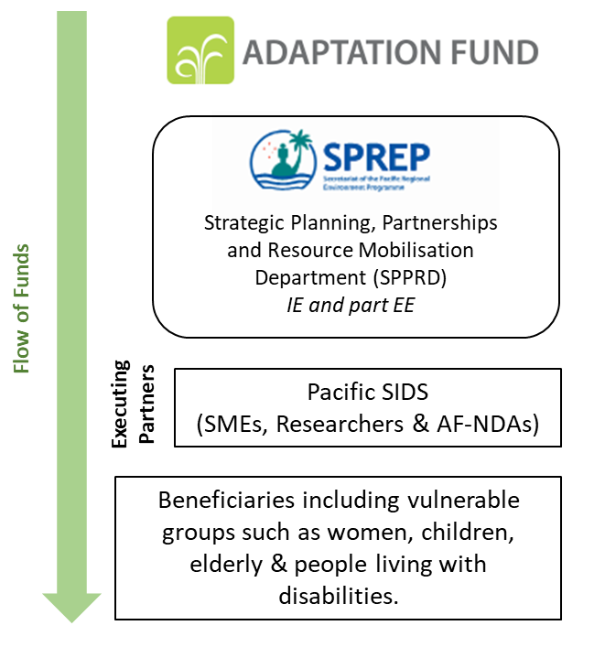
- The SPREP Small Grants Coordinator will be assigned the day-to-day coordination of this programme and placed within SPREP HQ in Apia Samoa at the Strategic Planning Partnerships and Resource Mobilisation Department (SPPRD). The design has SPREP as the implementing entity (IE) and part executing entity (EE). The part EE role is due to Components 2 and 3.

- The programme will utilise the existing regional presence of SPREP such as the sub-regional offices in Majuro, Marshall Islands and Suva, Fiji for better coordination at the sub-regional level. The Small Grants Coordinator will facilitate and administer the programme activities with the grantees, offer support to participating Pacific SIDS (grantees), and report to SPREP and the AF.
Figure 6: Programme management arrangements

- SPREP as a regional accredited and implementing entity for the Adaptation Fund (AF) and Green Climate Fund (GCF), and an executing entity to the Global Environment Facility (GEF) is well-placed to coordinate and lead on a regional small grants programme dedicated to innovative adaptation measures.

- The operations of the small grants programme will be guided by the SPREP Grants Policy and Manual including other institutional processes and policies such as the Financial Policy, Grievance Redress Mechanism, Gender, Disability and Social Inclusion (GEDSI), Environment and Social Safeguards policy and the Child Protection Policy.

- The programme has Component 2 to supplement capacity at the regional and national levels through SPREP Experts/staff and the Tomai Pacifique, a register of experts /specialists on a cost recovery basis. Component 2 also has dedicated budget for all participating Pacific SIDS (grantees) take part in specific activities with the Pacific Climate Change Centre (PCCC) innovation hub and supported /mentored by SPREP on the monitoring and reporting on the execution of activities funded by the programme.

As per Document AFB/B.25/6/Rev.2, regional project and programme proposals are allowed a higher and more flexible maximum level for administration costs, to help ensure regional cooperation, and, as such, the maximum level for the implementing entity management fee. For regional projects/programmes, the administrative costs (Implementing Entity Management Fee and Project/ Programme Execution Costs) at or below 10 per cent of the project/programme for implementing entity (IE) fees and at or below 10 per cent of the project/programme cost for the execution. In case the IE is serving as EE, which is acceptable AFB/PPRC.24/4 9 only under exceptional circumstances and must be well-justified, the execution cost should be limit to 1.5% of the part of the project/programme executed by the implementing entity. If the actual execution costs of the IE exceed the 1.5% cap a justification should be provided. As with regional projects and programmes, proposals for AFCIA programmes need to provide budgets for these two categories.

- The programme is requesting a total of USD 4,929,546.00 from the Adaptation Fund. The summary budget for programme execution is presented in Table 5.

Table 4: Programme Execution Budget
Budget Areas |  | Budget | Totals |  | Y1 | Y2 | Y3 | Y4 | Y5
Programme Execution Costs (PEC) - SPREP as part EE | Office equipment, supplies, etc. | 3,000 | 14,360 | Cap of USD 14,360 as per fee calculation sheet | 2,000 | 200 | 300 | 200 | 300
Programme Execution Costs (PEC) - SPREP as part EE | Coms, internet, etc. | 1,360 | 14,360 | Cap of USD 14,360 as per fee calculation sheet | 300 | 300 | 300 | 300 | 160
Programme Execution Costs (PEC) - SPREP as part EE | Contribution to Audit costs | 10,000 | 14,360 | Cap of USD 14,360 as per fee calculation sheet | 2,000 | 2,000 | 2,000 | 2,000 | 2,000
Programme Execution costs (PEC) - participating PSIDS (grantees) as EE | Office equipment, supplies, furniture, etc | 25,000 | 340,000 | Cap of USD 340,740 (refer to fee calculation sheet) |  | 20,000 | 5,000
 | Communication /internet costs/Utilities | 20,000 | 340,000 | Cap of USD 340,740 (refer to fee calculation sheet) | 4,000 | 5,000 | 5,000 | 5,000 | 1,000
 | Financial Audits @ PSIDS as EE | 45,000 | 340,000 | Cap of USD 340,740 (refer to fee calculation sheet) | 9,000 | 12,000 | 12,000 | 12,000
 | Support to 10 National Coordinators @ PSIDS | 250,000 | 340,000 | Cap of USD 340,740 (refer to fee calculation sheet) | 62,500 | 62,500 | 62,500 | 62,500

- The total programme execution costs are two-tied with (i) for SPREP as part EE role; and (ii) Pacific SIDS (grantees) as EE. The AF fees calculation matrix allows SPREP as IE with part EE an operation budget of maximum USD 14,360 (please note that this is in addition to SPREP IE fee) and Pacific SIDS as EE with a total budget of up to USD 340,740.

- The programme budget has also allocated 8.5% as Programme Cycle Management Fee, also referred to as IE fee of USD 386,248.

The arrangements for ensuring country-drivenness, in case where Letters of Endorsement from the Designated Authorities of the Fund are not provided at submission, should be described, including a timeline and point in process where such letters will be obtained and when and how they would be submitted to the AFB secretariat.

- The Implementing Entity, SPREP, has provided an outline of the proposed programme with the Adaptation Fund national designated authorities in the 14 Pacific SIDS. Additionally in response to the call for concept notes and proposals participating Pacific SIDS (SMEs, Researchers and AF-NDAs) will submit these with government endorsement. All interventions /activities to be funded by the programme are country-led designed that will be driven through the national consultations. SPREP through Component 2 will assist the design with technical assistance to develop concept notes, proposals and facilitate national consultations.

- It is to be noted that the AF-NDA will also participate in the call for concept notes and proposals processes more to enable country participation that do not have formally registered SMEs or Researchers. This programme is designed to have the AF-NDA involved comprehensively in the process and supported to enhance their role.

- Describe the measures for financial and project / programme risk management.

- Pacific SIDS already have some experiences in small grants management and there is existing understanding of the obligations and responsibilities associated with the correct and appropriate use of the funds for approved interventions.

- Figure 6 above illustrates the flow of funds with the Governments (AF-NDAs) having key roles in ensuring that the funded activities address country adaptation priorities. The AF-NDA, function as the leading agents to coordinate on ground executing partners and interventions, will be pertinent in managing financial and project/programme risks when the small grants are rolled out for implementation.

- The SPREP Financial Policy and fiduciary requirements and the Grants Policy and Manual sets out the legal and regulatory framework for providing grants and minimises financial risks such as inappropriate use of funds by the on-ground partners.

- The due diligence assessment in the evaluation process prior to finalising the grant agreement with grantees is another layer to ensure that there are national processes in place to administer funds.

- The AF -NDA will be the primary focal point to support the execution by the participating SMEs and researchers. The monitoring of funds and project activities will also be coordinated by these national agencies and shall report back to SPREP as required under the financing agreements with grantees.

- All participating Pacific SIDS (grantees) will be mentored and supported on the monitoring and reporting on activities funded by this programme – the mentoring and support will be coordinated by the SPREP Small Grants Coordinator through Component 2.

- Describe the measures for environmental and social risk management, in line with the Environmental and Social Policy of the Adaptation Fund.

The safeguard policies of the Fund will apply to the programmes. The small grant can be considered unidentified subprojects (USP) and, as such, the Fund policies regarding USPs, namely as per the “Guidance document for Implementing Entities on compliance with the Adaptation Fund Environmental and Social Policy” and “Updated Guidance for Implementing Entities on the Use of Unidentified Sub-Projects” (Document AFB/PPRC.30/54) will apply. This includes, for example, that, “for projects/programmes with activities/sub-projects unidentified at the time of submitting a proposal for funding, the IE will develop an Environmental and Social Management System (ESMS) for the project/programme and describe it with details in the proposal. In such cases, the project/programme ESMS will contain a process for identifying environmental and social risks for the unidentified activities/sub-projects and, when needed, the development of commensurate environmental and social management elements that will complement and be integrated in the overall ESMP. The project/programme ESMS will specify any other related procedures, roles, and responsibilities.”

- SPREP, as an accredited entity with the Adaptation Fund has an Environmental and Social Management System (ESMS) that is under review to strengthen and better align to multilateral entities such as the Adaptation Fund Environmental and Social Policy. This programme has referenced an Environmental and Social Management System Framework in Table 4 noting that all successful proposals will be subject to an environmental and social safeguard (ESS) screening during the evaluation process. The ESS screening will determine further required assessments as necessary and these will be aligned to the Adaptation Fund Environmental and Social Policy as well.

- If there is a trigger of the ESS during the screening and the applications are considered for funding, the proponent /proposed grantee will be provided the opportunity to develop an ESMP and resubmit the proposal. All ESMPs of funded projects will be integrated to the overall small grants programme and ESS provisions will be highlighted in the funding agreements for approved small grant projects. The grantees can request technical assistance through Component 2 for the development of an ESMP if required.

- Describe the monitoring and evaluation arrangements and provide a budgeted M&E plan.

- A Monitoring and Evaluation (M&E) Framework, reference below, has been developed to provide a ‘ready-to-go’ system that can be immediately introduced and implemented from commencement of the programme.

- The M&E Framework for the programme provides:

- a simple set of parameters to track progress and ensure that the broader activities funded by the small grants contribute to the overall programme objective.
- participating PSIDS (SMEs, researchers & AF-NDAs) and the Small Grants Coordinator at SPREP with logical, self-explanatory lists that specify the types of information that are required to collect so as to inform the AF indicators.
- the Small Grants Coordinator at SPREP to maintain a ‘satellite’ tracking view across all small grants funded projects with access to a complete form of project information (measurement – variables, baseline, mid-term target and end line target), status verification evidence, summary display options and the ability to see and respond to important issues, and to report to the Adaptation Fund.
- information relevant to be captured and report accordingly against the AF results framework.
.
- The M&E framework will be further refined at the inception phase of the programme when the proposals are evaluated and grant agreements finalised by SPREP.

Programme Outputs | Activity(ies) | Indicators | Measurement (variables) | Baseline level | Mid-term Target | End line Target | Data source | Monitoring and validation | Responsible Party | Small grants Activity Budget
Expected results on the output and outcome level of each activity. | Activity to be carried out /led by the Programme Execution Team placed with the Implementing Entity (IE), SPREP | Indicators required to examine whether the result was achieved. | Variables required to measure each of the indicators.  All proposals submitted by the respective execution partners are to address these variables. | Baseline value of the indicator  (i.e., the intervention by the small grants programme) | Midline value of the indicator | End line value of the indicator | Specify the primary source of data that will be used to measure the indicators. | Specify a secondary source of data that will be used to validate findings reported by the primary source. This may include third party evaluations, monitoring data, survey data etc. | The party responsible for collecting and reporting results for every indicator | USD
Output 1.1  Incubation of 20 innovative adaptation measures in climate-sensitive sectors from small and micro enterprises (SMEs), researchers and AF national designated authorities. | Incubation Phase  Activity 1.1.1  Call for concept notes from Pacific SIDS (small and micro enterprises (SMEs) Researchers & AF-NDAs) - note: technical assistance will be available to assist PSIDS develop their responses to the call through Component 2.  Activity 1.1.2  Shortlist 20 of the responses (concept notes) in Activity 1.1.1 and invite the 20 concept notes to submit proposals.  Activity 1.1.3  Evaluate the 20 proposals, conduct due diligence and recommend them to PRMG for approval to award grants of USD 50,000 each.  Activity 1.1.4  Work towards finalising and signing of the grant award agreement with the grantees. | Number of concept notes (CNs). | Who are the applicants? (SMEs /Researchers /AF NDA)  What are the focussed climate-sensitive sectors?  Are the targeted beneficiaries' information in desegregated form? (gender, age, people living with disabilities)  The selected 20 concept notes /proposals pass the due diligence assessment?  There is endorsement by the national government through the AF NDA.  What are the focused sectors that have been chosen for the accelerator phase? | 0 | > 20 | 20 | Number of responses/CNs as recorded by SPREP Registry. | Funding Agreements | Coordinator @ SPREP  Grantees | 1,139,000
 |  | Types (thematic /sector) of shortlisted concept notes. |  | 0 | 20 | 20 | Shortlisting report | Midterm Review and Terminal Review reports | Coordinator @ SPREP  Grantees | 1,139,000
 |  | Type of grantees (SMEs, Researchers & AF-NDAs) participating in the incubator phase. |  | 0 | 20 | 20 | Grant-award agreements with the 20 grantees. | Implementation progress reports | Coordinator @ SPREP  Grantees | 1,139,000
Output 1.2  Accelerating 10 selected incubated innovative adaptation measures for upscaling and replication. | Accelerator Phase  Activity 1.2.1  Select 10 successfully incubated innovative adaptation measures from the Incubation Phase.  Activity 1.2.2  Provide technical assistance (through Component 2) to further develop and finalise the necessary documentation (e.g., logframe, results framework, etc) for the 10 selected innovative adaptation measures.  Activity 1.2.3  Recommend the selected 10 to PRMG for endorsement.  Activity 1.2.4  Work towards finalising and signing of the grant-award agreement with the grantees. | Number of incubators available for selection into the accelerator phase |  | 20 | 10 | 10 | 1. Report on the selection of 10 innovative adaptation measures for the accelerator phase.  2. Full documentation for each selected 10 (e.g., proposal)  3. Record(s) of PRMG endorsement (e.g. meeting minutes)  4. Ten grant-award agreements  5. Implementation progress reports including financial. | Implementation progress reports |  | 2,107,000
 |  | Number of grant-awarded proposals for the acceleration phase |  | 20 | 10 | 10 |  |  |  | 2,107,000
Output 2.1  Strengthened capacity to access small grants programme to finance the incubation and acceleration of innovative adaptation measures. | Activity 2.1.1 /2.2.1  Call for expression of interest and associated cost estimates from the Tomai Pacifique resgister of prescreened experts /specialists, as required by PSIDS for the Incubation and Accelerator Phases.  Activity 2.1.2 /2.2.2  Select the technical assistance and award service contracts and deploy accordingly. | No. and type of viable innovative adaptation measures progressed towards upscaling and replication. | Who are the participating PSIDS?  What are the selected viable adaptation measures to be accelerated for upscaling and replication?  How are these viable adaptation measures accelerated? | 0 | 20 Incubator phase  10 Accelerator phase | 20 Incubator phase  10 Accelerator phase | 1. Selection of experts /specialists Reports  2. Technical assistance /consultancy agreements.  3. Progress reports /deliverables. | Financing Agreements  Midterm Review and Terminal Review reports | Coordinator @ SPREP  Participating PSIDS | 340,000
Output 2.2  Available expertise to assist in the execution of activities in the incubation and acceleration of innovative adaptation measures. |  |  |  | 0 | 20 Incubator phase  10 Accelerator phase | 20 Incubator phase  10 Accelerator phase |  |  |  | 340,000
Output 2.3  Participating stakeholders (SMEs, researchers & AF-NDAs) taking part in the PCCC innovation hub activities and are mentored and supported in the monitoring and reporting requirements. | Activity 2.3.1  Inform SMEs, researchers & AF-NDAs on the PCCC Innovation Hub activities and organise for their participation as appropriate.  Activity 2.3.2  Provide mentoring and support to all grantees on the monitoring and reporting requirements on their respective activities. | Number of participants and types of activities /training. | Who are the participating entities?  Which sectors?  Which PSIDS? | 0 | 5 | 10 |  | Training reports | PCCC innovation hub  PSIDS  Small Grants Coordinator | 137,000
Output 3.1  Increased learnings and knowledge products on innovative adaptation measures, predicted adverse impacts of climate change, and of appropriate responses published and shared. | Activity 3.1.1  Develop and finalise the terms of reference - will outline all activities associated with this component including deliverables and timelines - with the Information services Consultant.  Activity 3.1.2  Procure for the consultant and deliver on the ToR accordingly. | Number. of news outlets in the local press and media that participated in the awareness activities.  Types of information products produced /published. | Terms of Reference - clearly articulating the activities for Component 3.  Engagement details with the participating local news & media.  Evidence of type of products produced and disseminated | 0 | 5 | 10 | 1. Specific deliverables as per terms of reference - includes learnings and knowledge products on innovative adaptation measures, predicted adverse impacts of climate change, and of appropriate responses.  2. Evidence of participation of local media & press. | Products produced.  Details of engagement with local press & media. | Small Grants Coordinator | 466,000

- Include a results framework for the project / programme proposal, including milestones, targets, and indicators.

- A results framework, reference F below, has been developed to align the overall small grants programme objective, outcomes, and outputs with that of the Fund. The small grants programme indicators have also been developed to measure the necessary information /results from the small grants programme funded activities against the Fund’s indicators.

- Demonstrate how the project / programme aligns with the Results Framework of the Adaptation Fund
Project outcomes should be aligned with the Fund level outcome for innovation (Outcome 8) of the Strategic Results Framework and all others that may apply in the context of the project /programme. Please follow additional guidance provided in Document AFB/PPRC.29/44.

Small Grants Programme Objective | Objective Indicator(s) | Fund Outcome | Fund Outcome Indicator | Budget (USD)
Objective  The primary objective is to incubate and accelerate the upscaling, and replication of innovative adaptation measures in the targeted Pacific SIDS. | Objective Indicator 1  Evidence of viable innovative adaptation measures supported by the programme | Fund Outcome 8  Support the development and diffusion of innovative adaptation practices, tools, and technologies. | Fund Outcome Indicator 8  Innovative adaptation practices are rolled out, scaled up, encouraged and/or accelerated at regional, national and/or subnational level. | 4,189,000
 | Objective Indicator 2  Evidence of targeted beneficiaries with desegregated data where available.  (number of people and number & type of climate-sensitive sectors) |  |  | 4,189,000

Outcomes | Outcome Indicator | Measurement (variables) | Fund Output | Fund Output Indicator | Budget (USD)
Outcome 1  Enabling opportunities to incubate and accelerate innovative adaptation measures. | Outcome Indicator 1.1  a) 20 applicants selected and grant awarded for the incubation phase  b) 10 incubators selected, and grant awarded for up scaling and replication | Who and number of PSIDS participating?  Number of SMEs  Number of Researchers  Number of AF NDAs  Which selected innovative measures are potential for scaling up to regional levels? | Fund Output 8  Viable innovations are rolled out, scaled-up, encouraged and/or accelerated. | Fund Output Indicator 8.2  No. of key findings on effective, efficient adaptation practices, products and technologies generated. | 3,246,000
 | Outcome Indicator 1.2  Number. of people (desegrated by gender, age groups and people living with disabilities) benefiting from the funded innovative adaptation measures. | Who are the beneficiaries? Desegregated by gender, age including people living with disabilities.  What are the focused /dominant climate sensitive sectors? |  |  | 3,246,000
Outcome Indicator 1.3
Number and type of climate sensitive sectors targeted by the innovative adaptation measures.
Outcome 2  Available resources in technical assistance form for the incubation and acceleration of innovative adaptation measures. | Outcome Indictor 2.1  Number and type of technical assistance provided to PSIDS. | What technical assistance were requested by the PSIDS?  How effective have these being for the Objective of the programme? |  |  | 340,000
 | Outcome Indictor 2.2  Number and type of activities for PSIDS through the PCCC innovation hub. | What are the PCCC innovation hub activities (e.g., trainings) for PSIDS?  How many PSIDS participated? |  |  | 137,000
 | Outcome indicator 2.3  Number of grantees mentored /supported on monitoring and reporting. |  |  |  | 137,000
Outcome 3  Enhanced awareness on innovative adaption measures, predicted adverse impacts of climate change, and of appropriate responses. | Outcome Indicator 3.1  Percentage of the targeted population participating in awareness activities on innovative adaptation measures. | No. of people (desegregated data by gender and people living with disabilities) targeted by the awareness activities.  Type of learnings and knowledge products on innovative adaptation measures developed /published.  No. of news outlets in the local press and media that have covered the topic. | Fund Output 3.1  Targeted population groups participating in adaptation and risk reduction awareness activities. | Fund Output Indicator 3.1  No. of news outlets in the local press and media that have covered the topic. | 466,000
Outcome Indicator 3.2
Number & type of local news outlets participating.

- Include a detailed budget with budget notes, broken down by country as applicable, a budget on the Implementing Entity management fee use, and an explanation and a breakdown of the execution costs.

- The detail budget is presented below. The budget is also in yearly form with proposed disbursements discussed below, H.

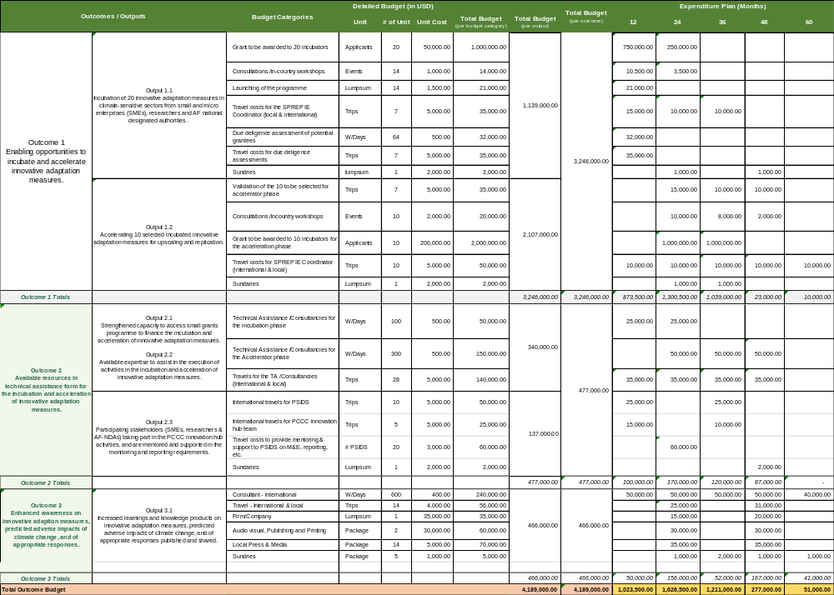

- Implementing Entity fee budget – as required by the Fund, the IE fee budget is also presented as follows.

Programme Cycle Management Fee charged by the Implementing Entity (8.5%)
Budget Breakdown as required by AF proposal | Total (USD)
SPREP Small Grants Coordinator - contribution to the employment package @ USD 26,248 per 12 months for 60 months | 131,240.00
Expansion of programme - new partnerships, new funding, etc | 5,000.00
Midterm review & terminal evaluation | 80,000.00
Support to IE Executives, Legal, Project Review & Monitoring Group | 80,000.00
Proposal evaluation meetings (PRMG TWG) | 4,940.00
SPREP Finance & Procurement cost recovery | 65,000.00
SPREP support functions such as IT, HR etc | 20,000.00
Total | 386,180.00

- Include a disbursement schedule with time-bound milestones.

- The proposed disbursement schedule as below.
 | Y1 | Y2 | Y3 | Y4/Y5 | Total
Disbursement 1 | 2,399,675.00
Disbursement 2 |  | 1,730,225.00
Disbursement 3 |  |  | 386,230.00
Disbursement 4 |  |  |  | 27,230.00 | 4,543,360.00
IE Fee (8.5%) | 203,972.38 | 147,069.13 | 32,829.55 | 2,314.55 | 386,185.60
Totals | 2,603,647.38 | 1,877,294.13 | 419,059.55 | 29,544.55 | 4,929,545.60

PART IV: ENDORSEMENT BY GOVERNMENTS AND CERTIFICATION BY THE IMPLEMENTING ENTITY

Record of endorsement on behalf of the government: Letters of endorsement may be provided at a later stage, if not possible to include with the fully-developed programme. In that case, the proposal should describe how the IE plans to secure governments’ endorsements of the initiative and when the IEs will provide the letters in the reports to the secretariat.
(Enter Name, Position, Ministry) | Date: (Month, day, year)
(Enter Name, Position, Ministry) | Date: (Month, day, year)
(Enter Name, Position, Ministry) | Date: (Month, day, year)

- Given that this is a small grants programme, country participation and specific support letters will be provided by those participating Pacific SIDS responding to the call for concept notes and subsequently proposals – the letter will be a requirement for all concept notes and proposals.

B. Implementing Entity certification Provide the name and signature of the Implementing Entity Coordinator and the date of signature. Provide also the project/programme contact person’s name, telephone number and email address
I certify that this proposal has been prepared in accordance with guidelines provided by the Adaptation Fund Board, and prevailing National Development and Adaptation Plans including other national frameworks such as the National Determined Contributions and subject to the approval by the Adaptation Fund Board, commit to implementing the project/programme in compliance with the Environmental and Social Policy of the Adaptation Fund and on the understanding that the Implementing Entity will be fully (legally and financially) responsible for the implementation of this project/programme.
Rupeni Mario
Implementing Entity Coordinator

Date: December 18 2024 | Tel. and email:+685 21929 (ext 277); rupenim@sprep.org
Project Contact Person: Rupeni Mario and Christina Taua
Tel. And Email: +685 21929; rupenim@sprep.org; christinat@sprep.org

Key policy documents: - PROGRAMME ON INNOVATION: OPERATIONAL POLICY AND GUIDANCE TO THE ADAPTATION FUND CLIMATE INNOVATION ACCELERATOR (AFCIA) IMPLEMENTING ENTITIES - GUIDANCE TO IMPLEMENTING ENTITIES FOR APPLICATION OF INNOVATION INDICATORS FOR FULLY DEVELOPED PROJECT/PROGRAMME PROPOSALS provides guidance on the new indicators that should be referenced when presenting alignment of project objectives and outcomes with the Fund level strategic outcome for innovation (Outcome 8).
The programme can have a thematic focus or foci, such as the following (i.e. this is not an exhaustive list): Agriculture and food security; Disaster risk reduction and early warning systems; Forests and land use management; Human health, including maternal and child health and welfare etc; Innovative adaptation financing; Local traditional ecological knowledge solutions, including harnessing or revival of indigenous, traditional solutions; Marine, fisheries, and oceans adaptation; Nature-based solutions, including ones that are biodiversity-supporting, in various settings (e.g. urban, peri-urban and non-urbanized); Urban adaptation and Water management.
https://pacificdata.org/
https://www.frontiersin.org/articles/10.3389/fmars.2019.00289/full
https://www.adaptation-fund.org/wp-content/uploads/2020/09/AF-Innovation-Slides.pdf
https://www.adaptation-fund.org/wp-content/uploads/2020/10/AFB.PPRC_.26.b.17-Options-for-further-defining-innovation-in-adaptation-1.pdf
These AF national designated authorities are considered as potential applicants as some Pacific SIDS may not have a formal set up of SMEs and researchers.
The draft SPREP Grants Policy refers to the responses to a CfP as concept notes – hence the reference made here.
For some clarifications on the concept of risk, please see INNOVATION PROJECT DESIGN ELEMENTS AND FURTHER CLARIFICATION ON THE CONCEPT OF RISK.
https://www.sprep.org/news/pacific-climate-change-centre-supports-the-pacific-to-access-climate-innovative-solutions
These national AF designated authorities are considered as potential applicants as some Pacific SIDS may not have a formal set up of SMEs and researchers. Hence every 14 Pacific SIDS has an equally opportunity to participate in this programme.
PRMG – project review and monitoring group. The PRMG is chaired by the SPREP Deputy Director General and meets once at the end of each quarter – 3 in-person PRMG meetings annually.
PRMG technical working group meets twice in a quarter and is chaired by the Director Strategic Planning, Partnerships & Resource Mobilisation (DSPPR) – 8 in-person TWG meetings annually
The PRMG LG composers of all SPREP programme Directors, Legal Counsel chaired by the Deputy Director General.
Available at: https://www.adaptation-fund.org/wp-content/uploads/2022/03/AFB.PPRC_.29.44-Guidance-to-IEs-for-inclusion-of-objectives-and-Indicators-for-Innovation.pdf
⁶ Each Party shall designate and communicate to the secretariat the authority that will endorse on behalf of the national government the projects and programmes proposed by the implementing entities.
The letter of endorsement could be requested, for instance, following a call for expressions of interest for countries to participate in the provision of small grants opportunities. Such plans should be outlined in Section III, Implementation Arrangements (A).

