
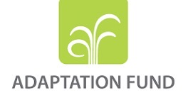

Green and Resilient Ecosystems for Somali Livelihoods – (Hal-Abuur) Project
Inception Workshop Report

Mogadishu, Somalia
6 – 11 May 2026

Contents
I. Introduction 1
II. Summary and Recommendations 1
III. Project Inception Workshop Objectives and Overview 3
IV. Project Overview 4
V. Workshop Presentations and Technical Sessions 4
VI. Revised Implementation Modalities and Start-up Actions 9
Agreed Start-Up Actions for Hal-Abuur: 11
VII. Conclusion 12
Annex I: Inception Workshop Agenda 13
HAL-ABUUR PROJECT INCEPTION WORKSHOP AGENDA 15
Day 2-5: Technical Workshop Agenda 16
Annex II: List of Participants 19
Annex III: Screen shot Online Endorsement of PSC members. 22

List of Acronyms
Acronym | Full Name
AF | Adaptation Fund
AWPB | Annual Work Plan and Budget
CCRIP | Community Climate Resilient Investment Plan
CLEF | Cluster-Level Extension Facilitator
ESMP | Environmental and Social Management Plan
ESP | Environmental and Social Policy
ESPs | Environmental and Social Principles
FMS | Federal Member State
GALS | Gender Action Learning Systems
GAP | Gender Action Plan
GGWI | Great Green Wall Initiative
GRM | Grievance Redress Mechanism
GP | Gender Policy
IFAD | International Fund for Agricultural Development
KM | Knowledge Management
KMC | Knowledge Management and Communication
M&E | Monitoring and Evaluation
MoAI | Ministry of Agriculture and Irrigation
MoECC | Ministry of Environment and Climate Change
MoLFR | Ministry of Livestock, Forestry and Range
NCF | National Climate Fund
NWFP | Non-Wood Forest Products
P/FFS | Pastoral/Farmer Field Schools
PIM | Project Implementation Manual
PMP | Pest Management Plan
PMU | Project Management Unit
PP | Procurement Plan
PPR | Project Performance Report
PSC | Project Steering Committee
RUMC | Resource User Management Committee
SADAR | Sadar Development and Resilience Institute
SEA | Sexual Exploitation and Abuse
SH | Sexual Harassment
USP | Unidentified Sub-Project
VDC | Village Development Committee
WPB | Work Plan and Budget

I. Introduction
- The Green and Resilient Ecosystems for Somali Livelihoods Project, known as Hal-Abuur, held its inception workshop from 6 to 11 May 2026. The formal ceremonial inception workshop took place on 6 May 2026 at NAC Hotel, Mogadishu, followed by technical working sessions from 7 to 11 May 2026.
- The project preparation process started with the Adaptation Fund (AF) Focal Point (FP) at that time’s endorsement letter issued on 17 August 2023, followed by the concept note submission to the Adaptation Fund on 15 December 2023 and the full project proposal submission in September 2024. The project was considered by the Adaptation Fund Board in October 2024 and received final Board approval in April 2025. Its implementation period starts from 1 July 2026 and is expected to run until 30 June 2032.
- Hal-Abuur is a six-year project financed through a US$10 million AF grant, implemented by the International Fund for Agricultural Development (IFAD) and executed by Sadar Resilience and Development Institut (SADAR) in Somalia. The project aims to enhance the climate resilience of ecosystems and livelihoods by operationalizing the Great Green Wall Initiative in Somalia.
- The project targets inland areas of Lower Shabelle (Baraawe), and Mudug (Hobyo). These areas were selected because of their climate vulnerability and relevance to the Great Green Wall Initiative.
- The workshop brought together IFAD, SADAR, the Hal-Abuur project team, federal and state government representatives, district authorities, the National Climate Fund which is the National Designated Authority for the Adaptation Fund, civil society representatives and technical specialists. The sessions provided an opportunity to review the project design, clarify institutional roles, discuss Adaptation Fund requirements, review the 2026 Annual Work Plan and Budget, procurement plan and agree on priority actions for the first year of implementation.

II. Summary and Recommendations
- The workshop formally launched the Hal-Abuur project and marked the beginning of implementation. It provided the project team and partners with a common understanding of the project objective, implementation arrangements, fiduciary requirements, requirements for compliance with AF Social and Environmental Policy (ESP) and Gender Policy (GP), reporting procedures and first-year priorities.
- The workshop confirmed the importance of finalizing the Project Implementation Manual as a priority start-up deliverable. The PIM should be revised to fully integrate Adaptation Fund requirements, including the Environmental and Social Management Plan, Grievance Redress Mechanism, Pest Management Plan, Gender Action Plan, Community Climate Resilient Investment Plan (CCRIP) screening procedures, procurement requirements, M&E responsibilities and reporting obligations.
- The first Project Steering Committee (PSC) meeting was convened virtually on May 7 2026 of the inception process. The PSC endorsed the Annual Work Plan and Budget and the Procurement Plan (PP) for 2026, providing the governance basis for the project to proceed with agreed start-up activities.
- The workshop recommended that the district diagnostic be treated as an immediate priority. The diagnostic should provide the evidence base for community selection, cluster identification and restoration planning. It should include land use, land cover, sand dunes, watershed boundaries, digital elevation models, rivers, roads, drought and flood vulnerability, and water availability. Some of these elements may require external consultancy support, while SADAR and the regional teams will support data collection and field verification.
- The workshop recommended that the project use a transparent table of communities to support eligibility screening, suitability assessment, ranking and final community selection. Indicators derived from the project design should be retained for accountability, while additional practical indicators and explanatory notes may be added where required.
- The workshop recommended that community mobilisation remain centred on the Shiir Guud (General Meeting/Gathering) process. Community-level CCRIPs should be prepared first and then consolidated into cluster-level CCRIPs, especially where interventions require coordination across communities, such as shared pasture management and watershed management.
- In relation to AF ESP and GP compliance requirements for Hal Abuur, the workshop recommended priority actions for the first year of implementation:
- Revise and update as needed the project Environment and Social Management Plan (ESMP), and integrate the relevant measures in the PIM, M&E system, and other relevant project documents. The ESMP should be used as a living tool throughout implementation, regularly updated as the project evolves, and used to track the implementation of mitigation measures and related indicators as part of reporting to IFAD and the Adaptation Fund, including through the Project Performance Report (PPR).
- Conduct the E&S risk screening of all CCRIPs, using the 15 Adaptation Fund Environmental and Social Principles, before approval, procurement or field implementation. Where new risks are identified, relevant mitigation measures must be integrated into the project ESMP or, where needed, into sub-project-level ESMPs. High risk CCRIPs will not be approved and will need to be redesigned.
- Establish, disclose and operationalize the project Grievance Redress Mechanism as soon as possible. The GRM should include community-level entry points, PMU/regional-level registration and follow-up, and escalation pathways to IFAD and the Adaptation Fund where required.
- Prepare the Pest Management Plan before any field activities involving pesticides, fertilizers or related agricultural inputs begin.
- Review and update the project Gender Action Plan as early as possible to reflect the target areas, beneficiary groups and implementation arrangements
- Finally, revise the PIM to include the specific AF ESP and GP requirements for the project. Elements to be included should cover, among others: the integration of relevant measures from the revised ESMP; guidance for the operationalisation of the project level Grievance Redress Mechanism; the outline and ToRs for the development and implementation of the Pest Management Plan; a clear delineation of the responsibilities for the project ESMP; the environmental and social risk screening procedures for CCRIPs; and the applicable procurement requirements, M&E responsibilities and reporting obligations.
- The workshop recommended that the cluster level facilitators (CLeF) arrangements be reviewed. The current draft PIM requirement that 30 per cent of CLeFs be women and youth should be removed, as it is not required under the project design. It was later recommended the CLeF selection should be merit-based and should focus on qualifications, field capacity and suitability for the role, while considering inclusion.
- The workshop also recommended that SADAR review the CLeF workload, compensation and team structure. The expected responsibilities under mobilisation, Pastoral/Livestock Farmer Field School (P/L/FFS facilitation and business skills training may require a broader staffing or outsourcing arrangement. SADAR will prepare a proposal for IFAD review within the available budget envelope.
- The workshop identified a design inconsistency regarding livelihood diversification cooperatives. Some parts of the design refer to 500 cooperatives, while the results framework holds the project accountable for organizing 2,000 households in cooperatives. The inception workshop agreed to record this inconsistency and interpret the operational target as 50 cooperatives, while maintaining the 2,000-household results framework target.
- The workshop recommended that knowledge management, communication, visibility and stakeholder engagement be established from the start of implementation. This should include an action tracker, stakeholder tracker, photo and document archive, field documentation system and practical knowledge products linked to M&E, communication and reporting.

III. Project Inception Workshop Objectives and Overview
- The inception workshop aimed to ensure a clear and common understanding of the Hal-Abuur project cycle, objectives, components, institutional arrangements and expected results. It also aimed to clarify the legal, financial, fiduciary, procurement, safeguards, reporting and implementation responsibilities of the institutions involved. It also presented the roles and responsibilities of IFAD, SADAR, MoECC, NCF, Federal Member States, the district authorities of Hobyo and Baraawe, and other key stakeholders. The workshop was conducted in a hybrid format combining in-person participation by all stakeholders based in Somalia and remote participation of the IFAD teams based in Cairo and Rome, and NCF team.
- The formal inception day was attended by federal ministries MoECC, MoAI, and MoLFR, the National Climate Fund, Federal Member State representatives of Galmudug and Southwest MoECCs, district authorities, civil society organisations, IFAD, SADAR and the Hal-Abuur project team.
- The workshop was organized through a combination of formal presentations, plenary discussions and technical working sessions. This format allowed participants to review the project design, discuss implementation arrangements, identify bottlenecks, clarify Adaptation Fund procedures and requirements, and agree on practical actions required for start-up.
- The technical sessions from 7 to 11 May 2026 focused on procurement, knowledge management and communication, gender and social inclusion, monitoring and evaluation, AF environmental, social and gender requirements, accountability, the Project Implementation Manual, district diagnostics, community mobilisation, CCRIPs, Adaptation Fund monitoring and reporting, and start-up work planning.

IV. Project Overview
- Hal-Abuur is a six year (2016-2031) project and is designed to enhance the climate resilience of ecosystems and livelihoods in Somalia by operationalizing the Great Green Wall Initiative (GGWI). The project is funded by AF $10 million grant, and it responds to land degradation, climate vulnerability, pressure on rangelands, weak natural resource management systems and limited livelihood diversification opportunities in pastoral and agro-pastoral areas.
- The project has three components:
- Component 1: Green and Resilient Agro-Pastoral and Pastoral Ecosystems. This component focuses on participatory planning, regreening interventions, reforestation, afforestation, reseeding, soil and water conservation techniques and site protection measures. It aims to restore degraded ecosystems and strengthen their resilience.
- Component 2: Resilient Agro-Pastoral and Pastoral Livelihoods. This component aims to improve the resilience of farming and pastoral practices through training, improved seeds and equipment, resilient nurseries, livelihood diversification and non-wood forest products. Gender and social inclusion are key features of the component.
- Component 3: Operationalization of the Great Green Wall Initiative. This component focuses on developing and implementing a national GGWI strategy and action plan, building national and state-level capacities, establishing coordination mechanisms and monitoring progress using the Land Degradation Surveillance Framework methodology.
- The project will be implemented by IFAD as the accredited Implementing Entity and SADAR as the Executing Entity. IFAD is responsible for legal and financial accountability to the Adaptation Fund, supervision, no-objection processes, safeguards compliance, fiduciary oversight and quality assurance. SADAR is responsible for day-to-day implementation, PMU management, recruitment, contracting, fund management, community facilitation, safeguards execution, monitoring and reporting.
- The Project Steering Committee (PSC) will provide strategic oversight. The PSC will review and endorse annual work planning and procurement plan, provide guidance on major implementation issues, and support coordination among the main institutions involved in the project.

V. Workshop Presentations and Technical Sessions
Day 1: Opening, Project Overview, Implementation Arrangements and Financial Management
- The formal inception workshop was held on 6 May 2026 at NAC Hotel, Mogadishu. The day included introduction and the official opening, presentation of the project overview, implementation arrangements, reflections from FMS/regional and district representatives, financing agreement orientation, presentation and approval of the AWPB and PP 2026, discussion of institutional and implementation issues, and financial management orientation.
- The project overview presentation introduced the project rationale, objective, target areas, components and expected results. It confirmed that Hal-Abuur will focus on inland areas of Lower Shabelle and Mudug, with Baraawe and Hobyo as pre-identified districts.
- The implementation arrangements presentation clarified the governance structure, institutional roles, coordination arrangements and reporting lines. The PSC was presented as the main governance body, supported by federal and state-level coordination mechanisms. The updated PSC chairmanship arrangement clarifies with the National Climate Fund (NCF), established by Presidential Decree and mandated to coordinate climate finance, serving as Chair of the PSC, and the Ministry of Environment and Climate Change (MoECC) serving as Co-Chair. The PSC members include the Federal Ministry of Agriculture and Irrigation (MoAI), the Federal Ministry of Livestock, Forestry and Range (MoLFR), the MoECCs of Southwest States and Galmudug States. IFAD and SADAR roles were clarified, including IFAD’s responsibilities as Implementing Entity and SADAR’s responsibilities as Executing Entity.
- The financing agreement session clarified the key obligations of IFAD, the MoECC and NCF and the executing entity SADAR. It reviewed the legal and fiduciary framework under which the project will be implemented.
- The financial management session reviewed disbursement, financial controls, audit requirements and accountability arrangements. It emphasized that expenditure must be recorded by component, outcome and output, and that subsequent transfers from the Adaptation Fund depend on reporting and implementation performance.
- The AWPB 2026 was presented during the inception process and subsequently endorsed by the first Project Steering Committee meeting during the second day (May 7, 2026) of the workshop. This endorsement is a key start-up milestone.

Day 2: Procurement, KMC, Gender and Social Inclusion, M&E and Ethics
- Day 2 focused on operational systems required for implementation. The agenda covered procurement, stakeholder expectations, knowledge management and communication, social inclusion and gender, monitoring and evaluation, reporting, safeguards and accountability, SEA/SH, anti-corruption, transparency, grievance handling and ethical standards.
- The procurement session reviewed IFAD procurement procedures, procurement planning, OPEN system of IFAD to track procurement activities, no-objection processes, evaluation committees, general procurement notices, bid evaluation reports, contract management, delivery notes and acceptance reports. The session emphasized the need to link procurement planning directly to the approved AWPB.
- The knowledge management and communication session emphasized that Hal-Abuur should document lessons, field evidence, stakeholder engagement, implementation challenges and good practices from the start. KMC will support adaptive management, visibility, reporting and future scaling of climate resilience approaches in Somalia.
- The gender and social inclusion session reviewed project targeting, inclusion requirements and practical considerations for implementation in Somalia. Particular attention was given to clan dynamics, IDP settings, minority and majority groups, field safety and the need for government validation of targeting criteria. The project Gender Action Plan was presented, with recommendations to revise and implement it during the first year.
- The monitoring and evaluation session reviewed the logframe, core indicators, results tracking and reporting responsibilities. The project will use tools such as Kobo Toolbox, beneficiary databases, GIS data, geotagged photos and regular reporting. Data should be disaggregated by sex, age, location and vulnerability category.
- The ethics and accountability session reviewed SEA/SH, anti-corruption, transparency, grievance handling and ethical standards. It emphasized the need to prevent harassment, abuse of authority, conflict of interest, sexual harassment, sexual exploitation and abuse, and to ensure clear reporting obligations for staff and partners.

Day 3: PIM, District Diagnostics, CCRIPs and Start-up Priorities
- Day 3 focused on the Project Implementation Manual, core implementation framework, Component 1 and Component 2 arrangements, Component 3 sequencing, governance, engagement with MoECC, NCF and Federal Member States (FMS), field coordination, start-up actions and linkages between the AWPB, procurement plan and PIM.
- The PIM review treated the project design as a reference point and accountability checklist. The discussion identified the need to translate design provisions into clear implementation procedures, templates, roles, sequencing and decision points.
- The district diagnostic was confirmed as a foundational start-up activity. It should inform community selection, cluster identification, restoration planning and risk screening. The diagnostic should include land use, land cover, sand dunes, watershed boundaries, digital elevation models, rivers, roads, drought and flood vulnerability, and water availability.
- The table of communities was reviewed as a tool to support eligibility screening, ranking, transparency and final selection. The project team will review the draft table and add supplementary indicators where needed.
- The mobilisation process was reviewed in detail. The workshop agreed that mobilisation should begin with community awareness and consent through the Shiir Guud, followed by formation or adaptation of institutions, restoration mapping, participatory visioning, initial prioritisation, final validation, task group selection, cash-for-work selection and capacity-building.
- The workshop agreed that community-level CCRIPs should be prepared first and consolidated into cluster-level CCRIPs. This approach will preserve community ownership while supporting coordinated implementation where restoration activities affect several communities.
- The eligible restoration menu was reviewed. It includes rehabilitation of degraded land, watershed treatment against erosion and runoff, riverbank protection and stabilization, Prosopis and invasive species management, dune fixation and restoration of vegetative cover.
- Component 2 task groups were also reviewed. These include GALS, assisted natural regeneration groups, P/L/FFS, business skills development, community nurseries, non-wood forest product value chains and livelihood diversification.
- The workshop agreed that the draft PIM requirement that 30 per cent of CLeFs be women and youth should be removed, as it is not required under the project design. CLeF recruitment should be merit-based.
- The discussions also noted that CLeF responsibilities may be too broad for the proposed compensation level. SADAR will review team composition, qualifications, compensation and possible outsourcing options and submit a proposal to IFAD.

Day 4: Technical Consolidation and PIM Revision Process
- Day 4 reviewed outstanding issues from Day 3, immediate action planning, onboarding, training, procurement, reporting, stakeholder follow-up, consolidated PIM comments, revision steps, responsibilities and submission timelines.
- The session confirmed the need to revise the PIM and bring forward its finalisation where possible. The revised PIM should include relevant measures from the updated project ESMP, GRM, PMP, GAP, CCRIP templates, mobilisation steps, procurement requirements, M&E responsibilities and Adaptation Fund reporting obligations.
- The district diagnostic was reconfirmed as an immediate activity. The team will prepare TORs, drawing on relevant experience and templates from other IFAD-supported projects, and submit them for IFAD review by 17 May 2026.
- The session also clarified that the project should align start-up sequencing with seasonal realities. Preparatory work should be completed early enough to allow selected productive activities and mobilisation steps to begin within the appropriate implementation window.
- The cooperative target inconsistency was reviewed. The project design text refers in some places to 500 cooperatives, while the results framework does not require that figure. The workshop agreed that the inception report should record this inconsistency and clarify the operational target as 50 cooperatives while maintaining the 2,000-household results framework target.
Day 5: Adaptation Fund Environmental and Social Policy requirements for the project, and AF Monitoring and Reporting requirements
- Day 5 was held online for SADAR and focused on safeguards, SEA/SH, grievance, gender and inclusion provisions in the PIM; M&E, reporting and results management in line with Adaptation Fund requirements; and financial management and disbursement sections of the PIM.
- The environmental, social and climate risk management session clarified that Hal-Abuur must comply with the Adaptation Fund Environmental and Social Policy. The Adaptation Fund E&S risk assessment follows the same broad logic as IFAD safeguards procedures, which are already familiar to Hal Abuur team, but uses 15 Environmental and Social Principles and gives more explicit attention to access and equity, marginalized and vulnerable groups, human rights, gender equality and social inclusion.
- Hal-Abuur is classified as a Category B project. The required instruments are the ESMP, Stakeholder Engagement Plan and project-level GRM and the Gender Action Plan (which was presented in the previous session).
- The ESMP was confirmed as a living tool. It must be revised during start-up, kept updated during implementation and integrated into the PIM, AWPB, procurement documents, bidding documents, contracts and M&E system. The project must keep track of progresses and report on them in the PPR.
- The session clarified that, since the project will implement community-driven climate-resilient investment plans, specific sites and activities will be confirmed progressively during implementation. Each CCRIP activity must therefore be screened once it becomes sufficiently concrete, to ensure that potential environmental and social risks are identified early, appropriate mitigation measures are applied, and activities do not fall within the scope of Unidentified Sub-Projects under Adaptation Fund requirements.
- All CCRIPs must be screened against the 15 Adaptation Fund Environmental and Social Principles before approval, procurement or implementation. If new risks are identified, mitigation measures must be integrated into the project ESMP or into sub-project-level ESMPs where required. High-risk activities cannot be financed and must be redesigned or excluded.
- The GRM must be established and disclosed as soon as possible. It should include community-level entry points, PMU/regional-level registration and follow-up, and escalation pathways to IFAD and the Adaptation Fund. Likely grievances may relate to targeting, exclusion, land, grazing, water, cash-for-work, labour and payments.
- The Pest Management Plan (PMP) should be prepared before any activity involving pesticides, fertilizers or related agricultural inputs begins. The Gender Action Plan should also be reviewed and updated as soon as possible.
- The Adaptation Fund monitoring and reporting session clarified that the inception workshop report must record participants, main outcomes, agenda, concerns raised and agreed solutions. The report must be submitted no later than one months after the workshop.
- The Project Performance Report (PPR) is the main annual reporting instrument for the Adaptation Fund. The PPR must provide a comprehensive update on project implementation, including project overview, financial data, procurement progress, risk assessment, Environmental and Social Policy compliance, Gender Policy compliance, GRM grievances, project rating, progress toward outputs and outcomes, lessons learned and the results tracker. It was also clarified that expenditures should be reported by component, outcome and output, in line with the approved project document and Adaptation Fund budget structure.
- As per the AF requirements, the PPR must be submitted one year after the start of project implementation and no later than two months after the end of the reporting year. For Hal-Abuur, the reporting period is linked to the inception workshop date (May 6-11,2026), which also determines the start of implementation for Adaptation Fund reporting purposes. The PPR will be important on documenting progress, supporting future disbursement requests, as subsequent Adaptation Fund tranches are linked to PPR clearance and implementation performance.
- To ensure consistency with IFAD’s financial reporting requirements, it has been recommended to align the PPR with the reporting quarter, thus setting the start date to 1 July, establishing the reporting period as 1 July (Year N) to 30 June (Year N+1).
- The PPR should include; the total expenditure incurred by SADAR during the reporting period, uncommitted amounts not yet disbursed, any interest earned on the grant account, expenditures linked to each approved output, and planned outputs and projected costs for the next reporting period. Delays in preparing, reviewing or clearing the PPR may delay subsequent tranches, while budget reallocations of 20 per cent or more at output level, and any changes to results framework indicators, require Adaptation Fund Board clearance.

VI. Revised Implementation Modalities and Start-up Actions
- The inception workshop confirmed several adjustments and clarifications required for implementation.
- PIM revision. The PIM will be revised and resubmitted around mid-June 2026. The revised PIM should integrate ESP requirements, including relevant measures from the ESMP, GRM, PMP, GAP, CCRIP templates, mobilisation steps, procurement procedures, M&E requirements and Adaptation Fund reporting obligations.
- District diagnostic. The diagnostic will be launched as a priority start-up activity. SADAR will prepare the ToRs and submit them to IFAD for review by 30 May 2026. The diagnostic will inform community selection, cluster identification and restoration planning.
- Community selection. The project will use the table of communities to support transparent selection. The table should document eligibility, suitability, ranking, cluster compatibility and final selection.
- Community mobilisation. The mobilisation process will remain centred on community-level Shiir Guud processes. SADAR will finalise the mobilisation approach and CCRIP templates before field mobilisation begins on September 15, 2026.
- Cluster-level CCRIPs. Community-level CCRIPs will be consolidated into cluster-level CCRIPs, especially for interventions involving shared pasture management, watershed management and other activities requiring inter-community coordination on December 15, 2026.
- Environmental and Social Policy compliance. ESMP will be revised, and relevant measures will be integrated into the PIM, AWPB, procurement documents, bidding documents, contracts and M&E system. CCRIPs will be screened against the 15 Adaptation Fund Environmental and Social Principles to assess potential E&S risks.
- GRM. The GRM will be established, disclosed and operationalized as early as possible. It will include local entry points, PMU/regional registration and escalation channels.
- PMP and GAP. The Pest Management Plan will be prepared before any relevant field activities begin. The Gender Action Plan will be reviewed and updated to reflect target areas, beneficiaries and implementation arrangements.
- CLeF arrangements. CLeF recruitment will be merit-based. SADAR will review the number, qualifications, compensation and responsibilities of CLeFs and may propose adjustments or outsourcing arrangements within the available budget envelope.
- Cooperative target clarification. The inception report records the reference to 500 cooperatives as a design inconsistency. For implementation purposes, the operational target is clarified as 50 cooperatives, while maintaining the results framework target of 2,000 households.
- Knowledge management and communication. The project will establish a basic knowledge management and documentation system from start-up, including an action tracker, stakeholder tracker, evidence archive, KMC strategy and agreed knowledge products.

The table summarizing agreed actions is presented below and specifies deadline and entities responsible for each action.

Agreed Start-Up Actions for Hal-Abuur:
Action | Responsible Party | Timeline
Prepare district diagnostic ToRs and submit to IFAD | SADAR / Hal-Abuur team | 30 May 2026
Review CLeF structure, qualifications, compensation and outsourcing options | SADAR | 30 May 2026
Refine AWPB priority actions and timelines for IFAD review and approval. | SADAR / Hal-Abuur team | 20 May 2026
Finalise revised PIM, including safeguards, GRM, PMP, GAP, KMC ESMPs and CCRIP template | SADAR / IFAD support | Mid-June 2026
Set up and disclose project-level GRM | SADAR / PMU | Mid-June 2026 (with PIM)
Prepare Pest Management Plan | SADAR / PMU / IFAD support | By 30 September 2026 and before relevant field activities -
Review and update Gender Action Plan | SADAR / PMU / IFAD support | Mid-June 2026 (with PIM)
Complete district diagnostics | SADAR / consultants / field team | 15 July 2026
Finalise CCRIP template and mobilisation steps | SADAR specialists | 15 July 2026
Develop or adapt VDC and RUMC training guidelines and manuals | SADAR specialists | 15 July 2026
Shortlist communities using the table of communities | SADAR | 1 August 2026
Finalise Community Selection | SADAR | 15 August 2026
Complete recruitment of full team, including CLeFs | SADAR | 15 August 2026
Identify FMS specialists | FMS / SADAR | 15 August 2026
Conduct staff induction | SADAR | 31 August 2026
Begin P/L/FFS group formation | SADAR | 31 August 2026
Start P/L/FFS activities | SADAR | From 1 September 2026
Develop or adapt bylaws for VDCs and RUMCs | SADAR specialists | 15 September 2026
Develop or adapt task group Training Manuals | SADAR specialists | 15 September 2026
Commence Community Mobilisation Steps | SADAR | 15 September 2026
Complete and approve CCRIPs, including Social and Environmental Screening using 15 ESPs | SADAR | 15 December 2026
Train VDCs and RUMCs | SADAR | January 2027
Form and Train Task Groups | SADAR | January 2027
Complete First Phase of Cash for Work on Restoration Activities | SADAR | 30 April 2027
Provide First Phase Task Group Training and Equipment | SADAR | 30 April 2027
Preparation of the first PPR to be submitted to IFAD and AF | SADAR – Hal-Abuur | to be submitted to AF before 1 September 2027, preparation should start well in advance to provide IFAD sufficient time to review

Project reporting timelines:
milestone | Coverage period | Expected date / deadline for submission
Project inception / start of implementation | / | 1 July 2026
Baseline study | / | By 1 July 2027
PPR 1 | 1 July 2026 – 30 June 2027 | Due by 1 September 2027
PPR 2 | 1 July 2027 – 30 June 2028 | Due by 1 September 2028
PPR 3 | 1 July 2028 – 30 June 2029 | Due by 1 September 2029
MTR / mid-term evaluation report | 1 July 2026 - 30 June 2029 | Due by 1 September 2029
PPR 4 | 1 July 2029 – 30 June 2030 | Due by 1 September 2030
PPR 5 | 1 July 2030 – 30 June 2031 | Due by 1 September 2031
Project completion |  | Project completes on the 30 June 2032
Final PPR6 / Project Completion Report | 1 July 2031 – 30 June 2032 | Due by 1 January 2033
Terminal / Final Evaluation |  | Due by 1 April 2033

VII. Conclusion
- The Hal-Abuur inception workshop formally launched the project and established the technical, fiduciary, compliance and reporting foundations for implementation.
- The workshop clarified the roles of IFAD, SADAR, government institutions, the PMU, Federal Member States and district authorities. It also confirmed the importance of the PSC in providing strategic oversight and endorsing key project decisions.
- The endorsement of the AWPB and PP 2026 by the first PSC meeting on May 7th provides the basis for the first year of implementation.
- The workshop confirmed that start-up should focus on finalising the PIM, launching district diagnostics, completing community selection, preparing mobilisation tools, revising the ESMP, establishing the GRM, preparing the PMP, reviewing the GAP and setting up monitoring, reporting and knowledge management systems.
- Hal-Abuur is now positioned to move into structured implementation, provided that the agreed start-up actions are completed on time and that Adaptation Fund requirements remain fully integrated into project systems and field procedures.

Annex I: Inception Workshop Agenda

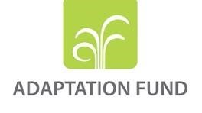
Day 1: Inception Workshop Agenda

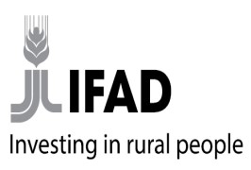
GREEN AND RESILIENT ECOSYSTEMS FOR SOMALI LIVELIHOODS
(HAL-ABUUR) PROJECT
Inception Workshop
6th May 2026 | NAC HOTEL - Mogadishu.
Hal-Abuur Project Summary
The HAL-ABUUR project is a six-year initiative funded by a US$10 million Adaptation Fund grant, implemented by IFAD (International Fund for Agricultural Development), and executed by the Sadar Development and Resilience Institute (SADAR) in Somalia. The project aims to enhance the climate resilience of ecosystems and livelihoods in Somalia by operationalizing the Great Green Wall Initiative (GGWI).
Georgarphic Target: The project focuses on the inland areas of Lower Shabelle (Barawe) and Mudug (Hobyo) regions, selected for their climate vulnerability and relevance to the GGWI. Project Objectives & Approach: To scale up climate resilience in Somali ecosystems and livelihoods. This will be achieved through three complementary components:
Component 1: Green and Resilient Agro-Pastoral and Pastoral Ecosystems: This focuses on participatory planning, regreening interventions (reforestation, afforestation, reseeding, and soil and water conservation techniques), and site protection measures. The goal is to restore degraded ecosystems and enhance their resilience.
Component 2: Resilient Agro-Pastoral and Pastoral Livelihoods: This component aims to improve the resilience of farming and pastoral practices through training, access to improved seeds and equipment, promotion of resilient nurseries, and diversification of livelihoods, including Non-Wood Forest Products (NWFPs). A key focus is gender and social inclusion.
Component 3: Operationalization of the Great Green Wall Initiative: This component focuses on developing and implementing a national GGWI strategy and action plan, building capacity at national and state levels, establishing coordination mechanisms, and monitoring progress using the Land Degradation Surveillance Framework (LDSF) methodology.
Workshop Objectives
- Establish a shared understanding of the Hal-Abuur project objectives, components, implementation arrangements, and expected results.
- Clarify the roles and responsibilities of IFAD, SADAR, MoECC, NCF, the Federal Member States, the District Authorities of Hobyo and Baraawe, and other involved key stakeholders.
Expected Participants
- Federal Ministries: Ministry of Environment and Climate Change (MoECC), Ministry of Agriculture and Irrigation (MoAI), Ministry of Livestock, Forestry and Range (MoLFR).
- National Climate Fund (NCF) — Designated Authority.
- State level MoECC; Galmudug and Southwest States,
- District Authorities of Hobyo and Baraawe — with strong participation expected during the inception day and during selected technical sessions
- Civil Society organizations.

HAL-ABUUR PROJECT INCEPTION WORKSHOP AGENDA
Time | Session / Activity | Lead / Presenter
08:30 – 09:00 | Registration of participants | SADAR Protocol Team
09:00 – 09:10 | Welcome remarks and introduction of guests of honour | Master of Ceremonies (SADAR)
09:10 – 09:20 | Opening remarks by the Chief Executive Officer of SADAR | SADAR CEO , Shukry Abdi
09:20 – 09:30 | Remarks by the Executive Director, National Climate Fund (NCF) – Liban Mohamed | NCF Executive Director
09:30 – 09:40 | Remarks by Acting DG and Director of Biodiversity, MoECC | MoECC Director General Mr Artan
09:40 – 09:50 | Remarks by the IFAD Country Director – Rasha Omar | IFAD Country Director
09:50 – 10:10 | Official opening statement by the Guest of Honour, followed by group Photo | Minister, MoECC (TBC)
10:25 – 10:40 | Tea & Refreshment Break | All
10:40 – 11:10 | Hal-Abuur presentation — Project overview: rationale, objectives, target areas, components, and expected results | IFAD/SADAR – Rasha Omar
11:10 – 11:35 | Hal-Abuur Implementation: Governance structure, Institutional roles, coordination arrangements, and reporting lines | IFAD / SADAR - Yusuf
10:35 – 11:50 | Reflections from FMS/regional and district representatives on local priorities and start-up expectations. | SADAR -
11:50 – 12:20 | Financing Agreement and general conditions: key obligations of IFAD, the Recipient, and the implementing entity | IFAD – Christa
12:20 – 12:30 | Reflections/ QA
12:30 – 13:45 | Lunch | All
13:45 – 14:30 | 2026 AWPB overview: key start-up priorities, sequencing, and immediate deliverables- presentation Annual work plan and budget and procurement plan in summary form. Approval of the AWPB. | SADAR - Yusuf and Abdullahi
14.30 – 14.50 | Open discussion and clarification of key institutional and implementation issues | IFAD / SADAR/ NCF/ MoECC
14.50 – 15.30 | Financial management orientation: disbursement basics, financial controls, audits, and accountability requirements | IFAD / SADAR - Federico
Time | Closing of the Inception Day | Lead / Presenter
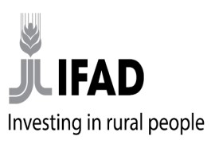

Day 2-5: Technical Workshop Agenda

TECHNICAL WORKSHOPS (Days 2 – 4)

Day 2 — Thursday, 7 May 2026
Time | Session / Activity | Lead / Presenter
09:30–10:00 | Recap of Day 1 and overview of Day 2 | IFAD / SADAR
10:00–11:15 | Procurement orientation: IFAD procurement procedures, procurement planning, and linkages with AWPB | IFAD / SADAR - Noor
11:15–11:30 | Coffee break
11:30–12:00 | Interactive stakeholder discussion: expectations from FMS/districts and practical issues for early implementation | IFAD-Mikael / SADAR
12:00–12:30 | KM & Communication, Visibility, and Stakeholder Engagement during start-up and implementation | IFAD - Gure
12:30–13.30 | Lunch break
14:00–14:45 | Social inclusion and gender in project implementation | IFAD- Valentina SADAR
15:00–15:45 | Monitoring, evaluation, and reporting: logframe, core indicators, results tracking, and reporting responsibilities | SADAR - Hussein
15:45–16:00 | Coffee break
16:00-16:45 | Safeguards and accountability: SEA/SH policy, anticorruption, transparency, grievance handling, and ethical standards | IFAD -Ethics – Liam
16:30–17:15 | Wrap Up of Day | Chair / All

Day 3 — Saturday, 9 May 2026
Time | Session / Activity | Lead / Presenter
09:30–10:00 | Opening of technical session: objectives, approach, and expected outputs | IFAD -Mikael/ SADAR
10:00–11:00 | Review of PIM structure and core implementation framework | IFAD - Mikael / SADAR
11:00–11:15 | Coffee break
11:15–12:30 | Component 1 and Component 2: Detailed review of implementation arrangements: roles, responsibilities, coordination, field structures, and reporting lines | IFAD - Mikael / SADAR /  MoECC
10:00–11:00 | Component 3: Review of component implementation modalities and early implementation sequencing | IFAD- Mikael / SADAR
13:15–14:15 | Lunch break
11:15–12:15 | Review of governance, engagement with MoECC/NCF/FMS, and field coordination arrangements | IFAD- Mikael / SADAR / MoECC / NCF
Time | Session / Activity | Lead / Presenter
15:15–16:00 | Agreement on priority start-up actions for May– June 2026 | IFAD- Mikael / SADAR
16:00–16:15 | Coffee break
16:15–17:15 | Review of AWPB and procurement plan linkages with the PIM | SADAR / IFAD- Mikael
17:15–17:30 | Summary of revisions agreed during Day 3 | Chair / Rapporteur

Day 4 — Sunday, 10 May 2026

Time | Session / Activity | Lead / Presenter
09:15–09:30 | Recap of Day 3 and outstanding issues | Chair / SADAR
09:30–10:00 | Review of immediate action plan: onboarding, training, procurement, reporting, and stakeholder follow-up | All technical participants
10:00-11:00 | Final review of consolidated PIM comments and next revision steps & Agreement on finalization process, responsibilities, and submission timeline for the revised PIM | All technical participants
11:00–11:15 | Coffee break
11:15-12:00 | Closing session: confirmation of agreed next steps and responsibilities | All technical participants
12:00-13:00 | Lunch break

Day 5 — Monday, 11 May 2026 (online for Sadar)
Time | Session / Activity | Lead / Presenter
10:00–12:00 | Review of AF Environmental and Social Policy requirements for the Hal Abuur project, including the project ESMP, priority actions for first year of implementation, and integration in the PIM | Isabel, Walid
12:00–13:00 | Project monitoring and reporting requirements vis a vis AF | Wietse
13:00-14:00 | Review of financial management sections of the PIM, funds disbursement | Federico

Annex II: List of Participants
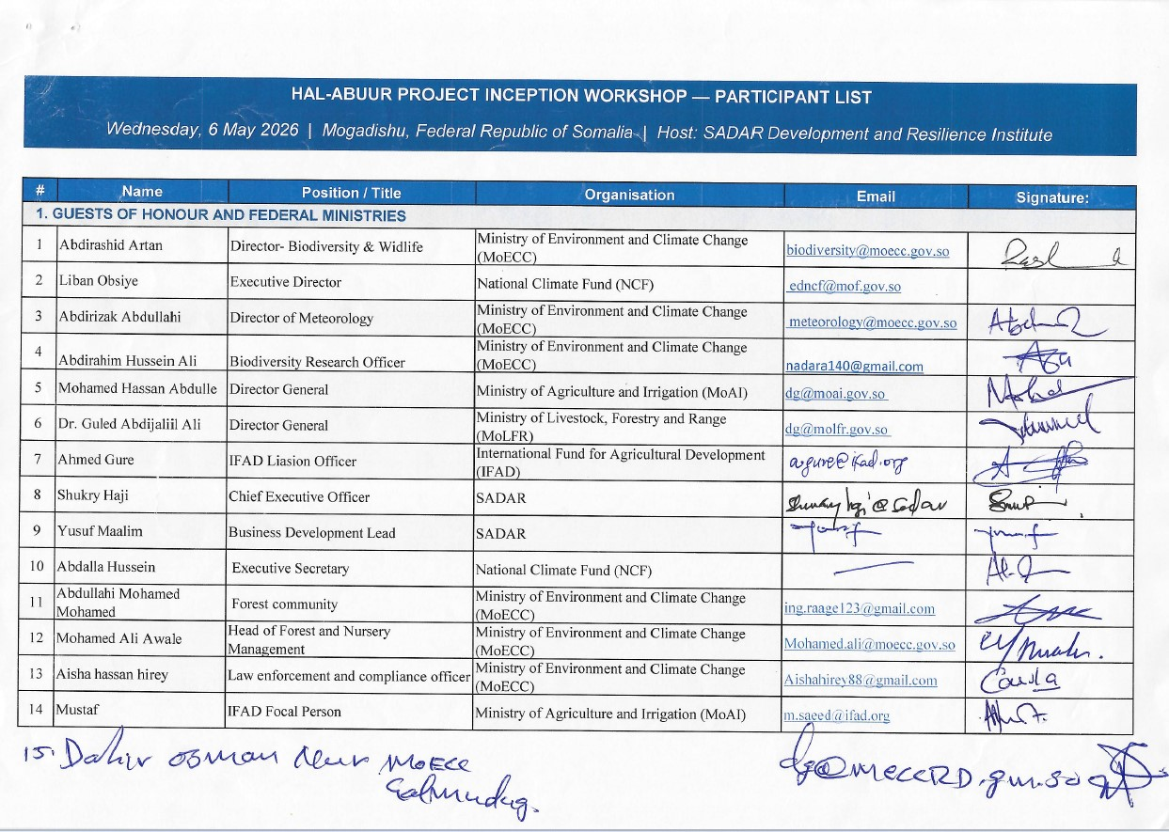
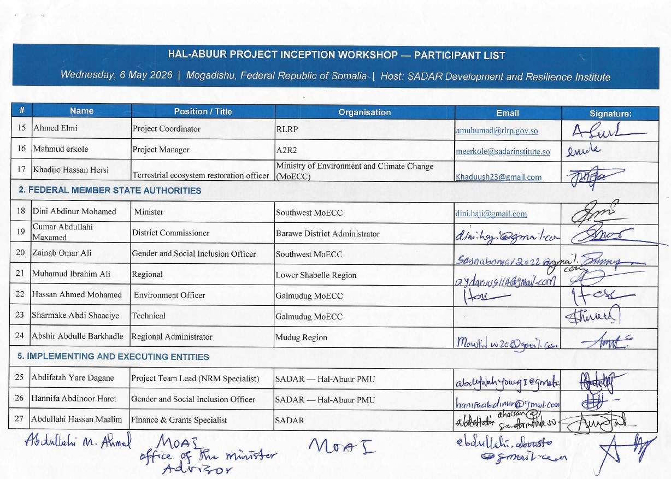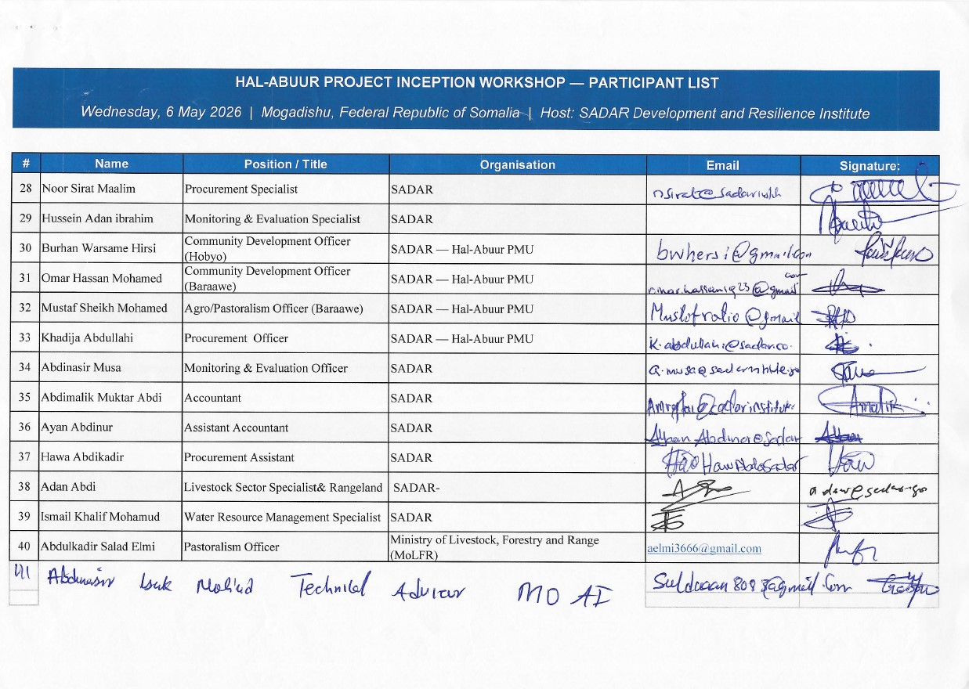

Annex III: Screen shot Online Endorsement of PSC members.
