Project monitoring report N3
Final report

Project Title: | LEARNING GRANT - Support for capturing and disseminating practical lessons from adaptation interventions in Armenia
Date submitted to AFB secretariat: | March 3, 2026
Country: | Republic of Armenia
Implementing Entity: | “Environmental Project Implementation Unit” State Agency
Adaptation Fund Grant I.D: | N/A
Grant Type: | Learning Grant
Project Description: | COLLAGE aims to collect, structure, and disseminate knowledge, transfer practical solutions to local communities through strengthened capacity of EPIU related to innovative land, water, and forest management strategies in the view of adaptation to climate change in Armenia. Integral to this mission is the assimilation of insights from two pivotal EPIU-implemented projects funded by the Adaptation Fund.  Project Sector: Knowledge and learning

Organizational works performed within the project
Formation of project staff | To ensure the effective implementation of the project, the following specialists have been engaged since the project launch and have played a key role in achieving the project's objectives:  - Project Coordinator  - Specialist in collection, analysis and development of training programs on scientific studies related to climate change adaptation  - Specialist in collecting best practices from the results of Adaptation Fund and other projects  - Specialist providing support in organizing training courses and developing guidelines.
Development of a work plan and implementation  schedule | The project activities were implemented in full compliance with the approved Work Plan and Implementation Schedule adopted at the project inception stage. The timeline was systematically structured to ensure the timely, coordinated, and efficient delivery of all planned outputs and results. Throughout the implementation period, project execution remained aligned with the established schedule, and all major milestones and deliverables were achieved within the stipulated timeframes. This reflects effective project planning, management oversight, and inter-institutional coordination.
Organization of discussions | From the project launch, a series of structured consultation meetings and discussions were organized with key stakeholders to align on the methodology and approach.  These involved representatives from the lead partner Armenian National Agrarian University (ANAU), as well as the Armenian State University of Economics (ASUE) and the National Polytechnic University of Armenia (NPUA), along with selected research institutes and scientific centers.  The meetings resulted in agreement on the overall methodological framework, roles and responsibilities, priority thematic areas, and mechanisms for continuous communication.  Each participating institution formally designated dedicated focal points to ensure effective coordination, timely information exchange, and operational follow-up throughout the project lifecycle.  This structured consultation and coordination process established strong, sustainable institutional partnerships and ensured continuous communication, alignment of activities, and implementation of agreed practical next steps. It significantly contributed to the effective and successful implementation of the project.
Development of  technical tasks | The technical tasks were developed in full accordance with the project's overall objective of establishing a platform for learning and knowledge exchange. The proposed learning activities were structured around four main tasks (A1–A4), each with clearly defined expected outcomes, timelines and responsibilities.  The following technical tasks were carried out:  Task A1: Identify, collect and systemize scientific knowledge and lessons learned related to adaptation measures implemented within the framework of 2 implemented AF- funded projects, as well as local knowledge, good practices and farmers adaptation strategies form selected Armenian provinces  Task A2: Initiation of a collaborative learning process aimed at integrating and validating recent research findings and practice-based evidence. This task included the establishment of a structured platform to facilitate the exchange of knowledge, good practices, and lessons learned among stakeholders.  Task A3: Development of the Atlas for Adaptation to Climate Change in Armenian Agriculture, providing a comprehensive overview of innovative climate adaptation solutions in the areas of water management, soil management, forest management, and crop production.  Task A4: Organization of dissemination events, field days, and thematic workshops to present project best practices and success stories to practitioners, researchers, and decision-makers, and to promote experience sharing and informed dialogue on climate change adaptation in agriculture.  The structured design and systematic implementation of these technical tasks ensured coherence with the project’s strategic objectives and contributed to the generation, validation, and dissemination of practical and evidence-based adaptation knowledge.
Proposed Learning Activities | Task A | Expected output of the activities | Progress(include  completion Date “month & year”) | Comments/Explanation (also explain any deviation from initial plan)
A1. Identify, collect and systemize scientific knowledge and lessons learned related to adaptation measures implemented within the framework of 2 implemented AF- funded projects, as well as local knowledge, good practices and farmers adaptation strategies form selected Armenian provinces. | Task A1.1. Develop comprehensive matrix to include specific sections for knowledge and innovative solutions derived from the Artik City project and the project focusing on communities adjacent to “Khosrov Forest” and “Dilijan” National Park. This matrix will continue to cover climate change adaptation in water, soil, forest management, and crop production in a systematic manner. | A1.D1. A comprehensive matrix incorporating specific learnings from the Artik City project and the project focused on communitie  Near “Khosrov Forest” and “Dilijan” National Park. | Completed | According to Task A1, the required matrix has been prepared. The matrix includes dedicated sections on knowledge and innovative solutions derived from:  - the Artik city closed stone pit waste and flood management project, and  - the project focused on communitie near “Khosrov Forest” and “Dilijan” National Park.  This matrix systematically incorporates climate change adaptation in the areas of water management, soil management, forest management, and crop productivity.  The matrix is available here.
 | Task A1.2. Extend the identification process to include units within the selected universities and other relevant institutions that have directly or indirectly contributed to or learned from the two AF-funded projects, alongside their ongoing climate change adaptation measures. | A1.D2. A comprehensive list of identified university units and other stakeholders with direct involvement or influence from the AF- funded projects. | Completed | To compile the comprehensive list, a systematic and structured approach was undertaken. Activities related to climate change adaptation were reviewed and analyzed across three universities and two projects funded by the Adaptation Fund. In parallel, the work of eight scientific centers (as presented in the “Organization of Discussions” section), including the Institute of Biology, the Institute of Botany, and the Scientific Center of Agrobiotechnology, was collected, assessed, and documented.  Furthermore, experts whose scientific research focuses on climate change and climate change adaptation were identified and engaged. Continuous knowledge exchange was facilitated, and regular communication was maintained with representatives of the three universities and eight scientific centers to ensure accuracy, relevance, and alignment of information.  As a result of this coordinated effort, a comprehensive and structured list of university units and other relevant stakeholders with direct involvement in, or influence from, the Adaptation Fund–funded projects has been developed.
 | Task A1.3. Establish communication channels between the identified universities units in order to collect scientific studies, reports, publications, or any relevant documentation. | A1.D3. Expanded contact information and communication channels encompassing stakeholders  from the AF-funded projects. | Completed | To achieve the establishment of effective communication channels and compilation of expanded contact information, the following has been accomplished:  - A Memorandum of Cooperation was developed and officially signed between the Armenian National Agrarian University (lead partner) and the Armenian State University of Economy. The agreement formalizes institutional collaboration, defines mechanisms for knowledge exchange, and establishes a framework for sustained academic and research cooperation.  - Targeted discussions and coordination meetings were organized with university representatives, research centers, and project stakeholders to determine the most effective communication formats and tools. As a result, agreed communication channels include:  - Official email correspondence,  - Shared cloud-based document repositories,  - Thematic working groups,  - Regular meetings.  - An expanded and structured contact database was developed, incorporating detailed contact information of representatives from partner universities, research institutions, and stakeholders involved in AF-funded projects. The database supports streamlined information exchange and facilitates continuous collaboration.  These measures have successfully established functional and reliable communication channels, enhanced information flow, and strengthened trust-based, long-term institutional relationships among academic and project partners.
 | Task A1.4. Design the guideline for gathering information to specifically focus on insights, practices, and strategies inspired by the learnings from the AF-funded projects, while also maintaining the collection of local knowledge from selected provinces. | A1.D4. A guideline and the list of identified actors in the selected provinces. | Completed | To fulfill the requirements of Task A1.4 and ensure delivery of A1.D4, a comprehensive Information Collection Guideline has been developed.  The Guideline provides a structured and methodological framework for gathering, analyzing, and systematizing knowledge-based information derived from the two Adaptation Fund funded projects. It specifically focuses on extracting actionable insights, best practices, innovative approaches, and strategic lessons learned, while simultaneously ensuring the continued and systematic collection of local and indigenous knowledge from selected provinces.  A comprehensive list of identified actors in the selected provinces has also been compiled as part of the guideline implementation.  The guideline is available here:  The Guideline aims to collect, analyze, and systematize knowledge-based information to evaluate the best practices, identify challenges, and develop recommendations from two Adaptation Fund-funded projects:  - "Artik City Closed Stone Pit Waste and Flood Management"  - "Strengthening Land-Based Adaptation Capacity in Communities Adjacent to Protected Areas in Armenia"  The Guideline establishes a comprehensive system for data collection, processing, analysis, and application, enabling a structured assessment of project effectiveness across temporal, geographical, climatic, environmental, and socio-economic dimensions.  It promotes systematic and efficient mechanisms for documenting indigenous and local knowledge from beneficiary communities and targeted regions. Furthermore, it supports the development and dissemination of participatory engagement tools within projects financed by the Adaptation Fund and other international environmental funding mechanisms.  The Guideline incorporates measurable indicators and standardized evaluation instruments designed to assess project objectives, outputs, outcomes, and long-term impacts. These tools are applicable at both pre-implementation and post-implementation stages, ensuring the monitoring of progress and dynamic changes over time.  Target users: Project implementing entities, academic and research institutions, monitoring and evaluation specialists, environmental and social experts, project evaluators, beneficiary communities, and other relevant stakeholders involved in climate adaptation and environmental initiatives.
 | Task A1.5. Conduct interviews and field visits, with a particular emphasis on extracting insights and practical knowledge from stakeholders, practitioners, and beneficiaries who have been part of or influenced by the two AF-funded projects. | A1.D5. Well-rounded compilationof documentation, case studies, reports, and research results, emphasizing learnings from the Artik City project and the project near “Khosrov Forest” and “Dilijan” National Park, alongside other  Relevant materials. | Completed | In order to systematically collect practical insights, field-based experiences, and lessons learned within the framework of the two implemented Adaptation Fund-funded projects, a series of structured interviews and field visits were conducted.  Field missions included consultations with key stakeholders, project practitioners, local authorities, and beneficiary communities. Through direct discussions, stakeholder engagement, and on-site observations, valuable practical knowledge and context-specific insights were documented and analyzed.  The key findings and synthesized results have been published on the designated learning and knowledge exchange platform. The collected knowledge has been further systematized into the following educational materials:  - Artik City Closed Stone Pit Waste and Flood Management Pilot Project  - Increased adaptability of natural and agricultural landscapes  - Enhanced quarry landscape resilience  - Reduced flood risks  - Raised residents' awareness and knowledge.  Full results are here.  - Strengthening Land-Based Adaptation Capacity in Communities Adjacent to Protected Areas  - Adapted natural and agricultural ecosystems  - Constructed irrigation networks  - Created alternative income sources  - Improved access to ecosystems  - Increased population knowledge.  Full results are here.  All collected materials (interviews, field notes, reports) were compiled to highlight best practices and key learnings.  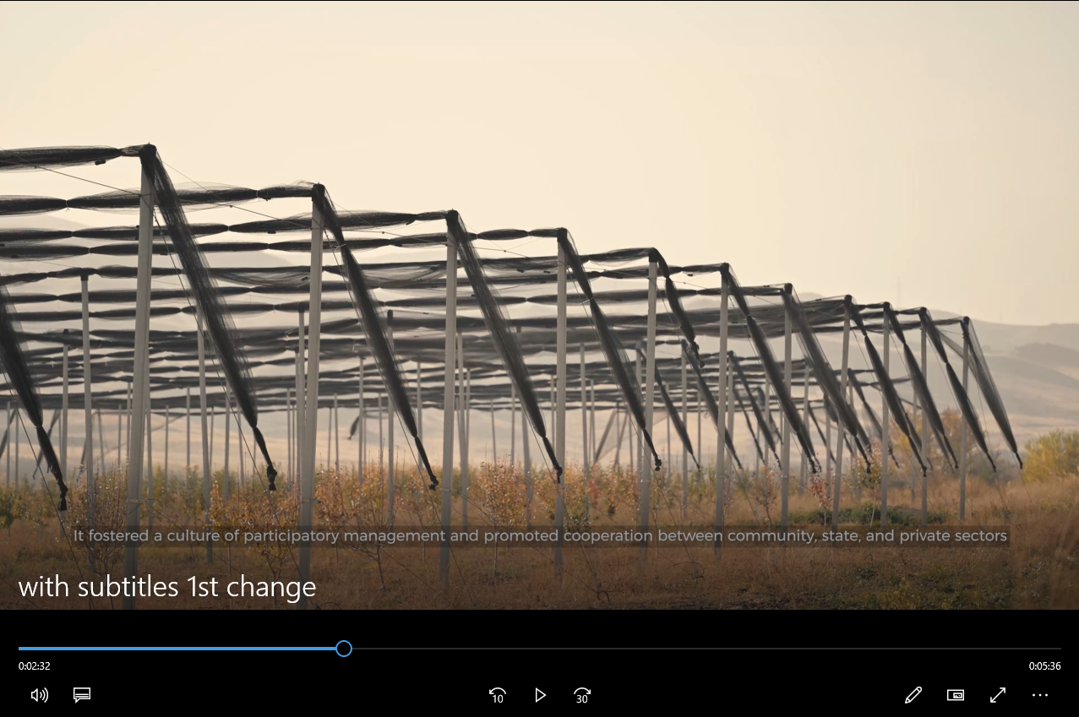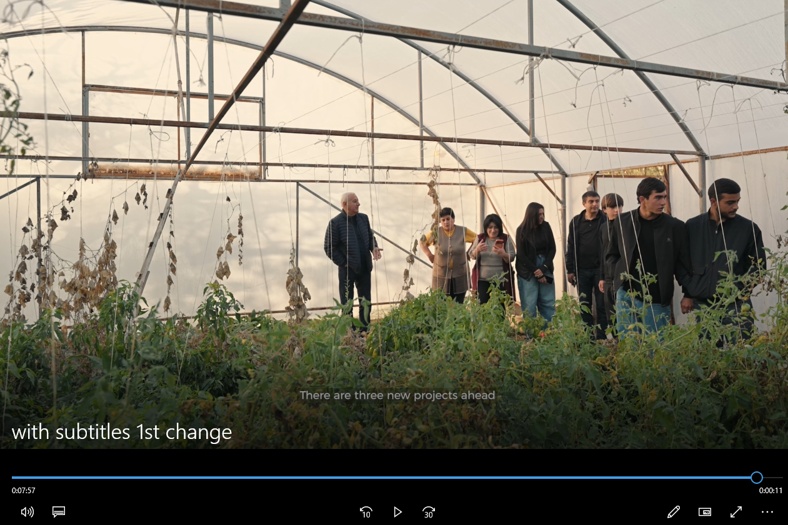
 | Task A1.6. Populate the matrix with all gathered knowledge, ensuring that insights from the AF-funded projects are distinctly highlighted alongside  other best practices | A regularly updated matrix of best practices from AF and other projects | Completed | A structured Best Practices Matrix has been developed to consolidate and organize the knowledge generated through project implementation. The matrix serves as a comprehensive reference tool, presenting insights from AF-supported initiatives alongside relevant experiences from other completed projects.  It is periodically updated to reflect newly collected findings and documented results. The matrix categorizes and systematizes climate change adaptation approaches across key sectors, including water resource management, soil protection, forest management, and agricultural production.  The Matrix is accessible via the QR code,  or through the link available here.
A2. Initiate a collaborative learning process to specifically include steps and timelines for integrating key  insights from the AF-funded 2 projects. Establish a platform for the exchange of knowledge, good practices and lessons learned. | Task A2.1. Develop a collaborative learning plan and outline the steps and timeline for integrating and validating lessons learned from the implementation of 2 AF-funded projects and experience-based information into a synergic content package. | A2.D1. A detailed learning plan, incorporating integration strategies for lessons from the AF-funded projects. | Completed | To ensure the systematic integration and validation of lessons learned and experience-based knowledge generated through the implementation of the AF-funded projects, a comprehensive Collaborative Learning Plan has been developed.  The Learning Plan outlines the methodological steps, validation processes, responsible stakeholders, and implementation timeline for consolidating and harmonizing insights derived from the two AF-funded projects into a coherent and synergistic knowledge package. Learning Plan is available here.  Building upon this framework, a dedicated platform has been established to facilitate the exchange of knowledge, dissemination of best practices, and systematic sharing of lessons learned.  The platform is available here.
 | Task A2.2. Mapping of actors by having gender consideration and concerns of the most vulnerable groups and communities to design the knowledge/content atlas. | A2.D2. An extended actors’ map, now including participants and stakeholders from the AF-funded projects. | Completed | Comprehensive gender-sensitive stakeholder identification and mapping activities were conducted, encompassing participants of Adaptation Fund funded projects as well as other relevant stakeholders.
 | Task A2.3. Engage identified actors and establish a multidisciplinary facilitated platform for the systematic exchange and collaborative learning between the actors representing project beneficiaries, universities and experts. | A2.D3  A platform where beneficiaries, representatives from universities and scientific institutions can exchange experiences and recommendations. | Completed | For platform creation and active participation, preparatory meetings were organized with academic institutions, partner universities (ANAU, ASUE, ASUE) and direct beneficiaries of the two projects funded by the AF. During these meetings, participants exchanged practical knowledge, shared project implementation experience, discussed challenges and success stories, and provided valuable suggestions on the structure, content and future activities of the platform.  The meetings contributed to defining the format of the platform’s activities (shared resources, thematic discussions) and fostered initial trust and engagement among the actors.  This preparatory phase has laid a solid foundation for the stable and effective operation of the platform, promoting ongoing collaborative learning and knowledge transfer between institutions and communities.  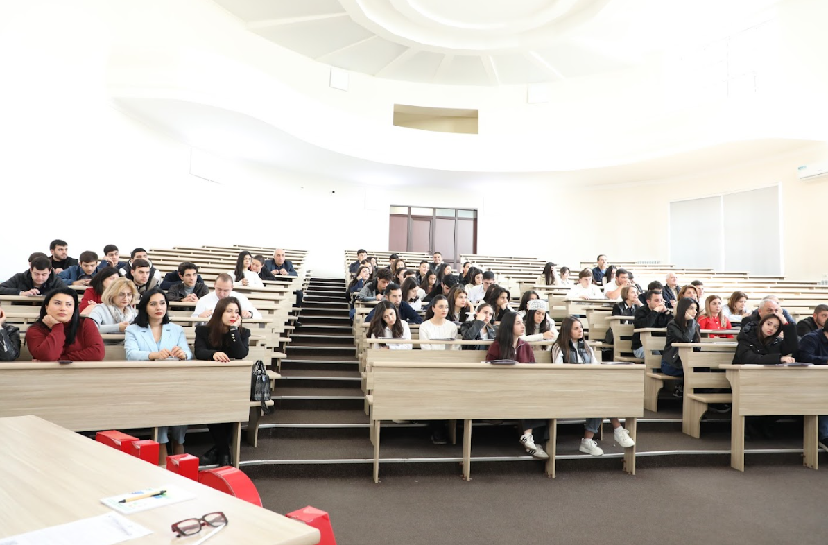
 | Task A2.4. Collaboratively analyse the gathered research results and experience-based information to identify suitable solutions as well as key findings and trends. Identify knowledge gaps and determine areas where additional research or information is needed to enhance the collective understanding. | A2.D4 Collected scientific studies, reports, field visit results and practical experience from interviews with stakeholder, analyzed together. The most effective adaptation solutions, main conclusions and trends, as well as knowledge gaps were identified. | Completed | To support structured joint discussions and analytical review, stakeholder interviews were conducted and relevant scientific studies, analytical reports, field mission findings, and practice-based evidence were collected.  The compiled materials were jointly examined with project partners, university representatives, and sectoral experts within a multidisciplinary coordination platform.  As a result of this process:  - Effective climate adaptation solutions successfully piloted under the two Adaptation Fund-supported projects were identified, including water-efficient irrigation systems and land restoration technologies.  - Key conclusions and trends were determined, particularly the importance of community engagement, technology accessibility, and long-term sustainability considerations.  - Critical knowledge gaps were revealed, notably the absence of long-term performance data on water-saving technologies and insufficient monitoring of land restoration impacts.  - Priority directions for further research were defined, including the development of long-term monitoring mechanisms and strengthened collaboration with local communities and academic institutions.  This structured assessment ensured evidence-based validation of lessons learned and informed recommendations for future adaptation initiatives.
A3. Develop an Atlas for adaptation to climate change in Armenia agriculture which provides an overview of innovative solutions, successfully piloted within the  framework of 2 AF- funded projects, related to the climate change adaptation in the fields of water, soil, forest management and crop production. | Task A3.1. While developing the Atlas, incorporate tailored-made factsheets that not only address farmers, researchers, and decision- makers but also specifically highlight the innovative solutions and best practices derived from the 2 AF-funded projects. These factsheets aim to boost the impact and implementation of the gathered knowledge, with a strong emphasis on applicability in rural areas. | A3.D1. The Atlas, which now includes a comprehensive Communication Strategy for EPIU, enriched with dedicated sections on the learning and best practices from the 2 AF-funded projects. | Completed | The “Atlas of Climate Change Adaptation in Agriculture of the Republic of Armenia” was developed to present innovative and effective agricultural solutions successfully tested in Armenia.  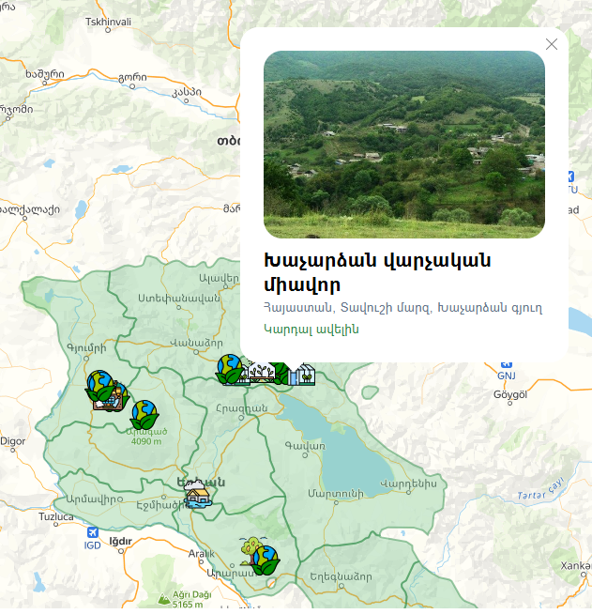  Specially designed brochures were prepared as part of the Atlas. These brochures target farmers, researchers, and decision-makers, while specifically highlighting innovative solutions and best practices derived from the two AF-funded projects. The brochures emphasize practical applicability in rural areas, focusing on climate change adaptation in the fields of water, soil, forest management, and crop production.  The Atlas incorporates a comprehensive EPIU communication strategy and includes the following materials:  - Newsletters:  - Publication: "Effective and Innovative Solutions for Climate Change Adaptation in the Implementation of Environmental Protection Department Programs"  - Atlas:
 | Task A3.2. In strengthening the capacity of EPIU, develop a specific Communication Strategy as part of the Atlas. This strategy should not only deliver knowledge and innovative solutions to farmers in selected rural areas but also emphasize how the learnings from the AF-funded projects can be applied to enhance climate adaptation in Armenia. The strategy should facilitate EPIU's endorsement and dissemination of these insights to key stakeholders. | A3.D2.A communication strategy approved by EPIU that defines how to provide knowledge and innovative solutions to farmers in selected rural areas, and highlights how lessons learned from AF-funded projects can be applied to improve climate change adaptation in Armenia. | Completed | A communication strategy has been developed that defines principles, roles, processes, and controls to ensure all communications are legitimate, accurate, timely, audience-oriented, accessible, and fully compliant with national legislation and donor requirements. The strategy adopts AF standards as the common framework and, where necessary, incorporates additional materials specifically tailored for donors.  Communication Strategy is here.  The “Environmental Projects Implementation Unit” State Agency of the Ministry of Environment of the Republic of Armenia, in collaboration with its project communication teams, implements this strategy as a five-year management framework (2025–2030) to guide communications across all projects funded by the AF, as well as projects jointly or fully funded by other institutional donors and international organizations where applicable.
A4. Organize dissemination events and field days to showcase 2 AF- funded projects’ best practices and success stories to practitioners and workshops to exchange experiences and present the information about adaptation to climate change for researchers and decision-making actors. | Task A4.1. Utilize the enriched Atlas, which includes dedicated sections on learnings and best practices from the 2 AF-funded projects, to organize four dissemination events in each province (eight in total). These 82 - day events are aimed at farmers, women, youth, experts, municipal decision makers and other practitioners, focusing on practical applications of the knowledge and solutions highlighted in the Atlas. Each event will target one of the mentioned groups (farmers and practitioners, with specific focus on women inclusion; youth; researchers and experts; decision makers and policy influencers) and will include in its agenda a day for round table discussions, exchange of experience on best practices, and a field day, which will involve a visit to AF- funded project sites to illustrate the results of best practices’ implementation on the ground. The first day of each event will be built on the basis of a target group-specific approach considering the group’s knowledge and experience with the discussed topics.  It is envisaged to provide the  inclusiveness of the dissemination events via inviting the representatives of the targeted groups from the neighbouring regions, which together with the targeted regions often complain about poor engagement in climate change related projects. For this purpose among others it is planned to exploit diverse methods of participant engagement-official municipal channels, connections of the partnering universities, public call, etc.  Among deliverables of the activity:  - a report will be developed summarizing the outcomes of the implementation of dissemination events, which will be further circulated via respective platforms, university pipelines, etc.  - 2 videos (one per region) will be developed showcasing the messages, outcomes of both the project and dissemination events, that will be further broadcast on television․ | A4.D1. Detailed lists of participants and comprehensive event agendas for each dissemination event, workshop, and round- table discussion, ensuring that each session is tailored to effectively convey the integrated knowledge from the Atlas, including the insights from the 2 AF- funded projects. | Completed | To present the best practices and demonstrated results of the two Adaptation Fund (AF)-funded projects and to promote structured knowledge exchange on climate change adaptation, a series of thematic workshops was organized for researchers and decision-makers. The enriched Atlas, incorporating dedicated sections on lessons learned and tested solutions, served as the primary reference and knowledge dissemination tool.  Dissemination activities were conducted in each region (four activities per region, eight in total). These eight two-day events targeted farmers, women, youth, experts, community leaders, and other practitioners, with a focus on the practical application of knowledge and solutions presented in the Atlas. Each event was tailored to one specific target group (farmers and practitioners with special attention to women's involvement; youth; researchers and experts; decision-makers and policy influencers) and included round-table discussions, best practice sharing, and field visits to AF-funded project sites to demonstrate on-the-ground results of best practices. The first day of each event was built around an approach tailored to the target group, taking into account their knowledge and experience on the topics discussed.  To ensure inclusivity of dissemination events, representatives from neighboring regions were invited alongside target regions, addressing common concerns about low participation in climate change-related projects. Various methods were applied to engage participants, partner university networks, public calls, and other outreach tools.  Key outputs of the dissemination activities include:  - A comprehensive report summarizing the implementation process, discussions, and results of the events, subsequently disseminated through relevant platforms and academic networks.  - Two video materials (one per province) highlighting key messages, demonstrated practices, and overall outcomes of both the AF-funded projects and the dissemination events, which were broadcast on television.  The Dissemination Implementation Report is available here:  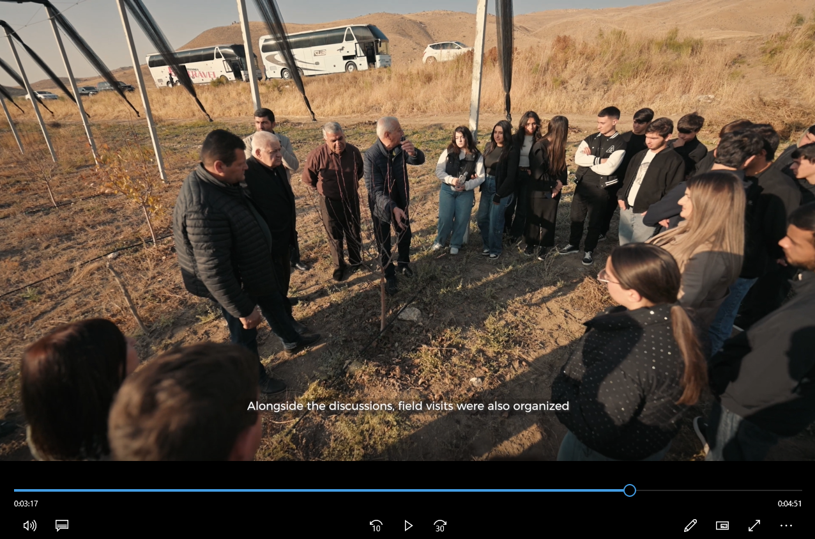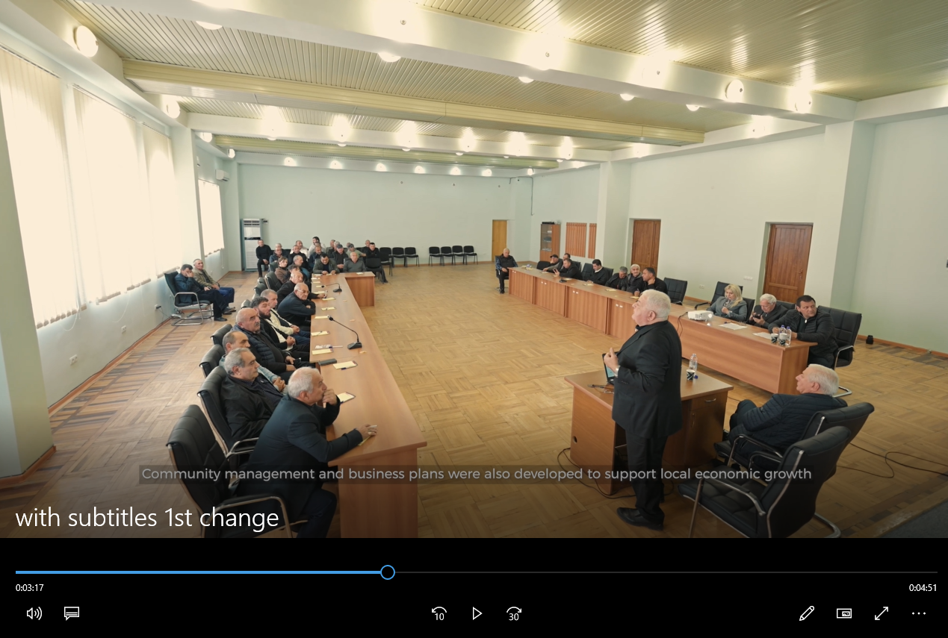  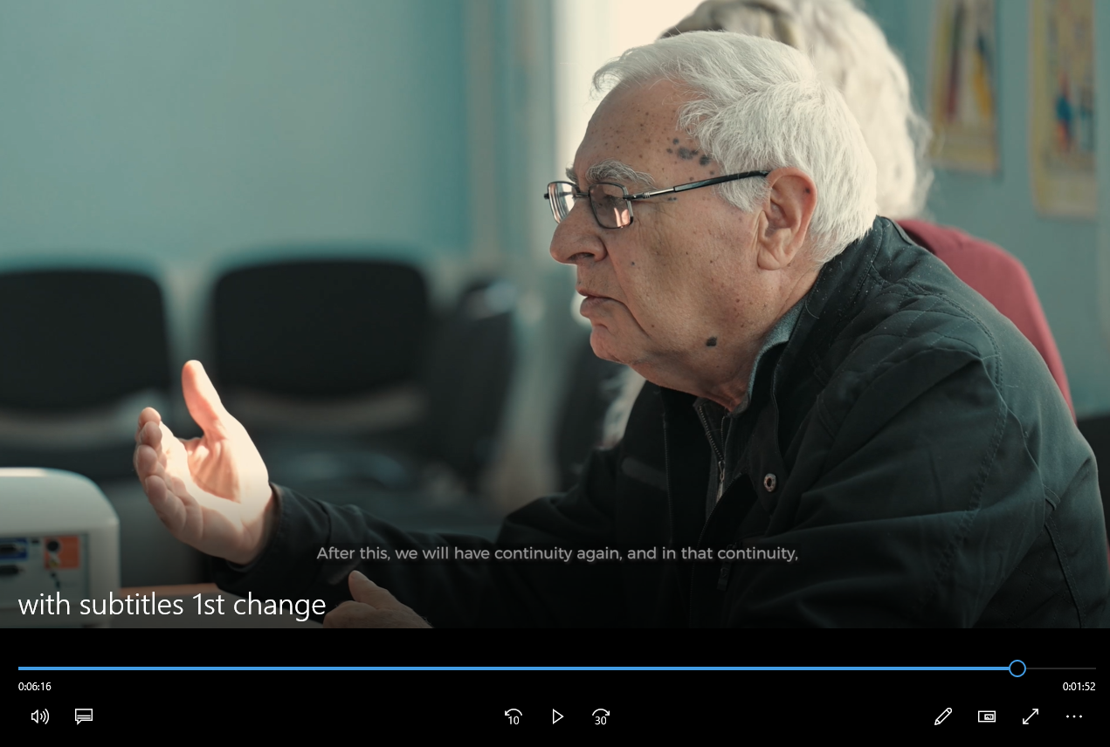
 | Task A4.2. Organize a scientific interdisciplinary workshop for researchers and experts from partner universities, as well as the broader academic community. This workshop will specifically emphasize the integration of insights from the 2 AF-funded projects into current academic and research endeavours.  Task A4.3. Conduct a round-table discussion for relevant decision- makers. This session will present and discuss the information from the Atlas, with a special focus on the policy implications of the adaptation strategies and lessons learned from the 2 AF-funded projects in the context of climate change in  Armenia. | A4.D2. An interdisciplinary scientific seminar was organized for researchers and experts from partner universities, as well as for the wider academic community. | Completed | An interdisciplinary scientific workshop was organized for researchers and experts representing partner universities, as well as members of the broader academic community.  The workshop focused on the analysis of both positive outcomes and implementation challenges identified within the framework of the two Adaptation Fund (AF)-supported projects. Particular attention was given to nature-based solutions, the sustainability of achieved results, and mechanisms to ensure long-term continuity and scalability.  Participants examined opportunities for integrating the findings and practical outcomes of the two projects into ongoing and planned scientific research initiatives. A shared position emerged emphasizing the importance of further developing successful approaches and identifying scientifically grounded solutions to address the challenges identified during project implementation.  In addition, a round-table discussion was convened for decision-makers engaged in climate change adaptation processes. The discussion centered on lessons learned from the two AF-supported projects and their relevance to national policy frameworks. Specific reference was made to the National Climate Change Adaptation Action Plan (2021–2025) and to ongoing and planned adaptation measures in the agriculture, land, and water resource management sectors.  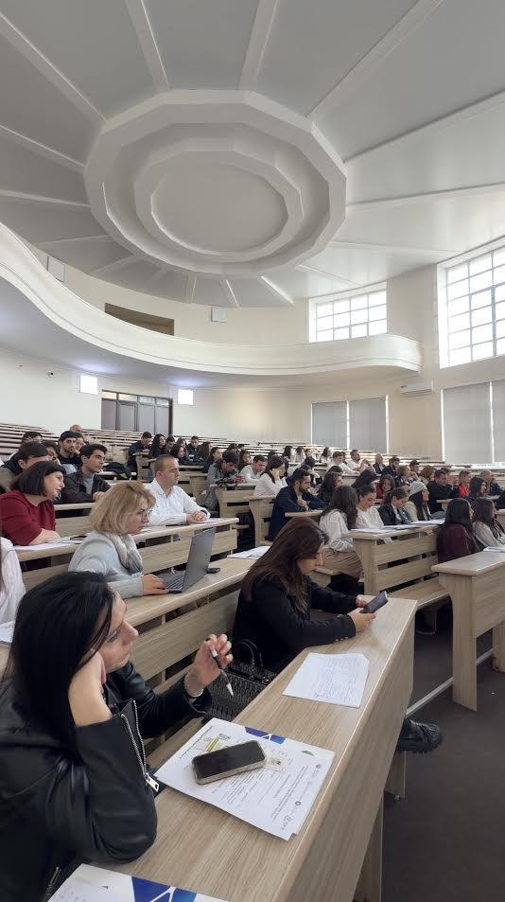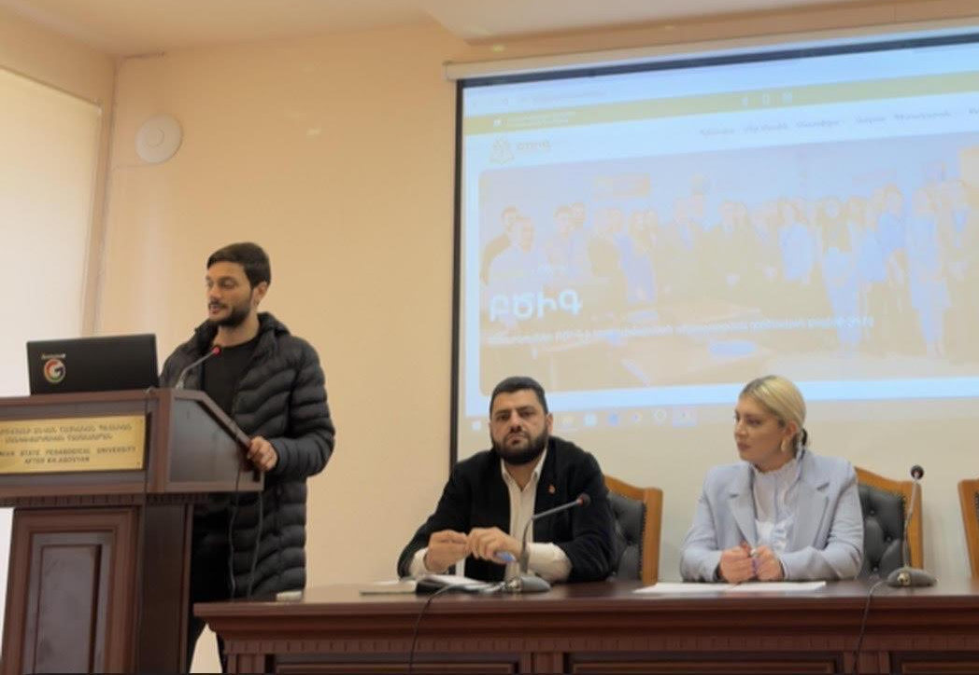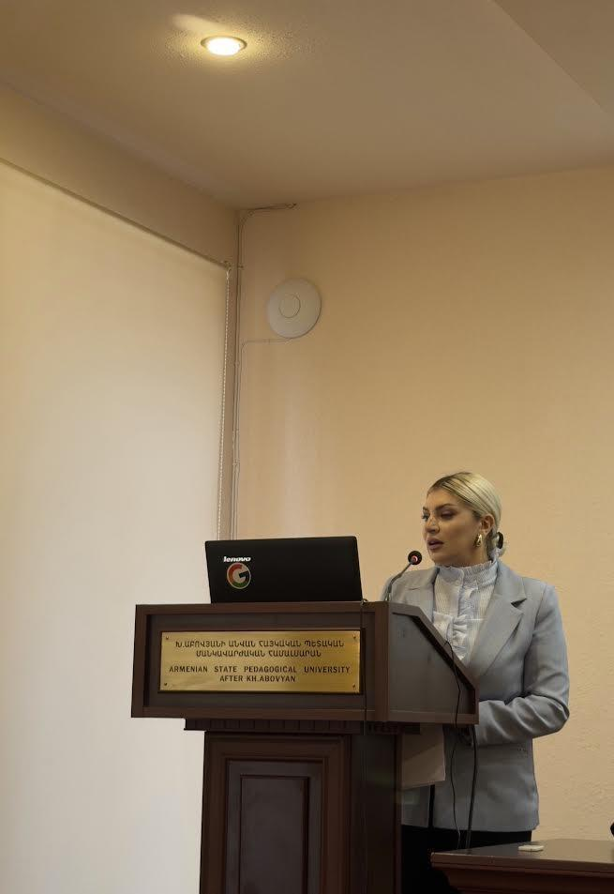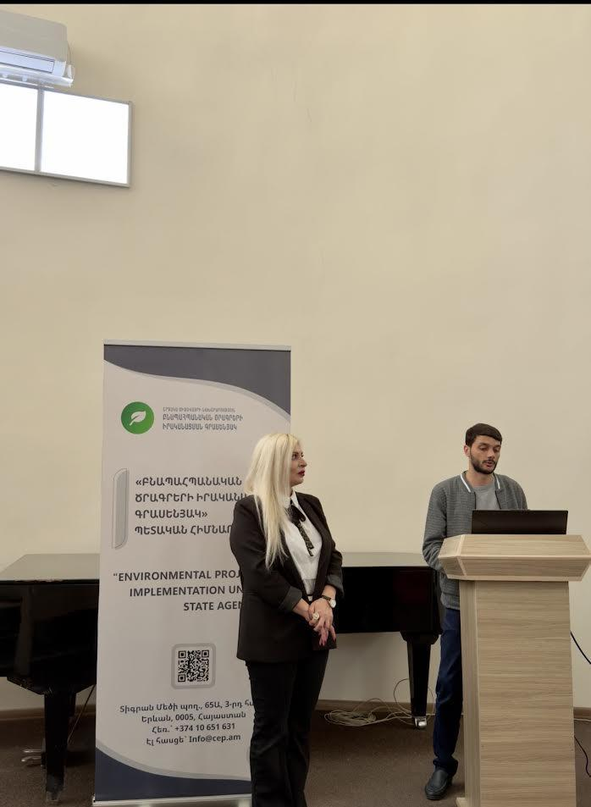
Overall comment on progress | General comment on progress  Based on the results of the first year of the project, the team continued its work in accordance with the approved timetable. Any deviations from the schedule were discussed with the project team and appropriate solutions were selected. Where necessary, these solutions were presented and agreed upon with the management of EPIU SA.  The rapid selection and approval of the formats for the matrix and atlas significantly increased the efficiency of the work. These tools have been regularly updated by the project specialists, as well as with new analytical data from other researchers, covering 4 sectors (Crop Production, Soil Management, Forestry Sector, Water Management).  All major universities (Armenian National Agrarian University – ANAU, Armenian State Pedagogical University – ASPU, Armenian State University of Economics – ASUE) and scientific institutions conducting studies on climate change adaptation have been identified and involved in cooperation.  A multidisciplinary platform has been created for systematic exchange and collaborative learning among the project beneficiaries, universities, and experts representing various stakeholders.  Through reliable sources and direct collaboration with scientists, a comprehensive collection of scientific studies in the field of adaptation has been gathered and created. This collection includes studies related to climate change and adaptation, waste management, water resources, forestry, crop production, soil management, and early warning systems.  Close cooperation has been established with 3 universities and several scientific centers, as well as sustainable connections with the communities, settlements’ leaders, and beneficiaries involved in the two AF-funded projects (“Artik city closed stone pit waste and flood management pilot project” and “Strengthening land-based adaptation capacity in communities adjacent to protected areas in Armenia”).  Significant results have been achieved within the framework of activity A4. Organize dissemination events and field days to showcase 2 AF-funded projects’ best practices and success stories to practitioners and workshops to exchange experiences and present the information about adaptation to climate change for researchers and decision-making actors.  The organized events made it possible to disseminate information about the two major AF-funded projects, the lessons learned, knowledge on climate change adaptation, as well as insights and local experiences regarding best solutions collected from farmers and rural residents.  The progress of the project was greatly facilitated by the approval of 3 projects by AF in 2025, as:  - During seminars, discussions, and other events, participants were provided with additional information about the 3 approved projects, and brief discussions were organized regarding the specifics of their implementation.  - Within the framework of the 3 approved projects, EPIU SA staff and project experts conducted numerous visits to regions and communities, and meetings and discussions were held at EPIU SA, during which the Learning Grant was presented.  As a result of these complementary activities, interest in the Learning Grant has increased among the population as an effective platform for obtaining information, discussing, and presenting opinions. This has contributed to the participation of numerous stakeholders interested in the 3 approved projects in the events organized under the Learning Grant.  Summary  Overall, the Learning Grant has successfully fulfilled all the tasks set before it.  For the first time, it has brought together in one platform the educational and scientific stakeholders who support the idea of climate change adaptation.  It has provided an opportunity to collect in one place the scientific studies related to adaptation.  A communication strategy has been developed for the capacity building of EPIU SA, which will be used both in the implementation of AF-funded projects and projects funded by other funds.  It has enabled the collection, analysis, and summarization of the results of the 2 projects implemented by AF, their comparison with the work carried out under other projects, the organization of discussions, and the identification of preferred directions for adaptation in various sectors.  For the first time, the Learning Grant made it possible to unite in one common platform in the country all organizations and individuals interested in climate change adaptation, who implement or are interested in implementing adaptation projects.  These achievements constitute a significant foundation for the effective implementation of future initiatives and demonstrate the institutional capacity of EPIU SA to advance Armenia’s climate adaptation agenda in a structured, strategic, and sustainable manner.

