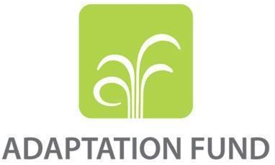

PROGRAMME ON INNOVATION: SMALL GRANT PROJECT PROPOSAL

PART I: PROJECT INFORMATION
Country: Indonesia
Title of Project: Developing “Climate Smart Community” System to Increase
Climate Resilience for Saddang Watershed Communities
National Implementing Entity: Kemitraan (The Partnership for Governance Reform)
Executing Entity/ies: Tim Layanan Kehutanan Masyarakat (TLKM)
Amount of Financing Requested: 250,000 (in U.S Dollars Equivalent)

Project Background and Context

Provide brief information on the problem the proposed project is aiming to solve. Outline the economic, social, development, and environmental context in which the project would operate.
- Saddang Watershed is one of the critical watersheds to be restored. This watershed crosses the administrative area of South Sulawesi Province with 661,932 ha, which is the second-largest watershed in South Sulawesi. Geographically, the Saddang watershed is in the administrative area of Tana Toraja, North Toraja and Enrekang Regency (upstream), and Pinrang Regency (downstream). Communities that depend on and utilize natural resources in the Saddang watershed for water and other basic needs totaled 1,184,215 people, consisting of 599,511 men (51%) and 584,704 women (49%). The majority of whom work as farmers. Saddang watershed also serves primary income sources such as rice fields covering an area of 133,354.79 ha, ponds covering an area of 17,378.37 ha, gardens of 90,354 ha, and livestock for as many as 10,734,898 individuals
- Climate issues are a big challenge for the Saddang watershed ecosystem community because they directly impact material and non-material losses. Climate phenomena such as drought and extreme rains have caused impacts in abrasion, flooding, landslides, increased sedimentation, and the loss of people's ponds into rivers. This extreme climatic condition has unwittingly changed people's land-use patterns to become more vulnerable (rebound vulnerability). One example is the long drought in the early 2000s which led to massive land conversion in the upstream watershed, from mixed coffee plantations to corn monocultures. The steep agricultural areas in Toraja, North Toraja, and Enrekang Regency will increase the potential for landslides in the future. Changes on a large scale will also increase sedimentation during this period and change river flow patterns. This drastic change in river flow patterns causes a shifting vulnerability. For example, in Pinrang Regency’s case, Paria Village, which used to be flooded frequently, has now moved to Baba Binanga Village.
- In addition, unsustainable land management activities such as agricultural practices in slope areas, monoculture farming in the highlands, and land conversion contributed to the increase in critical land area in the Saddang watershed, covering an area of 485.021.70 ha in 2018. One of the indications is by looking at the change in forest cover into agricultural land covering an area of 160,331.17 ha in 2020. As a result, nature's ability to support human needs has already reached its ability limit.
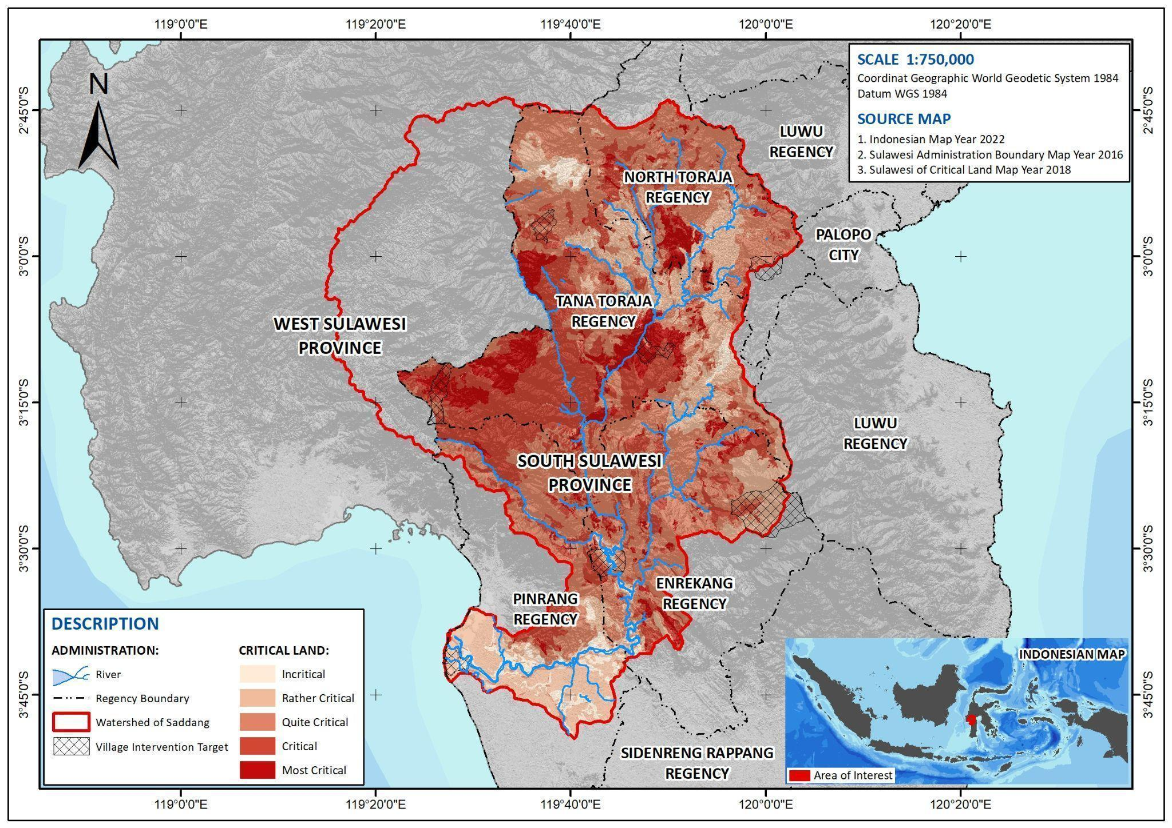

Figure 1. Saddang Watershed Situation Map
- The increase in critical land in the Saddang watershed poses a severe threat to the carrying capacity of the watershed, both its function as life support and its hydrological role. Moreover, uncertain climatic conditions and unsustainable land management increase the community's vulnerability in the watershed. So, in facing the challenges of climate change in the Saddang watershed, efforts are needed that are mutually integrated so that potential losses or losses from the impacts of climate change can be reduced. One of them is the need for real-time access to microclimate information (within the watershed) that is integrated so that farmers' losses can be minimized or anticipated. Dissemination of climate information that the central and regional governments have carried out in various media, socialization, or notification letters is still neglected by some communities in the Saddang watershed ecosystem. As one example, information regarding the opening or closing of the floodgates at the dam downstream of the Saddang watershed was informed a few days after it was carried out. This makes the information so that it cannot be used properly, so the community's anticipation in responding to these actions is weak. In addition to the issue of sources of information, the context of the knowledge capacity of the community in understanding the changes that occur to what extent this will have an impact is also something that needs to be considered. Capacity building and awareness-raising are still required to create a climate-aware community that can adequately reduce the level of vulnerability, whether in the present (short term) or the future (long term). The community suffers many losses in the affected sector due to conventional farming or aquaculture patterns that only refer to local knowledge. Some villages do not have communication or internet networks (blank spots or remote areas).
Environmental and Climate Change Context
- The destructive influence of accepting the impacts of climate change in the Saddang watershed is increasingly at risk. This impact continues to create new disasters in the Saddang watershed. In fact, in the last seven years, the disaster has damaged 2,220 people's houses in the Saddang watershed.
Table 1. Disaster Data
Regency | Disaster | Frequency | Fatalities | Damage to Infrastructure
Enrekang | Flood | 7 | 2,447 | 26
Enrekang | Landslide | 9 | 553 | 79
Enrekang | Tornado | 5 | 34 | 108
Enrekang | Forest and Land Fires | 8 | - | -
Pinrang | Flood | 10 | 4,600 | 580
Pinrang | Landslide | 4 | 30 | 8
Pinrang | Tidal Wave / Abrasion | 4 | 1,000 | 1
Pinrang | Tornado | 18 | 305 | 1,169
Tana Toraja | Flood | 5 | 865 | 7
Tana Toraja | Landslide | 45 | 1,123 | 138
Tana Toraja | Tornado | 22 | 264 | 80
Tana Toraja | Forest and Land Fires | 14 | - | -
North Toraja | Landslide | 11 | 10,616 | 31
North Toraja | Tornado | 9 | 10 | 14
TOTAL |  | 171 | 21,847 | 2,241
Source: Disaster Information and Communication Data Center, National Disaster Management Authority (2015-2021)
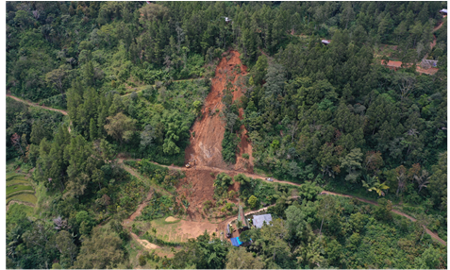
- In Table 1, it is noted that Tana Toraja Regency has the most frequent intensity of landslides and tornados. North Toraja Regency is the largest disaster impact recipient in the upstream Saddang watershed. While downstream of Saddang watershed, Pinrang Regency has the most incredible intensity of flood disaster. The disastrous events that occurred in four regencies greatly affected the decrease in the productivity of cultivated commodities. The occurrence of crop failure even resulted in the fatalities of 14 people and suffered as many as 17,809 people. The results of the vulnerability study of the Saddang watershed show that Tana Toraja Regency will experience an increase in the occurrence of landslides covering an area of 14,443.41 ha, while Pinrang Regency will experience an increase in the event of floods covering an area of 23,515.18 ha which has great potential to damage ponds, rice fields, and plantation in the 2040s.

Figure 2. Landslide in the upstream Saddang watershed, 2021 (Doc: Kemitraan-TLKM)
- The portrait of the landslide disaster in Figure 2 occurred in 2021 in Tana Toraja Regency and claimed lives. This incident destroyed 2 ha of community agricultural land because an overflow of landslides buried it, and it also impacted the public road access had to be closed for two days. This condition was previously unanticipated due to the absence of effective and quick access to climate information that the public could access as a basis for bringing signs of potential for disaster. Previously there was a climate information system built by the authorized agency. Still, the utilization of the information was not optimal because it only displayed macro-climate data. The scientific data and information had not been much elaborated into "knowledge" that was easily understood by the public. Climatic factors that cause landslides are high rainfall, and geographical factors such as slope conditions > 45% and the soil's ability to bind water have crossed the limit.

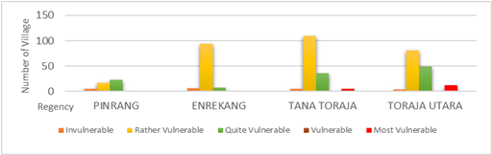

Figure 3. Graph of Climate Change Vulnerabilities
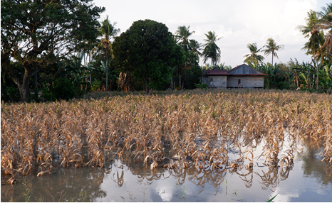
- The level of vulnerability of an area is strongly influenced by the support for physical, environmental, and socio-economic conditions in the village/urban village. Based on Figure 3, 95% of villages in the four regencies of the Saddang watershed are vulnerable to climate change. It was noted that the adaptability of the village/urban village was very low, ranging from 0.19 – 0.50, while the level of exposure was quite high, ranging from 0.70 – 0.87. The important aspect that drives landslides and floods with rainfall of 2,600 - 3,000 mm per year will result in 2,419 potential landslides and floods in the Saddang watershed in the 2040s. This puts the high potential of decreasing productivity and the risk of crop failures in sight.

Figure 4. Crop failure due to flooding in the Downstream Saddang watershed, 2021 (Doc: Kemitraan-TLKM)
- This impact also poses threats and significant losses in the downstream area of the Saddang watershed, increased sedimentation due to landslides in forest areas, changes in river flow patterns, and even flooding from upstream of the Saddang watershed, which causes crop failure losses, migration, and ablation to the loss of community ponds. In actual conditions, the sedimentation rate analysis in the Saddang watershed is 146,709.23 (tons per ha), and the projected climate change conditions in the 2040s will increase by 147,342.28 (tons per ha). One of them has occurred population migration due to flooding and ablation in Cilallang sub-village, Duampanua, Pinrang. Previously as many as 200 families living in one sub-village began to slowly decrease until now, only 20 families have survived and adapted to the threat of flooding and ablation. One of the residents has also lost his pond covering an area of + 10 ha, which is predicted to be in the hundreds of millions of rupiah. This project will be directed at building the community's adaptive intelligence, especially for the most affected smallholders. This will be very useful in making decisions or responding to these impacts so as not to cause more significant losses. Weather anomalies make it more difficult for small farmers to make decisions in agricultural practices, which are very dependent on when the rains come and when the dry season begins. By increasing the capacity of knowledge and skills in adapting and supported by information systems that apply to them, the decisions they take in responding to the crisis will become more appropriate and ensure the sustainability of their livelihoods.
Socio-Economic Context
- The development of a community structure will be in line with economic growth and development in a region. In principle, development based on a rapidly growing economy will reduce the carrying capacity of the environment and result in changes in the socio-economic structure of the community. In particular, the four regencies in the Saddang watershed have 117,360 people classified as poor, most of whom are in rural areas. Although these four regencies are not among the poorest regions of South Sulawesi, the poverty depth index with an average of 1.74 and the poverty severity index with an average of 0.37 is relatively low, so land clearing in the forest in rural areas are potential to happen. Based on statistical data, the number of unemployed increased in 2021 by 16,579 compared to 2020 by 16,393 people.
- In line with developments in the community structure, it becomes a challenge for village youth. The number of village youths who choose to migrate to urban areas to continue their education and careers has begun to increase. Currently, only less than 50 percent of young people survive living in rural areas. Migrating is one of the youth's efforts to revive their economy and get out of poverty. The need for the next generation in priority sectors is hampered because most young people who continue their education and career choose to live in urban areas.
- In addition, the role of women is also not comparable to the role of men in utilizing the Saddang watershed ecosystem. The contribution of women to priority sectors in the Saddang watershed is still very minimal. Based on statistical data, the percentage of women's income contribution in the Saddang watershed is still 38% average of the number of women in the Saddang watershed area. This is because the opportunity to continue education and a career is challenging if women have continued to the level of marriage, so women will be faced with the choice of being a housewife. Currently, the number of unemployed women is 5,815 people, and it is dominated by women who have graduated from college.
Developmental Context
- In the national context, Indonesia has the main objective of increasing through the National Action Plan for Climate Change Adaptation (RAN-API) 2014-2023 and the National Action Plan for Sustainable Development Goals (SDGs) 2015-2019 resilience to impacts. Climate change through a needs allocation approach strategy, policy dialogue, and policy reform, but there are still some challenges in its implementation. For example, adaptation activity interventions tend to be multi-sectoral, and their implementation has some differences or no integration between sectors. Some of the challenges are uncertainty and gaps in human resource capacity in managing adaptation issues. This project will answer the challenges in RAN-API problems by designing the system built to be sustainable and flexible by clarifying its working mechanism; in this case, it will map the stakeholders involved as monitoring and coordinating functions in program implementation. This project will also realize adaptation and mitigation governance in order to achieve the existing NDC targets as mandated in the Regulation of the Minister of Environment and Forestry Number P.16/MENLHK/SETJEN/SET.1/8/2020 concerning the Strategic Plan of the Directorate General of Climate Change Control year 2020 – 2024.
- The significant impact of climate change is the biggest contributor to farmers' losses. This inequality makes the South Sulawesi government continue to strive to achieve the Sustainable Development Goals (TPBs/SDGs). These efforts still require regional, site, and multi-sectoral support to complete the SDG’s target in 2030. Moreover, the Saddang watershed is designated as a sustainable food area: rice, corn, shrimp, and Special Economic Zones, as well as being a National Rice Reserve area with a contribution of 500 - 600 thousand tons per day. The impacts of climate change that are felt by the community of the Saddang watershed ecosystem cannot be directly resolved, so adjustments are needed to anticipate the major effects of climate change. This effort is carried out as a response to reduce potential losses. Data shows that if climate-resilient development is carried out at the National level, both in the form of adaptation and mitigation, the possible loss is projected to decrease by 58.3 Trillion Rupiah from 115.4 Trillion Rupiah (down nearly 50%).
- On a local government scale, South Sulawesi Provincial Regulation No. 1 of 2021 concerning the Regional Medium-Term Development Plan (RPJMD) for 2018-2023 accommodates the Medium-Term Development Plan in four regencies’ project intervention areas. However, its implementation also has challenges, namely, the gap between mitigation issues and adaptation management. This is reinforced by the Decree of the Governor of South Sulawesi Number 949/IV/2022 concerning the Establishment of the South Sulawesi Province Low Carbon Development Coordination Working Group (POKJA PPRK) in 2022. This POKJA PPRK will undoubtedly focus more on the issue of mitigation, so this project is expected to encourage adaptation strategies so that there is a balance in the management of climate change control actions. This project will also promote the Regional Action Plan for Climate Change Adaptation (RAD-API) at the regency level, which is expected to be an initiator in an effort to support regional development that mainstreams climate change adaptation at the provincial level.
- Ministry of National Development Planning or National Development Planning Agency (BAPPENAS) and Low Carbon Development Indonesia (LCDI) have developed the Indonesia Low Carbon Development Action Planning and Monitoring Application (AKSARA) system. However, this application is very oriented towards climate change mitigation actions, not yet mainstreaming the issue of climate change adaptation. So that in project implementation, climate change adaptation monitoring applications are made to strengthen the issue of climate change adaptation which will be integrated with existing systems. Several applications can be integrated, such as the application system that the Ministry of Environment and Forestry has created as supporting tools, including the National Registry System (SRN) and the Vulnerability Index Data Information System (SIDIK), and the SPECTRUM application. A weather monitoring application system from the Agency for Meteorology, Climatology, and Geophysics (BMKG) and the Pompengan River Center (BBWS) has strengthened climate and weather data. Project interventions will fulfill what is still lacking from the existing system and make it easier, efficient, and effective. It becomes an innovation that can be replicated and used as a supporting tool in the context of climate-resilient regional development.
Project Innovation Context
- The agricultural sector is the most significantly affected sector based on the previously collected information. Extreme rain (very heavy) in the upstream area and lasts for days will potentially cause an overflow of water downstream of the river (flood) and impact agricultural activities downstream. Several areas in the four regencies of the Saddang watershed are still unable to access climate information due to the absence of a communication network or internet network. So far, climate information obtained by the community, especially those living in the area, has no network, only through places of worship or information dissemination from the Village/Sub-District Head. When a large landslide occurs in the upstream watershed area, people in the downstream watershed area need to obtain information to anticipate and minimize the adverse effects of a flash flood. The use of technology in accessing climate information is essential, whether for agriculture, plantations, or as an alarm, if a disaster strikes. If farmers can find out in advance about the incident, the harvesting process may be carried out more quickly to reduce the high level of losses.
- Whether ready or not the community is in a watershed unit can be seen from the adaptation response during a disaster. Some responses are incidental or adaptive responses that are permanent or long-term responses. It needs to be supported by sufficient knowledge and skills to support the proper response before making a decision. Agricultural practices using local knowledge that villagers have widely used are currently no longer relevant in predicting climate or weather contexts (e.g., when it will rain or when the rainy and dry seasons begin). Because at this time, the season can no longer be predicted with a static approach. Even if climate change makes rain patterns more dynamic (it will come sooner or later than the previous year), it can still be predicted using a scientific approach.
- The previous Adaptation Fund project implemented by Kemitraan (the Partnership for Governance Reform) with KAPABEL Consortium in 2020-2022, namely "Community Adaptation for Forest-Food Based Management in Saddang Watershed Ecosystem," has initiated the first step for the development of this climate knowledge and learning system through development of the “Climate Smart Community” system. The project results have also resulted in the initial initiation of the development of an information system for monitoring climate change adaptation. However, it is still within the scope of the province of South Sulawesi. Besides that, based on data and information from previous project lessons, the project will require more extraordinary efforts to attract youth participation, especially in highland areas where most youth migrate to cities. There will be minimal youth actions that will contribute to village development for climate resilience. Funding for innovation projects from the Adaptation Fund will have a much greater and more significant impact on changes in adaptation patterns to climate change in the Saddang watershed by maximizing appropriate technology in carrying out adaptation actions. The knowledge capacity of the community and stakeholders will be further upgraded with capacity-building designs that will be tailored to the needs of the beneficiaries.
- The operationalization of the climate-smart community platform is still ongoing and managed by TLKM (EE) in collaboration with application developers. The previous AF project was an early stage in developing the watershed-based climate-smart community model. That previous project included socialization and training so users could interact via the presented platform. The process of assisting the use and development of applications will be accelerated through this innovation, with youth organizations serving as the driving force in the village. TLKM is currently in charge of operation and maintenance. This Innovation project will offer intensive support and tenacious advocacy to the government, particularly at the village level, so that the operation and financing can be handled independently by the village community.
- It should be noted that each village in Indonesia receives a Village Fund Budget (annually) from the Ministry of Village, Development of Disadvantaged Regions, and Transmigration of the Republic of Indonesia based on Law Number 6 of 2014. This fund can be allocated to ensure the operation and maintenance of the system. Cooperation with various relevant parties will be advocated for system development, such as the Communication and Information Services, The Regional Disaster Management Agency, The Meteorology, Climatology, and Geophysics Center, and The Regional Research and Development Planning Agency at both the provincial and regency levels.
- This innovation project with the theme "Developing Climate Smart Community Systems to Increase Climate Resilience for Saddang Watershed Communities" will address the strengthening of the adaptive capacity of elements of the Saddang watershed ecosystem community to increase their adaptive resilience through:
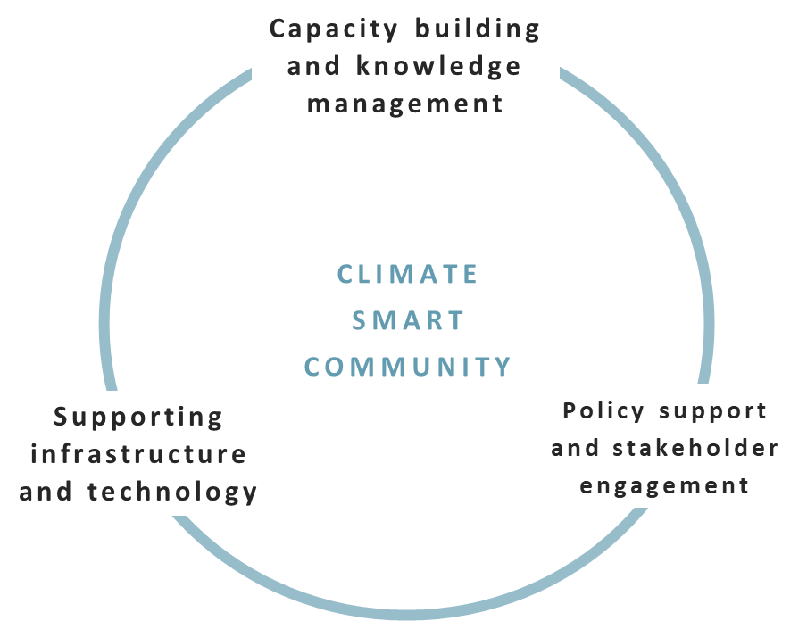
- Strengthening technology-based climate knowledge and learning systems in increasing awareness and adaptive capacity of the Saddang watershed ecosystem community through the development of the “Climate Smart Community” system. This system will strengthen local community knowledge in understanding the microclimate context in agricultural activities and anticipating disaster impacts by combining it with scientific knowledge that is easy to access and use. In addition to community capacity, supporting technology tools will be provided to ensure that increasing knowledge and learning capacity is carried out effectively and efficiently.
- Strengthening policies and participation of stakeholders to support the technology-based adaptive actions of the Saddang watershed ecosystem community through policy advocacy and development of an information system for monitoring climate change adaptation. This will significantly improve information governance related to climate change adaptation by building an integrated multi-sectoral climate change adaptation information system.
- Building collective intelligence through community-based research, knowledge management, and dissemination. Participatory research will be carried out by involving young local researchers whose capacity will be increased so that they are more sensitive to the issue of climate change and its potential impact on the villages where they live.

Project Objectives
List the main objectives of the project.
- The main objective of this project is to increase the adaptive capacity to climate change impacts of the community in four (4) regencies in the Saddang Watershed area. Specifically, the proposed project will address the following objectives:
- Development of technology-based climate knowledge and learning systems to increase awareness and adaptive capacity of Saddang watershed ecosystem community;
- Strengthening policies and participation of stakeholders to support the technology-based adaptive actions for Saddang watershed ecosystem community;
- Building collective intelligence through knowledge management and encouraging youth local community-based dissemination.

Project Components and Financing
Fill in the table presenting the relationships among project components, activities, expected concrete outputs, and the corresponding budgets. If necessary, please refer to the INSTRUCTIONS FOR PREPARING A REQUEST FOR PROGRAMME ON INNOVATION: SMALL GRANTS PROJECTS THROUGH DIRECT ACCESS for a detailed description of each term.
Project Components | Expected Concrete Outputs | Expected Outcomes | Amount (US$)
1. Development of technology-based climate knowledge and learning systems to increase awareness and adaptive capacity of Saddang watershed ecosystem community | 1.1.1. Strengthening community knowledge capacity in adapting to climate change  1.2.1. Development of technology-based supporting facilities and infrastructure to increase the adaptive capacity of the Saddang watershed ecosystem community  1.2.2. The existence of the equipment and or supporting devices in running the climate-smart community system | 1.1. Strengthening community capacity as an effort to increase technology-based climate resilience  1.2. Development and operation of the application of climate knowledge and learning “Climate Smart Community” | 111,071
2. Strengthening policies and participation of stakeholders to support the technology-based adaptive actions for Saddang watershed ecosystem community | 2.1.1. Increased capacity of the parties in formulating policies or strategic plans related to climate change adaptation  2.1.2. The existence of local government policies that strengthen technology-based climate change adaptation actions  2.1.3. Development and operation of climate change adaptation monitoring information systems in four regencies | 2.1. The ongoing support of the parties for climate change adaptation actions based on the use of technology | 59,072
3. Building collective intelligence through knowledge management and youth local community-based dissemination | 3.1.1. Strengthening the capacity of local youth climate observers who are also transformed into influencers for climate-smart communities  3.1.2. Dissemination of lessons learned from the climate change adaptation innovation program in the Saddang watershed | 3.1. The implementation of youth-based climate learning through the “climate-smart community system” | 49,607
4. Project Execution cost |  |  | 21,250
5. Total Project Cost |  |  | 219,750
6. Project Cycle Management Fee charged by the Implementing Entity (if applicable) |  |  | 9,000
Amount of Financing Requested |  |  | 250,000

Projected Calendar
Indicate the dates of the following milestones for the proposed project/programme
Milestones | Expected Dates
Start of Project Implementation | March 2023
Project Closing | August 2024
Terminal Evaluation | December 2024

PART II: PROJECT JUSTIFICATION

A. Project Components
Describe the project components, particularly focusing on the concrete adaptation activities of the project, and how these activities contribute to climate resilience.
Component 1: Development of technology-based climate knowledge and learning systems to increase awareness and adaptive capacity of Saddang watershed ecosystem community
- The development of technology-based climate knowledge and learning system aims to increase capacity and broaden the thinking horizon of village-level communities about the effects of climate change on their livelihoods and how they should act to adapt to face the challenges of the times. This idea is a development of the previous Adaptation Fund project in 2020-2022 with the title "Community Adaptation for Forest-Food Based Management in Saddang Watershed Ecosystem," which initiated the "Climate Smart Community" platform as a means to strengthen the adaptive capacity of the Saddang watershed community to climate change.
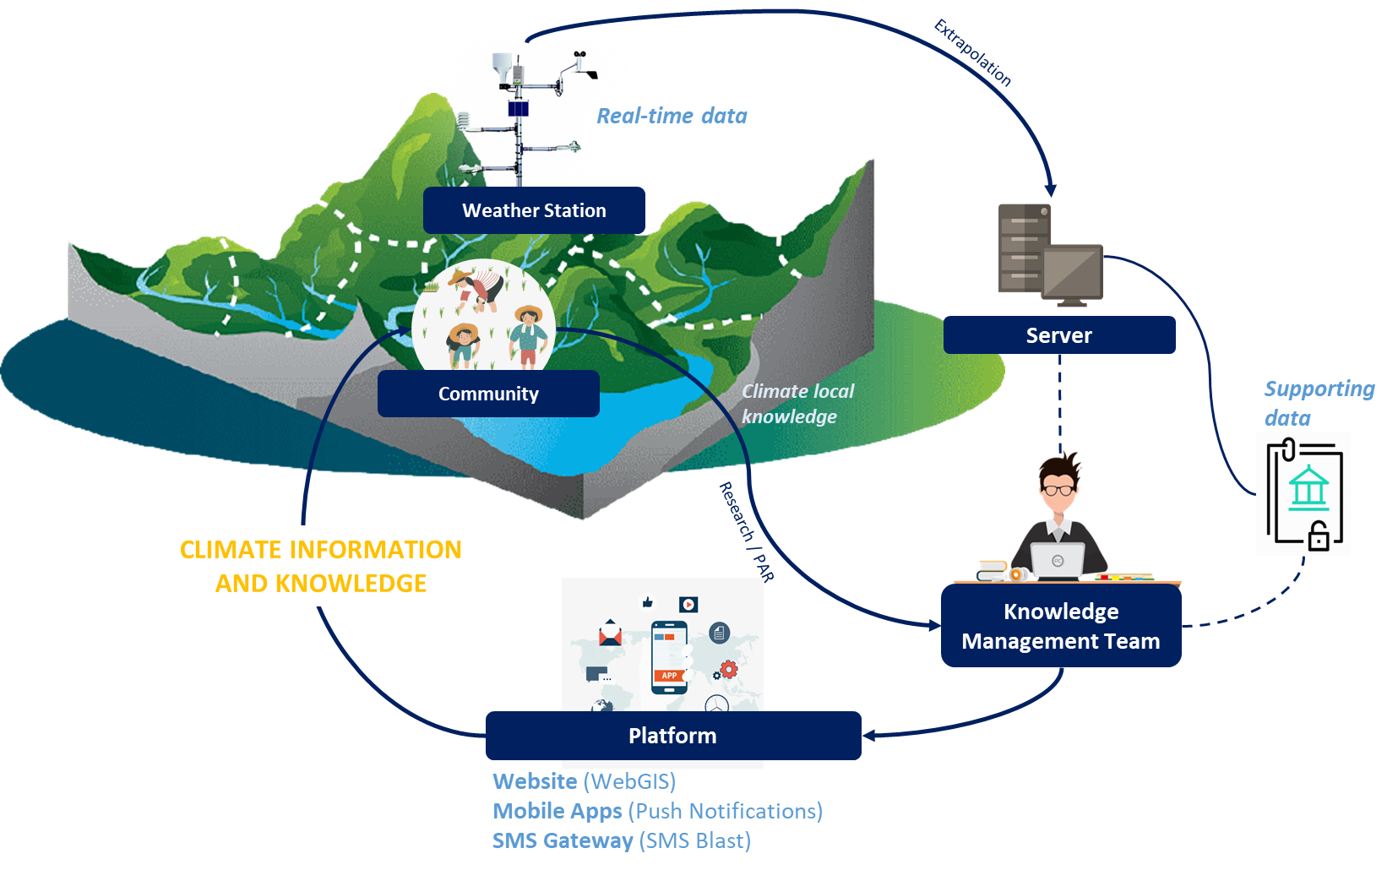
- Climate Smart is defined as the community can better understand the facts and current climate conditions in real-time, both direct impacts and impacts seen from upstream and downstream of the watershed. This knowledge can be used to help reduce the level of vulnerability that may occur. With this system, villagers can anticipate and respond appropriately to rescue and minimize impacts. For communities in the upstream watershed, access to information in the form of adaptive plants that can also contribute to the health of the watershed can be developed in order to reduce the potential for maladaptation in the upstream watershed, whose impact will be significantly felt by the community in the downstream watershed. For communities in the downstream watershed, information can be used to make decisions about their livelihoods. The information obtained can be used to anticipate potential impacts that will occur (for example, if there is extreme rain in the upstream watershed, then it is reinforced by indications of rising water in the downstream watershed, the community can respond more quickly, such as harvesting earlier and carrying out disaster preparedness).
- Stakeholders can use this smart community climate system platform for climate change adaptation to facilitate monitoring and ensure the dissemination of information about the situation and climate conditions in the Saddang Watershed in the context of Climate Change Adaptation. The main elements of this system include microclimate conditions in the village (rainfall, temperature, air, wind), climate education, and a means to share local knowledge about other climate change adaptations. However, currently, a lot needs to be developed from these initiatives, one of which is related to capacity building and further development of innovations that have been carried out previously. The scientific knowledge obtained through the technological devices presented needs to be elaborated with the local climate knowledge of the community to produce an information system based on local wisdom in the village. Therefore, this innovation project will aim deeper and further into developing the “Climate Smart Community” system, not just presenting a technology platform but also how the beneficiaries can quickly accelerate themselves so that the existing technology becomes more appropriate for use longer in the future.

Outcome 1.1. Strengthening community capacity as an effort to increase technology-based climate resilience
- The capacity-building element in this project targets 180 direct beneficiaries from 9 villages who will be given appropriate lessons to be more adaptive to climate change. The intervention villages were chosen by first conducting a Free, Prior, and Informed Consent (FPIC) process at the village level. We prioritize strengthening several villages, specifically those that were previously the site of an AF project intervention in the Saddang watershed. Several other villages (that were not intervention villages in the previous AF project) were chosen based on the coverage area that represented a watershed unity. A socio-economic, gender and ecological assessment will be conducted first, followed by a field survey and a review of documents containing statistical data about the village in the selection process. The village's level of vulnerability to climate change will also be determined using data from Indonesia's Vulnerability Index Data Information System (SIDIK).
- A minimum of 20 people will be chosen from each intervention village who have joined the Karang Taruna (Youth Organization in Village) group, as specified in Minister of Social Affairs Regulation No. 25 of 2019 concerning Karang Taruna, to strengthen their capacity and raise their awareness of climate change adaptation issues. These direct beneficiaries will become local champions or driving forces in spreading the perspective of climate change adaptation in each village. It will also have an impact on all villagers. The “Climate Smart Community” system will be ensured to work and be used as a reference for the community and parties in making decisions requiring consideration of climate information.
- The operation and maintenance of this system will be transferred gradually to the village-level community through the Village Government and enhanced with pertinent government collaboration at the provincial and regency levels. This innovation project will ensure multi-stakeholder cooperation runs in the system cycle. At the village community level, strengthening is carried out by the Karang Taruna and village governments. Both of them will become the main actors in running this system and influencing it in the future. The project implementer will support the development process and continue communicating with the village community, even until the project ends. Project implementers will also carry out intensive advocacy efforts to ensure that various parties participate. One of the instruments that can strengthen this advocacy process is the Climate Change Adaptation Working Group which involves multi-stakeholders. The working group work plan will include the operation and maintenance of the climate-smart community system to ensure this can continue. This outcome will be achieved through:
- Training: Trainings to support the adaptive capacity building of youth communities in rural project priority will be carried out, such as understanding microclimate; youth leadership, facilitating, and advocacy; dissemination training; climate-smart agriculture or climate-resilient agroforestry systems; disaster management; and gender-responsive climate-aware village assistance.
- Facilitating or Technical Assistance: The strategy in ensuring the deliverable of knowledge to beneficiaries is to involve trained village assistants who lived-in in the village that will internalize an understanding of climate change adaptation to beneficiaries.
Outcome 1.2. Development and operation of the application of climate knowledge and learning “Climate Smart Community”
- This project targets the development of the Climate Smart Community technology platform in terms of its unique features. Development is also carried out by increasing the number of climate stations to obtain more accurate real-time data and represent microclimate conditions with a broader range in the Saddang watershed landscape. This outcome will be achieved through:
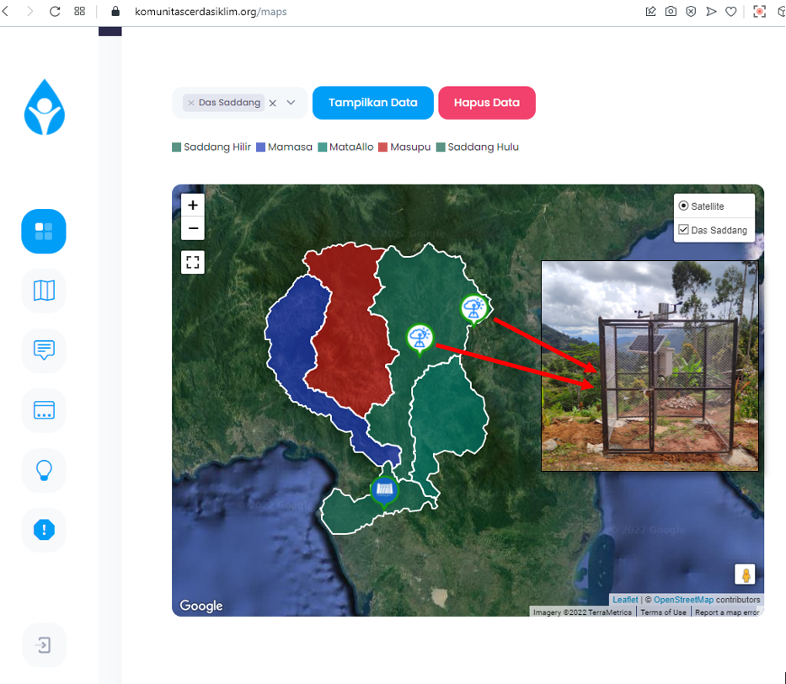
- IT System Development: Application development will be carried out by adding key features such as integrating local climate knowledge with scientific knowledge, increasing the capacity to receive data and information flows, and other features that will evolve based on user needs. In addition, development is also carried out on elements of supporting devices. Currently, two (2) weather stations are integrated with the Climate Smart community apps system in Tana Toraja and North Toraja Regencies. Five (5) more weather stations will be added to cover each of the Masupu, Mata Allo, and Saddang Hilir sub-watersheds in the Saddang watershed landscape, both upstream and downstream.
- Based on previous AF projects in the Saddang watershed, permission from the village government is required to install weather stations in the village. As a result, prior consultation with the village head is required to determine the best location for the weather station installation. The weather station will be installed on village-owned land, so a letter of cooperation or contract with the village is required, stating that the village-owned land will be used for the installation of the weather station, as well as the village government's commitment to maintaining and ensuring that the equipment will be maintained in the village.
Component 2: Strengthening policies and participation of stakeholders to support the technology-based adaptive actions for Saddang watershed ecosystem community
- Policy strengthening and stakeholder participation aim to ensure the sustainability of knowledge and learning systems in enhancing climate change adaptation actions. This will also support the achievement of component 1 of the project. Multi-stakeholder participation will be supported by strengthening digital information systems for various sectors' integrated climate change adaptation actions. Through this program, the strengthening and mainstreaming of climate change adaptation issues at the local government level will be encouraged by enhancing the institutional capacity, strengthening coordination between stakeholders, and promoting cross-sectoral policies.
Outcome 2.1. The ongoing support of the parties for climate change adaptation actions based on the use of technology
- The parties’ synergy is needed so that this system continues to run and will constantly develop. To achieve this, efforts are required to build a common understanding or vision to bridge the gap in understanding and sectoral ego in each key stakeholder entity. In facilitating the integration of key stakeholder data and information in carrying out climate change adaptation actions, technological facilities are needed that support the ease of sharing information. The previous project entitled "Community Adaptation for Forest-Food Based Management in Saddang Watershed Ecosystem" through AF funding has initiated the development of an information system for monitoring climate change adaptation. However, it is still within the scope of South Sulawesi Province. Developing an information system for monitoring climate change adaptation is necessary to internalize the regency level approach. This outcome will be achieved through:
- Capacity Building: Capacity building activities through training, socialization, workshops, and regular discussions will be carried out to ensure understanding of the development plan for climate change adaptation actions in each regency, as well as a mutual commitment to building collaborative works. One of the essential parts of this capacity building is training in simulations, whether it's a simulation of the implementation of joint monitoring of climate change adaptation to simulations of extreme weather that are integrated upstream and downstream to reduce the risk of loss. The following is an indicative list of potential stakeholders whose capacity will be increased:
Stakeholders / Institutions | Number of Persons
Government - Provincial Level
Centers for Climate Change and Forest and Land Fire Control of Sulawesi Region (BPPIKHL Sulawesi) | 1
Regional Development Planning, Research and Development Agency of South Sulawesi | 1
Meteorological, Climatological, and Geophysical Agency (BMKG) Region IV Makassar | 1
Regional Disaster Management Agency (BPBD) of South Sulawesi | 1
Environmental Agency (DLH) of South Sulawesi | 1
Low Carbon Development Working Group (POKJA PRKD) of South Sulawesi Region | 1
Government – Regency Level
Regional Development Planning, Research and Development Agency of North Toraja | 1
Regional Development Planning, Research and Development Agency of Tana Toraja | 1
Regional Development Planning, Research and Development Agency of Enrekang | 1
Regional Development Planning, Research and Development Agency of Pinrang | 1
Community Empowerment and Village Service (DPMD) of North Toraja | 1
Community Empowerment and Village Service (DPMD) of Tana Toraja | 1
Community Empowerment and Village Service (DPMD) of Enrekang | 1
Community Empowerment and Village Service (DPMD) of Pinrang | 1
Regional Disaster Management Agency (BPBD) of North Toraja | 1
Regional Disaster Management Agency (BPBD) of Tana Toraja | 1
Regional Disaster Management Agency (BPBD) of Enrekang | 1
Regional Disaster Management Agency (BPBD) of Pinrang | 1
Environmental Agency (DLH) of North Toraja | 1
Environmental Agency (DLH) of Tana Toraja | 1
Environmental Agency (DLH) of Enrekang | 1
Environmental Agency (DLH) of Pinrang | 1
Communication and Informatics Services of North Toraja | 1
Communication and Informatics Services of Tana Toraja | 1
Communication and Informatics Services of Enrekang | 1
Communication and Informatics Services of Pinrang | 1
Forest Management Unit (KPH) Saddang I – Tana Toraja | 1
Forest Management Unit (KPH) Saddang II – North Toraja | 1
Forest Management Unit (KPH) Mata Allo – Enrekang | 1
Forest Management Unit (KPH) Sawitto – Pinrang | 1
Government – Villages/Kelurahan Level
Head of Villages / Kelurahan | 9
Academics / Universities
Academics / Universities | 2
CSOs
CSOs | 2
Total Indicative Stakeholders (by person) | 43
- Policy Advocacy: To ensure that the climate change adaptation monitoring information system is running, it is necessary to advocate for building a joint commitment, either in the form of a working group or other arrangements, as well as a means of communication and multi-stakeholder coordination to encourage regional development that mainstreams the issue of climate change adaptation. With intensive communication and coordination, policies and commitments for cooperation directed toward climate-resilient development are enabled.
- Development of Adaptation to Climate Change Information System: The development of apps will be carried out so that the contents of the information system can also be implemented up to the regency level. In addition, several key features will be added based on key stakeholder inputs based on evolving needs in the implementation process.
Component 3: Building collective intelligence through knowledge management and youth local community-based dissemination
- Knowledge management and dissemination are directed to all project target parties to obtain information, increase awareness, and receive and utilize information to realize collective intelligence. Participatory action research will be carried out to disseminate local climate knowledge, which can also contribute to ensuring the functioning of the climate-smart community system.
Outcome 3.1. The implementation of youth-based climate learning through a “climate-smart community system”
- Youth-based climate learning will be carried out by encouraging young local climate observers at the village level in its implementation. Village facilitators will also assist the climate observation, collecting data, and conducting the Participatory Action Research (PAR). The data and information findings can lead to solutions formulated jointly with beneficiaries. This project will encourage the young village-based local climate observer while still mainstreaming the aspect of gender equality in the involvement of beneficiaries. This project aims to prepare at least one young person from each village to be a climate observer. The main criteria seen are the level of activity or participation in the group; having basic knowledge; thinking inclusively; having the enthusiasm to disseminate the knowledge obtained. This is necessary because the village climate observer will collect much data and information and capture the context and issues of climate change at the local level. The project lessons will be disseminated so that these lessons learned and climate change adaptation action innovation campaigns at local, national, and even international levels can be accepted and replicated in the future. This outcome will be achieved through:
- Capacity Building: Capacity building for local youth and village facilitators in conducting climate observation; collecting data; participatory action research (PAR); ethnography; mapping; and creating publication products through training activities and workshops. In addition, technical assistance is also carried out by involving experts from relevant universities or institutions in the consultation process.
- Community-based Broadcasting: This project will encourage the active participation of young village climate observers by establishing a community-based broadcasting radio (both digital and analog or local radio). With this, climate learning from the assisted-village youth can be disseminated more widely to youths in other areas in South Sulawesi and even Indonesia. On a local scale, local radio broadcasts can be the tools for villagers to listen to information about the local climate. The Karang Taruna group will run community-based radio broadcasting. As previously stated, funding for Karang Taruna (Youth Organizations in Village) can come from the State Revenue and Expenditure Budgets (APBN), Regional Revenue and Expenditure Budgets (APBD), and legal and non-binding sources of funding following the provisions of laws and regulations by Minister of Social Affairs Regulation No. 25 of 2019 concerning Youth Organizations, especially in Chapter IX: Funding, Article 44. During the project, Karang Taruna funding sources will be advocated for so that the relevant government can support it. After the project is completed, funding will be provided for the continued operation and maintenance of this community-based radio broadcasting system.
- Dissemination: The data and information collected will be analyzed to produce output in the form of articles, podcasts, or any publication product based on relevant themes so that they can be disseminated to spread climate knowledge. Digital publications are carried out through social media and websites. Campaign content creation will also be carried out by creating audio and/or visual content such as short videos, infographics, posters, flyers, leaflets, etc. The learning module will also be made as a guide for beneficiaries to use and utilize the application system, as well as a guide in conducting climate observations, data collection, and village ethnography.

B. Economic, Social and Environmental Benefits
Describe how the project provides economic, social and environmental benefits, with particular reference to the most vulnerable communities, and vulnerable groups within communities, including gender considerations. Describe how the project will avoid or mitigate negative impacts, in line with the Environmental and Social Policy of the Adaptation Fund.
- This project will provide various economic, social, and environmental benefits for all stakeholders. This project will provide suitable lessons to be replicated throughout other regions in South Sulawesi and even Indonesia to have a much broader impact. The beneficiaries of this project are re-directed to vulnerable communities as climate change impact recipients; in this case, communities in four (4) regencies in South Sulawesi (landscape area of ​​the Saddang watershed) and local institutions have been involved. This project is oriented toward participatory, transparent, and open principles so that all beneficiaries targeted by the project can be actively engaged in achieving the project’s main objectives. This project is also designed with gender mainstreaming in mind, with fair and unbiased inclusion of vulnerable and marginalized groups. The active involvement of women in all elements of the implementation of activities in this project will be one of the main concerns. The benefits obtained for all entities in this project are:
- Local Communities: Knowledge capacity will be improved, which is adaptive to understanding climatic conditions, including linear with land-use patterns in practical farming or planting according to time, both in the context of upstream watershed communities and downstream watershed communities those more affected. The community will also be aware of wise land use and adapt to the needs and applicable environmental standards to minimize land damage.
- Government: It will help to encourage adaptation and mitigation actions against climate change in accordance with regulatory mandates that are strengthened by advocating integrated management policies with one another, including minimizing the occurrence of miscommunication between government agencies involved. It can also trigger the establishment of new policies that are responsive to the environment.
- Civil Society Organization: They will be integrated into carrying out their projects to synergize, including sharing knowledge on lessons learned from projects, primarily adaptation actions to climate change.
- Academics / University: It will provide new data and information revealed from several field findings to trigger more comprehensive knowledge management. It also encourages the emergence of new research or research that can help solve various problems.
- Private Sector: Will share information regarding community-based environmental management by prioritizing community involvement in every activity carried out, including producing action guidelines in managing Corporate Social Responsibility (CSR) funds to benefit the environment and community.

C. Innovative Adaptation Practices
Describe how the project encourages or accelerates development of innovative adaptation practices, tools or technologies and/or describe how the project helps generate evidence base of effective, efficient adaptation practices, products or technologies, as a basis for potential scaling up.
- Climate Smart Community: This project will promote innovative adaptation technologies to help solve adaptation problems by caloborating local community climate knowledge and technology-based climate-related science knowledge. The project also encourages the development of the Climate Smart Community technology platform regarding its special features. The system to be built can provide climate information to anticipate disaster risks due to climate change. This system is also expected to assist parties such as Agency for Meteorology, Climatology and Geophysics Center (BMKG), National Disaster Management Authority (BNPB), researchers, and even local governments in receiving climate data. More simply, the table below provides a comparison of the existing conditions of climate data and information flows and what innovations are addressed through this innovative technology platform:
Before Innovation Project | Innovation Project- Climate Smart Community Apps
- Lack of coaching or capacity building for receiving data and climate information flows at the local level. | - Climate Smart Community platform provides guidance or capacity building for climate knowledge that is easily understood by local communities.
- Still using manual recording, which takes a long time to process the information | - Climate data is recorded automatically, and real-time is then transferred to the cloud server and managed by the knowledge management team so that it can be disseminated quickly.
- It takes quite a long procedure, and some parties are still having difficulty accessing climate information at the local level | - Climate information can be used by various parties and can be easily accessed through multiple platforms (mobile apps, website, SMS blast)

- Climate Change Adaptation Monitoring Information System: The innovation in this system is intended to integrate information about climate change mitigation actions carried out in the province of South Sulawesi by the parties. Information on actions and activities, both adaptation and mitigation of climate change, will be provided openly and transparently following a collective (participatory) agreement so that all parties can monitor, provide input and suggestions, and this information can also be used as a reference in preparing regional climate-resilient development plans.
- Youth Climate Observer: The lack of awareness of village youth in the Saddang watershed area has implications for the minimal level of regional climate resilience. It is at risk of having a greater impact on vulnerability. The direct involvement of youth in developing a climate-smart community system, community-based broadcasting radio, and becoming climate observers is an innovation that is carried out so that village youth can be more literate regarding climate issues so that they can become a driving force (influencers) for local adaptive actions later, armed with their knowledge. This innovation project is expected to shift the old paradigm that youth should continue their education and have a career in big cities to improve their standard of living, with a new paradigm that youth should continue their education, receive knowledge and learning, to give the best they can for rural development. In this case, it related to the issue of climate change, the impact of which will sooner or later be felt directly for their livelihoods in the future.
- The ideas in this project are highly possible to scaled-up and replicated. This project is expected to provide tangible benefits to the community, such as: (i) communities in the downstream watershed area are better prepared to face the threat of climate change because they can oversee weather conditions in the upstream watershed area in real time (whether it rains in intensity normal or extreme); (ii) smallholders have begun to use and compile a new planting calendar that considers updated climate information; (iii) the response to landslides in the upstream watershed area will be swift.
- Scalability: Assume these advantages are genuine, and the information is massively amplified. In that case, other village governments (apart from project intervention) are expected to prepare and facilitate the climate system because they are related to the village's livelihood interests. The government, particularly at the provincial and regency levels, will welcome the idea of implementing the project in other villages through local funding because it provides immediate benefits.
- Replicability: These adaptation actions can be more widely disseminated in other areas that require similar interventions (e.g., in other watershed areas vulnerable to the effects of climate change/disaster). This can be accomplished by strengthening policy support at the provincial level and forming provincial working groups. In the near future, the impact of dissemination will affect the replicability of the different areas that are also often affected by climate change (e.g., Luwu Regency, North Luwu Regency, Gowa Regency, Maros Regency, Makassar City, Bulukumba Regency and Bantaeng Regency). This is because these areas have the same problem and the same parties at the provincial and ministry level.

D. Compliance with Relevant National Technical Standards
Please confirm whether the project meets relevant national technical standards, where applicable, such as standards for environmental assessment, building codes, etc., and is in line with the Environmental and Social Policy of the Adaptation Fund.
- This project will become a more massive information channel among all stakeholders. All data and information content will be adjusted according to Presidential Instruction No. 9 of 2015 concerning the Management of Public Communication and Law No. 19 of 2016 concerning Information and Electronic Transactions, and the security and transparency of the data presented will follow the protocol of Presidential Regulation no. 39 of 2019 concerning the Indonesian One-Data Policy. This project is designed for gender-responsive sites by providing proportional opportunities in terms of involvement between men and women according to Presidential Instruction No. 9/2000 on Gender Mainstreaming in National Development, which applies to all ministries, including the Minister of Environment and Forestry Regulation No. P. 31/MenLHK/Setjen/Set.1/5/2017 concerning Guidelines for the Implementation of Gender Mainstreaming in the Environment and Forestry Sector.
- This project directs youths as the beneficiaries in disseminating knowledge and raising awareness of climate change adaptation. To ensure that the youth groups activities will intervene in the project achieve the goal and the sustainability, this project will encourage the strengthening of youth communities, namely Karang Taruna (Youth Organization). Karang Taruna is regulated under Indonesia’s Minister of Social Affairs Regulation No. 25 of 2019 concerning Karang Taruna. This regulation governs membership, rights, obligations, responsibilities, and funds. Funding for Karang Taruna can come from the State Revenue and Expenditure Budgets (APBN), Regional Revenue and Expenditure Budgets (APBD), and legal and non-binding sources of funding.
- Content Data and information regarding climate change adaptation will be guided by the Minister of Environment and Forestry Regulation No. P.33/Menlhk/Setjen/Kum.1/3/2016 concerning guidelines for the preparation of climate change adaptation actions by involving various sectors in its planning. In addition, the entire series of project activities will comply with relevant and applicable national regulations through the support of the Directorate General of Climate Change Control, particularly the Directorate of Climate Change Adaptation, and several Experts in the field of Biodiversity and Climate Change at Hasanuddin University.
- Several supporting tools in the "Climate Smart Community" system that are in direct contact with the environment, for example, the installation of climate stations, can be ensured that they have gone through a series of environmental standard procedures that comply with the ISO 140001 standard regarding Environmental Management Systems by carrying out several initial activities, namely an assessment of the impact analysis on the environment. The data in the Climate Change Adaptation Action Monitoring System developed in this project will be integrated with applications that BAPPENAS has made, in this case, the National Low Carbon Action Plan Planning and Monitoring Application System (AKSARA), as well as several applications that the Ministry has made of Environment and Forestry namely Information Systems Vulnerability Index Data (SIDIK), the National Registry System (SRN), and the SPECTRUM Application related to the need for data collection and calculation of android-based greenhouse gas emission reductions. Furthermore, data and information originating from the "Climate Smart Community" application are expected to be used by parties such as BMKG, BNPB, researchers, and even local governments.

E. Learning and Knowledge Management
If applicable, describe the learning and knowledge management component to capture and disseminate lessons learned.
- This project is oriented toward knowledge management, communication strategies, and appropriate learning systematics. The project includes one main component that focuses on knowledge management, namely Component 3 of the project. Strategies to ensure that learning and dissemination efforts are carried out are effective, including:
- Knowledge Cycle Management: In strengthening knowledge and learning in this program management cycle, this knowledge and learning will be captured and disseminated by forming a competent project Knowledge Management Team to be recruited. In project implementation, the Knowledge Management team will be formed to ensure the running of the IT systems built and maintain and manage the project database. The team also focuses on processing data and information and knowledge into audio, visual, or a combination of both contents to be later disseminated to increase awareness of regional climate change adaptation. The involvement of parties from college or relevant institutions as facilitators in capacity building that has been designed will also be carried out to support efforts to strengthen knowledge and learning.
- Established village youth-based climate observer group so that action-oriented research and dissemination efforts at the local level can run in a participatory manner. Youth and women's representatives from the village level are strengthened in their knowledge capacity to become influencers of climate change adaptation, both at the village level and at the same time as a catalyst for climate-smart communities, including the ability to manage data, disseminate and advocate.

F. Environmental and Social Impacts and Risks
Provide an overview of the environmental and social impacts and risks identified as being relevant to the project. Describe how the project will engage, empower and/or benefit the most vulnerable communities and social groups, including gender considerations, in line with the Environmental and Social Policy of the Adaptation Fund.
- This project does not provide significant environmental and social impacts and risks. Based on the OPG Annex 3-Environmental and Social Policy Adaptation Fund, it can be categorized in category C.
Checklist of environmental and social principles | No further assessment required for compliance | Potential impacts and risks – further assessment and management required for compliance
- Compliance with the law | Implementing Entitles will ensure that all activities comply with the law, and in principle, IE will ensure that all licensing components are to be implemented in compliance with applicable legislation. Related to this proposal on Part II - Section D | None
- Access and equity | The program does not hinder access to basic health services, clean water and sanitation, energy, education, housing, safe and decent working conditions, and land rights. The project also does not exacerbate existing inequities, particularly concerning marginalized or vulnerable groups. The project has been designed not to impede any group's access to the essential services and rights stated in the principles. | None
- Marginalized and Vulnerable Groups | At the program sites, marginal and vulnerable groups have been identified and facilitated in the previous program, namely through the “Community Adaptation for Forest-Food Based Management in Saddang Watershed Ecosystem” through the Adaptation Fund funding in 2020-2022. In planning this innovation program, marginalized and vulnerable groups were involved and participated in facilitation activities, and FGDs were held with several stakeholders. No further assessment is required. | None
- Human Rights | This program will respect Human Rights. This will be done by creating awareness among everyone involved in program implementation, including design, implementation, monitoring, and evaluation, of the Universal Declaration of Human Rights as a program-wide principle. So it does not require further assessment of compliance. No further assessment is required. | None
- Gender Equity and Women’s Empowerment | The program is designed so that women and men have equal opportunities to participate in accordance with gender policies and receive commensurate social and economic benefits. The Program will actively involve equal participation in program activities and stakeholder consultation. The program also ensures that both men and women effectively access positions in the program and that women are encouraged to apply and take up jobs. In essence, program design and implementation will ensure equal access for men and women. | None
- Core Labour Right | The program meets core labor standards as identified by the International Labor Organization / ILO core labor standards. The ILO's core labor standards are contained in the LO Declaration of Principles and Fundamental Rights in 1998. This Declaration includes four basic principles and rights, which are further developed in eight human rights conventions. The Program will incorporate core ILO labor standards in program design and implementation and create awareness among all involved about applying these standards. The entire programming is not related to the violation of core labour rights. | None
- Indigenous peoples | The program can be ensured that it will not conflict with the principles of Indigenous Peoples or the Rights of Indigenous Peoples and other international instruments that apply to indigenous peoples. The program does not directly involve indigenous peoples in program design and implementation. Therefore, no further assessment is required. | None
- Involuntary Resettlement | Not relevant | None
- Protection of Natural Habitats | Not relevant | None
- Conservation of Biological Diversity | Not relevant | None
- Climate Change | The project aims to increase adaptive capacity to climate change without causing beneficiaries to accept other climate change impacts and not be expected to contribute to GHG emissions. No further assessment is required. | None
- Pollution prevention & resource efficiency | The facilities and infrastructure provided will not cause pollution, waste production, and release of pollutants (including greenhouse gases). Therefore, no further assessment is required. | None
- Public Health | The facilities and infrastructure provided by this project will not interfere with public health. Therefore, no further assessment is required. | None
- Physical and Cultural Heritage | The facilities and infrastructure provided by this project will not damage the physical and cultural heritage of the village. No further assessment is required. | None
- Soil and Land Conservation | Not relevant | None

G. Justification for Funding Requested
Provide justification for funding requested, focusing on the full cost of adaptation reasoning.
- This innovation project targets all community elements in the Saddang watershed ecosystem as beneficiaries, specifically farmers, fish farmers, youth, and government staff who are direct beneficiaries. This project will impact the community where the platform used can be easily accessed by all parties as a medium for learning and disseminating knowledge about how to adapt to climate change, especially in the context of the Saddang watershed, where rural areas dominate the area. The technology-based innovation has become a new way of climate change adaptation action, especially in South Sulawesi. This can ensure that knowledge about climate change adaptation is spread to the village community level, which used to be very difficult to get access to information. With the funding of this innovation project, the initiation of technology-based climate change adaptation actions will provide greater development, renewal, and capacity building. It will have a greater impact on increasing community resilience to climate change. The impact will be more tangible, and advocacy steps will be carried out at the government level, so the possibility of this project being replicated will be even greater.
- Component 1: Without AF funding through this innovation project, the idea of a “Climate Smart Community” system will be more challenging to develop in the Saddang watershed landscape. This can be seen from the need for greater effort to convince local governments that the technology system created will directly provide significant benefits to the community. The government must be shown concrete evidence on the ground that this system is successful so that they can only be willing to invest in regional budgets to be allocated to technology-based climate change adaptation actions. Currently, the platform is up and running, and there are already two (2) weather stations in two (2) villages in the Saddang watershed operating. Both communities in the upstream and downstream watersheds will lose the opportunity to gain access to more effective and efficient information, which will be used as knowledge and lessons learned in taking action or responding to their livelihoods that are vulnerable to being affected by climate change conditions.
- Component 2: Without AF funding, the climate change adaptation monitoring information system will only be implemented at the provincial level. There has been no initiation from governments at the regency level within the province of South Sulawesi to participate in this climate change adaptation monitoring information system. In addition, government institutions will lose the opportunity to develop technological innovations in climate change adaptation actions to increase climate-resilient regions' development.
- Component 3: Without AF funding, village youth will lose the opportunity to increase their capacity to understand the context of climate change through the lessons they will need later. Ideas related to adaptive action based on the latest technology development will not be widely disseminated. Thus, public awareness of climate change adaptation issues has not been significantly increased.

PART III: IMPLEMENTATION ARRANGEMENTS

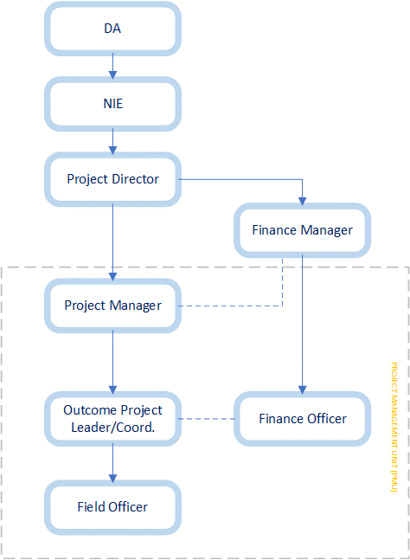
A. Arrangements for Project Implementation
Describe the arrangements for project / programme implementation.
- The implementing entity (IE) for this project is Kemitraan (the Partnership for Governance Reform), as the National Implementing Entity (NIE) of Adaptation Fund in Indonesia. This project will be implemented for 17 months. In project implementation, Kemitraan will work with the Yayasan Tim Layanan Kehutanan Masyarakat (TLKM) which in this project become Executing Entity (EE). TLKM had previously been the lead consortium of KAPABEL, which became EE in the Project Adaptation Fund for 2020-2022 entitled "Community Adaptation for Forest-Food Based Management in Saddang Watershed Ecosystem" in Indonesia. In the previous project, Kemitraan and TLKM established the Climate Smart Community Platform and Climate Change Adaptation Monitoring Information System in South Sulawesi. With the capacity and experience of each institution that will be involved in this project, it is hoped that this project will have a significant impact on the beneficiaries in a targeted, effective, efficient, and gender-responsive way.
- In the implementation to achieve the objectives, this project will be managed by the Project Management Unit (PMU) with the composition of the Project Director, Project Manager (PM), and Finance Manager (FM). The Project Director is in charge of leading the Executing Entity, which will be responsible for reporting project results to NIE and DA. The Project Manager (PM) will lead the implementation or execution of the project; ensure that all achievement of project outcome-output indicators go according to plan; report results based on M&E planning to the Project Director; coordinate and disseminate to relevant stakeholders both at the provincial and regency levels. To ensure that the project implementation agenda in the field is carried out correctly, effectively, and efficiently, it is necessary to obtain assistance from operational personnel. In this program, the Outcome Project Leaders/Coordinators will be recruited to assist PM tasks in pursuing the achievement of project indicators. In addition, the strategy in ensuring the process and maintenance of the project learning system can continue, namely by forming a Knowledge Management and Communication team which also helps PM to achieve project indicators.
- This project is oriented towards gender mainstreaming, from planning to implementation. It will ensure the sustainability of a gender-responsive project once the project is completed. Entities in project implementation will include adequate gender understanding as a criterion for selecting project staff and operational personnel. Furthermore, the capacity-building process will be carried out to increase awareness of gender issues and understand the content of the project components before implementation. It will also equip operational staff and personnel with adequate knowledge of gender mainstreaming considerations in programs and adequate capacity to support project implementation—gender-responsive change.

B. Monitoring and Evaluation
Describe the monitoring and evaluation arrangements and provide a budgeted M&E plan.
- In the project management cycle, monitoring and evaluation are an integral part of achieving the objectives of project implementation. Monitoring and Evaluation will provide the information needed to assess and guide project strategy, ensure effectiveness, meet reporting requirements, and inform future planning. M&E as an integral part of the project management flow is described as follows:

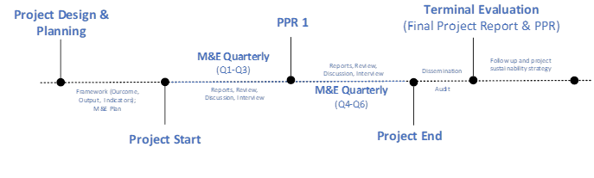
- The monitoring and evaluation plan is prepared by considering the program context, institutional capacity, information needs, and grant requirements. In this project, monitoring will be carried out by the PMU who is responsible for M&E. Monitoring will be carried out every quarter (3 months) to see that the process (activities) and program results (outputs, outcomes) are still running on the track. Monitoring is carried out using document review methods, interviews, and stakeholder discussions. Monitoring is directed to see efficiency, effectiveness, and results. The results of M&E can be used as learning materials for improvement or development in other places so that the M&E results obtained will be reported periodically to related parties: Adaptation Fund, Kemitraan (the Partnership for Governance Reform) as NIE, Directorate General of Climate Change Control, MoEF as the Designated Authority (DA), and sub-national and local stakeholders.
Deliverables | Time | Responsible | Cost
Quarterly Report | Jan 2023 (Oct – Dec 2022 period)  Apr 2023 (Jan – Mar 2023 period)  Jul 2023 (Apr – Jun 2023 period)  Oct 2023 (Jul – Sep 2023 period)  Jan 2024 (Oct – Dec 2023 period)  Apr 2024 (Jan – Mar 2024 period) | Project Manager (PM) | $ 1,786
Project Performance Report (PPR) – I | Oct 2023 | Project Manager (PM) | $ 357
Final Project Report & PPR  (Terminal Evaluation) | July 2024 | Project Manager (PM) | $ 357
Audit | May – June 2024 | Auditors | $ 2,893

C. Results Framework
Include a simple results framework for the project proposal, including milestones, targets, and indicators.
Result | Indicator | Baseline | Milestone | Means of verification
Component 1. Development of technology-based climate knowledge and learning systems to increase awareness and adaptive capacity of Saddang watershed ecosystem communities
Outcome 1.1.  Strengthening community capacity as an effort to increase technology-based climate resilience | Number of people that increasing their capacity to adapt to climate change | 0 | 180 direct beneficiaries (people) | Reports  Documentation
Output 1.1.1.  Strengthening community knowledge capacity in adapting to climate change | Number of people that increasing their knowledge capacity to adapt to climate change | 0 | 180 direct beneficiaries  (people) – 30% participation of women  Men: 125  Women: 55 | Reports  Documentation
Outcome 1.2.  Development and operation of the application of climate knowledge and learning “Climate Smart Community” | Number of facilities that exist to support climate adaptive capacity building application | 0 | 3 facilities  (1) Weather Station  (2) Cloud Server  (3) Operating Office | Reports  Documentation
Output 1.2.1.  Development of technology-based supporting facilities and infrastructure to increase the adaptive capacity of the Saddang watershed ecosystem community | Number of climate-smart apps that are running and improved | 0 | 1 application | Reports  Documentation
Output 1.2.2.  The existence of the equipment and or supporting devices in running the climate-smart community system | Number of weather stations equipment that integrated into the climate-smart community apps | 2 unit weather station | 7 unit weather station | Reports  Documentation
Component 2. Strengthening policies and participation of stakeholders to support the technology-based adaptive actions for Saddang watershed ecosystem community
Outcome 2.1.  The ongoing support of the parties for climate change adaptation actions based on the use of technology | Number of any relevant institutions that increase their participation in technology-based actions of climates changes adaptation | 0 | 43 people | Reports  Documentation
Output 2.1.1.  Increased capacity of the parties in formulating policies or strategic plans related to climate change adaptation | Number of people that increase their capacity in making policies or regional planning strategies that internalize climate change adaptation issues | 0 | 43 people - 30% participation of women  Men: 30  Women: 13 | Reports  Documentation
Output 2.1.2.  The existence of local government policies that strengthen technology-based climate change adaptation actions | Number of policies/ commitment | 0 | 2 policies/MoU/ Decree | Reports  Documentation
Output 2.1.3.  Development and operation of climate change adaptation monitoring information systems in four regencies | Number of monitoring information systems that are running and improved | 0 | 1 application | Reports  Documentation
Component 3. Building collective intelligence through knowledge management and youth local community-based dissemination
Outcome 3.1.  The implementation of youth-based climate learning through the “climate-smart community system” | Number of villages implementing climate learning through climate-smart community systems | 0 | 9 villages | Reports  Documentation
Output 3.1.1.  Strengthening the capacity of local youth climate observers who are also transformed into influencers for climate-smart communities | Number of local youth climate observer group | 0 | 1 group (minimum 1 person of each village) – 30% women participation  Men: 6  Women: 3 | Reports  Documentation
Output 3.1.2.  Dissemination of lessons learned from the climate change adaptation innovation program in the Saddang watershed | Number of content/ publication product | 0 | 1 broadcasting platform  1 podcast  1 short video  documentary  1 infographic  1 leaflet  1 poster  1 learning modules | Reports  Documentation

D. Alignment with Adaptation Fund Result Framework
Demonstrate how the project / programme aligns with the Results Framework of the Adaptation Fund
Project Objective(s) | Project Objective  Indicator(s) | Fund Outcome | Fund Outcome Indicator | Grant Amount (USD)
1. Development of technology-based climate knowledge and learning systems to increase awareness and adaptive capacity of Saddang watershed ecosystem communities | 180 people that Increased capacity and awareness of the community and stakeholders to adapt to climate change in the modern era | Outcome 3.  Strengthened  awareness and  ownership of  adaptation and  climate risk reduction  processes at local  level | 3.1. Percentage of targeted population aware of  predicted adverse impacts of climate change, and  of appropriate responses  3.2. Percentage of targeted population applying appropriate adaptation responses | 111,071
 | 1 innovation in practice, approach, tools, and technology in adapting to climate change through the development of the Climate Smart Community system | Outcome 8: Support the development and  diffusion of innovative adaptation practices,  tools and technologies | 8. Innovative adaptation practices are rolled out,  scaled up, encouraged and/or accelerated at  regional, national and/or subnational level.
2. Strengthening policies and participation of stakeholders to support the technology-based adaptive actions for Saddang watershed ecosystem community | 43 stakeholders that increase the capacity and support in carrying out collaborative actions for technology-based climate change adaptation in watershed landscapes | Outcome 2: Strengthened institutional capacity  to reduce risks associated with climate-induced  socioeconomic and environmental losses | 2.1. Capacity of staff to respond to, and mitigate  impacts of, climate-related events from targeted  institutions increased | 59,072
 | 2 policies as an effort to improve the climate resilience of the Saddang watershed ecosystem community | Outcome 7:  Improved policies and regulations  that promote and enforce resilience measures | 7.1. No. of policies introduced or adjusted to  address climate change risks (by sector)
3. Building collective intelligence through knowledge management and youth local community-based dissemination | People in 9 villages and also the stakeholders increase their understanding so that they can push the issue of climate change to become a priority | Outcome 3.  Strengthened  awareness and  ownership of  adaptation and  climate risk reduction  processes at local  level | 3.1. Percentage of targeted population aware of  predicted adverse impacts of climate change, and  of appropriate responses | 49,607
Project Outcome(s) | Project Outcome Indicator(s) | Fund Output | Fund Output Indicator | Grant Amount (USD)
Outcome 1.1.  Strengthening community capacity as an effort to increase technology-based climate resilience | 180 people that are increasing their capacity and awareness to adapt to climate change | Output 3.2: Strengthened capacity of national and subnational stakeholders and entities to capture and disseminate knowledge and learning | 3.2.1 No. of technical committees/ associations  formed to ensure transfer of knowledge | 80,714
Outcome 1.2.  Development and operation of the application of climate knowledge and learning “Climate Smart Community” | 3 facilities that exist to support climate adaptive capacity building application | Output 8:  Viable innovations are rolled out, scaled up, encouraged and/or accelerated. | 8.1. No. of innovative adaptation practices, tools  and technologies accelerated, scaled-up and/or  replicated  8.2. No. of key findings on effective, efficient  adaptation practices, products and technologies  generated | 30,357
Outcome 2.1.  The ongoing support of the parties for climate change adaptation actions based on the use of technology | 43 people (staff) from any relevant institutions that increase their participation in technology-based actions of climates changes adaptation | Output 2.1: Strengthened capacity of national and sub-national centers and networks to respond rapidly to extreme weather events | 2.1.1. No. of staff trained to respond to, and mitigate impacts of, climate-related events (by gender) | 59,072
 | 2 policies/ commitment/ MoU / decree that internalize climate change adaptation issues | Output 7:  Improved integration of climate-resilience  strategies into country development plans | 7.1. No. of policies introduced or adjusted to  address climate change risks (by sector)
Outcome 3.1.  The implementation of youth-based climate learning through the “climate-smart community system | 1 platform of media that managed to increase community awareness through the dissemination process | Output 3.1:  Targeted population groups participating  in adaptation and risk reduction awareness activities | 3.1.1 No. of news outlets in the local press and media that have covered the topic | 49,607
 | 9 villages implementing climate learning through climate-smart community systems  Conducting 1 climate observer group based on youth-village community  6 communication products will be created | Output 3.2: Strengthened capacity of national and subnational stakeholders and entities to capture and disseminate knowledge and learning | 3.2.1 No. of technical committees/ associations  formed to ensure transfer of knowledge  3.2.2 No. of tools and guidelines developed  (thematic, sectoral, institutional) and shared with relevant stakeholders

E. Budget
Include a budget, including a budget on the Implementing Entity management fee use, and an explanation and a breakdown of the execution costs.
Project Components | Outcomes | Main Activities | Cost ($) | Total ($)
Component 1: Development of technology-based climate knowledge and learning systems to increase awareness and adaptive capacity of Saddang watershed ecosystem communities | Outcome 1.1.  Strengthening community capacity as an effort to increase technology-based climate resilience | 1.1.1.1. Field Facilitator Trainings  1.1.1.2. Regular FGD meetings for targeted beneficiaries  1.1.1.3. Serial trainings for targeted beneficiaries  1.1.1.4. Operationalizations of Field Facilitators  1.1.1.5. Climate Smart Community socialization  1.1.1.6. Operationalizations of Outcome Project Coordinator - Climate Smart Community | 2,500  3,214  17,143  46,286  3,214  8,357 | 80,714
 | Outcome 1.2.  Development and operation of the application of climate knowledge and learning “Climate Smart Community” | 1.2.1.1. Procurement of apps development services  1.2.1.2. Forming the management team  1.2.1.3. Training/knowledge transfer to the management team  1.2.2.1. Procurement and installation of weather station  1.2.2.2. Procurement of supporting equipment | 10,714  357  714  12,500  6,072 | 30,357
Component 2: Strengthening policies and participation of stakeholders to support the technology-based adaptive actions for Saddang watershed ecosystem community | Outcome 2.1.  The ongoing support of the parties for climate change adaptation actions based on the use of technology | 2.1.1.1. Capacity building on drafting the policies and/or regional planning documents that internalize the climate change issues  2.1.1.2. Initial socialization to internalize the monitoring information system apps at the Regency level  2.1.1.3. Operationalizations of Outcome Project Coordinator – Policy Encouraging and Stakeholder Engagement  2.1.2.1. Workshop on forming multi-stakeholder coordination groups  2.1.2.2. Adaptation of Climate Change – Regional Action Plans Study  2.1.2.3. Workshop on finalization of the policy/strategic action plans draft  2.1.2.4. Policy advocation  2.1.3.1. Procurement of apps development services  2.1.3.2. Procurement of supporting equipment | 2,143  4,286  8,357  2,143  22,857  2,143  4,286  7,143  5,714 | 59,072
Component 3.  Building collective intelligence through knowledge management and youth local community-based dissemination | Outcome 3.1.  The implementation of youth-based climate learning through the “climate-smart community system” | 3.1.1.1. Socialization of local youth climate observer and forming the groups  3.1.1.2. Serial trainings for local youth climate observer  3.1.1.3. Operationalizations of Outcome Project Coordinator – Knowledge Management & Learning  3.1.1.4. Operationalizations of Knowledge Management Team  3.1.1.5. Reporting, Review, FGD, Interview, M&E  3.1.2.1. Operationalization of Community-Based Broadcasting (Radio)  3.1.2.2. Creating the communication product | 3,214  5,893  8,357  22,286  2,500  5,357  2,000 | 49,607
Project Execution Cost |  | Project Director (LoE 25%)  Project Manager  Finance Manager (LoE 30%)  M&E Specialists  Audit Program | 2,786  10,214  2,786  2,571  2,893 | 21,250
PCM Fees |  |  | 9,000 | 9,000
TOTAL (USD) |  |  | 250,000

F. Disbursement Schedule
Include a disbursement schedule with time-bound milestones.
Disbursement Schedule | Upon signature of the Agreement | 1 Year after Project Start | Total
Scheduled date | October 2022 | October 2023
Project Cost | $ 153,825 | $ 65,925 | $ 219,750
Project Execution Cost | $ 14,875 | $ 6,375 | $ 21,250
PCM Fees | $ 6,300 | $ 2,700 | $ 9,000
Total | $ 175,000 | $ 75,000 | $ 250.000

PART IV: ENDORSEMENT BY GOVERNMENT AND CERTIFICATION BY THE IMPLEMENTING ENTITY

A. Record of endorsement on behalf of the government
Provide the name and position of the government official and indicate date of endorsement. If this is a regional project/programme, list the endorsing officials all the participating countries. The endorsement letter(s) should be attached as an annex to the project/programme proposal. Please attach the endorsement letter(s) with this template; add as many participating governments if a regional project/programme:
Laksmi Dewanthi  Director General for Climate Change  Ministry of Environment and Forestry | Date: August, 2, 2022

B. Implementing Entity certification
Provide the name and signature of the Implementing Entity Coordinator and the date of signature. Provide also the project/programme contact person’s name, telephone number and email address
I certify that this proposal has been prepared in accordance with guidelines provided by the Adaptation Fund Board, and prevailing National Development and Adaptation Plans (President Decree No. 16 Year 2015; President Decree No. 60 Year 2021; MoEF Regulations No. P.13/Menlhk/Setjen/OTL.0/1/2016; MoEF Regulations No. P.33/Menlhk/Setjen/Kum.1/3/2016; Indonesia Intended Nationally Determined Contribution (INDC); COP 21 Paris Agreement signed by Government of Indonesia; Book and Map of Information System of Vulnerability Index Data (SIDIK); Climate Change Adaptation National Action Plan) and subject to the approval by the Adaptation Fund Board, commit to implementing the project/programme in compliance with the Environmental and Social Policy of the Adaptation Fund and on the understanding that the Implementing Entity will be fully (legally and financially) responsible for the implementation of this project/programme.
Laode M Syarif
Implementing Entity Coordinator
Date: (July, 21, 2022) | Tel. and email:  +62 21 2278 0580  laode.syarif@kemitraan.or.id
Project Contact Person:
Abimanyu S Aji
Program Manager
Tel. And Email:
+62 821 6512 0204
abimanyu.aji@kemitraan.or.id

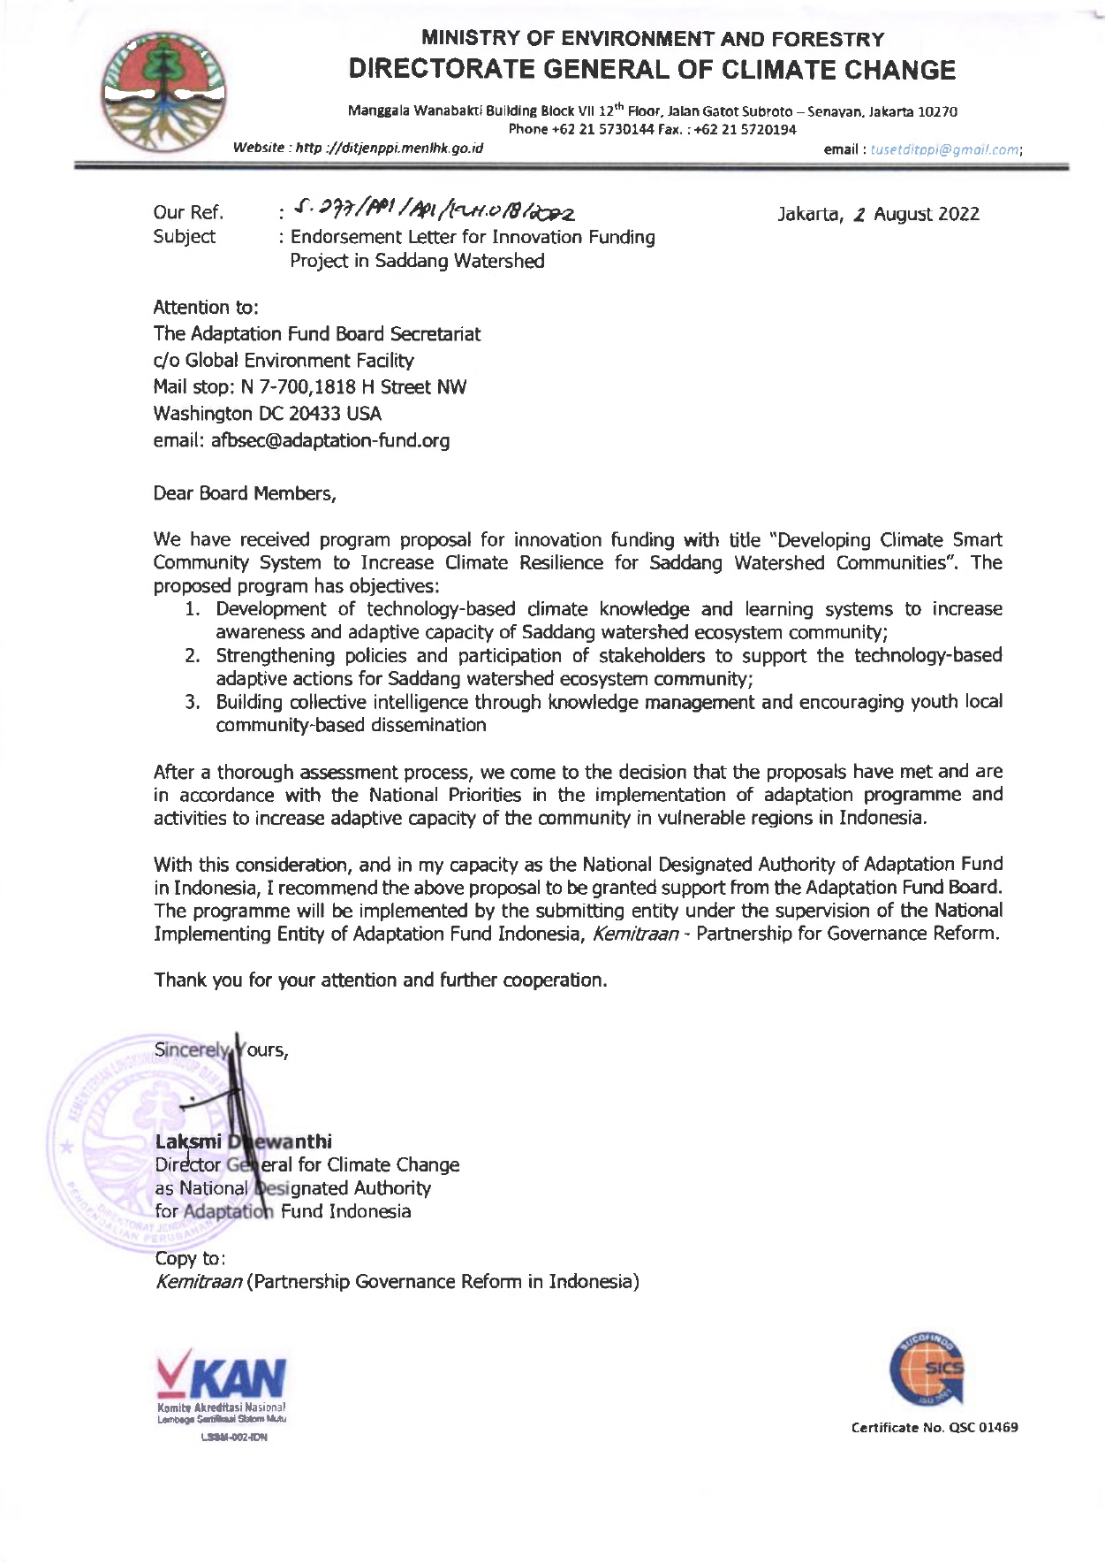

Watershed Management Information System, Website, 2022
Regency Statistics Document in Figures, Central Bureau of Statistics of South Sulawesi Province, 2022
Surveys and Interviews in Saddang Watershed Community, 2021
Naufal et.al, Adaptation from Maladaptation: A Case Study of Community-Based Initiatives in the Saddang Watershed, 2022 (Unpublished)
Critical Land Data Analysis, Watershed and Protected Forest Management Center Jeneberang-Saddang, 2018
Land Cover Data Analysis, Forest Area Designation Center, 2020
Vol. 1 No. 1: November, Mapping of Indications of Ecosystem Services for the Masupu Watershed, 2019
Disaster Data Analysis, National Disaster Management Authority, 2022
Community Vulnerability to Climate Change, Climate Change Risks, and Climate Change Adaptation Strategies Based Study on Saddang Watershed, TLKM Foundation (via KAPABEL) and Kemitraan, 2021
Surveys and Interviews in Saddang Watershed, 2021
Results of Vulnerability Data Analysis, Vulnerability Index Data Information System, Center for Climate Change and Forest and Land Fire Control, MoEF, 2022
Community Vulnerability to Climate Change, Climate Change Risks, and Climate Change Adaptation Strategies Based Study on Saddang Watershed, TLKM Foundation (via KAPABEL) and Kemitraan, 2021
Surveys and Interviews in Saddang Watershed, 2021
ibid, 2021
Regency Statistics Document in Figures, Central Bureau of Statistics of South Sulawesi Province, 2022
Surveys and Interviews in Saddang Watershed, 2021
Regency Statistics Document in Figures, Central Bureau of Statistics of South Sulawesi Province, 2022
Executive Summary Climate Resistant Development Policy Document, 2020-2045
Current application usage statistics can be seen at the following link: https://drive.google.com/drive/folders/1uqtj1Dsujqk0TQDizUS1B1GMUX8H051-?usp=sharing
The AF utilized OECD/DAC terminology for its results framework. Project proponents may use different terminology but the overall principle should still apply
Each Party shall designate and communicate to the secretariat the authority that will endorse on behalf of the national government the projects and programmes proposed by the implementing entities.

