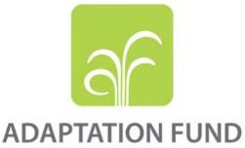

FULLY DEVELOPED PROPOSAL FOR SINGLE COUNTRY

PART I: PROJECT/PROGRAMME INFORMATION

Title of Project/Programme: Ger Community Resilience Project (GCRP)
Country: Mongolia
Thematic Focal Area: Urban Development
Type of Implementing Entity: Multilateral Implementing Entity
Implementing Entity: United Nations Human Settlements Programme
Executing Entities: World Vision International, Development Solutions
NGO
Amount of Financing Requested: US$7,965,882 (in U.S Dollars Equivalent)
Letter of Endorsement (LOE) signed: Yes ☒ No ☐
NOTE: The LOE should be signed by the Designated Authority (DA). The signatory DA must be on file with the Adaptation Fund. To find the DA currently on file check this page: https://www.adaptation-fund.org/apply-funding/designated-authorities

Stage of Submission:
☒ This proposal has been submitted before including at a different stage (concept, fully-developed proposal)
☐ This is the first submission ever of the proposal at any stage
In case of a resubmission, please indicate the last submission date: Click or tap to enter a date.
Please note that fully-developed proposal documents should not exceed 100 pages for the main document, and 100 pages for the annexes.

Contents

PART I: PROJECT/PROGRAMME INFORMATION 1
The Problem 4
Economic Context 5
Social Context 5
Environmental Context and specific climate change-related issues in the target area 7
Climate Change Issues 8
Summary of climate change hazards and their impacts 19
Drivers of Vulnerability and Adaptive Capacity Constraints 20
Project/Programme Objectives 21
Projected Calendar 22
Target Area (Khoroos or communities) 22
PART II: PROJECT/PROGRAMME JUSTIFICATION 30
Project components, concrete adaptation activities 30
Economic, social and environmental benefits 37
Cost-effectiveness 38
Consistency with national or sub-national development programmes 39
Compliance with relevant technical standards and policies 41
Duplication with other funding sources 42
The learning and knowledge management component 44
Stakeholder Consultations 45
Justification 49
Sustainability 52
Environmental and social impacts and risks 53
PART III: IMPLEMENTATION ARRANGEMENTS 57
Key Stakeholders and Implementation Arrangement 57
Financial and Management Risks 62
Monitoring and evaluation 64
Project Results Framework 74
Alignment with the Results Framework of the Adaptation Fund 79
Budget summary, details and notes 81
Disbursement schedule 92
PART IV: ENDORSEMENT BY GOVERNMENT AND CERTIFICATION BY THE IMPLEMENTING ENTITY 93
Annex 1 - Results of in-depth community consultations and Focus Group Discussions 96
Annex 2 – Environmental and Social Risk Screening, Impact Assessment and Environmental and Social Management Plan 123
Demonstrating compliance with the Adaptation Funds’ Social and Environmental Policy (ESP) 123
Annex 3 – Gender Baseline Assessment in Compliance with the Gender Policy of the Adaptation Fund 143
Annex 4 - UN-Habitat People’s Process Benefits Poster 151
Annex 5 Summary of Proposed Physical Construction Activities 153

Figures
Figure 1. Spatial Distribution of Precipitation 4
Figure 2. 2005 Urban Poverty Profile of Ulaanbaatar 6
Figure 3. Poverty Map, World Bank Study in 2014 6
Figure 4. Spring that has emerged and re-frozen during winter, with flowing water to the surface 8
Figure 5. Annual mean temperature deviation 1961-1990, relative to the baseline 9
Figure 6. Changes in warm days, Ulaanbaatar circled 9
Figure 7. Vulnerability in different sectors in the Central Region of Mongolia 10
Figure 8. Change in number of days, which has daily maximum temperature 11
Figure 9. Frequency of daily precipitation with different amount 11
Figure 10. Simulated current maximum flood peak discharge 12
Figure 11. Simulated spatial distribution of maximum flood discharge 13
Figure 12. Simulated spatial distribution of maximum flood discharge 13
Figure 13. Simulated spatial distribution of maximum flood discharge around Ulaanbaatar, 14
Figure 14. Current and future flood risk map of northern ger areas of Ulaanbaatar City 14
Figure 15. Winter flooding from burst of a spring 17
Figure 16. Spring flooding from ice melt 18
Figure 17. Summer rain flooding 19
Figure 18. Vulnerable locations in northern Ger areas north of Ulaanbaatar and the project’s three proposed target areas 24
Figure 19. Selected area: Area 1: Sukhbaatar District - Khoroos 15, 16, 18, 20 26
Figure 20. Selected area: Area 2: Songinokharkhan District - Khoroo 4, 5, 26 and 27 27
Figure 21 Photographs of different proposed location 28
Figure 22. Photographs of different proposed location 29
Figure 23. Target areas of the previous and proposed projects 43
Figure 24 Project Organogram 61
Figure 25. Prioritization of the problems by the community members: 98

Tables
Table 1. Present change of seasonal climate in Ulaanbaatar city, 1940-2015 10
Table 2. Future projection of climate extreme indices in Ulaanbaatar 12
Table 3. Present and future flood risks in the selected vulnerable khoroos in Ulaanbaatar ger areas versus land use and development plans under the current Urban Development Master Plan 15
Table 4. Concrete interventions and supporting activities (corresponding to prioritized resilience building interventions in the above) 32
Table 5. Economic, Social and Environmental benefits 37
Table 6. Compliance with laws and national technical standards 41
Table 7. Selected other relevant projects and programmes 43
Table 8. Participants of FGD among the khoroo officials 45
Table 9. Overview of Focus Group Discussions and individual meetings 46
Table 10. Justification for the project 49
Table 11. Checklist of compliance with AF Environmental and Social Principles 54
Table 12. Brief description of risks and possible mitigation measures 54
Table 13. Overview of financial and management risks and measures to mitigate these 62
Table 14. Monitoring and Evaluation (M & E) Framework 65
Table 15. M & E Budget 71
Table 16. Project results framework with indicators, their baseline, targets, risks & assumptions and verification means. 74
Table 17 - Project alignment with the Adaptation Fund Results Framework 79
Table 18 - Budget Summary 81
Table 19 - Detailed Budget 82
Table 20 Flood protection and drainage and resilient latrines 86
Table 21a - Climate Resilient Sanitation Facilities 87
Table 22. Disbursement schedule 92
Table 23. Global Gender Gap Index – Overview 143
Table 24. Gender equality by sector 143
Table 25. Beneficiaries in the target communities 146
Table 26. Gender Action Plan Summary Table 148

Project / Programme Background and Context:

The Problem
Mongolia is a landlocked, lower middle-income country in North-east Asia, bordering Russia to the North and China to the south and situated between 41°35’-52°06’N latitude and 87°47-119°57’E longitude. The country’s geography is characterized by high mountains in its north, west and central areas, with numerous peaks over 4,000m above mean sea level, and a high steppe, giving the country an average altitude above mean sea level of around 1,500m.

Mongolia’s capital, Ulaanbaatar, is also the country’s primary population center and its economic engine. Mongolia had a population of 3,409,939 in 2021, while Ulaanbaatar’s population was 1,639,172. Its population growth projection is estimated at 3.67 per cent per year, meaning that another million people will be added to the city by 2035.

Ulaanbaatar, accounts for two-thirds of Mongolia’s urban population and 48% of the nation’s population. Ulaanbaatar’s population more than doubled from 773,000 in 2000, representing an annual average increase of 3.1%. This growth was due to large in-migration from rural areas, due to:
- a series of climate change related extreme events, including harsh winter storms (which are known as “dzuds”), which have occurred more frequently in recent years and have decimated entire herds of animals and forced livestock herders to move.
- the transition to a market economy, which means economic opportunities are developing much more rapidly in the cities than in rural areas, and
- the right of Mongolian citizens to decide where to live that was reinforced first in 1992 in the Mongolian Law, and then in the Land Law of 2002, securing land rights and social benefits. In Ulaanbaatar, these laws ensured each resident a plot of land up to 700 m2.

These factors have reshaped the geography of the capital city and generated vast, sprawling peri-urban areas known as ‘Gers' covering an area of about 350 square kilometers where 60% of Ulaanbaatar’s population and 30% of the country’s population – around 774,000 people – live.

Figure 1. Spatial Distribution of Precipitation
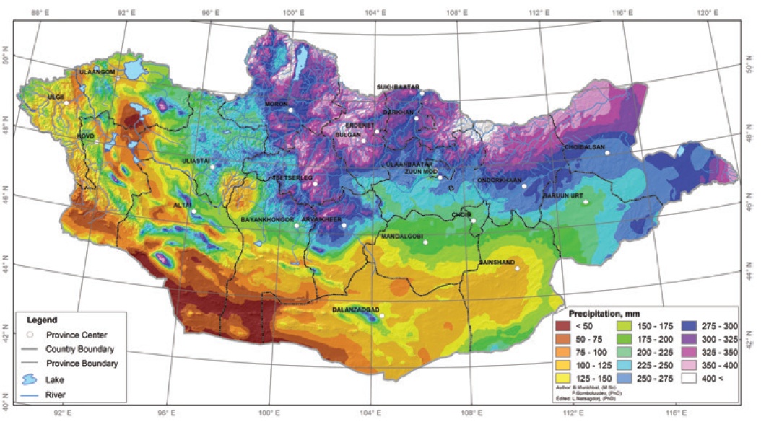

Given Mongolia’s location at the center of the Eurasian continent, its mountainous and high steppe topography and its northerly latitude, it has a cold and harsh climate. Ulaanbaatar and much of central and northern Mongolia are classified as having a monsoon influenced sub-arctic climate. This is characterized by a long winter with extremely cold temperatures. Daily minimum temperature in Ulaanbaatar in winter is typically between -25 and -30°C. The short summer, in July and August, can see daily maximum temperatures of around 20°C. The annual average temperature in Ulaanbaatar is -2.9°C. Precipitation levels are generally low, with most areas of the country receiving between 150 and 350 millimeters of precipitation per year.

While almost 50 percent of Mongolia’s population lives in Ulaanbaatar, much of the remaining rural population are pastoralists and livestock herders. These people are severely affected by dzuds. Dzuds are harsh winter storms followed by a severe freeze which prevents animals from being able to graze. A dzud in 2008, for example, killed 200,000 livestock, as well as 52 people.

Economic Context
The effects of the Covid-19 pandemic notwithstanding, Mongolia has seen rapid periods of economic growth; following an economic boom in the period 2010-2013, growth fell slightly, but the economy still grew by 5.6%, 7.7% and 5.6% in 2017, 2018 and 2019, respectively. Like many countries, Mongolia suffered the effects of the Covid-19 pandemic. Officially, the country recorded 921,000 cases of Covid-19, meaning that at least one quarter of the population was infected with Covid-19, while there were 2,179 officially recorded deaths.

The economy contracted by 4.4 per cent in 2020 and showed modest economic growth of 1.4 per cent in 2021. Projections show a modest recovery continuing in 2022, with growth forecast at 2.5 per cent. The country faces other economic headwinds, including very high inflation (14.4 per cent in March 2022), and numerous external challenges, including continued border closures with China, the fallout from the Russia-Ukraine conflict and global high commodity and oil prices. The impact of these challenges on urban poor settlements in Ulaanbaatar, the type that will be targeted by this project, are as yet unclear.

Irrespective of present macroeconomic challenges, Ulaanbaatar is the engine of Mongolia’s growth, combined with few livelihood opportunities in the rural areas, the impact of droughts and dzuds, rural-urban migration levels have been persistently high, and have been driving the population growth of Ulaanbaatar described above. Given that Mongolia’s 2nd largest city, Erdenet, had a population of just 104,612 in 2021, the primacy of Ulaanbaatar means that other Mongolian cities are not attracting rural-urban migrants in the way that Ulaanbaatar is.

Ulaanbaatar was originally planned as a city for as few as 500,000 people, and has therefore reached a population level up to 3 times what it was designed for. The consequence of this is that recent migrants, the poor and vulnerable tend to live in Gers; informal or semi-formal areas at the edge of the city. Ger areas are characterized by higher levels of poverty, social issues, a lack of infrastructure, fewer economic opportunities, and, increasingly, vulnerability to climate change.

Ulaanbaatar is divided into local administration units known as districts and ‘khoroos’, roughly equivalent to a ward. Re-districting exercises have been undertaken by the Municipality of Ulaanbaatar city time to time to improve people’s access to the essential public services and amenities in response to the population growth. After a re-districting exercise in April 2022, there are 9 districts and 203 khoroos in Ulaanbaatar. This project primarily works in eight khoroos of two districts, though its activities will directly impact several others.

Social Context
Successive waves of rural-migration and the construction of Ger areas combined with (i) little upgrading or extension of basic urban services; and (ii) government policy, since 2003, to grant each citizen about 700 square meters of land have reshaped the city’s geography.

The Ger areas mean that Ulaanbaatar is characterized by a large area of low-density urban sprawl and although people have been given plots, the areas are largely unplanned. These sprawling Ger areas are almost entirely low-income areas, lacking basic infrastructure such as roads and reliable water and sanitation and other infrastructures. Other social problems, including alcoholism, crime and violence are more prevalent in the Ger areas, and tend to correlate with higher levels of poverty and fewer social and economic opportunities.

The Urban Poverty Profile – generated as part of the Citywide Pro-poor “Ger Upgrading Strategy and Investment Plan” (GUSIP) programme by Cities Alliance and UN-Habitat in collaboration with the Government provides a snapshot of Urban Poverty in Ger Areas of Ulaanbaatar City in 2005, which remains relevant today (Figure 2); Figure 3 shows the poverty headcount in 2014, based on a study conducted by the World Bank – this shows little change in the distribution of poverty compared to the 2005 study, despite the increase in Ulaanbaatar’s population and economic growth over this time period.

Figure 2. 2005 Urban Poverty Profile of Ulaanbaatar
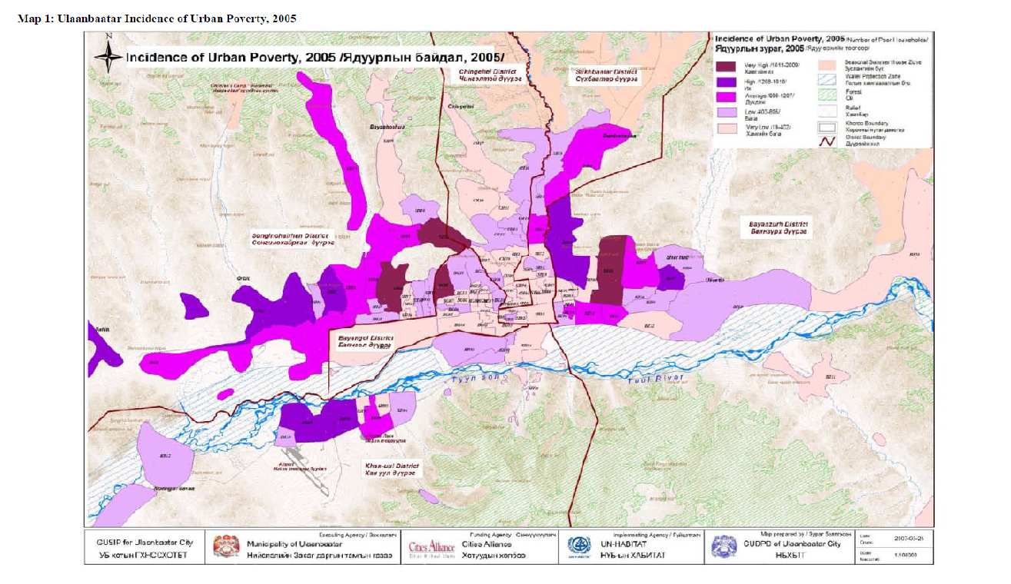
Figure 3. Poverty Map, World Bank Study in 2014
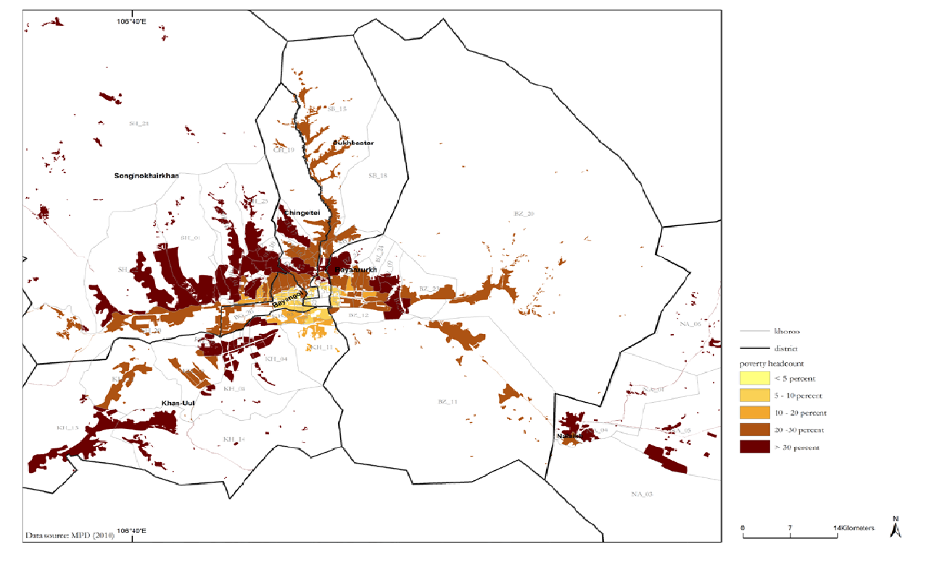

Female-headed households make up roughly 25% of homes in Mongolia. Data from Participatory Living Standards Assessment of the National Statistics Office (NSO) have identified that a disproportionate number of women-headed households are living in poverty and that the proportion is growing. Women are limited in their opportunity to engage in livelihood or employment opportunities because of the tasks at home. Those employed or engaged in small enterprises, need to work longer hours than men do to manage tasks both at home and at work. An Initial Gender Assessment that further explores the socio-economic and political status of women and their differentiated vulnerability to climate change has been included in Annex 3.

The social and economic problems highlighted above have arisen – at least in part – from a lack of long-term planning, infrastructure investment and effective land use regulation and the resultant haphazard development. People living in Ger areas are therefore poorly connected to the city core, more vulnerable to shocks including the impacts of climate change. Moreover, the absence of the necessary planning and governance pre-conditions for inclusive, effective and sustainable urban development means that Ulaanbaatar’s problems – and especially problems in the Ger areas are likely to worsen – even before the impacts of climate change are considered.

While various government and development partner initiatives have significantly improved living conditions in Ger areas, approaches have generally focused on specific sectors such as health or education, failing to design a sustainable vision and provide integrated solutions for the problems vulnerable people living in peri-urban areas.

Environmental Context and specific climate change-related issues in the target area
While Mongolia’s topography is varied, there a rough north-south divide, with the north characterized by rugged mountains and a sub-arctic climate and much of the south characterized by the Gobi Desert. The most mountainous area is the north-west with peaks of over 4,000 meters. Ulaanbaatar sits in a bowl-shaped valley in the north central part of the country, just inside the area classified as having a sub-arctic climate.

Mongolia is rich in mineral resources such as gold, silver, coal, precious stones, and gravel. Its mining sector is among the driving economic forces in the country; however, these industrial activities are a major cause of parts of rivers becoming heavily polluted. Rivers, such as the Selbe, Tolgoit, Uliastai, Belkh and Tuul for example, are not only utilized for industrial purposes, but also for household and drinking water consumption. The Tuul River is among the most polluted fresh water sources as the Selbe, Tolgoit, Uliastai and Belkh rivers and other small streams which flow through the Ulaanbaatar city including some of the peri-urban Ger areas targeted by this project, join the Tuul river at different points in the southern part of the city.

Other environmental issues affecting Ulaanbaatar but not directly relating to climate change include air pollution, stress on water resources, urban sprawl that affects adjacent natural areas and rapidly worsening traffic problems. Heating homes during the winter is a constant challenge in Mongolia, considering the extremely cold temperatures. The government recently banned burning raw coal, which had been the primary source of heat. This action has had a significant impact on air quality. Nevertheless, the city still suffers from substantial air pollution.

People living in Ger areas, such as those to be targeted by this project often experience the worst of Ulaanbaatar’s environmental issues. Ger areas are characterized by flooding, water scarcity, extreme cold, and, in recent years, bursting water springs. Floods often occur due to degradation of the land water retention capacity and urbanization in the hilly, steep sloped areas. These floods and other climate change related environmental problems should be seen as interactive with and exacerbators of the socio-economic problems highlighted above.

There is a network of 50-60 natural water springs running at a depth of 1.5-2.5 meters below Ulaanbaatar. These are fed by water sources in the hills to the north of the city and run roughly in a north-south direction. These springs are becoming increasingly susceptible to a phenomenon where differences between the surface and underground temperatures means the springs can burst unexpectedly and cause localized flooding. Because this phenomenon primarily happens in winter, the flood waters turn immediately to ice and then damage homes, property and infrastructure. This problem, referred to as bursting springs, is a major focus of this proposed project and is shown below in Figure 4 and in more detail in Figure 15.

Figure 4. Spring that has emerged and re-frozen during winter, with flowing water to the surface
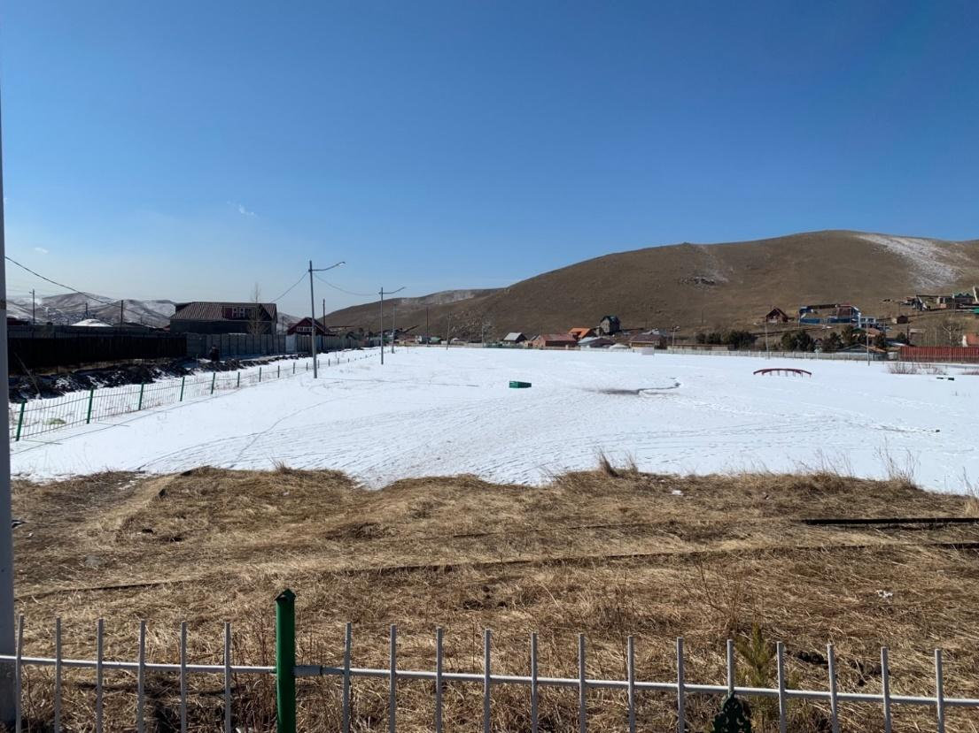

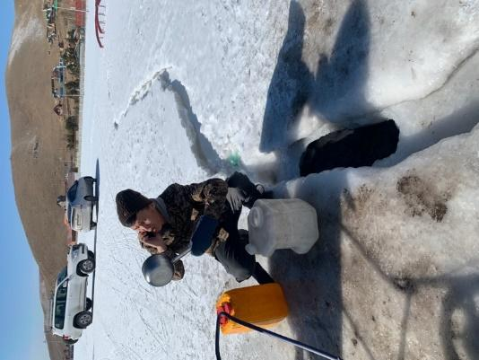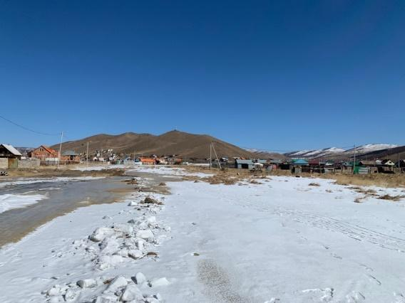

Climate Change Issues

According to Mongolia’s Third National Communication (3NC), the near surface temperature increased by 2.24°C in the period 1940-2015. This is shown by the black line in Figure 5, below. The warmest 10 years in the dataset all occurred since 2000, as shown by the red bars in Figure 5. Projections for the period 2016-2035 show a temperature increase of between 2°C and 2.3°C, depending which emissions scenarios are used, but could increase by as much as 6.3°C by 2100 under the high emissions RCP8.5 scenario. Downscaled projections for Ulaanbaatar specifically show a temperature increase between 1.7°C and 3.2°C depending on the model used.

In line with these temperature increases, frost days have decreased by around 15 per year, while warm summer days have increased by about 19 per year (as shown in Figure 6, where the size of the triangle represents the number of warm days – the larger the triangle, the greater the number of warm days). Ulaanbaatar (along with the far western region) has seen some of the most significant increases in unusually warm days. Dzuds – extreme winter storms and freezes – are taking place more frequently, and the most serious events in recent years occurred in 1999-2000, 2001-2002, and 2009-2010. As described above, dzuds cause devasting impacts to livestock and herding/pastoral communities and are directly linked to waves of rural-urban migration.
Figure 5. Annual mean temperature deviation 1961-1990, relative to the baseline
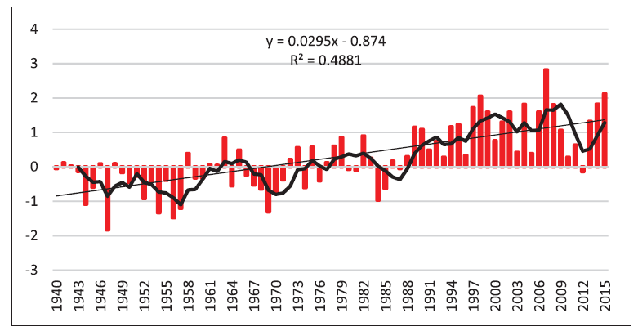

Figure 6. Changes in warm days, Ulaanbaatar circled
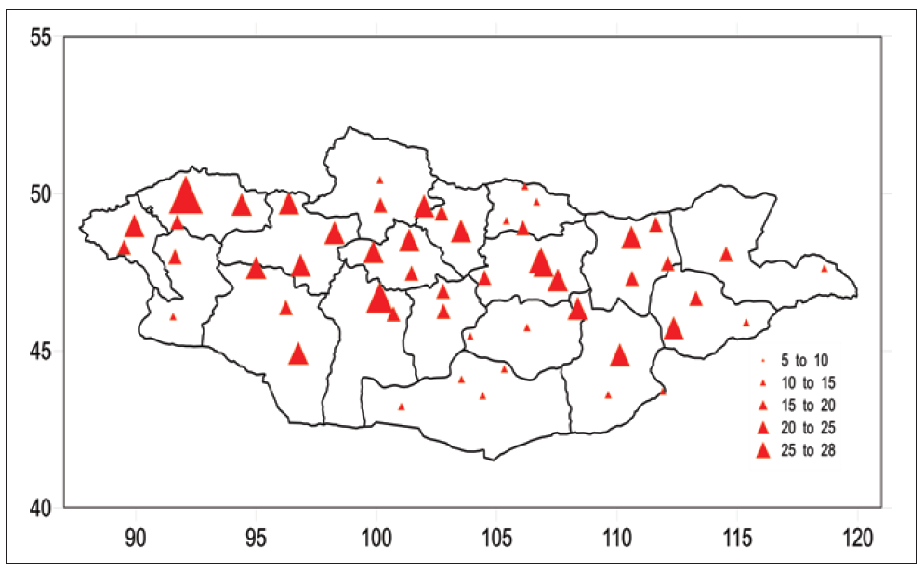

The 3NC highlights that there has been little discernable change in precipitation, with a 7 per cent decrease in rainfall over the 1940-2015 period, nationwide, with no statistically significant change observed in Ulaanbaatar. However, there has been a substantial increase in winter snow – 22 per cent increase between 1940 and 1960 and a further 40 per cent increase in the period 1961-2015. The 3NC points out that this increase is very likely to be climate change related.

The vulnerability assessment undertaken for the 3NC showed a moderate climate change risk for water resources and a substantially increasing risk for melting permafrost (See Figure 7). This is significant as melting permafrost is understood to be a major driver of the flooding that is affecting this proposed project’s target areas. This assessment also correlates with the observations of the communities that bursting springs are an increasingly common issue in the Ger areas on the periphery of Ulaanbaatar.

Figure 7. Vulnerability in different sectors in the Central Region of Mongolia
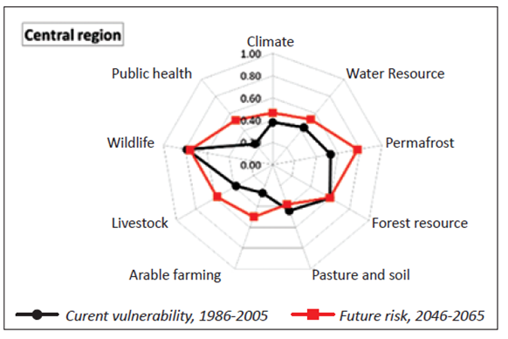

According to the climate change simulation that was conducted under the ongoing Adaptation Fund-funded Flood resilience in Ulaanbaatar Ger Areas project, the seasonal air temperature in Ulaanbaatar is projected to be increased by 1-1.5oC in 2016-2035 (2030), 1.3-3.1oC in 2046-2065 (2050), 1.2-5.6oC in 2081-2100 (2080) under different GHG scenarios with the respective precipitation increase by 2.8-12.1%, 6.2-30.7% and 5.1-52.4%.

Consequently, the daily maximum rainfall amount is expected to increase by 26% in 2030, 41% in 2050 and 53% in 2080. Based on the above results of the simulation model, the maximum flood discharge of the streams and rivers and spatial distribution of maximum flood runoff in Ulaanbaatar Ger areas and the target areas were calculated, and the mapping of current inundation and future flood risks was done. Please refer to Figure 11 for current inundation patterns and Figures 12-14 for projected future inundation in 2030, 2050 and 2080 respectively. Ulaanbaatar city experienced its most disastrous flooding in 1966, which is considered a 100-year flood event. Climate variables from that flooding were used as a peak scenario for the flood simulation under presented in Figures 12-14.

The simulation results show that approximately 24.9 square kilometers of the Northern Ger areas of Ulaanbaatar are currently at risk of inundation and the areas at risk of flooding will further increase by 12.5% in 2030, 20.8% by 2050 and 28.7% by 2080 due to further increases of temperature and daily maximum rainfall amounts. Overall, according to the simulation, depending on geomorphological condition of the floodplain and urbanization the areas with flood risk are expected to increase by 9.5-21.4% in 2030-2080.

Based on data from Buyant-Ukhaa meteorological station located 22 km south-west of downtown of Ulaanbaatar, which has longest available observation time series for Ulaanbaatar, the annual mean temperature in Ulaanbaatar increased by 2.6ºC over the last 75 years (0.4ºC greater than the average for Mongolia as a whole) and precipitation decreased by 5% over the same time period. In terms of seasonal change, winter temperatures increased by 3.7ºC, while the spring and autumn temperatures increased by 2.5ºC and 2.2ºC respectively. Precipitation increased by 38% in winter and 57% in spring, while it decreased by 13% in summer and 9% in autumn. This data is presented in Table 1. This indicates that the general warming trend intensity is greater in the cold winter season. These increases in winter temperatures are likely to be drivers of melting permafrost and the bursting springs phenomenon that is affecting the areas targeted by this project. The data indicates that precipitation is increasing in the cold season and decreasing in the warmer season.

Table 1. Present change of seasonal climate in Ulaanbaatar city, 1940-2015
Season | Temperature,ºC |  | Precipitation, mm
Season | 1961-1990 baseline average | Change | 1961-1990  baseline average | Change
Winter | -22.5 | 3.7 | 5.2 | 2.0 (38%)
Spring | -0.2 | 2.5 | 24.0 | 13.6 (57%)
Summer | 15.3 | 2.2 | 184.0 | -24.1 (-13%)
Autumn | -2.4 | 2.2 | 35.6 | -3.1 (-9%)
Annual | -2.5 | 2.6 | 248.7 | -11.7 (-5%)

As result of the warming, the number of hot days with a daily maximum temperature exceeding 30ºC, has increased significantly since 1995 and increased by 12 days per year over the period of 1966-2018. This is shown in Figure 8. In terms of daily rainfall, the number of heavy rainfall days, with occurrences of over 30-35 and 40-45mm rainfall have also increased significantly. This is shown in Figure 9, where the light green bars represent the baseline period (1967-1992) and the dark green bars represent the present period (1993-2018). Figure 9 shows that the number of rainy days with 10mm or less of rain have decreased but the number of rainy days with between 20-50mm of rain have significantly increased.

Figure 8. Change in number of days, which has daily maximum temperature
exceeding 30ºC in Ulaanbaatar
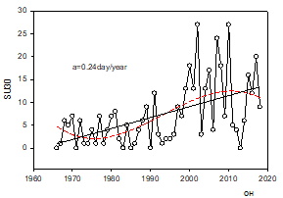
Figure 9. Frequency of daily precipitation with different amount
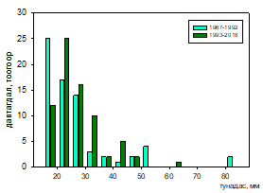

Climate extreme indices and future projections were also developed under the same study for the period 2016-2100. Projections for temperature and precipitation are presented in Table 2, below.

Table 2. Future projection of climate extreme indices in Ulaanbaatar
Variable | Name indices (unit) | Multi-year average | Projection of change  in 2016-2100
Air temperature | Below freezing day, (days) | 240 days | -46.3*
Air temperature | Growing season length, (day) | 151 days | 40.4
Air temperature | Annual maximum of maximum temperature, (ºС) | 34°C | 4.9*
Air temperature | Annual minimum of minimum, (ºС) | -25°C | 5.4*
Air temperature | Duration of heat wave, (day) | 33 days | 71.7
Air temperature | Cold wave duration, (day) | 21.1 days | -3.9*
Precipitation | Simple daily precipitation (mm) | 5.9mm | 0.3*
Precipitation | Maximum 5 days precipitation, (mm) | 42.2mm | 3.5*
Precipitation | Maximum number of consecutive wet days, (day) | 3.8 days | 1.3

The spatial distribution of flood risk was calculated from the numerical value of the maximum runoff during the 1966 flooding, as shown in Figure 10. The estimated flood peak discharge was 50-100 m³/sec in the upstream area of the Selbe River and 100-200 m³/sec 200-250 m³/sec in mid and lower sections of the Selbe River, respectively. Similarly in the case of the Uliastai River, the estimated flood peak discharge was 50-200 m³/sec, 200-350 m³/sec and 300-400 m³/sec, in the upstream, mid and lower downstream sections of the river, respectively. Figures 11-13 model the maximum stream flow in 2030, 2050, and 2080 respectively under a high emissions scenario and find that maximum stream flows in all streams in the northern Ger areas of Ulaanbaatar are likely to significantly increase, indicating that flooding will significantly worsen unless adaptation measures are taken.

Figure 10. Simulated current maximum flood peak discharge
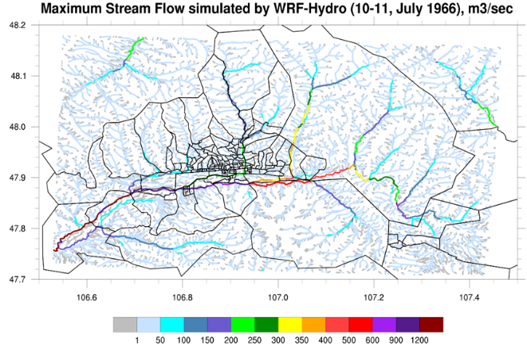

Figure 11. Simulated spatial distribution of maximum flood discharge
around Ulaanbaatar, m3/sec for 2030
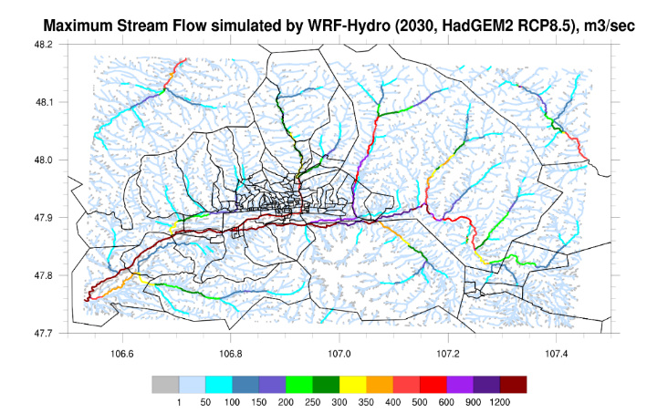

Figure 12. Simulated spatial distribution of maximum flood discharge
around Ulaanbaatar, m3/sec for 2050

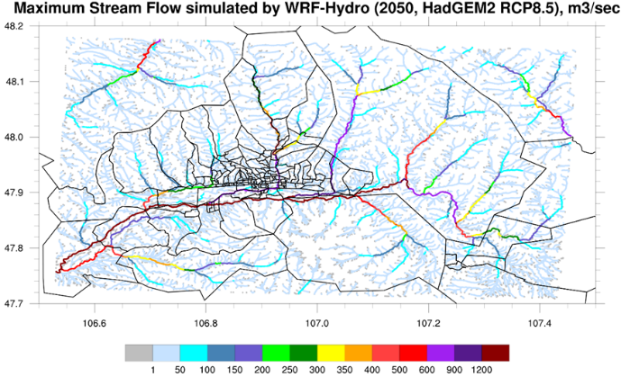

Figure 13. Simulated spatial distribution of maximum flood discharge around Ulaanbaatar,
m3/sec for 2080 (right)

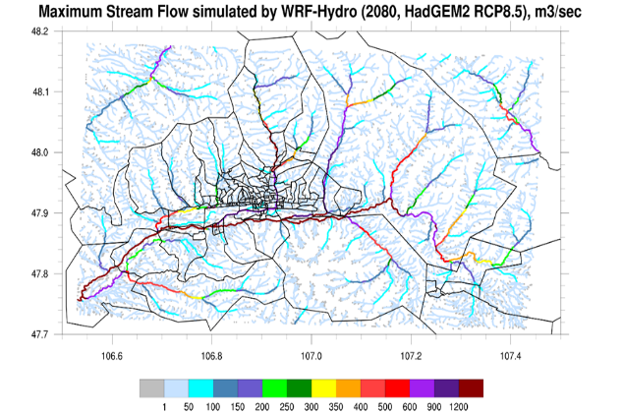

Figure 14. Current and future flood risk map of northern ger areas of Ulaanbaatar City
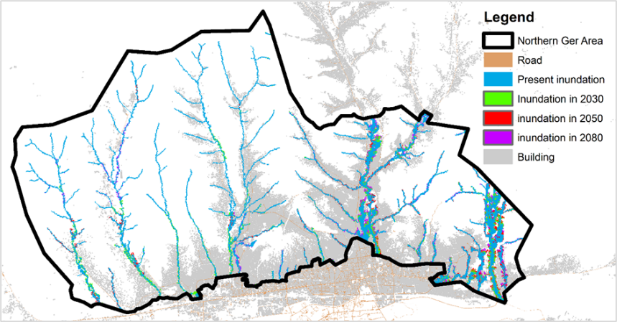

During the study, the team also reviewed the current land use and future land use plans for the northern ger areas of Ulaanbaatar against the flood risk maps. Figure 14 shows the current and future flood risk areas in the northern ger areas of Ulaanbaatar city. Table 3 illustrates review results of the current and future land use against the flood risk map in the cases of 6 khoroos of Ulaanbaatar ger areas which the current project proposal focuses on.

Table 3. Present and future flood risks in the selected vulnerable khoroos in Ulaanbaatar ger areas versus land use and development plans under the current Urban Development Master Plan
Flood risk and  current land use | Flood risk and Land Use Plan under the current city Master plan | Flood risk and Spatial Development Plan under the current city Master plan
15th Khoroo of Sukhbaatar District
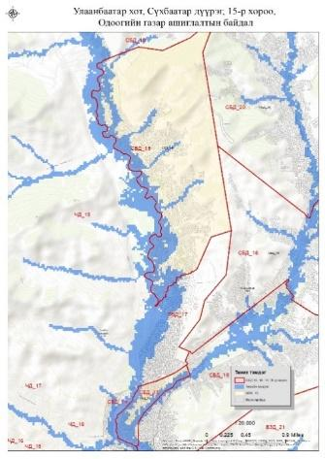 | 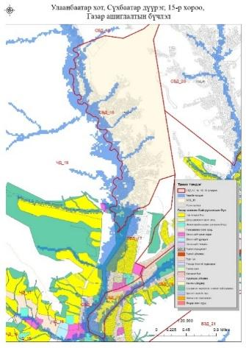 | 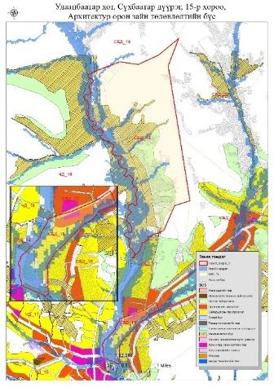

16th Khoroo, Sukhbaatar District
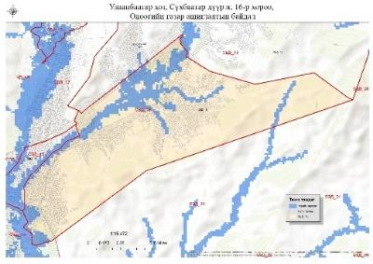 | 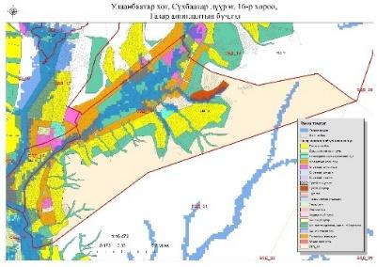 | 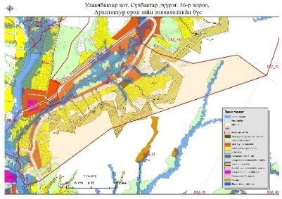
18th Khoroo, Sukhbaatar District

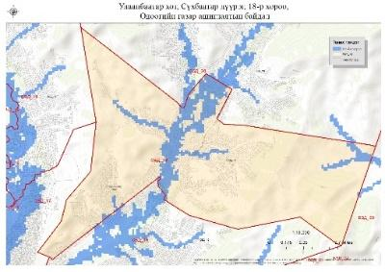 | 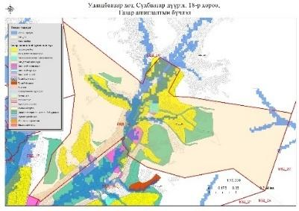 | 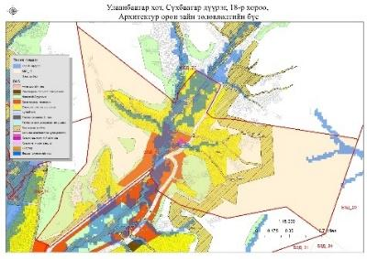

20th Khoroo, Sukhbaatar District
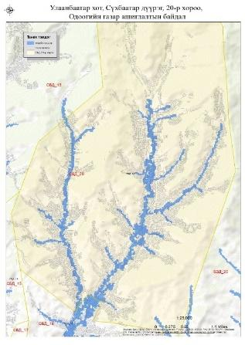 | 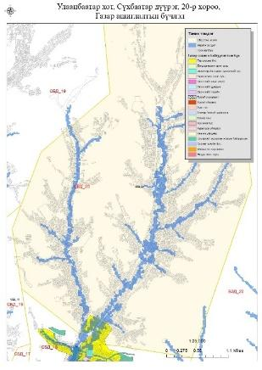 | 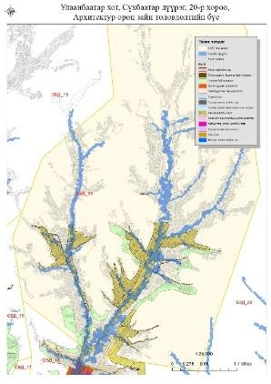
26 and 19th Khoroo, Songinokhairkhan district
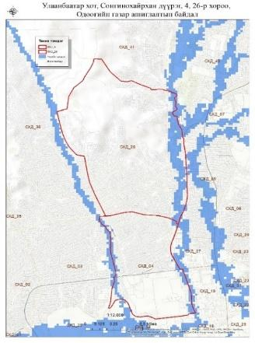 | 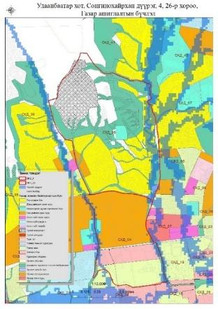 | 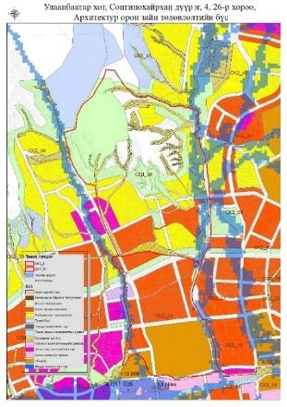
The first column of the Table 3 shows that in the six khoroos highlighted, the numbers and location of population and infrastructure that are at risk of flooding. The 2nd and 3rd columns show that numbers of development activities that have been planned under the current Urban development master plan of the city without consideration of flood risk. The review’s conclusion is that the existing flood risk will be increased in the future and more people and assets will be under flood risk if development continues under a business-as-usual scenario, even if the urban development master plan is implemented in its present form. This highlights the need for both physical adaptation measures and policy and capacity interventions to ensure that future planning and policy making effectively considers climate change and projected future flood risk, so that new infrastructure and public services planned for the rapidly growing Ger areas are not planned in a way that increases vulnerability.

Ger communities suffer from 3 types of flooding throughout the year. Apart from the flooding caused by heavy rain during the summer, there are the winter flooding from bursting springs and spring flooding from snow and permafrost melts. The number of burst springs in winter in the northern ger areas has been increased in recent years due to melting permafrost, creating a very challenging situation for households to cope with. When households are affected by flooding from burst springs, there is no option for households other than leaving the home to live somewhere else temporarily or permanently. Moreover, when families move, they often rent, which places an additional financial burden on them, further driving poverty and returning when the situation improves. Figures 15, 16, and 17 show photos of different types of flooding in Ger areas. All photos were taken in the khoroos targeted by the proposed project. Please note that the photos are small due to space constraints, but additional photographic evidence can be provided to the AF on request.

Figure 15. Winter flooding from burst of a spring

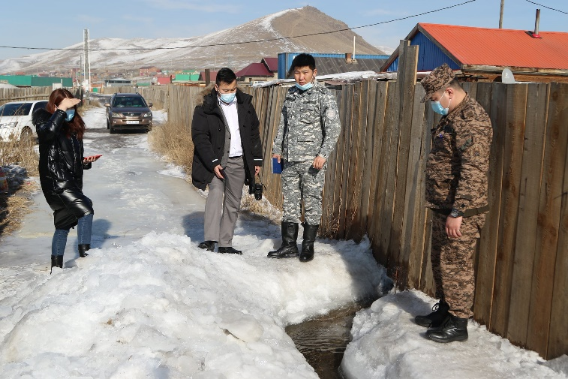 | 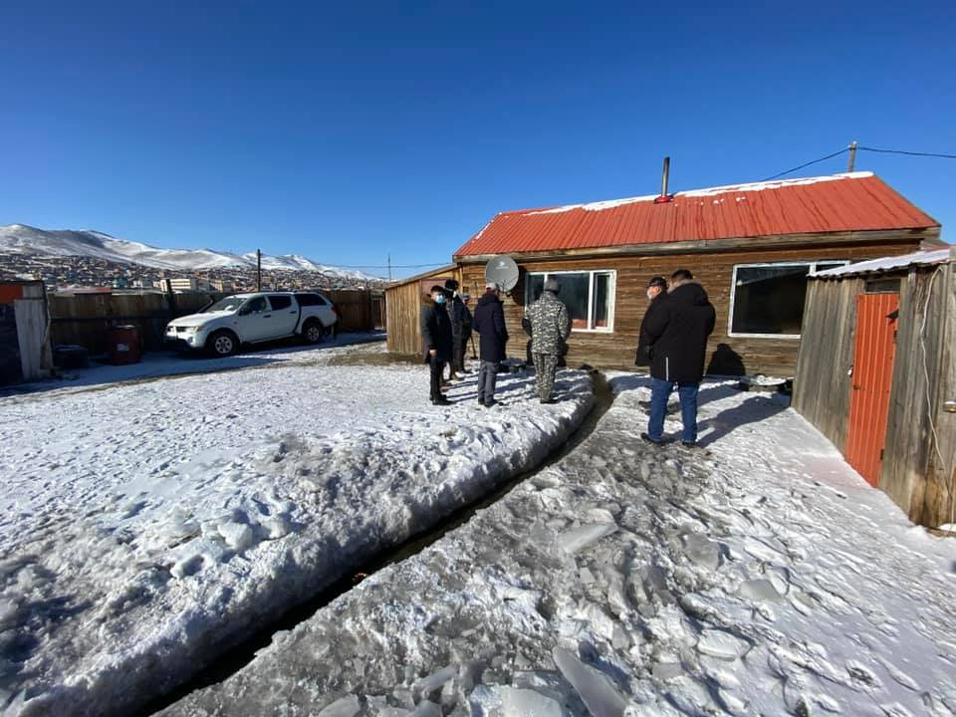
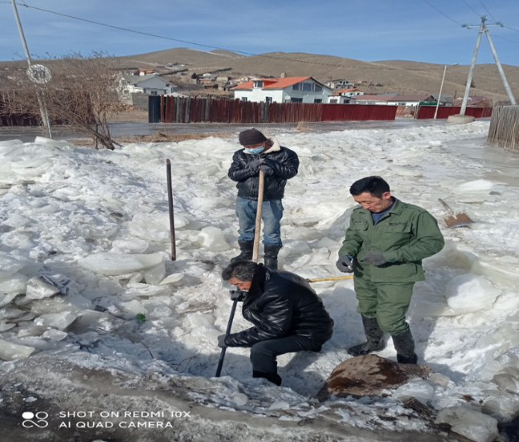 | 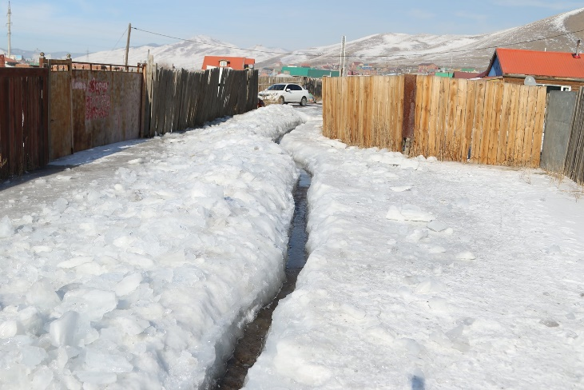
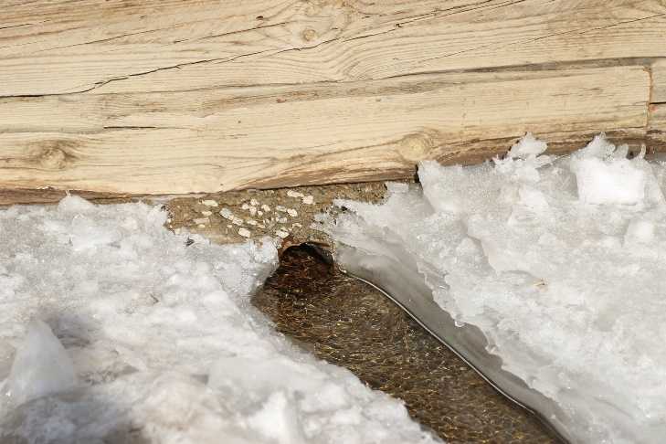 | 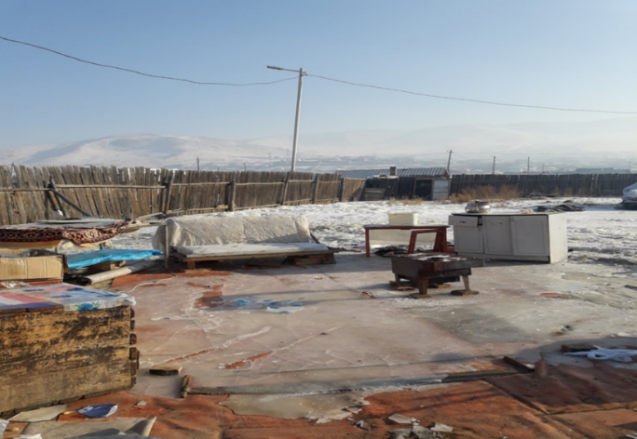
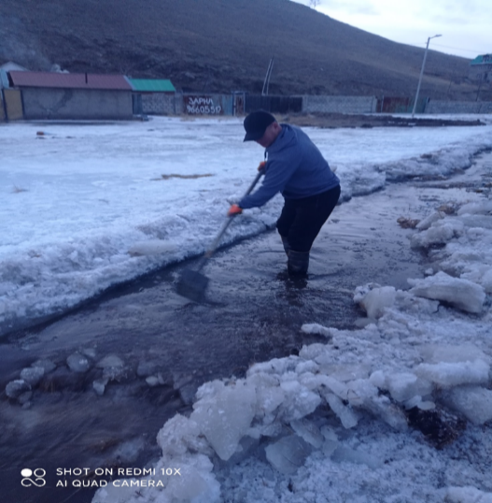 | 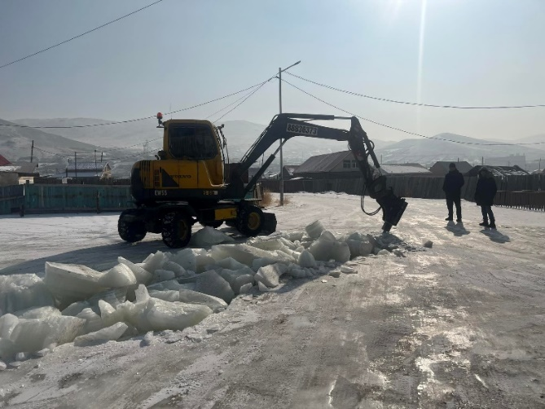

Figure 16. Spring flooding from ice melt

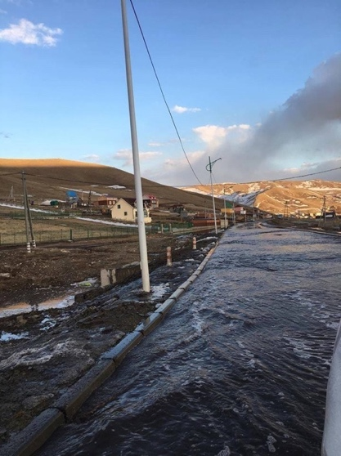 | 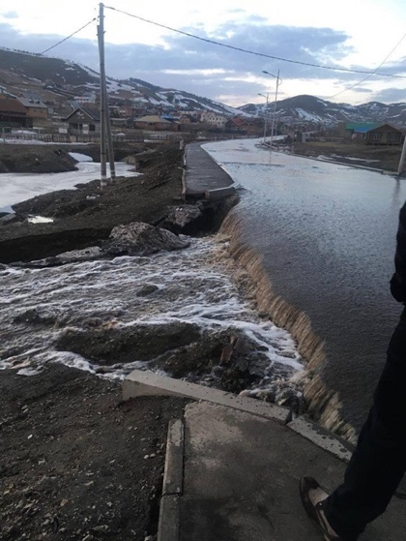
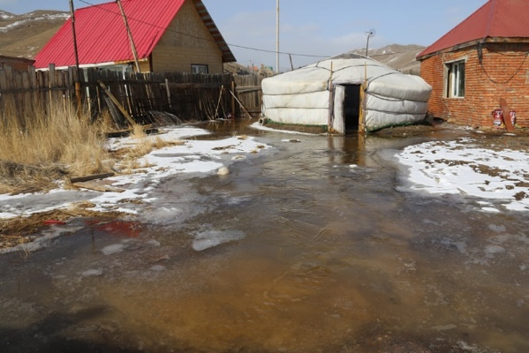 | 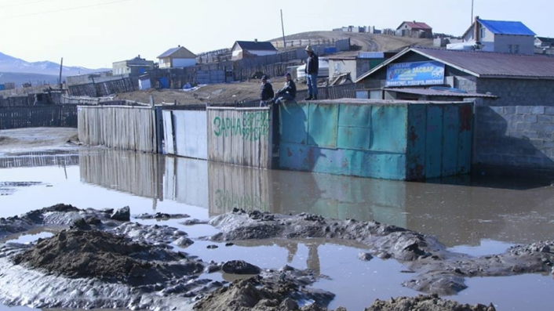
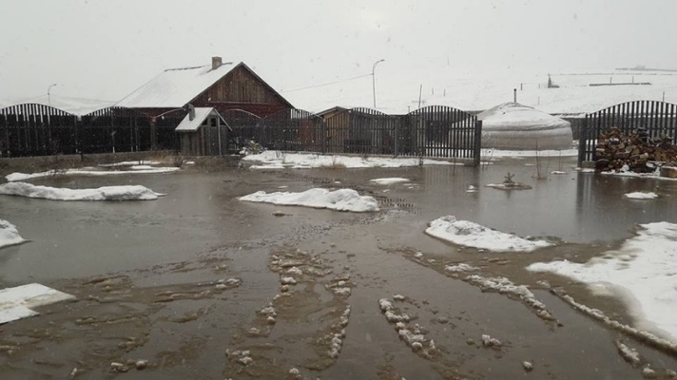 | 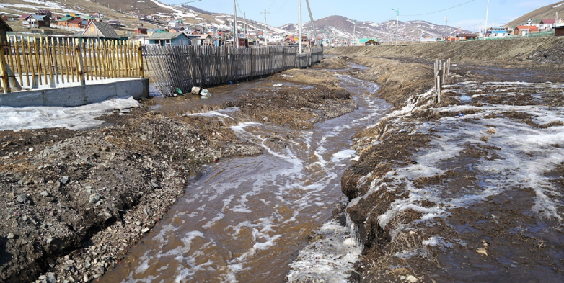
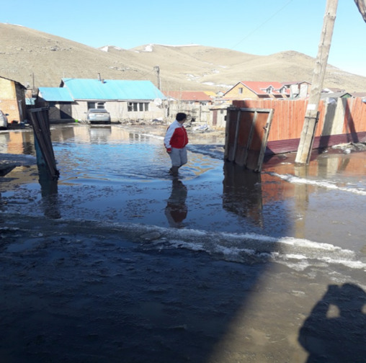 | 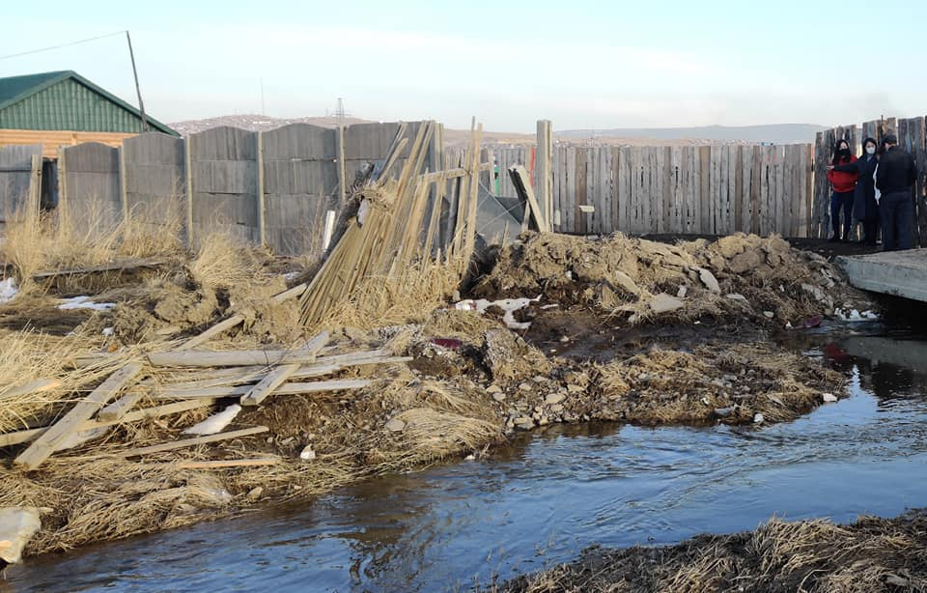

Figure 17. Summer rain flooding

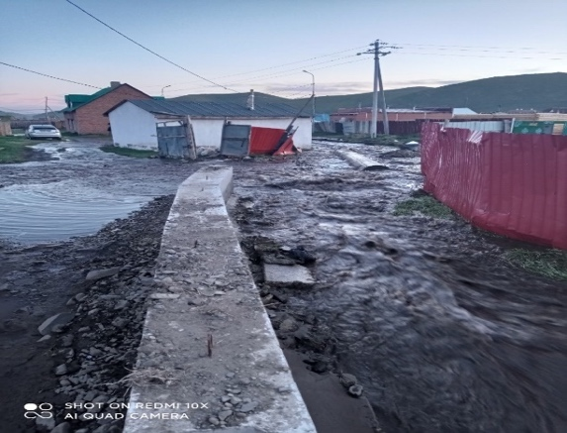 | 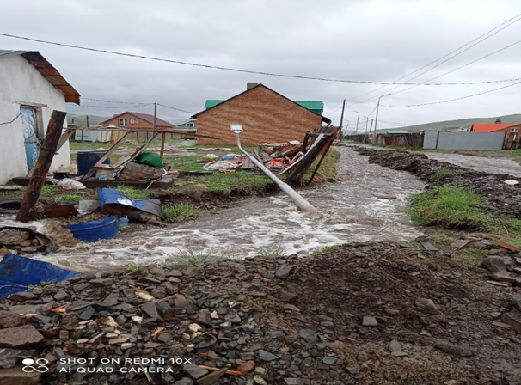
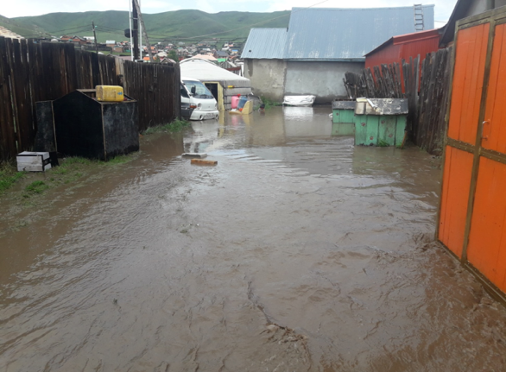 | 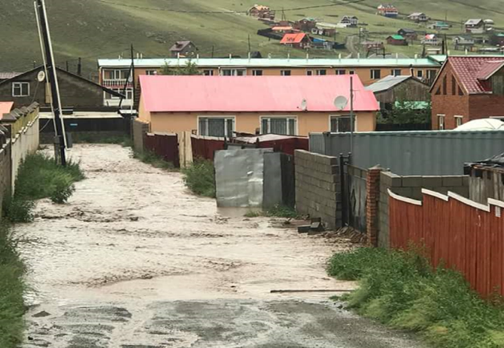
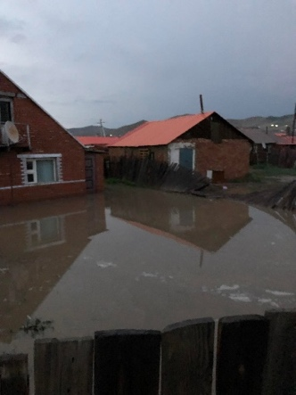
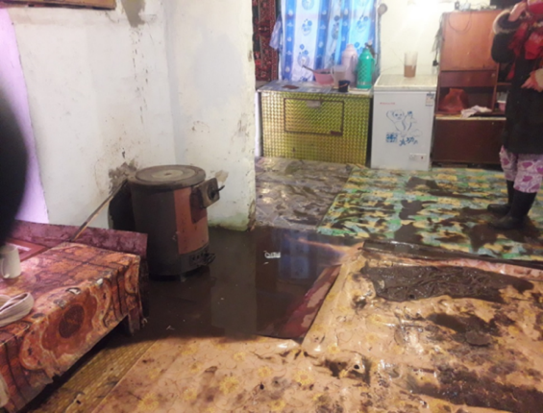
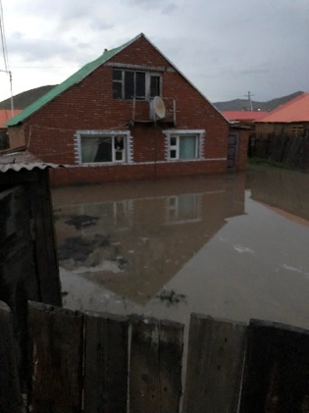

Summary of climate change hazards and their impacts

- Ulaanbaatar has experienced significant temperature increases. The annual average temperature has increased by 2.6°C in the last 75 years, and future projected increase could be as much as 6.3°C under a high emissions scenario
- Rainfall has shown a slight decline in the last 75 years, however, there are substantial variations between seasons. Future projections show no significant increasing or decreasing trend.
- Despite only slight changes in rainfall, flooding is a serious problem in Ulaanbaatar. There are three types of flooding, flooding arising from burst springs that occurs in winter, from snow melt in the nearby mountains that occurs in spring and from heavy rains that typically occurs in summer (see Figures 15, 16, and 17).
- It is estimated that a total of 12,564 people is extremely at risk from flooding in the project’s target areas, and a further 40,275 are moderately at risk. The secondary or knock-on impacts of this flooding have not yet been comprehensively estimated but will be further assessed during the preparation of the full funding proposal. However, consultations undertaken in the preparation of this proposal, highlight that the knock-on effects of flooding in the target areas are damage to houses and other assets, public health problems as the floods damage sanitation facilities, loss of income and livelihood opportunities, indebtedness as people have to borrow to repair their houses and damage to public infrastructure including access roads.

Drivers of Vulnerability and Adaptive Capacity Constraints
The rapid vulnerability assessment (Annex 1), desk research, community consultations and UN-Habitat’s past implementation experiences, including from the AF-funded FRUGA project, the following drivers of vulnerability and gaps in adaptive capacity have been observed. These have been linked to the project’s components and outputs, which are introduced in the next sub-section.

Extensive rural urban migration. This is partly driven by climate change, as increasingly frequent and severe dzuds in rural areas cause loss of livestock and incomes and therefore drive people to Ulaanbaatar to seek alternative economic opportunities. Because incomes are greater and economic opportunities more plentiful in Ulaanbaatar compared to rural areas, non-climate related migration is also high. New migrants tend to settle in the Ger areas where houses are poorer quality (and in some cases are in the form of traditional Mongolian tent houses), there is less infrastructure (including a near total absence of flood protection and drainage infrastructure) and a lack of other basic services, including sanitation.

While the project does not directly address the causes of rural-urban migration, Outputs 1.3 and 1.5 are designed to address vulnerability and urban adaptation into policy and planning, which in turn is designed to improve the knowledge base and capacity to address drivers of vulnerability, including rapid population growth driven by rural-urban migration.

Inadequate Infrastructure. As mentioned above, the Ger areas are almost entirely without protective and drainage infrastructure, which means they are unable to prevent flooding and cannot recover quickly when floods occur (which, as the consultations undertaken for this proposal highlight (See Table 9, for example) are happening persistently). Activities under Component 3 are designed to reduce vulnerability arising from a lack of (or inadequate) infrastructure.

Capacity and policy. Both national and local government have repeatedly highlighted capacity constraints as being a limitation on the ability to plan and programme adaptation actions. At the sub-national level, both the municipality and khoroo level officials consulted so far in the development of this proposal have highlighted that they need additional capacity. At the national level, high level targets, policies and plans are emerging; Mongolia submitted an updated Nationally Determined Contribution (NDC) in 2021, is currently developing a National Adaptation Plan (NAP) and has incorporated climate change into its Sustainable Development Vision 2030. However, these targets, policies and plans are either under formulation (NAP) or are recent, and so their objectives are in the early stages of being translated into actions on the ground.

Part II, Section D of this proposal elaborates on the alignment between this project and these strategies. Addressing vulnerability that is driven by a lack of capacity will be assessed under Outputs 1.1 and 1.2 an addressed by activities under Component 2 of the proposed project. Output 1.4. has been included to provide continued support to strengthening the policy and planning response at the national level, with a particular focus on NDC and NAP, on the understanding that these will guide future climate finance programming and investment.

Financial Resources. Finances are also extremely constrained in Mongolia. Sub-national government has very little budget at its disposal once it has met its operational costs and so cannot afford to programme multi-million-dollar adaptation investments. It’s investment in flood management is focused on flood response and clean-up in the immediate aftermath of a flood event. Similarly, national government has very minimal financial resources to programme into adaptation. Mongolia has innovated in trying to mobilise additional climate finance. XAC Bank, a commercial bank, has become accredited to the Green Climate Fund for example, however it has focused on mitigation projects such as in renewable energy where it can generate a return on its investment. So far, it has not developed any project ideas on adaptation.

This all means that Mongolia has a serious shortfall of domestic climate finance that it can invest in critical flood protection and drainage infrastructure, such as that proposed under this project. Financial resource constraints are addressed by Output 2.3, which has been included to strengthen local and national governments on mobilizing greater levels of domestic public and private finance.

Project/Programme Objectives
Main Objective
The main objective of the proposed project is to enhance the resilience of communities in eight khoroos of Ulaanbaatar to floods caused by snowmelt, bursting springs and melting permafrost. This objective will be achieved through four components that seek to achieve the following objectives:

- Enhance the policy and regulatory environment at the national and city level to reduce risks and enhance adaptive capacity in the future in terms of changing climate in urban areas
- Build capacity at the national, city and community level to adapt now and in the future
- Reduce risks from flooding through physical infrastructure in the target areas
- Improve and enhance the knowledge base to sustain and replicate the project’s gains.

Over 75% of the project’s investment (excluding Project Cycle Management Fee) will be in the physical infrastructure component. This reflects the preferences of the communities, khoroo and city administrations and national government. The effectiveness and sustainability of the infrastructure will be supported through the other Components, especially Components 2 and 4. Activities under the policy component (Component 1) will ensure that urban adaptation priorities in Ulaanbaatar and elsewhere – which meet the needs of two-thirds of Mongolia’s population – are mainstreamed into future updates of the NDC and Mongolia’s forthcoming National Adaptation Plan (NAP).
Project/Programme Components and Financing
Project/ Programme Components | Expected  Concrete Outputs | Expected Outcomes | Amount (US$)
Component 1 – Enhance the policy and regulatory environment at the national and city level to reduce risks and enhance adaptive capacity in the future | - Identify adaptation needs in the urban development sector:  - Review of existing adaptation policy and regulations from the urban context and suggest required integration of urban adaptation measures  - Detailed khoroo and District level flood/hazard risk, exposure and vulnerability assessment reports prepared for the selected Ger areas  - Integration workshops held to ensure that urban adaptation is prominently featured in Mongolia’s NAP and 2025 NDC update, and climate change adaptation considerations are mainstreamed into future urban-related policies and plans  - Urban adaptation mainstreamed into local government policy and planning in the target areas | Mongolia’s climate change (NDC and NAP), urban and sub-national policies and plans reflect urban adaptation considerations and future financing needs | 231,562
Component 2 –  Build capacity at the national, city and community level to adapt now and in the future | - Capacity building programme implemented at the sub-national level to plan for and manage urban adaptation actions  - Capacity building programme implemented at the community level to manage and maintain small-scale adaptation infrastructure  - Capacity built to meet future urban adaptation financing needs and community-based disaster risk reduction and assets protection trainings | Mongolia has the capacity in place to plan for, design, manage and finance its future urban adaptation needs | 317,310
Component 3 – Reduce risks from flooding through physical infrastructure in the target areas | - Technical studies – EIA, ESSS Scoping, and Engineering and hydrological studies- required for flood protection in the selected areas  - Flood protection infrastructure developed in response to climate change related flood impacts  - 1.54 km retention wall, 5.578 km urban drainage constructed, and 1.781 km drainage repaired in Khoroo 18, 20, 15, 16.  - 2.182 km of flood protection canals constructed in Khoroo 26, 5, 4, 27.  - Trees and bushes planted by the communities along the flood protection facilities to create additional resilience and broader environmental sustainability  - Flood resilient sanitation facilities constructed by the target communities | Physical assets developed in response to climate change impacts - specifically flood-adaptation measures | 5,623,898
Component 4 – Improve and enhance the knowledge base to sustain and replicate the project’s gains. | - Knowledge captured from project implementation and disseminated through media, web-stories and case studies  - National and local government and research community have increased knowledge resources at its disposal  - Bringing Global Knowledge on best practices to Implementing Partners and communities | National and local governments and communities have the knowledge necessary to manage their own adaptation planning and actions, now and in the future | 471,591
Sub-total |  |  | 6,644,361
6. Project/Programme Execution cost (9.5%) |  |  | 697,470
7. Total Project/Programme Cost |  |  | 7,341,831
8. Project/Programme Cycle Management Fee charged by the Implementing Entity (8.5%) |  |  | 624,051
Amount of Financing Requested |  |  | 7,965,882

Projected Calendar
Milestones | Expected Dates
Start of Project/Programme Implementation | July 2023
Mid-term Review (if planned) | July 2025
Project/Programme Closing | June 2027
Terminal Evaluation | June 2027

Target Area (Khoroos or communities)

The Flood Risk Assessment and Management Strategy of Ulaanbaatar City supported by the World Bank, specified the most vulnerable target settlements for hazard and risk mapping and the production and improvement of adaptive infrastructure which were: (1) Tolgoit zuunsalaa, (2) Mon Laa (3) District III, IV flood control levee (4) Selbe river (5) Gorkhi and (6) Baatarkhairkhan Uliastai river.

The review of the information from the Municipality has identified several areas shaded in red in the map in Figure 18 that are affected by flooding. The areas circled in green were visited by the project team during the development of this proposal. The area to the left of the picture are the target Khoroos in Songinokhairkhan District and the area in the centre are the target Khoroos in Sukhbaatar District. These areas belong to two main areas of the above list and are located in the lower bed of Tolgoit zuunsalaa and an upper arm of Selbe river.

This assessment corroborates the work done by UN-Habitat, presented above, which shows that in these areas, there are two particular problems requiring attention. The increase in temperature is thawing the under-surface permafrost layer and springs are emerging at several locations typically during the winter. In spring and summer, melting snow and heavy rain leads to flash flooding, especially in river basins and areas adjacent to rivers – which is the case in much of the overall area targeted by the project.

Without effective, well-constructed embankments, drainage infrastructure and other protective measures, floods will continue to damage houses and other infrastructure. Of particular concern is the use of pit latrine type toilets, that can turn floods into a public health hazard by contaminating water and causing disease outbreaks during and after flood periods.

Figure 18. Vulnerable locations in northern Ger areas north of Ulaanbaatar and the project’s three proposed target areas
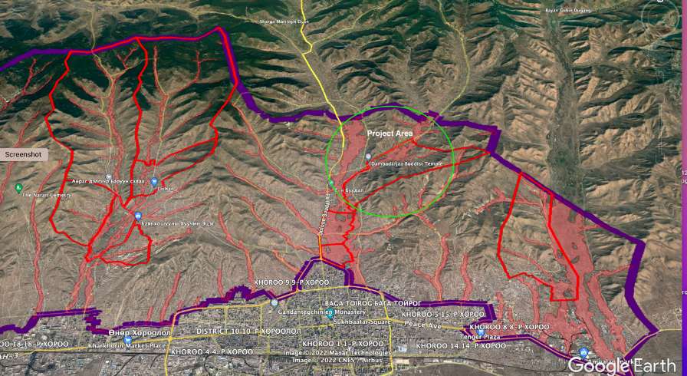

The most severely affected communities are the new settlers who have moved into the riverbeds, gullies and areas adjacent to them. In the lower-lying khoroos, stagnant water is an additional problem. This stagnant water, which is polluted due to overflow of the latrines, can stay for months and impedes the mobility of residents and access to critical services, with vehicles being unable to enter the khoroo. After the summer, the stagnant and polluted water freezes, causing a further hazard, and then melts again in summer.

With this information the UN-Habitat community mobilization and technical team conducted a rapid assessment of the area the following three locations: 15th Khoroo of Sukhbaatar District; 26th Khoroos of Songinokhairkhan District; and Bayanzurkh District. The international mission in March 2022 also visited the target field sites, to conduct an initial inspection.

After further consultation with the Governor’s Office and the three district authorities of Songinokharkhan, Sukhbaatar and Bayanzurkh Districts, the field visit by the AF focal person from the Ministry of Environment and Tourism, the UN-Habitat team identified the below mentioned khoroos as the most vulnerable in terms of being impacted by floods and/or areas from which run-off takes place on a frequent basis and require floods adaptation and protection work:

Area 1: Sukhbaatar District | Khoroo 15, 16, 18, 20
Area 2: Songinokharkhan District | Khoroo 4, 5, 26, 27
Area 3: Bayanzurkh District. | Visited by the team but not included in the proposal.

Area 1 contains a population of 32,495 persons living in 8,336 households on 6,468 plots. The prevalence of poverty in this area is approximately 20-30 per cent of the population. The area experiences frequent flooding particularly due to thawing of permafrost, bursting springs, and surface water flooding as there are no embankments around the springs and along the river to protect the houses. The residents then face serious health issues during flood periods as a consequence of floating garbage and overflowing of pit latrines.

Area 2 contains a population of 31,970 persons living in 8,437 households in 4,932 plots. The prevalence of poverty in this area is over 30 per cent. People in both khoroos reported surface water flooding, exacerbated by a lack of drainage and overflowing pit latrines solid waste contamination during flooding periods.

The combined population of these two areas is 67,932 residents of which approximately 32,343 residents (47.6%) are female; of which 24,400 residents (35.9%) are under 18 years old; 7,068 are elderly (above 60 years), and 1,615 are persons with disabilities. The preparatory work undertaken for the development of this proposal assesses that 40,275 of these people are moderately vulnerable to flooding, and 12,564 are extremely vulnerable to flooding. Please note that these figures are accurate at the time of the development of the project proposal, but will be revisited and if necessary updated during the inception phase of the project.

The below table shows the estimated numbers of beneficiaries as per the project outputs. It is expected that all 67,932 residents of the target areas will be beneficiaries of the physical infrastructure investments under Component 3; 12,564 people who have been assessed as highly vulnerable to flooding will be direct beneficiaries, and the remaining 55,368 will be indirect beneficiaries. Please note that the proposal has not estimated the number of beneficiaries under Output 4.1 as the proposal development team could not find or generate reliable data to estimate the number of people that can be reached through media and other communication channels. 50% of the direct and indirect beneficiaries will be women. Further details on the specific infrastructure investments, their location and beneficiaries are provided in Part II, Section A, below and in Table 4.

Output | Beneficiaries
- Identify adaptation needs in the urban development sector: | 100 (50% women) – local and national government
- Review of existing adaptation policy and regulations from the urban context and suggest required integration of urban adaptation measures | 100 (50% women) – local and national government
- Detailed Khoroo and District level flood/hazard risk, exposure and vulnerability assessment reports prepared for the selected Ger areas | 200 (50% women) – local and national government, khoroo level officials
- Integration workshops held to ensure that urban adaptation is prominently featured in Mongolia’s NAP and 2025 NDC update, and climate change adaptation considerations are mainstreamed into future urban-related policies and plans | 50 (50% women) National level officials from Ministry of Environment and Tourism
- Urban adaptation mainstreamed into local government policy and planning in the target areas | 200 (50% women) local and national government, khoroo officials (not counted as likely the same beneficiaries as Output 1.3
- Capacity building programme implemented at the sub-national level to plan for and manage urban adaptation actions | 200 (50% women) Municipal and khoroo level
- Capacity building programme implemented at the community level to manage and maintain small-scale adaptation infrastructure | - (50% women)
- Capacity built to meet future urban adaptation financing needs and community-based disaster risk reduction and assets protection trainings | 100 (50% women) Mostly municipal level
Component 3 – See Table 4 | 11,097 direct, 64,296 indirect. 50% gender balance
- Knowledge captured from project implementation and disseminated through media, web-stories and case studies | Not estimated
- National and local government and research community have increased knowledge resources at its disposal | - (50% women)
- Bringing Global Knowledge on best practices to Implementing Partners and communities | 1250 (50% women)

The above estimates give a total number of beneficiaries across all the project’s activities of 67,932. Of these, it is expected that at least 50% of the direct and indirect beneficiaries will be women. To ensure equitable distribution of the project benefits between men and women, an initial gender assessment was done, and a Gender Action Plan that describes the measures to promote gender equality and mainstream gender in the project’s outcomes was prepared and has been incorporated into the project’s monitoring and evaluation framework. Addressing gender concerns will entail close collaboration with women throughout the inception, implementation and monitoring and evaluation stages of the project. The project has been designed to actively encourage the involvement of women in implementation, management, decision making roles of the project. Focus group discussions among women will take place every 6 months and reports prepared by the project will contain a gender analysis and recommendations to mainstream gender considerations where appropriate. At the inception stage, the project will review the data in the Gender Action Plan to set up a definitive baseline from which to monitor progress.

The project’s grievance mechanism, outlined in the Environmental and Social Safeguards Annex will also provide a platform for women to provide feedback and to raise any concerns about inequality – anonymously if the user chooses to remain so. Equal involvement of women and men in the project activities will be ensured through community planning and consultations throughout the project period and the project will make sure women participate in decision-making around appropriate infrastructure design, operation and maintenance features. The project will thus take a transformative approach on their empowerment and resilience building activities.

will be women. Please note that a number of beneficiaries for Output 4.1 has not been estimated. It is not known how many people can be reached through media and other communications channels.

Figure 19. Selected area: Area 1: Sukhbaatar District - Khoroos 15, 16, 18, 20
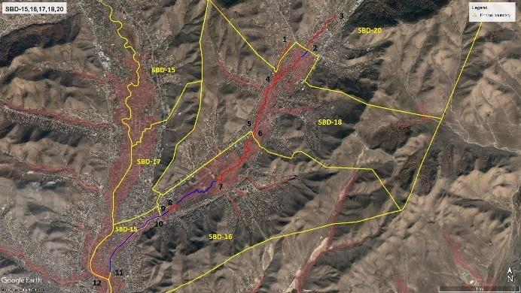

Figure 20. Selected area: Area 2: Songinokharkhan District - Khoroo 4, 5, 26 and 27
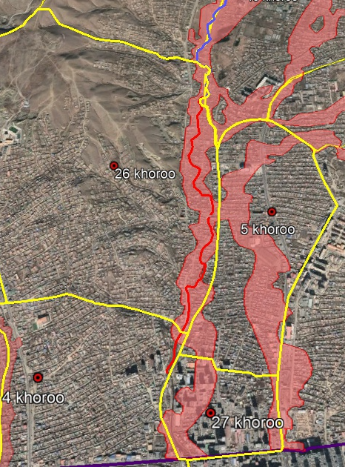

During consultations with communities and local and national government, several adaptation options were considered. These included protection of the areas around the sites where springs frequently burst, construction of embankments, construction of improved sanitation systems, drainage and wastewater infrastructure, waste management systems and disposal, tree planting and other, softer adaptation measures. The activities proposed in the table above, and described further in Part II, Section A, are directly influenced by these consultations.

Figure 21 Photographs of different proposed location
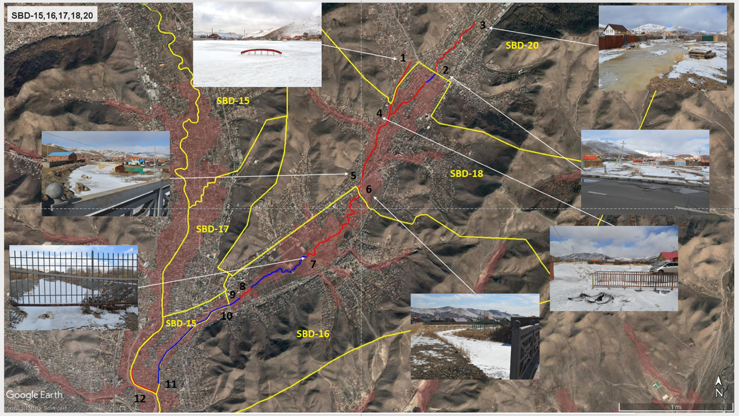

Figure 22. Photographs of different proposed location
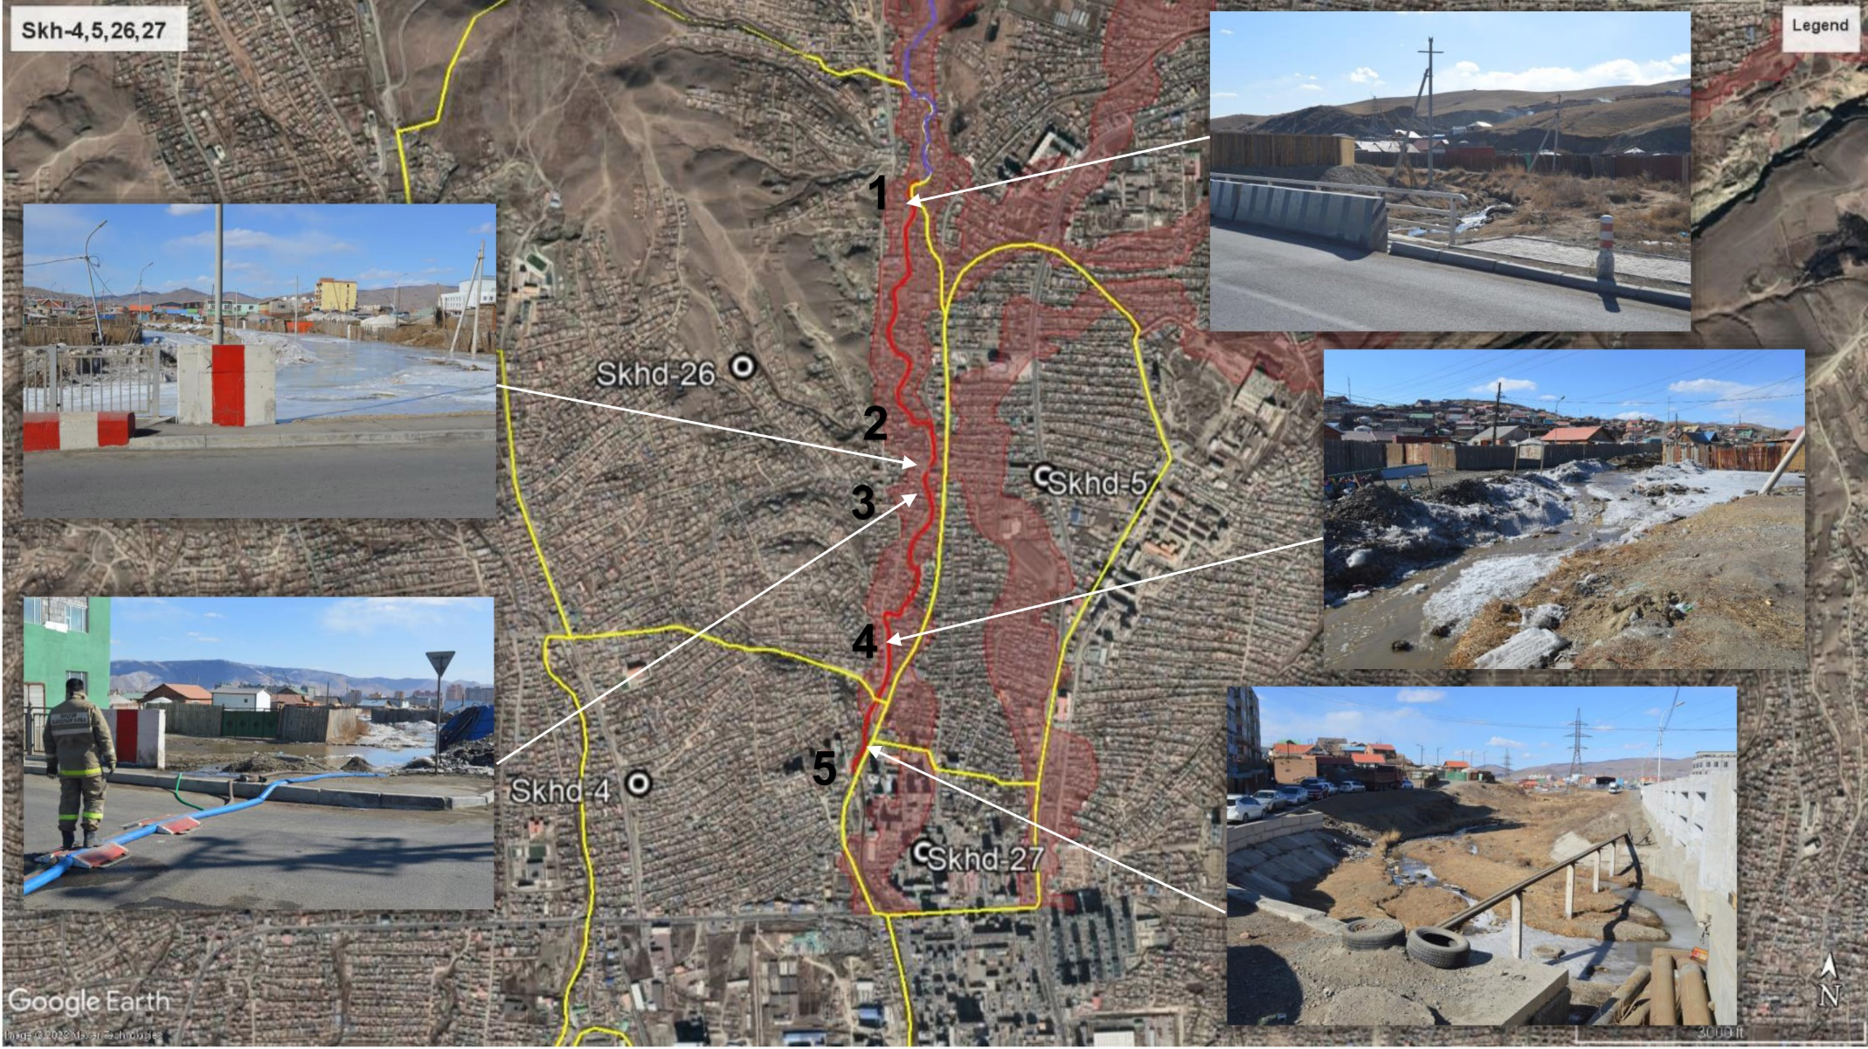

- Describe the project/programme components, particularly focusing on the concrete adaptation activities of the project, and how these activities contribute to climate resilience. For the case of a programme, show how the combination of individual projects will contribute to the overall increase in resilience.

PART II: PROJECT/PROGRAMME JUSTIFICATION

Project components, concrete adaptation activities

As Section 1 of this proposal establishes, Ulaanbaatar is vulnerable to the impacts of climate change. Khoroos 15, 16, 18, 20 of Sukhbaatar District and Khoroos 26, 5, 4 and 27 of Songinokhairkhan District, targeted by this project, are especially vulnerable, considering not only their exposure to climate change hazards by also their underlying vulnerability, arising from the low-income nature of the areas, unplanned urban development, and partial informality. Adaptive capacity is also low, given that local government budgets are constrained and there is minimal capacity among the communities themselves to construct, manage or maintain small-scale adaptation infrastructure.

To achieve the project’s overall objective, which is to enhance the resilience of communities of eight khoroos of Ulaanbaatar to floods caused by snowmelt and melting permafrost, the project will work in conjunction with communities, the local and national government and civil society to adapt to increasing snow melt and melting permafrost, which leads to bursting springs, flooding and damage to homes and infrastructure. However, to sustain and replicate the project’s successes, it will also work closely with the local, municipal and national level governments.

The activities proposed under the project have been designed to address the risks and vulnerabilities faced by the poorest and most vulnerable in the target khoroos. To do this, the measures are a combination of soft and hard activities and are interdependent and mutually supportive. The soft measures include a stronger policy component than the previous UN-Habitat-implemented Adaptation Fund project in Mongolia, which is designed to ensure that urban adaptation and resilience considerations are mainstreamed into future iterations of the NDC and the NAP. The capacity building component will focus on city and local level capacities and will enhance the ability of local officials to manage adaptation infrastructure, building on the experiences and best practices from the previous Adaptation Fund project. The capacity building component also contains activities designed to improve the financial sustainability of the interventions, as well as build capacity toward mobilizing further finance in the future.

The components and outputs of the project are as follows:

Component 1 – Enhance the policy and regulatory environment at the national and city level to reduce risks and enhance adaptive capacity in the future
1.1 Identify adaptation needs in the urban development sector
1.2 Review existing adaptation policy and regulations from the urban context and suggest required integration of urban adaptation measures
1.3 Detailed Khoroo and District level flood/hazard risk, exposure and vulnerability assessment reports prepared for the selected Ger areas
1.4 Integration workshops held to ensure that urban adaptation is prominently featured in Mongolia’s NAP and 2025 NDC update, and climate change adaptation considerations are mainstreamed into future urban-related policies and plans
1.5 Urban adaptation mainstreamed into local government policy and planning in the target areas

These outputs have been included in the proposed project to address the vulnerabilities that arise from limited adaptive capacity in policy and planning at the sub-national level. Outputs 1.1, 1.2, and 1.4 are specifically targeted to increase adaptive capacity through improved policy and planning at the national and subnational levels. Outputs 1.3 and 1.5 also relate to policy and capacity, but are specifically designed to respond to the urbanization challenges the northern Ger areas of Ulaanbaatar are facing, especially considering that climate change and the increased flooding it is causing have not been included in the current Urban Development Master Plan. As a result of the successful achievement of these outputs, Ulaanbaatar will be supported to plan more effectively for climate change and present and future flood risk. Through the project, the city will ‘lock in’ resilience through its master planning, rather than locking in vulnerability.

Component 1 has been designed to align with and contribute to several Outcomes and Outputs of the AF Strategic Results Framework. Project Outputs 1.1 and 1.2 align with and contribute to AF Strategic Results Framework Output 1.2 Targeted population groups covered by adequate risk reduction systems. Project Output 1.3 aligns with and contributes to AF Strategic Results Framework Output 1.1: Risk and vulnerability assessments conducted and updated. Project Outputs 1.4 and 1.5 contribute to and align with AF Strategic Results Framework Output 7: Improved integration of climate-resilience strategies into country development plans

Component 2 – Build capacity at the national, city and community level to adapt now and in the future
2.1 Capacity building programme implemented at the sub-national level to plan for and manage urban adaptation actions
2.2 Capacity building programme implemented at the community level to manage and maintain small-scale adaptation infrastructure
2.3 Capacity built to meet future urban adaptation financing needs and community-based disaster risk reduction and assets protection trainings

All Outputs under Component 2 have been included to address gaps in capacity at various levels of government. However, output 2.3 also addresses the lack of adaptive capacity in terms of financial resources. This will strengthen capacity at the national and sub-national level to mobilize greater levels of climate finance from domestic and international, public and private sources, and to explore new and/or innovative financing mechanisms.

Component 2 has been designed to align with and contribute to AF Strategic Results Framework Outcome 2: Strengthened institutional capacity to reduce risks associated with climate-induced socio-economic and environmental losses. Project Outputs 2.1 and 2.2 contribute to achieving AF Output 2.1: Strengthened capacity of national and sub-national centers and networks to respond rapidly to extreme weather events, while project Output 2.3 contributes to achieving AF Output 2.2 Increased readiness and capacity of national and sub-national entities to directly access and program adaptation finance.

Component 3 – Reduce risks from flooding through physical infrastructure in the target areas
3.1 Technical studies – EIA, ESSS Scoping, and Engineering and hydrological studies- required for flood protection in the selected areas
3.2. Flood protection infrastructure developed in response to climate change related flood impacts:
3.3 Trees and bushes planted by the communities along the flood protection facilities to create additional resilience and broader environmental sustainability
3.4 Flood resilient sanitation facilities constructed by the target communities

Outputs under Component 3 have been included to directly address the vulnerabilities that arise from inadequate infrastructure in the project’s target areas. Component 3 has been designed to align with and contribute to AF Core Indicator “Assets produced, developed, improved, or strengthened” to achieve the impact-level result “Increased adaptive capacity of communities to respond to the impacts of climate change” and Strategic Results Framework Outcome 4: Increased adaptive capacity within relevant development sector services and infrastructure assets. All outputs under the project’s Component 3 are designed to align with and contribute to AF Output 4: Vulnerable development sector services and infrastructure assets strengthened in response to climate change impacts, including variability.

Component 4 – Improve and enhance the knowledge base to sustain and replicate the project’s gains.
4.1 Knowledge captured from project implementation and disseminated through media, web-stories and case studies
4.2. National and local governments and climate change research communities have increased knowledge resources at its disposal
4.3 Bringing Global Knowledge on best practices to Implementing Partners and communities

Component 4 has been included to build knowledge that will support the institutionalization and sustainability of the benefits achieved through the activities implemented under the other components and also previous UN-Habitat implemented AF FRUGA project. It will also contribute to the generation of knowledge product about the impacts of permafrost thawing due to global warming in the target areas and ideas of preventive measures from further thawing. Enhanced knowledge, achieved through Component 4 can be seen as ‘essential underwriting’ of activities under Components 1-3. Component 4 aligns with AF Strategic Results Framework Outcome 3: Strengthened awareness and ownership of adaptation and climate risk reduction processes at local level. All outputs are designed to align with and contribute to AF Output 3.2. Strengthened capacity of national and subnational stakeholders and entities to capture and disseminate knowledge and learning.

Table 4. Concrete interventions and supporting activities (corresponding to prioritized resilience building interventions in the above)
Concrete interventions / activities |  | Target Khoroo | Estimated  number of  beneficiaries | Estimated cost  (US$) and cost-effectiveness of direct beneficiaries  (area within the Khoroo) | Design details
Area | Detailed activities (for more details see environmental and social risks screening sheets in annex 5) |  | Estimated  number of  beneficiaries |  | Location  (see maps) | Dimensions | Description  (incl. relevant info for risks screening)
Area 1 (Sukhbaatar District Khoroo 15,16,18, 20) | Embankment protection around spring  Construct a flood retention wall / embankment | 18 | Direct: 300  Indirect: 9,495 | 163,696 | See figures 21A  D1: From #375,  Belkh-48  to #300, Belkh-48 | Pkg 1  Length: 670m  1 – 3 m wide, 1.2 – 1.6m high compressed ground embankment with 1,5m concrete slope surface on concrete foundation | Pond, Cross section 2-2  Land status: public  Land use: park  Material: concrete, compressed ground
Area 1 (Sukhbaatar District Khoroo 15,16,18, 20) | Flood protection and drainage infrastructure  Drainage channels | 18 | Direct: 1628  Indirect: 9,495 | 254,366 | See figures 21A  C1: From #300,  Belkh-48  to #208, Belkh-48 | Pkg 1  Length: 546 m  1m wide, 1 – 1.2m high compressed ground embankment with 1,5m concrete slope surface on concrete foundation | Cross section 1-1  Land status: public  Land use: river  Material: concrete, compressed ground
Area 1 (Sukhbaatar District Khoroo 15,16,18, 20) |  | 18 | Direct: 1628  Indirect: 9,495 | 330,099 | See figures 21A  C3: From #365,  Belkh-48  to #208, Belkh-48 | Pkg 3  Length: 715 m  1m wide, 1 – 1.2m high compressed ground embankment with 1,5m concrete slope surface on concrete foundation | Cross section 1-1  Land status: public  Land use: river  Material: concrete, compressed ground
Area 1 (Sukhbaatar District Khoroo 15,16,18, 20) |  | 18 | Direct: 1628  Indirect: 9,495 | 488,700 | See figures 21A  C4: From #208,  Belkh-48  to #26, Belkh-39 | Pkg 4  Length: 1049 m  1m wide, 1 – 1.2m high compressed ground embankment with 1,5m concrete slope surface on concrete foundation | Cross section 1-1  Land status: public  Land use: river  Material: concrete, compressed ground  Preliminary alignment show that 2 plots encroached upon the riverbed will be affected.  Affected plot 4  309# Belh-48, 50#Belh-47, 50a#Belh-47, 50b#Belh-47
Area 1 (Sukhbaatar District Khoroo 15,16,18, 20) |  | 20 | Direct: 1,253  Indirect: 4,450 | 742,134 | See figures 21A  C1: From #1,  Tsolmon-11  to #422, Tsolmon-2 | Pkg 2  Length: 1,593 m  1m wide, 1 – 1.2m high compressed ground embankment with 1,5m concrete slope surface on concrete foundation | Cross section 1-1  Land status: public  Land use: river  Material: concrete, compressed ground
Area 1 (Sukhbaatar District Khoroo 15,16,18, 20) |  | 16 | Direct: 688  Indirect: 11,766 | 736,185 | See figures 21A  C5: From #102,  Oichid-1  to #14060, Dambadarjaa | Pkg 5  Length: 1,456 m  1m wide, 1 – 1.2m high compressed ground embankment with 1,5m concrete slope surface on concrete foundation | Cross section 1-1  Land status: public  Land use: river  Material: concrete, compressed ground
Area 1 (Sukhbaatar District Khoroo 15,16,18, 20) |  | 16 | Direct: 688  Indirect: 11,766 | 110,731 | See figures 21A  C6: From #25,  Belkhi-34  to #1-1, Belkhi-32 | Pkg 6  Length: 219 m  1m wide, 1 – 1.2m high compressed ground embankment with 1,5m concrete slope surface on concrete foundation | Cross section 1-1  Land status: public  Land use: river  Material: concrete, compressed ground
Area 1 (Sukhbaatar District Khoroo 15,16,18, 20) | Renovation of existing structure | 16 | Direct: 688  Indirect: 11,766 | 624,958 | See figures 21A  C7: From #1-1,  Belkhi-32  to #177, Belkh-8 | Pkg 6  Length: 1,781 m  1m wide, 1 – 1.2m high compressed ground embankment with 1,5m concrete slope surface on concrete foundation | Cross section 1-1  Land status: public  Land use: river  Material: concrete, compressed ground
Area 1 (Sukhbaatar District Khoroo 15,16,18, 20) | Flood protection and drainage infrastructure  Construct a flood retention wall / embankment | 15 | Direct: 320  Indirect: 6,648 | 151,410 | See figures 21A  D2: From #81, Dambadarjaa-20, to #7, Dambadarjaa-1 | Pkg 7  Length: 533 m  1m wide, 1 – 1.2m high compressed ground embankment with 1,5m concrete slope surface on concrete foundation | Cross section 1-1  Land status: public  Land use: river  Material: concrete, compressed ground
Area 1 (Sukhbaatar District Khoroo 15,16,18, 20) |  | 15 | Direct: 688  Indirect: 11,766 | 95,732 | See figures 21A  D3: From #177, Belkh-8, to #282, Belkh-11 | Pkg 7  Length: 337 m  1m wide, 1 – 1.2m high compressed ground embankment with 1.5m concrete slope surface on concrete foundation | Cross section 2-2  Land status: public  Land use: river  Material: concrete, compressed ground  Preliminary alignment show that 4 plots encroached upon the riverbed will be affected: 235#Belkh11, 282#Belkh11, 282a#Belkh11, 282b#Belkh11
Area 2 (Songinokhairkhan District Khoroo 26 and 5 and Khoroo 4 and 27) | Flood protection and drainage infrastructure  Drainage channels | 26 and 5 | Direct: 5,350  Indirect: 17,657 | 501,278 | See figure 21B  C1: From #33,  Bayanbulag-5  to #1, Bayanbulag-2 | Pkg 8  Length: 1076 m  1 – 3 m wide, 1.2 – 1.6m high compressed ground embankment with 1,5m concrete slope surface on concrete foundation | Cross section 1-1  Land status: public  Land use: river  Material: concrete, compressed ground  Preliminary alignment show that 4 plots encroached upon the riverbed will be affected: 7# Bayanbulag-5, 26#Bayanbulag-2, 21#Bayanbulag-2, 37#Bayanbulag-2
 |  | 26 and 5 | Direct: 5,350  Indirect: 17,657 | 375,492 | See figure 21B  C2: From #101,  Bayanbulag-1  to #1, Bayanbulag-2 | Pkg 9  Pkg C2: 806m  1 – 3 m wide, 1.2 – 1.6m high compressed ground embankment with 1,5m concrete slope surface on concrete foundation | Cross section 1-1  Land status: public  Land use: river  Material: concrete, compressed ground  Preliminary alignment show that 5 plots encroached upon the riverbed will be affected: 27#Bayanbulag-1, 30#Bayanbulag-1, 31#Bayanbulag-1, 52#Bayanbulag-1, 98#Bayanbulag-1
 |  | 4 and 27 | Direct: 870  Indirect: 14,280 | 151,686 | See figure 21B  C3: From #49,  Ikh naran-13  to #54, Ikh naran-8 | Pkg 10  C3: 300m  1 – 3 m wide, 1.2 – 1.6m high compressed ground embankment with 1,5m concrete slope surface on concrete foundation | Cross section 1-1  Land status: public  Land use: river  Material: concrete, compressed ground

Area 1 (Sukhbaatar District Khoroo 15,16,18, 20) | Flood resilient latrines  Construct suitable latrines (for rocky or muddy underground) | 20 | Direct: 526 (>268 women)  Indirect: 8,969  (Rest of Khoroo 20) | 84,143  = 161 pp | See figure 23 | 66 units of latrines | Design: see figure 23  Land status: mixed  Land use: residential  Designs will ultimately be agreed upon with residents. Design support comes from the university and other partners.  Latrines will be placed within residential plots. The selection of beneficiaries / locations within the khoroos will be done by the khoroo members themselves besides some basic criteria:  - Income / poverty  - Flood vulnerability  - Willingness to cost share  The final selection of residents / locations could not be done in advance because it’s an agreement process of the khoroo which would raise too much expectation without having secured the funding.
Area 1 (Sukhbaatar District Khoroo 15,16,18, 20) |  | 18 | Direct: 874 (>446women)  Indirect: 3,676  (Rest Khoroo 18) | 140,936  = 161 pp | See figure 23 | 109 units of latrines
Area 1 (Sukhbaatar District Khoroo 15,16,18, 20) |  | 16 | Direct: 936 (>477 women)  Indirect: 10,830  (Rest Khoroo 16) | 151,265  = 161 pp | See figure 23 | 117 units of latrines
Area 1 (Sukhbaatar District Khoroo 15,16,18, 20) |  | 15 | Direct: 143 (>73 women)  Indirect: 6,541  (Rest Khoroo 15) | 23,082  = 161 pp | See figure 23 | 18 units of latrines
Area 2 (Songinokhairkhan District Khoroo 26 and 4) |  | 26 and 5 | Direct: 622 (>317 women)  Indirect:9,806  (Rest Khoroo 26 and 5) | 100,461  = 161 pp | See figure 23 | 78 units of latrines
Area 2 (Songinokhairkhan District Khoroo 26 and 4) |  | 4 and 27 | Direct: 99 (>51 women)  Indirect: 10,329  (Rest Khoroo 4 and 27) | 15,255  = 154 pp | See figure 23 | 12 units of latrines

- Describe how the project/programme provides economic, social and environmental benefits, with particular reference to the most vulnerable communities, and vulnerable groups within communities, including gender considerations. Describe how the project/programme will avoid or mitigate negative impacts, in compliance with the Environmental and Social Policy and Gender Policy of the Adaptation Fund.

Economic, social and environmental benefits

The proposed project will build on the successful approach, which has proved to be effective during the AF-funded FRUGA project. That project adopted a form of the People’s Process, UN-Habitat’s successful community-driven approach to implementing projects for recovery and long-term resilience that has been implemented throughout the Asia-Pacific region over many years. The People’s Process is predicated on the idea that stronger social ties amongst the urban poor and vulnerable reduces risk across social, economic and environmental dimensions and provides essential support in times of current or future stress – such as severe floods whose impacts are worsening as a result of climate change. Without an approach that builds a more resilient community, people in Ulaanbaatar face ever-greater risks arising from climate change, as well as the possibility of mal-adaptation. The creation of a sense of social harmony between the urban policy makers, the residents and other groups in society allows for improved communication and the sharing of experiences which would ultimately lead to greater social resilience.

The target community mobilization and empowerment approach used in the previous AF-funded FRUGA project has been a successful element of the project implementation, and the project has made a positive contribution to the empowerment of women.

As result of the community mobilization and empowerment activities under the FRUGA project, as of 31 Dec 2022 139 community groups were formed representing 1770 households with 7260 people, out of which 53.9% were women. Being trained and facilitated under the project, the community groups (50.8% have women leaders) are leading now the climate change adaptation and disaster preparedness activities at the community level. 11524 people participated in the project activities out of which 65.5% were women. 1729 households which live in high flood risk areas improved their sanitation facilities to flood resilient improved toilets. Among the beneficiary households, 405 are female headed and 211 households have PWDs. The proposed project targets similar participation of and benefits for women, as outlined in the table below.

Table 5. Economic, Social and Environmental benefits
Type of benefit | Baseline | With/after project | Estimated benefits in numbers
Economic | As highlighted in Section 1 of this proposal, climate change is already leading to damage to housing and infrastructure (with severe economic implications), direct costs of clean-up and recovery and loss of livelihood. | There will be less damage to housing and public infrastructure, resulting in less public budget and private income/savings being invested in clean-up, recovery after flood events.  There will be potential for greater public and private investment in the newly flood-protected areas, in this rapidly growing area on Ulaanbaatar.  Community members will benefit from the option to provide cash-labour to the construction elements of the proposed project | 30% of the annual municipal budget that was previously invested in clear-up and recovery after flood events will be saved and can be used for other development, investment or service provision purposes.  More than 50% of the health expenses which are provided to the affected population due to flooding impacts will be saved  At least 30% of the costs invested at the household level in recovery and clean up during and after flood events will be saved and can be used for other purposes
Social | Climate change impacts in rural areas are a driver of rural-urban migration, such as the type currently being witnessed in Ulaanbaatar.  Flood impacts that are increasingly likely as a result of climate change will contribute to social dislocation between communities, as well as negative health impacts – especially for the elderly and more vulnerable segment of the population. | There will be a reduction in health-related impacts due to lower flood risks  While rural-urban migration is driven by factors outside the scope of the project, rural-urban migrants who move to the project’s target area will be less vulnerable (at present, recent rural-urban migrants – who often lack community and social safety nets, live in the area and are more vulnerable) | 9,539 people (of which 50% will be women) will be protected from potential flooding risks  3,201 most vulnerable people (at least 50% of which will be women) will have improved, accessible and flood resilient toilets  At least a 30% reduction in water-borne disease incidence
Environmental | As highlighted in Section 1, climate change is already causing negative environmental impacts to the target area, including snow melt, melting permafrost and higher temperatures and earlier thaws that drive flooding.]  The flood prone nature of the land in the target area means it cannot presently be used for any productive or environmental conservation purpose. | As a result of the project, there will be reduced flood risk.  Part of the currently flood prone area in Khoroo 18 was formerly used as a park/public space. The project will return the area to become safe and inclusive public space. This public space will include a number of trees that will make an incremental improvement air quality, as a co-benefit.  Land downstream of the project’s target site will be protected and consequently there will be a reduced risk of erosion | 171 hectares of land will be protected from flood risk  9.37km of riverbanks in Area 1 and 2.2km in Area 2 will be improved and protected from degradation arising from human activity

- Describe or provide an analysis of the cost-effectiveness of the proposed project/ programme

Cost-effectiveness

The proposed project will maximize investment in physical infrastructure to ensure the greatest return in terms of adaptation benefits per dollar spent. The project will also make several strategic investments in policy alignment and capacity development to ensure that urban adaptation considerations are mainstreamed into national policy, especially the under-development National Adaptation Plan (NAP) and future iterations of Mongolia’s Nationally Determined Contribution (NDC).

The cost-effectiveness rationale of Component 1 is that, by ensuring that urban adaptation needs – especially in Ulaanbaatar – are integrated into the NAP, NDC, urban-related policies and plans, and local government planning, there is a greater chance that future climate change and urban development investment will be targeted to the most vulnerable people, and that investments won’t be directed towards maladaptive activities, or investment that causes negative environmental and social impacts. Activities under Output 1.5 have been included in the project to ensure that decision makers at the city and national levels will have the most relevant and up-to date information available to them. In this regard, activities under Component 1 should be seen as strategic investments.

Component 2 is the capacity building component of the proposed project. These activities focus at the sub-national and community level and are designed so that ownership and management of the infrastructure assets can be transferred to and sustainably managed by the community and sub-national government. Activities under Output 2.3 have been included to ensure that financing needs can be met in the future. This project cannot meet all current and future adaptation needs of the people of Ulaanbaatar, so it is essential that capacity is built to support the future mobilization of domestic, international and public and private finance to meet current and future adaptation needs.

Component 3 are the physical adaptation infrastructure investments. Over 75 percent of the project’s execution budget will be invested in the physical infrastructures. In Khoroo 20 of Sukhbaatar District where a spring has burst, a flood defense embankment will be created that will also retain and enhance the features of the current park. The cost-benefit of the investment here will be increased by designing the infrastructure, so it forms part of a multi-functional green public space. This will bring co-benefits in terms of an urban ecosystem, the public good of a safe, inclusive public space and a contribution to improved air quality.

The embankment of the current river will be strengthened on both banks and provide a drainage channel so that the water does not overflow and flood the houses and ger plots. The character of the river will be maintained throughout the alignment. Based on initial consultations for the preparation of this proposal, it was agreed by the local engineering team that this drainage would be cheaper and less risky against the AF Environmental and Social Safeguard policy. The alternative would be to construct an underground system to gradually release melting permafrost. However, this would be more expensive, untested from an engineering perspective and carry greater risk of disruption to houses/private land.

Activities under Component 3 will also invest in flood protection measures in Khoroos 4, 5, 26 and 27 of Songinokharkhan District that will address overflows that emanate from the river. The engineering team has assessed that there is no feasible alternative other than to invest in these measures.

According to the hydrological study conducted by the engineers and hydrologists, and based on further consultation, the engineering solutions proposed are the only ones available that are likely to be effective in supporting communities in the target area to adapt. However, alternative citing of the drainage infrastructure was considered. However, under the alternate citing of the infrastructure in khoroos 15, 16, 18 and 20 of Sukhbaatar District, the infrastructure would affect 24 private residential plots. Households on these plots would be entitled to compensation under the law of between US$20,000 and US$50,000, depending on various factors, including the precise location and nature of the disruption. Taking the median of US$35,000, it can be estimated that if compensation had to be paid to all plot holders, this would add US$840,000 to the cost of the drainage infrastructure and would trigger a potentially serious environmental and social safeguard risk under the involuntary resettlement safeguard area of the AF Environmental and Social Policy.

A similar situation would also arise in Khoroos 4, 5, 26 and 27 of Songinokhairkhan District. During the preparation of the proposal, an alternative citing of the infrastructure was considered, but under this alternative citing, 26 private, residential plots would be affected. As above, plot holders would be entitled to compensation, so using the same assumptions as above, compensation would add an estimated US$910,000 to the cost of the infrastructure. As above, this alternative citing was not given further consideration as it would be too expensive and could potentially add a serious environmental and social safeguard risk under the involuntary resettlement safeguard area of the AF Environmental and Social Policy.

Other types of adaptation options, including ecosystem-based adaptation were considered but disregarded before costing could be done as they were deemed un-implementable or unlikely to be effective.

The alternative of taking no further action (i.e., not submitting a proposal) was also considered. However, the damage from flooding is costing the Municipality alone on average between US$1.4-1.7m per year at present, which is before the additional costs arising because of climate change are considered. This figure does not consider the amount individual households or small businesses in the target area have to invest each year in clean up and recovery from floods (these costs have not been estimated). Consultations with the Municipal Emergency Management Agency in 2021 revealed that the agency received 200 flood calls and rescued more than 230 people from flood hazard. Since the beginning of 2022, 140 flood calls were received and 155 people have been saved. These service costs have been paid from the emergency reserve funds of the Municipality. The Municipality owned Hydrology engineering company provides response services in the flood affected areas on call. According to the flood protection specialist of the Mayor’s Office, a team of 7-8 persons equipped with heavy machinery work to alleviate damage caused by winter flooding from November to March in around 20 places where springs burst, including all of the project’s target areas.

Finally, the project’s 4th component is around improved knowledge. This component has been included in compliance with the Adaptation Fund’s strategic programme and also to ensure that the knowledge and learning potential contained in the project can be captured, stored and shared with stakeholders across government, civil society and communities. Without this component, there would be a risk that knowledge is either not captured at all, or that it is captured but not institutionalized and there would be no contribution to institutional memory arising from the project.

- Describe how the project/programme is consistent with national or sub-national sustainable development strategies, including, where appropriate, national adaptation plan (NAP), national or sub-national development plans, poverty reduction strategies, national communications, or national adaptation programs of action, or other relevant instruments, where they exist.

Consistency with national or sub-national development programmes

Mongolia ratified the United Nations Framework Convention of Climate Change (UNFCCC) in 1993, the Kyoto Protocol in 1999 and the Paris Agreement on Climate Change in 2016. In doing this, it submitted a National Determined Contribution (NDC) to the Paris Agreement in 2015 and an updated NDC in 2021, ahead of the 26th Conference of the Parties (CoP) to the UNFCCC. Mongolia’s updated NDC includes both adaptation and mitigation targets. Under adaptation, there are several targets that are relevant to this project, and that this project contributes to achieving. This includes:
- “Conduct and regularly update risk assessments for natural disasters, and reduce the disaster risks based on the partnership of various stakeholders”, which is aligned with the proposed project’s Output 1.3: Detailed Khoroo and District level flood/hazard risk, exposure and vulnerability assessment reports prepared for the selected Ger areas
- “Identify social groups vulnerable to climate change and build their resilience to overcome the risks” which is aligned with the project’s Component 3, which implements adaptation actions through physical infrastructure and ecosystem-based measures. The project has worked to ensure that it targets the most vulnerable groups in the Ger areas of Ulaanbaatar
- “Ensure equality for the vulnerable groups and increase employment by providing knowledge and education.” This is aligned with the project’s Output 4.3 Bringing Global Knowledge on best practices to Implementing Partners and communities, which will support enhancing knowledge at various levels, including the community.

The project has also included Output 1.4: Integration workshops held to ensure that urban adaptation is prominently featured in Mongolia’s NAP and 2025 NDC update, and climate change adaptation considerations are mainstreamed into future urban-related policies and plans. This has been included to ensure that the next iteration of the NDC, which is likely to be developed during the proposed project’s implementation period, includes lessons learned from the project and more explicitly targets vulnerable urban populations.

Mongolia is currently developing a National Adaptation Plan (NAP), with support from UNEP and the Green Climate Fund. This project is in its early stages of implementation, which means that the NAP will be developed during the proposed project’s implementation period. As the NAP will guide investment in adaptation in the medium to long term, it is vital that steps are taken to ensure urban adaptation priorities are aligned, integrated and coordinated in the NAP formulation process. This will also be addressed by activities under Output 1.4.

Mongolia also has a National Programme on Climate Change, and while there is no specific climate change law, there are numerous laws relevant to climate change, including the Law on Air, Law on Energy, and Law on Forest. While these laws are not directly related to the proposed project, they are laws that must be complied with and therefore the project will ensure compliance throughout its implementation.

Mongolia’s Sustainable Development Vision 2030 is the overarching development framework. The proposed project is in alignment the following goals and objectives of Vision 2030:

- Goal 2, Sustainable Economic Development, Energy and Infrastructure Objective 6: Provide greater independence to urban areas and settlements, build roads and transportation, and engineering infrastructure, create a healthy, safe and comfortable living environment for citizens, and improve urban planning in line with world-class green development model.
- Goal 2.3.2, Coping with Climate Change: Objective 1: Establish national capacity to cope with climate change, and strengthen the system to prevent from meteorological hazard and natural disaster risks.
- Goal 2.3.3. Ecosystem Balance, Objective 2: Improve the planning of cities and urban settlements, enhance the quality of and accessibility to infrastructure facilities, advocate scientific and clean-living habits among the populace, and improve the quality of the environment and waste management systems.

All the interventions identified in Output 3 are aligned with the Ulaanbaatar Master Plan 2020, specifically under Priority 1: Ulaanbaatar will be a safe, healthy and green city that is resilient to climate change and Priority 2: Ulaanbaatar will provide a livable environment for its residents through appropriate land use planning, infrastructure and housing.

The proposed activities are consistent with the key strategic directions, recommendations and target areas within the Flood Risk Management Strategy of Ulaanbaatar City, including reduce flood risk through resilient urban development, land use and waste management, protection of social infrastructure and strengthened utility services.

- Describe how the project/programme meets relevant national technical standards, where applicable, such as standards for environmental assessment, building codes, etc., and complies with the Environmental and Social Policy of the Adaptation Fund.

Compliance with relevant technical standards and policies

The table below describes how the physical infrastructure constructed by the project complies with various national laws, standards and procedures. Components 1,2 and 4 are not included as they are ‘soft’ components, however, they are described below.

Please also note that the design and construction of the interventions will be following the various norms and standards mentioned in Basic Procedure for Hydro-technical Construction Design BND-33-01-03; River Hydrotechnical Construction BND-33-01-05; Hydrotechnical Construction Foundation BND-33-04-09; Capacity and Performance of Hydrotechnical Construction BND-33-05-09; Concrete and Ferroconcrete Structure for Hydro- technical Construction BND-33-06-09; and Norms and Regulations for Estimation of Hydrological Characteristics BND-201- 14-86.

In addition, the construction of sanitation works will assure adherence to the standards mentioned in MNS 5924: 2015 Pit latrine and Sewage Pit, Technical requirements; MNS3342:82 Nature and Environmental protection. General requirements for protecting ground water and hydrosphere from pollution; MNS 6055:2009 General environmental and space requirements for the persons with disability in the civil construction planning, and MNS 6279:2011 Water supply and sanitation facilities.

Table 6. Compliance with laws and national technical standards
Expected concrete output or intervention | Relevant laws, regulations, standards and procedures | Compliance, procedure and authorizing office | Potential risks and impacts identified during proposal preparation
3.1 Technical studies – EIA, ESSS Scoping, and Engineering and hydrological studies- required for flood protection in the selected areas | Related laws:  - Law on Land  - Law on Water  - Urban Development Law  - Disaster Management Law  - Building Code | - ToRs to be issued by the executing entity and discussed with relevant government stakeholders prior to issue/advertisement  - A competitive process will be undertaken to select a firm with the relevant knowledge, expertise and experience to undertake the studies with full legal compliance  - The selected contractor will enter into a contract that stipulates the laws and a contractual requirement to maintain full legal compliance  - The contract implementation will be closely monitored by the Project Management Unit, who will reserve the right to flag any legal compliance risks or issues | Risk that the technical studies do not actively consider AF Environmental and Social Policy principles.  Mitigation – Consideration of AF Environmental and Social principles will be a contractual obligation for the contractor.
3.2. Flood protection infrastructure developed in response to climate change related flood impacts:  - 1.540 km retention wall, 5.578 km urban drainage constructed, and 1.781 km drainage repaired Sukhbaatar District Khoroo 18, 20, 15, 16.  - 2.182 km of flood protection canals constructed in Songinokhairkhan District Khoroo 4, 5, 26 and 27 | Related laws:  - Law on Land  - Law on Water  - Urban Development Law  - Disaster Management Law  - Building Code  Norms & Standards:  - Basic Procedure for Hydrotechnical Construction Design BND-33-01-03  - River Hydrotechnical Construction BND-33-01-05  - Hydrotechnical Construction Foundation BND-33-04-09  - Capacity and Performance of Hydrotechnical Construction BND-33-05-09  - Concrete and Ferroconcrete Structure for Hydrotechnical Construction BND-33-06-09  - Norms and Regulations for Estimation of Hydrological Characteristics BND-201-14-86 | Engineering design stage:  - ToRs to be issued by the executing entity and discussed with relevant government stakeholders prior to issue/advertisement  - A competitive process will be undertaken to select a firm with the relevant knowledge, expertise and experience to undertake the studies with full legal compliance  - The selected contractor will enter into a contract that stipulates the laws and a contractual requirement to maintain full legal compliance  - The contract implementation will be closely monitored by the Project Management Unit, who will reserve the right to flag any legal compliance risks or issues  Construction phase  - Selection of the construction company, separate from the design company  - Contractual process with the construction company that follows the same principles as in selection of the design company (i.e., ensures legal compliance through contractual provisions)  - Contract for supervision, which details out legal compliance requirements, giving the supervisor a mandate to check and ensure continued legal compliance  - Further monitoring of the construction by the Project Management Unit | Activities under these outputs trigger the following risks under the AF’s Environmental and Social Policy
- Describe if there is duplication of project/programme with other funding sources, if any.

Duplication with other funding sources

UN-Habitat is a well-established implementation partner working with poor and vulnerable communities in Ulaanbaatar and has a long track record of supporting the local and national government in the areas of climate resilience, water and sanitation, infrastructure, urban planning, and affordable housing.

Beginning in 2018, UN-Habitat was the implementing entity on a project entitled ‘Flood Resilience in the Ger Areas’ (FRUGA), funded by the Adaptation Fund, and executed by World Vision. Prior to this, the agency had been supporting Mongolia on climate resilience through the Cities and Climate Change Initiative (CCCI), which was implemented in 12 countries in the Asia-pacific region.

The FRUGA project aimed to enhance the climate change resilience of the most vulnerable settlements in seven khoroos characterised by larger Ger areas. Under the project, a hydrological study was carried out, which in addition to making recommendations relevant to that project, also highlighted the urgent need to construct flood control and drainage facilities adjacent to the FRUGA target khoroos (see map below). This recommendation was made both a) because these areas adjacent to the FRUGA project (i.e., those targeted by this project) have adaptation needs in their own right and b) because adaptation in these areas will help to sustain the adaptation benefits achieved by the FRUGA project.

This assessment corroborated independent assessment work undertaken by UN-Habitat that also highlighted the flooding caused by bursting springs in the winter, snowmelt in the spring and heavy rain in the summer. That study found that the areas’ flood condition will continue to damage houses and other infrastructure at the same time increasing the flood risk in the downstream and other low-lying areas. without effective, well-constructed embankments, drainage infrastructure and other protective measures. Of particular concern is the also use of pit latrine type toilets, that can turn floods into a public health hazard by contaminating water and causing disease outbreaks during and after flood periods. Such risks and vulnerabilities are an ongoing threat to the adaptation gains made under the FRUGA project.

During the preparation of this proposal, the proposed target areas were visited and site inspected by the engineers and hydrologists who worked on the climate change and flood simulation model and flood risk mapping under the FRUGA project and these experts developed the alignment of the drainage and flood protection infrastructure presented in this proposal. Again, this was done with both the adaptation needs of the target communities and sustaining the adaptation benefits of the FRUGA communities in mind. The recommended areas and interventions were validated through the meetings with the target khoroo administrations and communities also with the local government agencies such as Urban Planning, Development and Engineering Departments of Ulaanbaatar Municipality and respective divisions at the district level, with all stakeholders agreeing that the proposed project is in alignment with and will enhance FRUGA (rather than causing overlap or duplication). These consultations also confirmed that the proposed interventions are consistent with the city master plan.

It is important to note that the proposed project was requested by government, with Ulaanbaatar Municipality in particular advocating for a second project. In addition to the consultations, the proposed target areas were visited by Ulaanbaatar Municipality staff and the AF Focal Point from the Ministry of Environment and Tourism to review and re-confirm both their vulnerability and to ensure that there is no overlap between FRUGA target areas and the proposed project. The map above shows the target areas. FRUGA target areas are shown in dark blue, while the proposed project is shown in green.

UN-Habitat was one of the implementing partners for the Ulaanbaatar Urban Services and Ger Areas Development Investment Programme of ADB, through the establishment of Community Development Councils (CDC’s) a key component of the agency’s flagship People’s Process. The agency also has prior experience implementing major WASH infrastructure projects in the other proposed locations of Songinokhairkhan District.

Figure 23. Target areas of the previous and proposed projects
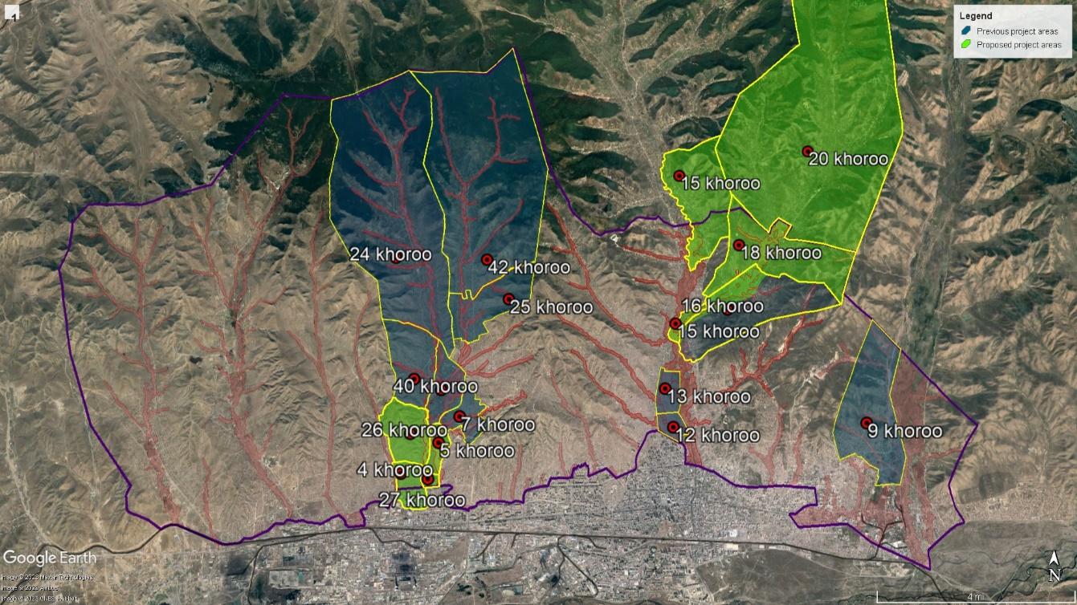

Based on UN-Habitat’s long-standing presence in Mongolia, its ability to work effectively with government at the national and sub-national level and other development partners. These working relationships will enable to project begin and be implemented smoothly and without delays.

There are several other relevant projects currently under implementation in Mongolia, which are listed in the table below. In all cases, UN-Habitat will endeavor to maintain continued coordination with the implementing agency/partner, to avoid duplication. Note, there are a number of GCF Readiness projects ongoing in Mongolia that focus on building capacity at the Ministry of Environment and Tourism. These projects have not been included for reasons of space but further consultations to be undertaken to ensure that the activities of these projects are not duplicated in the present proposed project.

Table 7. Selected other relevant projects and programmes
under implementation or recently completed in Mongolia

Implementing entity/donor | Project title | Approximate total budget | Project duration | Coordination
UNEP/GCF | Adaptation Planning support | US$2.9m | 3 years | This project will support Mongolia in the development of its first NAP. Coordination is vital to the success of output 1.1 of this proposed project
EBRD/GCF | Green Cities Facility | EUR744m | 5 years | Primarily a mitigation project. However, there are adaptation elements in the project in terms of housing and water supply. Further consultations will take place to avoid any duplication.
FAO/GEF (CBIT) | Strengthening Capacity in the Agricultural and Land-use Sectors for Enhanced Transparency in Implementation and Monitoring of Mongolia’s Nationally Determined Contribution | US$1.25m (inc co-finance) | 2018-2022 | While primarily rural-focused, this project supports transparency efforts around the NDC and therefore coordination will be required in the implementation of activities under Component 1 of this proposed project.
ADB/GCF | Ulaanbaatar Green Affordable Housing and Resilient Urban Renewal Project (AHURP) | US$544m (inc co-finance) | 2018-2026 | The project is focused on housing and does not work in the same target locations of Ulaanbaatar as this proposed project; however, further consultations will be necessary to avoid duplication
ADB/EBRD | Ger Area Urban Development Investment Program (GADIP) |  | 9 years | The multi tranche financing facility (MFF) program aim to support the Ulaanbaatar city master plan in upgrading priority service and economic hubs (sub-centers) in ger areas. The program is geographically targeted with multi sector interventions. It proposes an integrated solution to respond to the urgent demand for basic urban services and establish a network of well-developed urban sub-centers providing economic opportunities, housing, and urban services as catalysts for growth in the ger areas.

- If applicable, describe the learning and knowledge management component to capture and disseminate lessons learned.

The learning and knowledge management component

The project has included a dedicated knowledge component: Component 4 – Improve and enhance the knowledge base to sustain and replicate the project’s gains. This component includes three outputs, so that knowledge-building and sustaining activities can be focused at the local/community, city and national and global levels.

At the local level, informed by UN-Habitat’s People’s Process approach, and its two decades of project implementation experience in Mongolia, the project will involve beneficiaries and community organizations, as well as government at the khoroo level in the design, construction, management and maintenance of the infrastructure to be constructed under Component 3. Knowledge activities will focus on enhancing knowledge, capturing and documenting local knowledge that has not otherwise been captured, and ensuring that knowledge is passed on to future generations.

At the level of Ulaanbaatar Municipality and the national government, all lessons learned from the project will be captured and made publicly available in Mongolian language. UN-Habitat will work with UNDP and UNEP to ensure that all knowledge materials are made available on the under-development knowledge and information portal in the country. This approach will reduce duplication (i.e., the project will avoid building separate knowledge portals).

The project will also have a global knowledge element, both using UN-Habitat’s global network to inform the project of best practices from elsewhere, while also publishing stories and best practices to support Mongolia to be a global knowledge leader in urban resilience.

Other outputs/components of the project will produce knowledge products highlighting the key role of the women in the project and for climate change resilience. The focus on increasing participation by women in the community groups will promote their empowerment.

The capacity building activities under Component 2 will use updated versions of training materials used in earlier projects, including FRUGA. These materials will also be made available for government use and wider replication, again, utilizing the under-development knowledge and information platform.

The project will ensure that all outputs and knowledge products generated will be freely available online in Mongolian. This will be done through a combination of the UN-Habitat website and the under-development national level knowledge portals that are under development with support from UNEP and UNDP (as part of their support to NAP formulation and NDC implementation, respectively). Such platforms are multi-stakeholder initiatives, and the project will ensure there are pathways to continue both uploading knowledge products to these sites, and continued engagement with them by active stakeholders after the project implementation is complete.

- Describe the consultative process, including the list of stakeholders consulted, undertaken during project preparation, with particular reference to vulnerable groups, including gender considerations, in compliance with the Environmental and Social Policy and Gender Policy of the Adaptation Fund.

Stakeholder Consultations

The first international mission to Mongolia took place between 20 and 27 March, 2022, upon the reopening Mongolia’s borders. During this mission, the consultants visited the target field sites, to conduct an initial inspection. The mission also met with the Adaptation Fund Focal point, Mr. Batjargal Zamba to discuss the formative idea. During this meeting, Mr. Zamba encouraged UN-Habitat to proceed with the development of the concept note, in consultation with the Ministry of Environment and Tourism, Ulaanbaatar Municipality and representatives of the communities.

This design of the project has been informed by in-depth khoroo community level consultations and district level consultations with presiding Governors, conducted as part of a rapid needs assessment on climate vulnerability in the two target areas. Meetings were conducted with the designated khoroo representatives and consultations were made with the khoroos communities including the most vulnerable groups, persons with disability, elderly and recent migrants.

Focus group discussions and individual meetings were conducted among the khoroo officials and with representatives of community in 15, 16, 18, and 20th Khoroos of Sukhbaatar district and 4, 5, 26 and 27th Khoroos of Songinokhairkhan District. During the discussion the location of springs bursts were identified, and flood risk map was developed. Also discussed with their main concern and needs on flood facility. Demographic information was collected using a questionnaire prepared by UN-Habitat team. The information collected included: demographic data, existing social and physical infrastructure, existing projects in khoroo level, maintenance of the flood facilities and taken measures on flood risk from khoroo and district.

Table 8. Participants of FGD among the khoroo officials
Round One
Khoroo | 15 | 16 | 18 | 20 | 26 | 4
Participant | 5 | 6 | 4 | 3 | 9 | 6
Male | 0 | 1 | 1 | 0 | 2 | 1
Female | 5 | 5 | 3 | 3 | 7 | 5
Khoroo Governor | 1 | 1 | 1 | 0 | 1 | 1
Khoroo Coordinator | 1 | 1 | 0 | 1 | 1
Kheseg leader | 3 | 4 | 3 | 2 | 2 | 1

Round Two
Khoroo | 15 | 16 | 18 | 20 | 26 | 5 | 4 | 27
Participant | 20 | 22 | 20 | 20 | 21 | 21 | 20 | 20
Male | 3 | 6 | 7 | 7 | 8 | 10 | 3 | 1 11
Female | 17 | 16 | 13 | 13 | 13 | 11 | 17 | 9

Table 9. Overview of Focus Group Discussions and individual meetings
Round One

Meeting and date | Participants | Discussion points | Outcome
22 March 2022,  Meeting with 15th Khoroo administration and residents | - 15th Khoroo Governor of Sukhbaatar District  - Khoroo Manager  - 3 Kheseg Leaders  - A group of residents  100% of participants were women | - Briefing by Khoroo Governor on the khoroo area situation in terms of flood risk, existing flood protection facilities, history of flooding and damages and loss occurred due to flooding  - Comments by Khoroo manager, 3 Kheseg Leaders and community members on the current flood risk and challenges for households.  - The Khoroo Governor requested support to strengthen physical and institutional capacity of the khoroo to cope and adapt with flood risk. | - Household disaster risk assessment was done under World Vision Disaster resilient community project.  - An existing flood protection dam was constructed a long time ago and supposed to provide flood protection to Dambadarjaa 20-24th streets, but it has eroded in several places. The rest of khoroo areas don’t have any flood protection and residents suffer from flooding frequently.  - Khoroo mobilizes inhabitants for cleaning up the khoroo area including the flood dam.  - The Khoroo Governor has been requested for several years by residents to build flood protection facilities.
29 March 2022,  Meeting with 16th Khoroo administration and residents | - 16th Khoroo Governor of Sukhbaatar District  - Khoroo Manager  - 4 Kheseg Leaders  - A group of residents  83.3% of participants were women | - Briefing by Khoroo Governor on the khoroo area situation in terms of flood risk, existing flood protection facilities, history of flooding and damages and loss occurred due to flooding, current phenomena of winter spring burst and its impact on the residential areas  - Comments by participants on the current flood risk and challenges for households and khoroo administration.  - Support was requested by the Khoroo Governor to strengthen physical and institutional capacity of the khoroo to adapt to flood risk and find a good resolution for the bursting spring winter flooding | - Very little coverage of the flood protection facilities for the khoroo despite the high flood risk  - A hydrology study was done under the UN-Habitat FRUGA project  - Residents in Belkh-11 and Oichid-1 streets suffer from ground water flooding and burst of springs during winter  - District administration is planning to provide a bridge and small drainage in Oichid 1 street.  - Many small springs are located around the spring that is known as "Dondogdulam" mineral water spring  - There is a tree nursery in the 16th khoroo.  - Residents have been complaining about the persistent flooding situations to the Khoroo Governor but no improvement activity has undertaken for many years.
25 March 2022,  Meeting with 17th khoroo administration | - 17th Khoroo Governor of Sukhbaatar District  - Khoroo Manager  - Kheseg Leader  100% of participants were women | - Briefing by Khoroo Governor on the khoroo area situation in terms of flood risk, existing flood protection facilities, history of flooding and damages and loss occurred due to flooding, current phenomena of winter spring burst and its impact on the residential areas  - Comments by participants on the current flood risk and challenges for households and khoroo administration.  - A support was requested by the Khoroo Governor to strengthen physical and institutional capacity of the khoroo to adapt to flood risk and find a good resolution for the bursting spring winter flooding | - Household disaster risk assessment was done under World Vision Disaster resilient community project.  - Khoroo areas suffer from permafrost impact. Khoroo Office building was affected and cracked due to permafrost interaction  - Dambadarjaa 60-63rd streets are always wet due to stagnant water accumulation  - A spring burst during the winter has occurred frequently since 2018  - A small-scale drainage was constructed with the funding from District local development fund
22 March 2022,  Meeting with 18th khoroo administration | - 18th Khoroo Governor of Sukhbaatar District  - 3 kheseg Leaders  - 3 residents  71.4% of participants were women | - Briefing by Khoroo Governor on the khoroo area situation in terms of flood risk, existing flood protection facilities, history of flooding and damages and loss occurred due to flooding, current phenomena of winter spring burst and its impact on the residential areas  - Comments by participants on the current flood risk and challenges for households and khoroo administration.  - Support was requested by the Khoroo Governor to strengthen physical and institutional capacity of the khoroo to adapt to flood risk and find a good resolution for the bursting spring winter flooding | - A spring known as Gunjiin bulag has been a cause of winter flooding for the households in the khoroo frequently in the last 10 years. The residents have been requesting the khoroo, district and city administration for a sustainable solution of the problem. But they have been only able to provide a temporary support to break and remove ice coverage when its size becomes big.  - Ministry of Construction and Urban Development is piloting a small project called "Service center" to provide a localized solution of water and sanitation system for 200 households in the khoroo.
23 March 2022,  Meeting with 20th khoroo administration and residents | - A khoroo Manager  - 2 kheseg leaders  - A small group of local residents  100% of participants were women | - Briefing by Khoroo Governor on the khoroo area situation in terms of flood risk, existing flood protection facilities, history of flooding and damages and loss occurred due to flooding, current phenomena of winter spring burst and its impact on the residential areas  - Comments by participants on the current flood risk and challenges for households and khoroo administration.  - Support was requested by the Khoroo Governor to strengthen physical and institutional capacity of the khoroo to adapt to flood risk and find a solution to the bursting spring winter flooding | - The khoroo is located at the hilly area so during snowmelt and rain flash flood comes from the mountain side and brings stone and gravel.  - The area belongs to permafrost area. The most of houses are cracked under the influence of permafrost.  - Residents call often emergency service due to winter flooding because of spring burst. Emergency service provides only ice cracking and removal service. The residents are living with this problem for years now without a proper solution.
21 March 2022,  Meeting with administration and residents of 26th khoroo | - 26th Khoroo Governor  - Khoroo Manager  - 2 kheseg leaders  - A small group of local residents  77.7% of participants were women | Briefing by Khoroo Governor on the khoroo area situation in terms of flood risk, existing flood protection facilities, history of flooding and damages and loss occurred due to flooding, current phenomena of winter spring burst and its impact on the residential areas  - Comments by participants on the current flood risk and challenges for households and khoroo administration.  - A support was requested by the Khoroo Governor to strengthen physical and institutional capacity of the khoroo to adapt to flood risk and find a good resolution for the bursting spring winter flooding | - Household disaster risk assessment was done under World Vision Disaster resilient community project.  - The khoroo is located at the river basin area so most residents live in flood prone areas and suffer from flooding throughout of year.  - Residents call often emergency service during flooding but the emergency service provides only flood water pumping or ice removal service.  - The residents are living with this problem for several years without a long-term solution.
23 March 2022  Meeting with administration and residents of 4th khoroo | - 4th Khoroo Governor  - A kheseg leader  - 4 residents  83.3% of participants were women | - Briefing by Khoroo Governor on the khoroo area situation in terms of flood risk, existing flood protection facilities, history of flooding and damages and loss occurred due to flooding,  - Comments by participants on the current flood risk and challenges for households and khoroo administration.  - A support was requested by the Khoroo Governor to strengthen physical and institutional capacity of the khoroo to adapt with flood risk | - “Elderly Friendly Program” and “Women's Employment Support Sub-Program” are being implemented by Songinokhairkhan District Governor’s office.  - Small scale drainage pipes were built on Ikh Narang 2nd Street.  - There is a small bridge over the water source located on 13 Ikh Narang Street, 4th section, 4th khoroo, Songinokhairkhan district.

Round Two: Community Level

- Discussion about the challenges and problems people endure because of flooding
- Discussion about the potential measures at the community, khoroo, district and city levels

Meeting and date | Participants | Outcome
7 December 2022 | 15th khoroo  20 residents  85% female | As there is no embankment on the Selbe River, the area suffers from snowmelts in spring, heavy rains in summer and winter flooding due to burst of springs. Flood protection measures and community education about garbage management are required.
7 December 2022 | 16th khoroo  22 residents  45% female | 20th street and Toosgonii etses are in low-lying areas where water from surrounding mountains get collected in and inundate yards there. Also, Belkh 4, 11 and 7 streets get inundated. Water also fills the pit latrines.
8 December 2022 | 18th khoroo  20 residents  65% female | 5-6 places in the khoroo are affected by winter flooding. Spring bursts suddenly in the yards of the households, sometimes even from the bottom of the houses and gers and inundate the yard and neighboring yards. There are also several places which get flooded during snowmelt and summer rains. Also pit latrines gets flooded.
8 December 2022 | 20th khoroo  20 residents  65% female | Water coming from the surrounding mountains flood many places. Age the ground water table is high, pit latrines get flooded. Bursting springs are creating additional problems.
8 December 2022 | 27th khoroo  20 residents  35% female | Bursting of springs and surface flooding are major problems. Lack of sanitation facilities is another issue. The natural gullies draining the area gets flooded during rains and snowmelt.
9 December 2022 | 4th khoroo  21 residents  55% female | The current dike ends at Ikhnaran 1 and 2nd streets, so during raining season water accumulates in the neighbourhood. This water has become a breeding ground for mosquitoes and insects. Solution is required to drain the water.
9 December 2022 | 26th khoroo  21 residents  62% female | The bank of the Tolgoit River is badly degraded, so when there is snowmelt, the area gets flooded. This also damages houses and latrines. Need to strengthen the embankment and construct drainage.
27 December 2022 | 5th khoroo  20 residents  85% female | Springs emerge during summer from different places and the area gets inundated. Difficult to construct pit latrines because water emerges after 1m. Options are needed to take care of sanitation problems and flooding from snowmelt.

- Provide justification for funding requested, focusing on the full cost of adaptation reasoning.

Justification

Table 10. Justification for the project

Outputs | Baseline without AF | Additionality  (With AF) | How the proposed activities go beyond business as usual (BAU)
1.1 Identify adaptation needs in the urban development sector | There is a tendency to see climate change from only an environmental perspective. While not necessarily wrong, this approach is not holistic and can hinder decision makers’ ability to identify adaptation needs in urban areas. | The project interventions will encourage a more holistic model that closely integrates climate change adaptation and urban development, supporting Ulaanbaatar to become more resilient in the long term. | The BAU would be a continuation of the baseline where climate change is viewed as a specific environmental problem and urban development, migration and environmental degradation are seen as separate, sectoral issues.
1.2 Review of existing adaptation policy and regulations from the urban context and suggest required integration of urban adaptation measures
1.3 Detailed Khoroo level flood/hazard risk, exposure and vulnerability assessment reports prepared for the remaining Ger areas | No detailed risk, hazard or vulnerability information exists at the khoroo level in the target khoroos, meaning that future development planning and investment decisions will not be based on the latest vulnerability information. | Detailed risk, hazard and vulnerability information means that future development planning and investment decisions will consider present and likely future climate change risks | The BAU is that the target khoroos continue to develop in a haphazard and unplanned manner, characterized by substantial population growth, sprawl, inadequate infrastructure and public services, all exacerbated by increasingly severe flooding arising from climate change-driven floods and melting permafrost
1.4 Integration workshops held to ensure that urban adaptation is prominently featured in Mongolia’s NAP and 2025 NDC update, and climate change adaptation considerations are mainstreamed into future urban-related policies and plans | NAP is under development, NDC to be revised and updated around 2024. Future iterations may not consider urban vulnerability or adaptation needs. This would be problematic as almost half of Mongolia’s population lives in Ulaanbaatar alone | Urban resilience issues – especially the vulnerabilities and types of adaptation actions proposed by this project, will feature more prominently in the next NDC update and the forthcoming NAP | The BAU is that adaptation priorities, articulated by the next and future iterations of the NAP and NDC, will tend to be rural focused. While there are rural adaptation needs, this would miss the adaptation needs of the almost 50% of Mongolia’s population that lives in Ulaanbaatar, and is facing increasingly frequent and severe threads from flooding and melting permafrost.
1.5 Urban adaptation mainstreamed into local government policy and planning in the target areas | Urban plans/municipal development strategies are periodically updated. They may not adequately consider climate change risks or adaptation needs. Note that activities under Outputs 1.2 and 1.3 are justified through the same baseline without them and will achieve the same additionality. | Adaptation considerations are mainstreamed into plans/development strategies at the sub-national level. | Adaptation actions, if and when implemented would be stand-alone, or project based and outside the framework of urban planning or municipal development plans
2.1 Capacity building programme implemented at the sub-national level to plan for an manage urban adaptation actions | Existing capacities to plan for adaptation and development in a manner that fully considers climate change related risks, hazards and vulnerabilities is limited | Enhanced capacity building at the sub-national level will lead to future decision making that is better informed by present and future climate change risks | The BAU is either that capacity levels would remain the same (and therefore capacity relating to urban adaptation would be limited) or other funding or capacity building support would be sought, introducing the risk that it might not be focused on key challenges around adaptation in urban infrastructure for the poorest and most vulnerable communities.
2.2 Capacity building programme implemented at the community level to manage and maintain small-scale adaptation infrastructure | Community capacity to manage and maintain is thought to be low | Communities in the target Khoroos will have the capacity to manage and perform basic maintenance on the infrastructure, and will be aware of how to request more major maintenance, when required | The BAU is that capacity would likely remain low, as no other external partner seems likely to provide this support in the short-medium term. Where maintenance would take place, it would likely be provided by external contractors with a greater risk of community disempowerment or poor-quality maintenance work
2.3 Capacity built to meet future urban adaptation financing needs and community-based disaster risk reduction and assets protection trainings | Current capacity at the sub-national level to mobilize climate finance is very limited. Capacity at the national level exists, but most climate finance at present goes through the banking system, not sub-national government | There will be capacity to advocate for and partner in the mobilization of climate finance at the sub-national level, leading to greater resourcing for future adaptation actions | The BAU would be a continuation of the current situation where climate finance bypasses local/municipal government. Where provided, future adaptation finance would be reliant on outside donors and more likely to be top down, and not reflective of the vulnerabilities of the poorest and most vulnerable.
3.1 Technical studies – EIA, ESSS Scoping, and Engineering and hydrological studies- required for flood protection in the selected areas | People in the target khoroos are experiencing floods on a regular basis, largely relating to snow melt and melting permafrost. Without improved infrastructure, people in the target areas will continue to suffer to effects of these hazards, which become worse because of continually rising temperatures | People in the target khoroos will be resilient to floods as a result of improved infrastructure. | The BAU is that the target areas would continue to see population growth, a lack of infrastructure and basic services and increasing risks arising from climate change-related flooding and melting permafrost. Other adaptation options exist (as discussed in Part II, Section C of this proposal), however, they are not viable and so the most likely BAU is that no other funder is likely to support either the adaptation measures proposed in this proposal or other adaptation measures.
3.2. Flood protection infrastructure developed in response to climate change related flood impacts
3.3 Trees and bushes planted by the communities along the flood protection facilities to create additional resilience and broader environmental sustainability | There are currently no ecosystem-based adaptation measures that have been implemented or are planned in Ulaanbaatar | People in the target khoroos will be more resilient to floods as a result of the ecosystem-based adaptation measures implemented under this project | The BAU is that ecosystem-based adaptation measures would remain untested and therefore communities would not benefit from this low-cost adaptation option.
3.4. Flood resilient sanitation facilities constructed by the target communities | Floods cause sanitation issues in the target areas as traditional sanitation systems in Mongolia are not designed to cope with the frequency and severity of floods currently being experienced (which are likely to become worse in the future) | 400 households will be safer and more resilient as a result of the 400 flood-resilient sanitation facilities constructed and installed under the project. | The BAU is that the sanitation issues described in the baseline would persist and likely worsen, leading to increasing public health problems and pollution. It is unlikely another funder would provide support on this issue until a serious, large-scale public health problem emerged (this would then be a reactive, response project, rather than an adaptation measure).
4.1 Knowledge captured from project implementation and disseminated through media, web-stories and case studies | Without activities under this output, knowledge would not be captured or sustained. This would mean it less likely that the project’s benefits would be sustained | Knowledge will be captured and stored, and institutional memory will be increased | The BAU would be that knowledge would not be institutionalized and would dissipate. Global best practices would be slower to reach Mongolia, if indeed they were to reach at all.
4.2. National and local government has increased knowledge resources at its disposal
4.3 Bringing Global Knowledge on best practices to Implementing Partners and communities | There is no mechanism to bring best practices to Mongolia at present | Best practices from other relevant contexts will be introduced and learnings adapted.

Please note that there is no anticipated need for co-financing of any of the activities proposed under the project as the budget requested is sufficient to implement the activities in whole. However, government staff may contribute some time and other in-kind resources such as meeting facilities to support the project, but this has not been counted in the total budget at this stage.

As stated in Part I, the project has four objectives, one corresponding with each of the four components of the project. Activities under 1.1 and 1.2 are necessary to provide the most detailed and accurate analysis of the current policy and regulatory baseline. Activities under Output 1.3 are essential to provide local, city and national level decision makers accurate information necessary to enhance the policy and regulatory environment in a way that is based, as closely as possible, on the realities faced on the ground, as well as likely future scenarios. Activities under outputs 1.1, 1.2 and 1.3 should be seen as foundational building blocks to achieving the objective. Activities under Output 1.4 are focused on the national level. By focusing on the NDC, which sets high level priorities, goal and objectives for adaptation (and mitigation) and the NAP, which is currently under development lays out a detailed framework for prioritizing, financing, implementing and monitoring adaptation actions, the project ensures there is comprehensive integration in high-level national climate policy goals. Finally, activities under Output 1.5 will support the Ulaanbaatar Municipality to integrate adaptation into urban policy and planning. Combined, Outputs 1.4 and 1.5 strengthen Mongolia’s adaptive capacity to climate change through enhanced city and national level policy.

Objective two focuses on government capacity to adapt now and in the future. Activities under Output 2.1 focus at the municipal and khoroo level, the community level is targeted under Output 2.2 and Output 2.3 focuses on the national level. Output 2.1 should be seen as a continuation of the planning work under 1.5. Output 2.2 is necessary both to meet the objective but also to ensure buy-in, acceptance and sustainability at the community level, which is vital to the success of the project, while activities under Output 2.3 are necessary because without the capacity to mobilize more finance, from more diverse sources and through a greater range of funding instruments, Mongolia will not be able to meet its future adaptation needs.

The project’s third objective focuses on reducing risk in the target khoroos through physical infrastructure. Activities under 3.1 are the technical studies required. These should be seen as preparatory activities to ensure that the infrastructure is safe, effective and fit for purpose. The studies also include an ESIA that to review the risks identified and contribute to minimizing and mitigating them. Activities under Outputs 3.2, 3.3, and 3.5 are the physical constructions that have been selected the achieve greater resilience called for under the third objective. Finally, activities under 3.4 focus more on ecosystems, however, these (along with the physical infrastructure) are still physical adaptation measures that are expected to bring tangible adaptation benefits in terms of a reduction in vulnerability and increased resilience.

Finally, the project’s 4th objective relates to enhanced knowledge for sustainability. The three outputs under this objective focus on capturing and disseminating knowledge (4.1), increasing the knowledge resources that the government has at its disposal, and importing global best practices. All of these activities are necessary and would not happen without AF support. Each should be seen as equally necessary in achieving the project’s 4th objective.

- Describe how the sustainability of the project/programme outcomes has been taken into account when designing the project/programme.

Sustainability
Institutional

The proposed project is in full alignment with Mongolia’s urban development and climate change policy goals. To support institutional sustainability goals, the project’s components include activities around ensuring that the project’s area of focus is mainstreamed into the forthcoming NAP and future iterations of the NDC, and activities to build capacity at the community and municipal level.

Social

Community consultations were used extensively in the design of the concept note and preparation of the full proposal and will be used eventual implementation of the project. UN-Habitat’s People’s Process approach will be drawn upon to directly engage communities in the planning, design, construction, management and maintenance of the infrastructure built under the project. Moreover, because the project targets an area of Ulaanbaatar that is home to rural urban migrants (some of whom have already been the victims of dzuds – a climate change driven phenomenon – the project will have a secondary social benefit of increasing the resilience of these migrants. Finally, because the project will incorporate public space among the adaptation measures, it will contribute towards social cohesion and enhanced community wellbeing.

The knowledge activities under Component 4 of the project will support awareness raising on environment and health, while also building community capacity on project management, negotiation and cooperation as an enabler of building resilience in the community. Other activities in this component will produce knowledge products highlighting the key role of the women in the project and for climate change resilience.

Economic

Adaptation measures are essential to reduce economic losses and opportunity costs that arise from flooding. Avoiding damage from floods will have substantial economic benefits.

Financial

The project will support financial sustainability through activities under Output 2.3.

Environmental

The public space constructed in Khoroo 18 as part of the adaptation measures under Component 3 will bring secondary environmental sustainability benefits. While the remaining construction is not green infrastructure, building with nature principles will be essential. The project will take a ‘do-good’ approach to environmental sustainability and minimizing risk to Ulaanbaatar’s sensitive environment.

Infrastructure sustainability in the communities

The proposed project also considers sustainability of the infrastructure to be constructed under Component 3 as this accounts for over 75% of the project investment. The project will establish an institutional framework to support communities and sub-national government to sustain the interventions and replicate them in the future.

The project will be influenced by UN-Habitat’s People’s Process which puts people at the heart of their own adaptation and disaster risk reduction. Establishment of Community Development Councils (CDCs) of beneficiaries has been a demonstrated success in previous UN-Habitat projects, including the AF-funded FRUGA project.

Building such community-level institutions means that the organisational structures have potential to continue after the project has closed. The CDCs then coordinate and manage day-to-day management and maintenance of the infrastructure. Moreover, community governance structures like CDCs encourage communities to work together, reduce the potential for conflict and contributes to improved social cohesion, which is an important component of adaptive capacity.

The project will seek to use local materials, designs and local contractors to reduce environmental and social risk while supporting the local economy. The physical drainage infrastructure proposed under Outcome 3 was identified based on hydrologist and engineers’ recommendations based on a flood model that was developed under the FRUGA project funded by AF and implemented by UN-Habitat. The selected interventions were validated through the meetings with the target khoroo administrations and communities also with the local government agencies such as Urban Planning, Development and Engineering Departments of the Ulaanbaatar city and respective divisions at the district level. The interventions are also consistent with the city master plan.

According to current laws and regulations in Mongolia, the flood protection and drainage facilities will be registered as the property of Ulaanbaatar City upon completion, and the Municipality will formally inspect the construction and approve it.

There will then be a formal hand-over process and the Hydrology Facility Management Company will be in charge of operation and maintenance of the facilities, with partnership and consultation with the communities. Note that the Hydrology Facility Management Company is owned by the Municipality, and currently has an allocated budget of approximately US$1.2m per year. A portion of this budget will be allocated to maintenance of the infrastructure. The communities will work in partnership with the company, reporting, for example, maintenance issues that require investment or technical capability not available at the community level.

The sanitation component will be implemented through a tripartite agreement signed between the project, beneficiary households, and the Community Development Council (CDC) covering operation and maintenance roles and responsibilities. The beneficiary households will take responsibility for operation and maintenance of the facilities once construction has been completed.

- Provide an overview of the environmental and social impacts and risks identified as being relevant to the project/programme.

Environmental and social impacts and risks
During the preliminary consultations that have taken place in the preparation of this proposal, and through the diligent application of precautionary principles, potential risks for further screening have been identified against 13 of the 15 AF environmental and social principles.

Communities consulted in the initial phase highlighted some risks. These include the risk of maladaptation, in effective infrastructure design/construction that fails to protect them against flood waters, and prolonged inconvenience arising from delayed or slower than anticipated construction. These risks are captured under the climate change and involuntary resettlement principles, respectively.

Table 11. Checklist of compliance with AF Environmental and Social Principles
Checklist of environmental  and social principles | No further assessment anticipated required for compliance | Potential impacts and risks – further assessment and management required for compliance
Compliance with the Law |  | X
Access and Equity |  | X
Marginalized and Vulnerable Groups |  | X
Human Rights |  | X
Gender Equity and Women’s Empowerment |  | X
Core Labour Rights |  | X
Indigenous Peoples | X
Involuntary Resettlement |  | X
Protection of Natural Habitats |  | X
Conservation of Biological Diversity |  | X
Climate Change |  | X
Pollution Prevention and Resource Efficiency |  | X
Public Health |  | X
Physical and Cultural Heritage | X
Lands and Soil Conservation |  | X

The initial screening means that the proposed project is provisionally classified as a Category B project. This is because, although risks have been identified, they are expected to be small-scale, reversible and easily mitigated with management measures. This assessment will be re-confirmed during year 1 through an Environmental and Social Impact Assessment, and Management Plan (including budget and roles and responsibilities for project personnel) will be developed at the full funding proposal stage). Table 12, below, shows the preliminary risks identified so far and indicative risk mitigation measures. Unless stated, it is assumed that only the physical construction related activities under Component 3 will trigger risks. This table will be revisited and substantially elaborated at the full proposal stage.

Table 12. Brief description of risks and possible mitigation measures
Adaptation Fund environmental and social principles | Possible  Risks | Possible Risk  Mitigation Measures
Compliance with the Law | The physical construction activities in the Component 3 require building permits and design approval from national and local governments. And during the construction activities, related laws and regulations should be followed by the EEs and subcontractors. Initial screening identified a potential risk related to the compliance with the laws and regulations identified in Part II, Section E of this proposal | Compliance with the law is written into all contractual agreements with third party contractors. Regular monitoring/inspection
Access and Equity | If improperly sited or designed, the infrastructure may not benefit the poorest, most vulnerable or recent migrants | Continued consultation that gives strong weighting to the poorest, most vulnerable and recent migrants. Grievance mechanism. Please note that, for now, these two principles have been merged
Marginalized and Vulnerable Groups
Human Rights | Risks to human rights emerge from the risk of involuntary resettlement. See below | See involuntary resettlement, below.
Gender Equity and Women’s Empowerment | There is a risk that any negative impact of the project may disproportionately affect women. There is also a risk that the project’s soft activities under components 1, 2, and 4 may exclude women. | Quotas for the inclusion of women in activities under Components 1, 2, and 4. Engagement with women’s community groups or representatives at design and construction phase to reduce the risks of differentiated impacts
Core Labour Rights | Violations of labour rights of contractors working under or employed by the project | Ensuring that workers are paid a fair, living wage and that contractors comply with national laws and ILO core conventions
Indigenous Peoples | No risks identified. There are no indigenous people identified as living in the target area. Rural-urban migrants are captured under the access and equity and marginalized and vulnerable groups safeguarding area.
Involuntary Resettlement | The proposed drainage infrastructures are mainly on public land following the existing beds of rivers and spring. The risks of displacement will be mainly relevant to those plot owners who are affected in the areas required for construction activities. | Further research and consultation at the detailed design phase to ensure that infrastructure is only constructed on public land. Full prior and informed consent process prior to starting construction.
Protection of Natural Habitats | The proposed project is in a densely populated urban area. There are not thought to be any significant natural habitats or areas of important biodiversity in or near the project site. However, soil and rocks for construction are purchased through Mongolian companies. This will be explored in more detail during the project implementation and preventive measures will be developed and implemented as needed. | To ensure soil and rocks are not mined from areas where it can have a negative effect, such as from the river. This will be done by checking the sources of material before purchase by companies.
Conservation of Biological Diversity
Climate Change | There are two potential risks under this principle, unnecessary emissions arising from the construction or operation of the infrastructure, or maladaptation arising from poor design or improper functioning of it | Contractors will be required to source local materials where possible (reducing emissions from transportation). Avoiding maladaptation risks will be a factor in selecting design companies at the implementation stage
Pollution Prevention and Resource Efficiency | With improper site management, construction waste may be disposed of improperly | Requiring construction contractors to dispose of waste in compliance with procedures and guidelines of the government of Mongolia
Public Health | Risks to public health (and safety) could arise from the following: 1) Poor site management, 2) contamination of drainage water (either directly or indirectly from project activities), 3) Maladaptation (where infrastructure is ineffective or directs flood waters elsewhere) | Following safe construction site management best practices, principles and protocols, monitoring to ensure that waste and other harmful materials don’t contaminate water. See Climate Change principle for maladaptation.
Physical and Cultural Heritage | No risks identified
Lands and Soil Conservation | This risk has been triggered as construction will be taking place in a flood prone area | Further study will be undertaken during the preparation of the full proposal

The proposed project also considered the potential for inter-community tension arising from the location of the project’s interventions. No evidence could be found of tensions arising from similar previous projects, and no community members raised any examples of tensions arising from assistance being provided to one community over another. The selection of the project’s target areas followed a rigid process that involved a) selecting the most vulnerable communities according to available vulnerability information, b) working with government at the local and national level to ensure the communities chosen are the most vulnerable and the most in need and c) consulting with communities across numerous khoroos (not only those chosen by the project) to determine the most effective location for the intervention. This process was designed to both establish whether there is any risk of the project creating social tensions (and no evidence for such a risk was found) and mitigating that potential risk by going through a participatory, inclusive, consultative and vulnerability-focused approach to determining the project’s target areas.

PART III: IMPLEMENTATION ARRANGEMENTS

- Describe the arrangements for project/programme implementation

Key Stakeholders and Implementation Arrangement

The implementation arrangements described below have been agreed in close coordination with the Ministry of Environment and Tourism as the National Designated Authority to the Adaptation Fund and stakeholders from the Ulaanbaatar Municipality. The project will be implemented by UN-Habitat as Multilateral Implementing Entity accredited to the Adaptation Fund and as an integral part of the UN-Habitat Mongolia Country Programme with additional oversight support from the UN-Habitat Regional Office for Asia and the Pacific.

A Project Execution Unit (PEU) will be established to oversee day-to-day implementation of the project. A Project Board will be formed to provide in-country oversight and will be co-chaired by a representative from the Ministry of Environment and Tourism, Ulaanbaatar Municipality, and the UN-Habitat Mongolia Country Office.

A main Executing Entities for the project will be selected by UN-Habitat as per relevant UN rules and regulations. The EE will execute all activities outlined in the results framework, below. The day-to-day project implementation will be carried out by an Ulaanbaatar-based Project Execution Unit (PEU), staffed by personnel contracted by the main Executing Entity, who report to the Project Manager. The PEU will ensure there is regular liaison with beneficiary communities.

Below, the main stakeholders and their key functions, roles and responsibilities for the project are identified. The project organogram, which follows the management arrangement section, depicts the key stakeholders for the project and how they will coordinate with each other.

UN-Habitat is the multilateral implementing entity of the project and will provide project management support, oversight, management of fund flow and executing partners’ delivery, and secretariat of the Project Board. UN-Habitat staff will perform Project Implementation and Oversight, and will form a Project Implementation Unit.

UN-Habitat will enter into an Agreement of Cooperation with the selected Executing Entities to implement all activities identified under the Project’s Results Framework and Budget (see Part III, Sections E and F) worth a total of US$6,644,362.

The Ministry of Environment and Tourism (MoET) as National Designated Authority will be the key focal point for the project on behalf of the Government of Mongolia. MoET will co-chair the Project Board, which is the project’s main advisory and oversight mechanism. MoET will have access to all annual reports and technical/substantive outputs produced by the project.

The Ministry will also provide necessary guidance, support and information throughout the project, including the following:
  - Support regarding environmental administration issues relating to the construction of flood protection infrastructure in the target areas
  - Assistance to the completion of Environmental Impact Assessments where applicable
  - Support to the organisation of meetings and workshops relating to the relevant activities under all outcomes of the project
  - Provision of staff time to co-chair the Project Board

The Municipality of Ulaanbaatar and Local Authorities will not have a formal executing or reporting role in the project, but will support it in the following ways:
  - Supporting the establishment of and co-chairing project sub-working groups in the target districts
  - Provide support to overcome administrative issues relating to the construction of flood protection infrastructure in the target areas
  - Provide assistance to the completion of various administrative formalities relating to construction design, permission, approval and other related administrative matters
  - Provide support to the organisation of workshops, meetings and related activities at the sub-national level
  - Identify synergies between the National Emergency Management Agency and the project goals at the sub-national level
  - Provide staff time to the Project Board, and to facilitate project implementation as necessary.

In addition to the above, the Municipality and District and Khoroo level governors and their staff will play an important role in mobilising the Ger communities targeted by the project. The main recipients of the trainings to be conducted as part of the People’s Process will be the Municipal, District and Khoroo level authorities identified as partners for the project areas; to also include the municipal level Emergency Management team working on disaster response – providing the link between city level disaster response and emergency preparedness and climate adaptation and response.

Project Board

The Project Board will: (1) approve annual work plans and review key project periodical reports; (2) will review and approve the contractual agreements, including work plans, with a particular emphasis on environmental and social safeguards, budgets and payment schedules; (3) review any deviations and consider amendments to work plans and contractual arrangements.

The Project Board will meet at least once every six-months and whenever needed in fulfilment of the above functions. The Project Board will have the right to request ad hoc updates from the Project Manager and/or the MIE at any time during the project implementation. The Project Board will be co-chaired by a designated official from the Ministry of Environment and Tourism, Ulaanbaatar Municipality and the UN-Habitat Country Manager (or his or her designated appointee).

Project Execution Unit (PEU)

The PEU will provide day-to-day project management and execution and will serve as the secretariat to the Project Board and will take the role of quality assurance within the project. UN-Habitat has been the longstanding partner to the Ministry of Environment and Tourism, the Municipality of Ulaanbaatar and local governments in Ulaanbaatar and will provide expertise in working with ger communities and ability to implement upgrading and adaptation projects on a significant scale is recognized and valued by all partners.

The PEU will ensure:
  - efficient and effective implementation of project activities;
  - efficient coordination with project partners;
  - efficient coordination with UN-Habitat Mongolia country office and, if necessary, UN-Habitat ROAP-Fukuoka for necessary supervision and support to the project implementation;
  - identification of bottlenecks and potential impediments to project execution and raise with the Project Board to ensure decisions and action are taken
  - identification of synergies with potential project partners to add value to project and facilitate cooperation as necessary and
  - efficient coordination with beneficiary communities;
  - efficient coordination with the key stakeholders for successful implementation of the project; and
  - any other activities that facilitate project execution, as necessary.

The PEU will consist of:
  - Project Manager (National 1) Field Engineer (National 2); Urban Planner (National 1); Operations/Finance Officer (National 1); Social Mobilizers and Support staff (National 6); Monitoring and Reporting Officer (National 1)
  - Climate Change Advisor (International/National1); Community Development & Contract Advisor (International/National 1); Sustainable Urban Drainage Specialist (International/National 1)
Gender balance will be ensured in the recruitment of the staff.

The PEU will work consistently with the Project Board and relevant national and local government partners and the Executing Entity to ensure the project will be implemented in a timely manner, in view of the critical time window available for construction in Mongolia. With the project allocating approximately ¾ of the project funds on the implementation of concrete adaptation measures, and the construction season being very short, any delays would significantly hinder the smooth implementation of the physical measures.

The management, design, and operational setup of administration and logistics for all of the components will be done via the PEU led by the main Executing Entity. Due to the complex setup and nature of the project, UN-Habitat will be involved in the selection of PEU team members, who should have a strong background in complex community development projects and institutional strengthening.

All staff of the project execution team will be part of the technical management and substantive monitoring consultancy services signed between UN-Habitat and the main Executing Entity and will be contracted by the latter. The contracting modality between the UN-Habitat and the Executing Entity will be an Agreement of Cooperation, negotiated at the regional level and cleared by the respective agencies’ headquarters.

The PEU will also identify any issues or delays relating to project execution at the earliest possible stage and raise them with the Project Board/UN-Habitat Country Office as early as possible, so that any potential delays can be mitigated and, if appropriate, communicated to the focal person from the Adaptation Fund.

Furthermore, the PEU will be responsible for ensuring the cross-cutting issues such as gender equality, youth responsiveness, and human rights’ compliance throughout the implementation of the project. The assurance of gender, youth and human rights will be the role of the PEU and particularly the Project Manager, but the day-to-day monitoring around these issues will substantively fall into and be explicitly stated in the terms of reference of the Monitoring and Reporting Officer for monitoring gender and youth issues at field execution level. The Project Manager and Monitoring and Reporting Officer will also be responsible for ensuring that the project is executed in accordance with the Adaptation Fund Environmental and Social Policy.

The Monitoring and Reporting Officer will be responsible for delivering a training (in close cooperation with International/National Advisors for the project) to the Social Mobilizers of the Executing Entity on approaches for addressing gender and youth issues during project execution via the People’s Process; and monitoring their compliance during project delivery. An additional training will be done on human rights and the community grievance mechanism.

Ger Communities

The Ger Communities will be key partners in the execution of activities relating to community level infrastructure adaptation works through the formation of Community Development Councils (CDC’s) of which one will be setup per khoroo. Primary Groups (PG’s) consisting of approximately 20 households per group will be set up.

The formation of the CDC’s and the Primary Groups through the People’s Process undergo lengthy consultation steps where consensus is sought and gained across the entire community, by the community, before moving ahead to the next stage of project execution.

Furthermore the selection of the representatives that form these groups are done by the community through a vote using the principle of participation, hence the communities will take extra care in the selection of individuals they believe would represent their best interests as a whole and who would not engage in activities that are detrimental to the financial/economic, physical/environmental and human/social dimensions of the project and would be questioned by the communities themselves in such events, thus minimizing risk. This approach fosters trust, strengthens the social fabric and builds resilient communities.

Below are the roles and functions of the CDCs and the Primary Groups in relation to the People’s Process. There will be at least 50 percent female participation in the community groups and representation of persons with disabilities to ensure that their needs are addressed. Based on the lessons learned in the previous Adaptation Fund project and observations during the initial consultations in preparation of this proposal, the project will ensure women’s participation in culturally appropriate ways.

Primary Groups
- Group of 20 households, including four female-headed households will form Primary Group of the beneficiaries interested in installing improved latrines
- They will elect one Chair, one Vice Chair, one Treasurer and one Secretary, maintaining a gender balance
- With the assistance of the Social Mobilizer and Field Engineer the PG will prepare plan for implementing the improved latrines (in accordance with a format that will be provided)
- Upon completion of the construction, they will be able to review the budget spend to ensure transparency and fair pricing
- They will be responsible for collecting 10 percent household contribution towards maintenance
- Social Mobiliser and Field Engineer will provide assistance to the Primary Groups upon request

Community Development Councils
- The Chair of each Primary Group will be the member of the CDC
- They will elect one Chair, one Vice Chair, one Treasurer and one Secretary, maintaining a gender balance
- With the assistance of the Social Mobilizer and Field Engineer the CDC will prepare an integrated schedule of plans received from the PGs.
- The CDC will sign community contract with the respective Primary Groups who have collected 10% of their contributions
- The CDC will make subsequent disbursement based on physical progress and financial report certified by the Project Engineer and Social Mobilizer
- The CDC will prepare progress report and financial report and submit to UN-Habitat every three months
- The CDC will meet every four months (every 2 months during the construction season) to
- review status of all planning aspects of the physical works in the area
- review implementation status
- review the financial statement / progress
- assist in solving issues at community level and at official level
- provide suggestions on managing the project

Governance Arrangements

The project organogram, which reflects the governance and management arrangements described above, is presented below in Figure 24.

Legal and Financial Arrangements

UN-Habitat, the Ministry of Environment and Tourism, the Municipality of Ulaanbaatar (MUB), the District and Sub-district Governors and representatives of Ger communities within Songinokhairkhan and Sukhbaatar Districts will sign a joint Memorandum of Understanding to which this Project Document will be attached, to ensure that all partners are fully committed to the project.

The PEU will develop an operational manual that clearly outlines the roles and responsibilities of the key project stakeholders and contain all the necessary tools, forms and templates required to administer the project.

Launch of the Project

UN-Habitat will hold the inception workshop within three months of approval of the project by Adaptation Fund and clearance through UN-Habitat systems. The plan for the inception workshop will be presented to the Project Board.

At the launch of the project UN-Habitat Country Office together with the Executing Entity/PEU will organize a high-level inception workshop inviting all key stakeholders cited within project as well as INGO’s, academia, civil society and donors and representatives of the community, in order to present the concept, approach and the proposed outputs of the project, discuss impact and solicit feedback and inputs on a wide scale in a participatory manner. Comments and feedback will be sought, captured and incorporated for designing the most appropriate implementation workplan for the project.

Figure 24 Project Organogram

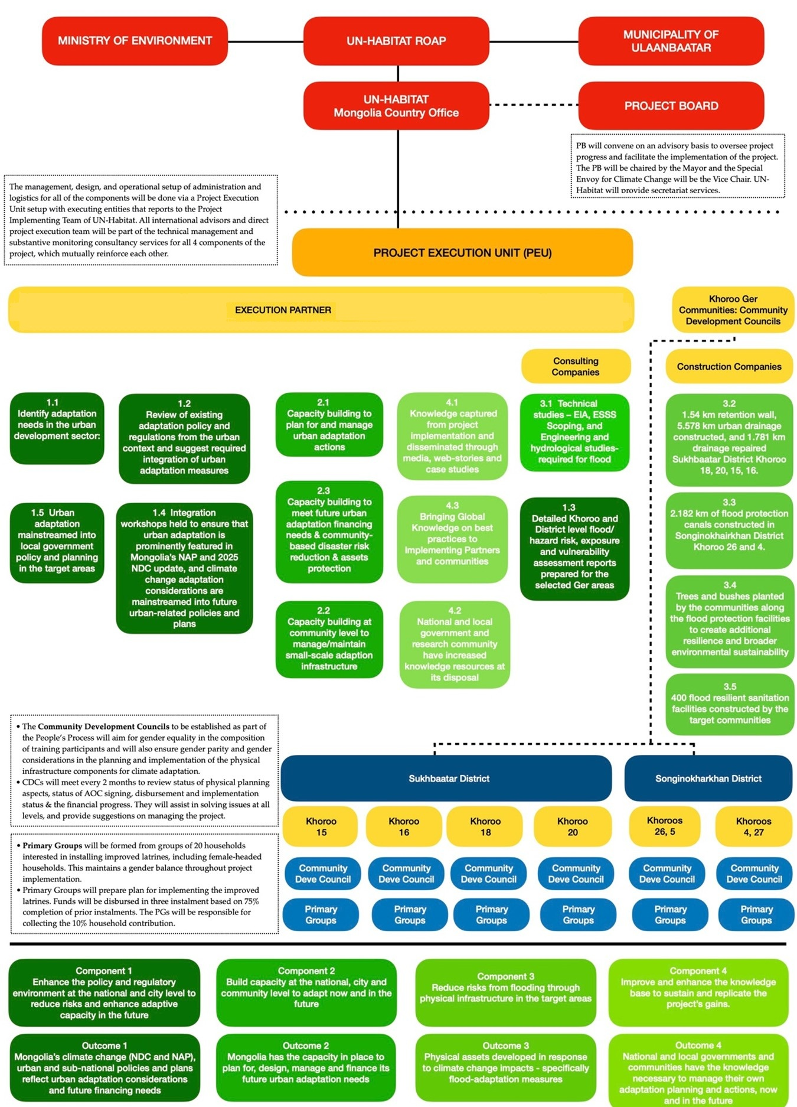
- Describe the measures for financial and project/programme risk management.

Financial and Management Risks
Under guidance of the UN-Habitat Regional Team Leader, the Project Manager assisted by the Operations Managers of the EEs and the Monitoring Officer will monitor the status of financial and project management risks, including those measures required to avoid, minimise or mitigate these risks, throughout the project.

The table below gives an overview of overall project management and financial risks, an assessment of the significance of the pertaining risks in terms of probability and impact and outlines measures that have been embedded in the project design in order to manage and/or mitigate these risks.

Table 13. Overview of financial and management risks and measures to mitigate these
Nr | Category and risk | Rating of probability and impact  (1: Low;  5: High) | Management/  Mitigation Measure
1 | Emergencies of global concern such as the Covid-19 pandemic | Impact: 5  Prob: 2 | - The project team will develop alternative ways to reach the project objective and deliver the outputs depending on the situation.
2 | Environmental/social:  Current climate and seasonal variability and long winters (October – April) result in infrastructure construction delays | Impact: 4  Prob: 2  (medium) | - It is proposed that the project will start in July so that there will be three (3) summers within the project duration and enough time for the technical design approval and construction of physical infrastructure. Procurement activities will be organized during winter and spring months so the construction season will be fully utilized for the construction activities.
3 | Environmental/social:  Continued post Covid-19 socio-economic impacts and challenges such as shortage and cost increase of construction materials | Impact: 4  Prob: 5 | - The physical infrastructure will be designed with an alternative solution to use more locally available materials without any quality compromise in order to reduce potential impacts of the limited availability of the construction material and cost increase.
4 | Institutional:  Loss of government support (at ministerial and municipal level) for the project (activities and outputs) may result in lack of prioritization of the project activities. | Impact: 2 Prob: 3 | - Establishment of a Project Board at national level and Sub-working Groups at the target district levels and the overall participatory and inclusive project design will improve national, municipal/ district and beneficiary level ownership throughout and thus enhance government support for project implementation.  - UN-Habitat will establish agreements (MoUs and AoCs) to ensure the executing entity will deliver project activities and outputs. UN-Habitat will facilitate planning processes to deliver these outputs at all levels of government and in communities.  - A strong participatory approach at the community level is required to ensure ownership and support of communities
5 | Institutional:  Loss of government support (at khoroo / community level) for the project (activities and outputs) may result in lack of prioritization of the project activities; | Impact: 2 Prob: 2 | - A strong participatory approach at the community level is required to ensure ownership and support of communities  - UN-Habitat already has strong ties in the target khoroos from former projects  - Participatory peoples process will organize and bring together different community sub-groups including host residents and new migrants fostering community spirit.
6 | Institutional:  Capacity constraints of local institutions, communities and the private sector may limit the effective implementation of interventions | Impact: 2 Prob: 2 | - The project has a strong capacity building and training component (component 2), designed to promote effectiveness and sustainability at the community level.  - UN-Habitat will contract expert in the field of climate change and green infrastructure, community organization and technical design and M&E to ensure quality control from UN-Habitat side.
7 | Financial:  Inflation and instability of the national currency leading to budget issues and increased prices for infrastructure delivery | Impact: 3 Prob: 2 | - All budgets will be in US$  - A clause will be included in contracts with private sector that they can’t increase the costs during the project duration once the contract has been signed.
8 | Institutional:  Communities may not adopt activities during or after the project, including infrastructure maintenance | Impact: 3 Prob: 1 | - To ensure ownership and sustainability, community members will need to bring in 10 percent of the value of the latrines.  - Capacity building and training of communities will be undertaken to improve their awareness and understanding of the benefits of the activities, including infrastructure maintenance (component 2).  - Communities will be involved in project implementation/decision making throughout the project. In depth community consultations will continue to take place
9 | Financial:  Complexity of financial management and procurement. Certain administrative processes could delay the project execution or could lack integrity | Impact: 2 Prob: 1 | - Financial management arrangements have been defined during project preparation.  - UN-Habitat’s control framework, under the financial rules and regulations of the UN secretariat, will ensure documentation of clearly defined roles and responsibilities for management, internal auditors, the governing body, other personnel and demonstrates prove of payment / disbursement.  - Procurement will be done by the executing entity as agreed through AoCs (with relevant conditions). The project manager and the project team have a certifying role (for key procurements / expenditures). The Project Management Officer (PMO) in ROAP will have the oversight responsibility  - UN-Habitat will assist communities with contracting appropriate private sector partners, including clear conditions and binding arrangements in the contract
10 | Institutional:  A lack of coordination between and within national government partners. | Impact: 1 Prob: 1 | - The Project Board under the co- leadership of the MoET will be established to ensure coordination between and within the national government partners. Should UN-Habitat observe coordination problems, the agency will try to resolve issues directly with concerned parties and or the Project Board.

- Direct management responsibility of the ESMP will be under the national project manager. The project manager will have oversight / final compliance responsibility. Changes or additional activities will need to be approved by the project management committee. Inputs from the technical advisory group, including Ulaanbaatar municipality, will be requested to provide inputs to risk assessment of potential risks, if these are required.
- All project activities have been screened against the 15 environmental and social risks areas during project preparation phase. Outcomes will need to be confirmed when the project commences (i.e. inception). When changes in activities or additional activities are required, a ‘screening safeguarding procedure’ will be used, together with a sub-project risks screening tool. This process includes beneficiaries’ vulnerable groups consultations. The grievance mechanism (see below) can also be used to express concerns regarding possible risks and impacts.
- A gender specific approach has been developed to comply to the Adaptation Fund’s principles-based Gender Policy (GP) and its accompanying Gender Action Plan (GAP) and ESP principle 5.

There are no specific budget requirements for project compliance to the ESP and GP. The proposed interventions will not require residents to resettle elsewhere during the construction period. UN-Habitat (through community engagement social mobilizers and M&E focal points) will monitor access to the area and guarantee all affected householders will have access to their plots at all times. Any other costs which do arise due to minor inconveniences during construction phase, or if it is deemed necessary to provide temporary accommodation and agreed as necessary to include/consider in consultation with all stakeholders (beneficiary communities, local authorities and project coordination team) – this can be accommodated within the overall budget.

- Describe the measures for environmental and social risk management, in line with the Environmental and Social Policy and Gender Policy of the Adaptation Fund.

Building on the information presented in Part II, Sections E and K of this proposal, which outlines the initial screening process that was carried out in the design of the project. Part II Section H and Annex I describe in detail the consultations that have been carried out as part of the design of this proposal. These consultations have formed a key part of both the project design and the development of the Environmental and Social Risk Screening and Impact Assessments, presented in Annex 2.

Based on the screening against the principles of the Environmental and Social Policy of the Adaptation Fund, the project has been categorized as a Category B project. This is the project presents some localized risks against the several of the Environmental and Social Policy’s Risk Categories IF environmental and social risk management and mitigations measures are not taken. To that end, Annex 2 outlines a plan that the project will take to manage and mitigate risk. A budgetary provision of ?? has been made to implement the Environmental and Social Management Plan.

The plan describes how the project, once under implementation, will continuously monitor risks to compliance with the Environmental and Social and Gender Policies. In addition to the budget, the plan also describes the roles and responsibilities for monitoring and management arrangements to ensure the project is in compliance with the Environmental and Social and Gender Policies of the Adaptation Fund throughout its implementation.

- Describe the monitoring and evaluation arrangements and provide a budgeted M&E plan, in compliance with the ESP and the Gender Policy of the Adaptation Fund.

Monitoring and evaluation
UN-Habitat will ensure the timeliness and quality of project implementation. The oversight and general guidance of the project will be provided by the Project Advisory Committee.

The Monitoring and Evaluation (M & E) of progress in achieving project results will be based on targets and indicators established in the Project Results Framework (see below) and monitoring of the status of identified environmental and social risks and measures required to avoid, minimize, mitigate environmental and social risks, and financial and project management risks and mitigation measures. In this process the project will comply with formal guidelines, protocols and toolkits issued by the AF, UN-Habitat and the government of Mongolia. UN-Habitat will ensure that the project team and the key national executing partners are fully briefed on the M&E requirements.

The Gender Action Plan is incorporated in the monitoring and evaluation framework of the project, and proposed indicators – including those relating to the participation and engagement of and benefits for women will used to monitor the progress of the project . The monitoring of the GAP will be done using a participatory approach with the key stakeholders at the kheseg, khoroo, district, and municipal levels

Activities will be planned and monitored by the Project Implementation Unit as approved by the Project Board. Activities particularly related to Component 3 will be detailed through consultation with the local stakeholders through their Community Development Councils and with the participation of the local authorities (khoroo/district). This exercise will facilitate participatory, results-based monitoring by the communities themselves.

An Audit of the project’s financial management will be conducted as part of ROAP supervision, following UN finance regulations and rules and applicable audit policies.

The M&E Framework of the project will be implemented as described in the table below.
Table 14. Monitoring and Evaluation (M & E) Framework
Expected Result | Indicators | Baseline | Targets | Interim Targets | Data Sources | Frequency | Responsible | Reporting
Project objective: to enhance the resilience of communities in six Khoroos of Ulaanbaatar to floods caused by snowmelt, bursting springs and melting permafrost. | Number of direct and indirect beneficiaries that are less vulnerable to flooding (AF Core Indicator) | 0 | 67,932 | 20,000 | Sex disaggregated attendance sheet  Sex disaggregated database of participation of the target beneficiaries in the project activities  Meeting minutes  Evaluation reports | Quarterly and annual basis | Project Manager  Project Implementation Unit  Project Board  UN-Habitat ROAP  PEU team members | Inception report  Periodic progress reports  Project evaluation reports
 | Number of people living in partner cities and human settlements that are less vulnerable to climate change impacts (UN-Habitat DOC3 Domain level indicator)
 | Percentage of women that are less vulnerable to flooding | 0 | 50% | 50%
Outcome 1  Mongolia’s climate change (NDC and NAP), urban and sub-national policies and plans reflect urban adaptation considerations and future financing needs | Number of partner countries with stronger urban content in nationally determined contributions, national adaptation plans, nationally appropriate mitigation action and other global climate action frameworks and instruments (UN-Habitat DOC3) |  | +1 | +1 | Relevant documents’ review  Qualitative  content analysis | Once | Project Manager and PEU  team members  UN-Habitat ROAP  Consultants | Terminal report
 | Number of projects/ programmes that conduct and update risk and vulnerability assessments (AF Indicator 1.1) |  | +1 | +1
Output 1.1  Identify adaptation needs in the urban development sector | Number of policies reviewed | 0 | 2 | 2 | Relevant documents’ review  Qualitative  content analysis | Annual basis | Project Manager  Project Implementation Unit  Project Board  Project Execution Unit  Consultants | Annual progress reports
Output 1.2.  Review of existing adaptation policy and regulations from the urban context and suggest required integration of urban adaptation measures | Number of reviewed adaptation policy and regulations | 0 | 2 | 2 | Relevant documents’ review  Qualitative content analysis | Annual basis |  | Annual progress reports
Output 1.3.  Detailed Khoroo and District level flood/hazard risk, exposure and vulnerability assessment reports prepared for the selected Ger areas | Number of risk and vulnerability assessments | 0 | 6 | 3 | Sex disaggregated attendance sheet  Sex disaggregated database of participation of the target beneficiaries in the project activities  Reports of vulnerability assessments | Quarterly basis | Project Manager  Project Implementation Unit  Project Board  Project Execution Unit  Consultants | Inception report  Periodic progress reports  Project evaluation reports
 | Percentage of women participating in risk and vulnerability assessments | 0 | 50% | 50%
Output 1.4.  Integration workshops held to ensure that urban adaptation is prominently featured in Mongolia’s NAP and 2025 NDC update, and climate change adaptation considerations are mainstreamed into future urban-related policies and plans | Number of workshops held | 0 | 3 | 2 | Sex disaggregated attendance sheet  Sex disaggregated database of participation of the target beneficiaries in the project activities  Workshop documentations | Quarterly basis | Project Manager  Project Implementation Unit  Project Board  Executing Entities  Consultants | Periodic progress reports  Project evaluation reports
 | Percentage of women participating in integration workshops | 0 | 50% | 50%
Output 1.5.  Urban adaptation mainstreamed into local government policy and planning in the target areas | Number of policies introduced or adjusted to address climate change risk (AF indicator 7.1)  Number of effective resilience-building activities, recommendations and/or interventions incorporated into partner city plans, policies and initiatives (CCTA) | 0 | 2 | 2 | Relevant documents’ review  Qualitative content analysis | Annual basis |  | Periodic progress reports  Project evaluation reports
Outcome 2  Mongolia has the capacity in place to plan for, design, manage and finance its future urban adaptation needs | Percentage of targeted population aware of predicted adverse impacts of climate change, and of appropriate responses (AF Indicator 3.1) | 0 | 100% | 40% | Sex disaggregated attendance sheet  Sex disaggregated database of participation of the target beneficiaries in the project activities  Reports of related surveys | Quarterly | Project Manager  Project Implementation Unit  Project Board  Executing Entities  Consultants | Periodic progress reports  Project evaluation reports
 | Percentage of women aware of predicted adverse impacts of climate change, and of appropriate responses | 0 | 50% | 50%
Output 2.1.  Capacity building programme implemented at the sub-national level to plan for and manage urban adaptation actions | Number of awareness campaigns and trainings in line with AF indicator 2.1.2 | 0 | 4 per Khoroo | 2 per Khoroo | Sex disaggregated attendance sheet  Sex disaggregated database of participation of the target beneficiaries in the project activities  Reports of related survey and assessments | Quarterly basis | Project Manager  Project Implementation Unit  Project Board  Executing Entities | Periodic progress reports  Project evaluation reports
 | No. and type of risk reduction actions or strategies introduced at local level | 0 | 2 | 1
 | Percentage of women participating in awareness campaigns and trainings | 0 | 50% | 50%
Output 2.2.  Capacity building programme implemented at the community level to manage and maintain small-scale adaptation infrastructure | Number of awareness campaigns and trainings in line with AF indicator 3.2.2 | 0 | 4 per  Khoroo | 2 per Khoroo | Sex disaggregated attendance sheet  Sex disaggregated database of participation of the target beneficiaries in the project activities  Reports of related survey and assessments | Quarterly basis | Project Manager  Project Implementation Unit  Executing Entities | Periodic progress reports  Project evaluation reports
 | No. and type of risk reduction actions or strategies introduced at community level | 0 | 2 | 1
 | Percentage of women participating in awareness campaigns and trainings | 0 | 50% | 50%
 | Percentage of women leaders among the community groups | 0 | 50% | 20%
Output 2.3.  Capacity built to meet future urban adaptation financing needs and community-based disaster risk reduction and assets protection trainings. | Number of awareness campaigns and trainings in line with AF indicator 2.2.1 | 0 | 4 | 2 | Sex disaggregated attendance sheet  Sex disaggregated database of participation of the target beneficiaries in the project activities | Quarterly basis | Project Manager  Project Implementation Unit  Executing Entities | Periodic progress reports  Project evaluation reports
 | Percentage of women participating in awareness campaigns and trainings | 0 | 50% | 50%
Outcome 3  Physical assets developed in response to climate change impacts - specifically flood-adaptation measures | Number of assets produced, developed, improved, or strengthened to respond to the impacts of climate change (AF Core Indicator) | 0 | 4 Flood facilities  400 improved resilient toilets | 30% | Related technical reports  Site visits  Sex disaggregated beneficiary’s database | Quarterly basis | Project Manager  Project Implementation Unit  Executing Entities | Project periodical reports  Project evaluation reports
 | Percentage of beneficiary women | 0 | 50% | 50%
Output 3.1  Technical studies – EIA, ESSS Scoping, and Engineering and hydrological studies- required for flood protection in the selected areas | Number of studies | 0 | 4 | 50% | Study reports | Quarterly basis | Project Manager  Project Implementation Unit  Executing Entities | Project periodical reports  Project evaluation reports
 | Percentage of women consulted for the technical studies | 0 | 50% | 50% | Sex disaggregated attendance sheet  Study documentations | Quarterly basis |  | Project periodical reports  Project evaluation reports
Output 3.2  Flood protection infrastructure developed in response to climate change related flood impacts | Number of flood protection infrastructures strengthened or constructed to withstand conditions resulting from climate variability and change (AF 4.1.2) | 0  0  0 | 1.54km retention wall  5.578km drainage  2.182 km canals | 30% | Reports of Executing Entities  Site visits | Quarterly basis | Project Manager  Project Implementation Unit  Executing Entities | Project periodical reports  Project evaluation reports
Output 3.3  Trees and bushes planted by the communities along the flood protection facilities to create additional resilience and broader environmental sustainability | Number of trees and bushes planted to withstand conditions resulting from climate variability and change | 0 | 100% | 20% | Community reports  Site visits  Sex disaggregated participation database | Quarterly basis | Project Manager  Project Implementation Unit  Executing Entities | Project periodical reports  Project evaluation reports
Output 3.4  Flood resilient sanitation facilities constructed by the target communities | Number of populations with access to improved sanitation (UN-Habitat DOC1) | 0 | 1000 | 500 | Related technical reports  Site visits  Sex disaggregated beneficiary’s database  Interviews with target groups | Quarterly basis | Project Manager  Project Implementation Unit  Executing Entities | Project periodical reports  Project evaluation reports
 | Number of toilets that are appropriate for women, elderly and disabled (UN-Habitat SII) | 0 | 400 | 200
Outcome 4  National and local governments and communities have the knowledge necessary to manage their own adaptation planning and actions, now and in the future | Number of effective resilience-building activities, recommendations and/or interventions incorporated into partner city plans, policies and initiatives. (UN-Habitat CCTA)  Number of key findings on effective, efficient adaptation practices, products and technologies generated (AF 8.2) | 0 | 2 | 1 | Document review  Qualitative content analysis | Quarterly basis | Project Manager  Project Implementation Unit  Executing Entities | Project periodical reports  Project evaluation reports
Output 4.1.  Knowledge captured from project implementation and disseminated through media, web-stories and case studies | Number of stories, information, cases, observations posted in media including project webpages | 0 | 10 | 5 | Document review  Qualitative content analysis | Quarterly basis |  | Project periodical reports  Project evaluation reports
Output 4.2.  National and local government and research community have increased knowledge resources at its disposal | Number of institutions trained in line with AF indicator 3.1.1. | 0 | 5 | 2 | Documentation review | Quarterly basis | Project Manager  Project Implementation Unit  Executing Entities | Project periodical reports  Project evaluation reports

Table 14a&b – Adaptation Fund Core Impact Indicator “Number of Beneficiaries” for future reporting

Adaptation Fund Core Impact Indicator “Number of Beneficiaries”
Date of Report |  | March 1, 2023
Project Title |  | Ger Community Resilience Project (GCRP)
Country |  | Mongolia
Implementing Agency |  | UN-Habitat
Project Duration |  | 4 years
 |  | Baseline (absolute number) | Target at project approval (absolute number) | Adjusted target first year of implementation (absolute number) |  | Actual at completion (absolute number)
Direct beneficiaries supported by the project |  | 0 | 12,564
Female direct beneficiaries |  | 0 | 6,282
Youth direct beneficiaries |  | 0 | 3,769
Indirect beneficiaries supported by the project |  | 0 | 55,368
Female indirect beneficiaries |  | 0 | 27,684
Youth indirect beneficiaries |  | 0 | 16,610
Adaptation Fund Core Impact Indicator “Assets Produced, Developed, Improved, or Strengthened”
Date of Report | March 1, 2023
Project Title | Ger Community Resilience Project (GCRP)
Country | Mongolia
Implementing Agency | UN-Habitat
Project Duration | 4 years
 | Baseline |  | Target at project approval |  | Adjusted target first year of implementation |  | Actual at completion
Sector (Disaster reduction)
Targeted Asset  2) Physical asset  (produced/improved/  strengthened) | 0 |  | - 1.54 km retention wall, 5.578 km urban drainage constructed, and 1.781 km drainage repaired in Khoroo 18, 20, 15, 16.  - 2.182 km of flood protection canals constructed in Khoroo 26 and 4.  - Trees and bushes planted by the communities along the flood protection facilities to create additional resilience and broader environmental sustainability  - 400 flood resilient sanitation facilities constructed by the target communities
Changes in Asset (Quantitative or qualitative depending on the asset)

For the M & E budget and a breakdown of how implementing entity fees will be utilized in the supervision of the M&E function, please see the detailed budget (section G). For related data, targets and indicators, please see the project proposal results framework (section E).

Table 15. M & E Budget

Type of M & E Activity | Reference | Total | Year 1 | Year 2 | Year 3 | Year 4 | Year 5
Measurements of means of verification (baseline assessment and M & E plans) | Output 4.1 | 25,000 | 25,000 | - | - | -
Direct Project Monitoring and Quality Assurance including progress and financial reporting, project revisions, technical assistance and risk management | Field monitoring officer | 74,576 | 8,228 | 17,444 | 18,666 | 20,159 | 10,079
Independent mid-term and terminal evaluation | Evaluation by HQ | 33,000 | - | - | 13,000 | - | 20,000
Project management committee meetings | Community consultations and steering Committee Meetings | 8,850 | 2,300 | 2,800 | 2,800 | 950
ROAP supervision | ROAP Oversight, Monitoring Missions | 75,500 | 17,500 | 17,500 | 17,500 | 17,500 | 5,500
Total |  | 216,926 | 53,028 | 37,744 | 51,966 | 38,609 | 35,579

M&E Activities

a. Project Board

The Project Board will meet every six months, and ad-hoc meetings will be held as needed. The meeting will review the delivery of inputs and outputs, project progress and provide guidance and coordination. The first Project Board meeting will be held within the first two months of the start of the project.

b. Periodic Project Site Visits

Members of the Project Board and representatives of UN-Habitat will visit project sites and hold meetings with the local stakeholders to review the implementation of project activities.

c. Community Level Participatory Monitoring

At the community level, the Primary Groups and Community Development Councils will prepare a plan for the community level activities. Annual targets to measure progress will be established through a participatory process/workshop which will be facilitated by the project field staff (social mobilizers).

Project activities implemented at the community level as part of Component 3 will be primarily monitored by the Primary Groups and Community Development Councils according to the targets and indicators set in the annual plan. A participatory community monitoring system will be the basis for measuring project progress. Particularly for the improved latrines, the Primary Groups will collect household beneficiary data, map location of the beneficiaries in the khoroo and photo document progress of construction.

The findings will be discussed during the monthly meetings of the Primary Groups and Community Development Councils and documented through written minutes. This will not only involve the communities in data collection but also provide opportunity to discuss issued in project implementation, replication and maintenance. The reports from the community level will be aggregated and feed into the overall project monitoring and reporting.

To track the gender and youth responsiveness and impact of the project a rapid survey will be organized by the national implementation team through targeted Focus Group Discussions with women and youth during the project.

d. Mid-term and Final Evaluations

A mid-term and final evaluations will be conducted at the midpoint and three months before the end of the project respectively following UN-Habitat guidelines. The evaluations will be conducted by an independent team of international and national experts. The scheduling of the evaluations and the terms of references will be discussed at the Project Board and consulted with the donor. The Terms of Reference will be prepared by UN-Habitat focusing on delivery of project activities as initially planned (or modified after the mid-term evaluation) and will also look at the impact and sustainability of the results. The evaluation will provide recommendations for follow-up activities. The evaluation process will include community feedback, with women and men from diverse groups.

e. Financial Audits

A professional, certified organization will review the financial management of the project and adherence to required standards and regulations.

f. Monitoring of the potential intervention risks and mitigation measures

For risk identification - Part II. E (Table 6– Compliance with technical standards) shows which of the risk areas (i.e. principles) have been triggered per project output / activity and per concrete intervention. This is based on a risk screening and impacts assessment (see Annex 2), which in turn are based on community inputs and field visits. For the non-concrete activities, information is provided about how to minimize risks Monitoring / reporting on these will be done annually as shown below.

The Environment and Social Management Plan (ESMP) in Annex 2 includes monitoring indicators and frequency and monitoring responsibilities for monitoring for identified potential risks and mitigation measures for the flood protection and drainage and resilient latrines concrete interventions and supporting measures under other components

Risks monitoring arrangements:
- This monitoring program commensurate with actions identified below and will report on the monitoring results to the Fund in the mid-term, annual, and terminal performance reports. Monitoring will be done to ensure that actions are taken in a timely manner and to determine if actions are appropriately mitigating the risk / impact or if they need to be modified in order to achieve the intended outcome.
- Annual reporting will include information about the status of implementation of this ESMP, including those measures required to avoid, minimize, or mitigate environmental and social risks. The reports shall also include, if necessary, a description of any corrective actions that are deemed necessary.
- Direct monitoring responsibilities will be under the national project manager. The project manager will have oversight / final compliance responsibility. When changes or additional activities are required, monitoring indicators will be changed or added as well.
- Gender specific indicators and targets have been developed as shown in the results framework and summarized in Annex 3
- There are no specific budget requirements for risks monitoring other than show in part III.D and the budget.

Reporting

a. Inception Workshop and Report

A Project Inception Workshop will be held within the first three months of the start of the project to help build ownership of the project. It will be participated by members of the Project Advisory Committee, representative from the Khoroo/District level, representatives from the community and members of the Project Implementation Unit. One of the outputs of the workshop will be to prepare the annual work plan for year one.
The Inception Workshop will address a number of key issues, including:
- assist all participants to fully understand the project objectives and activities and take ownership of the project
- discuss the organizational structure of the project
- discuss the roles and responsibilities of all agencies involved in the project including decision making, reporting, and lines of communication
- discuss conflict resolution mechanisms.
- review and agree on the indicators, targets and their means of verification, and recheck assumptions and risks.
- prepare and framework finalize the annual work plan for year one.
- discuss project monitoring, evaluation and reporting requirements
- discuss financial procedures.

By the end of the first quarter of the start of project implementation, an Inception Report will be submitted to the Project Board and the donor.

b. Quarterly Reports

The Project Implementation Unit will be responsible for preparing the Quarterly Reports to be submitted to the Project Board and the donor. The Project Manager will prepare the report based on information the field staff and reports from the CDCs. A qualitative Bi-annual Report will be prepared once a year and an annual report including a financial status report once a year. The report will be submitted by the end of the first month of the next quarter.

The Social Mobilizers (Field Coordinators) will prepare quarterly reports of the field activities in consultation with the Khoroo CDCs and discussed at the Khoroo Level Coordination Unit. After that the report will be provided to the UN-Habitat Project Manager as input for the Project Quarterly Report.

c. Annual Project Reports

The Project Implementation Unit will be responsible for preparing the Annual Reports to be submitted to the Project Board and the donor. The Project Manager will prepare the report based on information the field staff and reports from the CDCs. The Annual Report will include project activities implemented from 1 January to 31 December and submitted by 31 January.

The Social Mobilizers (Field Coordinators) will prepare quarterly reports for the field activities in their area of responsibility in consultation with the Khoroo CDCs and discussed at the Project Coordination Unit. After that, the report will be provided to the UN-Habitat Project Manager as input for the Project Annual Quarterly Report.

The Annual Report will include:
  - progress made towards the project objectives and project outcome with indicators for cumulative progress
  - project outputs delivered as per annual targets in the annual plan
  - lessons learned and better practices identified
  - comments on risk assessment and adaptive measures
  - environmental and social risks (i.e. status of implementation of ESMP, including those measures required to avoid, minimize, or mitigate environmental and social risks. The reports shall also include, if necessary, a description of any corrective actions that are deemed necessary;
  - project financial and management risks (same as per above).
  - financial status
  - other issues, concerns, observations.

d. Site Visit and Community Level Meeting /Workshop / Training Reports

The Social Mobilizers (Field Coordinators) will prepare photo documented site visit reports and reports on all community-level meetings, workshops, and training within one week of the event.

e. Final Evaluation Report

The Team Leader of the team of independent consultant will prepare the Final Evaluation Team which will describe the achievements made by the project based on the project reports, field visits and consultations with all stakeholders. The report will provide reasons for discrepancies between the expected and actual results and also elaborate on the impact and sustainability of the results.

f. Terminal Report

The Project Manager and members of the Project Implementation Unit will prepare a comprehensive Terminal Report during the last three months of the project. It will summarize the results achieved (objectives, outcomes, outputs), lessons learned, problems and other relevant issues

- Include a results framework for the project proposal, including milestones, targets and indicators, including one or more core outcome indicators of the Adaptation Fund Results Framework, and in compliance with the Gender Policy of the Adaptation Fund.

Project Results Framework
Table 16. Project results framework with indicators, their baseline, targets, risks & assumptions and verification means.
Expected Result | Indicators | Baseline | Targets | Interim Targets | Means of Verification | Frequency | Risk, Impact, Mitigation | Responsi-bility
Project objective: to enhance the resilience of communities in eight khoroos of Ulaanbaatar to floods caused by snowmelt, bursting springs and melting permafrost. | Number of direct and indirect beneficiaries that are less vulnerable to flooding (AF Core Indicator) | 0 | 67,932 | 20,000 | Project annual report  Evaluation Report | Annual basis | Key risks:  - Emergencies of global concern such as Covid-19 pandemic  - Continued post Covid-19 socio-economic impacts and challenges such as shortage and cost increase of construction materials  Mitigation:  The project team will develop alternative ways to reach the project objective and deliver the outputs depending on the situation. | UN-Habitat
 | Number of people living in partner cities and human settlements that are less vulnerable to climate change impacts (UN-Habitat DOC3 Domain level indicator)
 | Percentage of women that are less vulnerable to flooding | 0 | 50% | 50%
Project component 1: Enhance the policy and regulatory environment at the national and city level to reduce risks and enhance adaptive capacity in the future in terms of changing climate in urban areas
Outcome 1  Mongolia’s climate change (NDC and NAP), urban and sub-national policies and plans reflect urban adaptation considerations and future financing needs | Number of partner countries with stronger urban content in nationally determined contributions, national adaptation plans, nationally appropriate mitigation action and other global climate action frameworks and instruments (UN-Habitat DOC3) |  | +1 | +1 | Document review  Qualitative  content analysis | Annual basis | Risk: Loss of government support (at ministerial and municipal level) for the project activities may result in lack of prioritization of the project activities.  Mitigation:  - Establishment of a Project Board at national level and the overall participatory and inclusive project design will improve national, municipal/ district and beneficiary level ownership throughout and thus enhance government support for project implementation. | UN-Habitat
 | Number of projects/ programmes that conduct and update risk and vulnerability assessments (AF Indicator 1.1) |  | +1 | +1 | Document review  Qualitative content analysis | Annual basis |  | UN-Habitat
Output 1.1  Identify adaptation needs in the urban development sector | Number of policies reviewed | 0 | 2 | 2 | Review Documenta-tion | Annual basis |  | UN-Habitat

Output 1.2.  Review of existing adaptation policy and regulations from the urban context and suggest required integration of urban adaptation measures | Number of reviewed adaptation policy and regulations | 0 | 2 | 2 | Document  review | Annual basis | - UN-Habitat will establish agreements (MoUs and AoCs) to ensure executing entity will deliver project activities and outputs. UN-Habitat will facilitate planning processes to deliver these outputs at all levels of government and in communities.  - A strong participatory approach at the community level is required to ensure ownership and support of communities | UN-Habitat
Output 1.3.  Detailed Khoroo and District level flood/hazard risk, exposure and vulnerability assessment reports prepared for the selected Ger areas | Number of risk and vulnerability assessments | 0 | 6 | 3 | Document  review | Quarterly |  | UN-Habitat
 | Percentage of women participating in risk and vulnerability assessments | 0 | 50% | 50% | Attendance sheet | Quarterly |  | UN-Habitat
Output 1.4.  Integration workshops held to ensure that urban adaptation is prominently featured in Mongolia’s NAP and 2025 NDC update, and climate change adaptation considerations are mainstreamed into future urban-related policies and plans | Number of workshops held | 0 | 3 | 2 | Document  review | Quarterly |  | UN-Habitat
 | Percentage of women participating in integration workshops | 0 | 50% | 50% | Attendance sheet | Quarterly |  | UN-Habitat
Output 1.5.  Urban adaptation mainstreamed into local government policy and planning in the target areas | Number of policies introduced or adjusted to address climate change risk (AF indicator 7.1)  Number of effective resilience-building activities, recommendations and/or interventions incorporated into partner city plans, policies and initiatives (CCTA) | 0 | 2 | 2 | Document review  (Qualitative content analysis) | Annually |  | UN-Habitat

Project component 2: Build capacity at the national, city and community level to adapt now and in the future\
Outcome 2  Mongolia has the capacity in place to plan for, design, manage and finance its future urban adaptation needs | Percentage of targeted population aware of predicted adverse impacts of climate change, and of appropriate responses (AF Indicator 3.1) | 0 | 100% | 40% | Document  review | Quarterly | Risk: Loss of government support (at Khoroo / community level) for the project (activities and outputs) may result in lack of prioritization of the project activities  Mitigation:  - A strong participatory approach at the community level is required to ensure ownership and support of communities  - UN-Habitat already has strong ties in the target Khoroos from former projects  - Participatory peoples process will organize and bring together different community sub-groups including host residents and new migrants fostering community spirit.  Risk: Communities may not adopt activities during or after the project, including infrastructure maintenance  Mitigation:  - Capacity building and training of communities will be undertaken to improve their awareness and understanding of the benefits of the activities, including infrastructure maintenance.  - Communities will be involved in project implementation/decision making throughout the project. In depth community consultations will continue to take place | Executing Entity
 | Percentage of women aware of predicted adverse impacts of climate change, and of appropriate responses | 0 | 50% | 50% | Attendance sheet | Quarterly |  | Executing Entity
Output 2.1.  Capacity building programme implemented at the sub-national level to plan for and manage urban adaptation actions | Number of awareness campaigns and trainings in line with AF indicator 2.1.2 | 0 | 4 per Khoroo | 2 per Khoroo | Documenta-tion report | Quarterly |  | Executing Entity
 | No. and type of risk reduction actions or strategies introduced at local level | 0 | 2 | 1 | Document review | Annually |  | Executing Entity
 | Percentage of women participating in awareness campaigns and trainings | 0 | 50% | 50% | Attendance sheet | Quarterly |  | Executing Entity
Output 2.2.  Capacity building programme implemented at the community level to manage and maintain small-scale adaptation infrastructure | Number of awareness campaigns and trainings in line with AF indicator 3.2.2 | 0 | 4 per  Khoroo | 2 per Khoroo | Documenta-tion report | Quarterly |  | Executing Entity
 | No. and type of risk reduction actions or strategies introduced at community level | 0 | 2 | 1 | Document review | Quarterly |  | Executing Entity
 | Percentage of women participating in awareness campaigns and trainings | 0 | 50% | 50% | Attendance sheet | Quarterly |  | Executing Entity
Output 2.3.  Capacity built to meet future urban adaptation financing needs and community-based disaster risk reduction and assets protection trainings. | Number of awareness campaigns and trainings in line with AF indicator 2.2.1 | 0 | 4 | 2 | Documenta-tion report | Quarterly |  | Executing Entity
 | Percentage of women participating in awareness campaigns and trainings | 0 | 50% | 50% | Attendance sheet | Quarterly |  | Executing Entity

Project component 3: Reduce risks from flooding through physical infrastructure in the target areas
Outcome 3  Physical assets developed in response to climate change impacts - specifically flood-adaptation measures | Number of assets produced, developed, improved, or strengthened to respond to the impacts of climate change (AF Core Indicator) | 0 | 4 Flood facilities  400 improved resilient toilets | 30% | Project periodical reports | Annually | Risk: Current climate and seasonal variability and long winters (October – April) may result in infrastructure construction delays  Mitigation measure:  - It is proposed that the project will start in July so that there will be three (3) summers within the project duration and enough time for the technical design and approval of it.  - Procurement activities will be organized during winter and spring months so the construction season will be fully utilized for the construction activities.  Risk: Continued post Covid-19 socio-economic impacts and challenges such as shortage and cost increase of construction materials  Mitigation measure:  The physical infrastructure will be designed with an alternative solution to use more local materials without any quality compromise in order to reduce potential impacts of the limited availability of the construction material and cost increase.  Risk: Capacity constraints of local institutions, communities and the private sector may limit the effective implementation of interventions  Mitigation measure:  - The project has a strong capacity building and training component (component 2), designed to promote effectiveness and sustainability at the community level  - UN-Habitat will contract expert in the field of climate change and green infrastructure, community organization and technical design and M&E to ensure quality control from UN-Habitat side.  Risk: Inflation and instability of the national currency leading to budget issues and increased prices for infrastructure delivery.  Mitigation measure:  - All budgets will be in US$  - A clause will be included in contract with private sector that they can’t increase the costs during the project duration. | Executing Entity
 | Percentage of beneficiary women | 0 | 50% | 50%
Output 3.1  Technical studies – EIA, ESSS Scoping, and Engineering and hydrological studies- required for flood protection in the selected areas | Number of studies | 0 | 4 | 50% | Study reports | Quarterly |  | Executing Entity
 | Percentage of women consulted for the technical studies | 0 | 50% | 50% | Attendance Sheet  Sex disaggregated data collection | Quarterly |  | Executing Entity
Output 3.2  Flood protection infrastructure developed in response to climate change related flood impacts | Number of flood protection infrastructures strengthened or constructed to withstand conditions resulting from climate variability and change (AF 4.1.2) | 0 | 1.54km retention wall  5.578km drainage  2.182 km canals | 30% | Project periodical and technical reports  Site visits | Quarterly |  | Executing Entity
Output 3.3  Trees and bushes planted by the communities along the flood protection facilities to create additional resilience and broader environmental sustainability | Number of trees and bushes planted to withstand conditions resulting from climate variability and change | 0 | 100% | 20% | Project periodical reports  Site visits | Quarterly |  | Executing Entity
Output 3.4  Flood resilient sanitation facilities constructed by the target communities | Number of populations with access to improved sanitation (UN-Habitat DOC1) | 0 | 1000 | 500 | Sex disaggregated data collection | Quarterly |  | Executing Entity
 | Number of toilets that are appropriate for women, elderly and persons with disability (UN-Habitat SII) | 0 | 400 | 200 | Interviews with target population | Quarterly |  | Executing Entity
Project component 4: Improve and enhance the knowledge base to sustain and replicate the project’s gains.
Outcome 4  National and local governments and communities have the knowledge necessary to manage their own adaptation planning and actions, now and in the future | Number of effective resilience-building activities, recommendations and/or interventions incorporated into partner city plans, policies and initiatives. (UN-Habitat CCTA)  Number of key findings on effective, efficient adaptation practices, products and technologies generated (AF 8.2) | 0 | 2 | 1 | Document review  (Qualitative content analysis) | Quarterly | Risk: A lack of coordination between and within national government partners.  Mitigation measure:  A Project Board under the co-leadership of the MoET will be established to ensure coordination between and within the national government partners. Should UN-Habitat observe coordination problems, the agency will try to resolve issues directly with concerned parties and or the Project Board | Executing Entity
Output 4.1.  Knowledge captured from project implementation and disseminated through media, web-stories and case studies | Number of stories, information, cases, observations posted in media including project web-pages | 0 | 10 | 5 | Document review | Quarterly |  | Executing Entity
Output 4.2.  National and local government and research community have increased knowledge resources at its disposal | Number of institutions trained in line with AF indicator 3.1.1. | 0 | 5 | 2 | Document  review | Quarterly |  | Executing Entity
 | Percentage of women participation | 0 | 50% | 50% | Attendance sheet | Quarterly |  | Executing Entity
Output 4.3.  Bringing Global Knowledge on best practices to Implementing Partners and communities | Number of documentations of best practices shared with the implementing partners and communities | 0 | 2 | 1 | Document  review | Quarterly |  | Executing Entity

- Demonstrate how the project/programme aligns with the Results Framework of the Adaptation Fund

Alignment with the Results Framework of the Adaptation Fund
Table 17 - Project alignment with the Adaptation Fund Results Framework
Project Objective(s) | Project Objective Indicator(s) | Fund Outcome | Fund Outcome Indicator | Grant Amount (USD)
Project objective: to enhance the resilience of communities in eight khoroos of Ulaanbaatar to floods caused by snowmelt, bursting springs and melting permafrost. | Number of direct and indirect beneficiaries that are less vulnerable to flooding (AF Core Indicator)  Number of people living in partner cities and human settlements that are less vulnerable to climate change impacts (UN-Habitat DOC3 Domain level indicator)  Percentage of women that are less vulnerable to flooding | Increased adaptive capacity of communities to respond to the impacts of climate change | Number of beneficiaries (direct and indirect)
Outcome 1  Mongolia’s climate change (NDC and NAP), urban and sub-national policies and plans reflect urban adaptation considerations and future financing needs | Number of partner countries with stronger urban content in nationally determined contributions, national adaptation plans, nationally appropriate mitigation action and other global climate action frameworks and instruments (UN-Habitat DOC3)  Number of projects/ programmes that conduct and update risk and vulnerability assessments (AF Indicator 1.1) | Output 2.1: Strengthened capacity of national and  sub-national centers and networks to respond rapidly  to extreme weather events | 2.1.2 No. of targeted institutions with increased capacity to minimize exposure to climate variability risks (by type, sector and scale) | 231,562
Outcome 2  Mongolia has the capacity in place to plan for, design, manage and finance its future urban adaptation needs | Percentage of targeted population aware of predicted adverse impacts of climate change, and of appropriate responses  Percentage of women aware of predicted adverse impacts of climate change, and of appropriate responses | Output 2.1: Strengthened capacity of national and  sub-national centers and networks to respond rapidly to extreme weather events | 2.1.1 No. of staff trained to respond to, and  mitigate impacts of, climate-related events (by  gender) | 317,310
Outcome 3  Physical assets developed in response to climate change impacts - specifically flood-adaptation measures | Number of assets produced, developed, improved, or strengthened to respond to the impacts of climate change  Percentage of beneficiary women | Output 4: Vulnerable development sector services and infrastructure assets strengthened in response to climate change impacts, including variability | 4.1.2 No. of physical assets strengthened or  constructed to withstand conditions resulting from  climate variability and change (by sector and scale) | 5,623,898
Outcome 4  National and local governments and communities have the knowledge necessary to manage their own adaptation planning and actions, now and in the future | Number of effective resilience-building activities, recommendations and/or interventions incorporated into partner city plans, policies and initiatives.  Number of key findings on effective, efficient adaptation practices, products and technologies generated | Output 3.2: Strengthened capacity of national and subnational stakeholders and entities to capture and  disseminate knowledge and learning | 3.2.2 No. of tools and guidelines developed (thematic, sectoral, institutional) and shared with relevant stakeholders | 471,591

¹ The AF utilized OECD/DAC terminology for its results framework. Project proponents may use different terminology but the overall principle should still apply

- Include a detailed budget with budget notes, a budget on the Implementing Entity management fee use, and an explanation and a breakdown of the execution costs.

Budget summary, details and notes
Table 18 - Budget Summary
Project Components | Outputs | TOTAL | Year | Year | Year | Year | Year
Project Components | Outputs | TOTAL | 1 | 2 | 3 | 4 | 5
Project Components | Outputs | TOTAL | 6 m | 12 m | 12 m | 12 m | 6 m
Component 1 – Enhance the policy and regulatory environment at the national and city level to reduce risks and enhance adaptive capacity in the future | 1.1 Identify adaptation needs in urban development sector | 12,486 | 12,486 | - | - | - | -
 | 1.2 Review of existing adaptation policy and regulations from the urban context and suggest required integration of urban adaptation measures | 17,486 | 17,486 | - | - | - | -
 | 1.3 Detailed Khoroo and District level flood/hazard risk, exposure and vulnerability assessment reports prepared for the selected Ger areas | 109,050 | 54,243 | 54,807 | - | - | -
 | 1.4 Integration workshops held to ensure that urban adaptation is prominently featured in Mongolia’s NAP and 2025 NDC update and climate change adaptation considerations are mainstreamed into future urban-related policies and plans | 45,949 | 10,171 | 11,707 | 11,911 | 12,160 | -
 | 1.5 Urban adaptation mainstreamed into local government policy and planning in the target areas | 46,591 | 9,742 | 9,908 | 13,222 | 13,719 | -
Component 2 –  Build capacity at the national, city and community level to adapt now and in the future | 2.1 Capacity building programme implemented at the sub-national level to plan for and manage urban adaptation actions | 80,422 | 14,440 | 19,232 | 19,933 | 20,679 | 6,048
 | 2.2 Capacity building programme implemented at the community level to manage and maintain small-scale adaptation infrastructure | 99,432 | 16,360 | 23,683 | 24,599 | 25,719 | 9,071
 | 2.3 Capacity built to meet future urban adaptation financing needs and community-based disaster risk reduction and assets protection trainings | 137,456 | 20,200 | 32,406 | 33,932 | 35,799 | 15,119
Component 3 – Reduce risks from flooding through physical infrastructure in the target areas | 3.1 Technical studies – EIA, ESSS Scoping, and Engineering and hydrological studies- required for flood protection in the selected areas | 199,840 | 199,840 | - | - | - | -
 | 3.2. Flood protection infrastructure developed in response to climate change related flood impacts | 5,424,058 | 114,789 | 3,036,710 | 1,907,769 | 288,194 | 76,596
 | 3.3 Strengthening embankment by planting trees and bushes (community to be mobilised)
 | 3.4 Flood resilient sanitation facilities constructed by the target communities
Component 4 – Improve and enhance the knowledge base to sustain and replicate the project’s gains. | 4.1 Knowledge captured from project implementation and disseminated through media, web-stories and case studies | 164,850 | 49,300 | 51,800 | 51,800 | 11,950 | -
 | 4.2. National and local government has increased knowledge resources at its disposal
 | 4.3 Bringing Global Knowledge on best practices to Implementing Partners and communities | 306,741 | 46,532 | 97,145 | 81,532 | 64,032 | 17,500
 | SUBTOTAL | 6,644,361 | 565,589 | 3,337,488 | 2,144,698 | 472,252 | 124,334
Project/programme execution cost (9.5%) |  | 697,470 | 101,590 | 171,180 | 171,180 | 171,180 | 82,340
Total Project cost |  | 7,341,831 | 667,179 | 3,508,668 | 2,315,878 | 643,432 | 206,674
ROAP |  | 69,918 | 7,989 | 24,016 | 27,733 | 7,705 | 2,475
Evaluation Support costs (HQ) |  | 33,000 | - |  | 13,000 | - | 20,000
Project Cycle Management Fee charged by the implementing entity |  | 521,133 | 47,262 | 249,598 | 164,053 | 45,580 | 14,640
Sub-total (Implementing entity fee – 8.5%) |  | 624,051 | 55,251 | 273,614 | 204,786 | 53,285 | 37,115
Amount of financing requested |  | 7,965,882 | 722,430 | 3,782,282 | 2,520,664 | 696,717 | 243,789

Table 19 - Detailed Budget
Budget Note | Components |  | TOTAL | Year | Year | Year | Year | Year
 |  |  |  | 1 | 2 | 3 | 4 | 5
 |  |  |  | 6 m | 12 m | 12 m | 12 m | 6 m
 | Output 1.1
1.1a | Main Partner | IP - 1 | 10,686 | 10,686 | - | - | -
1.1b | Workshops, Consultations |  | 1,500 | 1,500 | - | - | -
1.1c | Report |  | 300 | 300 | - | - | -
 | Sub-total |  | 12,486 | 12,486 | - | - | -
 | Output 1.2
1.2a | Main Partner | IP - 1 | 15,686 | 15,686 | - | - | -
1.2b | Workshops, Consultations |  | 1,500 | 1,500 | - | - | -
1.2c | Report |  | 300 | 300 | - | - | -
 | Sub-total |  | 17,486 | 17,486 | - | - | -
 | Output 1.3
1.3a | Main Partner | IP - 1 | 105,650 | 52,743 | 52,907 | - | -
1.3b | Workshops, Consultations |  | 3,000 | 1,500 | 1,500 | - | -
1.3c | Report |  | 400 | - | 400 | - | -
 | Sub-total |  | 109,050 | 54,243 | 54,807 | - | -
 | Output 1.4
1.4a | Main Partner | IP - 1 | 34,749 | 7,371 | 8,907 | 9,111 | 9,260
1.4b | Workshops, Consultations |  | 8,000 | 2,000 | 2,000 | 2,000 | 2,000
1.4c | Report |  | 3,200 | 800 | 800 | 800 | 800
 | Sub-total |  | 45,949 | 10,171 | 11,707 | 11,911 | 12,160
 | Output 1.5
1.5a | Main Partner | IP - 1 | 30,591 | 5,742 | 5,908 | 9,222 | 9,719
1.5b | Workshops, Consultations |  | 12,000 | 3,000 | 3,000 | 3,000 | 3,000
1.5c | Report |  | 4,000 | 1,000 | 1,000 | 1,000 | 1,000
 | Sub-total |  | 46,591 | 9,742 | 9,908 | 13,222 | 13,719
 | TOTAL Output 1 |  | 231,563 | 104,128 | 76,422 | 25,133 | 25,879 | -
 | Output 2.1
2.1a | Workshops, Consultations | IP - 1 | 78,022 | 13,840 | 18,722 | 19,333 | 20,079 | 6,048
2.1b | Report |  | 2,400 | 600 | 600 | 600 | 600
 | Sub-total |  | 80,422 | 14,440 | 19,322 | 19,933 | 20,679 | 6,048
 | Output 2.2
2.2a | Workshops, Consultations | IP - 1 | 90,032 | 15,760 | 23,083 | 23,999 | 25,119 | 9,071
2.2b | Report |  | 2,400 | 600 | 600 | 600 | 600
 | Sub-total |  | 99,432 | 16,360 | 23,683 | 24,599 | 25,719 | 9,071
 | Output 2.3
2.3a | Workshops, Consultations | IP - 1 | 135,056 | 19,600 | 31,806 | 33,332 | 35,199 | 15,119
2.3b | Report |  | 2,400 | 600 | 600 | 600 | 600
 | Sub-total |  | 137,456 | 20,200 | 32,406 | 33,932 | 35,799 | 15,119
 | TOTAL Output 2 |  | 317,310 | 51,000 | 75,411 | 78,464 | 82,197 | 30,238
 | Output 3.1
3.1a | Technical Study | IP - 1 | 80,000 | 80,000 | - | - | -
3.2b | EIA, ESS implementation |  | 119,840 | 119,840 | - | - | -
 | Sub-total |  | 199,840 | 199,840 | - | - | -
 | Output 3.2, 3,3, 3,4
3.2 | Physical Infrastructure Implementation | IP - 1 | 4,857,916 | 45,253 | 2,894,662 | 1,739,948 | 125,309 | 52,744
3.3 | Embankment strengthening (tree planting) | IP - 1 | 50,000 | - | 10,000 | 20,000 | 20,000
3.4 | Improved Latrine construction support | Comm Con | 516,142 | 59,536 | 132,048 | 147,821 | 142,885 | 23,852
 | Sub-total |  | 5,424,058 | 114,789 | 3,036,710 | 1,907,769 | 288,194 | 76,596
 | TOTAL Output 3 |  | 5,623,898 | 314,629 | 3,036,710 | 1,907,769 | 288,194 | 76,596
 | Output 4.1 and 4.2
4.1a | Measurement of Means of Verification, Inception Report | IP - 1 | 25,000 | 25,000 | - | - | -
4.1b | Community Consultations | IP - 1 | 2,600 | 800 | 800 | 800 | 200
4.1c | Project Board Meetings | IP - 1 | 3,500 | 1,000 | 1,000 | 1,000 | 500
4.1d | Local Sub-working Group Meetings | IP - 1 | 2,750 | 500 | 1,000 | 1,000 | 250
4.1e | Seminar / Training / Workshops | IP - 1 | 35,000 | 10,000 | 10,000 | 10,000 | 5,000
4.2a | International Workshops & Conferences | IP - 1 | 40,000 | - | 20,000 | 20,000 | -
4.2b | Studies Surveys, Reports | IP - 1 | 14,000 | 2,000 | 4,000 | 4,000 | 4,000
4.2c | Visibility, Web Development, Advocacy | IP - 1 | 42,000 | 10,000 | 15,000 | 15,000 | 2,000
 | Sub-total |  | 164,850 | 49,300 | 51,800 | 51,800 | 11,950
 | Output 4.3
4.3a | Community Deve Advisor (Coordinator) | IP - 1 | 120,000 | 12,000 | 36,000 | 36,000 | 24,000 | 12,000
4.3b | Travel / Mission | IP - 1 | 55,000 | 5,500 | 16,500 | 16,500 | 11,000 | 5,500
4.3c | Climate Change Assessment Specialist | IP - 1 | 31,680 | 7,920 | 7,920 | 7,920 | 7,920
4.3d | Travel / Mission | IP - 1 | 22,000 | 5,500 | 5,500 | 5,500 | 5,500
4.3e | Sustainable Urban Drainage Specialist | IP - 1 | 50,561 | 10,112 | 20,225 | 10,112 | 10,112
4.3f | Travel / Mission | IP - 1 | 27,500 | 5,500 | 11,000 | 5,500 | 5,500
 | Sub-total |  | 306,741 | 46,532 | 97,145 | 81,532 | 64,032 | 17,500
 | TOTAL Output 4 |  | 471,591 | 95,832 | 148,945 | 133,332 | 75,982 | 17,500
 | SUB-TOTAL Program |  | 6,644,361 | 565,589 | 3,337,488 | 2,144,698 | 472,252 | 124,334
 | PROJECT EXECUTION COST
5.1 | Project Leader |  | 48,000 | 12,000 | 12,000 | 12,000 | 12,000
 | National Staff
5.2 | National Project Manager |  | 216,000 | 27,000 | 54,000 | 54,000 | 54,000 | 27,000
5.3 | Finance Officer |  | 134,400 | 16,800 | 33,600 | 33,600 | 33,600 | 16,800
5.4 | Drivers |  | 91,200 | 11,400 | 22,800 | 22,800 | 22,800 | 11,400
 | Travel Related to Execution
5.5 | Travel / Mission |  | 27,500 | 5,500 | 5,500 | 5,500 | 5,500 | 5,500
 | Operations
5.6 | Vehicle Operations & Maintenance |  | 52,800 | 6,600 | 13,200 | 13,200 | 13,200 | 6,600
5.7 | Communication |  | 9,600 | 1,200 | 2,400 | 2,400 | 2,400 | 1,200
5.8 | Office Rent |  | 72,000 | 9,000 | 18,000 | 18,000 | 18,000 | 9,000
5.9 | Office Operations |  | 28,800 | 3,600 | 7,200 | 7,200 | 7,200 | 3,600
5.10 | Office Supplies and Stationery |  | 9,920 | 1,240 | 2,480 | 2,480 | 2,480 | 1,240
5.11 | Office Equipment |  | 7,250 | 7,250
 | TOTAL |  | 697,470 | 101,590 | 171,180 | 171,180 | 171,180 | 82,340
 | Sub- total |  | 7,341,831 | 667,179 | 3,508,668 | 2,315,878 | 643,432 | 206,674
6 | ROAP |  | 69,918 | 7,989 | 24,016 | 27,733 | 7,705 | 2,475
7 | Evaluation |  | 33,000 | - | - | 13,000 | - | 20,000
8 | PSC 7% |  | 521,133 | 47,262 | 249,598 | 164,053 | 45,580 | 14,640
 | Sub- total (implementing entity fee) |  | 624,051 | 55,251 | 273,614 | 204,786 | 53,285 | 37,115
 | TOTAL |  | 7,965,882 | 722,430 | 3,782,282 | 2,520,664 | 696,717 | 243,789

Table 20 Flood protection and drainage and resilient latrines
Components |  | TOTAL | Year | Year | Year | Year | Year
Components |  |  | 1 | 2 | 3 | 4 | 5
Components |  |  | 6 m | 12 m | 12 m | 12 m | 6 m
Drainage
Sukhbaatar Khoroo 18 D1 Package 1 | Yr2 | 163,696 | 4,697 | 158,999 | - | -
Sukhbaatar Khoroo 18 C1 Package 1 | Yr2 | 254,366 | 3,828 | 250,538 | - | -
Sukhbaatar Khoroo 18 C3 Package 3 | Yr2 | 333,099 | 5,013 | 328,086 | - | -
Sukhbaatar Khoroo 18 C4 Package 4 | Yr2 | 488,700 | 7,354 | 481,3346 | - | -
Sukhbaatar Khoroo 20 C2 Package 2 | Yr2 | 742,134 | 11,168 | 730,966 | - | -
Sukhbaatar Khoroo 16 C5 Package 5 | Yr3 | 736,185 | - | - | 680,1443 | 39,441 | 16,601
Sukhbaatar Khoroo 16 C6 Package 6 | Yr3 | 110,731 | - | - | 102,302 | 5,932 | 2,497
Sukhbaatar Khoroo 16 C7 Package 6 | Yr3 | 624,958 | - | - | 556,409 | 48,243 | 20,306
Sukhbaatar Khoroo 15 D2 Package 7 | Yr3 | 151,410 | - | - | 130,895 | 14,438 | 6,077
Sukhbaatar Khoroo 15 D3 Package 7 | Yr3 | 95,732 | - | - | 82,761 | 9,129 | 3,842
Songinokhairkhan Khoroo 26 and 5 C1 Package 8 | Yr 2 | 501.278 | 7,543 | 493,735 | - | -
Songinokhairkhan Khoroo 26 and 5C1 Package 9 | Yr 2 | 375,492 | 5,650 | 369,842 | - | -
Songinokhairkhan Khoroo 4 and 27 C3 Package 10 | Yr 3 | 151,686 | - | - | 140,139 | 8,126 | 3,421
Design and Supervision required by Law (3%) |  | 128,449 |  | 81,150 | 47,299
Sub-total |  | 4,857,916 | 45,253 | 2,894,662 | 1,739,948 | 125,309 | 52,744
Strengthening Embankment - Tree planting |  | 50,000 |  | 10,000 | 20,000 | 20000
Sub-total |  | 50,000 | - | 10,000 | 20,000 | 20,000

Table 21a - Climate Resilient Sanitation Facilities
Components |  | TOTAL | Year | Year | Year | Year | Year
Components |  |  | 1 | 2 | 3 | 4 | 5
Components |  |  | 6 m | 12 m | 12 m | 12 m | 6 m
Resilient toilets
Sukhbaatar Khoroo 18 |  | 140,936 | 18,964 | 24,453 | 36,350 | 54,669 | 6,500
Sukhbaatar Khoroo 20 |  | 85,143 | 12,643 | 24,453 | 24,231 | 19,880 | 3,936
Sukhbaatar Khoroo 16 |  | 151,265 | 25,286 | 36,680 | 36,350 | 45,972 | 6,977
Sukhbaatar Khoroo 15 |  | 23,082 | - | 22,009 | - | - | 1,073
Songinokhairkhan Khoroo 26 and 5 |  | 100,461 | 12,643 | 24,453 | 36,350 | 22,364 | 4,651
Songinokhairkhan Khoroo 4 and 27 |  | 15,255 | - | - | 14,540 | - | 715
Sub-total |  | 516,142 | 69,536 | 132,048 | 147,821 | 142,885 | 23,852

Budget Notes
With reference to Table 19, detailed budget
A. Output 1.1
1.1 Identify adaptation needs in the urban development sector
1.1a. An agreement of cooperation (AOC) will be signed with an external partner to assess the adaptation needs in consultation with the stakeholders. $10,686 has been budgeted as a lump sum for consultation fees. This will be implemented during year 1 of the project.
1.1b. Consultations and workshops will be organized with the stakeholders during the preparation and for the presentation of the findings. $1,500 has been budgeted for this.
1.1c. $300 has been budgeted for the preparation of draft and final reports.

B. Output 1.2
1.2 Review existing adaptation policy and regulations from the urban context and suggest required integration of urban adaptation measures
1.2a. An agreement of cooperation (AOC) will be signed with an external partner to review the existing adaptation policies and regulations in consultation with the Ministry. $15,686 has been budgeted as a lump sum for consultation fees. This will be implemented during year 1 of the project.
1.2b. Consultations and workshops will be organized with the stakeholders during the preparation and for the presentation of the findings. $1,500 has been budgeted for this.
1.2c. $300 has been budgeted for the preparation of draft and final reports.

C. Output 1.3
1.3 Detailed Khoroo and District level flood/hazard risk, exposure and vulnerability assessment reports prepared for the selected Ger areas
1.3a. An agreement of cooperation (AOC) will be signed with an external partner to prepare flood/hazard risk, exposure and vulnerability assessment reports related to the three target districts in the northern ger areas for which $105,650 has been budgeted as a lump sum. This will be started during year 1 of the project.
1.3b. Consultations and workshops will be organized with the stakeholders during the preparation and for the presentation of the findings. $3,000 has been budget for this.
1.3c. $400 has been budgeted for the preparation draft and final reports.

D. Output 1.4
1.4 Integration workshops held to ensure that urban adaptation is prominently featured in Mongolia’s NAP and 2025 NDC update, and climate change adaptation considerations are mainstreamed into future urban-related policies and plans
1.4a and 1.4b. $42,749 has been budgeted to organize workshops in consultation with the Ministry to ensure that urban adaptation is prominently featured in Mongolia’s NAP and 2025 NDC update. The budget will be for facilitation and workshop expenses.
1.4c. $800 has been budgeted annually for the preparation report and for dissemination. $3,200 has been allocated for four years.

E. Output 1.5
1.5 Urban adaptation mainstreamed into local government policy and planning in the target areas
1.5a and 1.5b. $42,591 has been budgeted annually to organize workshops in consultation with the Ministry and the Municipality to mainstream urban adaptation issues into local government policy and planning. The budget will be for facilitation and workshop expenses where municipal, district and khoroo officials will be invited.
1.4c. $1,000 has been budgeted annually for the preparation report and for dissemination. $4,000 has been allocated for four years.

F. Output 2.1
2.1 Capacity building programme implemented at the sub-national level to plan for and manage urban adaptation actions
2.1a, 2.1b Trainings programs will be conducted at sub-national level (district and kHoroo) to plan for an manage urban adaptation actions. $78,022 has been budgeted for training expenses for four years and $600 annually for reporting.

G. Output 2.2
2.2 Capacity building programme implemented at the community level to manage and maintain small-scale adaptation infrastructure
2.2a, 2.2b Training programs will be conducted at community level to manage and maintain infrastructure. $97,032 has been budget for training expenses and $600 annually for reporting.

H. Output 2.3
2.3 Capacity built to meet future urban adaptation financing needs and community-based disaster risk reduction and assets protection trainings
2.3a, 2.3b Training programs will be conducted for ministry and municipal staff to meet future urban adaptation financing needs and community-based disaster risk reduction and assets protection trainings. $135,056 has been budgeted for training expenses and $600 annually for reporting.

I. Output 3.1
3.1 Technical studies – EIA, ESSS Scoping, and Engineering and hydrological studies- required for flood protection in the selected areas
3.1a. An agreement of cooperation (AOC) will be signed with an external partner to prepare engineering and hydrological studies for which $80,000 has been budgeted as a lump sum. This study will be conducted during year 1 of the project.
3.1b Similarly EIA and ESS scoping studies will be conducted through an external partner for which $119,840 had been budgeted. This study will be conducted during year 1 of the project.
4.3c, 4.3e. Technical supervisory support will be provided by Climate Change Assessment Specialist and Sustainable Urban Drainage Specialist. The costs are budget in Output 4.3

J. Output 3.2
3.2. Flood protection infrastructure developed in response to climate change related flood impacts
3.2a Following physical infrastructure (drainage) construction activities are proposed in the budget and will be contracted to construction companies through the implementing partner: (See Table 20 for an annual breakdown and Annex 5 for details of alignment)

Components | Pack-age | Length  m | Location | TOTAL
Sukhbaatar Khoroo 18 | 1 | 670 | D1: From #375, Belkh-48 to #300, Belkh-48 | 163,696
Sukhbaatar Khoroo 18 | 1 | 546 | C1: From #300, Belkh-48 to #208, Belkh-48 | 254,366
Sukhbaatar Khoroo 18 | 3 | 715 | C3: From #365, Belkh-48 to #208, Belkh-48 | 333,099
Sukhbaatar Khoroo 18 | 4 | 1049 | C4: From #208, Belkh-48 to #26, Belkh-39 | 488,700
Sukhbaatar Khoroo 20 | 2 | 1253 | C1: From #1,Tsolmon-11to #422, Tsolmon-2 | 742,134
Songinokhairkhan Khoroo 26 and 5 | 8 | 1076 | C1: From #33, Bayanbulag-5 to #1, Bayanbulag-2 | 736,185
Songinokhairkhan Khoroo 26 and 5 | 9 | 806 | C2: From #101,  Bayanbulag-1 to #1, Bayanbulag-2 | 110,731
Sukhbaatar Khoroo 16 | 5 | 1456 | C5: From #102, Oichid-1  to #14060, Dambadarjaa | 624,958
Sukhbaatar Khoroo 16 | 6 | 219 | C6: From #25,  Belkhi-34 to #1-1, Belkhi-32 | 151,410
Sukhbaatar Khoroo 16 | 6 | 1781 | C7: From #1-1, Belkhi-32  to #177, Belkh-8 | 95,732
Sukhbaatar Khoroo 15 | 7 | 533 | From #81, Dambadarjaa-20, to #7, Dambadarjaa-1 | 501.278
Sukhbaatar Khoroo 15 | 7 | 337 | D3: From #177, Belkh-8, to #282, Belkh-11 | 375,492
Songinokhairkhan Khoroo 4 and 27 | 10 | 300 | C3: From #49, Ikh naran-13 to #54, Ikh naran-8 | 151,686
Design and Supervision required by Law (3%) |  |  |  | 128,449
Sub-total |  |  |  | 4,857,916
3.2b Upon approval of the project design by the respective government department, it is officially stipulated that 3% of the project cost is allocated for supervision and completion certification.

K. Output 3.3
3.3 Trees and bushes planted by the communities along the flood protection facilities to create additional resilience and broader environmental sustainability
3.3 $50,000 is budgeted for flood protection measures (tree plantation) in the budget and will be contracted through the implementing partner. The community groups (primary groups and community development groups) will be actively involved in this activity.

L. Output 3.4
3.4 Flood resilient sanitation facilities constructed by the target communities
3.4a Following physical infrastructure (latrines) construction activities are proposed in the budget and will be contracted through the implementing partner: (See Table 20 for annual breakdown and Annex 5 for details)

Components | No. of Units | TOTAL
Sukhbaatar Khoroo 18 | 109 | 140,936
Sukhbaatar Khoroo 20 | 66 | 85,143
Sukhbaatar Khoroo 16 | 117 | 151,265
Sukhbaatar Khoroo 15 | 18 | 23,082
Songinokhairkhan Khoroo 26 and 5 | 78 | 100,461
Songinokhairkhan Khoroo 4 and 27 | 12 | 15,255
Sub-total | 400 | 516,142

3.4b This component will be implemented through community contracts with the Community Development Councils in each khoroo.

M. Output 4.1
4.1 Knowledge captured from project implementation and disseminated through media, web-stories and case studies
4.1a Measurement of Means of Verification, Inception Report: A lump sum of $25,000 is allocated for measurement of Means of Verification and preparation of Inception Report
4.1b Seminar / Training / Workshops: National level seminars/workshops/consultations will be organized to discuss project experience and findings and seek professional inputs. $35,000 has been budgeted for this.
4.1c International Workshops & Conferences: A budget of $20,000 in year 2 and 3 (total $40,000) has been allocated to cover costs for participation in climate change related international conference/workshop by senior government officials.
4.1d Studies Surveys, Reports: Production of various studies, survey and reports is budget at $14,000 for the project period.
4.1e Visibility, Web Development, Advocacy: Production of various project visibility and advocacy material and development of web page and maintenance is budgeted at $42,000.

N. Output 4.2
4.2. National and local governments and climate change research communities have increased knowledge resources at its disposal
4.2a Community Consultations: Community Consultation meetings will be scheduled every four months. Expenses for each meeting is budgeted at $200 with a total allocation of $2,600.
4.2b Project Board Meetings: The Project Board meetings will be scheduled every six months. Expenses for each meeting is budgeted at $500 with a total allocation of $3,500.
4.2c Local Steering Committee Meetings: The Local Steering Committee meetings will be scheduled every four months. Expenses for each meeting is budgeted at $250 with a total allocation of $2,750.

O. Output 4.3
4.3 Bringing Global Knowledge on best practices to Implementing Partners and communities
4.3a Ten person-months (over the project period) of technical and supervisory support by one Community Development and Construction Supervision Advisor is budgeted at $12,000 per month. A total budget of $120,000 is budget for the fees.
4.3b Travel and DSA (14 days for each mission) for the Consultant is budgeted at $5,500 per mission for ten missions during the project period. A total budget of $55,000 is budget for the missions.
4.3c Four person-months (over the project period) of technical and supervisory support by one Climate Change Assessment Specialist is budgeted at $7,920 per month. A total budget of $31,680 is budget for the fees.
4.3d Travel and DSA (14 days for each mission) for the Consultant is budgeted at $5,500 per mission for four missions during the project period. A total budget of $22,000 is budget for the missions.
4.3e Five person-months (over the project period) of technical and supervisory support by one Sustainable Planning (Environment) Specialist is budgeted at $10,112 per month. A total budget of $50,561 is budget for the fees.
4.3f Travel and DSA (14 days for each mission) for the Consultant is budgeted at $5,500 per mission for five missions during the project period. A total budget of $27,500 is budget for the missions.

P. Project Execution Cost
5.1 The Human Settlement Officer at the Regional Office of UN-Habitat will provide oversight support for which $12,000 is budgeted every year with a total budget of $48,000 for the project period.
5.5 The above Officer will visit the Project area for monitoring the activities. Five missions are scheduled for the project period for which $27,500 is allocated.
Following national staff are budgeted:
5.2 National Project Manager for 48 person-months at $4,500 per month with a total allocation of $216,000. The staff member will be contracted through UNDP or LICA.
  - One Finance Officer for 48 person-months at $2,800 per month with a total allocation of $134,400
  - One driver for 48 person-months at $950 per month with a total allocation of $91,200.
Following Operations costs are budgeted:
5.6 Operation of one vehicle including fuel, maintenance, insurance, parking at $1,100 per month. Total budget $52,800.
5.7 Communication costs at $200 per month. Total budget $9,600.
5.8 Office rent at $1,500 per month. Total budget $72,000.
5.9 Office operations at $600 per month. Total budget $28,800.
5.10 Office supplies and stationery at $207 per month. Total budget $9,920
5.11 $7,250 is allocated for purchase of various office equipment.
The total allocation for project execution costs comes to 9.5%

Q. Project Cycle Management Fee
6. Project Support Cost by the UN-Habitat Regional Office is budgeted at 0.95% of total cost.
7. $33,000 has been budgeted for UN-Habitat HQ Evaluation Unit support to the project
8. UN-Habitat HQ Project Support Cost is budgeted at 7% of total cost.
The total allocation for the above three items comes to 8.5%

R. Monitoring Costs
  - The costs for monitoring activities detailed in section D have been allocated in different sections of the budget,
  - The major monitoring costs are allocated for Field Monitoring Officer ($74,576) and oversight by the Project Manager in the Regional Office of UN-Habitat ($75,500). Budget is also allocated for regular review by project stakeholders through community and steering committee meetings ($8,850).

Type of M & E Activity | Total | Year 1 | Year 2 | Year 3 | Year 4 | Year 5
Measurements of means of verification (baseline assessment and M & E plans) | 25,000 | 25,000 | - | - | -
Direct Project Monitoring and Quality Assurance including progress and financial reporting, project revisions, technical assistance and risk management | 74,576 | 8,228 | 17,444 | 18,666 | 20,159 | 10,079
Independent mid-term and terminal evaluation | 33,000 | - | - | 13,000 | - | 20,000
Project management committee meetings | 8,850 | 2,300 | 2,800 | 2,800 | 950
ROAP supervision | 75,500 | 17,500 | 17,500 | 17,500 | 17,500 | 5,500
Total | 216,926 | 53,028 | 37,744 | 51,966 | 38,609 | 35,579

- Include a disbursement schedule with time-bound milestones.

Disbursement schedule
Table 22. Disbursement schedule
Schedule date | TOTAL | Upon Signing | March 2024 | March 2025 | March 2026
A. Project Funds (US$) | 6,644,361 | 1,399,961 | 3,575,464 | 1,190,412 | 478,524
B.Programme Execution | 697,470 | 144,385 | 213,975 | 128,385 | 210,725
C. Programme Cycle Mgt | 624,051 | 130,030 | 320,229 | 126,285 | 47,507
TOTAL | 7,965,882 | 1,674,376 | 4,109,668 | 1,445,082 | 736,756

 | Year 1 | Year 2 | Year 3 | Year 4
 | 1st disbursement – upon agreement signature | 2nd disbursement – One Year after project start  - Upon First Annual Report  - Upon financial report indicating disbursement of at least 70% of funds | 3rd disbursement - Two years after project start  - Upon Second Annual Report  - Upon financial report indicating disbursement of at least 70% of funds | 4th disbursement – Third Year after Project Start  - Upon Third Annual Report  - Upon financial report indicating disbursement of at least 70% of funds
Milestone | Milestones (by end of year)  - Inception workshop completed and report prepared  - implementing partner identified and contracted  - detailed design of year 2 infrastructure projects/activities initiated  - Website established  - Advocacy materials produced  - Project Board meeting held | Milestones (by end of year)  - Adaptation needs in urban development sectors identified  - Review of existing adaptation policies and regulations initiated  - Integration workshop held to ensure that urban adaptation is prominently featured in Mongolia’s NAP and 2025 NDC update  - Capacity building programme designed / implemented started at the sub-national level to plan for and manage urban adaptation actions  - Capacity building programme designed / implemented started at the community level to manage and maintain small-scale adaptation infrastructure  - detailed design of year 3 infrastructure projects/activities initiated  - contractors contracted for implementation of infrastructure projects  - Advocacy materials produced  - Project Board meeting held | Milestones (by end of year)  - Review of existing adaptation policies and regulations completed  - Integration workshop held to ensure that urban adaptation is prominently featured in Mongolia’s NAP and 2025 NDC update  - Capacity building programme implemented at the sub-national level to plan for and manage urban adaptation actions  - Capacity building programme implemented at the community level to manage and maintain small-scale adaptation infrastructure  - Capacity built to meet future urban adaptation financing needs and community-based disaster risk reduction and assets protection trainings.  - contractors contracted for implementation of infrastructure projects  - handover of completed infrastructure projects initiated  - Advocacy materials produced  - Project Board meeting held | Milestones (by end of year)  - Urban adaptation mainstreamed into local government policy and planning in the target areas  - Capacity built to meet future urban adaptation financing needs and community-based disaster risk reduction and assets protection trainings.  - contractors contracted for implementation of infrastructure projects  - 100% of infrastructure/ natural assets constructed / developed and handover of completed infrastructure projects initiated  - Advocacy materials produced  - Regional advocacy  - Project Board meeting held

PART IV: ENDORSEMENT BY GOVERNMENT AND CERTIFICATION BY THE IMPLEMENTING ENTITY

A. Record of endorsement on behalf of the government²

Dr. Batjargal Zamba,  National Designated Authority for the Adaptation Fund, Ministry of Environment and Tourism of Mongolia  Address: Juulchny gudamj 5, Chingeltei Duureg,  Ulaanbaatar 15160 Mongolia  Tel: 976-11-326614; Fax: 976-11 329968  e-mail: zbatjargal@mne.gov.mn; z_batjargal@yahoo.com | Date:  7 January 2023

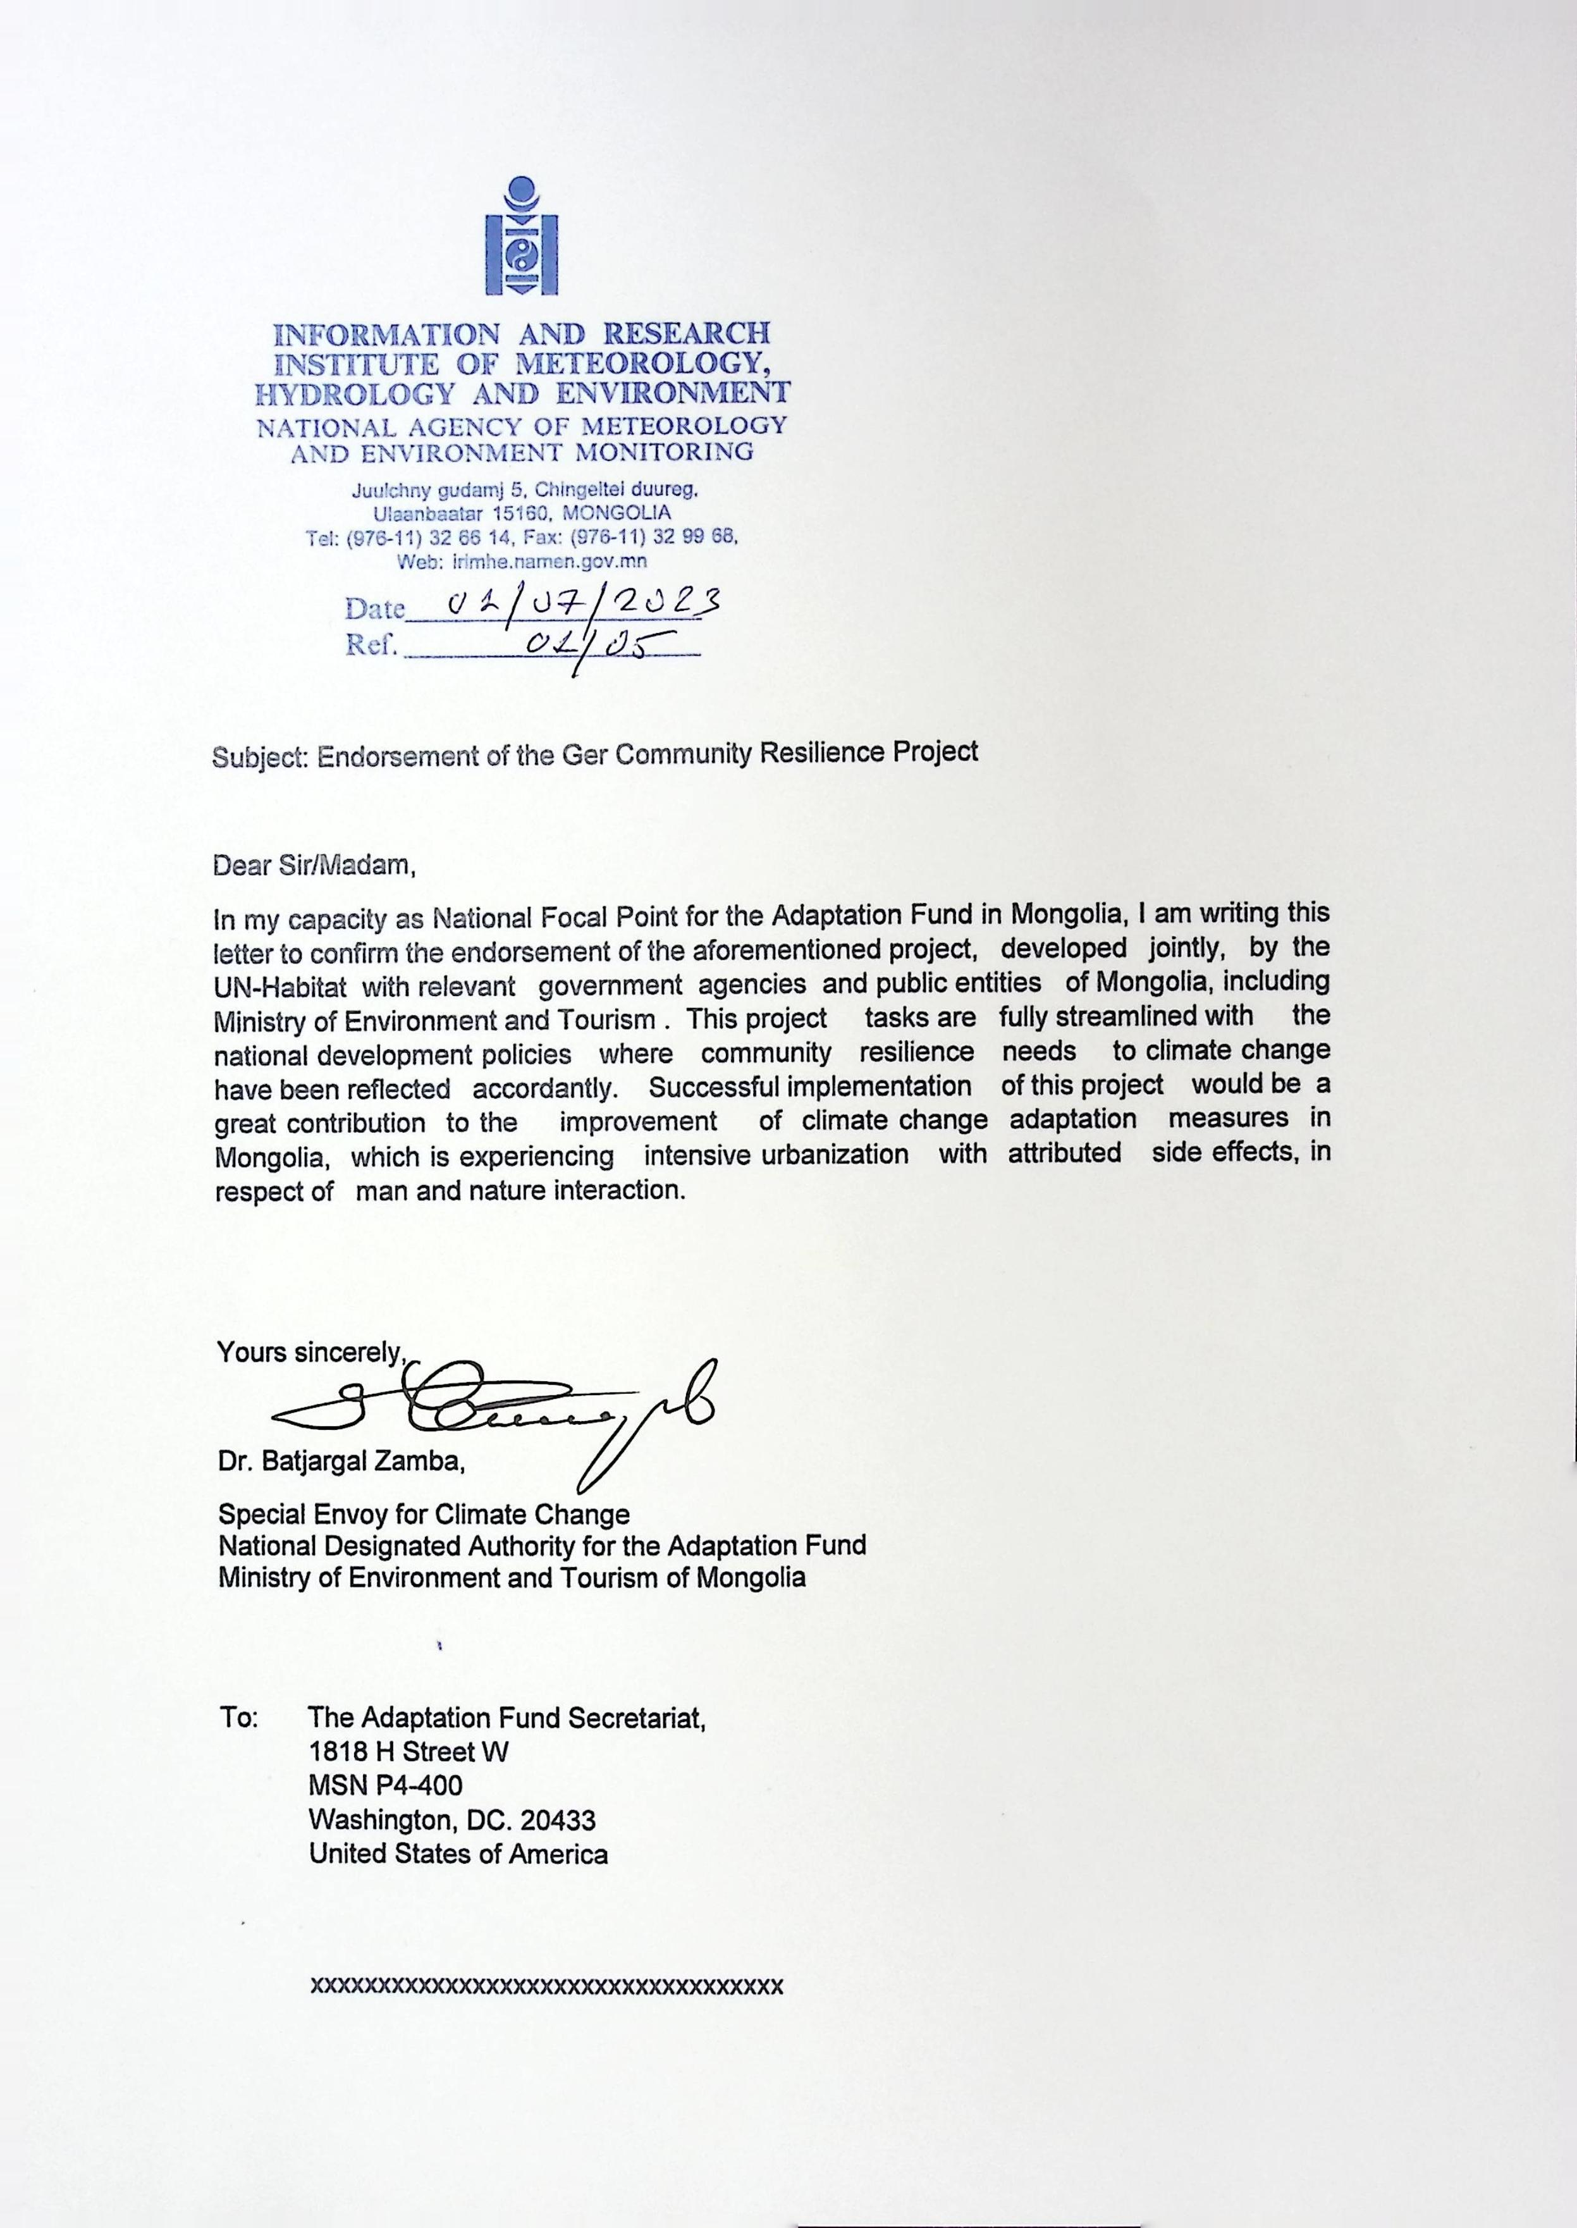
Implementing Entity certification

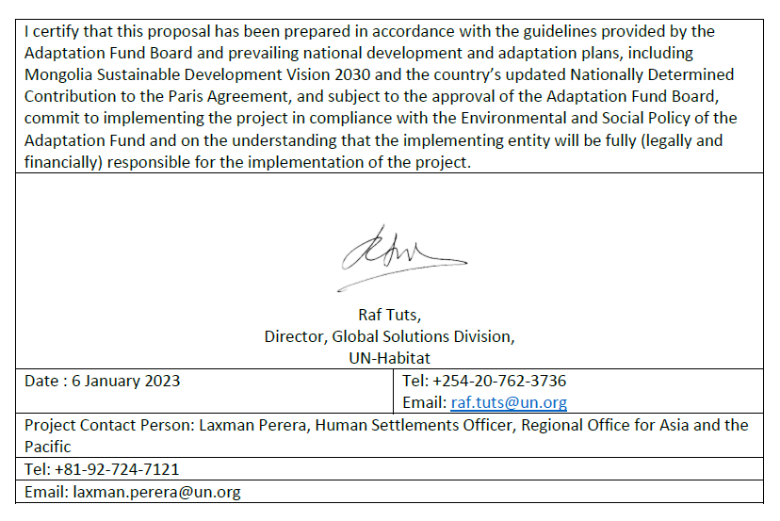

Annex 1 - Results of in-depth community consultations and Focus Group Discussions

No | District | Khoroo name | Position | Name | Contact number
1 | Sukhbaatar | 15 | Khoroo Governor | Ts.Sarantuya | 99218951
2 | Sukhbaatar | 15 | Social worker | L.Tsendsuren | 88047577
3 | Sukhbaatar | 15 | Coordinator | G.Enkhdaguul | 88838343
4 | Sukhbaatar | 15 | Family Clinic | L. Odonchimeg | 99904665
5 | Sukhbaatar | 15 | Resident | U. Otgonsaikhan | 89804240
6 | Sukhbaatar | 15 | Resident | B.Nyamkhuu | 88668415
7 | Sukhbaatar | 15 | Resident | N. Dulamsuren | 99807924
8 | Sukhbaatar | 15 | Resident | Sh.Otgonjargal | 91171104
9 | Sukhbaatar | 16 | Khoroo Governor | B.Erdenesukh | 99114391
10 | Sukhbaatar | 16 | Social worker | B.Olonbayar | 88070531
11 | Sukhbaatar | 16 | Coordinator | R.Batdelger | 96600987
12 | Sukhbaatar | 16 | Family Clinic | S. Sainaa | 88110698
13 | Sukhbaatar | 16 | Resident | D. Ariuntungalag | 96161188
14 | Sukhbaatar | 16 | Resident | Batbayar | 95178498
15 | Sukhbaatar | 16 | Resident | Bayarkhuu | 88625878
16 | Sukhbaatar | 16 | Resident | Soyoltsetseg | 80587073
17 | Sukhbaatar | 18 | Khoroo Governor | Ts. Tsogtod | 99244045
18 | Sukhbaatar | 18 | Social worker | Kh.Unurjargal | 98022202
19 | Sukhbaatar | 18 | Coordinator | G.Khishiggerel | 80139318
20 | Sukhbaatar | 18 | Family Clinic | D.Pagma | 89993555
21 | Sukhbaatar | 18 | Resident | B. Nyamgerel | 80338021
22 | Sukhbaatar | 18 | Resident | P. Lhagvasambuu | 95897266
23 | Sukhbaatar | 18 | Resident | D.Batkhishig | 89069622
24 | Sukhbaatar | 18 | Resident | Tsetsgee | 99988448
25 | Sukhbaatar | 20 | Khoroo Governor | S.Nergui | 99198175
26 | Sukhbaatar | 20 | Social worker | A.Lhagvatsetseg | 88843588
27 | Sukhbaatar | 20 | Coordinator | Ts.Undrakh | 99140223
28 | Sukhbaatar | 20 | Resident | L. Nyamtsog | 99913286
29 | Sukhbaatar | 20 | Resident | B. Purevdulam | 99845310
30 | Sukhbaatar | 20 | Resident | M. Chuluunkhuu | 99529292
31 | Sukhbaatar | 20 | Resident | D.Oyunchimeg | 88540212
32 | Songinokhairkhan | 4 | Khoroo Governor | R.Dashzeveg | 88069808
33 | Songinokhairkhan | 4 | Social worker | G.Nominsaikhan | 91270716
34 | Songinokhairkhan | 4 | Coordinator | G.Ankhjargal | 95125004
35 | Songinokhairkhan | 4 | Family Clinic | G.Bayarsaikhan | 99771868
36 | Songinokhairkhan | 4 | Resident | G. Lhachinsuren | 91195032
37 | Songinokhairkhan | 4 | Resident | A. Orkhontuya | 88989079
38 | Songinokhairkhan | 4 | Resident | D. Delgertsetseg | 85852418
39 | Songinokhairkhan | 4 | Resident | B. Burenmend | 88077042
40 | Songinokhairkhan | 5 | Khoroo Governor | E.Batbayar | 99061610
41 | Songinokhairkhan | 5 | Coordinator | U.Chamin Erdene | 99766683
42 | Songinokhairkhan | 5 | Family Clinic | Myagmartseren | 89941424
43 | Songinokhairkhan | 5 | Resident | Orgilsaikhan | 88315295
44 | Songinokhairkhan | 5 | Resident | Tsetsegsaikhan | 88178379
45 | Songinokhairkhan | 5 | Resident | Chantsandulam | 86999368
46 | Songinokhairkhan | 5 | Resident | Munkh ochir | 88950046
47 | Songinokhairkhan | 26 | Khoroo Governor | B. Batbayar | 96030409
48 | Songinokhairkhan | 26 | Coordinator | Kh.Togtokhnyam | 88806098
49 | Songinokhairkhan | 26 | Family Clinic | T. Ankhjargal | 95125004
50 | Songinokhairkhan | 26 | Resident | B. Gantugs | 89034403
51 | Songinokhairkhan | 26 | Resident | Ts. Adiyasuren | 88222655
52 | Songinokhairkhan | 26 | Resident | S. Uranchimeg | 88935858
53 | Songinokhairkhan | 26 | Resident | J. Byambakhuu | 86099286
54 | Songinokhairkhan | 27 | Khoroo Governor | N.Enkhjargal | 98110420
55 | Songinokhairkhan | 27 | Social worker | Ya. Enkhdolgor | 91119916
56 | Songinokhairkhan | 27 | Coordinator | B. Nyamkhishig | 88780432
57 | Songinokhairkhan | 27 | Family Clinic | N.Uzmee | 80433390
58 | Songinokhairkhan | 27 | Resident | S.Tsermaa | 99246898
59 | Songinokhairkhan | 27 | Resident | D.Galbadrakh | 99159103
60 | Songinokhairkhan | 27 | Resident | E.Temuulen | 95604662
61 | Songinokhairkhan | 27 | Resident | B.Selenge | 99832861

Minutes of Focus Group Discussion for Flood Risk Assessment

Date:  2022.12.09 | Venue: Community Hall of 4th Khoroo | Number of attendees: 21  Male– 10, Female - 11
Participants: Representation of the 4th Khoroo communities in flood prone areas
Objective: Rapid needs assessment and prioritization for flood related issues

Agenda:

Time | Title | Remarks
09:00 – 09:30 | Registration | Social mobilisers
09:30 – 09:40 | Introduction of objectives of the discussion | Social mobilisers
09:40 – 11:30 | Discussion about the challenges and problems people endure because of flooding | All participants
11:30 – 12:30 | Discussion about the potential measures at the community, khoroo, district and city levels | All participants
12:30 - 13:00 | Wrap up and closing | Social mobilisers

Proceeding:

The meeting was started by Ms.Tsogzolmaa Tsegmid, UN-Habitat Social Mobiliser with her introduction of the objective of the meeting. After that she started the discussion with the questions about the challenges and problems because of the flooding.

The participants discussed their state of living condition and listed out the flood related challenges. Then they did the exercise of the prioritization of the issues with the guidance of the meeting organizers.

The first ranking issue was the increase of fly and mosquitoes due to the accumulated wastewater in the neighborhood while the 2nd issue was soil pollution and blockage of the drainages and gullies by garbage, 3rd issue was the inundation of the areas in the rain flooding.
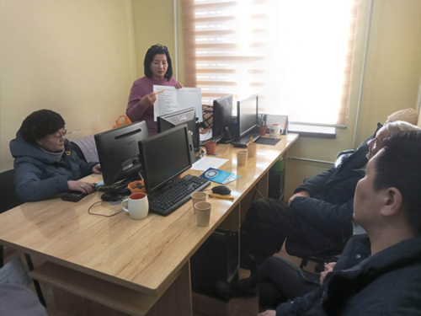
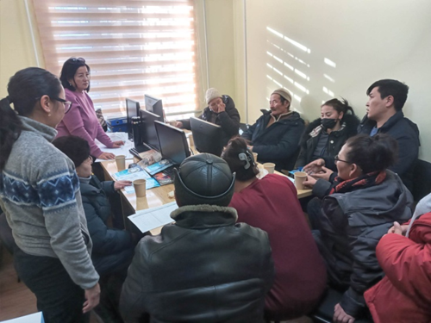
As the next step, the participants discussed about the potential solutions of the problem, what can be done by the people and by the local government.

In the scope of the discussion about the potential solutions, participants articulated and requested for help as one of the most pressing issue as the following:

- A dike was built with a closed end in Ikhnaran 1 and 2nd streets because 2 plot owners did not let the dike pass over their land. It creates now new problems in that neighborhood which include the overflow of the dike when it rains and collected water in the dike smells bad and attract fly and mosquitoes as some households dispose their wastewater directly to the dike and also rain brings households’ wastewater to the dike. The residents think that if the closed end of the dike can be opened and a proper draining solution be made, the neighborhood flood problem will be relieved. No one has an information about who built the dike and why they left without solving the problem.

The meeting organizers agreed with the participants to visit the area and hear the people live in the area. After the meeting they went with the participants to see the area. The below is the photos of the area.

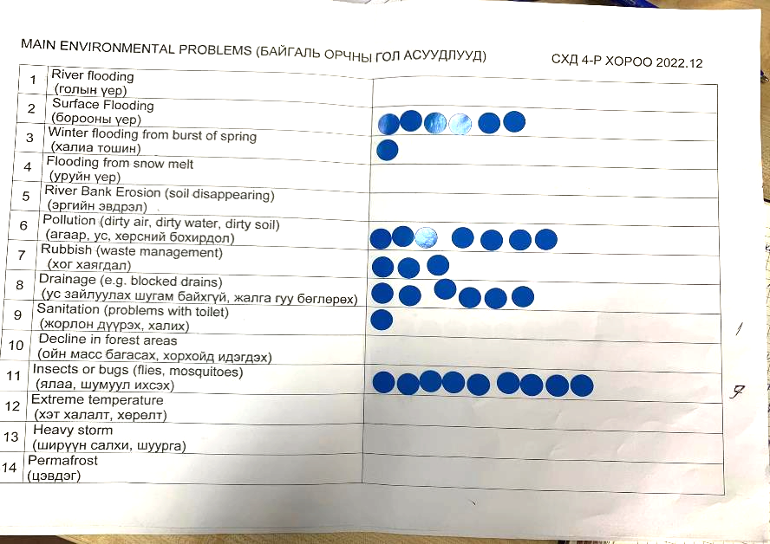
Figure 25. Prioritization of the problems by the community members:

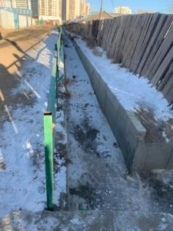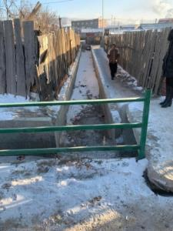
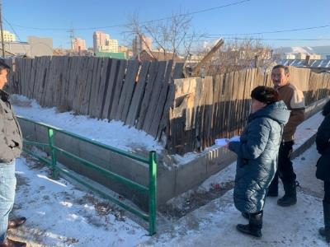
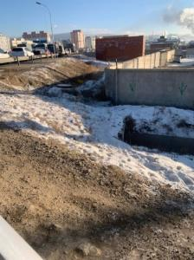

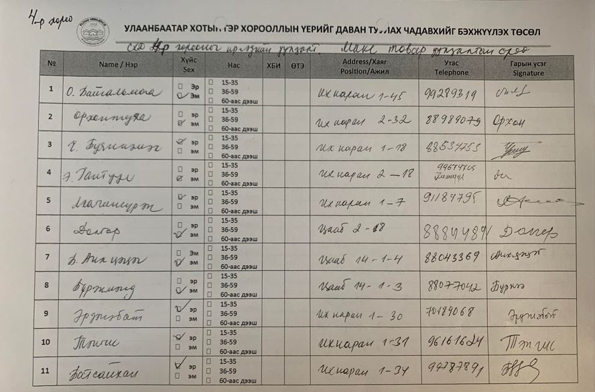
Attendance sheet
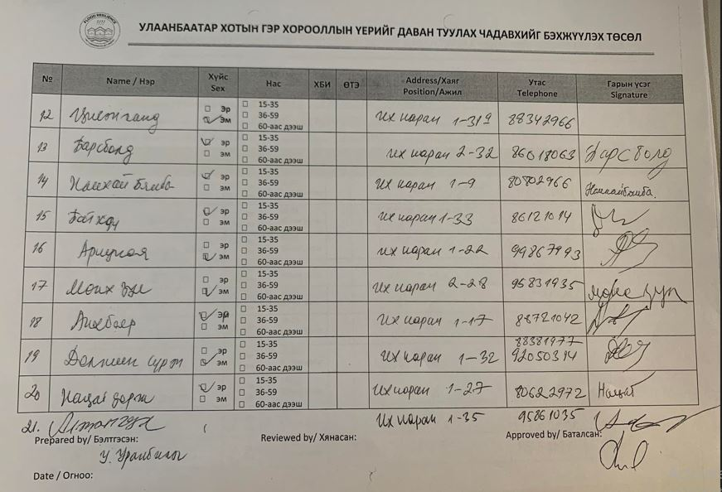

Minutes of Focus Group Discussion for Flood Risk Assessment

Date:  2022.12.27 | Venue: Community Hall of 5th Khoroo | Number of attendees: 20  Male– 3, Female – 17
Participants: Representation of the 5th Khoroo communities in flood prone areas
Objective: Rapid needs assessment and prioritization for flood related issues

Agenda:

Time | Title | Remarks
14:00 – 14:30 | Registration | Social mobilisers
14:30 – 14:40 | Introduction of objectives of the discussion | Social mobilisers
14:40 – 16:30 | Discussion about the challenges and problems people endure because of flooding | All participants
16:30 – 17:30 | Discussion about the potential measures at the community, khoroo, district and city levels | All participants
17:30 - 18:00 | Wrap up and closing | Social mobilisers

Proceeding:

The meeting was started by Ms.Tsogzolmaa Tsegmid, UN-Habitat Social Mobiliser with her introduction of the objective of the meeting. After that she started the discussion with the questions about the challenges and problems because of the flooding.

The participants discussed their state of living condition and listed out the flood related challenges. The following issues were articulated by the participants:
- Most of the streets in the khoroo area have muddy surface. The water comes out during summer from underground at the different places every year. With the digging about 1m down, water comes out, so pit latrines must be built on elevated surface. During winter when the excreta in the latrines get frozen people take out those and dispose as solid waste then use again the pit latrines.
- Although people live in difficult situation, all they have land titles so the khoroo office and land department cannot make them move out and resettle somewhere. Only option for the khoroo and land department is just to alert them on the potential danger when the summer is rainy.
- Polluted soil provides bad smells and attracts fly and mosquitoes.
- Wet ground freezes during winter so the foundation and wall of the houses get cracks and damages in the structure due to the interaction with the frozen ground. Humidity also affects furniture in the houses and causes deformation of the furniture.
- During winter, many households leave their badly affected houses and live in rental houses somewhere else in the district.
- When snow melts in spring, the areas get inundated.
- There is no school in the khoroo. So, children of the khoroo go to the school in the 6th khoroo for longer distance while exposed to soil and air pollution.

The participants grouped and prioritized the issues with the guidance of the meeting organizers. The first ranking issue was the soil, water and air pollutions while the 2nd issue was the sanitation problems due to the flooding, 3rd issue was the flooding from snowmelt.
As the next step, the participants discussed about the potential solutions of the problem, what can be done by the people and by the local government. The followings were suggested by the people:
- Flood protection dikes are required for 27⁻32nd streets
- Swampy areas need to be dried
- Green areas to be established
- To plant trees to reduce soil and air pollution
- Households need to be connected to water and sanitation system

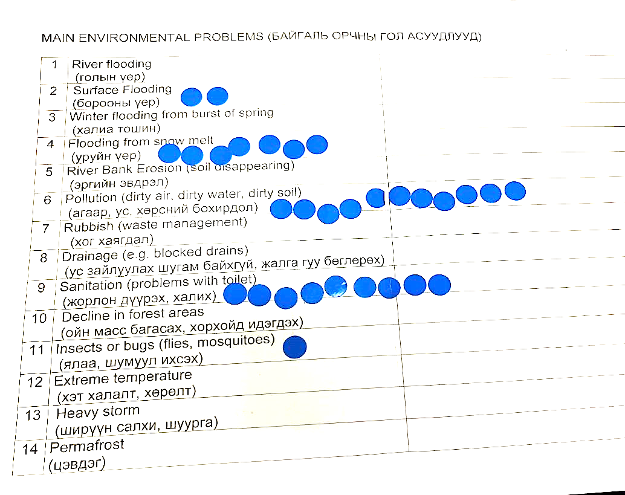

Attendance
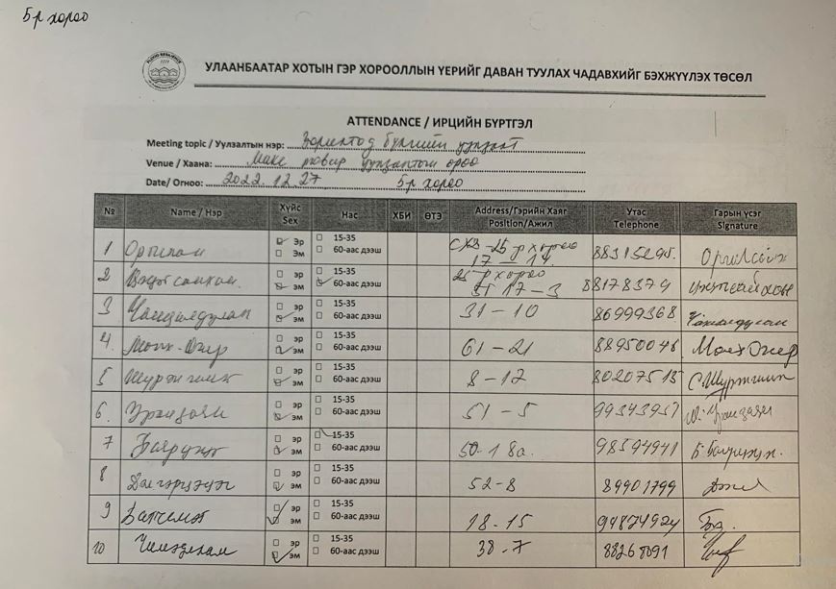
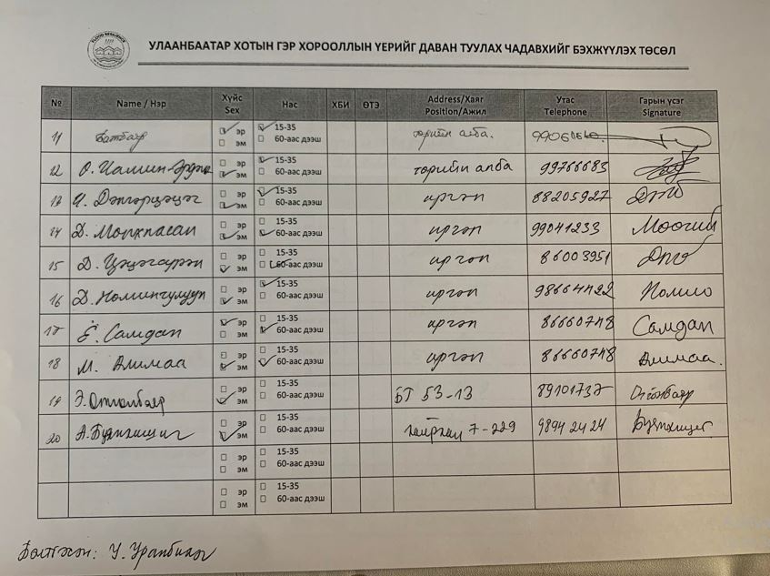

Minutes of Focus Group Discussion for Flood Risk Assessment

Date:  2022.12.09 | Venue: Community Hall of 26th Khoroo | Number of attendees: 21  Male– 8, Female - 13
Participants: Representation of the 26th Khoroo communities in flood prone areas
Objective: Rapid needs assessment and prioritization for flood related issues

Agenda:

Time | Title | Remarks
14:00 – 14:30 | Registration | Social mobilisers
14:30 – 14:40 | Introduction of objectives of the discussion | Social mobilisers
14:40 – 16:30 | Discussion about the challenges and problems people endure because of flooding | All participants
16:30 – 17:30 | Discussion about the potential measures at the community, khoroo, district and city levels | All participants
17:30 - 18:00 | Wrap up and closing | Social mobilisers

Proceeding:

The meeting was started by Ms.Tsogzolmaa Tsegmid, UN-Habitat Social Mobiliser with her introduction of the objective of the meeting. After that she started the discussion with the questions about the challenges and problems because of the flooding.

The participants discussed their state of living condition and listed out the flood related challenges.

- The households have been challenged with the increased impacts of winter flooding in recent years.
- The bank of Tolgoit river has been badly degraded so when river level rises the households get inundated. The affected households received already notifications of resettlement from the district authority, but refuse to move out as the proposed relocation places are out of the town where there is no school, kindergarten and basic amenities.
- Inundation is not only problem, but it has also been resulted in serious cracks and damages in the foundations of the buildings, inundated pit latrines create an environment that endangers human health.
- In 2021 winter, District emergency office and Hydrology facilities department had to come many times to remove ice and pump the water during the winter flooding. This year they informed already that they don’t have budget so the khoroo office should relocate people from flood zone.
- Tolgoit river is heavily polluted. Children get skin rash while playing in the river during summer.

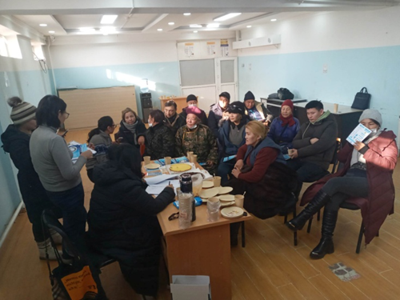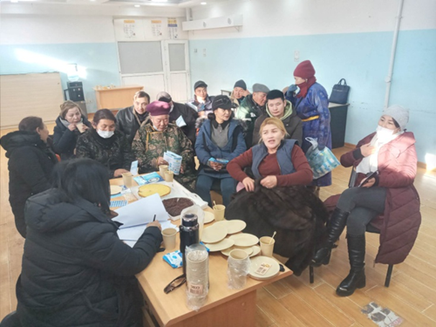

After the problem listing the participants did the prioritization of the issues with the guidance of the meeting organizers.

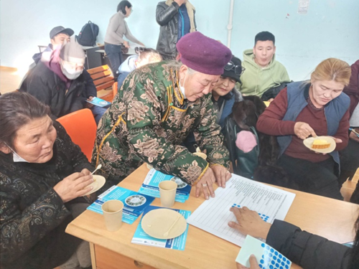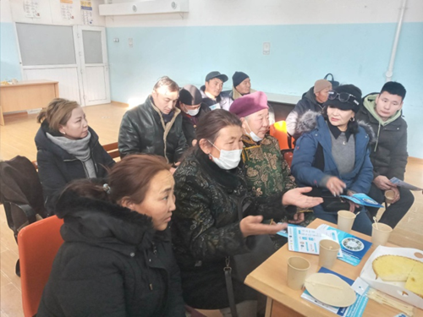

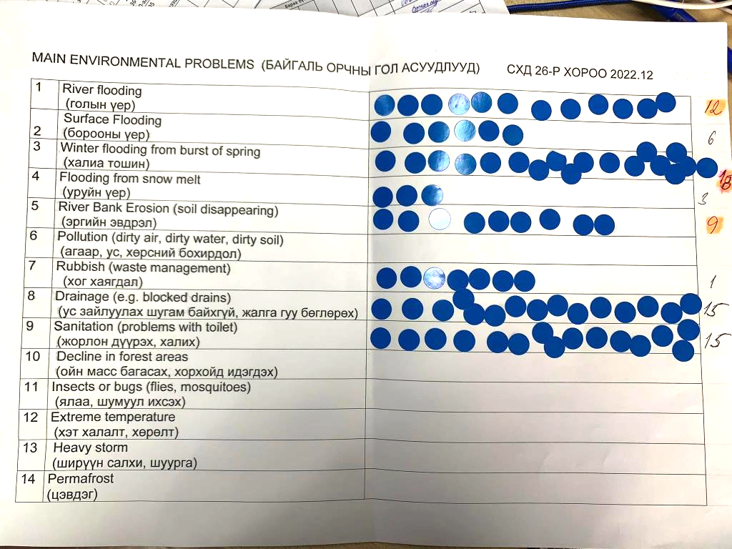
Prioritization of the issues by communities:

The issue of winter flooding was ranked as the priority to address while the drainage and pit latrine overflow problems were ranked as 2nd and 3rd.

Regarding the potential measures to reduce the flood risk the following were suggested by people:
- The existing bridge over Tolgoit river does not have capacity to cope with winter flooding so easily blocked creating disastrous situation in upper stream area. So a bigger bridge is required in its place.
- A proper embankment is required for Tolgoit river.
- A proper drainage system is required also.

The wrap up of the meeting was done by Tsogzolmaa Tsegmid, UN-Habitat SM. The participants requested the meeting organizers to visit the most problematic areas after the meeting and provide support to improve their living condition.

The photos of the areas visited by the team are shown in the below.

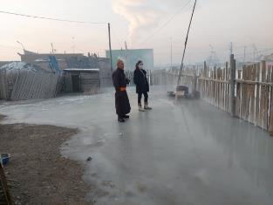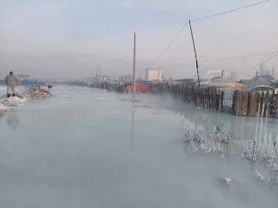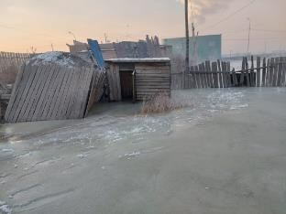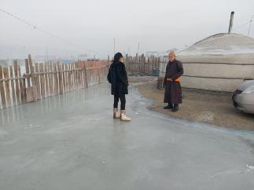
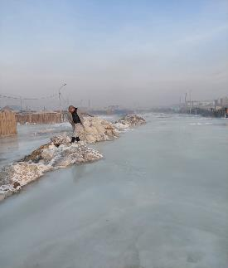
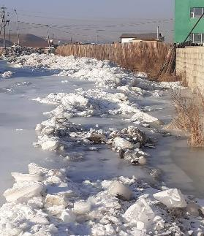

Attendance

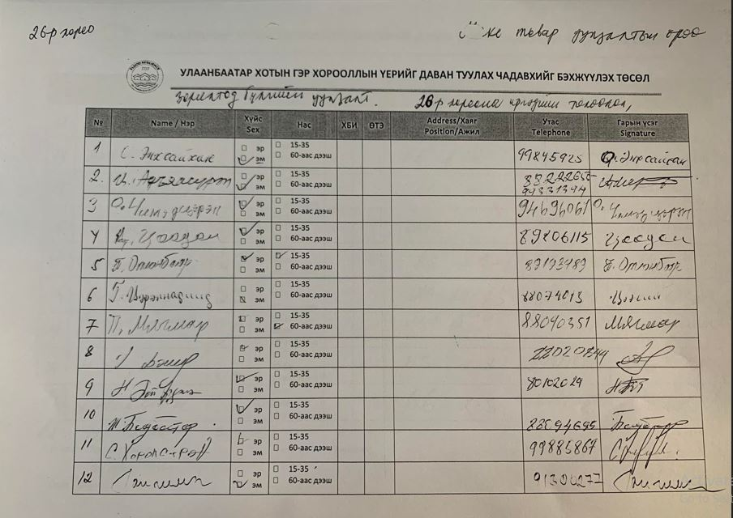
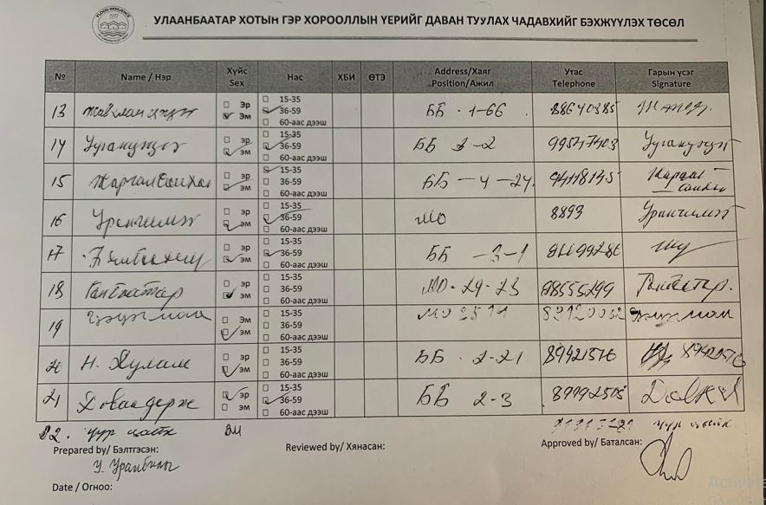

Minutes of Focus Group Discussion for Flood Risk Assessment

Date:  2022.12.08 | Venue: Community Hall of 27th Khoroo | Number of attendees: 20  Male– 11, Female – 9
Participants: Representation of the 27th Khoroo communities in flood prone areas
Objective: Rapid needs assessment and prioritization for flood related issues

Agenda:

Time | Title | Remarks
14:00 – 14:30 | Registration | Social mobilisers
14:30 – 14:40 | Introduction of objectives of the discussion | Social mobilisers
14:40 – 16:30 | Discussion about the challenges and problems people endure because of flooding | All participants
16:30 – 17:30 | Discussion about the potential measures at the community, khoroo, district and city levels | All participants
17:30 - 18:00 | Wrap up and closing | Social mobilisers

Proceeding:

The meeting was started by Ms.Tsogzolmaa Tsegmid, UN-Habitat Social Mobiliser with her introduction of the objective of the meeting. After that she started the discussion with the questions about the challenges and problems because of the flooding.

The participants discussed their state of living condition and listed out the flood related challenges.

The following issues were identified by the participants:

- Since 2019, 2 and 3rd streets fully and 4th street partially have been inundated and 50 households live in disastrous situation. It is a low-lying area and when there is rainy summer the water stays there throughout of a year. During winter the stagnant water freezes and the slippery surface challenges people’s and cars’ movements. Pit latrines are all the time full and overflow time to time.
- The natural gullies in the khoroo area play important role for draining the flash flood water but time to time when there is a heavy rain or intense flash flooding overflow happen and households in the vicinity get inundated.
- Winter flooding is another challenge for the khoroo community. During winter ice cover extends affecting many plots. As of today, in Dec 2022, there is already an ice buildup with 500 m length and 25-30 m width.
- People try with their best to protect their plots and assets from winter flooding by building earth dam and barriers. However, in few days, the water level rises to the extent of the barrier and plots and entire streets get inundated and then water freezes.
- People call an emergency service from the emergency management units of the district and city when the situation gets disastrous. The emergency service comes and provides an immediate relief to open the access ways by cracking the ice and pumping the excess water but it does not solve the problem. So this process repeats again and again until the ice melts down completely.
- The water from the melt of the accumulated ice runs to lower lying streets creating an inundation of the streets during spring.
- People live in inconvenient, unsafe, and unhealthy environment with risks of flooding and danger to human health due to slippery in winter and wet during other seasons, ground. Also, it affects livelihood and economy of households as the household assets degrade with the influence of water and ice requiring for regular maintenance and fixing.

Then they did the exercise of the prioritization of the issues with the guidance of the meeting organizers. The first ranking issue was the winter flooding issues while the 2nd issue was the sanitation problems due to the flooding, 3rd issue was the air, soil and water pollutions problems.

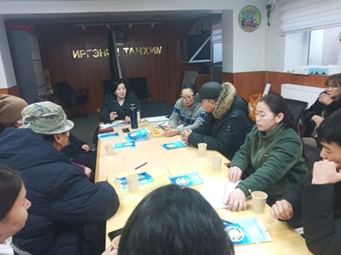
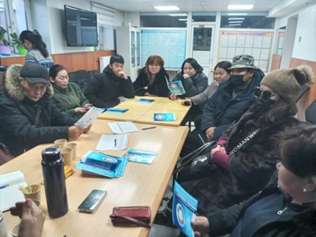

As the next step, the participants discussed about the potential solutions of the problem, what can be done by the people and by the local government.

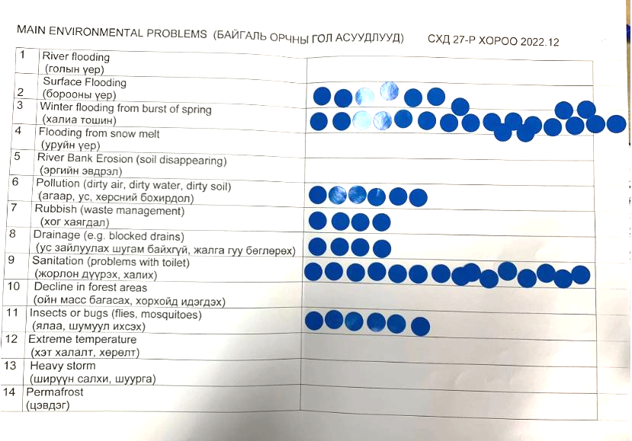
The wrap up of the meeting was done by Tsogzolmaa Tsegmid, UN-Habitat SM. The participants requested the meeting organizers to visit the most problematic areas after the meeting and provide support to improve their living condition. The photos of the areas visited by the team are shown in the below.
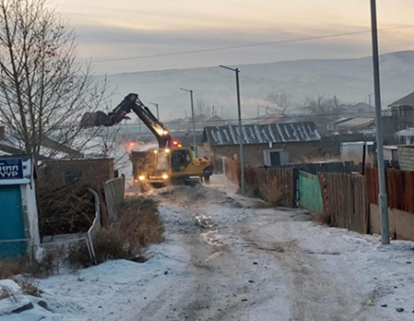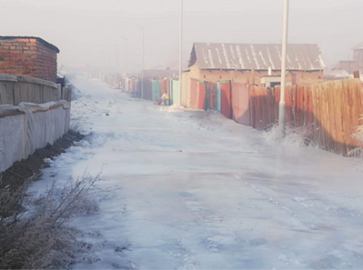

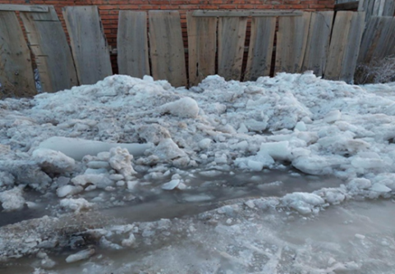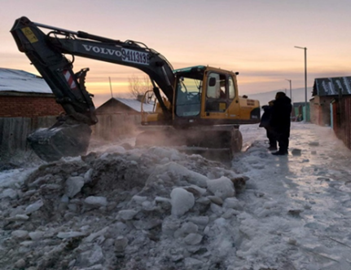

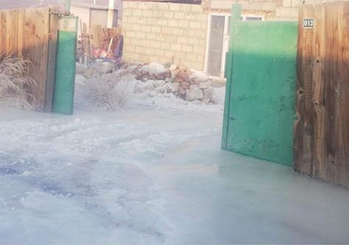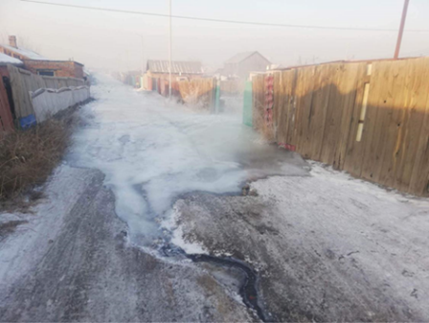

Attendance
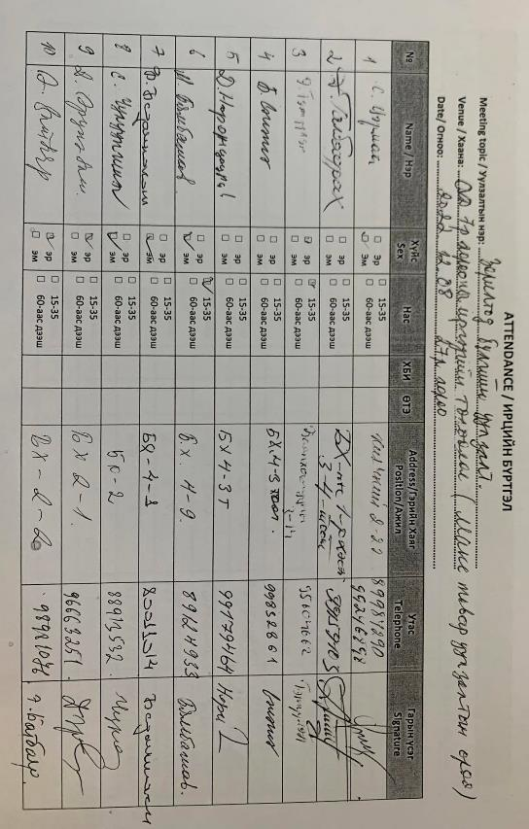

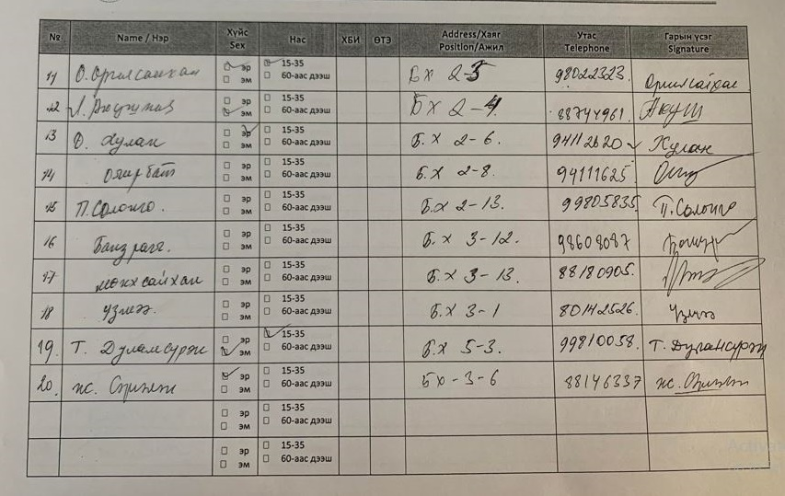

Minutes of Focus Group Discussion for Flood Risk Assessment

Date:  2022.12.07 | Venue: Community Hall of 15th Khoroo | Number of attendees: 20  Male– 3, Female – 17
Participants: Representation of the 15th Khoroo communities in flood prone areas
Objective: Rapid needs assessment and prioritization for flood related issues

Agenda:

Time | Title | Remarks
09:00 – 09:30 | Registration | Social mobilisers
09:30 – 09:40 | Introduction of objectives of the discussion | Social mobilisers
09:40 – 11:30 | Discussion about the challenges and problems people endure because of flooding | All participants
11:30 – 12:30 | Discussion about the potential measures at the community, khoroo, district and city levels | All participants
12:30 - 13:00 | Wrap up and closing | Social mobilisers

Proceeding:

The meeting was started by Ms.Zolzaya Namsrai, UN-Habitat Social Mobiliser with her introduction of the objective of the meeting. After that she started the discussion with the questions about the challenges and problems because of the flooding.

The participants discussed their state of living condition and listed out the flood related challenges. The following issues were articulated by the participants. Also, they shared the photos of recent flooding:
- 15th khoroo is located along the Selbe river but there is no embankment of the river.
- The khoroo area was rich with natural springs according to the elderly residents.
- Dominant households have land titles. However, there are some households that were settled without permission.
- Front yards adjacent to the riverbank suffer from the burst of springs and inundation. The households call often the emergency service for an immediate relief.
- Households that live in 80-100m distance from the river were notified to move out and resettle somewhere by the land department but haven’t moved.
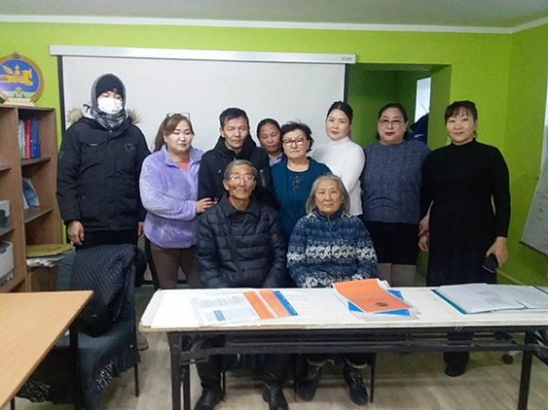
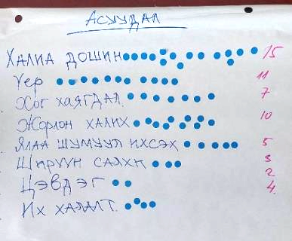
- The areas suffer from flooding throughout a year: from snowmelts in spring, heavy rains in summer and winter flooding due to burst of springs.
- Natural gullies are only drainage system in the area. During winter the water from spring fills up the gullies and gets frozen so any excess water causes inundation of the neighborhood yards. The accumulated ice in the gullies don’t easily melt during spring so a little snowmelt causes flash flooding of the area.
- In recent summer rains, floodwater many times inundated the houses of the households at the risk areas and got the pit latrines spill over. The situation lasted for many days to dry up as there is no drainage system while creating unhealthy environment for the entire population in the vicinity. This was resulted in rise of fly and mosquitoes and increase of waterborne and digestive system diseases among the population. Khoroo office calls emergency services upon the request from residents for support, but it does not help much in general.
- Swampy surface restricts car movements in the settlement.
- As Khoroo office does not have budget, their support action is limited with small number of trees planting so far.

After this the participants grouped and prioritized the issues with the guidance of the meeting organizers. The first ranking issue was the winter flooding while the 2nd issue was the summer flooding, 3rd issue was the pit latrines that overflow during a flooding.

As the next step, the participants discussed about the potential solutions of the problem, what can be done by the people and by the local government. The followings were suggested by the people:

- Flood protection infrastructure and river embankment are to be constructed
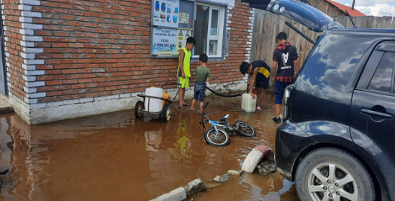
- Take measurement to change the mindset of the residents who throw their garbage to the natural gullies and block the drain.
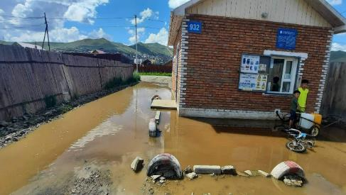
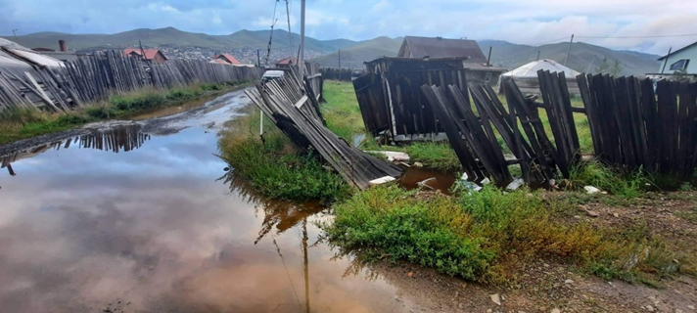

The meeting was wrapped up and closed by Ms. Zolzaya Namsrai, UN-Habitat SM.

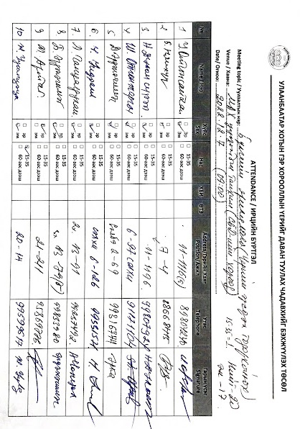
Attendance
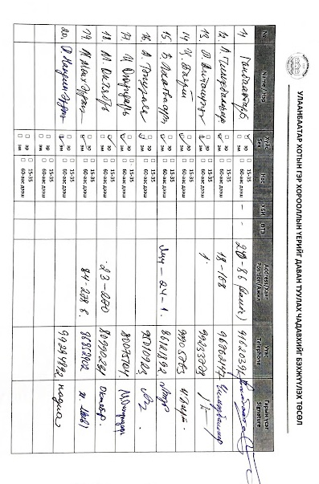
Minutes of Focus Group Discussion for Flood Risk Assessment

Date:  2022.12.07 | Venue: Community Hall of 16th Khoroo | Number of attendees: 22  Male– 6, Female – 16
Participants: Representation of the 16th Khoroo communities in flood prone areas
Objective: Rapid needs assessment and prioritization for flood related issues

Agenda:

Time | Title | Remarks
14:00 – 14:30 | Registration | Social mobilisers
14:30 – 14:40 | Introduction of objectives of the discussion | Social mobilisers
14:40 – 16:30 | Discussion about the challenges and problems people endure because of flooding | All participants
16:30 – 17:30 | Discussion about the potential measures at the community, khoroo, district and city levels | All participants
17:30 – 18:00 | Wrap up and closing | Social mobilisers

Proceeding:

The meeting was started by Ms.Zolzaya Namsrai, UN-Habitat Social Mobiliser with her introduction of the objective of the meeting. After that she started the discussion with the questions about the challenges and problems because of the flooding.

The participants discussed their state of living condition and listed out the flood related challenges.

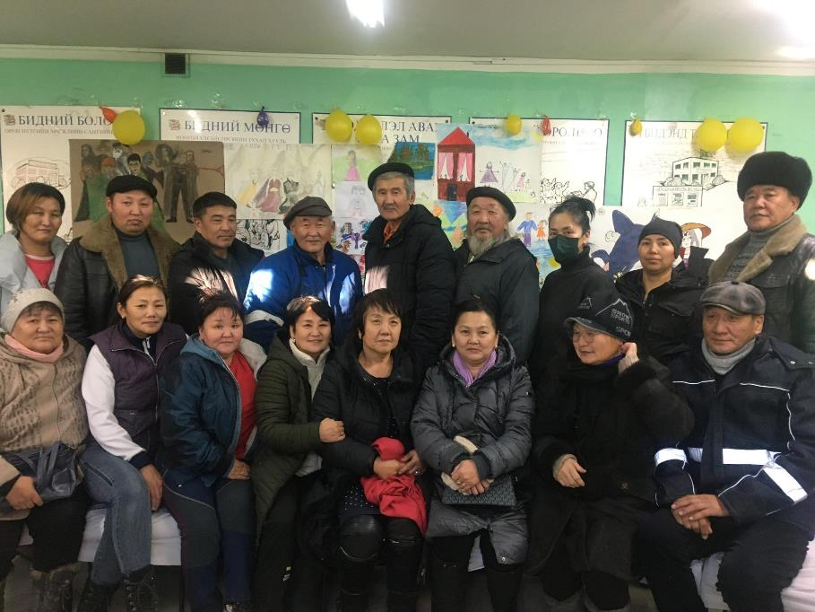
The following issues were articulated by the participants:
- 20th street is in low lying area which water from surrounding mountains get collected in and inundate yards there. Water also comes to and fills the pit latrines. One of the reasons could be that some households settled on the way of water flow in the gully.
- Belkh 4th street does not have a proper facility to drain floodwater that comes towards the street. One option could be to widen the old drainage at the right side of the street.
- At the place called Toosgonii etses, flash flood comes from the mountains and inundates yards in the lower side of the main road. In the last bus stop area at Toosgonii etses a public toilet is required. An open defecation by commuters is an issue in there.
- Belkh 11th street is almost wetland. Pedestrian and car movements are challenging. People experience economic losses from cracks and damages in their house structures.
- Belkh 7th street gets inundated when it rains. Water comes from the point where Telmen shop is.
- Fences in the Oichid 1st street were collapsed. It may be because the soil is soft and wet.

After this the participants grouped and prioritized the issues with the guidance of the meeting organizers. The first ranking issue was the flooding while the 2nd issue was the inundation of the yards, 3rd issue was the pit latrines that overflow during a flooding.

As the next step, the participants discussed about the potential solutions of the problem, what can be done by the people and by the local government. The followings were suggested by the people:

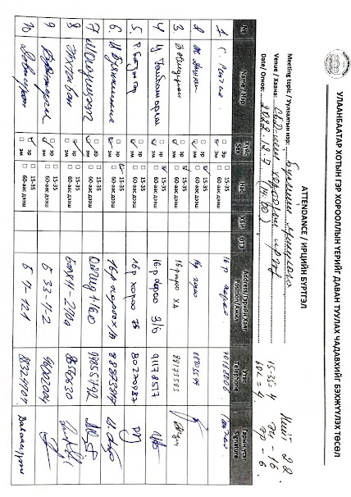
- Water comes from the main road at Belkh 11th street so drainage channels need to be constructed for the main road.

The meeting was wrapped up and closed by Ms. Zolzaya Namsrai, UN-Habitat SM.

Attendance

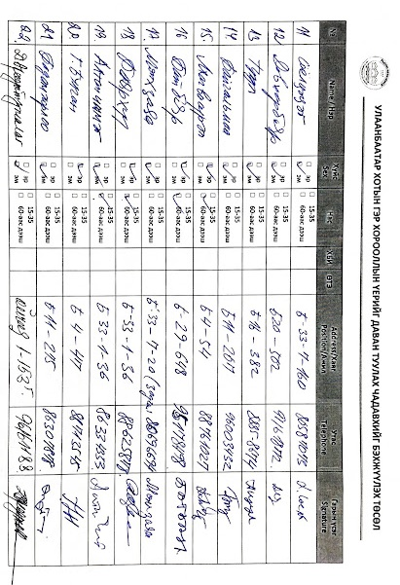

Minutes of Focus Group Discussion for Flood Risk Assessment

Date:2022.12.08 | Venue: Community Hall of 18th Khoroo | Number of attendees: 20  Male– 7, Female – 13
Participants: Representation of the 18th Khoroo communities in flood prone areas
Objective: Rapid needs assessment and prioritization for flood related issues

Agenda:

Time | Title | Remarks
14:00 – 14:30 | Registration | Social mobilisers
14:30 – 14:40 | Introduction of objectives of the discussion | Social mobilisers
14:40 – 16:30 | Discussion about the challenges and problems people endure because of flooding | All participants
16:30 – 17:30 | Discussion about the potential measures at the community, khoroo, district and city levels | All participants
17:30 - 18:00 | Wrap up and closing | Social mobilisers

Proceeding:

The meeting was started by Ms.Zolzaya Namsrai, UN-Habitat Social Mobiliser with her introduction of the objective of the meeting. After that she started the discussion with the questions about the challenges and problems because of the flooding.

The participants discussed their state of living condition and listed out the flood related challenges.

The following issues were articulated by the participants.
- 5-6 places in the khoroo territory have the winter flooding issue. In there, a spring bursts suddenly in the yards of the households, sometimes even from the bottom of the houses and gers and inundate the yard and neighboring yards. A woman said that she rushed to the meeting after hearing the meeting will discuss the flood issue. She cried while talking about her story. According to her, she lent her salary for some years from bank and built a house. But the house got inundated due to winter flooding to the level of windowsills. As there is no way to stay in the house, her family left the house and rent a place to stay. According to her, it is not only her family, but many households also rent a room somewhere else once their houses got affected by the winter flooding.
- There are also several places which get flooded during snowmelt and summer rains.
- The pit latrines in the flood prone areas are challenging to manage as those easily get filled up with the flood water and ground water. When an overflow of the pit latrines occurs, soil and air get polluted with excreta causing the water and air borne diseases spread among the population. They do disinfections after each flooding, but the problem persists as the reasons of the problem are not solved.
- The flood water pollutes the water in the ground well. However, people keep using the water for their consumption.
- Flood impacts health, mentality, assets, and economic states of the households. Inundated house, assets, furniture require maintenance and fixation which impacts the household economy.

After this the participants grouped and prioritized the issues with the guidance of the meeting organizers. The first ranking issue was the winter flooding while the 2nd issue was the lack of drainage system and blockage of the natural drains by the solid waste, 3rd issue was the pit latrines that overflow during a flooding.

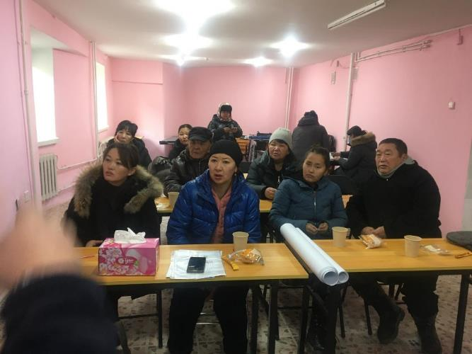
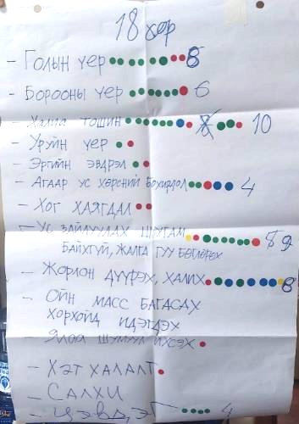

As the next step, the participants discussed about the potential solutions of the problem, what can be done by the people and by the local government. The followings were articulated by the people:
- People wish to protect themselves from flooding, but they feel powerless against the natural disaster and lack with the professional guidance and government support.
- Khoroo does not have any budget while the district has but not sufficient for building flood protection facilities. The measurements from the district are limited with the immediate relief action when a disaster happens.
- The residents approached many times elected parliamentarian members for support. But they come and see the problem and disappear.
- An embankment is required to be constructed to protect inhabitants from the river flooding.
- Trees and bushes planting may contribute to the water absorption capacity of the soil.
- Mindset changing influential activities are required for the households and commuters which discharge their solid and liquid wastes to the natural drains.

The meeting was wrapped up and closed by Ms. Zolzaya Namsrai, UN-Habitat SM.

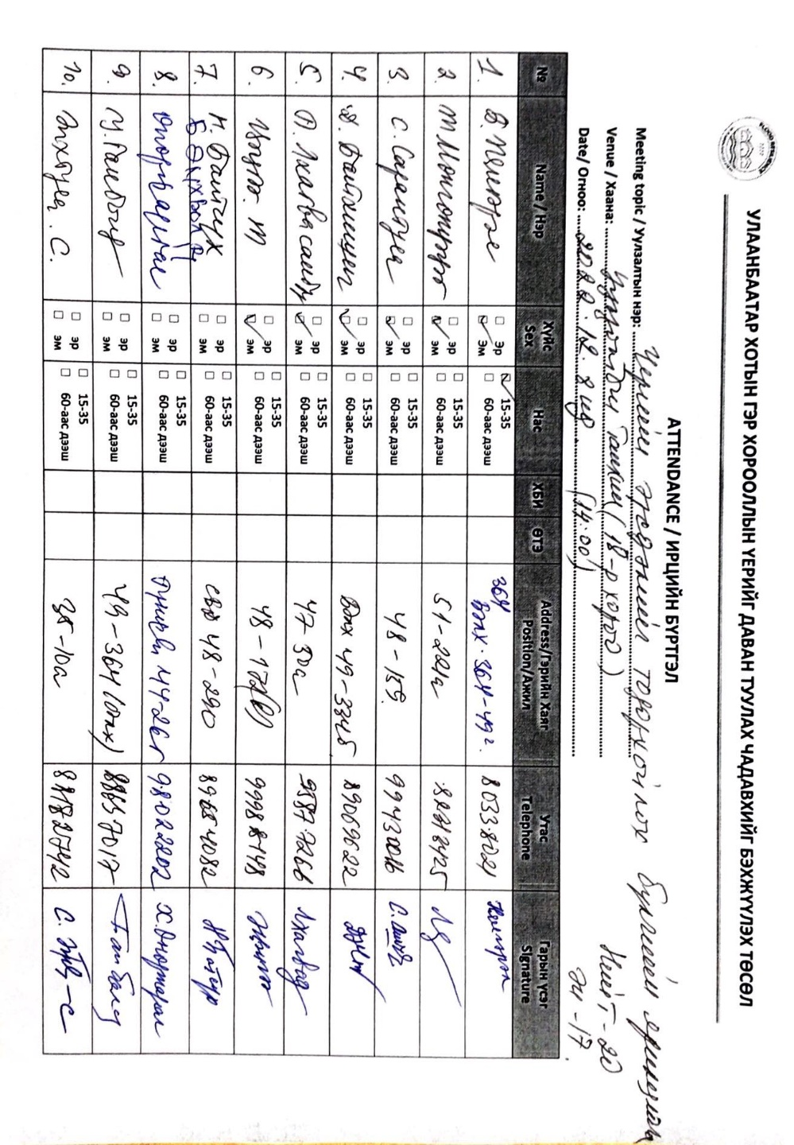
Attendance

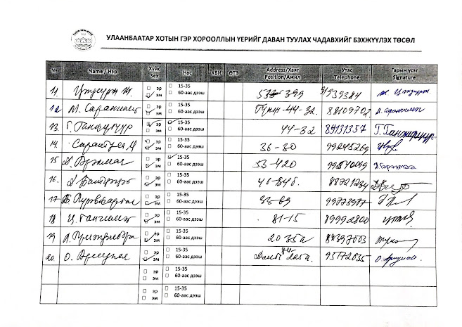

Minutes of Focus Group Discussion for Flood Risk Assessment

Date:2022.12.08 | Venue: Community Hall of 20th Khoroo | Number of attendees: 20  Male– 7, Female – 13
Participants: Representation of the 20th Khoroo communities in flood prone areas
Objective: Rapid needs assessment and prioritization for flood related issues

Agenda:

Time | Title | Remarks
09:00 – 09:30 | Registration | Social mobilisers
09:30 – 09:40 | Introduction of objectives of the discussion | Social mobilisers
09:40 – 11:30 | Discussion about the challenges and problems people endure because of flooding | All participants
11:30 – 12:30 | Discussion about the potential measures at the community, khoroo, district and city levels | All participants
12:30 - 13:00 | Wrap up and closing | Social mobilisers

Proceeding:

The meeting was started by Ms.Zolzaya Namsrai, UN-Habitat Social Mobiliser with her introduction of the objective of the meeting. After that she started the discussion with the questions about the challenges and problems people endure because of the flooding.

The participants discussed their state of living condition and listed out the flood related challenges. The following issues were articulated by the participants:

- There are few places with the problem of bursting natural springs in the khoroo area. One of them is Donj residential area. Inhabitants of the area suffer from winter flooding and experience inundation of their yards and houses during winter.
- The khoroo area was initially planned as a summer house area but gradually converted to the year-round residential areas due to the illegal occupation of the land by in-migrants to the city. They built their houses where land is available including the riverbed areas without much consideration of flood risk. When they experience flooding, they prefer to sell the houses to some people who does not know that the place has a flooding problem. A new owner stays there until they experience same problem. The story continues an owner to another. At the same time by building houses and other assets in the flood risk areas they change the original eco system and the river and springs’ natural flow ways. As result of this, flooding and inundation occur in new places where there was no such problem.
- The khoroo area has the places where flood water comes from the surrounding mountains with high intensity. In those places inhabitants experienced serious losses such as an entire house even with a dog was washed away by flood.
- In the places where the ground water table is high, people experience difficulties with the pit latrines’ overflow and its health impacts.
- Most people in the khoroo have some experiences of flood impacts including the physical, mental and health losses.

After this the participants grouped and prioritized the issues with the guidance of the meeting organizers. The first ranking issue was the winter flooding while the 2nd issue was the summer flooding, 3rd issue was the lack of the drainage system and human induced blockage of the natural drains as the main reason of inundation of the areas.

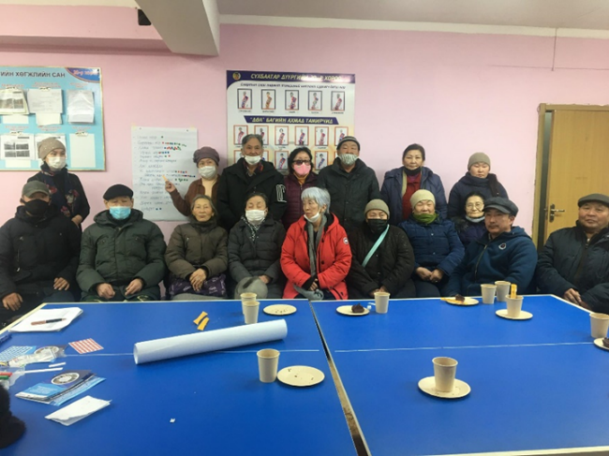

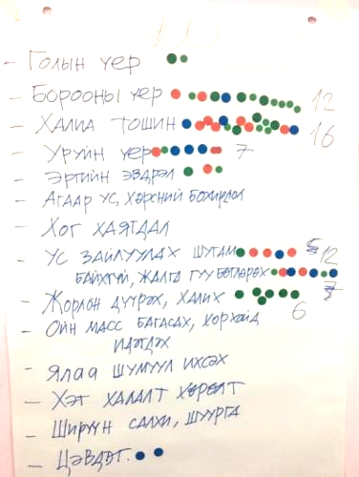
As the next step, the participants discussed about the potential solutions of the problem, what can be done by the people and by the local government. The followings were articulated by the people:
- People wish to take measurements for flood protection but they feel powerless against the natural factor and lack with guidance and economical resources.
- It would be important to solve the flood problem at its starting points but not in the downstream areas.
- There are elder people who have the knowledge and experiences about the area flood situation and needs of flood protection facilities. It would be important to consult with them when the project designs the flood protection infrastructure.
- The most required facilities would be an embankment of river and bridges to cross the risky areas.
- Mindset changing activities are required for those households and commuters who discharge their solid and liquid wastes to the natural drains.

The meeting was wrapped up and closed by Ms. Zolzaya Namsrai, UN-Habitat SM.

Attendance

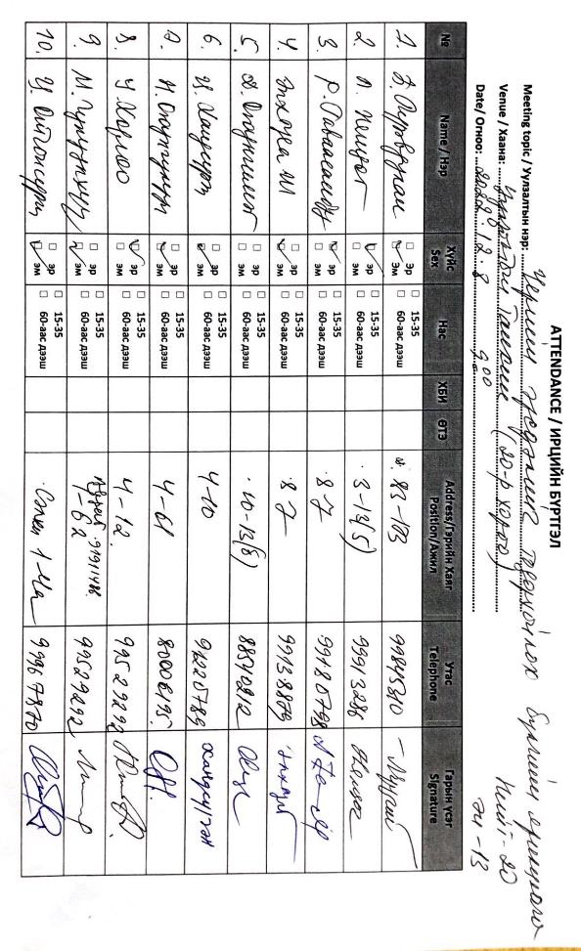
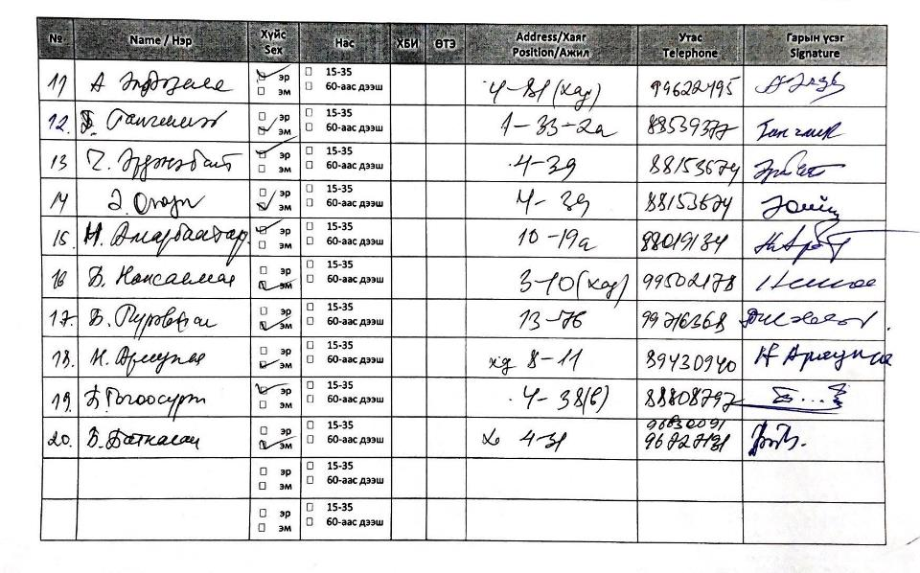

Annex 2 – Environmental and Social Risk Screening, Impact Assessment and Environmental and Social Management Plan

Demonstrating compliance with the Adaptation Funds’ Social and Environmental Policy (ESP)

Part 1 – Context and Background

The purpose of this Annex is to demonstrate the project’s compliance with the Environmental and Social and Gender Policies of the Adaptation Fund. It provides an analysis of the potential environmental and social risks of the project’s physical activities and highlights opportunities, concluding in an Environmental and Social and Gender Policy Compliance Plan. The contents of this plan will be made available to the Project Board before the project commences, and it will be used as a basis to brief beneficiary communities before the project commences. Its contents will be translated into local language prior to the start of the project, and its key findings and messages will be simplified to enable beneficiary communities to understand them.
Compliance with environmental and social safeguards
Environmental and social safeguards are essential tools to prevent and mitigate the potential for undue and unintended harm that could arise from project activities. In line with the Adaptation Fund’s ESP and GP and UN-Habitat’s Environmental and Social Safeguard Policy (ESSP), UN-Habitat and its partners are required to conduct risk screenings and impact assessments of all activities that have even a negligible risk of causing unintended harm.
To ensure compliance with the Environmental and Social Policy of the Adaptation Fund, all project activities are screened in this Annex against the 15 environmental and social principles, as defined in the Environmental and Social Policy of the Adaptation Fund. Where risks have been identified, this annex analyses the potential for impact and describes the measures that have been built into the project to avoid or mitigate risks and their impacts. Throughout the project, investments have been designed. This Annex supersedes any previous environmental and social safeguards related annex that has been submitted in previous versions of this proposal.
To ensure compliance with the Adaptation Fund Gender Policy, extensive information has been provided in Part 1 of the proposal.
The analysis presented in this Annex is based on various data from numerous government sources, other secondary sources and where this is not available, primary data gathered by the project formulation team. All investments identified in the project have been developed in consultation with local and national government and target beneficiary communities. The proposed measures to avoid, mitigate and manage environmental and social safeguards risks have also been discussed extensively with local and national government stakeholders and communities.
Please note that the information presented in this Annex is a summary of a broader environmental and social safeguard screening and impact assessment. All key information is provided here. The initial analysis has been presented in summary form for reasons of space.
Table 2.1. Outline Risk Screening and categorization
Checklist of environmental and social principles | No further assessment required for compliance | Potential impacts and risks – further assessment required for compliance | Explanation why principle has been triggered (or not)
- Compliance with the law |  | X | The physical construction activities proposed under Component 3 require building permits and design approval from national and local governments by law.  There are numerous laws and regulations relating to construction activities.  Without risk mitigation measures taken in advance to ensure compliance with the law, there is a risk that the project maybe violate local or national level laws and regulations.
- Access and equity |  | X | There could be a risk that different groups are not equally involved in planning and implementation stages of the processes under the project and consequently potentially marginalised groups may not derive equal benefit from it.
- Marginalized and vulnerable groups |  | X
- Human rights |  | X | Risks to human rights emerge from potential risk to Core Labour Rights and of involuntary resettlement. See principles 6, Core Labour Rights and principle 8, involuntary resettlement.
- Gender equality and women’s empowerment |  | X | There is a risk that any negative impact of the project may disproportionately affect women because women are more likely to undertake domestic work at homes served by the drainage infrastructure, and to provide care to children and the elderly in and around the home. Women are also more likely to be negatively affected by, for example, having to pass construction areas en-route to taking children to school and performing other such unpaid work tasks. There is also a risk that the project’s soft activities under components 1, 2, and 4 may exclude women.
- Core labour rights |  | X | There is a risk that contractors working under, or employed directly by the project may have their core labour rights violated, even if unintentionally.
- Indigenous people | X |  | In consultations and research undertaken in the preparation of this project proposal, no people who are classified or self-identify as indigenous were found. While many people in Ger communities targeted by the project are migrants from rural areas, they are not identified (by themselves or by the government) as indigenous and as such are considered ‘marginalised or vulnerable groups’ and potential risks, impacts and management measures are identified under ESP Principles 2, Access and Equity, and 3, Marginalized and Vulnerable Groups.
- Involuntary resettlement |  | X | Almost all of the drainage infrastructure will be constructed on public land following existing riverbeds and springs. However, a small number of private plots will be affected by the construction and therefore there is a risk of involuntary resettlement without risk management and mitigation measures.  In addition, there is still a low-level of risk of involuntary resettlement where construction takes place on public land as there is a chance that private plot holders’ access or livelihood earning capability may be affected without risk management and mitigation measures.
- Protection of natural habitats |  | X | The proposed project is in a densely populated urban area. There are not thought to be any significant natural habitats or areas of important biodiversity in or near the project site. However, the construction works will require soil and rocks that are not already present at the site and therefore will have to be purchased. This presents risks as without mitigation measures, the soil and rocks may be acquired from environmentally unsustainable sources. Risk mitigation measures are proposed in this regard.
- Conservation of biodiversity |  | X
- Climate change |  | X | There are two potential risks under this principle if risk mitigation measures are not taken; unnecessary emissions arising from the construction or operation of the infrastructure, or maladaptation arising from poor design or improper functioning of it.
- Pollution prevention and resource efficiency |  | X | With improper site management, there is a risk that construction waste may be disposed of improperly. Construction activities may cause dust and noise pollution. Also there is a risk that the proposed drainage canals could be used to dump garbage. The combination of these risks and their potential impacts mean that risk mitigation and management measures are required, and are proposed below.
- Public health |  | X | Without appropriate risk management and mitigation measures, Risks to public health (and safety) could arise from the following:  1) Poor construction site management, causing health risks to both construction workers and people living in the area affected by construction.  2) Contamination of drainage water (either directly or indirectly from project activities),  3) Maladaptation (where infrastructure is ineffective or directs flood waters elsewhere, affecting the health of residents downstream of the project’s target area)
- Physical and cultural heritage | X |  | During the field visits and consultations conducted in the preparation of the proposal, no heritage sites were found to be situated within the target areas. The target area is a low-rise but densely populated urban area. Because the area has been populated relatively recently as part of Ulaanbaatar’s rapid urban growth and sprawl, there are no sites of historical, religious or cultural importance in the target area or adjacent to them, and no areas nearby on UNESCO World Heritage lists.
- Lands and soil conservation |  | X | This risk has been triggered as construction will be taking place in a flood prone area and therefore there is a risk to soil stability and small embankments.  The additional risk regarding procurement of soil and rocks from other areas of Mongolia is considered under ESP Principles 9, Protection of Natural Habitats, and 10, Conservation of Biodiversity.

Environmental and Social Risks Description
Principle 1: Compliance with the law
Screening result: Potential low-level of risk arising from Outputs 3.2 and 3.3
Explanation: Issues relating to Compliance with the Law have been checked and reviewed as Part of Part II, Section E of the proposal. The construction activities proposed under Outputs 3.2 and 3.3 require building permits and design approval by local and national governments under the law. There are also numerous laws and regulations relating to construction activities, including a requirement that construction work be carried out during the construction season, from Mya to September, given the harsh winter climate in Mongolia.
The project development team assess that there are no legal compliance issues relating to activities under Output 3.4 other than involuntary resettlement issues relating to prior consent. This is discussed under Principle 8 – Involuntary Resettlement.
No legal compliance issues were found with any other activities proposed under the project. The risk level has been assessed to be low, and can be easily addressed. Risk management and mitigation measures have therefore been identified and are discussed below.
Principle 2: Access and equity and Principle 3: Marginalized and vulnerable groups
Screening result: Potential low-level of risk arising from Outputs 3.2-3.4
Explanation: For the purpose of this Environmental and Social Safeguards Annex, these principles have been merged because they cover similar issues; marginalized or vulnerable groups are at risk of inequitable access, without risk mitigation and management measures.
The potentially marginalized groups identified during the assessment are women (and especially female-headed households), recent migrants from rural areas and landless people/people on low incomes living in rented accommodation (people can fit into more than one category and there is some overlap between them). This risk arises under Outputs 3.2-3.4.
Outputs 3.2 and 3.3 provide protective infrastructure and therefore it is assumed that this infrastructure will provide equal benefits to people living in the target area. As the improved public space under Output 3.3 will open access to all, there is no additional risk of exclusion or unequal benefit. However, without public consultation that includes the aforementioned potentially marginalized groups, there is a risk that infrastructure planning and design may not be participatory and therefore exclude potentially marginalized groups. Therefore, a low level of risk exists and management and mitigation measures are proposed.
Activities under Output 3.4 will provide adaptation through service, rather than protective infrastructure. This activity will target poor, vulnerable and female-headed households. However, a level of risk still exists as renters and recent migrants could potentially be excluded (whereas women have been factored into project design). This is also a low level of risk, but given that the risk exists management and mitigation measures are proposed below.
Principle 4: Human rights
Screening result: Potential low-level risk arising under the project as a whole
Explanation: Risks to human rights emerge from potential risk to core labour rights and of involuntary resettlement. See principles 6, Core Labour Rights, and Principle 8, Involuntary Resettlement. The project has been screened for other potential human rights related risks and no realistic risks could be found. This is partly influenced by Mongolia’s strong recent record on human rights. According to the United Nations Office of the High Commissioner for Human Rights, of the 18 ‘core’ human rights treaties, Mongolia has ratified 17 of them. The on treaty to not be ratified is the International Convention on the Protection of the Rights of All Migrant Workers and Members of their Families. This also explains why risk has been triggered under Principles 2, 3 and 6. Risks and management and mitigation measures relating to workers are discussed under those respective principles
Principle 5: Gender equality and women’s empowerment
Screening result: Potential low-level risk arising under the project as a whole
Explanation: There is a general but low-level risk that all activities under the project may have insufficient participation from women. This is partly due to lower rates of labour force participation among women, and because government departments at the national and sub-national level are heavily male dominated.
More specific risks arise in relation to the physical infrastructure works under Outputs 3.2 and 3.3. There is a risk that any negative impact of the project may disproportionately affect women because women are more likely to undertake domestic work at homes served by the drainage infrastructure, and to provide care to children and the elderly in and around the home. Women are also more likely to be negatively affected by, for example, having to pass construction areas en-route to taking children to school and performing other such unpaid work tasks.
Measures to ensure gender equality have been built into the project design in activities under Output 3.4.
Given these low-level risks, management and mitigation measures have been proposed. In addition, a gender annex has been provided that describes gender equality (and inequality) issues in Mongolia in more detail.
Principle 6: Core labour rights
Screening result: Low levels of risk throughout the project, but especially in relation to Outputs 3.2 and 3.3.
Explanation: Generally there is a low-level of risk to core labour rights in Mongolia. Mongolia has ratified 9 of 10 ILO Fundamental Conventions and 2 of 4 Governance Conventions. The only Fundamental Convention not ratified relates to Occupational Health and Safety. Moreover, the ILO Conventions have been reflected in national laws, meaning that Mongolia has comparatively strong labour force/labour rights legal protections.
Risk therefore arises in terms of non-compliance with the law. In this regard, risk arises particularly in relation to physical works under 3.2 and 3.3 where engineering and construction contractor companies will be used by the project (rather than the project directly hiring people). In this case, there is a risk, without management or mitigation measures that various labour rights, including minimum wages, the right to unionize, and workplace health and safety could be affected (even unintentionally). In this regard, management and mitigation measures for this risk are proposed below.
Principle 7: Indigenous people
Screening result: No risk triggered
Explanation: In consultations and research undertaken in the preparation of this project proposal, no people who are classified or self-identify as indigenous were found. While many people in Ger communities targeted by the project are migrants from rural areas, they are not identified (by themselves or by the government) as indigenous and as such are considered ‘marginalised or vulnerable groups’ and potential risks, impacts and management measures are identified under ESP Principles 2, Access and Equity, and 3, Marginalized and Vulnerable Groups.

Principle 8: Involuntary resettlement
Screening result: Moderate risk arising under Outputs 3.2-3.4. No risk arising from other outputs under the project.
Explanation: The sanitation facilities to be constructed under Output 3.4 are designed to enhance adaptive urban basic services in people’s homes. At no point during or after this part of the project will people need to vacate their homes. In most cases, the sanitation facilities are an outdoor block, usually in the existing yard of the plot. No additional land acquisition is required for this activity. Moreover, the activity has been designed to be community-led under the People’s Process, which has the co-benefit of reducing risks of (among other things) involuntary resettlement, as the beneficiaries lead their own construction process. However, there is still a low level of risk under this activity, as the construction phase will lead to some disturbance in terms of noise, possibly construction workers from outside the household and the presence of building materials at the site.
Regarding the protective infrastructure to be constructed under Outputs 3.2 and 3.3, there is a moderate risk. While the majority of the drainage infrastructure under 3.2 and all of the ecosystem-based protective measures under 3.3 are on public land, and small number of private plots are affected. This raises a moderate risk relating to these plots, even thought the project does not plan to resettle these plot holders.
A low level of risk also arises from the construction works, which will be ongoing in several stages over 3 years. During construction works, plot holders may be inconvenienced or have access to their plots temporarily limited. The assessment could find no evidence, either through site visits or community consultations, that people use the land on or adjacent to where the drainage will be constructed for their livelihoods (e.g. through agriculture or roadside/street vending), however, the possibility that such activity could occasionally exist cannot be eliminated entirely.
Risk management and mitigation measures are proposed below.
Principle 9: Protection of Natural Habitats and Principle 10: Conservation of biological diversity.
Screening Result: Low risk under Outputs 3.2 and 3.4. No risk under any other outputs of the project.
Explanation: The project is being implemented in a densely populated urban area. The nearest national parks and/or protected areas are the Bogd Khan Ul Protected Area and the Gorki Terelj National Park. Bogd Khan Ul is relatively close to the target area – the closest point is approximately 10 kilometres away straight line distance from the nearest part of the project site – it is separated by downtown Ulaanbaatar and Chinggis Avenue – Ulaanbaatar’s main orbital highway. Therefore there is little connection between Bogd Khan Ul and the target site (i.e. no shared waterway, no animal corridor or common breeding ground, etc). Gorki Terelj is a large national park approximately 60km east/northeast of Ulaanbaatar by road (though its nearest point is around 20km straight line distance from the project site). The park has an area of 29,490 square kilometres. Ulaanbaatar is downstream of some areas of the park (some of the streams that cause flooding relating to the spring thaw originate in Gorki Terelj). However, given the localized nature of the construction activities within the suburban areas of Ulaanbaatar, the team assessed that there is no realistic risk to either area as a result of the project’s proposed activities.
However, a low level of risk does arise from the construction works which will require soil and rocks that will have to be procured. Without risk management and mitigation measures, there is a risk that this soil/rocks could be procured through pits or quarries that damage the environment (whether or not this is in a national park or protected area). In this regard, risk management and mitigation measures are presented below.
Principle 11: Climate change
Screening result: Low level of risk arising from physical works under Outputs 3.2 – 3.4
Explanation: Greenhouse gas emissions could be generated by project activities if mitigation measures are not taken. For example, imported materials lead to greater GHG emissions because of the transportation necessary to get them to Mongolia. Waste generated from construction can cause methane emissions if improperly disposed of or recycled. The project may also prove mal-adaptive if the drainage infrastructure does not work, or simply diverts flood waters from one populated area to another. The sanitation infrastructure under Output 3.4 could prove maladaptive if it is not flood resilient and contributes to contaminating water during flood periods.
To address this, risk management and mitigation measures have been proposed.
Principle 12: Pollution prevention and resource efficiency
Screening result: Low risk under Outputs 3.2-3.4. No risks identified under other outputs
Explanation: Construction activities under Output 3.2 will use concrete and other construction inputs, such as rocks, sand and soil. This is likely to generate a small amount of waste which, if disposed of incorrectly, would risk localized pollution. This infrastructure is not expected to lead to waste generation or resource inputs in its day-to-day operation. While not directly related to the construction or operation of the drainage facilities, there is also a risk that they could be used by communities to dispose of household solid waste.
Under Output 3.4 the project will also use some construction materials. As these are household level, this will include timber, tiles and small amounts of concrete, which will generate very small amounts of localized waste. The sanitation facilities will not generate waste in their daily use and will not use much water resources was water-saver designs have been chosen.
The project will not use any hazardous materials such as asbestos.
In all of the above, there is a low risk that, without prior mitigation measures, contractors could use imported materials that generate greater emissions, rather than locally-sourced materials.
The risk levels from the above are low, but appropriate risk management and mitigation measures are proposed below.
Principle 13: Public Health.
Screening Result: Low risk arising from activities under Outputs 3.2-3.4
Explanation: Risks under the Public Health screening area fall under 3 categories: 1) risks to public health and safety that arise from poor construction site management, causing potential health and safety impacts to both workers and the public. 2) Contamination of drainage water either from construction activities or from pollutants outside the project (i.e. people illegally dumping solid waste – see above) or 3) Maladaptation which results in either directing flood waters from the beneficiary communities to other downstream communities, impacting health and safety, or because the sanitation facilities under Output 3.4 don’t work properly.
Reflecting the above, risk management and mitigation measures have been designed, below.
Principle 14: Physical and cultural heritage.
Screening result: No risks
During the field visits and consultations conducted in the preparation of the proposal, no heritage sites were found to be situated within the target areas. The target area is a low-rise but densely populated urban area. Because the area has been populated relatively recently as part of Ulaanbaatar’s rapid urban growth and sprawl, there are no sites of historical, religious or cultural importance in the target area or adjacent to them, and no areas nearby on UNESCO World Heritage lists.
Principle 15: Land and soil conservation
Screening result: Low risk under Output 3.2 and 3.3
Explanation: Given that soil will be both used and disturbed during the construction of the drainage facilities, a low level of risk is present under Land and Soil Conservation, but this has been addressed under ESP Principles 9, Protection of Natural Habitats, and 10, Conservation of Biodiversity.
The table below describes the potential impact of the risks described above if no risk management or mitigation measures were put in place. This information is hypothetical but describes impacts that could reasonably be expected.
The impact assessment below is presented in summary form to comply with proposal length restrictions. It was prepared using secondary data, reports, analysis and in some cases through interviews and consultations to reach conclusions about the likely impacts of the risks if risk management and mitigation measures are not implemented.
Table 2.2. Environmental and Social Impact Assessment for investments under Component 3
Project activities |  | Potential risk / impact | Impact assessment
Activities |  | Potential risk / impact | Impact assessment
 | All investments (see right-hand column where impacts relate to specific investments) | Risks identified all under ESP Principles, except Principles 7 and 14 | Compliance with the law  As outlined above, Activities under Outputs 3.2 and 3.3 require building permits and design approval at the sub-national and national level.  Failure to comply with this legal/regulatory requirement would result in either an illegal construction or a construction that does not comply with regulatory requirements. The impacts of this could be as follows:  - A construction where safety is compromised  - Potential for legal proceedings against one or more of EE, UN-Habitat, or the Ministry of Environment and Tourism  - Reputation damage for the above parties  - Worsened relations with communities  Access and Equity and Potentially Marginalised Groups  The project has two types of investments. Investments 3.2 and 3.3 provide general benefits to all people in a specified geographic location and there is no discrimination in the benefits they provide. Flood protection, for example, provide the same adaptation benefits to all people living within the geographic range of the defences they provide. In the proposed project, only Investments under output 3.4 provide targeted benefits. With this in mind, the risk assessment only identified access and equity risks under Investment 3.4 (beyond the need for continued inclusive participation in the infrastructure design).  Regarding the sanitation infrastructure activities under Output 3.4, risks were identified for 3 broad categories of potentially marginalised groups: 1) Women (particularly female-headed households), 2) recent migrants from rural areas, 3) landless, people living in rented houses and the poor. There is similar but slightly different potential impacts:  - Exclusion (i.e. where facilities are not provided/certain households are overlooked despite their need) – this applies to all 3 categories, because of (implicit or explicit) prejudice against one or more of these groups, or selection methods that fail to reach those in greatest need  - Design features create safety issues – this particularly affects women/FHHs. If sanitation facilities are constructed outside the home or in unlit corners of plots, this may create safety issues (actual or perceived) that discourage women from availing of the facilities. Note that many plots are large, with the actual dwelling either in the centre or at one side of the plot. If this sanitation facilities are constructed away from the dwelling or close to the plot fence, this could create safety issues.  - Inability to agree with plot-owners. This affects the people in rented accommodation category. If households are selected based on need but then agreement is not reached with plot owners in the case of rented houses, this could create an additional type of exclusion or a situation where facilities are constructed but then have to be removed because consent has not been gained from the plot owner.  Human Rights  As highlighted in the risk assessment, human rights issues mainly present themselves in terms of involuntary resettlement, core labour rights and gender equality. As such, these concerns are addressed under these respective principles. No additional human rights risks were identified, and the proposal development team was satisfied that Mongolia’s commitments on human rights mean no additional risks, beyond the aforementioned, present themselves. As such, no further impacts identified, but general management and mitigation measures are presented, below.  Gender Equality and Women’s Empowerment (for all components)  As shown below, there are important differences between men and women in terms of opportunities in education and work. Women in Mongolia are more educated in terms of school graduation than men and often more actively participate in community activities compared with men. However, where there are sex-related differences in employment opportunities and outcomes, this is analysed below under Core Labour Rights, below.  As Part 1 of the proposal highlights, floods have serious impacts and the levels of impact faced by women and men are partly determined by pre-existing gender inequalities. Moreover, women and other vulnerable groups often take longer to recover after flood events as men may return to the labour market, but women tend to remain in the home and take on financial and domestic burden during the recovery period.  These key gender-based inequalities and discrimination that exist have the potential to impact women's capacity to build resilience. As women are structurally disadvantaged by entrenched gender inequality, direct and indirect discrimination, and social and economic disadvantage, they are burdened by the worst impact of disasters and climate change. Moreover, the elderly, children and the disabled people also face crucial disadvantages as a group due to their dependency on other people, with women often taking on caring roles.  Female-headed households make up roughly 25% of homes in Mongolia. The Time Use Survey (NSO Mongolia, 2009) has noted that single-parent families, which are usually female-headed, continue to become more vulnerable, particularly to flooding, suffering from land grabbing, and reduced levels of disaster assistance. This explains why women have been identified as a potentially marginalised group, under Principle 3.  Data from the Participatory Living Standards Assessment of the NSO have identified that a disproportionate number of female-headed households live in poverty and that the proportion is growing. The unemployment rate is higher among young women than young men, and it has been rising among young women. Women are limited to engage in livelihood or employment opportunities because of the tasks at home.  In some cases, women are left alone to manage the household due to the death of a husband or due to divorce. The Human Development Report of Mongolia 2016 indicates that "young women face more difficulties entering or re-entering the labor market. The occupational segregation of women is widespread, resulting in a concentration of women in a narrow range of occupations such as education (where 80.6 percent of people employed in the sector are female), health and welfare (79.4 percent female workers), and the social sciences, business, and law (64.3 percent female workers). Women employed or engaged in small enterprises need to work longer hours than men to manage tasks at home and work.  The data indicate that 4% of households in the target area are female headed, while 10.2% of people live below the poverty line in terms of income level. They are one of the prioritized vulnerable target groups for the concrete project interventions under Component 3 (construction of flood control facilities and improved sanitation facilities). This suggests that proactive measures to be developed and includes to ensure women especially vulnerable ones benefits from the project.  Core Labour Rights  As highlighted above, there is a risk to people working on construction and planting activities under the project. This risk must be seen in the context of fairly high rates of informality in unskilled and semi-skilled work in Mongolia. Despite signing all eight fundamental conventions of the ILO into law, enforcement can be patchy, and compliance limited.  The labour force participation rate in Mongolia was 74.1 per cent for men and 58.9 for women in 2021. It is worth noting that men outnumber women in the construction sector with the rate 4:1. Women in Mongolia continue to receive lower wages than men in many sectors of the economy, particularly in rural areas. In 2018, women earned 82.1% of the average monthly remuneration of men. This is almost a 20% wage gap, and the gap is widest in manufacturing, construction, information and communications, finance, and insurance.  Without mitigation measures, the impacts of the risks identified above are as follows:  - The sub-contractors working on the flood protection infrastructure under Outputs 3.2 and 3.3 would be in breach of labour laws, exposing them and potentially the project to legal issues. If this were to happen, then  - Workers employed using project funds may be underpaid, denied labour rights or exposed to unsafe working practices, potentially leading to physical injuries.  - Women may be differentially treated, especially considering that the construction sector is male-dominated in Mongolia (as in many countries)  Extensive legal and contractual means exist to ensure executing entities and any sub-contractors comply with Mongolian laws and international labour related norms and standards. Beyond this, there will be regular monitoring to ensure compliance. These measures are detailed further in the next section of this Annex.  Indigenous people  As no risk is triggered under this principle, no impacts have been identified.  Involuntary Resettlement  The realistic impacts arising from the risks identified are as follows under outputs 3.2 and 3.3:  - Without permission, work could be carried out in private plots. This has several damaging impacts: it creates legal issues for the project, it could result in construction being halted, or it could mean that households feel they have to move (though note that, despite the works involving a small number of plots, there is no realistic risk of resettlement)  - For all other plots, the works could lead to noise, disrupted access or general inconvenience. Noise may disturb young children and people who work in or from home. Access issues may prevent people from earning a living or children from attending school, and some people, especially FHHs, may feel threatened or unsafe when construction workers are working in the vicinity of their households.  Under Output 3.4 there are slightly different risks and potential impacts:  - Disturbance from construction could lead to noise and construction workers on site. See above potential impacts  Protection of Natural Habitats and Conservation of Biodiversity  The only risk identified relates to the soil and rocks required for the construction. If this risk occurs, the impact would be damage to nature or wildlife in areas where the material is excavated. As this risk is hypothetical, and the locations or rock quarrying and soil extraction can’t be identified, the impact cannot be quantified, but risk management and mitigation measures are included.  Climate Change  2 risks have been identified under this principle, increased GHG emissions and maladaptation. For GHG emissions the impact would be: a negative contribution to Mongolia’s efforts, as identified in the NDC update, to reduce its GHG emissions. This could also lead to reputational risks for the Adaptation Fund, the implementing and executing entities, and the government, especially the Ministry of Environment and Tourism.  The risk of maladaptation, the risk is that either the infrastructure is ineffective, or it simply moves floodwaters elsewhere. The impacts of these potential maladaptations are as follows:  - Under 3.2 and 3.3, ineffective infrastructure would result in a wasted investment and continued vulnerability to climate change related flooding hazards as outlined in Part I of the proposal  - Ineffective infrastructure could also lead to reputation risk or damaged relations between the beneficiary communities, the I/E/EE and the government, especially the Ministry of Environment and Tourism  - Moving flood waters elsewhere would simply transfer the vulnerabilities outlined in Part I of the proposal to another location. It could also increase the impacts, if flood waters are shifted to either more densely populated areas. It could also increase the dollar value of damages of future flooding if high value infrastructure is affected.  - Relating to the sanitation infrastructure under Output 3.4, this could lead to negative health impacts if the sanitation facilities don’t function as designed  Pollution Prevention and Resource Efficiency  The construction activities may generate noise pollution and solid wastes.  According to IGES and the UN Environment Programme, Construction and Demolition waste includes “most commonly includes paper/cardboard, garden/ vegetation, wood/timber, carpets, other textiles, rubber, glass, plastics, metals, hazardous waste, ceramics, soil/rubble, cobbles/boulders, clean soil, concrete, plasterboards, bricks, asphalt/bitumen, cement sheet, insulation and others”. The types of waste likely to be generated from this project (the investments under Component 3) fit into this category (however, no hazardous materials are to be used).  In many cases in Mongolia, construction related waste is not disposed of correctly, sustainably or in accordance with the law. There are numerous potential impacts of this. 1) It leads to increased local pollution problems such as unsafe/hazardous conditions in nearby water bodies, 2) Solid waste blocks drainage facilities, contributing to flooding in flood prone areas and 3) Open solid waste emits methane, a greenhouse gas up to 20 times more potent than carbon monoxide.  Considering these issues, management and mitigation measures are proposed in the following section.  Public Health  Component 3 involves construction sites. As highlighted above (in Core Labour Rights), construction sites and unsafe construction practices carry risks to workers and the neighbourhood communities. The potential impact of these is potential for physical injuries arising from unsafe construction site management practices Considering the construction site risks and impacts, noted above, management and mitigation measures are proposed in the next section.  Physical and Cultural Heritage  Initial consultations and risk screening assessments have not identified potential risks related to these principles for the component 3 and related outputs. No heritage sites are situated within or near the target areas.  Land and Soil Conservation  Impacts from project failures under Component 3, for which risks occur to land and soil conservation, are highlighted above under protection of natural habitats and climate change. No additional impacts arise that are not discussed there.

Table 2.3. Environmental and Social Risk Management and Mitigation
Environmental and Social Policy Area | Risk and impact assessment | Measures proposed to avoid, manage or mitigate risks
Compliance with the Law | Low risk | UN-Habitat will require the Executing Entity to produce all permits and permissions for construction prior to construction commencing. UN-Habitat will, as part of its oversight function, ensure that all construction works will take place during the permitted construction season in Mongolia (usually May – September). Express written consent (complying with FPIC principles) will be gained in writing before any household level sanitation works will commence under Output 3.4.
Access and Equity and Marginalized and Vulnerable Groups | Low risk | Under Component 3, extensive consultation processes have already been held as part of the proposal development. However, before construction starts there will be a further consultation process before, during and after construction of the drainage infrastructure to ensure continued consent, inclusion and that there has been no change in the circumstances described in the proposal.  Under Output 3.4, the sanitation facilities to ensure that the poorest households have been selected, that they are receiving the support they need and that the facilities continue to work – and/or there is a maintenance plan in place. They will be consulted for the detailed design and implementation of the planned flood protection infrastructure and improved toilets. Specific needs expressed during community consultations will be reflected and tracked to ensure that flood facilities and improved toilets are designed and implemented to pose no risk and negative impacts to children, youth and older persons. Community monitoring will be conducted during and after the processes and improvements based on the grievances and comments from the beneficiary communities will be done.
Human rights | Low risk | UN-Habitat Human Rights Officer will monitor the compliance of the human rights during the project. In case of unanticipated case of violation of human rights the respective mitigation measures will be developed and implemented with consultation of key stakeholders including the beneficiary communities.  A clause will be included in all contracts stating that the contractor will comply to human rights markers (and all other safeguard standards)
Gender equality and women’s empowerment | Low risk | There will be a target of 50% of women engaged in the design and build of all infrastructure under component 3, with designs reflecting the perspectives and needs of women.  Under training/capacity building activities under Components 1&2, a target of 50% women participation will be used. Communities will be organized, and quotas will be used to ensure women and girls are included / represented. For government workshops and trainings, quotas will apply.  Under Output 3.4, the as part of the consultation process, sanitation facility designs will be specifically discussed in women/FHH only focus/discussion groups to ensure that the designs are inclusive, benefit women and do not lead to unintended risks in terms of safety or women feeling reluctant to use them.
Core labour rights | Low risk | All workers employed under the project and by its contractors will be formalized, with proper, legally binding contracts that workers understand. All construction contract workers will have the right to have their contracts explained to them, and will be empowered to report anonymously to the National Project Manager or through the grievance mechanism if they feel they are being unfairly treated in any way. Targets for female employment will be set in conjunction with contractors.  Compliance with minimum wage, if applicable. Ensuring equal pay for men and women.  All workers will be given basic safety equipment, including helmets and high visibility jackets. Construction will only take place during the daylight hours. Construction will take place between the months of May and September, in compliance with the law, and so construction workers are not exposed to Ulaanbaatar’s extreme cold temperatures.
Involuntary Resettlement | Moderate risk (3.2-3.4) | Community Development Councils will be formed with membership of all households benefitting from construction. The design of drainage sections will be done through a participatory planning process involving the CDC. The intervention is budgeted in a way that inhabitants can be compensated for expenses if they need to temporary relocate during construction. Moreover, an alternative drainage plan has been developed (and has already been considered) if inhabitants do not agree. Besides that, a clause will be included in all contracts stating that contractors will comply to human rights markers (and other relevant safeguard standards). The UN-Habitat Human rights officers and PWG will check compliance.  Note that while this Annex summarizes the ESIA, a ‘reassessment’ will take place as part of the detailed engineering design work. At this stage, the occupancy status of the plots affected by construction activities under 3.2 will be re-checked as there is potential for change in the situation between now and works commencing.
Protection of Natural Habitats and conservation of biological diversity | Low risk | While risks are thought to be minimal against this principle, contractors will be required contractually to demonstrate that they are sourcing materials from local sources in a way that is not detrimental to the environment. Contractor procurement records will be checked. Also, a hydrological study is planned before the detailed design development to double check if there is any factor related to this principle that can be affected by the proposed intervention.
Climate Change | Low risk | In line with the above, contractors will be required to prefer local materials over imported materials. The detailed engineering design under 3.1 will be required to demonstrate that maladaptation does not occur by, for example, shifting flood waters to other built up areas.
Public Health | Low risk | References to standards and laws to which the activity will need to comply will be included in all legal agreements with all sub-contractors, including steps and responsibilities for compliance. It will be ensured that each person associated with the project is aware of domestic and international laws and compliance needs to technical standards requirements.  Beneficiary communities will conduct community monitoring on the impacts of the construction activities on the human health and safety.
Land and Soil Conservation |  | See above for protection of natural habitats. The detailed engineering design under Output 3.1 will re-confirm that no soil disturbance will take place as a result of the construction activities

General management arrangements in place to avoid or reduce potential environmental and social risks
Both the management arrangements below and the general measures, beneath, are based on a combination of secondary research and information about typical risks and risk avoidance, management and mitigation practices in Mongolia, the community consultations conducted in preparation of this proposal and the length experience of the proposal development team in Mongolia and internationally. These measures are similar to other projects implemented by UN-Habitat in the Asia-Pacific region, funded by the Adaptation Fund.
- Responsibilities: Direct responsibility for this implementation of the project in accordance with this plan lies with the Project Manager, who has oversight and compliance responsibility. Any changes or additional activities that arise during the project implementation that add value to or complement proposed sub-projects (within allowable limits set by the Adaptation Fund) will need to be cleared by the Project Manager and approved by the Project Board.
- Management and implementation of risk mitigation measures: Mitigation measures, including awareness raising and capacity building related to compliance with the Environmental and Social and Gender Policies are part of the project activities and are budgeted under these.
- A gender baseline has been developed to comply with the Gender Policy of the Adaptation Fund and this is presented separately.
- A budget has been prepared, and is presented below

General measures to be put in place to reduce environmental and social risks
The following general actions will be put in place to ensure compliance with the Environmental and Social Policy.
- All memorandums of understand, agreements of cooperation with any executing entity (ies) will include reference to and compliance with the 15 principles of the AF ESP and the Gender Policy.
- That UN-Habitat staff specialized in human rights issues will check for compliance with the ESP during the project’s implementation. The gender focal point will also check compliance against principle 5 and the Gender Policy during implementation. The project in its current form has passed the UN-Habitat PAG with agency requirements for human rights, gender, youth and climate change.
- Continued coordination with focal points within the national and local governments, responsible for compliance with national and local standards will take place throughout the project.
- Capacity building and awareness raising: The project manager and his or her team will provide capacity building and awareness raising on compliance with the environmental and social and gender policies to executing entities and target communities so that they are aware of potential risks and are better placed to avoid or mitigate them, or recognized the potential for them and raise them through the appropriate channels, including the grievance mechanism (described below). This capacity building and awareness raising will be done in the inception phase of the project, prior to the commencement of construction.

Grievance Mechanism
Principles
- The grievance mechanism will apply to all the project’s target areas and will be open to beneficiaries and non-beneficiaries alike. It will allow them accessible, transparent, fair and effective means to communicate with the project management if there are any concerns regarding the project design and implementation. All employees, executing entities and contractors and people in the target areas will be made aware of the grievance mechanism to lodge any complaint, criticism, concern or query regarding the project’s implementation.
- The mechanism considers the particular needs of different groups in the target communities. It combines anonymous mailboxes at community level, a trained local facilitator in each community who can listen to grievances while assuring anonymity and a telephone number that enables people to call anonymously. These options allow people to make their grievance in local language, with options for people with lower levels of literacy, and internet and smart phone usages. Moreover, any stakeholder involved with the project can use any workshop, training or any other event organized by the project, either in public (i.e. through open floor discussion) or in private (i.e. discretely with UN-Habitat or executing entity staff involved with the workshop) can raise a grievance verbally.
- Project staff, including those from the executing entities will also be trained to recognize grievances from community members and how to deal with grievance reports. The local facilitators in each community will also be trained on to recognize dissatisfaction and on how to report grievances. In addition, monitoring activities will also provide an opportunity for beneficiary communities to voice their opinions as they wish. This recognizes that some people don’t feel confident in directly confronting grievances and don’t like to be seen to complain. It allows people to raise issues in a subtle and anonymous way.
- All grievances will be anonymized and presented to the Project Implementing Unit. All grievances will be treated with equal and urgent importance, regardless of who raised them, or the mode by which they did so.
- All stakeholders, including beneficiaries will be made aware of the grievance mechanism, their options for reporting, what constitutes a grievance and their right in anonymity at the start of the project, and/or whenever the project first makes contact with them (i.e. during the inception phase, whether in training, or whichever activities come first). Stakeholders will be reminded of the grievance mechanism periodically throughout the project.
- The address and email address of the Adaptation Fund will be made public (i.e. project website, Facebook and mailbox) for anyone to raise concerns regarding the project:

Adaptation Fund Board secretariat
Mail stop: MSN P-4-400
1818 H Street NW
Washington DC

Operationalizing the grievance mechanism

The UN-Habitat Environmental and Social Safeguards System (v 3.1) lays out a clear process for the operationalization of the Grievance Mechanism at the institutional level.

At the global level, any stakeholder who has been affected by a UN-Habitat-implemented project can communicate online either through the website or by email - to unhabitat.esss@un.org. Persons wishing to submit a grievance who are not connected to the internet can also send a grievance in writing to the UN-Habitat headquarters.

This project will follow the above procedure by setting up an inbox, confidential telephone number and having a mailing address or postbox. These contact modalities will be made public and during focus groups, consultations, and trainings stakeholders will be made aware of these contact media. At the same time, any public signs or notice boards erected during the construction phase will contain contact details for the local and global grievance mechanisms. Moreover, the project will work with community leaders during any consultations or dialogues to sensitize them to the grievance mechanism and procedure, so that they in-turn can support community members who may wish to raise a grievance but do not feel empowered to do so.

The inflow and outflow procedure throughout the agency (at global, country and project level), as prescribed by the UN-Habitat Environmental and Social System v3.1 is as follows:

      - Receive and register communications from the public
      - Screen and assess the issues raised and determine how to address them
      - Provide, track and document responses, if any, and
      - Adjust the management programme, if appropriate.
The ESS System calls for UN-Habitat to provide a response to any grievance raised within “a reasonable timeframe” following the above steps.

Risk Monitoring and Evaluation Arrangements
- This monitoring programme, as outlined in Tables 2.4 and 2.5 below will be used to measure the effectiveness of actions and collate results which will be reported to the Adaptation Fund in annual, mid-term and final (terminal) reports. Monitoring will be done to ensure that actions are taken in a timely manner and to determine if actions are appropriately mitigating the risk/impact, or if they need to be modified in order to achieve the intended outcome.
- Annual reporting will include information about the status of implementation of this compliance plan. The reports shall also include, if necessary and required, a description of any corrective actions that are deemed necessary.
- Direct monitoring responsibilities will be under the Project Manager, who will also have oversight and compliance responsibility. If changes or additional activities are required, monitoring indicators will be modified or added as well, as required.
- Gender specific and/or disaggregated indicators and targets have been developed as shown in the results framework and summarized below.
- The budget required is shown below

Table 2.4. Monitoring of ESS management measures
Action | Indicator and method | Responsibility and frequency
Implementation of grievance mechanism | - Grievance mechanism information is shown in target areas (e.g. Union Council offices)  - Grievance mechanism information is shown on UN-Habitat project website | Project manager  Within half a year from inception
Consent process (communities) | - Consent sheets are signed by each community member before the project begins any physical works under 3.2 – 3.4 | Project manager, Executing Entity  Before inception of physical works
Permission (government) | - Full written permission from each required government agency obtained before construction begins | Project manager, UN-Habitat, Executing Entity

Table 2.5. Monitoring Arrangements for ESS Risks
Project activities |  | Potential risk / impact | Measures to avoid or mitigate risks / impacts | M & E arrangements
Component | Activities | Potential risk / impact | Measures to avoid or mitigate risks / impacts | Indicator and method | Responsibility and frequency
Component 3:  Reduce risks from flooding through physical infrastructure in the target areas | Output 3.2 Flood protection infrastructure developed in response to climate change related flood impacts  and  Output 3.3 Trees and bushes planted by the communities along the flood protection facilities to create additional resilience and broader environmental sustainability | Compliance with the law | Obtain all permissions/approval required by law/regulations | `Permissions obtained in writing with relevant signatures, stamps, etc | Executing Entity  , Project Manager, UN-Habitat. Before construction starts, as necessary
 |  | Access and equity  Marginalised and vulnerable groups | Engagement of vulnerable groups | Consultations conducted | Executing Entity  , Project Manager, UN-Habitat. Before construction starts, annual, in case of reports of potential for violation
 |  | Gender equality and women’s empowerment | Women’s participation in decision making | Women engaged through consultations and in decision-making positions | Executing Entity  , Project Manager, UN-Habitat. Before construction starts, as necessary
 |  | Core labour rights | Formalised labour | All workers have proper contracts, in compliance with the law, paid above minimum wage. Contracts, reporting, worker testimony gained through informal discussions | Executing Entity  , Project Manager, UN-Habitat. Before construction starts, annual
 |  | Involuntary resettlement | Continued access to houses, no disruption to livelihoods | All people have unhindered access to their houses throughout, and there is no damage. Photographs, testimony gained through informal discussions | Executing Entity  , Project Manager, UN-Habitat. Before construction starts, ongoing
 |  | Protection of natural habitats and conservation of biodiversity | Sil and rocks procured from sustainable sources | Procurement records, evidence of supplier | Executing Entity  , Project Manager, UN-Habitat. Before construction starts, when materials are procured
 |  | Climate change | Local materials | Local materials used throughout. Procurement documents | Executing Entity  , Project Manager, UN-Habitat. Before construction starts, when materials are procured, annual
 |  | Pollution prevention and resource efficiency | Waste minimised and properly disposed of | All waste effectively disposed of. Procurement documents (ensuring responsibility), photographs | Executing Entity  , Project Manager, UN-Habitat. During construction, annual.
 |  | Public health | Safe construction  Water hygiene | Safety training provided. Protective gear available. Photos, reports  Water hygiene practices observed. Training materials | Executing Entity  , Project Manager, UN-Habitat. Before construction starts, as necessary
` | Output 3.4  Flood resilient sanitation facilities constructed by the target communities | Access and equity  Marginalised and vulnerable groups | Equitable access for women, FHHs and other vulnerable groups | Men and women have equal access and get equal benefit. Survey  Equal access for migrant families. Survey informal interviews and focus groups | Executing Entity  , Project Manager, UN-Habitat. Before activities start, annual
` |  | Gender equality and women’s empowerment | Female participation in training and decision making | Women are in decision making positions at the community level | Executing Entity  , Project Manager, UN-Habitat. Before activities start, annual
` |  | Core labour rights | Formalised labour | All workers have proper contracts, in compliance with the law, paid above minimum wage. Contracts, reporting, worker testimony gained through informal discussions | Executing Entity  , Project Manager, UN-Habitat. Before activities start, annual
` |  | Involuntary resettlement | No resettlement. Continued access to and use of homes as normal, with minimum disruption | All people have unhindered access to their houses (including neighbouring houses) and there is no damage. Photographs, testimony gained through informal discussions | Executing Entity  , Project Manager, UN-Habitat. Before activities start, annual
` |  | Climate change | Local materials | Local materials used throughout. Procurement documents | Executing Entity  , Project Manager, UN-Habitat. Before activities start, annual
` |  | Pollution prevention and resource efficiency | Waste minimised and properly disposed oF | All waste effectively disposed of. Procurement documents (ensuring responsibility), photographs | Executing Entity  , Project Manager, UN-Habitat. Before activities start, annual
` |  | Public health | Safe construction  Water hygiene | Safety training provided. Protective gear available. Photos, reports  Water hygiene practices observed. Training materials | Executing Entity  , Project Manager, UN-Habitat. Before activities start, annual

Budget for Environmental and Social Risk Mitigation, Management and Monitoring and Evaluation
A total budget of $199,840 has been made available for re-confirming the EIA and ESSS under Component 3.1

Annex 3 – Gender Baseline Assessment in Compliance with the Gender Policy of the Adaptation Fund

This gender assessment has been developed to provide the following:
1) A situational analysis of the gender issues in the local context in Ulaanbaatar and, in light of this, to demonstrate what measures have been taken to ensure that women and men will have equal opportunities to build resilience, address their differentiated vulnerabilities and increase their capacity to adapt to climate change impacts through the project implementation, and
2) To ensure compliance with the international gender and climate change treaties and, consequently, adherence to the Adaptation Fund Gender Policy.

This Gender Assessment is preliminary and will be revisited and expanded during the inception phase of the project to ensure the project’s results framework, budget and environmental and social safeguards approach are designed in a way to meet the differentiated adaptation needs of men and women, and to ensure that the project does not discriminate between men and women or contribute in any other way to gender inequality.

Gender Equality Status

In the World Economic Forum Global Gender Gap Index, Mongolia is ranked 7th in the region (out of 20 East Asia and Pacific countries) and 69th globally (156 countries) with a score of 0.716.

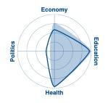
Table 23. Global Gender Gap Index – Overview

 | Rank | 2006 | Rank | 2021
Global Gender Gap Index | 42 | 0.682 | 69 | 0.716
Economic participation and opportunity | 21 | 0.704 | 23 | 0.769
Educational attainment | 20 | 0.999 | 73 | 0.993
Health and survival | 1 | 0.980 | 1 | 0.980
Political empowerment | 101 | 0.046 | 116 | 0.122

Gender equality has been one of the primary priorities of the Government of Mongolia, and Mongolia's success in progressing gender equality in health and education is very noteworthy. However, over the past 15 years, the ranking of Mongolia has fallen in three out of the four areas. The 2017 edition of the Global Gender Gap Index ranked Mongolia 53 out of 145 nations, indicating that Mongolia is falling slightly in the rankings and that women’s equality is either stagnating or not proceeding as quickly as in other nations.

Table 24. Gender equality by sector

 | Rank | Score | Avg | f | m | f/m
Health and survival
Healthy life expectancy, years | 1 | 1.060 | 1.029 | 63.8 | 57.1 | 1.12
Educational attainment
Literacy rate, % | 1 | 1.000 | 0.897 | 98.7 | 98.2 | 1.00
Enrolment in primary education, % | 119 | 0.984 | 0.755 | 95.2 | 96.8 | 0.98
Enrolment in secondary education, % | 1 | 1.000 | 0.950 | 51.3 | 48.7 | 1.05
Enrolment in tertiary education, % | 1 | 1.000 | 0.927 | 76.7 | 54.7 | 1.40
Economic participation and opportunity
Labour force participation rate, % | 85 | 0.795 | 0.655 | 58.9 | 74.1 | 0.79
Estimated earned income, int’l $1,000 | 54 | 0.666 | 0.494 | 9.7 | 14.5 | 0.67
Legislators, senior officials, managers, % | 24 | 0.775 | 0.349 | 43.7 | 56.3 | 0.78
Professional and technical workers, % | 1 | 1.000 | 0.755 | 54.1 | 46.0 | 1.18
Political empowerment
Women in parliament, % | 113 | 0.209 | 0.312 | 17.3 | 82.7 | 0.21
Women in ministerial positions, % | 85 | 0.232 | 0.235 | 18.8 | 81.2 | 0.23
Years with female/male head of state (last 50) | 72 | 0.000 | 0.144 | 0.0 | 50.0 | 0.00

Health: Significant progress has been made in the health sector, but such gains can be interrupted by climatic events coming on top of economic stresses (as in 2007-2009) and the COVID-19 pandemic. Also, there is a significant gender gap in health between women and men. The average life expectancy for women in 2021 was 63.8 years, which was 5.7 years longer than men at 57.1 years. The air pollution in Ulaanbaatar city, which is several times worse than the safe levels recommended by the World Health Organization, has a high impact on the health of pregnant women, fetus weights, and stillbirths. In addition, the city has high levels of pulmonary diseases, asthma, and other respiratory diseases, especially among children and the elderly. Low-level access to safe drinking water and using of basic sanitation facilities (pit latrines) expose many of the population to an increased risk of disease outbreaks.

Education: Achieving gender parity in education has been one of the outstanding achievements for Mongolia, with a literacy rate of 98.7% for women and 98.2% for men. The enrollment in primary school for females was 95.2% and 96.8% for males, but at higher levels of education, women are increasingly more educated than men.

Economic sectors: The four leading economic sectors in Mongolia are (i) agriculture, forestry, fisheries, and hunting; (ii) wholesale and retail trade, car and motorcycle maintenance services; (iii) the processing industry; and (iv) the mining industry. Men’s labor force participation rate and income are significantly higher than women’s across all sectors. Male labour force participation is 74.1% compared to female participation at 58.9%. Women in Mongolia continue to receive lower wages than men in many sectors of the economy, particularly in rural areas. In 2018, women earned 82.1% of the average monthly remuneration of men. This is almost a 20% wage gap, and the gap is widest in manufacturing, construction, information and communications, finance, and insurance. The tradition of passing land and other immovable property down to sons is still strong. In a 2014 survey, only 17.6% of the respondents planned to transfer the title deeds to their daughters.

Governance: Mongolia is well down the world ranking with a 17.3% representation of women in the Parliament (where 30% is considered a minimum critical mass required for women as a group to exert a meaningful influence in legislative assemblies). Women hold only 18.8% of ministerial positions. During the past 50 years, no woman has risen to the position of head of state. Therefore, much focus on improving gender equality in key socio-economic and political areas is required alongside the challenges of combating disaster and climate impacts. According to the 2021 Global Gender Gap Index of the World Economic Forum, the political empowerment of women was assessed as particularly low in Mongolia, which was placed 116th out of the 156 countries listed. Women also remain underrepresented in civil service leadership roles. Mongolian women, therefore, do not yet have a strong voice in the political and policy-making processes. The COVID-19 pandemic has adversely affected people. Out of 26 State Emergency Commission members, only three were women (11.5%).

Effects of COVID-19: Compared to men, women are more likely to be working on the front lines and fighting against the coronavirus pandemic. Women make up 81.9 percent of all health workers in Mongolia, which is much higher than the global average of 70.0. During the lockdown period, women, especially women with disabilities and pregnant women, had difficulty getting urgent medical services. Maternal mortality increased by 27.8 percent. Due to the lockdowns, there was indoor crowding, and the increased burden of unpaid work at home has negatively impacted women's mental health, increased work burden, and increased domestic and gender-based violence. During the COVID-19 pandemic, the pre-existing inequalities in the health sector and in health status have increased women's vulnerability. The micro, small and medium-sized enterprises, a sector largely dominated by women, faced severe revenue loss.

Others: With the increasing rise in risks related to climate and disaster, the disparity in socio-economic development is likely to be exacerbated by climate change related impacts. Both direct and indirect impacts of climate change and hazards for women and men are determined by preexisting gender inequalities.

Female-headed households make up roughly 25% of homes in Mongolia. The Time Use Survey (NSO Mongolia, 2009) has noted that single-parent families, which are usually female-headed, continue to become more vulnerable, particularly to flooding, suffering from land grabbing, and reduced levels of disaster assistance.

Data from the Participatory Living Standards Assessment of the NSO have identified that a disproportionate number of female-headed households live in poverty and that the proportion is growing. The unemployment rate is higher among young women than young men, and it has been rising among young women. Women are limited to engage in livelihood or employment opportunities because of the tasks at home.

In some cases, women are left alone to manage the household due to the death of a husband or due to divorce. The Human Development Report of Mongolia 2016 indicates that "young women face more difficulties entering or re-entering the labor market. The occupational segregation of women is widespread, resulting in a concentration of women in a narrow range of occupations such as education (where 80.6 percent of people employed in the sector are female), health and welfare (79.4 percent female workers), and the social sciences, business, and law (64.3 percent female workers). Women employed or engaged in small enterprises need to work longer hours than men to manage tasks at home and work.

Legal and Administrative Framework Protecting and Promoting Gender Equality

Mongolia’s Constitution enshrines basic principles of gender equality and prohibits gender-based discrimination. The Law on Promotion of Gender Equality, Article 16 stipulates that “men and women have equal rights in the political, economic, social, and cultural life and family relations.” This legal framework creates an enabling environment not only for women as individuals but also for women-led enterprises. Furthermore, Article 14 stipulates that “everyone shall be free from any type of discrimination based on his/her ethnicity, language, race, age, sex, social status, wealth, employment, position, religious belief, viewpoints, and education level.”

At the global and regional level, the Sendai Framework for Disaster Risk Reduction 2015−2030, the Ha Noi Recommendations for Action on Gender and Disaster Risk Reduction, and the Ulaanbaatar Declaration of the 2018 Asian Ministerial Conference on Disaster Risk Reduction all recognize the importance of promoting the participation of women in decision-making in disaster risk reduction (DRR) and ensuring gender-sensitive policies for disaster risk management.

The Ulaanbaatar Declaration specifically called on all governments and stakeholders to: “Promote full and equal participation of women in leading, designing, and implementing gender-sensitive disaster risk reduction policies, plans, and programs, through joint efforts by public and private sector, supported by appropriate legal frameworks and allocation of necessary resources.”

Gender equality has been an important focus area for the Government of Mongolia. Several legal documents contain more specific provisions on gender equality: the Constitution of Mongolia (1992), Law on Promotion of Gender Equality (2011), Labour Law (1999), Law on Domestic Violence (2005), Law on Social Welfare (2012), Law on Family (1999), Law on Environmental Protection (LEP) 1995 (Rev. 2008)

In line with these policies, several programs are being implemented by the government: National Program on Ensuring Gender Equality (2017-2021), National Programme of Community Participatory Disaster Risk Reduction (2015–2025), National Action Programme on Climate Change (NAPCC) 2011, National Green Development Policy (NGDP) 2014, Environmental Sector Gender Strategy 2014–2030.

Other programs include the National Program on Combating Domestic Violence, the National Program on protection from trafficking in children and women for sexual exploitation, the Mid-term Strategy and Action Plan for Implementing the Law of Mongolia on Promotion of Gender Equality (2013 – 2016), National Program on Combating Domestic Violence, National Program on protection from trafficking in children and women with the purpose of sexual exploitation, Mid-term Strategy and Action Plan for Implementation of the Law of Mongolia on Promotion of Gender Equality (2013 – 2016), etc.

The National Committee on Gender Equality is the government body led by the Prime Minister responsible for implementing gender equality. It comprises 13 Ministries of Mongolia as its sub-council, nine districts, 21 provinces, and the city of Ulaanbaatar as its subcommittees. One gender focal person is assigned at the Ulaanbaatar Municipality, and there are social welfare workers in every khoroo are assigned as the gender focal persons.

On the international level, Mongolia is a signatory to several international instruments pertaining to women's rights and gender equality, most importantly the Convention on the Elimination of All Forms of Discrimination against Women (CEDAW), which it ratified in 1981.

Data baseline – overview of disaggregated data (beneficiaries) in target communities

The data collected by UN-Habitat from the eight khoroos in two target districts show that 67,932 people live in 16,773 households. In one-third of the cases, more than one family lives in one plot. In the proposed project target areas, there appears to be a balanced representation of both men and women. The combined number of men for the eight khoroos slightly exceeds that of women. The project will actively encourage women's involvement in implementation, advisory, and decision-making roles as part of its design.

The data indicate that 3.4% of households in the target area are single headed, while 8.2% of people live below the poverty line in terms of income level. They are one of the prioritized vulnerable target groups for the concrete project interventions under Component 3 (construction of flood control facilities and improved sanitation facilities).

Table 25. Beneficiaries in the target communities

Information | Khoroo |  |  |  |  |  |  |  | TOTAL
Information | 15 | 16 | 18 | 20 | 4 | 5 | 26 | 27 | TOTAL
No. of Plots | 1,089 | 1274 | 1,996 | 2,109 | 1,273 | 1,155 | 2,456 | 48 | 11,400
Households | 1,818 | 3,056 | 1,996 | 1,466 | 1,819 | 1,852 | 2,960 | 1,806 | 16,773
Total population | 6,684 | 11,766 | 9,495 | 8,050 | 6,697 | 7,229 | 10,428 | 7,583 | 67,932
Male | 3,364 | 5,813 | 4,771 | 5,762 | 3,316 | 3,572 | 5,254 | 3,737 | 35,589
Female | 3,320 | 5,953 | 4,724 | 2,288 | 3,381 | 3,657 | 5,174 | 3,846 | 32,343
People with disability | 212 | 293 | 202 | 256 | 184 | 129 | 202 | 137 | 1,615
Single headed family | 138 | 140 | 76 | 41 | 38 | 69 | 62 | 41 | 564
Households under poverty line | 128 | 170 | 143 | 52 | 431 | 469 | 456 | 439 | 1,380

Initial Gender Assessment

During the initial consultations, meetings with the key stakeholders were conducted where most participants were women. The discussions focused on problems being faced, mitigation measures, identification of specific needs regarding proposed interventions, and interest in participating in project activities and the decision-making process.

During on-site consultations via the People's Process, women were observed to be very active in the communities. The number of women attendees in the initial consultations exceeded that of the men. Aside from the numbers, the women participants were observed to provide substantive inputs in analyzing the problems and issues and coming up with recommended solutions. Equal involvement of women and men in the project activities will be ensured through community planning and consultations throughout the project. Besides that, the following stakeholders have been consulted to understand specific gender issues and needs:

Type of stakeholder | Key stakeholders
National/City government | Department of Climate Change, Ministry of Environment and Tourism  Municipality of Ulaanbaatar – Engineering Division under the Mayor’s Office, Hydrology facilities management company, Emergency Management Agency
Local Authorities & Communities | District authorities of Songinokhairkhan and Sukhbaatar districts and eight Khoroo Authorities, residents from Khoroos 4, 5, 26, 27, 15, 16, 18 and 20.

Gender Considerations in the proposed project

The Gender Action Plan will describe the proposed measures to be included in the project design to promote gender equality and mainstream gender in the project's four (4) main outputs.

Addressing the gender concerns will entail close consultation and collaboration with women from the project design stage, implementation, operations, and monitoring and evaluation. The project, as part of its concept and design, will actively encourage the involvement of women in implementation, advisory, and decision-making roles contributing to alleviating the absence of women in the fields of science, technology, and construction.

Women in Mongolia are mainly responsible for household tasks such as household water and sanitation, health and hygiene, cooking and managing food, childcare so they are more vulnerable to flood hazards, experiencing deficits in food, clothing, communications, fuel wood, disease exposure, water quality problems, and sexual harassment. Therefore, the project will make sure women participate in decision-making around appropriate infrastructure design, operation and maintenance features. The project will thus take a transformative approach on their empowerment and resilience building activities.

Equal involvement of women and men in the project activities will be ensured through community planning and consultations throughout the project period.

Entry points to integrate gender considerations (how to empower women)

The specific gender objectives for the project are:
- To integrate gender sensitive urban adaptation measures in the NDC, NAP and other relevant policies
- To contribute to improving gender equality within the targeted eight Ger khoroo settlements
- To promote women’s empowerment and women’s leadership within the project implementation and within decision-making bodies.
- To support and strengthen the women’s resilience building for flood related risks

The project design and approach are 'gender-responsive' because, even during the project preparation phase, gender equality and women's empowerment have been proactively considered in the project’s design. The initial data collection focused on issues, needs, perceptions, activity prioritization, and identifying and verifying specific gender-related risks and impacts. This has been done through desk research, women's focus group discussions, and community decision-making processes.

Design of intervention activities

The project aims to provide people access to better sanitation and flood resilient environment, improving their quality of life and family health. The benefits will be achieved through the construction of flood control facilities and improved sanitation. As per the results of stakeholders’ consultations, the anticipated impacts of project interventions are the following:

Flood control facilities: The provision of flood facilities will increase environmental safety and security and lessen the risk of waterborne diseases brought by a flash flood and overfill of pit latrines. It will also enable the local Government and communities to improve the road network and access to their plots for better and safe mobility in the area, especially for women, children, and the elderly and differently abled.

Improved sanitation will include better hygiene practices and convenience, especially for women, children, and persons with disabilities. Other potential benefits include decreased incidences of waterborne and other diseases related to water pollution and poor sanitation, and economic or business opportunities due to reliable sanitation services. The risk of women and children to waterborne infectious diseases, and consequently the medical costs of these diseases, will be reduced due to improved sanitation facilities at the household level. Proper household practices on sanitation, hygiene, and health will be communicated to the target area communities through a community awareness program involving information, education, and communication campaign.

Gender-responsive indicators

Women are well represented in community groups. Therefore, the project design team found no evidence to suggest that women have unequal opportunities to participate in the project and do not benefit equally from interventions.

However, the project will ensure 50% representation during the meetings, consultations, community votes, participatory planning, and monitoring initiatives under the People's Process approach. A comprehensive list of indicators will be included in the Gender Action Plan. The main gender-focused indicators the project will aim to achieve are:
- 50% of the members of the communities established to implement the project will be female
- 50% of trainees at all training/workshops and learning events will be female
- Commitment to greater involvement of female senior government representatives in the project
- 50% of direct beneficiaries of improved toilets will be female

Gender disaggregated information will be collected to monitor progress toward and achievement of the above gender targets. Gender FGDs will be conducted every 6 months, and an analysis will be included in project reports to establish a qualitative baseline of gender perceptions and monitor changes in behaviors and attitudes as the project progresses.

Promoting an enabling environment for gender equality: Implementation, Performance Monitoring and Evaluation

Policy Arrangements: The Project Executing Unit will aim to enhance gender equality in the composition of members by reaching out to female government representatives and including them in the Project Board.

Management Arrangements: The principal Gender Focal Point for the project will be the National Project Manager of the Implementing Entity. The counterpart gender focal point within Government will be the designated gender focal point of the Municipality of Ulaanbaatar. Furthermore, a gender focal point will be established for each executing entity and partner as a condition of project participation.

Capacity Building Strategy: The community groups established as part of the People's Process, will aim for gender equality in the composition of training participants and will also ensure gender parity and gender considerations in the planning and implementation. Women will form 50% of the community groups and will receive the training and capacity building designed for the training on project implementation delivered by the Peoples Process. Women will be encouraged to be involved in executing operations and maintenance plans and mechanisms for concrete interventions.

Monitoring: The monitoring of the GAP will be done using a participatory approach with the key stakeholders at the kheseg, khoroo, district, and municipal levels. Disaggregated data focused on climate change-related issues, needs and perceptions of vulnerable groups, activity prioritization, and identifying and verifying potential risks and impacts will be collected through community surveys and public consultations

Specific Focus Group Discussions will be held with women as well as those in vulnerable situations to discuss the prioritization and selection processes of interventions proposed under the project. Vulnerable groups will continue to be consulted via FGDs beyond the community consultation processes of the People's Process. The grievance mechanism to be established under the project will further provide a platform for feedback and consultation where necessary.

During community mobilization planning and implementation, IE and EE staff will ensure sensitization around gender issues will be conducted for both women and men around gender-specific participation and roles within the project.

Knowledge Management, Information Sharing and Reporting

All knowledge components of the project will also ensure gender parity and gender considerations in the planning and implementation. The Operational Manual developed for the project will contain a Gender approach linked to AF GP. The project will maintain a gender and age disaggregated database of direct beneficiaries and stakeholders involved in the project. The lessons learned in workshops and training organized for the city- and district government officials will also try to ensure 50 percent women's participation if possible.

A specific knowledge component to track the gender and youth responsiveness and impact of the project, a rapid survey on Knowledge Attitudes and Practices (KAP), will be organized by the national implementation team through targeted Focus Group Discussions with women and youth during the project.

Table 26. Gender Action Plan Summary Table

Project  Components | Outputs | Activities | Indicator | Target | Verification Means | Responsibility Party
Project component 1: Enhance the policy and regulatory environment at the national and city level to reduce risks and enhance adaptive capacity in the future in terms of changing climate in urban areas | Output 1.1-1.5  Review of existing adaptation policy and regulations from the urban context and suggest required integration of urban adaptation measures; Detailed Khoroo and District level flood/hazard risk, exposure and vulnerability assessment reports prepared for the selected Ger areas | - Ensure the required review and risk assessment activities and workshops have at least 50% of women  representation  - Ensure urban adaptation measures are gender sensitive | Percentage of women participating in review and risk and vulnerability assessments  Number of urban adaptation measures that are gender sensitive | 50% | Attendance Sheet  Sex disaggregated data collection  Periodic reports  Documentation of the urban adaptation measures | UN-Habitat Gender Specialist  Executing Entity Gender Specialists and  Community Mobilisers
Project component 2: Build capacity at the national, city and community level to adapt now and in the future | Output 2.1  Capacity building programme implemented at the sub-national level to plan for and manage urban adaptation actions  Output 2.2.  Capacity building programme implemented at the community level to manage and maintain small-scale adaptation infrastructure  Output 2.3.  Capacity built to meet future urban adaptation financing needs and community-based disaster risk reduction and assets protection trainings. | Capacity building programme implemented at the sub-national level with at least 50% women engagement  Community mobilization, organization and capacity building at the community level with at least 50% women engagement | Percentage of women participating in awareness campaigns and trainings | 50% | Attendance Sheet  Sex disaggregated data collection  Periodic reports | UN-Habitat Gender Specialist  Executing Entity Gender Specialists and  Community Mobilisers
Project component 3: Reduce risks from flooding through physical infrastructure in the target areas | Output 3.1 – 3.4  Physical assets developed or strengthened in response to climate change related flood impacts as prioritized (by Khoroos drainage and sanitation) – implemented through community contracting | Ensure the target population consulted for the technical studies with at least 50% women representation  Ensure the women, elderly, PWD are consulted for the designs of flood facilities and improved toilets and their specific needs are integrated in the implementation | Percentage of women consulted for the technical studies  Number of women with access to improved sanitation  Number of toilets that are appropriate for women, elderly and PWD (UN-Habitat SII) | 50% | Attendance Sheet  Sex disaggregated data collection  Periodic reports | UN-Habitat Gender Specialist  Executing Entity Gender Specialists and  Community Mobilisers
Project component 4: Improve and enhance the knowledge base to sustain and replicate the project’s gains. | Output 4.1.  Knowledge captured from project implementation and disseminated through media, web-stories and case studies trainings.  Output 4.2.  National and local government and research community have increased knowledge resources at its disposal  Output 4.3.  Bringing Global Knowledge on best practices to Implementing Partners and communities | Knowledge sharing and capacity building programme implemented at the sub-national  and community level with at least 50% women engagement | Percentage of women participation | 50% | Attendance Sheet  Sex disaggregated data collection  Periodic reports | UN-Habitat Gender Specialist  Executing Entity Gender Specialists and  Community Mobilisers

Annex 4 - UN-Habitat People’s Process Benefits Poster
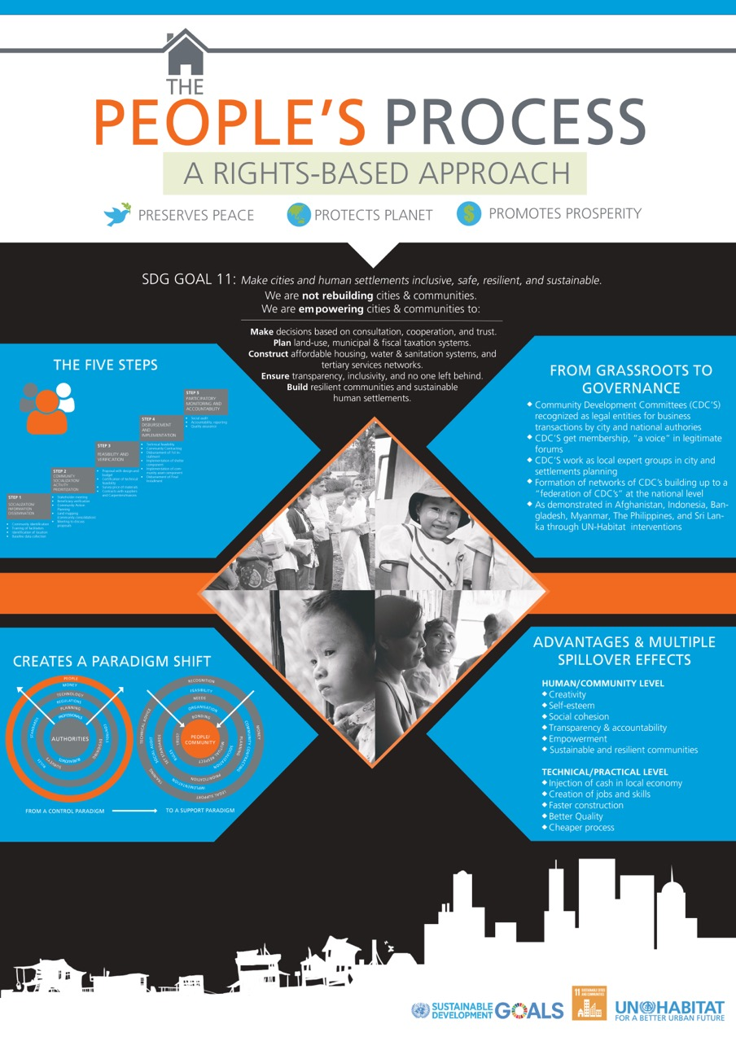

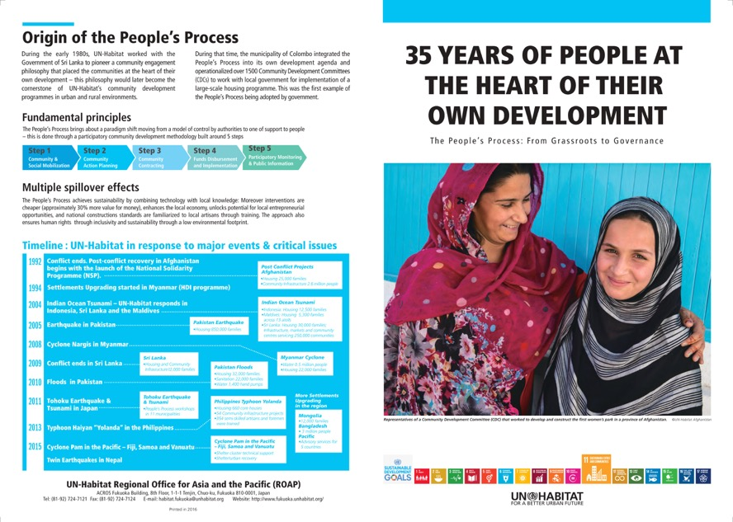

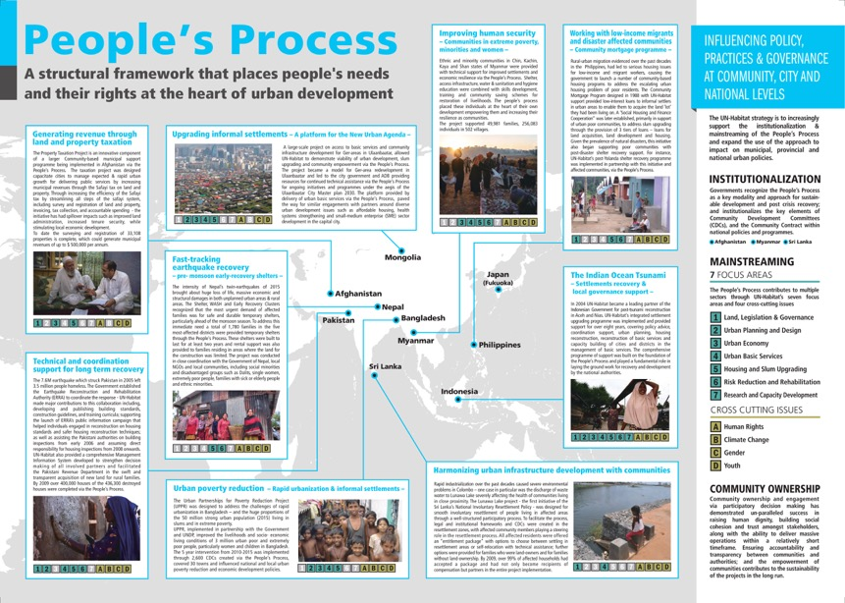

Annex 5 Summary of Proposed Physical Construction Activities

A. Summary

As a response to the khoroo-specific climate change resilience building needs and intervention prioritization by communities, the project will concentrate on two main concrete interventions (to address flood risks and related water pollution and health risks due to flooded latrines: 1) Flood protection and drainage infrastructure and 2) flood resilient latrines. The interventions focus on addressing climate change impacts in the hot spot areas of the target Khoroos, while maximizing (downstream) benefits. Importantly, to ensure effective operation and sustainability / maintenance of the project interventions, supporting activities to ensure this have been identified.

Over 75 per cent of the project’s execution budget will be invested in the physical infrastructures. The infrastructure to be constructed will include:
a. Sukhbaatar District Khoroo 18, 20, 15, and 16.
- 1.54 km retention wall,
- 5.578 km urban drainage constructed
- 1.781 km drainage repaired
b. Songinokhairkhan District Khoroo 4, 5, 26, and 27
- 2.182 km of flood protection canals

In Khoroo 20 of Sukhbaatar District where a spring has burst, a flood defense embankment will be created that will also retain and enhance the features of the current park. The cost-benefit of the investment here will be increased by designing the infrastructure, so it forms part of a multi-functional green public space. This will bring co-benefits in terms of an urban ecosystem, the public good of a safe, inclusive public space and a contribution to improved air quality.

The embankment of the current river will be strengthened on both banks and provide a drainage channel so that the water does not overflow and flood the houses and ger plots. The character of the river will be maintained throughout the alignment. Based on initial consultations for the preparation of this concept note, it was agreed by the local engineering team that this drainage would be cheaper and less risky against the AF Environmental and Social Safeguard policy. The alternative would be to construct an underground system to gradually release melting permafrost. However, this would be more expensive, untested from an engineering perspective and carry greater risk of disruption to houses/private land.

Proposed activities will also invest in flood protection measures in Khoroos 4, 5, 26 and 27 of Songinokharkhan District that will address overflows that emanate from the river. The engineering team has assessed that there is no feasible alternative other than to invest in these measures.

According to the hydrological study conducted by the engineers and hydrologists, and based on further consultation, the engineering solutions proposed are the only ones available that are likely to be effective in supporting communities in the target area to adapt.

However, alternative citing of the drainage infrastructure was considered. Under the alternate citing of the infrastructure in Khoroos 15, 16, 18 and 20 of Sukhbaatar District, the infrastructure would affect 24 private residential plots. Households on these plots would be entitled to compensation under the law of between US$20,000 and US$50,000, depending on various factors, including the precise location and nature of the disruption. Taking the median of US$35,000, we can estimate that if compensation had to be paid to all plot holders, this would add US$840,000 to the cost of the drainage infrastructure, and would trigger a potentially serious environmental and social safeguard risk under the involuntary resettlement safeguard area of the AF Environmental and Social Policy.

A similar situation would also arise in Khoroos of Songinokhairkhan District. During the preparation of the concept note, an alternative citing of the infrastructure was considered, but under this alternative citing, 26 private, residential plots would be affected. As above, plot holders would be entitled to compensation, so using the same assumptions as above, compensation would add an estimated US$910,000 to the cost of the infrastructure. As above, this alternative citing was not given further consideration as it would be too expensive and could potentially add a serious environmental and social safeguard risk under the involuntary resettlement safeguard area of the AF Environmental and Social Policy.

Planned Flood Facilities (Khoroo 15,16,18 and 20 Sukhbaatar District)

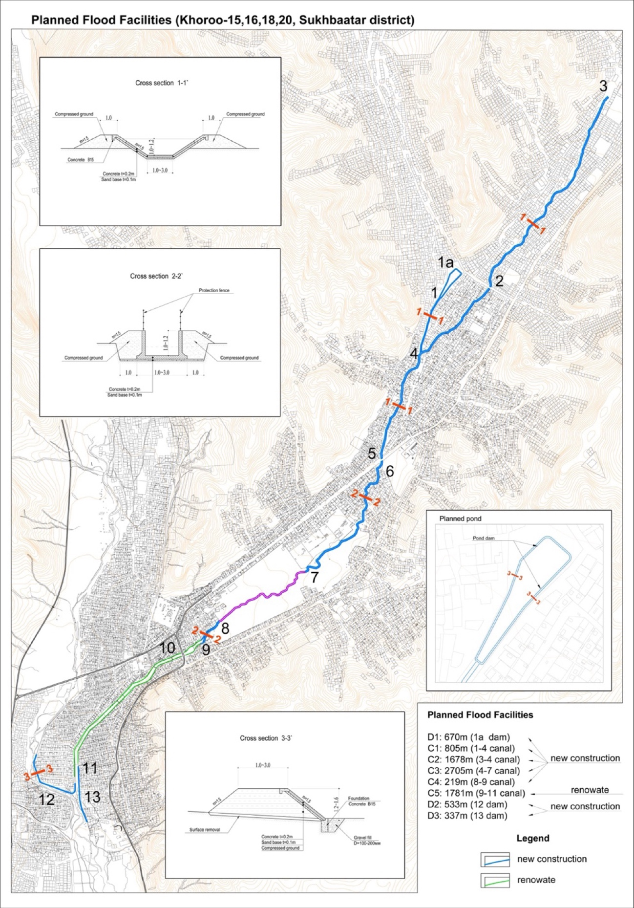

Planned Flood Facilities (Khoroo 4, 5, 26 and 27 Songinokhairkhan District)

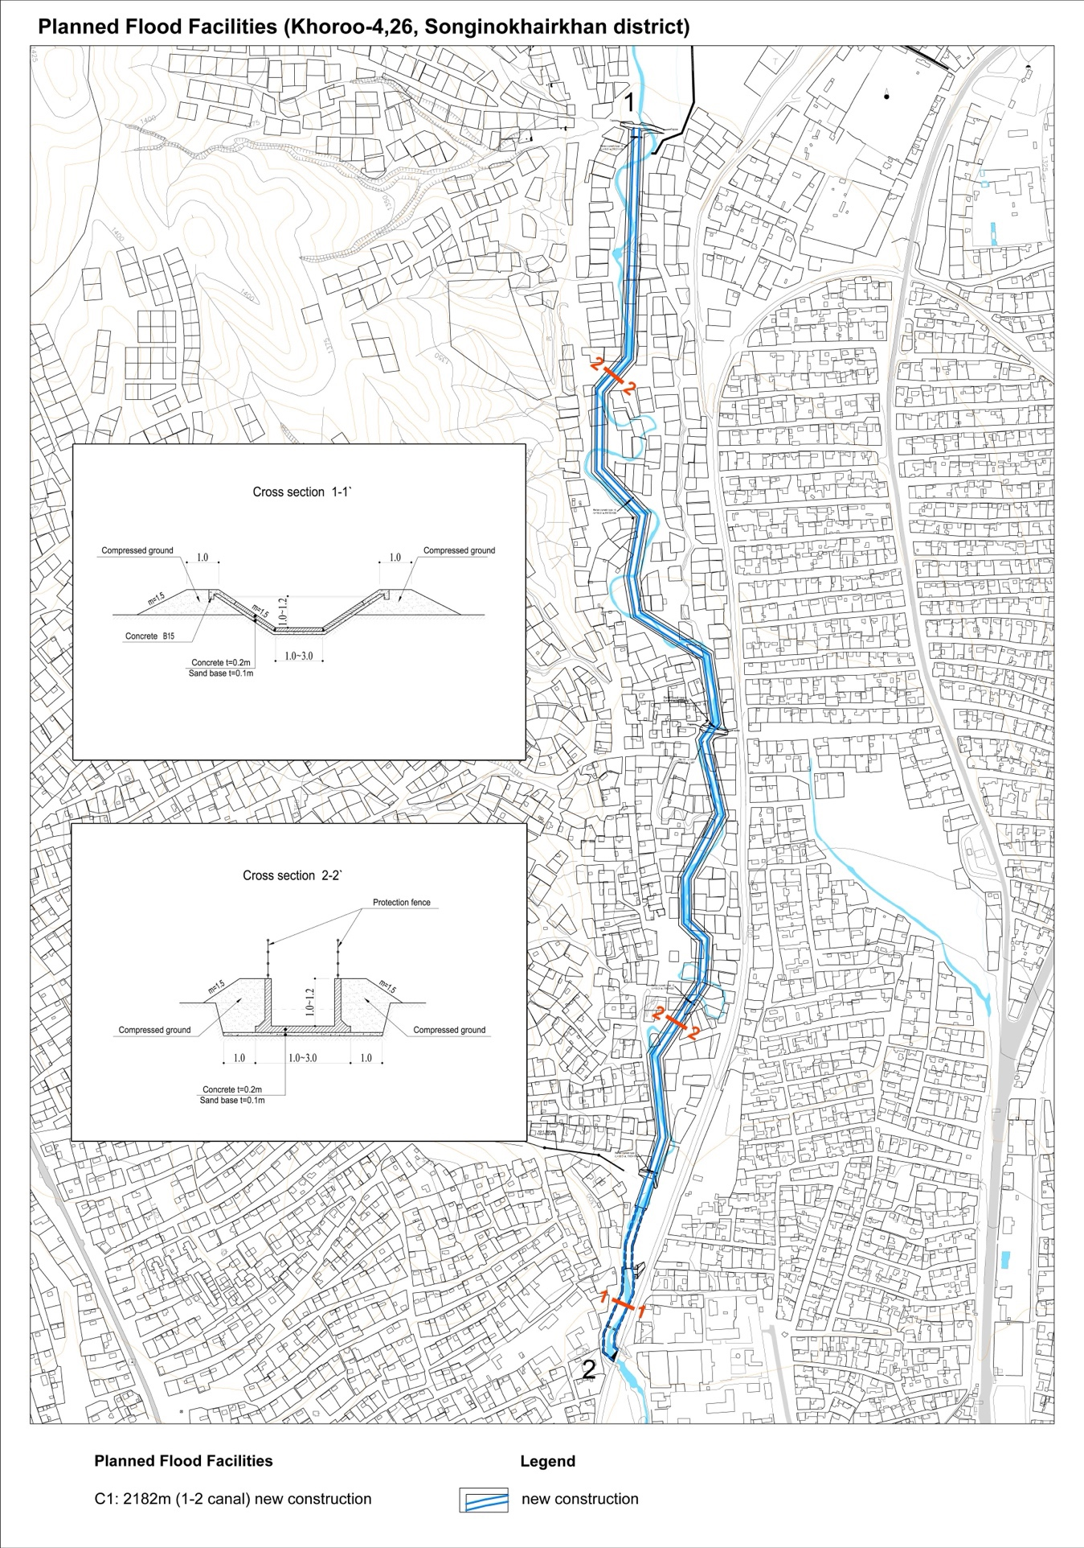

Summary | Budget | 2 | 3 | 4
Summary | Budget | 12 m | 12 m | 12 m
Year 2
Sukhbaatar Khoroo 18 D1 Package 1 | 147,735 | 147,735 | - | -
Sukhbaatar Khoroo 18 C1 Package 1 | 241,359 | 241,359 | - | -
Sukhbaatar Khoroo 18 C3 Package 3 | 316,066 | 316,066 | - | -
Sukhbaatar Khoroo 18 C4 Package 4 | 463,710 | 463,710 | - | -
Sukhbaatar Khoroo 20 C2 Package 2 | 704,186 | 704,186 | - | -
Songinokhairkhan Khoroo 26 and 5  C1 Package 8 | 475,646 | 475,646 | - | -
Songinokhairkhan Khoroo 26 and 5  C1 Package 9 | 356,292 | 356,292 | - | -
Year 3
Sukhbaatar Khoroo 16 C5 Package 5 | 643,625 | - | 643,625 | -
Sukhbaatar Khoroo 16 C6 Package 6 | 96,809 | - | 96,809 | -
Sukhbaatar Khoroo 16 C7 Package 6 | 511,739 | - | 511,739 | -
Sukhbaatar Khoroo 15 D2 Package 7 | 117,527 | - | 117,527 | -
Sukhbaatar Khoroo 15 D3 Package 7 | 74,309 | - | 74,309 | -
Songinokhairkhan Khoroo 4 and 27  C3 Package 10 | 132,615 | - | 132,615 | -

B. Area 1 Sukhbaatar District Khoroo 18, 20

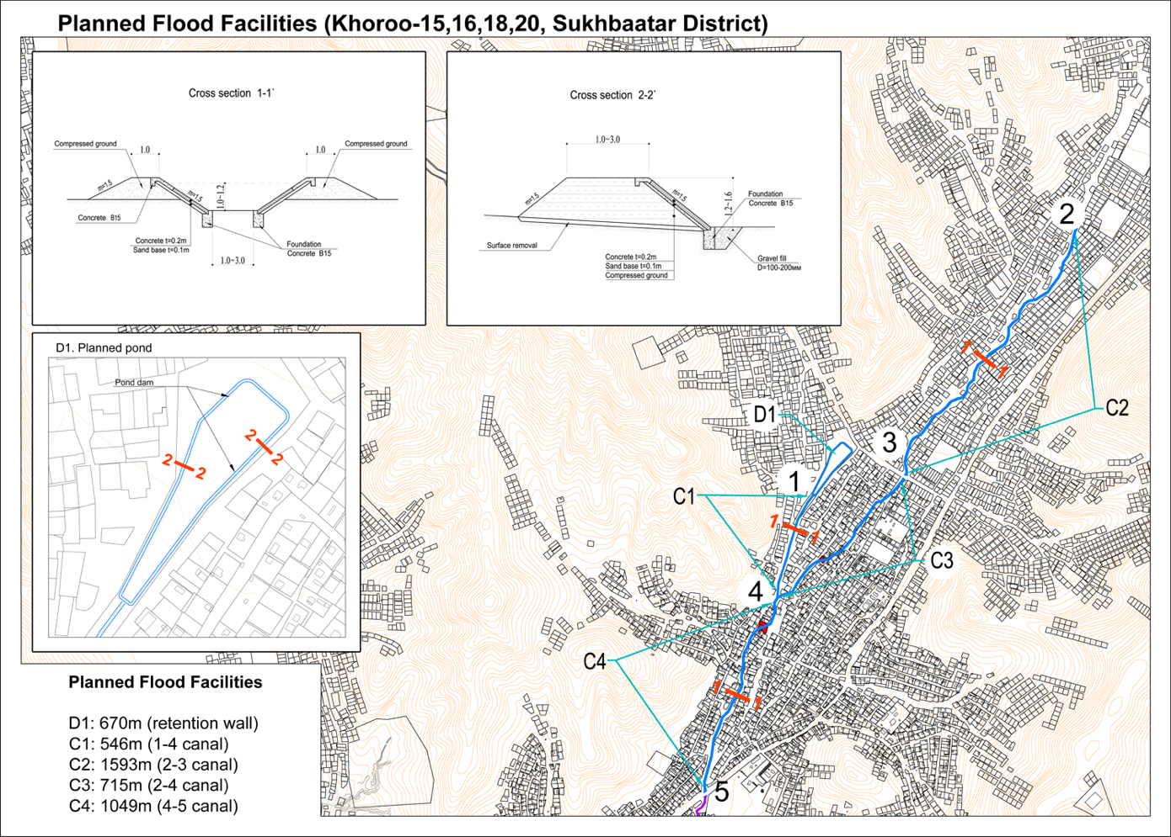

LOCATION D1 KHOROO 18

There is currently a park where a burst spring has emerged and flooded not only the park but also the nearby houses. So, it is proposed to construct an embankment (670m) around the park as shown in cross-section 2-2. The work will consist of 1.2 to 1.6m of compressed earth embankment with concrete surface. The tree-planting work will also focus on this area. There will be a co-benefit to this activity of restoring the park to be a safe, inclusive and usable public space.

Location | From #375, Belkh-48 to #300, Belkh-48
Current land status: | Public
Land use: | Park
Detailed activity: | Embankment protection around spring, Construct a flood retention wall / embankment
Reference | Pkg 1 Pond
Cross section | Cross section 2-2
Length | 670m
 | 1 – 3 m wide, 1.2 – 1.6m high compressed ground embankment with 1,5m concrete slope surface on concrete foundation
Material | concrete, compressed ground

LOCATION C1, C2, C3 and C4 – KHOROO 18, 20

C1, C2, C3 and C4: are located along an existing stream where the bank will be strengthened with compressed earth with concrete surface as shown in cross section 1-1. The length of each section is 546 metres, 1593m, 715m and 1049m respectively.

LOCATION C1 KHOROO 18

Location | From #300, Belkh-48 to #208, Belkh-48
Current land status: | Public
Land use: | River
Detailed activity: | Flood protection and drainage infrastructure, Drainage channels
Reference | Pkg 1
Cross section | Cross section 1-1
Length | 546m
 | 1m wide, 1 – 1.2m high compressed ground embankment with 1,5m concrete slope surface on concrete foundation
Material | concrete, compressed ground

LOCATION C2 KHOROO 20

Location | From #1, Tsolmon-11 to #422, Tsolmon-2
Current land status: | Public
Land use: | River
Detailed activity: | Flood protection and drainage infrastructure, Drainage channels
Reference | Pkg 2
Cross section | Cross section 1-1
Length | 1,593m
 | 1m wide, 1 – 1.2m high compressed ground embankment with 1,5m concrete slope surface on concrete foundation
Material | concrete, compressed ground

LOCATION C3 KHOROO 18

Location | From #365, Belkh-48 to #208, Belkh-48
Current land status: | Public
Land use: | River
Detailed activity: | Flood protection and drainage infrastructure, Drainage channels
Reference | Pkg 3
Cross section | Cross section 1-1
Length | 715m
 | 1m wide, 1 – 1.2m high compressed ground embankment with 1,5m concrete slope surface on concrete foundation
Material | concrete, compressed ground

LOCATION C4 KHOROO 18

Location | From #208, Belkh-48 to #26, Belkh-39
Current land status: | Public
Land use: | River
Detailed activity: | Flood protection and drainage infrastructure, Drainage channels
Reference | Pkg 4
Cross section | Cross section 1-1
Length | 1,049m
 | 1m wide, 1 – 1.2m high compressed ground embankment with 1,5m concrete slope surface on concrete foundation
Material | concrete, compressed ground
Households affected | Preliminary alignment show that 2 plots encroached upon the riverbed will be affected. Affected plot 4 309# Belh-48, 50#Belh-47, 50a#Belh-47, 50b#Belh-47

C. Area 1 Sukhbaatar District Khoroo 16, 15

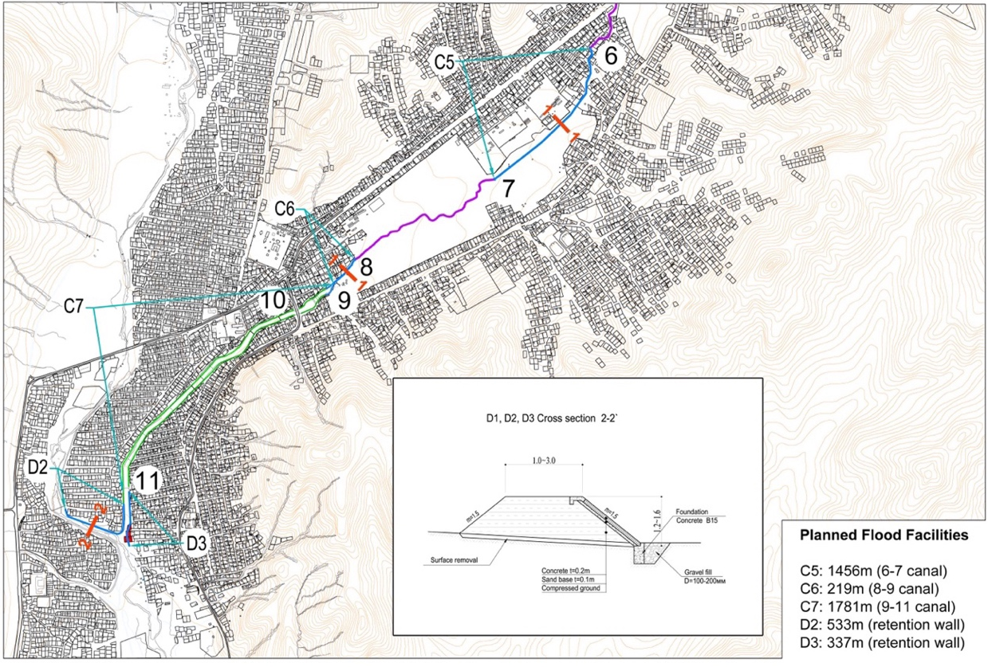

LOCATION C5, C6 and C7

- C5, C6: are continuations of the above work on strengthening the banks along the stream as shown in cross section 1-1. The length is 1456m and 219m.
- C7: There is already an existing canal which require repair and reinforcement. The total length is 1,781m.
- D2 and D3: These two locations of 533m and 337m require reinforcement of the bank as shown in cross-section 2-2.

LOCATION C5 KHOROO 16

Location | From #102, Oichid-1 to #14060, Dambadarjaa
Current land status: | Public
Land use: | River
Detailed activity: | Flood protection and drainage infrastructure, Drainage channels
Reference | Pkg 5
Cross section | Cross section 1-1
Length | 1,456m
 | 1m wide, 1 – 1.2m high compressed ground embankment with 1,5m concrete slope surface on concrete foundation
Material | concrete, compressed ground

LOCATION C6 KHOROO 16

Location | From #25, Belkhi-34 to #1-1, Belkhi-32
Current land status: | Public
Land use: | River
Detailed activity: | Flood protection and drainage infrastructure, Drainage channels
Reference | Pkg 6
Cross section | Cross section 1-1
Length | 219m
 | 1m wide, 1 – 1.2m high compressed ground embankment with 1,5m concrete slope surface on concrete foundation
Material | concrete, compressed ground

LOCATION C7 KHOROO 16

Location | From #1-1, Belkhi-32 to #177, Belkh-8
Current land status: | Public
Land use: | River
Detailed activity: | Flood protection and drainage infrastructure, Drainage channels
Reference | Pkg 6
Cross section | Cross section 1-1
Length | 1,781m
 | 1m wide, 1 – 1.2m high compressed ground embankment with 1,5m concrete slope surface on concrete foundation
Material | concrete, compressed ground

LOCATION D2 KHOROO 15

Location | From #81, Dambadarjaa-20, to #7, Dambadarjaa-1
Current land status: | Public
Land use: | River
Detailed activity: | Flood protection and drainage infrastructure, Drainage channels
Reference | Pkg 7
Cross section | Cross section 1-1
Length | 533m
 | - 1m wide, 1 – 1.2m high compressed ground embankment with 1,5m concrete slope surface on concrete foundation
Material | concrete, compressed ground

LOCATION D3 KHOROO 15

Location | From #177, Belkh-8, to #282, Belkh-11
Current land status: | Public
Land use: | River
Detailed activity: | Flood protection and drainage infrastructure, Drainage channels
Reference | Pkg 7
Cross section | Cross section 1-1
Length | 337m
 | - 1m wide, 1 – 1.2m high compressed ground embankment with 1,5m concrete slope surface on concrete foundation
Material | concrete, compressed ground
Households affected | - Preliminary alignment show that 4 plots encroached upon the riverbed will be affected: 235#Belkh11, 282#Belkh11, 282a#Belkh11, 282b#Belkh11

D. Area 2 Songinokhairkhan District Khoroo 4, 5, 26 and 27

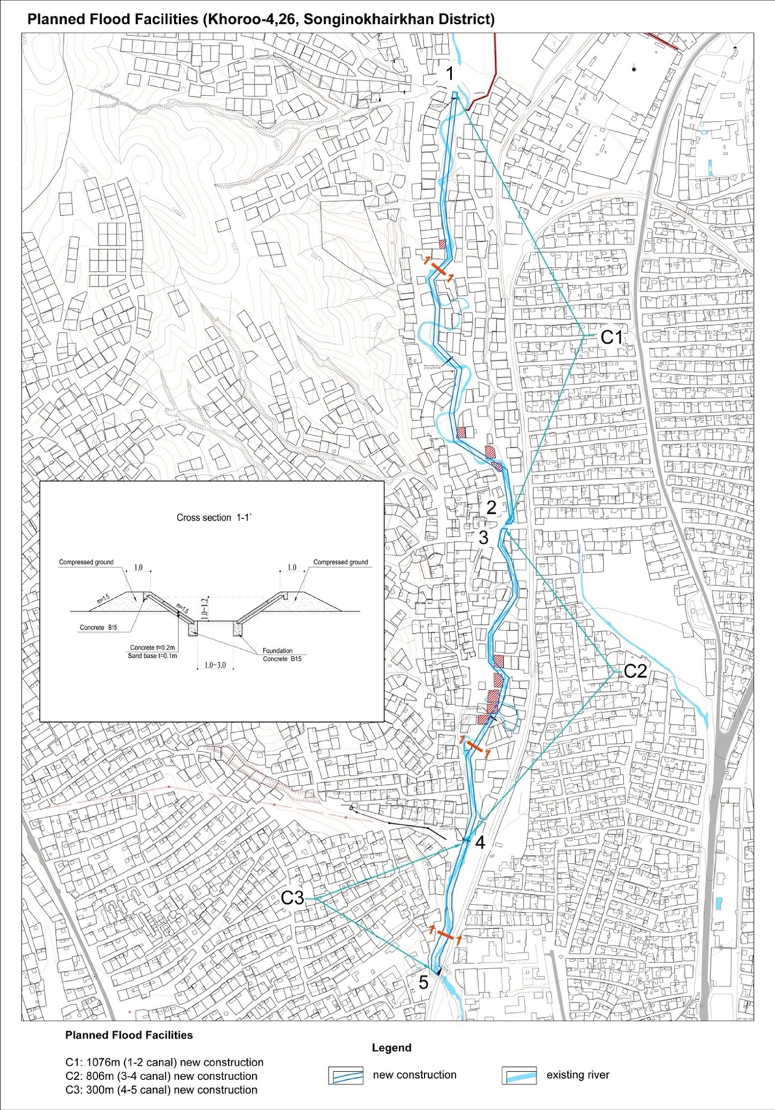

In Khoroo 26 and 5, the project will focus on avoiding future development / settlement in the riverbed through land use planning. Besides that, the settlers that are already located in the riverbed, will be sensitized about the fact that they are living in a high-risk area.

In Khoroo 4 and 27 the project will focus on developing the drainage channels that will benefit the most inhabitants. In the north-east sections, the proposed drainage channel will capture all water coming from the north-east. In the southern sections, the drainage channel will divert flood water to avoid flooding of large apartment blocks and the build-up of stagnant water in the western section of the Khoroo. In the remaining area of the Khoroos, the project will focus on increasing the flood resilience of latrines, also benefitting downstream areas from run-off of polluted water.

The drainage interventions are proposed to be constructed in residential areas (there are no shops or restaurants) which will not disrupt existing local livelihoods and income generation activities. Interventions are also designed in a way so as to not disrupt daily life in terms of access or reduced mobility – in addition to guaranteeing access to plots at all times, there will be no restrictions on access to main roads.

LOCATION C1, C2 and C3

C1 and C2 in khoroo 26 and 5 will be 1076m and 806m in length and C3 in khoroo 4 and 27 will be 300m long. The drain is located along an existing stream where the bank will be strengthened with compressed earth with concrete surface as shown in cross section 1-1.

LOCATION C1 KHOROO 26 and 5

Location | From #33, Bayanbulag-5 to #1, Bayanbulag-2
Current land status: | Public
Land use: | River
Detailed activity: | Flood protection and drainage infrastructure, Drainage channels
Reference | Pkg 8
Cross section | Cross section 1-1
Length | 1,076m
 | 1m wide, 1 – 1.2m high compressed ground embankment with 1,5m concrete slope surface on concrete foundation
Material | concrete, compressed ground
Households affected | Preliminary alignment show that 4 plots encroached upon the riverbed will be affected: 7# Bayanbulag-5, 26#Bayanbulag-2, 21#Bayanbulag-2, 37#Bayanbulag-2

LOCATION C2 KHOROO 26 and 5

Location | From #101, Bayanbulag-1 to #1, Bayanbulag-2
Current land status: | Public
Land use: | River
Detailed activity: | Flood protection and drainage infrastructure, Drainage channels
Reference | Pkg 9
Cross section | Cross section 1-1
Length | 806m
 | 1m wide, 1 – 1.2m high compressed ground embankment with 1,5m concrete slope surface on concrete foundation
Material | concrete, compressed ground
Households affected | Preliminary alignment show that 4 plots encroached upon the riverbed will be affected:30#Bayanbulag-1, 31#Bayanbulag-1, 52#Bayanbulag-1, 98#Bayanbulag-1

LOCATION C3 KHOROO 4 and 27

Location | From #49, Ikh naran-13 to #54, Ikh naran-8
Current land status: | Public
Land use: | River
Detailed activity: | Flood protection and drainage infrastructure, Drainage channels
Reference | Pkg 10
Cross section | Cross section 1-1
Length | 300m
 | 1m wide, 1 – 1.2m high compressed ground embankment with 1,5m concrete slope surface on concrete foundation
Material | concrete, compressed ground

E. Cross Sections

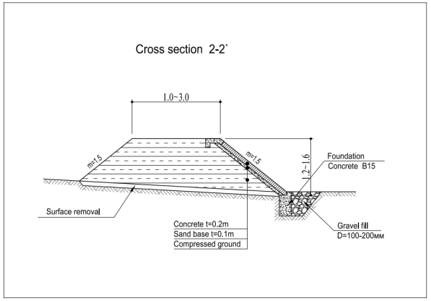
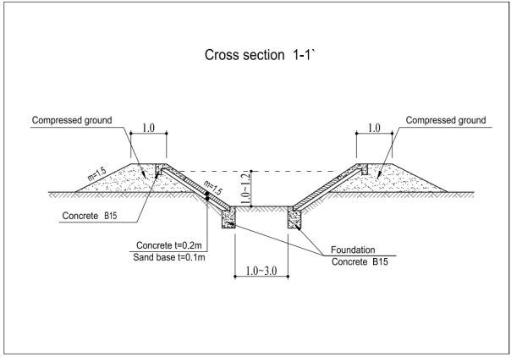

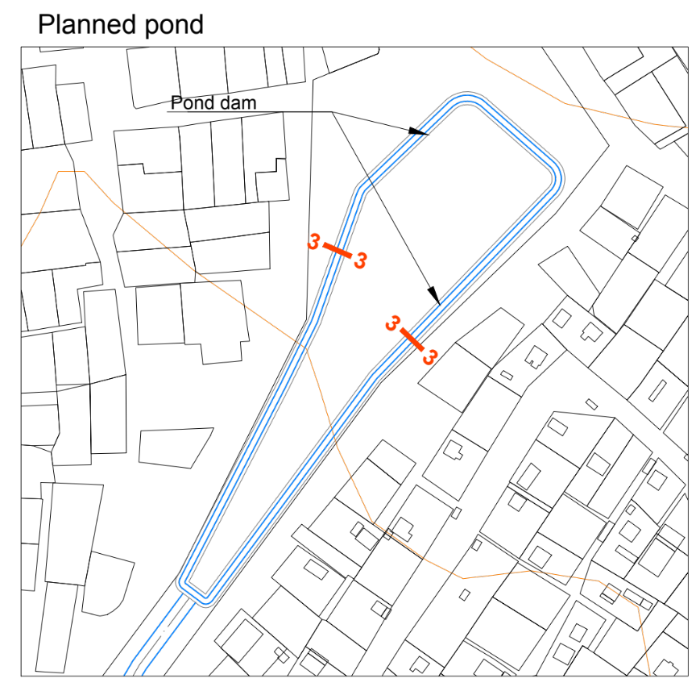

F. Flood Resilient Latrines

The figure below shows a schematic drawing of the improved and affordable pit latrines to be provided to vulnerable households. The septic tanks will be strengthened in consideration of the permafrost interaction, ensure that wastewater does not leak or penetrate into the soil and ground water table and provide convenient access for emptying. The design will take into consideration the needs of the elderly and the persons with disability.

Current land status: | mixed
Current land use: | residential
Designs | will ultimately be agreed upon with residents. Design support will come from the university and other partners.
Location | Latrines will be placed within residential plots
Beneficiaries | The selection of beneficiaries / locations within the khoroos will be done by the khoroo members themselves besides some basic criteria: Income / poverty, Flood vulnerability, Willingness to cost share

Area 1 Sukhbaatar District | Khoroo 15 | 18 units
Area 1 Sukhbaatar District | Khoroo 16 | 117 units
Area 1 Sukhbaatar District | Khoroo 18 | 109 units
Area 1 Sukhbaatar District | Khoroo 20 | 66 units
Area 2 Songinokhairkhan District | Khoroo 4 and 27 | 12 units
Area 2 Songinokhairkhan District | Khoroo 26 and 5 | 78 units
TOTAL |  | 400 units

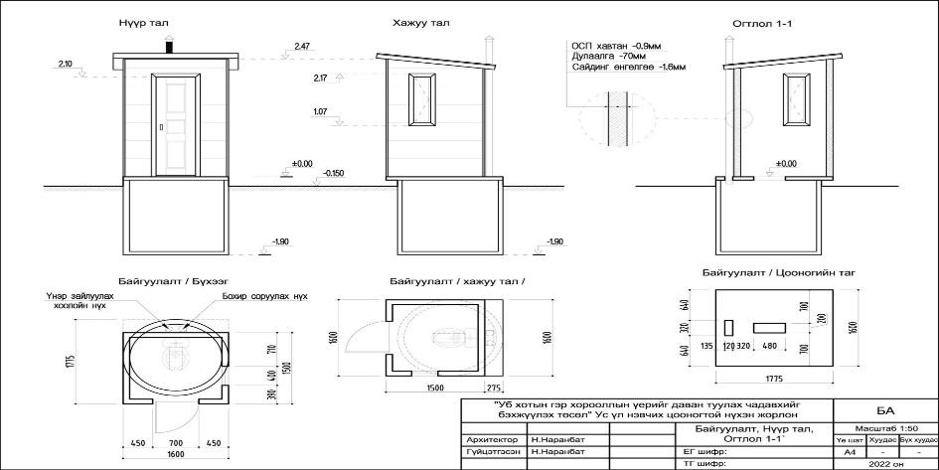

Note that Water Resources and Permafrost are both drivers of flooding in broader vulnerability in Ulaanbaatar’s peri-urban Ger areas.
At project completion, the proponent could report on % targeted population reached or successfully supported (the absolute numbers could then be deduced from that figure)
The AF utilized OECD/DAC terminology for its results framework. Project proponents may use different terminology but the overall principle should still apply
https://indicators.ohchr.org/ - correct at the time of submission
https://www.ilo.org/dyn/normlex/en/f?p=1000:11200:586390951201::::P11200_INSTRUMENT_SORT:1
http://gorkhi-terelj.mpa.gov.mn/about
Kumar Singh, R. Yagasa, R. and Dickella, P (2018) State of Waste Management in Phnom Penh, Cambodia, p.21

