
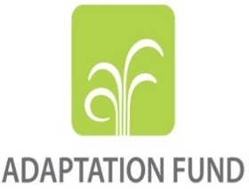

PROJECT ON STRENGTHENING THE CAPACITY, ADAPTATION AND RESILIENCE OF RURAL COMMUNITIES TO CLIMATE CHANGE IN THE CENTRAL AFRICAN REPUBLIC (CAPRCA / IACAR)

MINISTRY OF AGRICULTURE AND RURAL DEVELOPMENT

PROJECT TO STRENGTHEN THE ADAPTIVE CAPACITY AND RESILIENCE OF RURAL COMMUNITIES TO CLIMATE CHANGE IN THE CENTRAL AFRICAN REPUBLIC (CAPRCA / IACAR)

INCEPTION WORKSHOP HELD ON 11 FEBRUARY 2026 AT THE KITIKA HOTEL, BANGUI
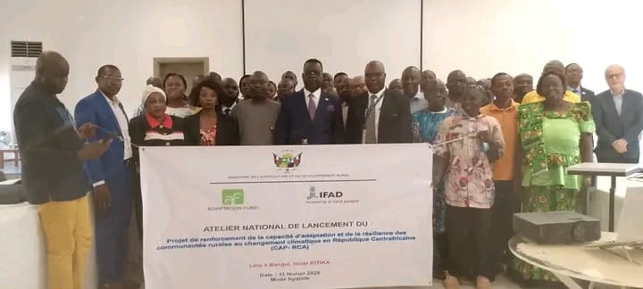

CONTENTS

ACRONYMS AND ABBREVIATIONS 2
I. INTRODUCTION 3
II. SUMMARY AND RECOMMENDATIONS OF THE INCEPTION WORKSHOP 3
III. OBJECTIVES AND OVERVIEW OF THE INCEPTION WORKSHOP 5
3.1 Objectives of the workshop 5
3.2 Official ceremony 5
IV. IACAR PROJECT OVERVIEW 7
4.1 Objectives of the IACAR project 7
4.2 Institutional Arrangement 7
4.3 Project Components and Activities 8
4.4 Implementation Modality 8
V. WORKSHOP PRESENTATIONS 9
5.1 Setting up the workshop office 9
5.2 Presentation Session 9
5.2.1 Presentation of IFAD and its operations in CAR 9
5.2.2 Adaptation Fund Presentation and Environmental and Social Procedures 12
5.2.3 Respective Responsibilities Government-CAR, IFAD, FA 15
5.2.4 Updates on the environmental fund projects implemented in the Central African Republic presented by the National Climate Coordination 16
5.2.5 Capacity building of participants on the monitoring mechanism and reporting systems of the Adaptation Fund 17
VI- BRAIN STORMING AND PRELIMINARY ACTIVITIES 20
6.1 Governance and Institutional Installation 20
6.2 Administrative, Financial and Logistics Management 20
6.3 Strategic and Budgetary Planning 20
6.4 Baseline Studies and Performance Framework 20
VII - SUMMARY OF THE WORK AND TECHNICAL CLOSURE 23
VIII- APPENDICES 24
ANNEXE1: Fact sheet on the adaptation projects underway in the Central African Republic according to the National Climate Coordination (CNC) 24
APPENDIX 2: Speech by the representative of DIRCAB, representative of the Minister 26
APPENDIX 3: Speech by the National Climate Coordinator 28
ANNEX 4: Agenda of the workshop 30
APPENDIX 5: List of Participants 57

ACRONYMS AND ABBREVIATIONS

AND: Designated National Authority
ANDE: National Agency for the Development of Livestock
CAPRCA (IACAR being the acronym in English): Project to Strengthen the Capacity of Rural Communities to Adapt and Resilience to Climate Change in the Central African Republic
CNC: National Climate Coordination
CTA: Agricultural Transformation Center
DGE: Directorate-General for the Environment
ESP: Environmental and Social Policy Compliance
FA: Adaptation Fund
FAO: Food and Agriculture Organization of the United Nations
IFAD: International Fund for Agricultural Development
GHGs: Greenhouse gases
MADR: Ministry of Agriculture and Rural Development
MEDD: Ministry of Environment and Sustainable Development
MEPCI: Ministry of Economy, Planning and International Cooperation
MESA: Ministry of Livestock and Animal Health
CTCBP: Support Programme for the Promotion of Resilient Agribusiness in the Central African Republic
PEAJ: Youth Support Livestock Project
PND: National Development Plan
UNDP: United Nations Development Programme
PPR: Performance Project Report
PRAPAM: Project to Improve Productivity and Access to Markets for Agropastoral Products in the Savannahs
PREPAS: Project for the Revival of Agro-pastoral Production in the Savannahs
REPALCA: Network of Indigenous Peoples in the Central African Republic
PMU: Project Management and Coordination Unit

INTRODUCTION

On Wednesday, February 11, 2026 from 9:30 a.m., the launching workshop of the Project to Strengthen the Capacity to Adapt and Resilience of Rural Communities to Climate Change in the Central African Republic (CAPRCA -and IACAR, its acronym in English-) opened in the conference room of the KITIKA Hotel.
This official launch of the workshop was chaired by Dr. NAMKOSSERENA Salomon, Chief of Staff of the Ministry of Agriculture and Rural Development, who underlined the strategic importance of this project in strengthening the capacities and coordination of actors to reduce the direct effects of climate change for the benefit of about 20,000 direct beneficiaries, 50% of whom are women and 30% are young people. He recalled that the project aims to go beyond one-off technical interventions to become a real lever for structural transformation, by sustainably integrating adaptation to climate change into local planning and development processes. The opening ceremony brought together representatives of public institutions, technical and financial partners, as well as key players in the sector. (See attendance list in the appendix).
It should be recalled that as part of the strategic response to climate shocks affecting the country's food security and economic stability, the Government of the Central African Republic, IFAD and the Adaptation Fund (AF) have agreed to set up IACAR aimed at reducing the vulnerability of rural communities in the project area to the effects of climate change. and improving the food security and nutrition of vulnerable poor communities. Also, the project will also promote policy dialogue on resilience building and policy gaps in the crop and livestock sectors, with a view to developing a robust climate resilience policy.

SUMMARY AND RECOMMENDATIONS OF THE INCEPTION WORKSHOP

- Key Points
Discussions with stakeholders on the IACAR project showed the need to strengthen national capacities to take ownership of the requirements of the AF, including its monitoring and reporting mechanism, as well as the submission of PPRs. Also, the participants are convinced that the success of this IACAR project will depend on effective coordination between implementing partners, the active involvement of beneficiary communities and implementing institutions (MADR, MEDD). This should be done with careful consideration of the following:
- Capacity building: ownership by the PMU and implementing partners of the Adaptation Fund's requirements for environmental and social policy compliance (ESP), performance-based monitoring and reporting (PPR);
- Governance: need for synergy between the management unit (PMU) and the various partners to ensure effective and efficient coordination;
- Operationalization: Prioritization of intervention areas for rice, cassava and maize growth sectors.
- Sustainability: community ownership and active and meaningful involvement of beneficiary communities and regional and departmental directorates of agriculture and the environment to guarantee the maintenance and monitoring of infrastructure (developed lowlands, tracks, water).

- Key recommendations
In the light of the project's attention, the participants made the following recommendations:

No. | Recommendations | Actors involved | Implementation date
1 | Develop/review the Environmental and Social Management Plan (ESMP) before the implementation of the project | MEDD, Consultant | 15/05/2026
2 | Recruit an environmental and social safeguard specialist with strong expertise in climate change adaptation | MADR, MEDD, CNC, IFAD | 30/04/2026
3 | Proceed with the recruitment of key project personnel and ensure that the coordinator is recruited with a solid foundation in project management. Mastery of environmental, social and climate assessment is a major asset for this position | MADR MEDD, IFAD | 30/04/2026
4 | Train the PMU on the Adaptation Fund criteria (its standards) and its monitoring mechanism | IFAD | 15/05/2026
5 | Create synergy between public-private implementing partners and producers, set up a mechanism for regular monitoring of implementing partners | PMU, MADR and IFAD | Continue
6 | Train all project implementing partners on the donor's financial procedures and supporting the resources allocated | PMUs and IFAD | 30/05/2026
7 | As part of knowledge management, set up the mechanism for sharing experience and good practices | PMU | Continue
8 | Implement the IACAR project taking into account the priorities contained in the national cassava and rice strategies | MADR and UGP | Continue
10 | Create a permanent monitoring framework for the sectoral departments involved | MADR, MEDD and PMU | 30/05/2026
11 | Provide the PMU with a communication plan on project activities | PMU | 30/10/2026
12 | Install a digitalization system and connectivity (geospatial data) for project monitoring and evaluation. | PMU | 30/10/2026
13 | Involving private actors in the management of community infrastructure | PMU | Continue
14 | Plan mini technical workshops to frame activities, refine Year 1 AWPB, GPP and management manuals | ATI, Experts, Partners, MADR, MEDD, MEPCI, CNC | 10 to 30/03/2026

OBJECTIVES AND OVERVIEW OF THE INCEPTION WORKSHOP

3.1 Objectives of the workshop

The general objective of this workshop was to officially launch the start of the project to strengthen the adaptive capacity and resilience of rural communities to climate change in the Central African Republic (IACAR) financed by the Adaptation Fund (FA) and placed under the supervision of the Ministry of Agriculture and Rural Development (MADR). IFAD is responsible for the provision of funds, support to the management unit and supervision of the project. More specifically, this workshop aimed to: ensure national ownership, present the theory of change and clarify the modus operandi of the start and implementation of the project.
The methodology used consisted of making PowerPoint presentations of the various themes on the agenda, engaging in constructive discussions and exchanges with questions and answers and validating the recommendations made by the participants in plenary. The work of the workshop focused on the following points:
- Official ceremony;
- Establishment of the presidium of the workshop;
- Progress of the work;
- Closure of the work.

3.2 Official ceremony

Three speeches punctuated this ceremony, namely: the speeches of the Representative of the IFAD Country Director, the National Climate Coordinator, Representative of the Minister of Environment and Sustainable Development and the opening speech of the Director of Cabinet of the MADR.
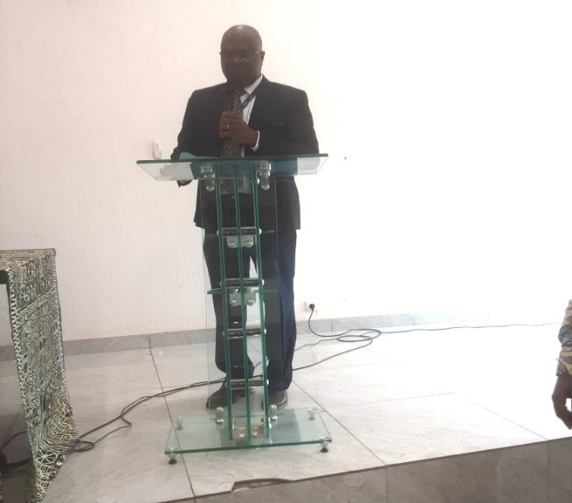
In his remarks, the Representative of the IFAD Country Director, Dr Abdoulaye GONDE, placed particular emphasis on the conditions of climatic and environmental vulnerability that the CAR is facing, in particular on the disruption of the seasons, climatic hazards, recurrent droughts, etc. These hazards have had a considerable impact on the economic, social and environmental fabric of the country.
Figure 1:Speech by the Representative of the IFAD Country Director
As such, the country must invest more in early warning systems, climate planning, and the sustainable management of natural resources by focusing on the principle of prevention and anticipation in order to enable communities to be resilient to its effects.
For the Representative of the Country Director, the IACAR project, whose objective is to implement a set of concrete adaptation measures in certain profitable value chains (Maize, Rice, Cassava) in the country, is the result of a strong partnership between IFAD, the Adaptation Fund and the Government of CAR. It fully meets the national priorities set out in the revised NDC, the National Adaptation Plan (NAP), the National Strategy for the Fight against Climate Change and the Paris Agreement.
This project aims to support 20,000 rural households through climate-smart techniques, the establishment of resilient infrastructure and institutional capacity building.
To conclude his remarks, he urged the national party to take ownership of the said project and to clearly define the role and responsibilities that each actor can play during this start-up phase in order to achieve the expected results for the benefit of the populations affected by the effects of climate change.

The second speech was delivered by Mr. Igor TOLA KOGADOU, National Climate Coordinator, Representative of the Minister in charge of the Environment. In his speech, he recalled that climate change is one of the major challenges facing the CAR, although it emits low greenhouse gases (GHGs), the country suffers disproportionately from its effects. These impacts of climate change affect rural communities whose livelihoods rely mainly on agriculture, livestock and the exploitation of natural resources. Faced with this reality, adaptation is no longer an option but a strategic necessity to guarantee food security, social stability and the sustainable development of the country.
For the National Climate Coordinator, the IACAR project is a lever for structural transformation, making it possible to integrate climate change adaptation measures into local and sectoral planning. It should not be limited to a simple technical intervention. This is why the National Coordinator did not fail to express his deep gratitude to IFAD and the AF for their multifaceted support, but also to testify their commitment to a collective response to the challenges of climate change.
In concluding his remarks, he reaffirmed the strong commitment of the Central African Republic to continue its adaptation efforts and to mobilize more climate finance for the benefit of the most vulnerable populations.
After these speeches, Dr. Salomon NAMKOSSERENA, the Director of Cabinet of the MADR, representing the Minister took the floor for the speech of the occasion.
At the beginning of his speech, he first thanked the participants, on behalf of the Minister of Agriculture and Rural Development, for having responded favorably to this invitation for the launch of the IACAR project despite their multiple professional occupations. This already testifies to the national interest he has in the development of the rural environment in the CAR and particularly in the implementation of this project.

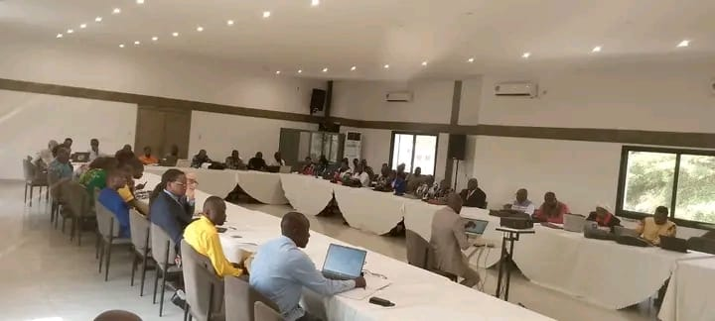

Figure 2: Speech by the Director of Cabinet of the MADR Figure 3: Overview of the audience
In his speech, he mentioned the climatic hazards to which the CAR is exposed with extreme rainfall, floods, droughts etc. These hazards directly affect food/nutrition security as well as the livelihoods and socio-economic stability of rural communities because by the end of this century, increases in average annual temperatures of 3.1 to 5.7°C will be observed and the country will not be spared.

Faced with these challenges, the IACAR project, developed with the support of IFAD and financed by the Adaptation Fund, is a strategic and ambitious response because it aims to strengthen the resilience of agricultural production systems, improve rural infrastructure and consolidate institutional capacities for effective governance.
Finally, the Representative of the Minister, on behalf of the Government of the Central African Republic, expressed his deep gratitude to the Adaptation Fund for its financial support, as well as to IFAD for its role as an implementing entity and its technical support. He recalled that this workshop is a decisive step that will allow the national party to take ownership of the project, share a common understanding of the objectives and clarify the role and responsibilities of each actor.
A family photo, followed by the withdrawal of the officials, marked the end of this sequence.

IACAR PROJECT OVERVIEW

4.1 Objectives of the IACAR project
The overall objective is to reduce the direct effects of climate change for about 20,000 direct beneficiaries, 50% of whom are women and 30% of young people, and 119,000 indirect beneficiaries. The project aims to move beyond one-off technical intervention to become a lever for structural transformation, integrating climate change adaptation into local planning.

4.2 Institutional Arrangement
The project is led and executed by the Ministry of Agriculture and Rural Development (MADR) for coordination, with the technical support of the Ministry of Environment and Sustainable Development (MEDD). IFAD provides overall supervision of the successful implementation of the project, ensuring compliance with the requirements of the Adaptation Fund.

4.3 Project Components and Activities
- Component 1: Resilient agriculture. This component deals with improving productivity in rice ($3.67 million), cassava and maize ($0.44 million) and income diversification (fish farming; Poultry farming and small ruminants; fields and peasant school, etc.) $1.10 million; it will increase productivity in a sustainable and sustainable way through income-generating activities for poor households, develop alternative livelihoods for youth and women as well as the adoption of new technologies;
- Component 2: Resilient infrastructure. This component takes into account the rehabilitation of 120 km of rural roads, the modernization of storage stores, the supply of drinking water, sanitation and community management, the construction of rural and supply infrastructure;
- Component 3: Institutional strengthening. This component deals with the training of the sectoral workers involved, support for the national meteorological system, the integration of climate into national policies, etc. and the assessment and coordination of adaptation activities.

4.4 Implementation Modality
The governance of the IACAR is based on a link between strategic supervision, national coordination and operational execution. The IACAR is institutionally anchored within the Ministry of Economy and Planning, representing the beneficiary, and the Ministry of Agriculture and Rural Development (MADR), the supervisory ministry, in conjunction with the other sectoral ministries involved. Operational implementation is carried out by the Management and Coordination Unit (UGC), an autonomous body created by ministerial instruction and endowed with legal personality and administrative and financial autonomy. The UGC ensures planning, technical and fiduciary management, monitoring and evaluation and coordination with the decentralised services.
Strategic governance is entrusted to the Steering Committee, chaired by the MADR and composed of representatives of the Ministry of Economy and Planning, Finance and sectoral ministries (Environment, Livestock, Water and Forests, infrastructure), umbrella organizations of farmers' organizations, civil society, the private sector and technical and financial partners. The SC validates the Annual Programme of Work and Budget (AWPB), approves procurement plans and guides the implementation strategy. A Technical Support Committee reviews the submitted documents in advance, follows up on the recommendations and monitors compliance with fiduciary and environmental commitments.
The UGC is supported by International Technical Assistance (ITA) covering key areas (technical coordination, financial management, procurement, monitoring and evaluation, infrastructure, environmental and social management).
The ITA brings methodological rigour, compliance with IFAD standards and capitalization of best practices. It plays a mentoring and strategic oversight role to ensure technical efficiency and fiduciary reliability

WORKSHOP PRESENTATIONS

5.1 Setting up the workshop office
When the work resumed, a round table allowed all the participants to present their civility and a presidium was set up and composed of the following personalities:

President: Mr. ABDOULAYE Adji, Central Inspector of Agriculture at MADR;
Vice-President : Mr. KANNEH Sidiki, Head of the NGO TEARFUND;
Rapporteur: Mr. KONDAYEN Arsène, Support Expert;
Deputy Rapporteur: Mr. FEIZOURE Flory Cassin, Head of Environmental and Social Safeguarding at the PEAJ.

5.2 Presentation Session
When the work resumed, the president of the session gave the floor to the rapporteur for the reading of the agenda which was adopted after amendment by the participants.
Returning to the floor, the Chair clarified the methodology used, including PowerPoint presentations by the selected Experts and a series of questions that would pave the way for discussion/exchange and possible contributions.
Following the main theme of the workshop, three presentations were made successively by the consultant in charge of supporting the IFAD portfolio in the Central African Republic, Mr. Edem WETRO, and the Representative of the Country Director Dr. Abdoulaye GONDE. To facilitate exchanges and debates between participants, the workshop secretariat opens a list of five speakers after each presentation for questions, clarifications and contributions.

5.2.1 Presentation of IFAD and its operations in CAR

IFAD's portfolio in the Central African Republic (CAR) currently revolves around four major initiatives, representing a significant financial commitment to rural development:

- Active and closed projects: The portfolio includes two active projects, PRAPAM and PEAJ. The PREPAS (budget of $30.4 million for 30,000 households) was closed on December 31, 2025. The latter has a satisfactory record, marked by the strengthening of farmers' capacities, the construction of processing infrastructure and improved climate resilience;
- New Perspectives: The 8-year, $60.3 million CTCBP programme was approved by IFAD's Executive Board in December 2025 and the Funding Agreement is awaiting signature. It aims to support 30,000 households in resilient agribusiness;
- Current challenges: Due to institutional and governance challenges in the country, our current portfolio is experiencing some difficulties due to certain poor fiduciary management. Despite these advances, the implementation of PRAPAM and PEAJ is currently hampered by disbursement being in on hold, slowing down the progress of their activities in the field.
- Indeed, in the light of the findings of the 2024 external audit reports submitted to IFAD in January 2026, and some of the resulting fiduciary findings, IFAD, in accordance with its rules and procedures, proposed to the government:
  - A total cancellation of the PRAPAM rather than the partial cancellation requested by the Government;
  - A joint analysis with a view to restructure the PEAJ.
- In addition, IFAD has taken transitional operational measures to ensure that the cancellation of PRAPAM does not prevent the implementation of IACAR activities. These measures include, among others, the recruitment of a consultant to launch the start-up workshop and facilitate the implementation of the first activities of the project pending the finalization of the recruitment process of an International Technical Assistance to support the implementation of the portfolio projects in CAR.

Exchanges between the actors on the first presentation

- Dr. Zouaka, veterinarian at the Ministry of Livestock: Raises two major points. First, he asks for a concrete clarification on the expected role of the Ministry of Livestock in the project. Then, it questions the specific choice of poultry farming and small ruminants for income diversification, questioning the exclusion of large livestock (cattle), particularly with regard to greenhouse gas emissions (methane);
- Mr. Sombo: Need clarification on the Agricultural Processing Centers (CTAs) planned under the CTPDP: will the processed products be finished/semi-finished products?
- Mr. Boniface, Fishery Engineer: raised concerns about the lack of quantified data in fish farming, in particular: the quantity of fry to be acquired, the number of tanks to be built, type and quantity of modern ovens, etc.) and about the undefined distribution of the remaining 20% of beneficiaries to complete the 50% women and 30% young people);
- Mrs. Gbaza, Representative of ACDA: insisted on the rigour to be put in the targeting of beneficiaries. This concernis shared by several participants because targeting has always been a real difficulty for previous projects carried out where some who were entitled to support were abandoned in favour of unindicated people;
- Ms. Sandrine Nambessa, Consultant at the World Bank: Asked if the $10 million represents the overall amount of the project, she highlighted the environmental/social risks in the presentation and the lack of a dedicated manager for these risks in the staff. It also requests clarification and clarification on the following subjects:
  - IACAR's intervention strategies in the areas covered by the three IFAD projects (PREPAS, PRAPAM and PEAJ);
  - the interactions of IACAR funded by the Adaptation Fund with ongoing project initiatives (CTCBP and others);
  - the total cost and duration of the IACAR project as well as the number of beneficiaries;
  - the market gardening component (sites, beneficiaries, type of support);
- The representative of the Ministry of Livestock and Animal Health (MESA) expressed concern about the livestock component of the IACAR Project and the failure to take into account the beef sector;
- The representative of REPALCA would like to ensure the level of effective involvement of indigenous peoples (Fulani and Aka) in the project; He raises the issue of knowledge management in the context of this project; and questions the place of organisations (POs) in the new project.

Responses to Participants' Concerns

- In response to the concern raised by the MESA representative on the livestock component and the failure to take into account the cattle sector by the project, the Representative of the Country Director, Dr. Abdoulaye GONDE explained that IFAD targets the most vulnerable with short-cycle activities (poultry, small ruminants) rather than cattle, more complex to manage for this public. He mentions ANDE as a technical partner in the field;
- The IACAR project was developed to complement PRAPAM, with funding from the Adaptation Fund. In view of the difficult context that PRAPAM is experiencing and in order to respect the principles of the FA for the implementation of projects, it was agreed to execute IACAR autonomously;
- The project areas are the same localities as those of the PRAPAM project (sharing some localities with PREPAS and PEAJ) where many small rural producers have been supported. The pooling of resources will make it possible to provide adequate responses to vulnerable households by reducing the effects of climate change on activities;
- The total cost of the IACAR project is $10 million and the duration of the intervention is 5 years (February 11, 2026 to February 10, 2031). This budget is used to ensure the activities. Environmental and social risks are integrated and mitigated in the technical components (impact assessments, compensation for roads, etc.);
- The CTAs designate, within the framework of the PARCA, agri-food processing centres and will target finished or semi-finished products to create added value and jobs;
- Missing or ill-defined quantitative data on fish farming and market gardening will be evaluated and adjusted during the technical framing and the development of the logical framework;
- Targeting: the experts reassured the participants that a targeting strategy will be developed at the beginning of the project with capacity building of institutional partners and field actors to ensure inclusive targeting;
- Environmental risk management: a specialist in environmental and social safeguards will be recruited within the PMU with a good knowledge of the Adaptation Fund's Compliance with Environmental and Social Policies (ESP);
- Regarding quotas in the distribution of beneficiaries: It is specified that the 50% of women and 30% of young people are results objectives for the total number of beneficiaries, and not a cumulative effect of 100%;
- Indigenous peoples are indeed taken into account among the direct beneficiaries of the project and are concerned by the targeting;
- Finally, the experts reassured the participants that some activities, the contours of which seem unclear, will be readjusted to the context during the preliminary phases of the project (the planned fish farming activities include the construction of tanks and the purchase of juveniles as well as the training of farmers on farming techniques and the monitoring of fish growth, without a full value chain analysis).
Recommendations
- Develop the targeting strategy and take gender into account
- Provide for the recruitment of an Environmental, Social and Climate Safeguard Expert within the PMU to manage risks related to the 15 compliance principles of the AMF
- Develop the project's knowledge management plan
- Promote the digitalization of project activities for accurate and effective monitoring and evaluation
- Specify certain project activities

5.2.2 Adaptation Fund Presentation and Environmental and Social Procedures
- The Adaptation Fund
This presentation was made by Dr. Abdoulaye GONDE. The Adaptation Fund is a fund created in 2001 to finance concrete adaptation measures targeting the most vulnerable communities with an amount of $40 million per country and $25 to $10 million per project. Since 2010, approximately $850 million has been committed to funding 123 projects around the world. Countries eligible for the fund are developing countries that are parties to the Kyoto Protocol and are particularly vulnerable to the adverse effects of climate change. Finally, in terms of approval: all projects must be approved by the designated national authority (DNA) of the country concerned.
- Presentation on the Environmental and Social Safeguard Procedures of the Adaptation Fund
This part was presented by Mr Edem WETRO. Managing these risks is critical to the success of projects/programs supported by the Adaptation Fund, and the expected results are outlined in the 15 Environmental and Social Principles (Principles) of the SEP. The following 15 principles therefore apply to IACAR:
- Principle 1: Compliance with legislation. IACAR must comply with all applicable national and international legislation;

- Principle 2: Access and equity. IACAR will provide fair, equitable, and inclusive access to expected benefits, without hindering access to basic health services, clean water and sanitation, energy, education, housing, safe and decent working conditions, and land rights. IACAR should not exacerbate existing inequalities, particularly those affecting marginalized and vulnerable groups;

- Principle 3: Marginalized and vulnerable groups. IACAR should avoid imposing disproportionate negative impacts on marginalized and vulnerable groups, including children, women and girls, the elderly, indigenous peoples, tribal groups, internally displaced persons, refugees, persons with disabilities, and persons living with HIV/AIDS. When reviewing IACAR, IFAD will assess and take into account the specific impacts on marginalized and vulnerable groups;

- Principle 4: Human rights. IACAR should respect and, where appropriate, promote fundamental human rights;

- Principle 5: Gender equality and women's empowerment. IACAR is designed and will be implemented so that women : 1) have the same opportunities to participate, in line with the Fund's Gender Policy (PG), 2) enjoy comparable social and economic benefits, and 3) do not experience disproportionately negative impacts during the development process;

- Principle 6: Fundamental rights at work. IACAR must comply with the core labour standards promulgated by the International Labour Organization;

- Principle 7: Indigenous peoples. The Adaptation Fund has ensured that IACAR is consistent with the rights and responsibilities set out in the United Nations Declaration on the Rights of Indigenous Peoples and other applicable international instruments relating to indigenous peoples;

- Principle 8: Involuntary resettlement. IACAR has been designed and will need to be implemented in a way that avoids or minimizes the need for involuntary resettlement. Where limited involuntary resettlement is unavoidable, due process will be followed so that displaced persons are informed of their rights, consulted on the options available to them, and offered technically, economically and socially feasible resettlement alternatives or fair and adequate compensation;

- Principle 9: Protection of natural habitats. IACAR will not result in unjustified transformation or degradation of critical natural habitats, in particular those that are: (a) legally protected, (b) formally candidates for protection, (c) recognized by authoritative sources for their high conservation value, including as critical habitat, or (d) recognized as protected by traditional or indigenous local communities;

- Principle 10: Preservation of biodiversity. IACAR is designed and will be implemented in a way that avoids any significant or unjustified reduction or loss of biodiversity and avoids any introduction of known invasive species;

- Principle 11 : Climate change. IACAR must not result in any significant or unwarranted increases in greenhouse gas emissions or other factors responsible for climate change;

- Principle 12: Pollution Prevention and Resource Efficiency. IACAR is designed and will be implemented in compliance with applicable international standards in order to maximize energy efficiency and minimize the use of material resources, waste generation and the release of pollutants;

- Principle 13: Public health. IACAR is designed and will be implemented in a way that avoids potentially significant negative impacts on public health;

- Principle 14: Cultural and physical heritage. IACAR is designed and will be implemented in such a way as to prevent the alteration, degradation, destruction or disappearance of any cultural and natural heritage whose value is recognized at the community, national or international level. In addition, IACAR should not permanently hinder access to and use of these cultural and natural heritages by the communities present;

- Principle 15: Land and soil conservation. IACAR is designed and will be implemented in a way that promotes soil conservation and avoids degradation or conversion of productive land or land that adds significant value to ecosystem services.

- Discussions after the presentation on environmental safeguard procedures
The content of this presentation raised questions among the participants who highlighted the following main points:
- Provide for the recruitment of an environmental and social safeguard specialist instead of an adaptation specialist as provided for in the presentation;
- How to appropriate the methodology to verify compliance with the 15 principles of the AM;
- Alignment with the 09 standards of IFAD's SECAP;
- The appropriate timing to carry out the vulnerability study.

Recommendations
- Instead of an adaptation specialist, the participants wanted to recruit an environmental and social safeguard specialist to update the project's GCMP
- The environmental criterion would also be an asset for the recruitment of the Coordinator
- The following SES instruments are indispensable
  - Environmental, Social and Climate Management Plan (ESMP);
  - Stakeholder Engagement Plan (PPGTP);
  - Complaint Management Mechanism (PMM);
- To avoid delays, it is advisable to prepare the SRTs for environmental studies in advance

5.2.3 Respective Responsibilities Government-CAR, IFAD, FA

This presentation highlights the respective roles of the national side, the Adaptation Fund and IFAD in the governance of the project. We will remember the following:

The Adaptation Fund (Donor): provides funding and strategic monitoring:
- Funding: It disburses the necessary resources for the coming biennium (N+1) to IFAD annually, based on the balance sheets of the previous year (N).
- Evaluation: It audits the quality of annual performance reports as well as independent evaluations (mid-term and close-out), examining IFAD's responses to the recommendations made.
IFAD (Implementing Entity): provides the technical and fiduciary interface:
- Flow management: he transfers funds to the Project Management Unit (PMU) and guarantees the compliance of procedures and risk control.
- Supervision: he conducts the annual missions, validates the performance reports and organizes the independent mid-term and end-of-project evaluations.
The National Party (Government and PMU, Executing Entity): The Central African State and its branches ensure the institutional anchoring and execution of:
- The Government: It provides the legal and administrative framework necessary for the creation of management bodies (Steering Committee, PMU, etc.);
- The PMU (Executing Agent): It develops the essential operational tools (PTBA, PPM, PEPP, MGP). She is also responsible for annual performance reports;
- The Designated National Authority: It receives copies of the PMU's reports to assess their performance. This validation is crucial, as it attests to real progress and the consideration of environmental, social and climate criteria, thus conditioning the continuation of disbursements by the Adaptation Fund.
To conclude his presentation, the Consultant Portfolio Support Officer for the start-up workshop urged the national party to involve the Designated National Authority in the monitoring and some events related to the project.
Exchanges and discussion on the responsibilities of the parties
One participant wanted to know precisely the link between the Designated National Authority (DNA) and the other technical and financial partners.
Response to the concern: on this issue, the presenter went into detail by highlighting the partnership links according to three levels, namely: strategic, supervision and operational.
Strategic and Policy Level (Governance): ensures the project's compliance with international and national commitments.
- The Adaptation Fund (AF): This is the Funder. It provides financial resources in the form of a grant. It ensures that the project meets the criteria for global climate resilience.
- The Designated National Authority (DNA): The FA's official interlocutor in the Central African Republic. Its role is to validate the relevance of the project in relation to the country's priorities. It issues the "Letter of No Objection" without which the project cannot exist.
- The MEDD (Ministry of Environment and Sustainable Development): This is the supervising Ministry. It provides overall policy oversight and ensures that the project meets the country's environmental and social standards

The Management and Supervision Level: the fudiciary aspect and action on the ground.
- IFAD acts as the Implementing Entity (of the Adaptation Fund). The FA entrusts him with the management of the funds. IFAD provides technical expertise, manages disbursements, and oversees procurement to ensure transparency. It also oversees the implementation of the project's technical activities.

The Operational and Technical Level (Executing Entity)
- MADR is the Key Technical Partner. Since IACAR targets agricultural production, MADR is involved in the choice of seeds, the development of lowlands and the supervision of producers through its extension services.
- The Project Coordination Unit (PCU): Generally placed under the MEDD but working in close collaboration with the MADR, it ensures the day-to-day management (AWPB, reports, monitoring and evaluation).

To these explanations given, the Focal Point of the Adaptation Fund in CAR, who is at the same time the Director of the National Adaptation Fund within the National Climate Coordination, also provided clarifications on the practical aspects of the partnership and the links between the donor, the Country, the MEDD, the Designated National Authority, the National Climate Coordination (CNC) and other institutions.

5.2.4 Updates on the environmental fund projects implemented in the Central African Republic presented by the National Climate Coordination
This presentation was made by the Adaptation Fund Focal Point in the Central African Republic who presented in a synoptic table 06 projects in progress (execution, approval or under review) and whose sheet is annexed to this report. He also asked other actors to report to the Climate Coordination all projects carried out or under discussion related to the strengthening of adaptation capacities in the country for synergy and better monitoring.
The reactions to this presentation were much more contributions, among which we retained:

- Contribution to the discussions:

- Mrs. NAMBESSA Sandrine, representing the World Bank, informed the participants that the Bank devotes about 5% of its financing to adaptation activities and that all projects subject to financing must be in line with the National Development Plan (NDP) of the Central African Government. She also made important announcements on the projects under negotiation, the main ones being: i) the ENA project where meetings and discussions were initiated in 2025 to complete the studies necessary for the execution of the said project; ii) the Multi-Phase Program with an amount of $64 million for forest financing where a first meeting will be held on February 14, 2026; and (iii) the US$10 million PROVIR Project on the Agricultural Sector and Climate Change.

5.2.5 Capacity building of participants on the monitoring mechanism and reporting systems of the Adaptation Fund

This informative presentation focused on the Adaptation Fund's (AF) project monitoring requirements and its performance-based reporting system.
Overall, IACAR planning and monitoring and evaluation (M&E) are based on results-based management that guides decisions, strengthens accountability, and consolidates institutional learning. The UGC is leading the process with the help of the ministries concerned, regional directorates, farmers' organizations and partners. Each year, a AWBP is developed in a participatory manner based on consultations with decentralised technical services and local organisations. These decentralized AWPPs will be consolidated by the UGC and then validated by the Steering Committee before being forwarded to IFAD for no objection. This mechanism ensures coherence between local priorities, project objectives and national commitments.
The AWPBO is based on three main instruments: the logical framework integrated into the Results Measurement Framework (CMF), the Environmental, Social and Climate Management Plan (ESMP) and the Costab. In accordance with the rules of the FA, the launch date of the start-up workshop is the reference date for the start of the operationalization of IACAR. Thus, February 11, 2026 remains the reference and start year of IACAR. Each year, the AWPB for year N+1 must be submitted to IFAD for a no-objection. This requirement ensures that activities start on time and are integrated into national budget cycles. In addition, the project will be subject to a semi-independent, mid-term and completion evaluation, coordinated by IFAD and subject to analysis and approval by the Adaptation Fund.
The M&E framework is structured around the COSOP Results Framework, the NDP, the SDGs, the IACAR Logical Framework and IFAD's Operational Results Measurement System (ORMS). A procedures manual will specify the processes, tools, responsibilities and reporting schedules. Standardised dashboards will allow stakeholders to monitor progress and compare progress against set targets. The evaluation will focus on indicators of direct outputs and outcomes, as well as cross-cutting dimensions: gender equality, youth inclusion, participation of vulnerable groups, and climate resilience. The data collected will be used to adjust strategies and guide decision-making.
Three Outcome Indicator Surveys (IOCs) are planned: a baseline baseline survey, a mid-term survey and a final survey. They will measure the progress and impacts of the project in accordance with IFAD and FA protocols. Thematic studies will complement these surveys to deepen the analysis of the effects on the empowerment of women and youth, food security, climate risk management, inclusion and social cohesion and the dynamics of farmers' organizations. The methods will combine quantitative data and qualitative analyses to identify the share of change attributable to the intervention.
IACAR will adopt a digital monitoring and evaluation system based on the Hive application acquired under PRAPAM and aligned with the next CTCBP project. The Hive application is adapted to the context of low connectivity and security constraints. This system integrates data collection via KoboCollect, real-time monitoring of activities and beneficiaries, as well as financial and physical dashboards. A Geographic Information System (GIS) associated with a Geoportal will make it possible to spatially represent the interventions and ensure increased transparency. All stakeholders, from UGC to farmers' organizations, will receive training in the use of digital tools and IFAD standards. Each member involved will sign a performance contract defining their role and responsibilities.
The planning and M&E framework will ensure rigorous monitoring, regular production of reliable information, and direct support for the strategic decisions of the PC and IFAD. It will strengthen the project's adaptability, secure the sustainability of interventions and feed into supervision missions, mid-term review and completion. This system will be a key pillar for the success of IACAR and the consolidation of the IFAD portfolio in CAR.
For the EAF, it should be noted that each project must be linked to the EAF Strategic Outcome Framework, which predefines 8 outcomes, which in turn are linked to indicators (result and output indicators). For the present project, 03 main results are concerned, namely:
- Outcome 2: Strengthened institutional capacity to reduce risks associated with climate-induced socioeconomic and environmental losses
- Outcome 4: Increased adaptability within relevant departments in the development sector and infrastructure assets
- Outcome 6: Diversified and strengthened livelihoods and income sources for vulnerable people in targeted areas

The project must align with at least one result indicator and one output indicator, among the 03 strategic outcomes concerned.

- Principles of successful adaptation action: an adaptation is considered successful if it is feasible, effective, just (social equity) and contextualized;
- Reporting obligations:
  - Inception report: to be produced within two months of the inception workshop, including participants, outcomes, concerns and solutions discussed,
  - Project Progress Report (PPR): to be submitted annually, within two months of the end of the reference year. The last PPR serves as the completion report.
The exhibitor also detailed the ten (10) sections structuring the Fund's reporting framework, which cover the entire life cycle of the project:

- Operational management: Overview of monitoring, start-up workshop and annual performance reports;
- Fiduciary Management: Financial data, procurement (procurement and purchasing) and audited financial reports;
- Compliance and Safeguards: Risk assessment, compliance with environmental, social and gender policies;
- Impact measurement: Implementation indicators, strategic results framework, ratings and performance monitoring;
- Capitalization: Mid-term and final evaluations, as well as the extraction of lessons learned throughout the review process.
Finally, the speaker drew the attention of the participants to the following points:
- The review through the PPRs allows the Adaptation Fund Secretariat to flag irregular reports that may lead to further analysis and trigger other oversight mechanisms available to the Council.
- The receipt and validation of the PPRs triggers the renewal of the advance of funds. No PPR, no payment of funds;
- Compliance with the schedule for the preparation and submission of the expected PPRs (annual rhythm).
- Participants' concern about the follow-up mechanism
The participants wanted to know whether there is a recourse mechanism for the beneficiaries and the surrounding populations;
Recommendations for the monitoring system
- Provide training to the main implementing actors (PMUs, sectoral ministries, sub-supervisory support structures, umbrella structures of POs, NGOs, private sector and local authorities) on the performance indicators, ESP standards and financial procedures of the Adaptation Fund: the responsibility lies with IFAD;

- Comply with procurement procedures and rigorously ensure that receipts for purchases and expenditures are made in the context of activities: responsibility lies with the PMU;

- Justify any delays;

- Do not introduce unapproved changes to reports;

- Ensure that gender indicators are monitored and integrated into risk analysis: Monitoring and Evaluation Officer and the Coordinator;

- Anticipate the submission of documents and be proactive in feedback and not to delay document validations.

VI- BRAIN STORMING AND PRELIMINARY ACTIVITIES
The objective of this presentation section was to jointly identify and agree on the first activities to be included in the first AWPB covering a period of 12 months. These activities mainly concern administrative actions, the technical framework of the programme and the key studies to be carried out from the start-up phase. These include:

Governance and Institutional Installation

Objective: To establish the legal and human foundations of the project.
In addition to the official IACAR launch workshop, the following should be planned:
- Recruitment: Accelerated initiation of the recruitment of the implementation team (key and technical staff), ideally before the account is opened;
- Piloting: Proposal of the composition of the National Steering Committee and monitoring of its administrative formalization;
- Partnerships: Identification of key implementing partners and modalities for collaboration;

Administrative, Financial and Logistics Management

Objective: To remove the preconditions for disbursement.
In addition to the signing of the financial agreement (signed on 10 February 2026), the administrative files must be finalised.
- Contractualization:
- Banking: Opening of the bank account dedicated exclusively to the IACAR project.
- Accounting System: Reconfiguration and installation of the TOMPRO accounting software, acquired as part of the PRAPAM.
- Procedures Manuals: Development of the three essential manuals:
  - Technical execution manual;
  - Administrative and Financial Manual;
  - Monitoring and evaluation manual.

Strategic and Budgetary Planning
Objective: To adjust the programming to the realities on the ground.
- Technical Review: Realization of a macro-review of activities and costs (post-start-up workshop).
- Annual Programming: Development of the Year 1 Annual Work Plan and Budget (AWBV) for submission to IFAD.
- Procurement: Drafting of the Procurement Plan (PPM) for the first 12 or 18 months.

Baseline Studies and Performance Framework
Objective: To establish the baseline and measurement tools.
- Technical Studies: Drafting of the ToRs for the initial studies (quantification of the indicators of the logical framework, indicators of the Adaptation Fund and environmental certification).
- Baseline Situation: Baseline Study carried out via a multidimensional survey in the intervention area.
- Safeguards: Review of the Environmental and Social Management Plan (ESMP) annexed to the IACAR PRODOC.
- Results-based management: Effective implementation of the monitoring and evaluation system.

At the component level, the following actions were evaluated and framed:
COMPONENT 1 – Climate-resilient agricultural and post-harvest production and livelihood diversification

Result 1.1: Resilient agricultural production and plant diversification

Activities to be implemented in Year 1:
- Site identification
- Breeding of pest-resistant rice varieties and promotion of improved cropping practices (in partnership with AfricaRice)
- Establishment and support of agricultural field schools (FFS) / integrated farming models
- Capacity building in modern composting techniques
- Selection of pest-resistant cassava varieties and promotion of good cultural practices
- Development and dissemination of a guide to good agroecological practices
- Capacity building of extension services (soil fertility, agroforestry, biopesticides, soil restoration)
- Establishment of an ICT platform for the exchange of knowledge and market information

Result 1.2: Diversification through livestock and fish farming

Activities to be implemented in Year 1:
- Identification of sites for the construction of earthen dams for fish farming activities
- Start of the creation of fish farms and implementation of value chain services (fingerlings, inputs)
- Development of the terms of reference for the recruitment of a fish farming consultant
- Training of producers in fish farming (tilapia and clarias)
- Creation and capacity building of fish farmers' cooperatives
- Studying the impact of poultry and commercial livestock on livelihoods
- Selection of local breeds of resistant poultry and dissemination of good breeding practices
- Support for women in poultry farming and commercial livestock (small ruminants, poultry)

COMPONENT 2 – Productive infrastructure and access to climate-resilient services

Result 2.1: Resilient storage and transport infrastructure

Activities to be implemented in Year 1:
- Study for the Rehabilitation of Storage Warehouses to Resist Humidity and Flooding
- Studies on the protection and rehabilitation of secondary roads and agricultural roads Support to local authorities and farmers' organizations for the development and implementation of maintenance plans for agricultural roads and paths

Result 2.2: Access to safe drinking water and sanitation
Activities to be implemented in Year 1:
- Studies on the climate-resilient construction and rehabilitation of drinking water supply and sanitation networks Capacity building in sustainable drinking water management
- Development of new lowlands.

COMPONENT 3 – Institutional strengthening, public policy and knowledge management

Outcome 3.1: Institutional Capacity and Climate Policy
Activities to be implemented in Year 1:
- Support to organizations representing AKA indigenous peoples for land advocacy;
- Capacity building of ministries, civil society and partners in climate risk management and adaptation;
- Strengthening the national meteorological service and local relays;
- Provision of technical agents with equipment, tools and training for environmental, social and climate monitoring;
- Technical assistance for the improvement of policy frameworks integrating climate risks.

Outcome 3.2: Monitoring and evaluation, knowledge management and coordination
Activities to be implemented in Year 1:
- Implementation of a measurement, notification and verification (MRV) system (Operationalization of the cell as an activity)
- Strengthening the monitoring and evaluation and knowledge management system (baseline surveys)
- Development of the knowledge management plan and production of dissemination materials (newsletters, media)

Points of attention for the next step

Faced with the evolution of costs since 2023 (date of the design of IACAR) and to compensate for the examination of the scope of certain activities that should be carried out in synergy with PRAPAM (currently in the cancellation phase), the participants recommended that the MADR with the ATI initiate a phase of strategic review of the project activities, indicators and implementation costs.

This stage of consultation with technical partners will make it possible to adjust the content of the activities, the associated indicators, the composition of the PMU and the project budget to the realities on the ground. On the occasion, the holding of a technical workshop for revision and updating will have the advantage of building a concerted multi-year AWPB guaranteeing:

- Compliance with national strategies;
- Efficiency through the pooling of partners' efforts;
- Budgetary and technical feasibility;
- The performance of the monitoring and evaluation system.

VII - SUMMARY OF THE WORK AND TECHNICAL CLOSURE

By way of summary, a summary of the essential points of the day was presented, followed by the reading and adoption in plenary session of the recommendations resulting from this meeting.
To conclude, the agro-environmental expert mobilized in support of the launching workshop called Arsene Kondayen, said that the IACAR project will contribute to:
- Respond to the major climate challenges facing the country;
- Sustainably improve food and nutrition security;
- Strengthening livelihoods;
- Protecting natural resources;
- Promote the empowerment of women and youth.
The sustainability of the gains should be achieved by
- Community ownership;
- The professionalization of cooperatives;
- The operationalization of a maintenance plan for roads and hydraulic structures;
- Lasting institutional strengthening;
- Integration of climate-smart practices into national policies.
Resuming the floor, the Chairperson of the session pointed out that the work of the workshop had taken place in a spirit of consultation, conviviality and professionalism and the participants had unanimously validated the various recommendations. He urged all stakeholders to maintain this good working atmosphere and to make themselves available for the framing of some of the activities mentioned in the next steps.
Finally, the Chairperson of the session ended his remarks with a word of thanks from the Government and its hierarchy to the Representative of the Country Director who came especially for this workshop, the consultant in support of the IFAD portfolio in the Central African Republic for the collaboration with the MADR and the sectors in the framework of monitoring projects in the current and future country He congratulated all the participants as well as the national experts in support for their multifaceted contributions, their sense of responsibility, commitment and patriotic dedication for the good conduct of this work. After wishing the participants a safe return to their place of origin, he adjourned the meeting at 5:30 p.m.

APPENDICES

ANNEXE1: Fact sheet on the adaptation projects underway in the Central African Republic according to the National Climate Coordination (CNC)

Designation | Implementing actors | Fiduciary/Landlord Agency
Project to Strengthen the Adaptive Capacity and Resilience of Rural Communities to Climate Change in the Central African Republic (CAP-CAR)  Amount: 10 Million USD | Ministry of Agriculture and Rural Development (MADR), Ministry of Environment and Sustainable Development (MEDD) | IFAD/Adaptation Fund  Observation: Expectation of implementation
Integrated community-based management of high-value forest ecosystems in the south-west of the Central African Republic. | Implemented by the Central African Government, through the (MEDD) | UNEP support as a GEF agency  Observation: Ongoing
Community Adaptive Capacity Building Project for Integrated Management Intensification and Landscape Restoration in the South-West Region of CAR.  Duration 2024-2028/Amount: USD 9 million | Implementation by FAO. | - LDCF Fund  Observation: in progress
Regional Project: Integrated Water Resources Management and Early Warning System for Climate Change Resilience in the Lake Chad Basin.  Amount: 11 Million USD. | World Meteorological Organization (WMO)/ Lake Chad Basin Commission (CBLT), Global Water Partnership Central Africa (GWP-CAf) and governments | Adaptation Fund  Observation: Waiting for official launch of the project
Project to improve access to water, resilient water resources management and disaster preparedness in the Central African Republic. Amount 28 million $US. | - Implementing Partner UNICEF. | - Waiting for approval by the Green Climate Fund.
Integrated adaptation programme to address the effects of change  Climate Change on Agricultural Production and Food Security in the Central African Republic  Amount: USD 3,180,000 | MEDD and MADR | - UNDP/GEF  Comment: Pending GEF approval
Livestock Support Project for Climate Change Adaptation and Resilience Building in the Central African Republic  Amount: USD 9,800,000 |  | GEF funding. The project comes in synergy with IFAD's PEAJ project.

APPENDIX 2: Speech by the representative of DIRCAB, representative of the Minister

Opening remarks

Ladies and Gentlemen Directors of Cabinet,
Representatives of Technical Institutions,
Ladies and Gentlemen Technical and Financial Partners, Ladies and Gentlemen Actors of Civil Society,
Distinguished guests, dear participants,

On behalf of the Ministry of Agriculture and Rural Development, I would like to welcome you to this national workshop to launch the Project to Strengthen the Adaptive Capacity and Resilience of Rural Communities to Climate Change in the Central African Republic (IACAR).

Your presence illustrates the collective commitment of all stakeholders:
- The sectoral ministries and their directors of cabinet: Agriculture and Rural Development, Environment and Sustainable Development, Water and Forests, Public Works, Livestock and Animal Health, Economy and Planning, Energy and Hydraulics;
- The national technical structures : ACDA, ANDE, ICRA, DGE, DGPA, DGIAR, DGESP;
- Farmers' and civil society organizations: CNOP-Caf, REPALCA, FNEC, FMNM, OFCA, MEFP, FNPAC;
- Technical and financial partners: International Fund for Agricultural Development (IFAD), Adaptation Fund, World Bank, African Development Bank, WFP, UNDP, FAO;
- International NGOs and the private sector: Welthungerhilfe, Husaca Limited Company, Société Bimbosaine, Diversité Services, Impact Consulting, SMCAF, SAGINCO, and others.

Ladies and gentlemen,
The Central African Republic is one of the most vulnerable countries to climate change. Projections point to an increase in average annual temperatures of 3.1°C to 5.7°C by the end of the century, accompanied by increased variability in rainfall and an intensification of extreme events, such as floods and droughts. These phenomena directly affect the food security, livelihoods and socio-economic stability of our rural communities.
Faced with these challenges, the IACAR project, developed with the support of IFAD and financed by the Adaptation Fund, is a strategic and ambitious response. It aims to strengthen the resilience of agricultural production systems, improve rural infrastructure and strengthen institutional capacities for effective governance of adaptation.
On behalf of the Government of the Central African Republic, I would like to express our deep gratitude to the Adaptation Fund for its financial support, as well as to IFAD for its role as an implementing entity and its technical support. I would like to thank in particular the IFAD representative present at this workshop, whose presence testifies to the constant commitment of this strategic partner to the Central African Republic.
This workshop marks a decisive step in ensuring national ownership of the project, sharing a common understanding of its objectives and clarifying the roles and responsibilities of each.

I declare open the national workshop to launch the IACAR project and wish our work every success.
Thank you.

APPENDIX 3: Speech by the National Climate Coordinator

Inception Workshop of the Project to Strengthen the Adaptive Capacity and Resilience of Rural Communities to Climate Change in the Central African Republic
- Your Excellency the Minister of Agriculture and Rural Development,
- Representatives of Technical and Financial Partners,
- Representatives of the Sectoral Departments,
- Distinguished guests,
- Ladies and gentlemen,
It is with real honor and deep commitment that I am speaking at this workshop to launch the Project to Strengthen the Adaptive Capacity and Resilience of Rural Communities to Climate Change in the Central African Republic, on behalf of the Minister in charge of Environment and Sustainable Development, who was unable to attend.
Climate change is one of the major challenges facing our country today. The Central African Republic, although a low emitter of greenhouse gases, is disproportionately affected by the effects of climate change: irregular seasons, floods, prolonged droughts, lower agricultural yields, ecosystem degradation and increased food insecurity.
These impacts particularly affect our rural communities, whose livelihoods rely heavily on agriculture, livestock and the exploitation of natural resources. Faced with this reality, adaptation is no longer an option: it is a strategic necessity to guarantee food security, social stability and the sustainable development of our country.
Ladies and gentlemen,
The project we are launching today is fully in line with the vision of the Central African Government, which is reflected in particular in:
- The National Development Plan;
- the Nationally Determined Contribution (NDC);
- the initial National Adaptation Plan (NAP);
- The National Strategy for the Fight against Climate Change;
- And the commitments made under the Paris Agreement.
This project is not limited to a technical intervention. It is a lever for structural transformation, making it possible to integrate climate adaptation into local and sectoral planning.
On behalf of the Government, I would like to express our deep appreciation to our technical and financial partners for their continued support. Their commitment testifies to the international solidarity that is essential in the face of a global challenge that requires collective responses.
Ladies and gentlemen,
- The success of this project will depend on several key factors:
- Effective coordination between sectoral ministries;
- Active involvement of local authorities;
- Real ownership by the beneficiary communities;
- Rigorous and transparent monitoring and evaluation;
- And sustained political commitment.
Our role, as the national institution in charge of climate, will be to ensure the coherence of interventions, the respect of international commitments and the alignment of the project with national priorities.
I therefore appeal to all the actors present: let's make this project a model of integrated, inclusive and sustainable intervention. Let us make it a concrete example of resilience for development.
In conclusion, I reaffirm the strong commitment of the Central African Republic to continue its adaptation efforts and to mobilize more climate finance for the benefit of our most vulnerable populations.
- Together, let's build the resilience of our rural communities.
- Together, let's build a more secure and sustainable future for the Central African Republic.
Thank you for your kind attention.

ANNEX 4: Agenda of the workshop

Schedules Tasks |  | Actors
08.30-09.00 | Arrival and installation of participants  Checking the internet connection and testing | Workshop Moderator
09.00-10:00 | Opening session of the inception workshop  - Constitution of the presidium of the workshop (president and two rapporteurs).  - Workshop Overview (Workshop Objectives and Program Overview)  - Presentation of the participants | Workshop Moderator
09.00-10:00 | - A word from an IFAD representative | IFAD PTL
09.00-10:00 | - A word from a representative of the Ministry of the Environment | Chief of Staff or Adjustment Fund Coordinator
09.00-10:00 | Opening remarks  - A representative of the Minister in charge of Agriculture | MADR's Chief of Staff
10.00-10.05 | Family photo | Workshop Moderator
10:05-10:25 | Coffee break | Workshop Moderator
10:25-11:10 | Presentations:  - Presentation of IFAD and its operations in CAR | Edem
10:25-11:10 | - Presentation of the Adaptation Fund | Gonde
10:25-11:10 | - Respective Responsibilities Government of CAR, IFAD, Adaptation Fund | Edem
11:10-11:30 | Questions / Answers – Debate | Edem
11:30-12:30 | The RCARCR project in detail  Presentation:  - Project objectives, components, costs, schedule and milestones  - Theory of change, implementation strategy, institutional arrangements, partnerships and targeting of the IACAR project.  - Presentation of the phasing of the start-up conditions and the first operational modalities of implementation | Edem
12:30-13:30 | Lunch
1:30pm-1:50pm | - Presentation of other adaptation projects in the CAR | Coordination of the Adaptation Fund
1:50pm-2:30pm | Comments, Questions and Answers (with the Audience) on the Presentations | Coordination of the Adaptation Fund
2:30pm-3:15pm | Implementation scoping for the start-up phase  - Presentation of the main start-up activities  - Presentation of the operating procedure | Edem
15:15-16:00 | Partnerships for the implementation of the project  Presentation of the main actors and partners identified | Edem
16:00-16:30 | Comments, Questions and Answers (with the Audience) on the Presentations | Edem
4:30 p.m.–5:00 p.m. | Coffee break
5:00 p.m.–5:30 p.m. | Project monitoring modalities for the Adaptation Fund  - Key information to share annually  - Risk Management, Environmental and Social Policy & Gender Policy  - Performance Evaluation & Indicators  - Lessons Learned & Monitoring Framework | Edem
5:30pm-5:45pm | Comments, Questions and Answers (with the Audience) on the Presentations | Edem
17:45-18:00 | Closing  Summary and outlook: next steps, conclusion, evaluation of the workshop | MADR's Chief of Staff

APPENDIX 5: Presentations made during the workshop.
The Adaptation Fund
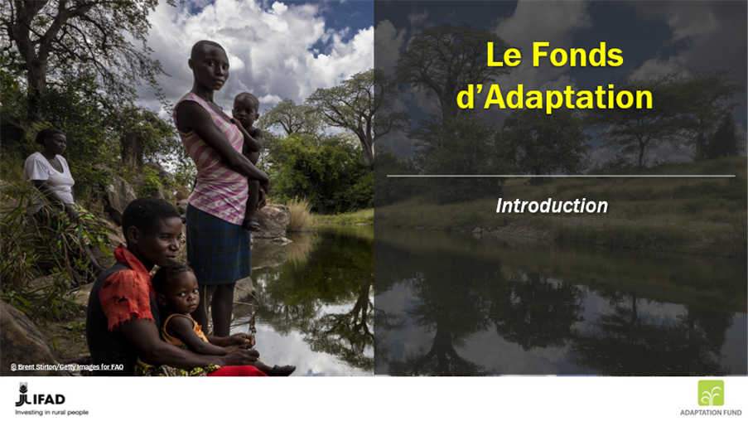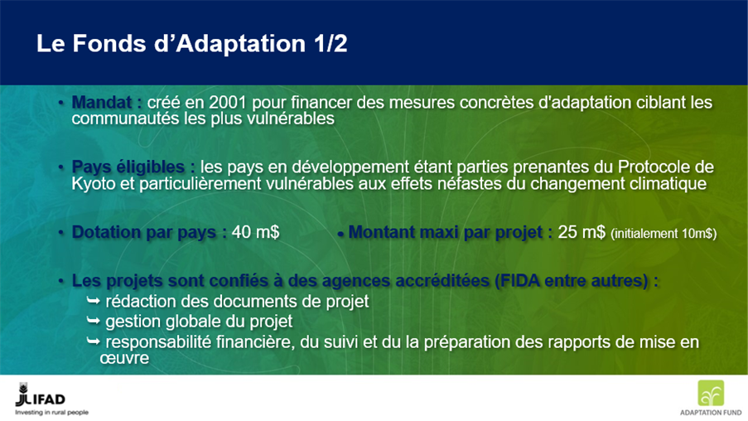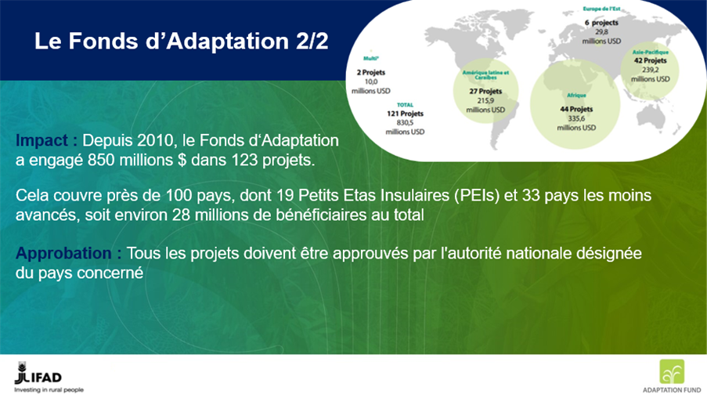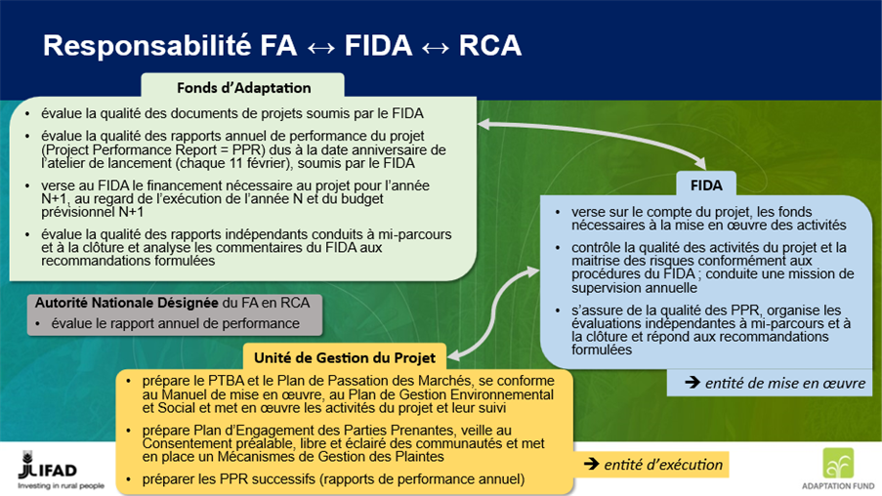
IFAD Portfolio in CAR
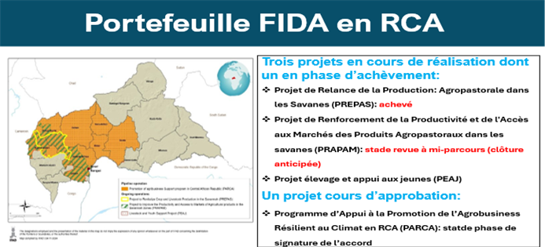
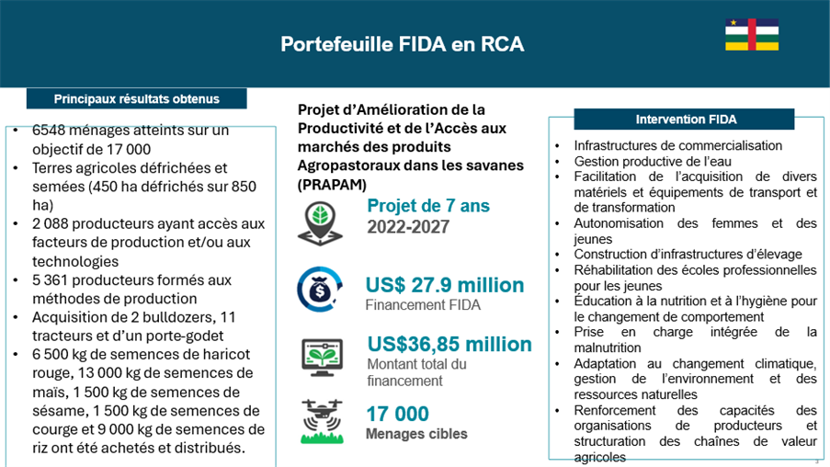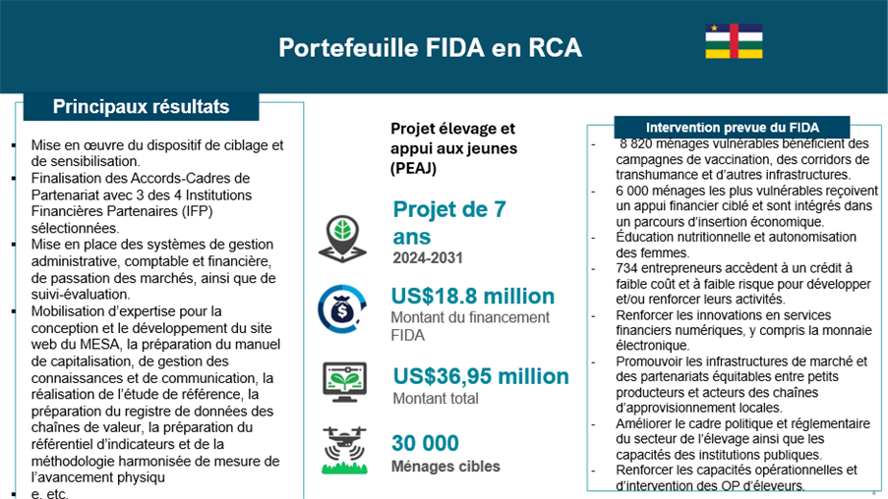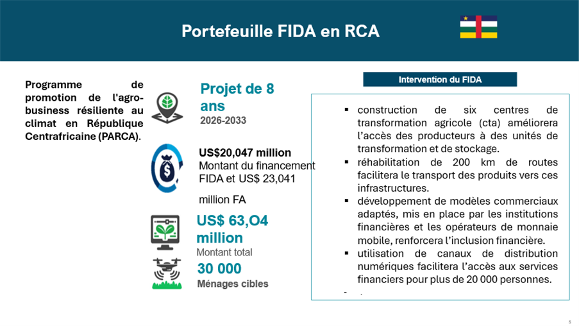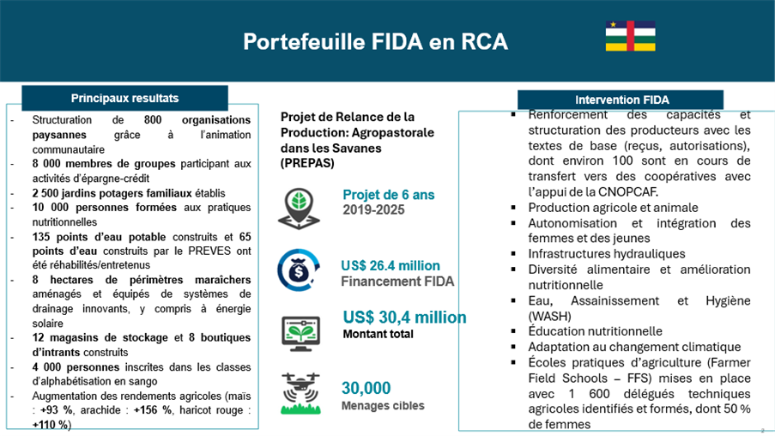
CAP-CAR: Strengthening the adaptive capacity and resilience of rural communities to climate change in the Central African Republic
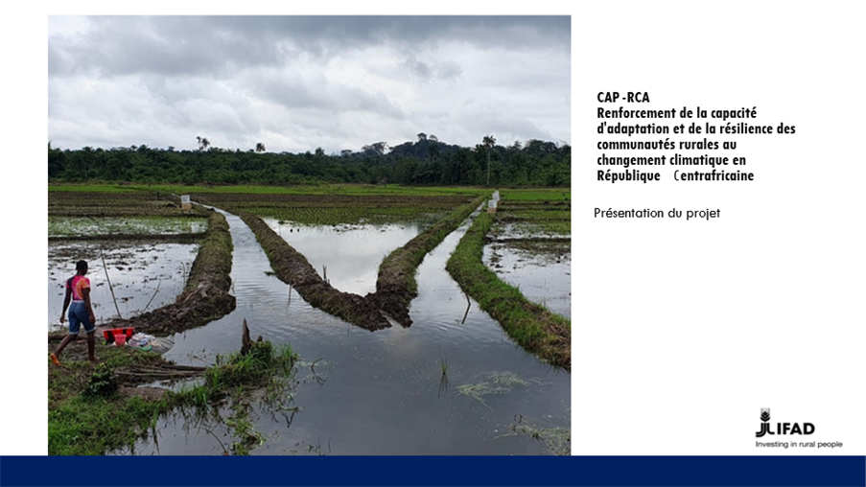
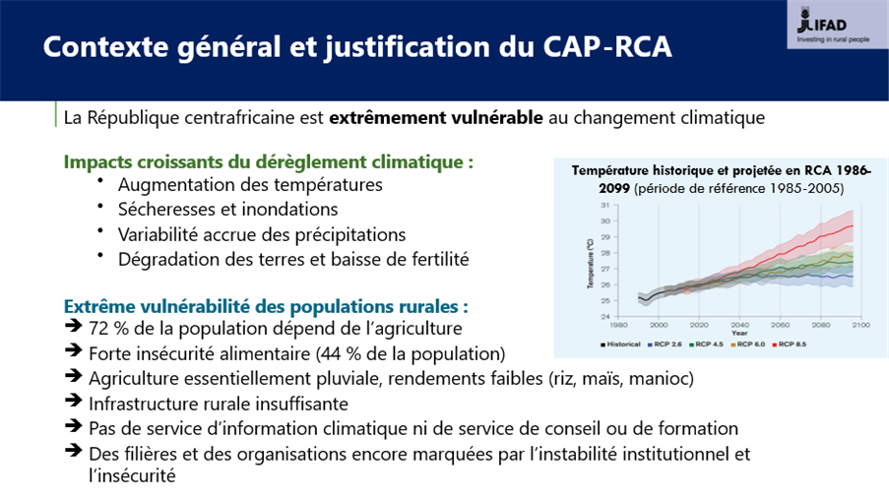
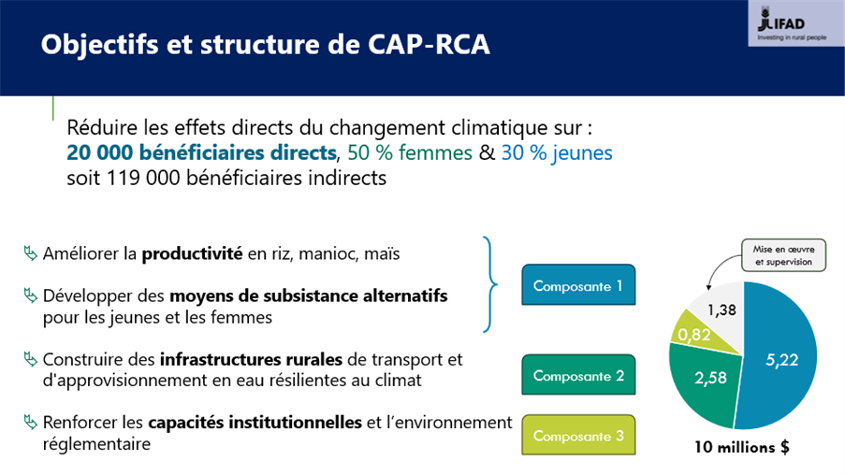
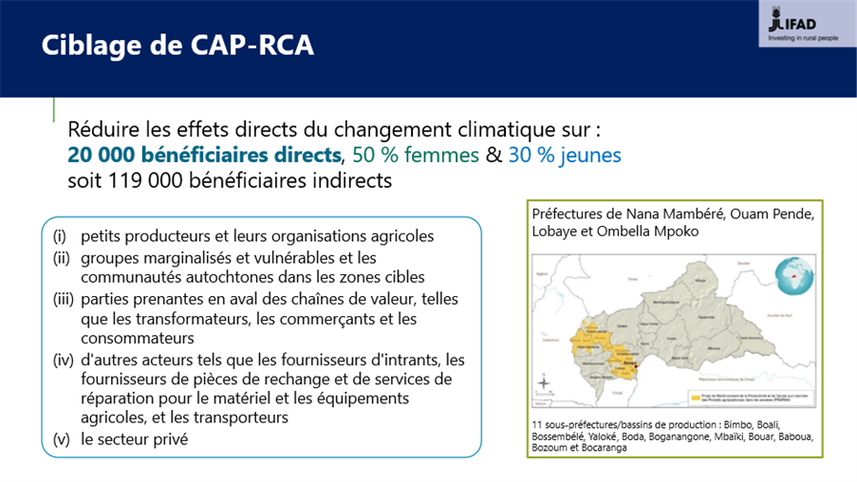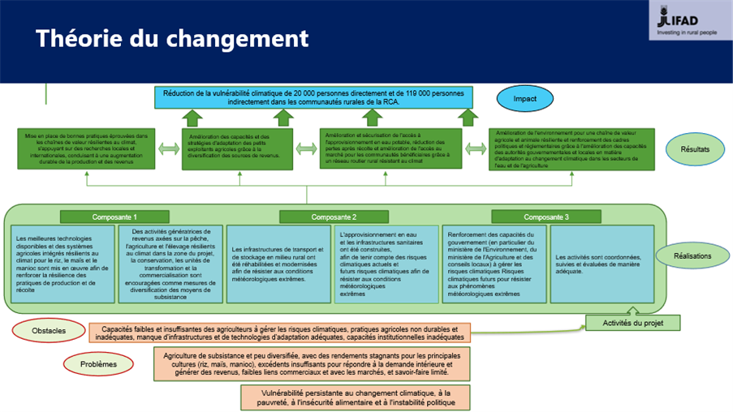
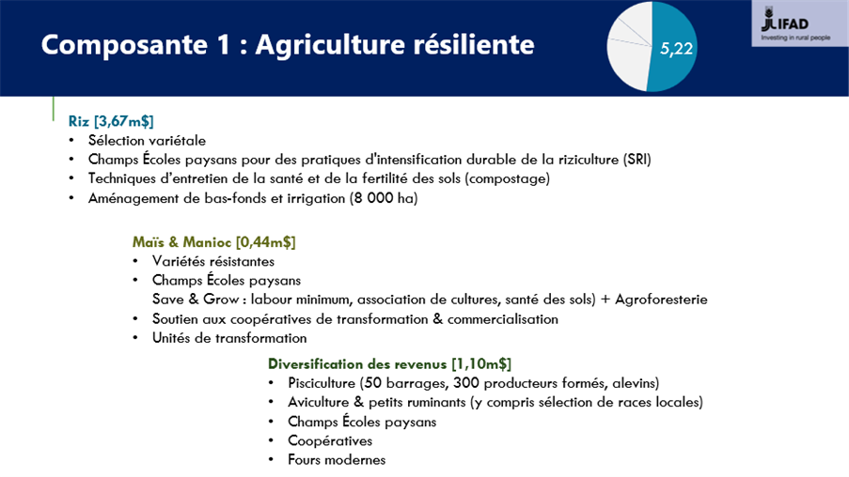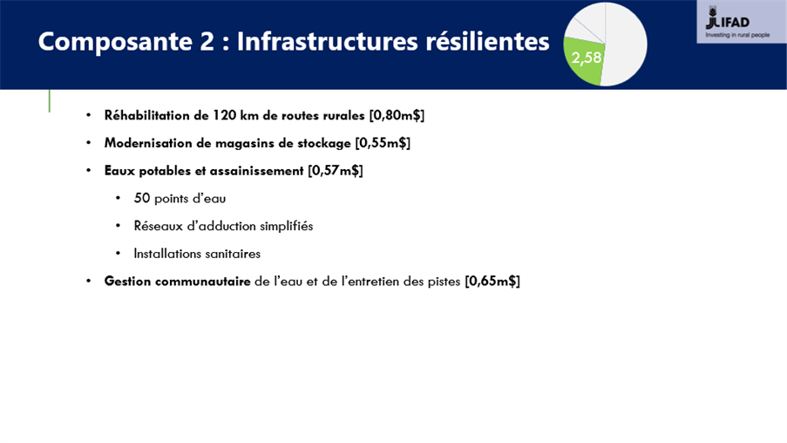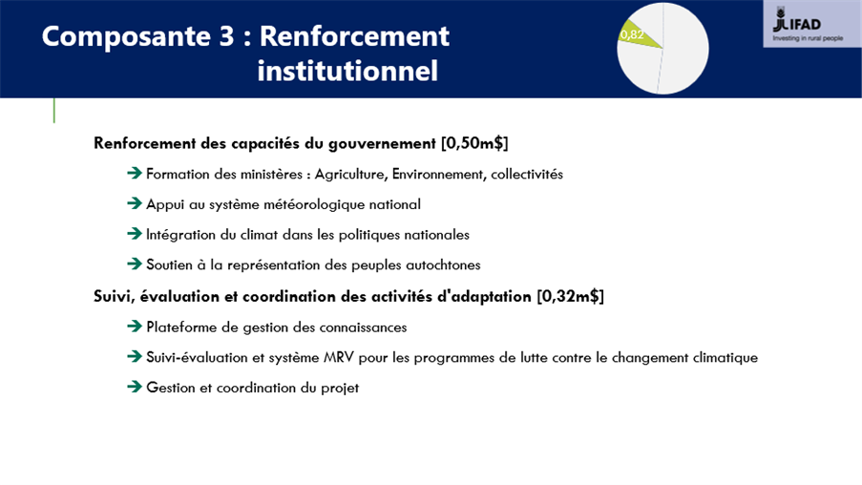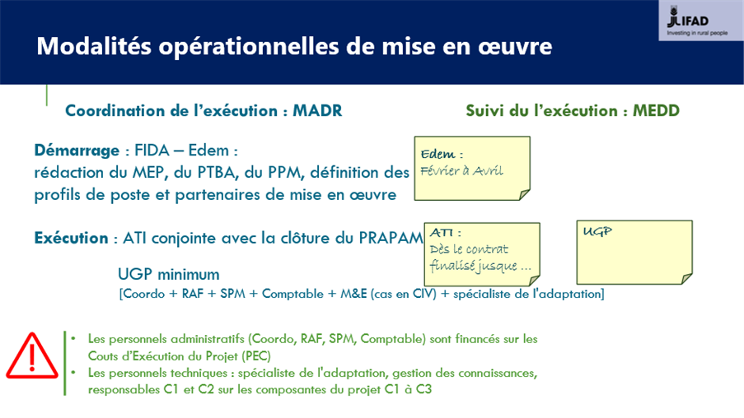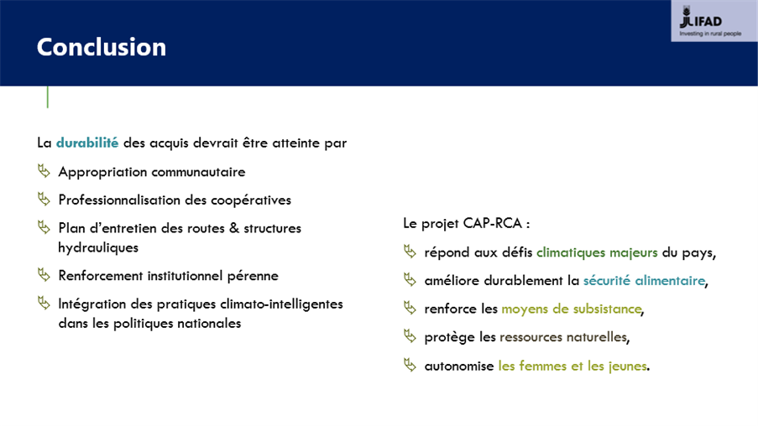


Monitoring and reporting systems of the Adaptation Fund
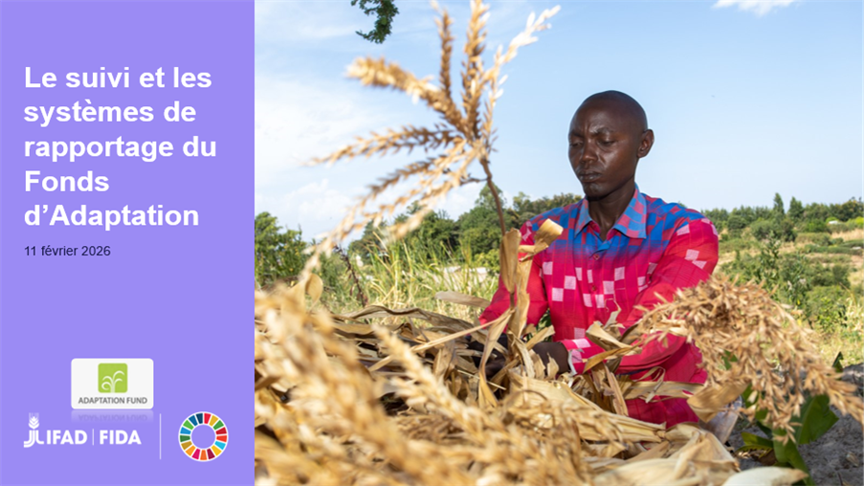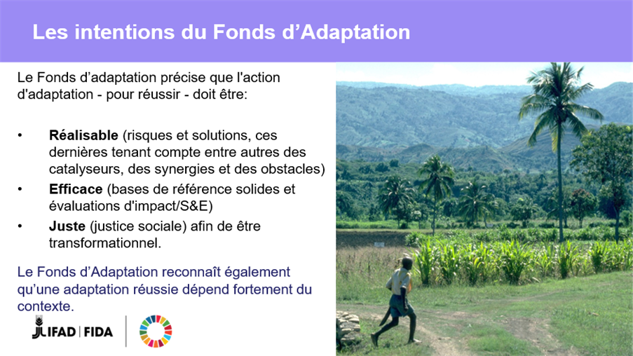
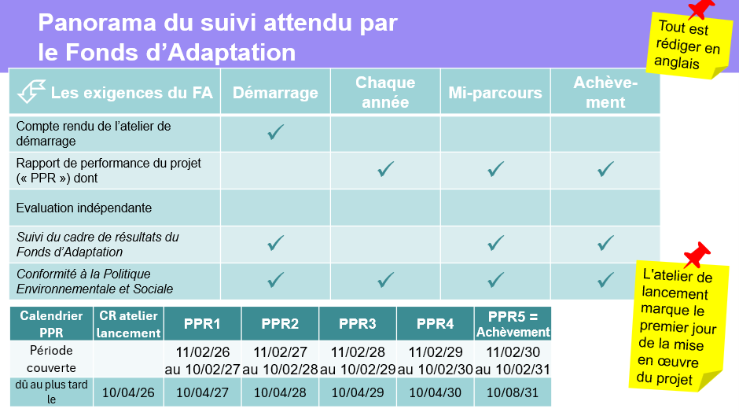
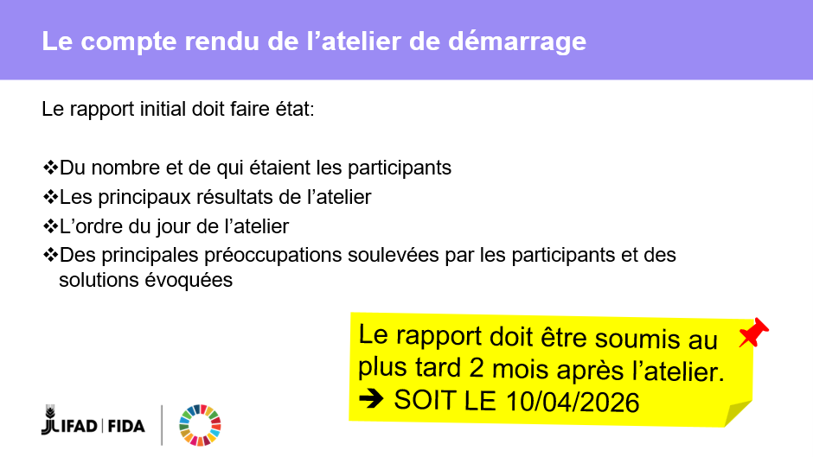
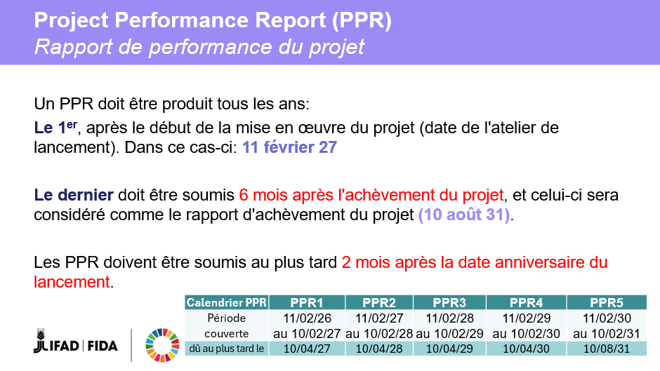
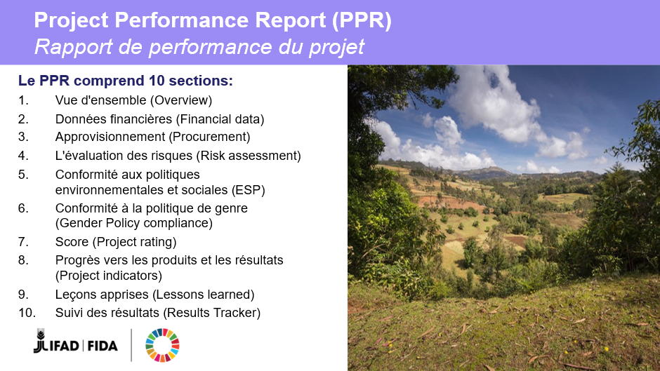
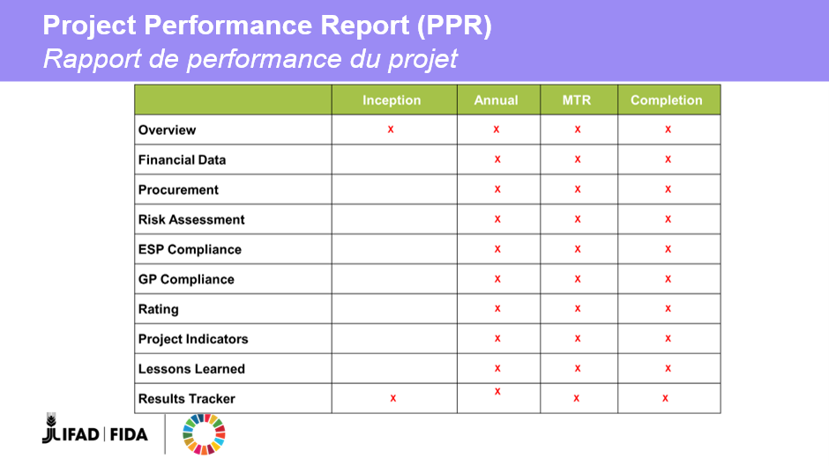

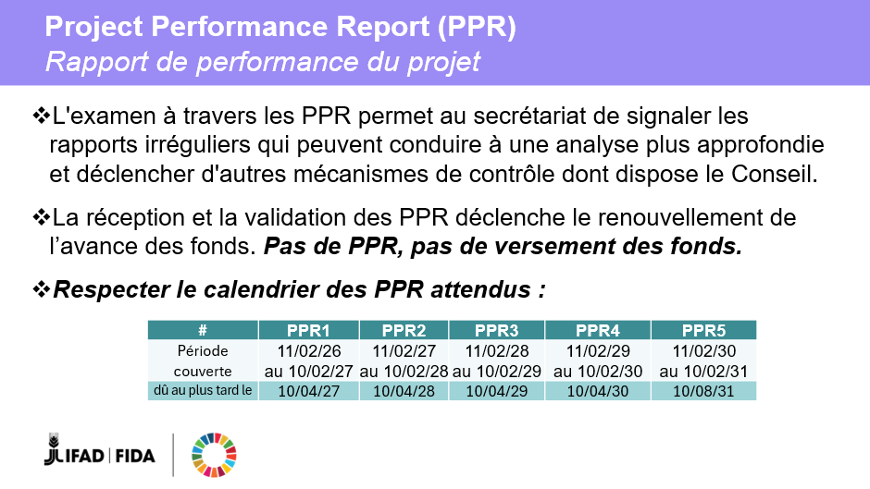
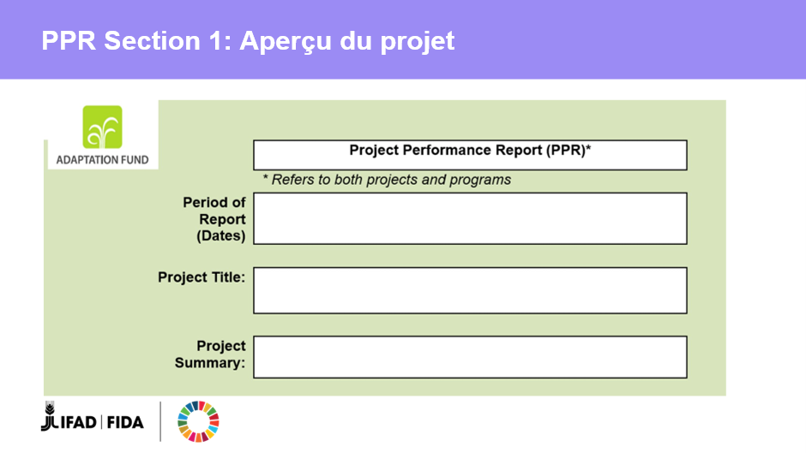
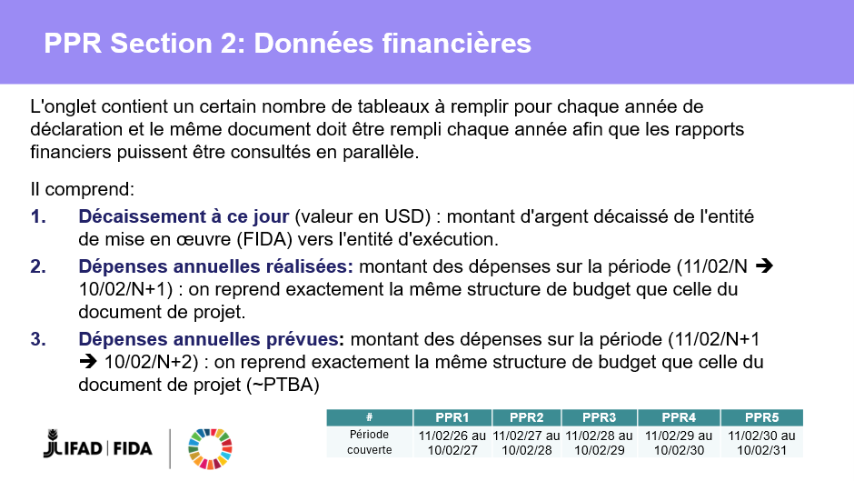
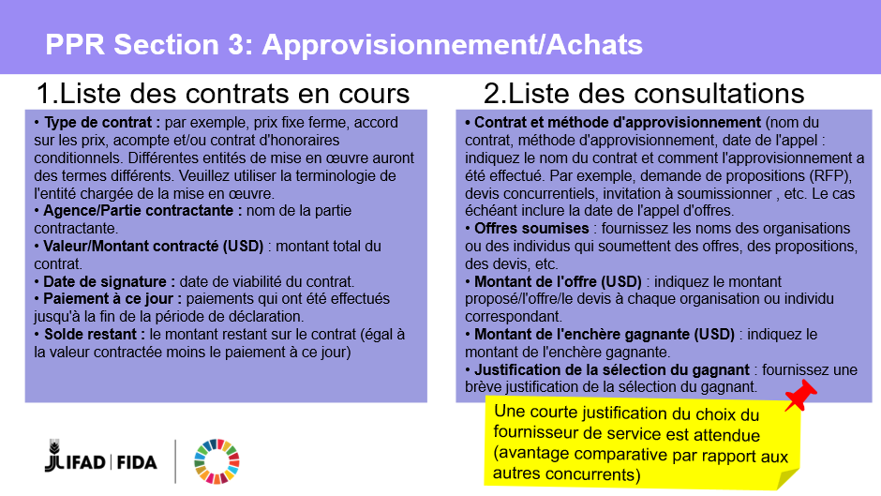

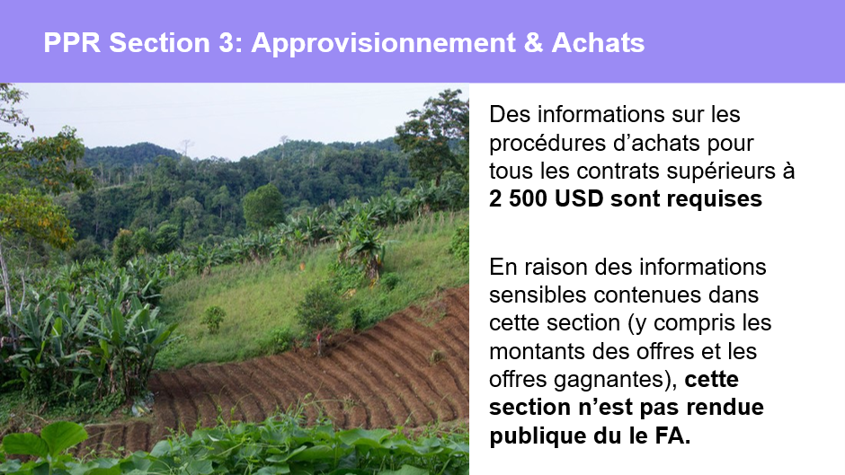
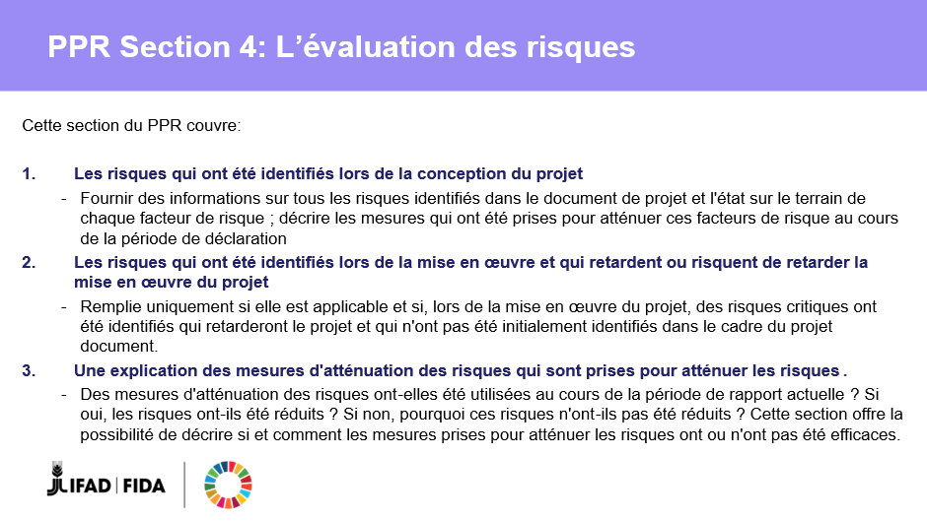

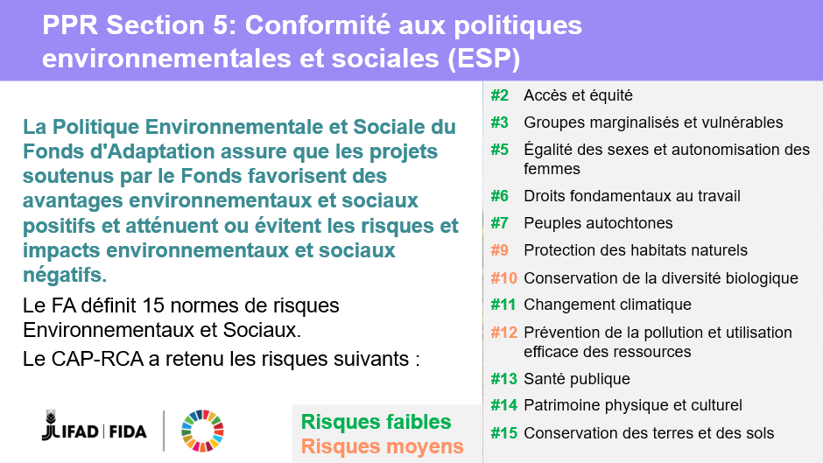

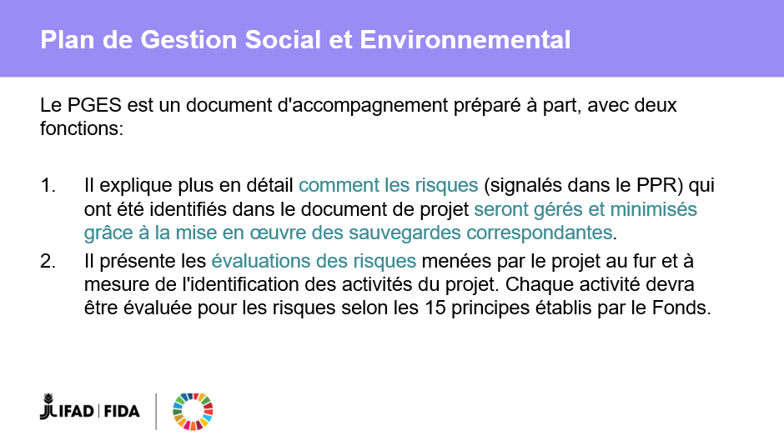
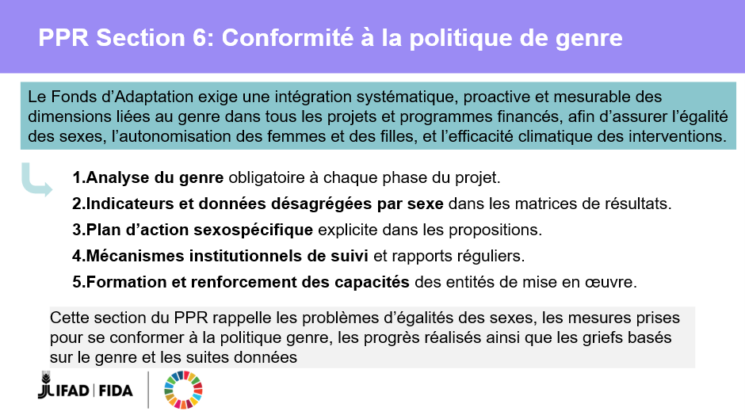
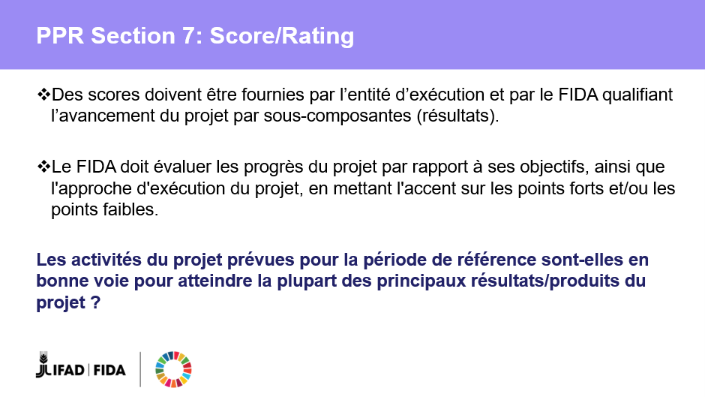
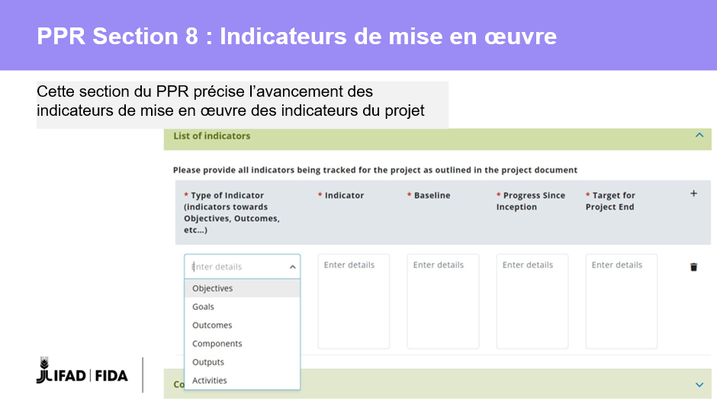
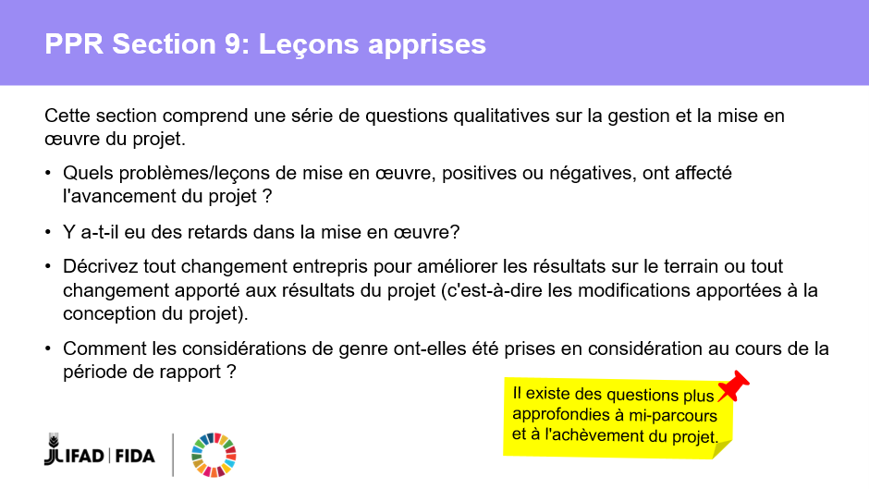
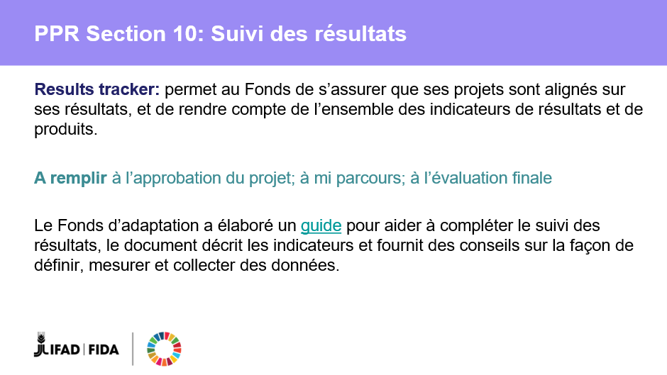
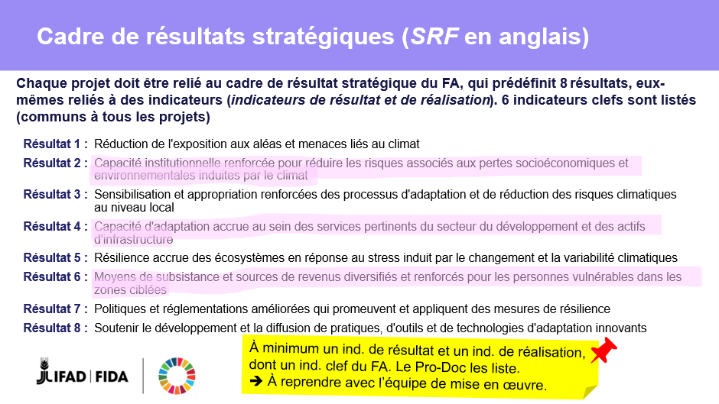
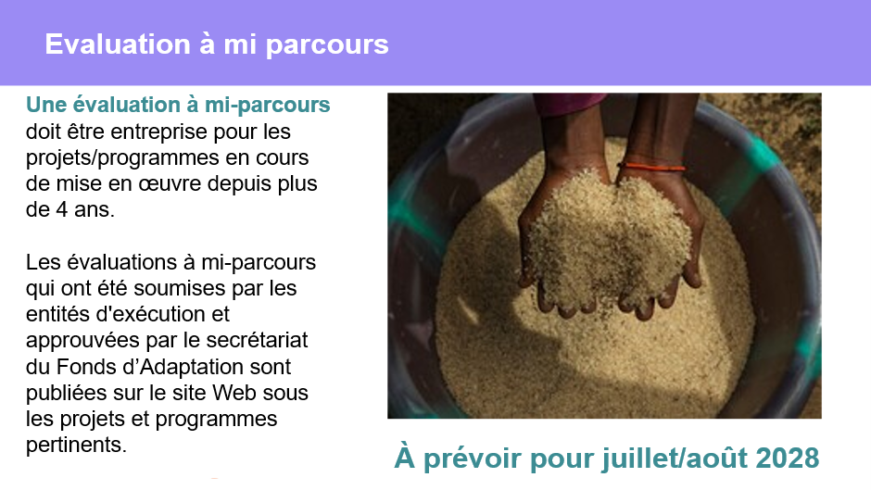
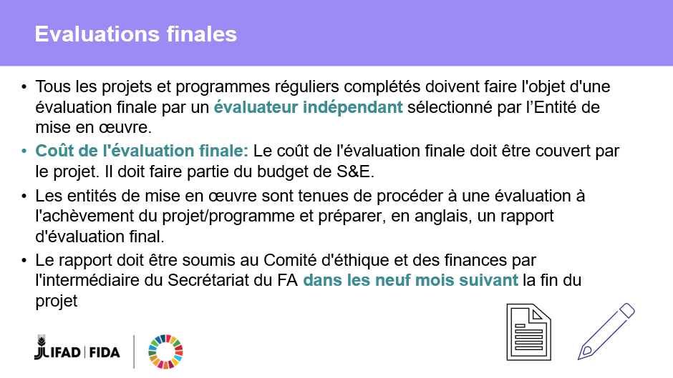
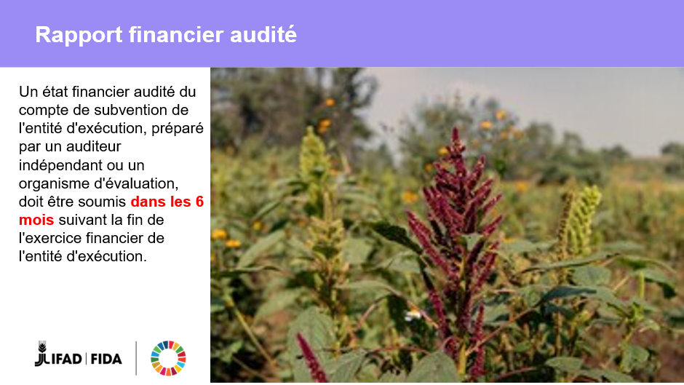

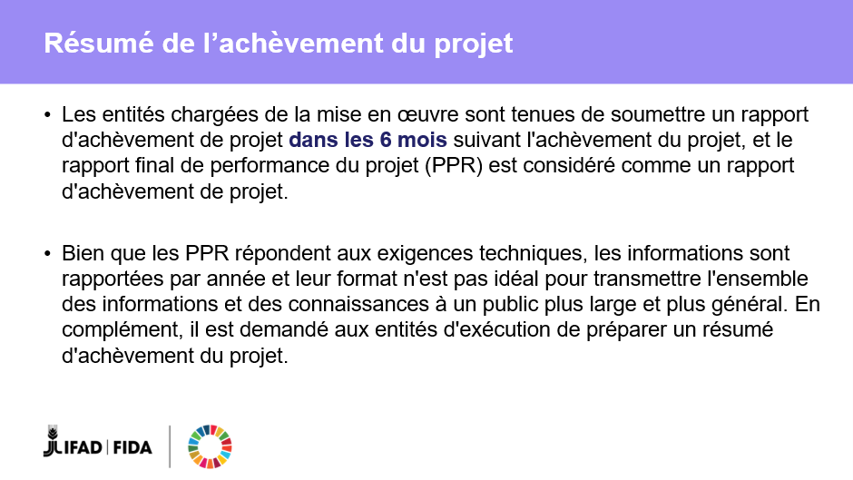
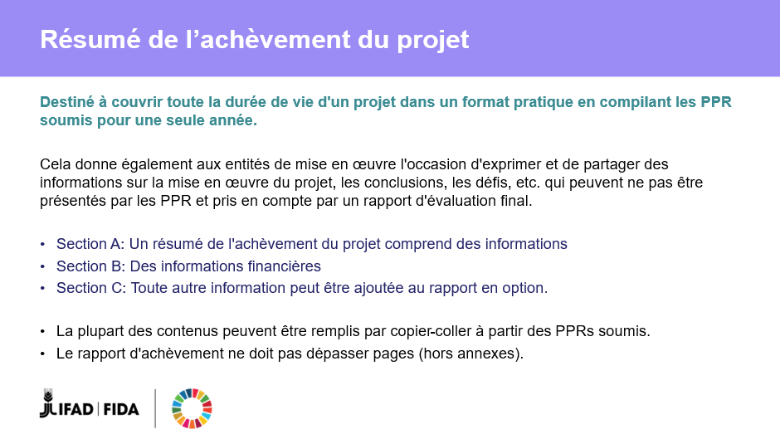
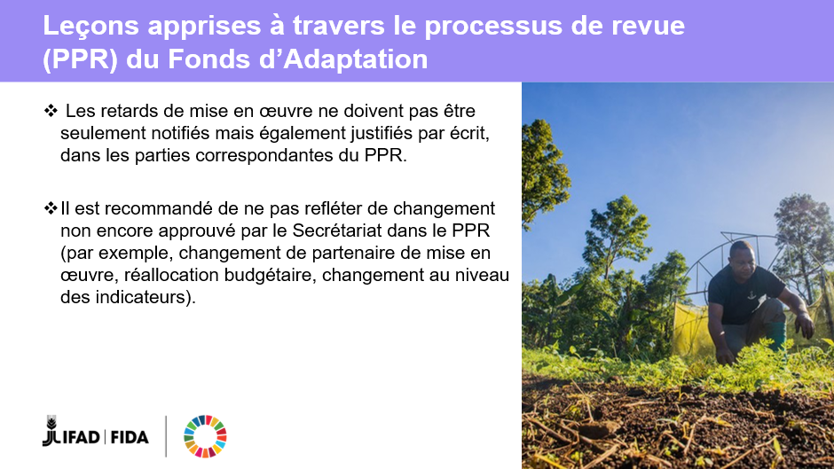
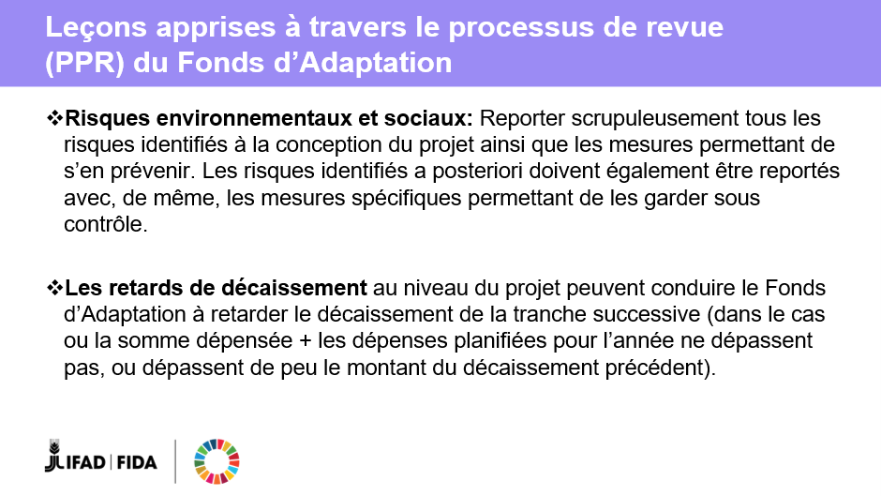


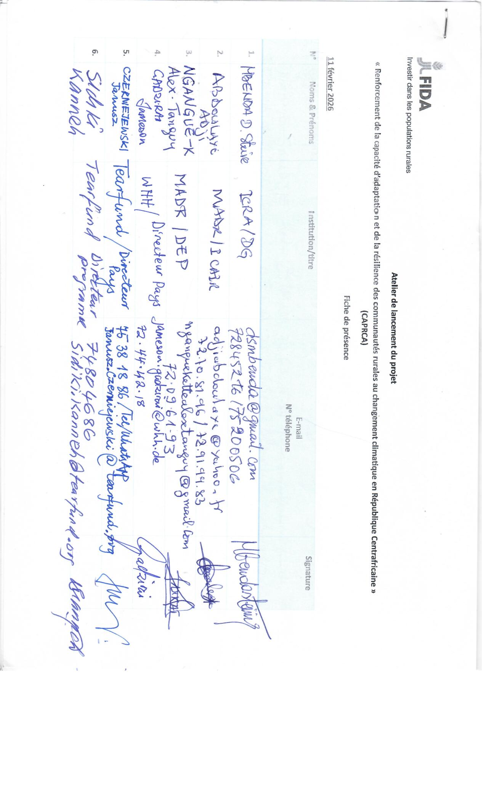
APPENDIX 5: List of Participants
