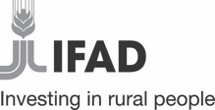 |  | 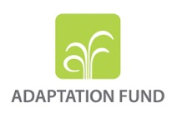

Regional Resilient Pastoral Communities Project (RRPCP-ADAPT)

Inception Workshop Report

Bishkek, Kyrgyz Republic
3-4 July 2024
Table of Contents

I. Introduction 1
II. Summary and Recommendations 1
III. Project Inception Workshop Objectives and Overview 2
IV. Project Overview 2
V. Workshop Presentations 4
VI. Revised implementation modalities 8
Annex 1: Workshop Agenda 9
Annex 2: List of Participants 11

List of Acronyms

AF | Adaptation Fund
APIU | Agricultural Projects Implementation Unit
AWPB | Annual Work Plan and Budget
BALI | Business for Action Learning and Innovation
CGP | Competitive Grants Programme
COVID-19 | Coronavirus Disease 2019
ESMP | Environmental and Social Management Plan
ESP | Environmental and Social Principles
FAO | Food and Agriculture Organization
FM | Finance Management
GALS | Gender Action Learning System
GIS | Geographic Information System
GP | Gender Policy
IFAD | International Fund for Agricultural Development
IFRs | Interim Financial Reports
IW | Inception Workshop
KM | Knowledge Management
M&E | Monitoring and Evaluation
MNRETS | Ministry of Natural Resources Ecology and Technical Supervision of the Kyrgyz Republic
MoE | Ministry of Emergency of the Kyrgyz Republic
MoEC | Ministry of Economy and Commerce of the Kyrgyz Republic
MoF | Ministry of Finance of the Kyrgyz Republic
MWRAPI | Ministry of Water Resources Agriculture and Processing Industry of the Kyrgyz Republic
NEN | Near East, North Africa and Europe Division of IFAD
PIM | Project Implementation Manual
PPR | Project Performance Report
RRPCP-ADAPT | Regional Resilient Pastoral Communities Project - Adapt
SC | Steering Committee
SEA | Sexual Exploitation and Abuse
SeC | Selection Committee
SH | Sexual Harassment
SFF | State Forest Fund
USP | Unidentified Sub-Project
WFP | World Food Programme

Introduction
- The Government of Kyrgyz Republic supported by the International Fund for Agricultural Development (IFAD), submitted the USD 9,999,313 Regional Resilient Pastoral Communities Project (RRPCP-ADAPT) project to the 38th Adaptation Fund (AF) Board meeting and was approved on 8 April 2022. The agreement between IFAD and the AF was signed on 7 November 2022.

- The Inception Workshop (IW) for the Adaptation Fund funded project Regional Resilient Pastoral Communities Project (RRPCP-ADAPT) was held on 3-4 July 2024 and it officially launched the project. The workshop was spread over two days with the first day being an open session for national and international stakeholders. The second day was focused on training and provided implementation support and advice to the Agricultural Projects Implementation Unit (APIU) of MWRAPI. These sessions were attended by development partners, civil society actors, potential project participants, the APIU and IFAD experts in environment and climate; Adaptation Fund; livestock and pastures; agribusiness; procurement; finance management (FM); monitoring and evaluation (M&E); ethics; knowledge management (KM); and a social inclusion and gender among others.

Summary and Recommendations
- Following the ratification of the project by the Kyrgyz Parliament in late June 2024, the workshop was an opportunity to help the project staff set the project implementation priorities and sequencing of activities for the development of the first Annual Work Plan and Budget (AWPB) for 2024.
- The workshop recommended for the project to finalise the Project Implementation Manual (PIM) ensuring that the implementation requirements such as the AF Environmental and Social Policy and Gender Policy was fully integrated.
- The project was reminded to finalise the 18-month AWPB and Procurement Plan (PP) as per IFAD requirements prior to the first disbursement.
- The workshop recommended the project to select the leskhozes (forestry enterprises) that were not supported previously by other donor projects. As planned in the project document, the identification of the sites will be done in Year 1 of the project and this suggestion will be taken into consideration.
- The implementing partners such as Community Development and Investment Agency (ARIS) and Community Development Alliance (CDA) were removed from the implementation of the project based on the Government’s request to facilitate a competitive selection process and to ensure the selection of partners with the highest qualifications and most cost-effective proposals, thereby optimizing the quality and efficiency of project implementation. The APIU was advised to focus early on, on the development of the Terms of References for strong Service Provider(s) that will be key for a successful project implementation. However, ARIS and CDA can still participate in tenders along with other Service Providers. The Service Provider(s) will be hired following IFAD standard procurement procedures. The cost of the service providers shall be part of the overall cost for the implementation of the respective activities.
- The project will be implemented with the oversight and support of the Steering Committee (SC), whose composition remains the same as stipulated in the full proposal. The SC will be chaired by the MWRAPI and co-chaired by the MNRETS and will also include other ministries and departments, as well as representatives of three NGOs in the field of agriculture. Additionally, the SC will include representatives of civil society, national academia, and the country's research sector as observers.
- The project will identify and work together with a relevant research institute to conduct a water availability and drought assessment that will help to identify the exact project sites.
- The APIU was recommended to build on and adjust their current M&E system that reflects the project activities following the AF project full proposal.

Project Inception Workshop Objectives and Overview

- The RRPCP-ADAPT inception workshop officially launched the project and marked the beginning of its implementation. The workshop aimed to ensure a clear and common understanding of the project cycle, objectives, and goals; to clarify the roles and responsibilities of the entities involved in implementation; and to explain the legal and financial conditions outlined in the financing agreement, along with the associated procedures and responsibilities. Additionally, the workshop focused on assisting the APIU in finalizing the project's Annual Work Plan and Budget (AWPB) and the Project Implementation Manual (PIM). It also served as an opportunity to describe and discuss the policies and procedures of the Adaptation Fund and IFAD, including fiduciary and reporting requirements, and to clarify the processes of official supervision reviews and implementation support for project improvements.
- The workshop was officially opened by Mr. Kubat Kaseyinov, First Deputy Minister of the Ministry of Water Resources, Agriculture, and Processing Industry, and Ms. Dina Saleh, Director of the Near East, North Africa, and Europe Division (NEN) in IFAD. It was attended by approximately 60 stakeholders from key government organizations, including representatives from ministries such as MWRAPI, MNRETS, the Ministry of Finance (MoF), the Ministry of Economy and Commerce (MoEC), the Ministry of Emergency (MoE), and Parliament. International agencies, including the Food and Agriculture Organization (FAO) and the World Food Programme (WFP), also participated, along with NGOs such as ARIS, CAMP ALATOO, the Pastures Association of Kyrgyzstan, and the Kyrgyz Association of Exporters and Importers. The workshop was organized and delivered using a combination of presentations and plenary discussions, allowing participants to raise key issues, identify challenges, discuss practical solutions, and agree on priority actions to advance the project.

Project Overview
- The Kyrgyz Republic, a small landlocked country in Central Asia, is bordered by Kazakhstan to the north, China to the east and south, Uzbekistan to the west, and Tajikistan to the southwest. The terrain ranges from 142 to 7,439 meters above sea level, with 90% of the area located above 1,500 meters, supporting a population of approximately five million people. The country’s climate varies by altitude, including valley-sub mountain, mountain, high mountain, and nival belt zones, with an overall continental climate featuring hot summers and cold winters. Bishkek, the capital, has an average annual temperature of 10.4°C and an estimated annual precipitation of 533 mm, ranging from 150 mm on plains to over 1,000 mm in mountains. There has been a significant increase in average annual temperatures from 1885 to 2010, with precipitation trends fluctuating.
- In 2011, the forest cover in Kyrgyzstan was estimated at 954,000 ha, accounting for 5.8% of the total land area, with primary forests comprising 28% and planted forests making up 57,000 ha. The majority of forests, situated between 700 and 3,600 meters above sea level, include spruce, walnut-fruit, juniper, and riverside forests, with poplars planted for timber and windbreaks. All forests fall under the State Forest Fund (SFF) and are regarded as precious natural resources due to their environmental and ecological functions.
- Despite being forest-poor, Kyrgyz forests play a critical role in global environmental regulation and climate change prevention. They provide essential ecosystem services, such as mudslide prevention and water regulation, and are vital for the irrigation-dependent agriculture of Central Asia. Natural grasslands and pastures dominate high-altitude and low-rainfall areas, making pasture management a primary land use. Sustainable agricultural land management is crucial for maintaining ecosystem services like carbon storage and water retention.
- However, Kyrgyz forests face severe degradation due to overharvesting for fuel and construction, exacerbated by the country's fragile topography. This leads to soil erosion, landslides, and poor water management. The forestry sector is under threat from the lack of timber imports, overgrazing, and population growth, resulting in a significant reduction in forest cover. Livestock grazing, especially in low and middle altitudes, has further degraded forests, with pasture management challenges due to improper herd management. Between 1990 and 2018, the number of cattle, cows, and horses increased, while sheep, goats, and poultry declined.
- The forestry sector’s economic situation is dire, with inadequate financial resources for forest management and limited private sector engagement. This leads to forest loss, environmental hazards, and a vicious cycle of overgrazing and land degradation, worsened by climate change. The country lacks an integrated management framework for pasture and forest resources.
- The COVID-19 pandemic has severely impacted the Kyrgyz economy. Predictions in March 2020 indicated real GDP growth would slow to 0.4%, inflation would rise to 12%, and the current account deficit would widen to 14.5% of GDP. By July 2020, the economic effects were evident, with significant declines in tax revenues and remittances due to lockdowns and border closures.
- Climate change is projected to significantly impact the Kyrgyz Republic's agriculture, water resources, livestock, and forestry sectors. Rising temperatures, increased precipitation variability, and reduced surface water due to evapotranspiration and glacial melt will exacerbate aridity, irrigation challenges, and desertification. These changes will likely reduce crop yields and food availability, with wheat and maize particularly sensitive to rainfall timing, and increase the prevalence of agricultural diseases and pests. Water stress is expected to rise due to altered precipitation patterns, glacier reduction, and increased demand, leading to significant declines in river flows and water availability for agriculture and sanitation.
- Livestock will face decreased pasture coverage, water scarcity, and increased biological stress, leading to greater vulnerability to diseases and reduced productivity. Forestry ecosystems will experience altitudinal shifts due to temperature rises, reducing their surface area and altering species composition. These changes will collectively hinder food security, increase poverty, especially in rural areas, and may drive migration for economic opportunities, while exacerbating environmental hazards such as floods, mudslides, and erosion.
- Addressing these challenges led to the development of the RRPCP-ADAPT project funded by the Adaptation Fund (AF). The project goal is to contribute to rural poverty alleviation in the country through increased climate resilience, incomes and gender-sensitive growth in rural farming communities. The AF funding will be used to achieve this goal through the following components:

- Capacity development to integrate climate change adaptation and gender equity for resilient ecosystems and livelihoods (USD221,000).
- Climate-adaptive investments in forest and rangeland rehabilitation (USD5,010,000).
- Climate-resilient alternative income development (USD3,407,063).

Workshop Presentations
Day 1
- The introductory presentation provided a comprehensive overview of the project. The IFAD team began by emphasizing the importance of enhancing the understanding of climate change impacts among stakeholders. The presentation outlined the project's main goal: to contribute to rural poverty alleviation through increased climate resilience and gender-sensitive growth in farming communities.
- Climate Rationale. A significant portion of the presentation was dedicated to the climate rationale behind the project. It detailed various climate hazards affecting the region, such as rising temperatures, increased frequency and intensity of floods, heat stress, mudslides, and droughts. Each hazard was described in terms of its impact on livestock, pastures, and rural livelihoods, highlighting the urgent need for adaptive measures.
- Target Groups. The project targets multiple groups, including vulnerable rural households, pasture users, and Leskhozes (forest enterprises). It aims to reach approximately 20,700 households, or around 109,710 individuals, with a focus on women and youth. The presentation emphasized the importance of involving these groups in the project to ensure inclusive and effective implementation.:
- The presentation outlined several key outcomes of the project:
- Outcome 1.1: Capacity for transformative gender approach in climate resilient livelihoods enhanced. This outcome will implement gender-transformative approaches (BALI) & mainstream gender across all project’s components to women participate in and benefit equally. This outcome should not be conceived as a stand-alone part of the project as it provides the foundation for the implementation of other key project outcomes and the effective implementation of its targeting and gender strategies.
- Outcome 1.2: Knowledge management. This outcome focuses on conducting water vulnerability assessments and integrating data from climate risk studies. Field surveys and GIS mapping will be used to establish baseline data on water availability in climate-sensitive pastures. The project will collect and disseminate information on successful experiences in project-funded activities. Campaigns will be conducted to gather and present farmers' experiences with water scarcity, and materials will be prepared for media outreach. A project website will be developed to communicate project characteristics and results, helping to expand the reach of innovative climate-resilient strategies.
- Outcome 2.1: Climate-smart afforestation and reforestation enabled. The project aims to establish two nurseries producing a significant number of climate-resilient seedlings annually. This includes creating business models for nurseries, identifying suitable locations, training forestry staff, and developing and implementing nursery work plans. The nurseries were expected to produce 1.5 million spruce seedlings and 400,000 walnut seedlings annually, along with other species.
- Outcome 2.2: Afforestation / reforestation enhanced and pastureland degradation reduced. The project will implement pasture management plans designed to mitigate degradation and enhance resilience covering an estimated area of 190,000 ha. This includes the introduction of rotational grazing practices to prevent overgrazing, reduce soil compaction, and enhance soil health. The project aimed to restore degraded pastures and promote sustainable herd management. This outcome also includes design and implementation of afforestation, reforestation and enrichment plans on the total area of 4,000 ha.
- Outcome 3.1: Gender-transformative entrepreneurship promoted. The Business for Action Learning and Innovation (BALI) programme is a key initiative under this outcome, aimed at promoting gender-transformative entrepreneurship and income diversification among vulnerable households. The BALI programme will equip participants with the skills to develop and implement viable business plans, thereby reducing dependence on fragile pastures. Special focus was placed on engaging women and youth, with at least 50% of the beneficiaries being women and 30% being youth.
- Implementation arrangements. The presentation on implementation arrangements provided a comprehensive framework for the project's implementation. The project’s institutional framework was clearly defined, with the Adaptation Fund as the donor and IFAD serving as the Implementing Entity. The Executing Entity will be the Ministry in charge of Agriculture (currently called the Ministry of Water Resources, Agriculture and Processing Industry - MWRAPI) in close cooperation with the Ministry of Natural Resources, Ecology and Technical Supervision (MNRETS). The Agricultural Projects Implementation Unit (APIU) under the MWRAPI will be the primary body responsible for executing the project.
- Key responsibilities outlined for the APIU included financial management, procurement, performance management, monitoring and evaluation, day-to-day execution of the project and reporting. The presentation emphasized the importance of local and regional partners, including local self-government bodies and community groups, in the project's implementation. These partners were crucial for mobilizing pasture users, selecting project activities, and identifying beneficiaries. Overall, the presentation highlighted a structured approach to achieving the project's goals, with a strong focus on coordination, detailed planning, and community involvement to ensure successful implementation and oversight.
- Financial Management Arrangements & General Fiduciary Aspects. The presentation was focused on financial management framework, which includes the establishment of designated accounts in USD and local currency, tax exemptions for goods and services, and detailed plans for capacity development and climate-adaptive investments. Key conditions for withdrawal of funds were outlined, such as the establishment of the project Steering Committee (SC), appointment of key personnel, submission of a draft PIM, and the setup of functional accounting software.
- The presentation emphasized the importance of a robust financial management environment, detailing risk assessments and mitigation measures to ensure project delivery is not adversely impacted. Annual Work Plans and Budgets (AWPBs) are critical tools for planning, monitoring, and managing project performance, with strict guidelines for submission and revision. Disbursements are based on interim financial reports (IFRs), which include cash forecasts, sources and uses of funds, and designated account reconciliations. Internal controls were highlighted as essential for maintaining project integrity, with recommendations for regular updates to the PIM and adherence to documented procedures. The presentation concluded with an overview of the IFAD Client Portal, in-kind contributions, and guidelines for winding up activities, ensuring comprehensive understanding and compliance with financial and reporting requirements.

Day 2

- Introduction to the AF: operational procedures, USPs and PPRs. The workshop session specifically dedicated to the AF procedures and rules highlighted the Environmental and Social Principles (ESP) essential for project compliance. It explained the concept of Unidentified Sub-Projects (USPs), which are activities not concretely identified at the proposal stage and, therefore, cannot be initially assessed for ESP risks. To manage these USPs, the project employs strategies like GIS mapping, technical assessments, feasibility studies, and public consultations to ensure they do not trigger adverse environmental or social impacts. The compliance steps involve rigorous monitoring and documentation of all activities, ensuring adherence to the ESP and Gender Policy (GP) risk mitigation measures detailed in the RRPCP-ADAPT project document. The APIU was reminded to keep the ESMP as a living document, requiring continuous updates throughout the entire project lifetime. Specific measures include training stakeholders on risk identification and mitigation, conducting feasibility studies, and involving the Selection Committee (SeC) in the approval process of competitive grants programme (CGP) to ensure all projects meet the required standards.
- Furthermore, the presentation covered the Annual Project Performance Report (PPR), a critical component for maintaining project transparency and accountability. The PPR, required annually from the start of project implementation, ensures that the project adheres to the AF's policies and guidelines. It includes detailed reports on financial data, procurement, risk assessments, and compliance with ESP and GP. The timely submission of PPRs is crucial, as delays can halt fund disbursement for up to two years. The workshop also addressed the concept of material changes within the project, which include significant budget reallocations, restructuring, changes in project indicators or activities, and adjustments to the disbursement schedule. Any material change requires approval from the Adaptation Fund Board, ensuring that all project modifications align with the original goals and compliance requirements.
- Monitoring and Evaluation (M&E). This presentation aimed to provide a comprehensive understanding of M&E roles and functions, the M&E system and plan, and the results framework. Key objectives of the M&E system include tracking project progress, supporting decision-making, and ensuring that implementation is on track or requires corrective action. The presentation emphasized the importance of systematic, timely, and participatory M&E plans that guide the project on what to measure and evaluate, ensuring continuous learning and feedback among stakeholders.
- The AF full proposal’s results framework was highlighted as a crucial tool for informing what needs to be measured. It provides a structured representation of project objectives, indicators, baseline data, targets, and means of verification. The framework connects inputs to outputs, outcomes, and impacts, helping to visualize and track the project's progress. Data management and collection mechanisms were also discussed, focusing on the need for standard data forms, trained field staff, and established timelines for data collection. Tools for monitoring the implementation of activities versus targets, such as surveys and GIS systems, are essential for collecting the required information to measure indicator progress.
- Additionally, the presentation covered the alignment of the RRPCP-ADAPT project with the Adaptation Fund's results framework. The importance of gender mainstreaming and knowledge management was also emphasized. The management information system (MIS) was described as a vital component for linking the results framework with the AWPB and procurement plan targets. The MIS supports data disaggregation by sex and age and provides both online and offline data availability with regular backups and security measures. The M&E system will provide the empiric data as the primary source of information on which any Knowledge Sharing product will be developed during project implementation.
- Knowledge Management (KM). This presentation emphasized the importance of integrating KM into project activities to enhance learning, innovation, and evidence-based decision-making. Additionally, IFAD's KM strategy was explained, focusing on knowledge generation, knowledge use, and building an enabling environment for learning and sharing. The strategy centers on the knowledge of staff and partners, highlighting the value of peer-to-peer sharing through communities of practice and networks. The session also detailed the types of knowledge IFAD expects projects to collect, including lessons learned, successful practices, innovations, policy engagement, challenges, and opportunities for scaling up.
- The presentation outlined the process for generating and disseminating knowledge within the RRPCP-ADAPT project. Key activities include utilizing knowledge platforms and websites, publishing technical documents, and organizing knowledge-sharing events. Communication channels such as internal and external media, social media, and project websites are crucial for reaching various stakeholders, including smallholder farmers, project partners, government bodies, and the global community. The KM plan for RRPCP-ADAPT aims to improve understanding of climate-related challenges in Kyrgyzstan, particularly water scarcity in pastures, and to document gender-transformative entrepreneurship approaches. Roles and responsibilities for KM were clearly defined, with the M&E and Gender Specialist, KM and Communications Specialist, and other consultants playing pivotal roles in collecting, analyzing, and disseminating project-related knowledge.
- The final part of the presentation focused on the practical steps needed to implement the KM strategy. This includes preparing terms of reference for a KM and Communications Specialist, developing communication channels, creating an online KM repository, and establishing a project website. The workshop emphasized the need for a structured KM plan that addresses specific goals, target audiences, tools, methodologies, and budget allocations. It also highlighted the importance of linking KM activities with the M&E system to ensure that collected data is effectively used to generate insights and guide project implementation. By systematically capturing and sharing knowledge, the RRPCP-ADAPT project aims to enhance its impact, promote sustainable practices, and contribute to broader policy dialogues on climate resilience and rural development.
- Procurement. This was followed by a presentation on IFAD’s procurement procedures including IFAD’s most recent procurement system called OPEN. The procurement of goods, works and services under the Project will be under the responsibility of the APIU. Project procurements will be carried out in accordance with the IFAD Procurement Manual, guidelines as reflected in the PIM. Prior to any purchase, the APIU will submit a Procurement Plan to IFAD for approval. The Procurement Plan will specify the procurement method for each contract financed, and the thresholds, ceilings and prior/post review that will be used in the procurement of the Project. It will also indicate any additional requirements that may be set out in the Procurement Manual in relation to particular procurement methods. The Procurement Plan is complementary of the AWPB. The first Procurement Plan will be updated after the launch of the Project and will cover the first 18 months of Project implementation and must be submitted to IFAD for no-objection. The Procurement Plan will be updated bi-annually (or as necessary) to cover the subsequent Project implementation periods as part of the AWPB.
- Prevention of sexual harassment, sexual exploitation and abuse. The presentation, coordinated by the IFAD Ethics Office, addressed the critical issue of sexual misconduct within IFAD operations, emphasizing its corporate priority to uphold the highest ethical standards. The presentation categorizes sexual misconduct into three types: sexual harassment, sexual exploitation, and sexual abuse. It underscores IFAD's zero-tolerance stance towards these behaviors, highlighting the organization's responsibility to maintain a safe and respectful work environment. The presentation explained the significant negative impacts of sexual misconduct on victims, communities, and IFAD’s credibility, stressing that all personnel must adhere to core values of integrity, respect, professionalism, and focus on results.
- The presentation provided detailed definitions and examples of sexual misconduct. Sexual harassment involves any unwelcome sexual advances or conduct in the workplace that creates a hostile environment. Sexual exploitation is the abuse of a position of power for sexual purposes, including transactional sex, even in countries where prostitution is legal. Sexual abuse encompasses any non-consensual sexual act, including those involving minors under the age of 18. The presentation uses real-life-inspired scenarios to illustrate these behaviors, emphasizing the need for IFAD personnel to maintain the highest conduct standards both professionally and personally.
- Roles and responsibilities in preventing and responding to sexual misconduct were clearly outlined. IFAD and project personnel must behave ethically, report incidents, and cooperate with investigations. SEA focal points were tasked with raising awareness and coordinating responses. Borrowers and implementing partners must ensure project compliance with IFAD’s SEA Policy, report any incidents, and include SEA clauses in agreements with staff and contractors. The Ethics Office, responsible for handling reports, ensures confidentiality and imposes disciplinary measures, including dismissal and potential criminal action. Reporting mechanisms were detailed, including confidential helplines and email contacts, ensuring that all reports are treated seriously and anonymously if preferred. The presentation concluded with guidance on supporting victims, emphasizing empathy, listening, and taking appropriate action to ensure their safety and confidentiality.

Revised implementation modalities
- This inception workshop was the opportunity to validate some minor adjustments in the implementation modalities as requested by the Kyrgyz Government through its Ministry in charge of Agriculture (as spelled out in the signed Financing Agreement between IFAD and the Kyrgyz Government).
- As such, it was confirmed that the Executing Entity will be the Ministry in charge of Agriculture (currently called the Ministry of Water Resources, Agriculture and Processing Industry - MWRAPI) in close cooperation with the Ministry of Natural Resources, Ecology and Technical Supervision (MNRETS), which is the National Designated Authority in the country, not both as stipulated in the Financing Agreement between IFAD and AF. Second, according to the established terminology, the executing entity is called the Lead Project Agency (LPA) in the agreement between IFAD and the Government.
- Although the roles of the Chair (Ministry in charge of Agriculture) and Co-chair (MNRETS) in the SC have not changed from what was stated in the AF Full Proposal and the Financing Agreement between IFAD and AF, the composition has been slightly revised in the FA between IFAD and the Government, based on the Government's suggestion. Specifically, instead of the State Agency for Local Self-Government and Inter-Ethnic Relations (SALSGIER) and the State Agency of Architecture, Construction, Housing, and Communal Economy, the Government recommended adding the Ministry of Economy and Commerce, as its participation in this project's implementation is deemed more relevant.
- Furthermore, implementing partners such as CDA and ARIS, as initially foreseen in the project proposal, will not anymore be recruited under Direct Contracting, but can still participate in tenders along with other Service Providers for the implementation of specific activities related to GALS/BALI, as well as farmers mobilization/support for grant proposal preparation.

Annex 1: Workshop Agenda
The Kyrgyz Republic
Regional Resilient Pastoral Communities Project - Adapt (RRPCP-Adapt) – Inception Workshop Agenda
Bishkek 3-4 July 2024

Date/time | Tentative Programme | Presenters | Remarks
1 July 2024, Monday
Arrival of the mission team in Bishkek
2 July 2024, Tuesday
Preparation with the team and discussions on the PIM for finalization by the end of the workshop
3 July 2024, Wednesday
09:30-10:00 | Welcome and Opening Remarks | Mr Bakyt Torobayev, Minister of Water Resources, Agriculture and Processing Industry  Mr Melis Turgunbaev, Minister of Natural Resources, Ecology and Technical Supervision  Ms Dina Saleh, Regional Director, NEN
10:00-10:15 | Introduction by IFAD | Mr Samir Bejaoui, Country Director, Kyrgyzstan | Country portfolio+long-standing experience
10:15-10:45 | Project objectives, overall scope and Afforestation/Reforestation activities | Mr Khafiz Atymtay, IFAD Mission Team Leader/Environment and Climate Programme Officer
10:45-11:15 | Livestock and Pasture related activities | Mr Antonio Rota, Senior Livestock Specialist
11:15-11:45 | Targeting, Social Inclusion and Gender Mainstreaming | Ms Valentina Franchi, Senior Gender and Social Inclusion Specialist (remotely) | Including GALS
11:45-12:15 | Agribusiness related activities | Ms Elena Isaeva, Agribusiness Specialist | Including BALI
12:15-13:00 | Implementation arrangements, project stakeholders and partners and their roles | Mr Chakib Nemaoui, Country Programme Officer  Mr Tamchybek Tuleev, APIU Director
13:00-13:30 | Budget and financial management guidelines for both IFAD and AF | Ms Alaa Abdelkarim, Regional Finance Officer
13:30-13:40 | Summary and Recap of Day 1 | Mr Samir Bejaoui, Country Director, Kyrgyzstan
13:40-15:00 | Lunch
4 July 2024, Thursday
10:30-11:30 | Project workplan over the lifetime of the project, with focused discussion on year one | Mr Tamchybek Tuleev, APIU Director
11:30-13:00 | Working session with the in-country team
13:00-14:00 | Lunch
14:00-15:30 | Introduction to the AF; operational procedures; USPs and PPR | Mr Wietse Michiels, Technical Officer on Adaptation Fund (remotely)
15:30-16:00 | IFAD M&E and Reporting requirements | Ms Jeszel Topacio, Programme Liaison Associate (remotely)
16:00-16:30 | IFAD SECAP Guidelines | Mr Khafiz Atymtay, IFAD Mission Team Leader/Environment and Climate Programme Officer
16:30-17:00 | Knowledge management in NEN  Communications in NEN | Ms Isabelle Stordeur, Regional Analyst (remotely)  Mr Mohamed Adam, Communications Analyst (remotely)
17:00-17:30 | Procurement guidelines | Ms Giulia Marcellini, Procurement Consultant
17:30-18:00 | Prevention of sexual harassment, sexual exploitation and abuse | Ms Berkis Patricia Perez, Chief of Ethics Division  Mr Liam Sisto Celindano, Ethics Intern, Ethics Office
5 July 2024, Friday
All day | Finalization of PIM | In-country mission team + others remotely, if needed

Annex 2: List of Participants
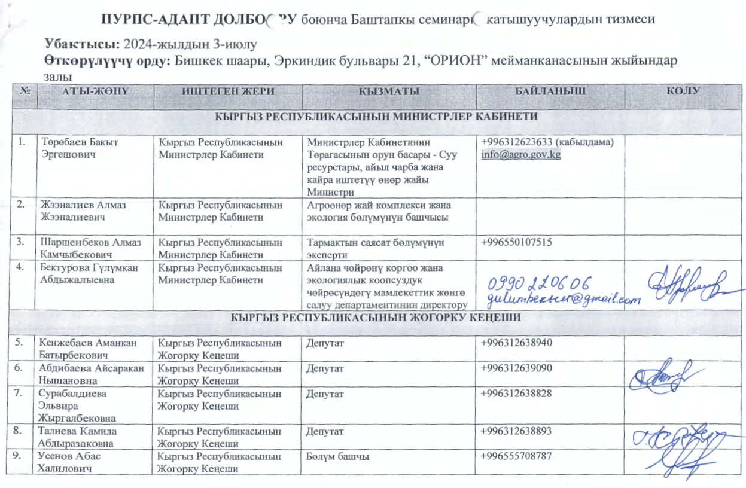
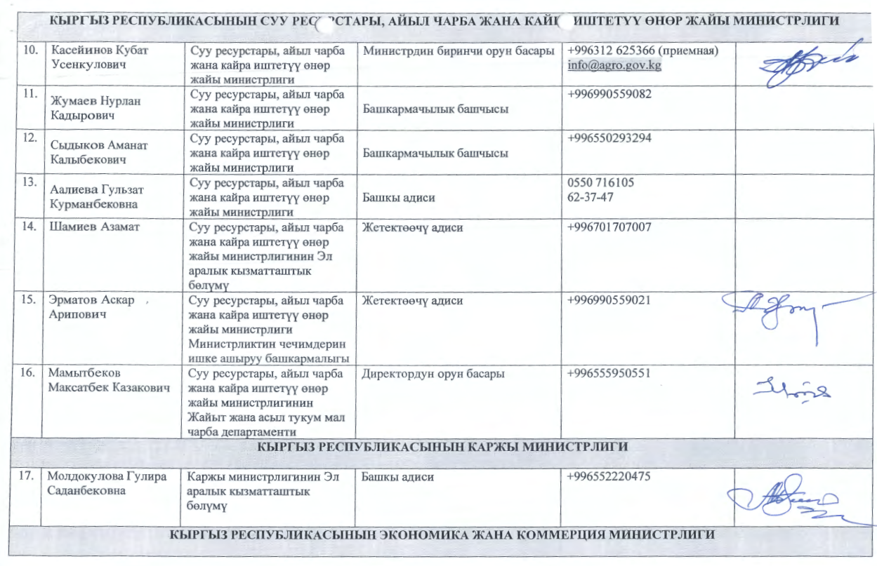
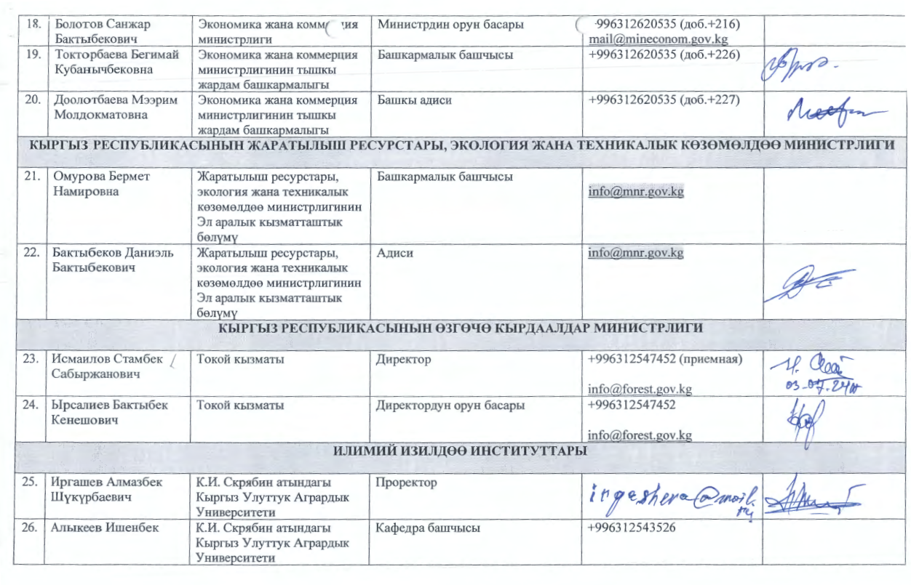
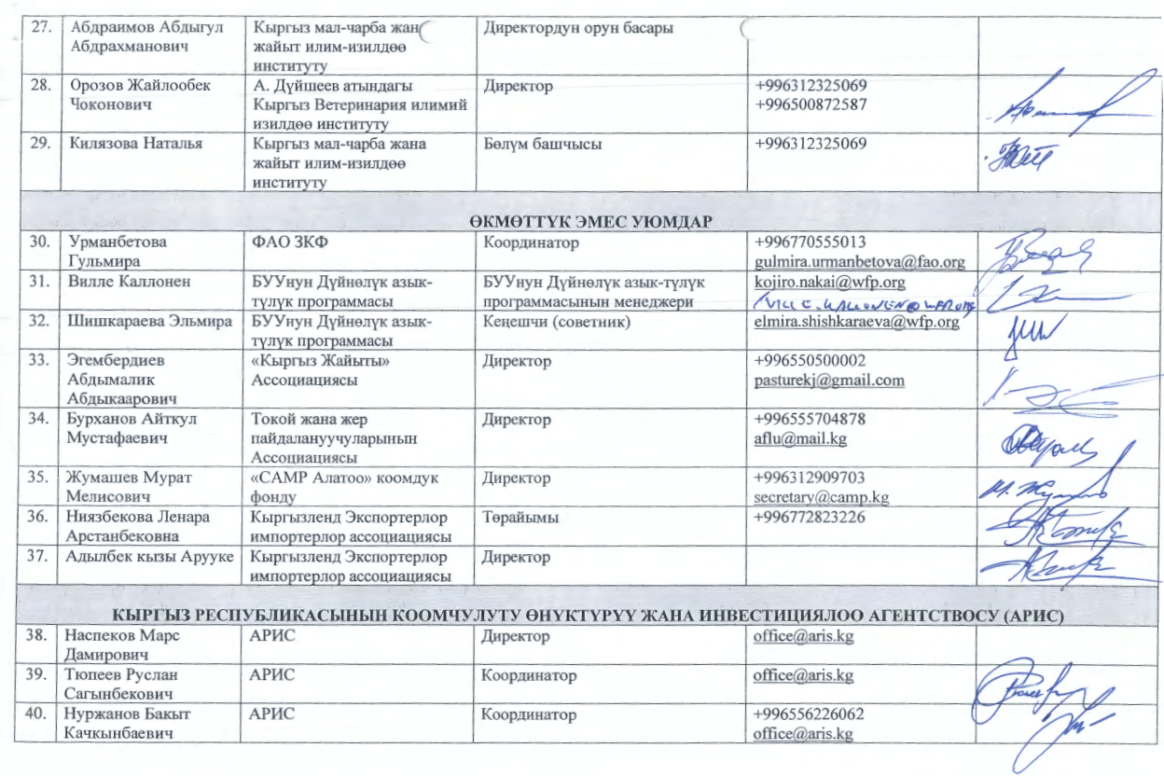
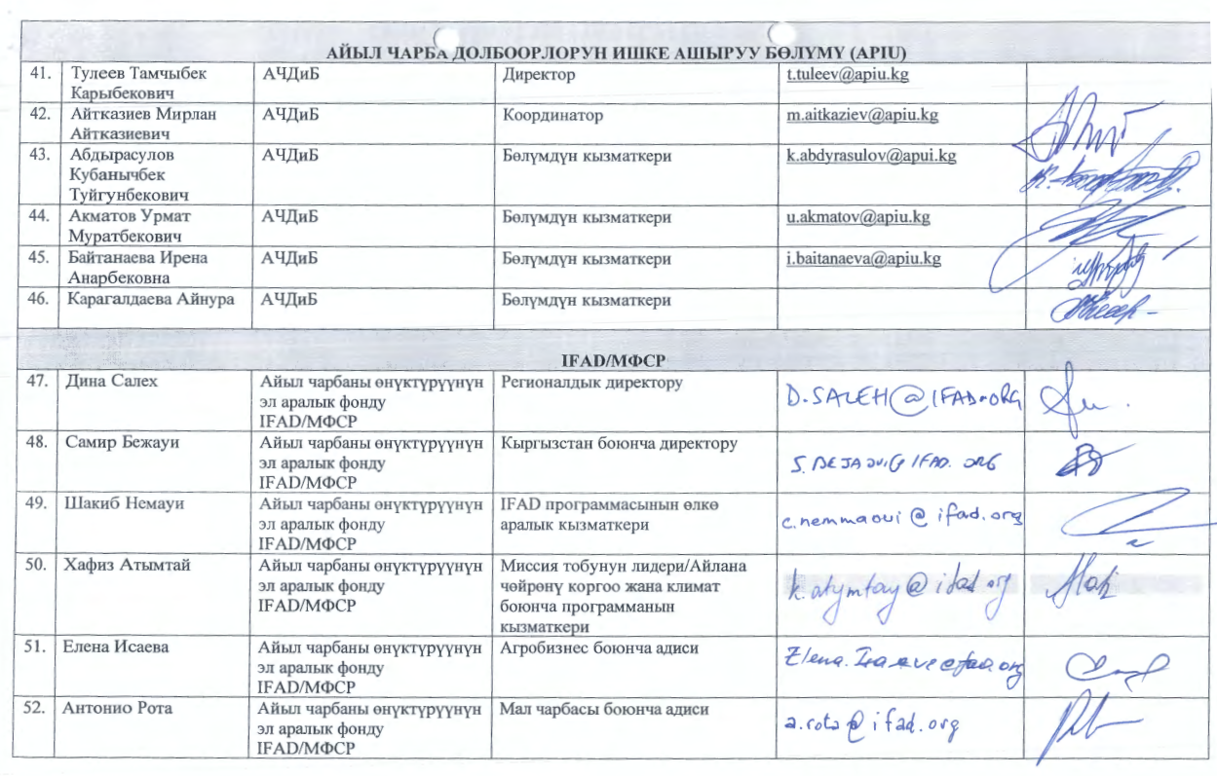
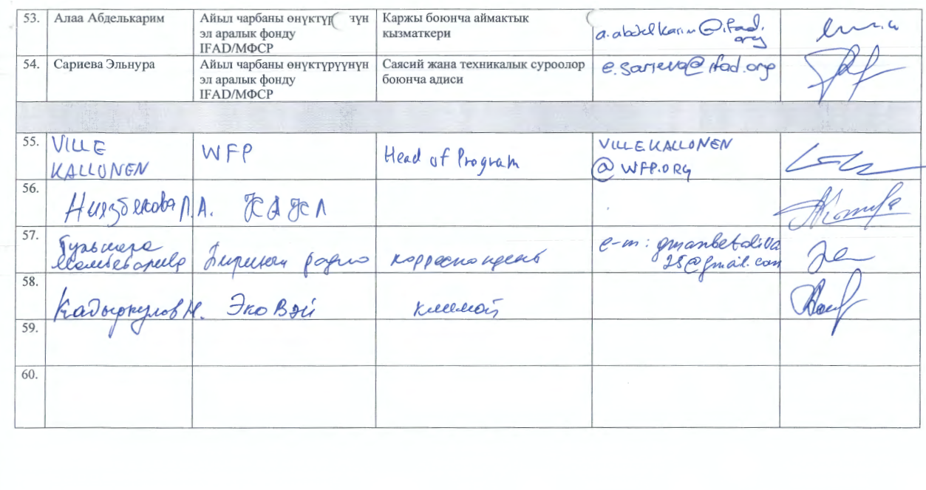

At the time of the design was called the Ministry of Agriculture (MoA) and was subsequently renamed.
At the time of the design was called the Ministry of Agriculture (MoA) and was subsequently renamed.

