
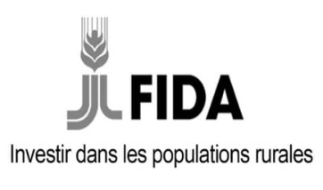
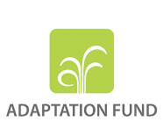

"PROJECT TO STRENGTHEN THE ADAPTIVE CAPACITY AND RESILIENCE OF RURAL COMMUNITIES TO CLIMATE CHANGE IN THE BANDAMA WATERSHED IN CÔTE D'IVOIRE"

Inception Workshop and Trainings
ABIDJAN/BOUAKE-IVORY COAST

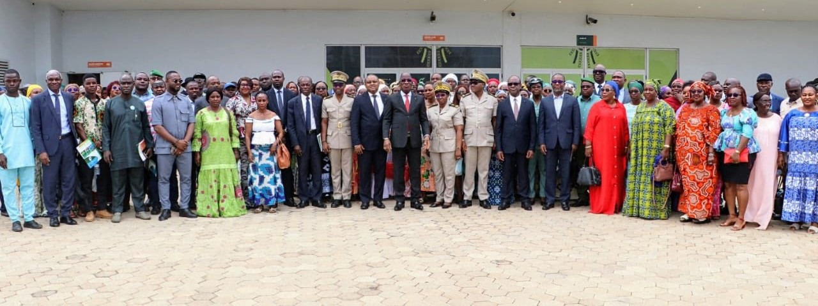
ABIDJAN, 08-09 JULY 2025
BOUAKÉ, 11 JULY 2025

TABLE OF CONTENTS

LIST OF PHOTOS 4
LIST OF ACRONYMS 5
I. BACKGROUND & RATIONALE 6
II. OBJECTIVES AND EXPECTED OUTCOMES OF THE WORKSHOP 7
2.1. Objectives 7
2.2. Expected results 7
III. PROJECT INCEPTION ACTIVITIES 8
3.1. The introductory workshop with key stakeholders 8
3.1.1. Welcome by IFAD's Country Director 10
3.1.2. Opening remarks by the Representative of the Minister of the Environment, Sustainable Development and Ecological Transition 11
3.1.3. Presentation of the basic documents 12
3.1.4. Presentation of the Project 13
3.1.5 Work in the committee for the multi-year planning of the activities of each component and restitution in plenary 15
3.2 Capacity building sessions for the BCCAP team, decision-makers and focal points 16
3.2.1 Contracting Training 16
3.2.2 Financial Management Training 17
3.2.3 Equity and Ethics Training 17
3.2.4 Training on the Environmental and Social Safeguard Procedures of the Adaptation Fund 20
3.2.5 Training on monitoring and evaluation systems 22
3.2.6 Training on Knowledge Management, Capitalization and Scaling: IFAD Procedure 24
3.2.7 IFAD's practical advice 25
3.3 Official Launch Ceremony of the PACCB Project 26
3.3.1 Speeches by the authorities present 27
3.3.2 Technical presentation of the project 29
3.3.3 Intervention by the representative of the women beneficiaries 30
3.3.4 Official launch speech of the project and closing of the session 31
IV. Main results obtained 32
V. RECOMMENDATIONS 33
VI. ANNEXES 34
Appendix 1: Attendance Lists 35
Appendix 2: Some photos 69

LIST OF PHOTOS

Photo 1: The participants of the introductory workshop 7
Photo 2: General view of the introductory workshop room 9
Photo 3: IFAD Country Director 9
Photo 4: Colonel YAO Marcel, Representative of the Minister of the Environment 10
Photo 5: Official BCAP Launch Ceremony 25
Photo 6: Presence of Customary and Religious Chiefs at the launch of the PACCB 26
Photo 7: Speech by IFAD's Country President in Bouaké 28
Photo 8: Remarks by the BCCAP Coordinator 29
Photo 9: Mrs. KOUADJO Adjoua E. Representative of the women beneficiaries 29
Photo 10: Minister ASSAHORE Konan Jacques 30
Photo 11: Prefectural authorities of the targeted regions 68
Photo 12: beneficiary populations 68
Photo 13: Director of the Bélier Regional Council (left), PRE Project Coordinator (middle), PNCC Coordinator (right) 68
Photo 14: The Minister and some authorities 69
Photo 15: Arrival of Mr. ASSAHORE Konan Jacques 69

LIST OF ACRONYMS

ADERIZ- Rice Sector Development Agency
ANADER- National Agency for Rural Development Support
AF- Adaptation Fund
FAO - Food and Agriculture Organization of the United Nations
IFAD - International Fund for Agricultural Development
FIRCA - Interprofessional Fund for Agricultural Research and Advisory
MEMINADERPV - Ministry of State, Ministry of Agriculture, Rural Development and Food Production
MFFE- Ministry of Women, Family and Children
MINEDDTE- Ministry of the Environment, Sustainable Development and Ecological Transition
MINEF - Ministry of Water and Forests
MIRAH - Ministry of Animal and Fisheries Resources
PACCB- Project to Strengthen the Adaptive Capacity and Resilience of Rural Communities to Climate Change in the Bandama Watershed in Côte d'Ivoire
PNCC - National Programme for the Fight against Climate Change
UNDP - United Nations Development Programme
PRE- Draft Payment of Discounts around the TAI Park
RAF - Financial Affairs Manager
SODEFOR- Forest Development Company
SODEXAM- Airport, Aeronautics and Meteorological Operating and Development Company
SPM- Procurement Specialist
UCP - Project Coordination Unit

BACKGROUND & RATIONALE
Côte d'Ivoire is now one of the countries most exposed to the effects of climate change, ranking 145th out of 181 on the Global Vulnerability Index. Progressive changes in climate and weather variability significantly affect rainfall and temperature patterns, leading to a decrease in water availability, which has a negative impact on agricultural productivity. This situation is all the more worrying given that the agricultural sector accounts for more than 21 per cent of the country's gross domestic product (GDP) and is the main source of income for a large part of the rural population. Climate vulnerability is therefore particularly acute in these areas, where livelihoods depend heavily on land and natural resources. In this context, it is becoming imperative to provide concrete and adapted solutions to the populations concerned, by offering them tools to face climate hazards and strengthen their resilience. It is in this perspective that the Ministry of the Environment, Sustainable Development and Ecological Transition (MINEDDTE), through its National Climate Change Programme (NCCP), has requested the support of the International Fund for Agricultural Development (IFAD) for the development of a project to be submitted to the Adaptation Fund.
The "Project to Strengthen the Adaptive Capacity and Resilience of Rural Communities to Climate Change in the Bandama Watershed in Côte d'Ivoire" (PACCB) has been selected and has received a grant of US$6 million (€5,016,741) from the Adaptation Fund. The financing agreement was signed on 23 April 2024 between the Republic of Côte d'Ivoire and IFAD, designated as the project's implementing agency. This project aims to address major climate vulnerabilities affecting agricultural systems and water resources management, with a particular focus on rice, cassava and cocoa value chains in the Bandama watershed. It aims to strengthen the resilience of vulnerable rural communities and their ecosystems to improve food security and livelihoods in the targeted areas.
The development objective of the project is to strengthen the resilience of smallholder farmers and rural populations to the effects of climate change in the Bélier, Gbêkê and Marahoué regions, located around the Bandama basin. To achieve this objective, the project focuses on three main areas: the establishment of climate information and early warning systems to support planning and decision-making in agricultural value chains; improved production and climate-resilient post-harvest practices, combined with diversification of livelihoods; and finally, institutional capacity building, political commitment and knowledge management related to climate change adaptation. More concretely, the project aims to reduce the direct impacts of climate change on 15,600 smallholder cassava, rice and cocoa farmers, 45% of whom are women, by improving regulatory systems, access to climate-resilient plant material, market access, and other downstream levers. Ultimately, it will indirectly benefit 93,600 people involved in the targeted value chains.
The implementation of the project is carried out by a Coordination Unit (UCP) under the supervision of MINEDDTE and the supervision of IFAD. In order to ensure effective ownership of the objectives by all stakeholders and to lay the foundations for coherent implementation, an official kick-off workshop was organized on July 8, 9 and 11, 2025 in Abidjan. This workshop, which brought together institutional, technical and operational actors, marks the official start of the activities of the PACCB project.

OBJECTIVES AND EXPECTED OUTCOMES OF THE WORKSHOP

Objectives
The overall objective of this workshop is to generate buy-in for its implementation among key stakeholders in the "Project to Strengthen the Adaptive Capacity and Resilience of Rural Communities to Climate Change in the Bandama Watershed" and to train the project team and focal points on IFAD's management procedures and techniques.
Specifically, the following were discussed:
- Present the objectives, components and expected results of the project;
- Strengthen the capacities of the project team, decision-makers, and focal points of beneficiary institutions;
- Develop a roadmap for the implementation of the project.

Expected results
At the end of the workshop, the expected results are as follows:
- The project is officially launched and the stakeholders have a clear understanding of the project;
- The capacities of the project team, decision-makers and focal points of beneficiary institutions are strengthened;
- The roadmap for the implementation of the BCCAP is developed
- Recommendations are made.
This report is structured around the following points:

- The conduct of the introductory and training workshops, as well as the official launch ceremony of the project;
- The main results obtained;
- The recommendations of the workshop;
- Next steps.

PROJECT INCEPTION ACTIVITIES
The Launch of the "Project to Strengthen the Adaptive Capacity and Resilience of Rural Communities to Climate Change in the Bandama Watershed" took place over three days on 8, 9 and 11 July 2025 in three stages: (i) an introductory workshop with key stakeholders, (ii) a capacity building workshop of the PACCB team, decision-makers and focal points and (iii) an official launch ceremony.

The introductory workshop with key stakeholders
Photo 1: The participants of the introductory workshop
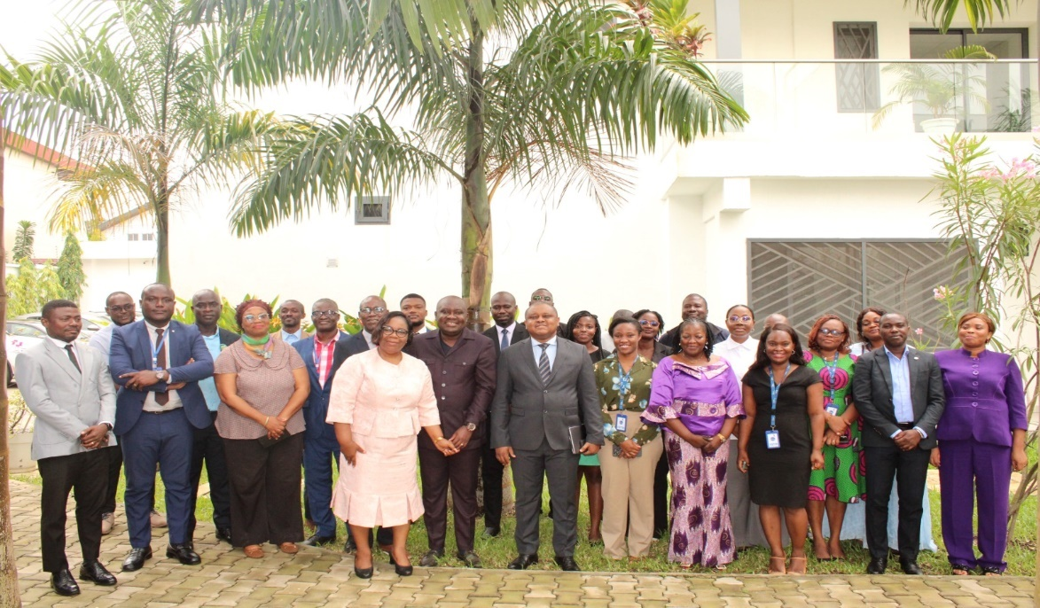
Source: Image UCP
The opening ceremony of the PACCB launch workshop, combined with a training session to impit key stakeholders, was held on 08 July 2025 in Abidjan, at the premises of IFAD's country office in Côte d'Ivoire, located within the regional office for West and Central Africa.
This inaugural session took place in the presence of Mr. YAO Marcel, Representative of the Ministry of the Environment, Sustainable Development and Ecological Transition (MINEDDTE), and Mr. Hermann MESSAN, IFAD Country Director in Côte d'Ivoire.
The event brought together about thirty-five (35) participants, including fourteen (14) women, from the following structures:
- Ministries :
  - Ministry of the Environment, Sustainable Development and Ecological Transition (MINEDDTE);
  - Ministry of State, Ministry of Agriculture, Rural Development and Food Production (MEMINADERPV);
  - Ministry of Finance and Budget;
  - Ministry of Planning and Development;
  - Ministry of Water and Forests (MINEF);
  - Ministry of Animal and Fisheries Resources (MIRAH);
  - Ministry of Women, Family and Children (MFFE).
- Technical and Financial Partners (TFPs):
  - International Fund for Agricultural Development (IFAD);
  - Food and Agriculture Organization of the United Nations (FAO);
  - United Nations Development Programme (UNDP).
- Implementing partners :
  - FIRCA;
  - ADERIZ;
  - SODEFOR;
  - ANADER;
  - Coffee-Cocoa Consulting;
  - SODEXAM.
- PACCB Project Team
The work of this first day began at 09:00 and ended at 18:24, according to the following agenda:
- Welcome by IFAD's Country Director;
- Opening speech delivered by the Representative of the Minister of the Environment;
- General presentation of the basic documents related to the project;
- Detailed presentation of the PACCB project;
- Work in committees, devoted to the multi-year planning of activities for each of the project components;
- Presentation to the plenary of the results of the group work.

Photo 2: General view of the introductory workshop room
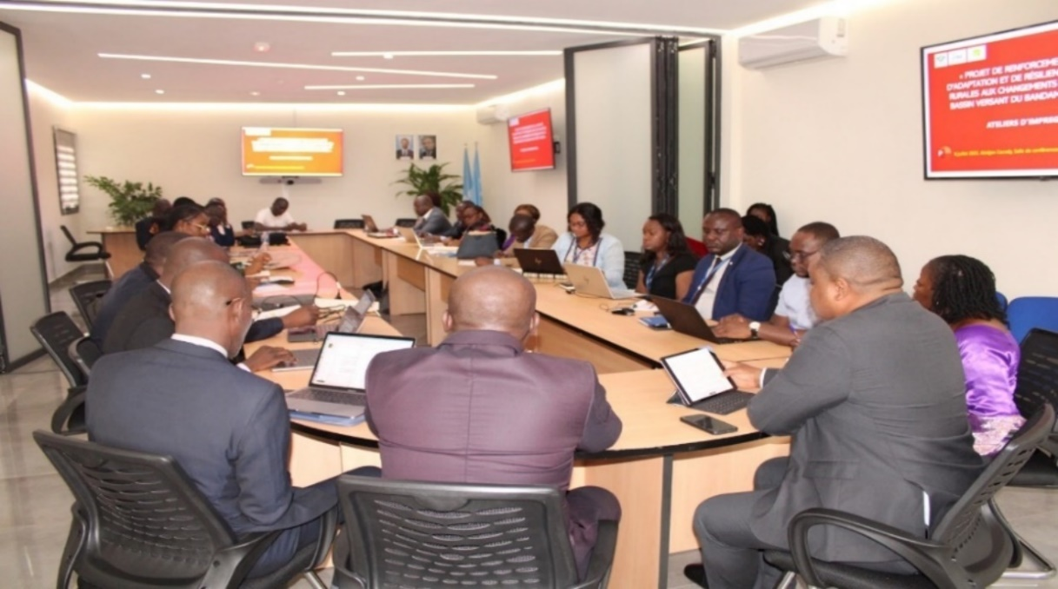
Source: Image UGP

Welcome by IFAD's Country Director

Photo 3: IFAD Country Director
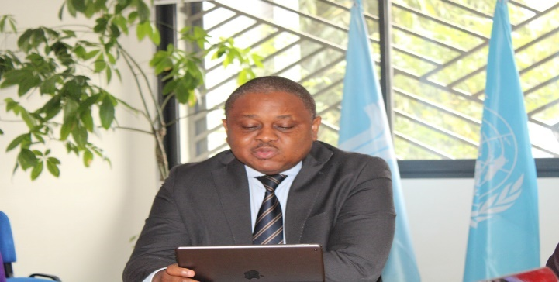
Source: Image UGP

In his opening remarks, Mr. Hermann MESSAN, IFAD's Country Director in Côte d'Ivoire, thanked and welcomed the authorities present as well as the representatives of the participating technical structures. He then took stock of the Ivorian agricultural context, highlighting its great vulnerability to the effects of climate change. According to him, the continued degradation of agricultural ecosystems directly threatens the food security and livelihoods of rural populations. It is in this dynamic of shared awareness with the government authorities that the project entitled "Project to strengthen the adaptive capacity and resilience of vulnerable rural communities in the face of climate change in the Bandama watershed in Côte d'Ivoire", abbreviated PACCB, was born.

Mr. MESSAN highlighted the catalytic role of the PACCB in the transformation of agricultural systems, in particular through the adoption of innovative and resilient solutions, adapted to current climate challenges. He also commended the joint mobilization and coordinated efforts of all stakeholders that made it possible to bring the financing process to a successful conclusion.
Finally, he said that the project is benefiting from a grant of US$6 million, granted by the Adaptation Fund, with IFAD as the executing agency.

Opening remarks by the Representative of the Minister of the Environment, Sustainable Development and Ecological Transition

Photo 4: Colonel YAO Marcel, Representative of the Minister of the Environment
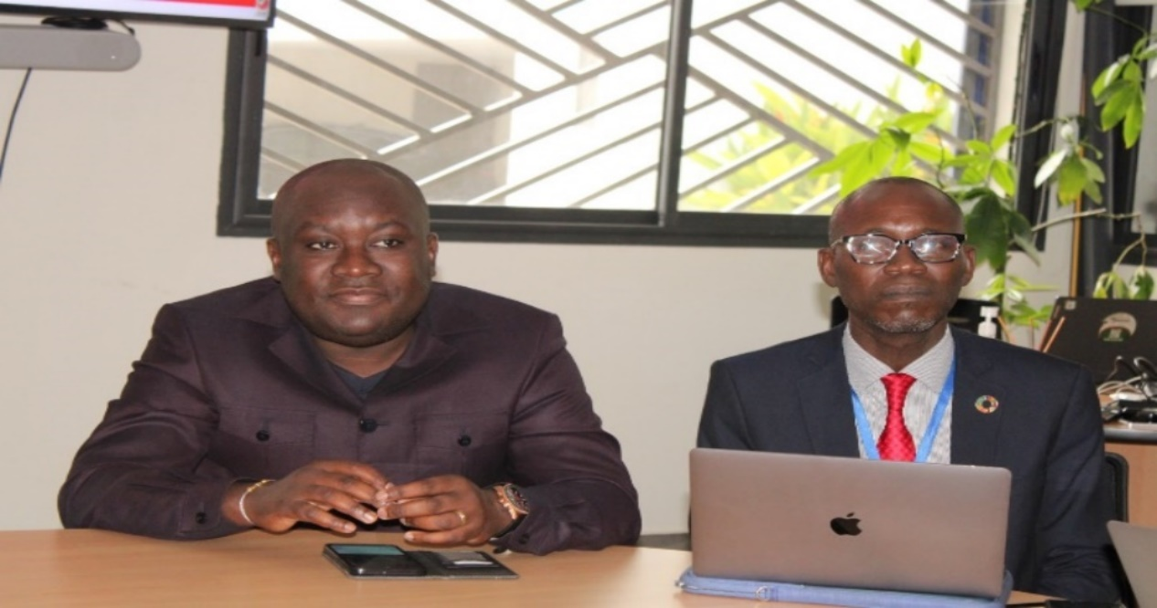
Source: Image UGP

Following the welcome speech of the Country Director, Colonel YAO Marcel, Director of International Cooperation and Financing Mobilization, National Focal Point of the Adaptation Fund and the Green Climate Fund, representative of the Minister of the Environment, Sustainable Development and Ecological Transition (MINEDDTE), delivered his opening remarks.
In his speech, Mr. YAO Marcel expressed the strategic interest of this pilot project for the Ministry, in that it aims to sustainably improve the living conditions of the rural populations of the Bandama watershed. He stressed that this ambitious project aims to reduce the negative impacts of climate change on 15,600 smallholder cassava, cocoa and rice producers, and that it will indirectly benefit about 93,600 people working along the targeted value chains of these three value chains. He also insisted on the need for rigorous management, scrupulous compliance with the procedures of the Adaptation Fund, as well as the active involvement of sectoral ministries throughout the process of design and implementation of the project.
Finally, he expressed his deep appreciation to IFAD and the implementing partners UNDP and FAO for their support in the formulation of this important project for the three (3) target regions.
The workshop was officially declared open on behalf of Minister ASSAHORE Konan Jacques, Minister of the Environment, Sustainable Development and Ecological Transition, marking the effective launch of the operational activities of the PACCB.

Presentation of the basic documents

- Donation Agreement

Mr. SANOGO Mohamed, Coordinator of the National Program for the Fight against Climate Change (PNCC) reviewed the various steps that led to obtaining financing for the project. He traced the process from the development of the concept note in 2019, carried out with technical support from FAO and UNDP, to the official submission of the project in 2022, with the support of IFAD, which resulted in the signing of the financing agreement on 23 April 2024 between the Republic of Côte d'Ivoire and the International Fund for Agricultural Development (IFAD).

He then presented the overall structure of the grant agreement, highlighting its annexes, including the project description, budget allocation, as well as implementation clauses. Finally, he gave an overview of the main national and international partners involved in the implementation of the project.
- Project Procedure Manual
At the end of Mr. SANOGO Mohamed's presentation, Mr. KROUBA Romaric, Financial Affairs Manager (RAF) of the PACCB, took the floor to dispense with the project's procedures manual. The Manual is divided into three main parts:
- Administrative management procedures;
- Budgetary, financial and accounting management procedures and
- Safety, hygiene and health procedures.
Finally, he indicated that the Manual will be validated with all implementing partners and key stakeholders of the project.

Presentation of the Project
The BCCAP was presented during the second part of the morning by the Project Coordination Unit (PCU).
Mrs. DJINDA Bénédicte-Shadriska, Technical Assistant at the PNCC, opened the session by explaining the objectives of the project, the area of intervention, as well as the strategic alignment of the PACCB with national policies and strategies in the field of development and the fight against climate change. She was followed by Mrs. LOBOGNON Philomène, Monitoring and Evaluation Specialist, who gave an in-depth presentation on the different components of the project, the expected results, the major activities to be carried out, as well as the expected socio-economic and environmental benefits.
Finally, Mr. ANDE Jean Yves, Coordinator of the project, intervened to explain the implementation modalities, the organizational mechanism of implementation, as well as the budget distribution according to the main categories of expenditure (works, equipment, provision of services, training, operation, etc.).
From this presentation, the following highlights can be noted:

- The "Project to strengthen the adaptive capacity and resilience of vulnerable rural communities to climate change in the Bandama watershed in Côte d'Ivoire" (PACCB) has a duration of five (5) years;
- The overall objective of the project is to address key climate vulnerabilities in agriculture and water resources management in the rice, cassava, and cocoa value chain in the Bandama watershed;
- The project has four specific objectives:

  - Specific Objective 1: Strengthen the production and adaptation capacity, technical skills and knowledge base of 5000 cocoa smallholders, 5,600 cassava farmers and 4000 rice farmers in climate-smart agriculture production models and 1000 for other enterprises (processing and marketing activities) and cooperatives of which 45% are women and 40% youth among the direct beneficiaries;

  - Specific Objective 2: Increase the use of climate-resilient seeds of improved cocoa, cassava and rice varieties for farmers' organizations, cooperatives, youth and farmers' organizations, other commercial farmers and extension services using SIPE;

  - Specific Objective 3: Provide alternative livelihoods such as fish farming for youth and women's organizations along the Bandama Basin, in addition to agroforestry value chains;

  - Specific Objective 4: Strengthen the institutional capacity of these agencies to effectively carry out their respective mandates for smallholders and cooperatives, in coordination with other sectoral ministries, including the Ministry of Agriculture.

- The project will achieve the objective through three components:

Component 1: Climate Information and Early Warning Systems (CEIS) for adaptive capacity building, programming and planning in cocoa, rice and cassava value chains, coupled with a knowledge base information system on innovative climate-smart agricultural technologies/practices.

  - Result 1.1. Development and improvement of existing early warning systems and hydrometeorological observation networks to improve data collection, interpretation and understanding for farmers' adaptation actions.

  - Result 1.2. Strengthening the capacity and knowledge of value chain actors to understand climate risks and better adapt to climate shocks.

Component 2: Climate-resilient agricultural production and appropriate post-harvest measures combined with livelihood diversification.

  - Result 2.1. Development and improvement of existing early warning systems and hydrometeorological observation networks to improve data collection, interpretation and understanding for farmers' adaptation actions.

  - Result 2.2. Strengthening the capacity and knowledge of value chain actors to understand climate risks and better adapt to climate shocks.

Component 3: Institutional capacity-building, political commitment and knowledge management.

  - Result 3.1: The capacity of the government (in particular the Ministry of the Environment) and stakeholders (SODEXAM, ANADER, etc.) to manage climate risks is strengthened.

  - Result 3.2: Activities are properly coordinated, monitored and evaluated.

- Data highlighted:

- The project will be implemented in the regions of the
- Gbêkê: Bouaké, Béoumi, Sakassou, Botro,
- Ram: Didivie, Djekanou, Tiebissous, Toumodi,
- Marahoué: Bonon, Bouaflé, Gohotafla, Sinfra, Zuenoula;

- Targeted crops: cassava, cocoa, rice;

- Beneficiaries: 15,600 direct beneficiaries (rice, cassava and cocoa producers) and 93,600 indirect beneficiaries.

Work in the committee for the multi-year planning of the activities of each component and restitution in plenary

The afternoon of this day was devoted to committee work. The participants were divided into three working groups, each corresponding to one of the components of the project. The mandate of these commissions was to:

- Identify the activities to be implemented and plan them over the entire five years of the project;

- Define the product indicators as well as the quantitative targets to be achieved;

- Specify the sources of funding (State contribution, donor support, tax exemptions), the categories of expenditure, as well as the implementation operators.
The work took place in a friendly and collaborative atmosphere, based on the project document and the field experience of the participants.
Following these discussions, several comments were made in plenary, including:
- The need to clarify certain formulations of activities, in particular those related to capacity building;

- The importance of adjusting multi-year planning, as some groups have pointed out that four years are planned, even though the contractual duration of the project is five years.
The workshop concluded with a plenary presentation of the work of the commissions, followed by operational recommendations for the continuation of the planning process.

Capacity building sessions for the BCCAP team, decision-makers and focal points

The second day of the BCAP launch was held on Wednesday, August 09, 2025. This training day started at 9:15 a.m. and ended at 5:32 p.m. It was mainly devoted to building the capacity of the project team. IFAD's national and international experts took turns to transmit the knowledge and skills essential for the efficient management of projects financed by the International Fund for Agricultural Development (IFAD) and the Adaptation Fund.

Contracting Training
The training on procurement was provided by Mr. ADJIMOTI Jerôme. This training enabled participants to better master the technical and procedural requirements applicable in IFAD and Adaptation Fund funded projects.
The training began on the legal and regulatory framework which was based on the alignment between national texts and donor policies. The documents cited were the financing agreement, the letter to the borrower, the country-specific framework, IFAD's procurement guidelines, IFAD procurement manuals, and the staff and consultancy manual. This basis then made it possible to approach the procurement cycle in a structured way, from planning to contract closing.
Particular attention was paid to the procedure for examining and notifying donors, in particular the steps subject to no objection, and to how to manage validation flows via digital platforms such as Online Procurement, with a view to traceability and reducing delays. Procurement methods have also been reviewed in line with the thresholds defined and the specificities of acquisitions.
Finally, the trainer insisted on the importance of contract monitoring, guaranteeing the proper technical and financial execution of commitments, as well as on the use of the Open system to promote transparency and public access to market information.
This training helped to consolidate the internal practices of the projects, while ensuring their alignment with the institutional standards of IFAD and the Adaptation Fund.

Financial Management Training
This training was given by Mrs. Aïssata BANGOURA. She recalled that project objectives were more easily achieved when management processes were an integral part of the project cycle and that there was empirically demonstrated a direct correlation between effective financial management and greater development impact.
Indeed, sound financial management promotes the efficient implementation of projects and the sustainability of projects, by providing access to reliable information on the financial situation and by assuring stakeholders that project funding has been spent only for the intended purposes allowed and in an efficient and cost-effective manner.
" Financial management" means the set of terms and conditions that the Borrowers put in place to withdraw financing, receive and spend project funds from various sources as approved, record financial transactions, and report to stakeholders on the use of resources in accordance with the provisions of the Financing Agreement and the principles of integrity and transparency.
Appropriate financial management systems and procedures have the following characteristics:
- They give guarantees as to the use of the funds for the intended purposes;
- They ensure that the individuals and institutions responsible for administering the funds are accountable;
- They produce reliable and up-to-date information to support decision-making;
- They are subject to independent review and oversight by internal and external control entities.

Equity and Ethics Training
The training was provided by Ms. Virginie DEGA, Senior Officer at the Audit and Oversight Office (AUO) of IFAD and Ms. Isabelle Robin, Gender Specialist at the Office of Ethics and Professional Conduct (IFAD).
Mrs. Virginie DEGA first presented the anti-corruption policy.

It can be noted that IFAD's management of its funding takes strict measures to ensure that resources are used exclusively for the intended purpose, in accordance with the principles of economy, efficiency and social justice.
IFAD implements several lines of defence against corruption:
- Internal controls conducted by project staff, partners and counterparties;
- Regular internal and external audits, as well as direct supervision by IFAD;
- Complaint mechanism, investigation procedures and applicable sanctions.
- Scope of the anti-corruption policy:

This policy covers all operations financed or managed by IFAD and applies to:
  - Its staff and external collaborators;
  - Suppliers, public and non-governmental beneficiaries, as well as any third parties involved.

- Targeted misconduct includes:

  - Fraud : deliberately deceptive acts or omissions to obtain an unfair advantage;
  - Collusion : unlawful agreements to influence decisions improperly;
  - Coercion : threats or pressure to alter an action or decision;
  - Obstruction : destruction or falsification of evidence during IFAD investigations.

- Measures and penalties provided for:
Recipients of funding must strictly comply with anti-corruption guidelines. In the event of a breach, several sanctions may be applied:
  - Administrative sanctions (expulsion, reprimands, reparations);
  - Disciplinary measures or reports to local authorities;
  - Operational sanctions (rejection of contracts, cancellation of financing).

A reporting system is available to all parties via the anti-corruption hotline or the address: anticorruption@ifad.org.

Then, Ms. Isabelle Robin, Gender Specialist, presented IFAD's policy on sexual harassment, sexual exploitation and abuse. The presentation showed that the International Fund for Agricultural Development (IFAD) has a zero-tolerance policy towards sexual harassment and sexual exploitation and abuse in all its activities and operations. This policy aims to ensure a safe, respectful working environment that is free from any form of abuse towards beneficiaries, staff or partners.
In line with international standards, IFAD defines such behaviour as serious violations of human integrity and dignity, with devastating consequences. The policy applies to all IFAD staff, consultants, suppliers, subcontractors and grantees.
The main axes of this policy are:
- Active prevention, through awareness-raising, mandatory training, background checks, and the integration of risk assessment into project design;
- Secure reporting mechanisms, allowing victims or witnesses to report any incident confidentially, including anonymously;
- Rigorous repression, with internal investigations, severe disciplinary sanctions (up to and including dismissal or termination of contract), and the possibility of referral to the national authorities;
- Whistleblower protection and victim assistance, including referrals to support services.
IFAD ensures that strict contractual clauses are included with regard to its partners and suppliers to prevent and sanction any breach of this policy. It also encourages cooperation with other organizations to strengthen collective effectiveness in combating such practices.
An operational guide to support IFAD Borrowers and Beneficiaries in understanding and applying the zero-tolerance policy against sexual harassment, sexual exploitation and abuse (SEA) in the context of financed projects was also presented.

It recalls that these acts constitute serious human rights violations, undermine IFAD's mission and undermine the trust of the targeted rural communities. The guide outlines the contractual obligations related to IFAD's funding, including:

- Promptly inform IFAD of any allegations or suspicions of abuse;
- Take appropriate and satisfactory measures;
- Communicate the results of the actions taken;
- Integrate specific clauses into consultant and supplier contracts (e.g., self-declarations, background checks).

The guide takes a survivor-centred approach, ensuring confidentiality, listening, protection from retaliation, and access to legal and medical services. It also highlights the importance of SEA risk assessment in all stages of the project cycle (planning, implementation, supervision), in line with IFAD's SECAP procedures.

Finally, SEA focal points are designated in each region to support partners, and the Ethics Office remains available for any statement or request for advice.

Training on the Environmental and Social Safeguard Procedures of the Adaptation Fund
This training was given by Mr. BROU Bernard. During his presentation, he highlighted the environmental and social safeguard policy of the Adaptation Fund. Approved in November 2013 and revised in March 2016, the Fonds' Environmental and Social Policy (ESP)2 ensures that projects and programs supported by the Fonds promote positive environmental and social benefits and avoid or mitigate negative environmental and social risks and impacts. Managing these risks is critical to the success of projects/programs, and the expected results are outlined in the 15 Environmental and Social Principles (Principles) of the SEP. These 15 principles are:

- Principle 1: Compliance with legislation. Projects/programmes supported by the Fund must comply with all applicable national and international legislation;

- Principle 2: Access and equity. Projects/programmes supported by the Fund will provide fair, equitable and inclusive access to expected benefits, without hindering access to basic health services, clean water and sanitation, energy, education, housing, safe and decent working conditions and land rights. Projects/programmes should not exacerbate existing inequalities, particularly those affecting marginalised and vulnerable groups;

- Principle 3: Marginalized and vulnerable groups. Projects/programmes supported by the Fund should avoid imposing disproportionate negative impacts on marginalized and vulnerable groups, including children, women and girls, the elderly, indigenous peoples, tribal groups, internally displaced persons, refugees, persons with disabilities and persons living with HIV/AIDS. When reviewing proposed projects/programmes, the implementing entities will assess and consider the specific impacts on marginalised and vulnerable groups;

- Principle 4: Human rights. Projects/programmes supported by the Fund shall respect and, where appropriate, promote fundamental human rights;

- Principle 5: Gender equality and women's empowerment. Projects/programmes supported by the Fund will be designed and implemented in such a way that men: 1) have the same opportunities to participate, in line with the Fund's Gender Policy (PG), 2) enjoy comparable social and economic benefits, and 3) do not experience disproportionately negative impacts during the development process;

- Principle 6: Fundamental rights at work. Projects/programmes supported by the Fund must comply with the core labour standards promulgated by the International Labour Organization;

- Principle 7: Indigenous peoples. The Fund will not support projects/programmes that are incompatible with the rights and responsibilities set out in the United Nations Declaration on the Rights of Indigenous Peoples and other applicable international instruments relating to indigenous peoples;

- Principle 8: Involuntary resettlement. Projects/programmes supported by the Fund should be designed and implemented in such a way as to avoid or minimize the need for involuntary resettlement. Where limited involuntary resettlement is unavoidable, a formal procedure will be followed so that displaced persons are informed of their rights, consulted on the options available to them, and offered technically, economically and socially feasible resettlement alternatives or fair and adequate compensation;

- Principle 9: Protection of natural habitats. The Fund will not support projects/programmes that would result in unjustified transformation or degradation of critical natural habitats, in particular those that are: (a) legally protected, (b) formally candidates for protection, (c) recognized by authoritative sources for their high conservation value, including as critical habitat, or (d) recognized as protected by traditional or indigenous local communities;

- Principle 10: Preservation of biodiversity. Projects/programmes supported by the Fund will be designed and implemented in a way that avoids any significant or unjustified reduction or loss of biodiversity and avoids any introduction of known invasive species;

- Principle 11 : Climate change. Projects/programmes supported by the Fund must not result in any significant or unjustified increase in greenhouse gas emissions or other factors responsible for climate change;

- Principle 12: Pollution Prevention and Resource Efficiency. Projects/programmes supported by the Fund should be designed and implemented in accordance with applicable international standards in order to maximize energy efficiency and minimize the use of material resources, waste generation and the release of pollutants;

- Principle 13: Public health. Projects/programmes supported by the Fund will be designed and implemented in a way that avoids potentially significant negative impacts on public health;

- Principle 14: Cultural and physical heritage. Projects/programmes supported by the Fund will be designed and implemented in such a way as to avoid the alteration, degradation, destruction or disappearance of any cultural and natural heritage whose value is recognized at the community, national or international level. In addition, projects/programmes should not permanently impede access to and use of these cultural and natural heritages by the communities present;

- Principle 15: Land and soil conservation. Projects/programmes supported by the Fund will be designed and implemented in a way that promotes soil conservation and avoids degradation or conversion of productive land or land that adds significant value to ecosystem services.

After detailing the 15 safeguarding principles of the Adaptation Fund, Mr. BROU focused on the environmental and social review and assessment process.
Also, he reminded the project team of the need to recruit a safeguarding specialist who will allow the environmental, social and climate management plan of the project to be updated.
Finally, he drew the team's attention to the various essential elements that the project must have. Namely:
- An environmental and social management plan;
- A vulnerability study;
- A stakeholder engagement plan;
- A complaint management plan.

Training on monitoring and evaluation systems
This training was provided by Mrs. Fanny MINJAUW, Environment and Climate Monitoring and Results Specialist (GEF, GCF, AF) at the International Fund for Agricultural Development.

The objective of the paper was to present the monitoring and evaluation (M&E) framework and reporting requirements related to the implementation of projects financed by the Adaptation Fund, including the BCAP.
It was structured around the following points:
- Fund's Strategic Results Framework (SRF): The project must align with at least one result indicator and one output indicator, among the Fund's 8 strategic outcomes, covering among others reduced exposure to climate risks, institutional capacity building, ecosystem resilience, livelihood diversification and promotion of appropriate policies;
- Principles of successful adaptation action : An adaptation is considered successful if it is feasible, effective, just (social equity) and contextualized;
- Reporting obligations :
  - Inception report : to be produced within two months of the inception workshop, including participants, outcomes, concerns and solutions discussed,
  - Project Progress Report (PPR): to be submitted annually, within two months of the end of the reference year. The last PPR serves as the completion report;
- Content of the PPR (10 sections):
  - Overview;
  - Financial and co-financing data;
  - Procurement/purchasing;
  - Risk assessment;
  - Compliance with environmental and social policies;
  - Compliance with gender policy;
  - Scoring of project performance;
  - Progress towards results;
  - Lessons learned;
  - Monitoring of indicators via the Results Tracker.

- Required assessments :
  - Mid-term evaluation (mandatory for projects of more than 4 years);
  - Final evaluation by an independent evaluator, to be submitted within 9 months of project closure;
  - Project completion summary (max. 20 pages, in addition to the final PPR).

- Key recommendations :
  - Ensure traceability of identified risks (before and during implementation);
  - Justify any delays;
  - Ensure the rigour of justifications in the purchasing processes;
  - Do not introduce unapproved changes to reports;
  - Ensure that gender indicators are monitored and integrated into risk analysis.

Training on Knowledge Management, Capitalization and Scaling: IFAD Procedure

This training was given by Mr. Boris KOUASSI. First, he recalled that Knowledge Management is an approach that consists of identifying, creating, organizing, storing, sharing and using knowledge and know-how within an organization, in order to improve performance, innovation and decision-making. The objectives of this management are to:
- Strengthen the impact of projects by valuing existing and emerging knowledge: Leverage previous experiences and integrate learnings to improve performance;
- Structure the capitalization and scale-up processes from the design of the project;
- Ensure that best practices are documented and ready to be replicated;
- Create an environment conducive to continuous learning, sharing of experiences and innovation: Stimulate exchanges and collective reflection.
Then, the three strategic axes were presented. These are:
- Knowledge generation;
- The use of knowledge;
- Building an environment that facilitates evidence-based learning and sharing.
Also, IFAD's knowledge management products are:
- Publications/blogs;
- Digital tools;
- Partnerships;
- Sharing platforms;
- Technical data sheets;
- Case studies;
- Guidance/capitalisation notes;
- Information centres.
In addition, during this training, emphasis was placed on the key elements of knowledge management:
- The purpose, objectives and expected results;
- Link to the purpose and objectives of the project;
- Describe the main activities, approaches and tools, as well as the budget;
- Define the target audiences, the communication and dissemination plan as well as the knowledge products;
- Define the roles and responsibilities of project managers and staff, as well as implementing partners;
- Political commitment and partnership building;
- Indicators and monitoring methods.

In the end, the trainer concluded his presentation by highlighting good practices in knowledge management. These are:
- Writing project success stories by interviewing beneficiaries;
- The establishment of a feedback system to collect feedback from beneficiaries;
- The use of quantitative data in narratives as evidence: increased yields, revenues, productive assets.

IFAD's practical advice
Following these training sessions, practical advice was provided by some participants, Mrs. Odile SARASSORO and her team to the project team to ensure the full success of the implementation of the project. Especially:
- Develop an accessible, transparent and functional complaint management system;

- Leverage lessons learned from previous projects to improve BCAP implementation;

- Strengthen collaboration between the Project Coordination Unit, the Accounting Agency and the Financial Control for a smooth and coherent management;

- Ensure full ownership by the project team of the following strategic documents: grant agreement, project document, implementation manual, AWPB, monitoring and evaluation plan, and procurement plan;

- Work in synergy with relevant national entities to facilitate procurement processes;

- Implement a continuous capitalization process throughout the project management (identification of good practices, successes and points of vigilance), with well-defined capitalization themes;

- Develop upstream the terms of reference (ToR) of the planned activities to anticipate execution deadlines;

- Ensure alignment of national procurement procedures with those of IFAD, in order to avoid incompatibility or irregularities;

- Implement a monitoring and evaluation manual accompanied by appropriate tools to ensure effective management of results;

- Use the simplified procedure as much as possible for contracts with an amount of less than 40,000,000 CFA francs, in order to optimize the time taken to award them.

Official Launch Ceremony of the PACCB Project

Photo 5: Official Launching Ceremony of the BCCAP
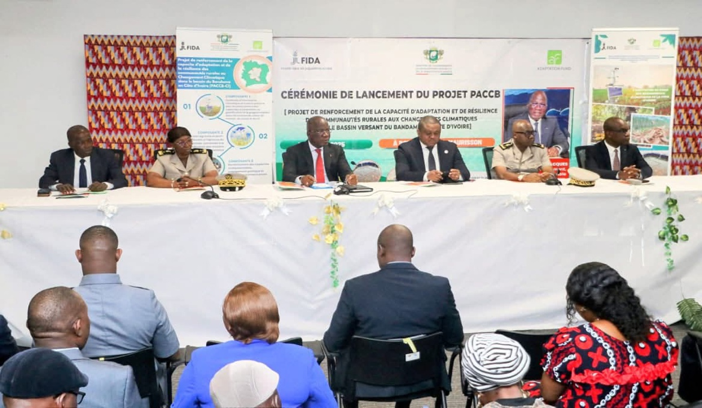
Source: Image UGP

The official launching ceremony of the Project to Strengthen the Capacity to Adapt and Resilience of Rural Communities to Climate Change in the Bandama Watershed (PACCB) was held on Friday, July 11, 2025, from 9:54 a.m. to 11:00 a.m., in the conference room of the Stade de la Paix in Bouaké. It took place in the presence of the Administrative and Governmental authorities, the IFAD Country Director in Côte d'Ivoire, the project's stakeholders, as well as under the high authority of Mr. ASSAHORE Konan Jacques, Minister of the Environment, Sustainable Development and Ecological Transition (MINEDDTE).
This solemn ceremony marked the official launch of the activities of the PACCB. It aimed to share the objectives, expected results, as well as the framework for the implementation of the project with all stakeholders, with the aim of ensuring their effective mobilization and collective ownership.
The ceremony consisted of several stages:
- A series of speeches by the authorities present;
- The technical presentation of the project;
- The intervention of the representative of the women beneficiaries;
- Introductory speech by the Minister of the Environment.

Photo 6: Presence of Customary and Religious Chiefs at the launch of the PACCB
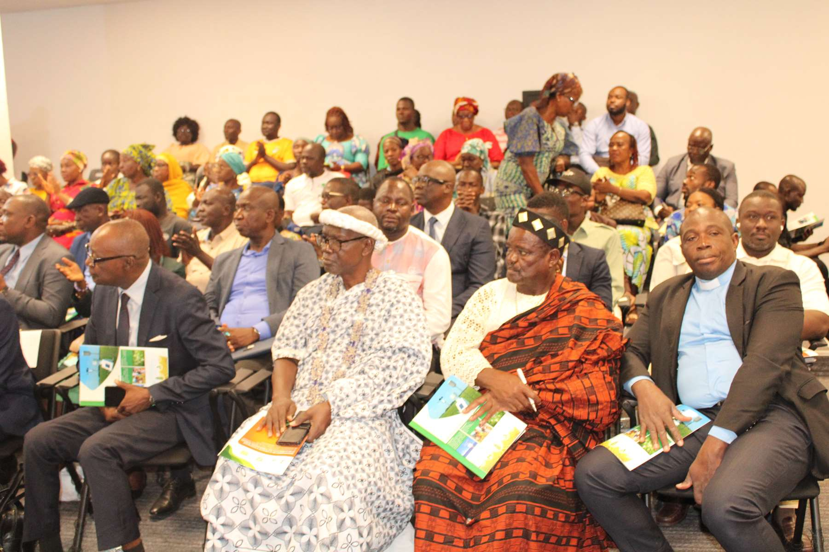
Source: Image UGP

Speeches by the authorities present

Welcome by Mr. FOFANA Mépouké, Representative of the Mayor Amadou KONE of Bouaké

The opening of the official launching ceremony of the PACCB Project began with the welcome speech delivered by Mr. FOFANA Mépouké, representative of the Mayor of the municipality of Bouaké, Mr. Amadou KONE. In his speech, he called for a collective and solidarity commitment to the climate challenges faced by rural populations. He stressed that climate change poses a real threat to the living conditions of communities, and that, in this context, the PACCB project represents a concrete and resilient opportunity, both for the sustainable management of water resources and for the strengthening of agricultural production systems.
In conclusion, he thanked the Adaptation Fund and IFAD, commending their commitment to supporting the construction of sustainable local economies and working towards a more resilient future to the effects of climate change.

Remarks by IFAD's Country Director
Following the intervention of the representative of the Mayor of the commune of Bouaké, Mr. Hermann MESSAN, IFAD Country Director in Côte d'Ivoire, took the floor at 10:20 a.m. to deliver his speech. He expressed the honor and privilege that belongs to him to participate in this official launching ceremony of the Project to Strengthen the Adaptive Capacity and Resilience of Rural Communities to Climate Change in the Bandama Watershed (PACCB).
In his remarks, he welcomed the collective awareness of the growing threat that climate change poses to agriculture, food security and the livelihoods of rural people. He recalled that the PACCB project aims to provide a concrete response to this problem, through an inclusive approach, emphasizing the active participation of women and youth, in accordance with the orientations of the National Agricultural Investment Program – Phase II (PNIA II).
Continuing his speech, Mr. MESSAN thanked the Minister of the Environment, Sustainable Development and Ecological Transition, for his constant commitment, as well as the technical partners such as FAO and UNDP for their support throughout the project development process.
He concluded by reiterating IFAD's strong commitment to sustainably support the Government of Côte d'Ivoire in its efforts to improve the living conditions of rural populations and build more climate-resilient agricultural systems.

Photo 7: Speech by IFAD's Country President in Bouake

Source: Image UGP

Technical presentation of the project

The technical presentation of the PACCB was given by Mr. Andé Jean Yves KONAN, Coordinator of the said project, who had the task of detailing the foundations, structure and ambitions of the PACCB to the authorities present and all the stakeholders.
In his speech, he recalled that the project was designed in 2021, with the aim of responding in a targeted and coherent manner to the main climate vulnerabilities affecting agricultural systems and the livelihoods of rural populations. The project is based on four major strategic axes, namely:

- Improving the productivity of targeted crops, namely cocoa, rice and cassava;
- Strengthening the resilience of smallholder farmers and vulnerable communities;
- Promoting alternative livelihoods, including for women and youth;
- Improving the regulatory framework and institutional capacities of the structures involved.

The Coordinator said that the implementation of the project will cover the regions of Bélier, Gbêkê and Marahoué, located in the Bandama watershed. The PACCB plans to directly impact 15,600 smallholder farmers and about 1,000 cooperatives or groups, 45% of which are women and 40% are youth. Ultimately, more than 93,600 indirect agricultural actors along the cocoa, rice and cassava value chains will also benefit from the project's spin-offs.

Photo 8: Remarks by the BCCAP Coordinator
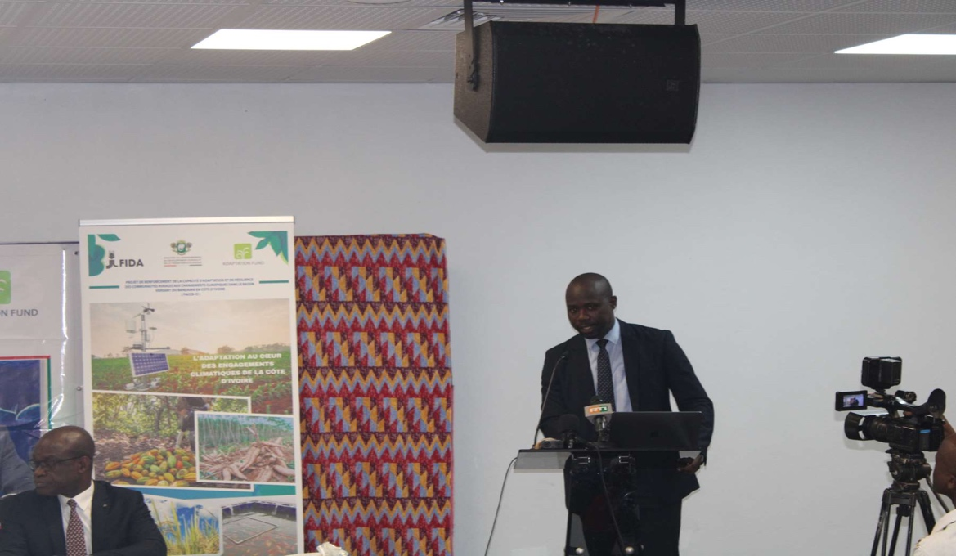
Source: UCP image

Intervention by the representative of the women beneficiaries

Photo 9:Mrs KOUADJO Adjoua E. Representative of women beneficiaries

Source: Image UCP

Speaking on behalf of the women gathered within the "Anouazèfè" association, Mrs. KOUADIO Adjoua Evelyne, President of the said organization, expressed her deep gratitude to Mr. ASSAHORE Konan Jacques, Minister of the Environment, Sustainable Development and Ecological Transition (MINEDDTE) and President of the Regional Council of the Gbêkê region, for her constant commitment to the women of the region since her accession to these Responsibilities.
She also expressed her sincere thanks to the donors present, saluting their significant contribution to the development of rural women, and more broadly, to the improvement of the living conditions of households in the beneficiary localities of the project.

Official launch speech of the project and closing of the session

Photo 10: Minister ASSAHORE Konan Jacques
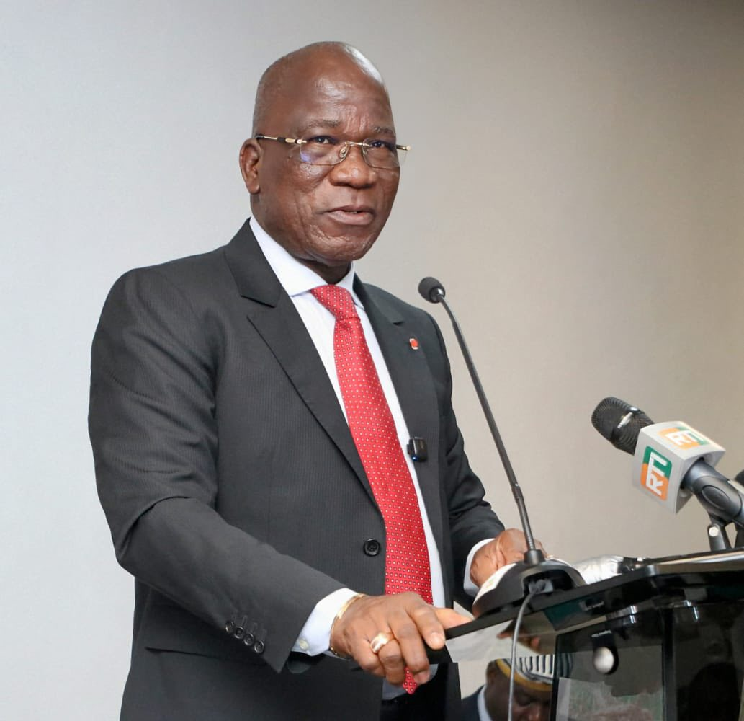
Source: Image UCP

Minister ASSAHORE Konan Jacques, Minister of the Environment, Sustainable Development and Ecological Transition (MINEDDTE) and President of the Regional Council of the Gbêkê region, took the floor to close the series of official speeches. He first addressed his greetings and thanks to the administrative and prefectural authorities, the IFAD Country Director, as well as the technical and financial partners involved in the implementation of the project, saluting their remarkable mobilization on the occasion of this ceremony.
In his speech, the Minister recalled that Côte d'Ivoire is among the most vulnerable countries to the effects of climate change, stressing the worrying consequences of this phenomenon on ecosystems and agricultural production. He mentioned that, in the face of accelerated land degradation and weak national response mechanisms, international development institutions estimate a reduction of up to 40% in agricultural production by 2050 if concrete measures are not taken.
Taking the example of the Gbêkê region, he illustrated the situation by noting that rice, cassava and cocoa crops, which are the pillars of the local economy, are strongly affected by the effects of climate change: rainfall disruptions for rice, parasitic attacks for cassava, and rising temperatures for cocoa. In this context, the introduction of sustainable and resilient agricultural practices is becoming more urgent than ever.
Minister ASSAHORE Konan Jacques then stressed that this launching ceremony is a pivotal step towards an effective implementation of the PACCB project. He urged all stakeholders to be actively involved to ensure the full success of the project. He stressed the strategic role of local development structures, the quality of the partnership established, and expressed his special gratitude to IFAD, the main implementing partner, for its constant support.
In conclusion, after reiterating his gratitude to all the partners and actors present, the Minister officially declared the Project for Strengthening the Capacity to Adapt and Resilience of Rural Communities to Climate Change in the Bandama Watershed (PACCB) officially launched.

Main results obtained
The BCAP kick-off workshop was held in a constructive atmosphere, marked by a good learning dynamic and strong stakeholder engagement. It has made it possible to achieve significant results, detailed below.
- Policymakers, focal points of line ministries, implementing partners and project team members were briefed on the BCCAP baseline data;

- The project team benefited from capacity building on the management requirements of projects funded by IFAD and the Adaptation Fund;

- The BCCAP was officially launched, with a shared understanding of its objectives by all stakeholders;

- Stakeholders were sensitized and mobilized, with a strong participation of women (more than 100 present at the official ceremony);

- Collaboration between the project team and IFAD experts has been initiated;

- A roadmap for the implementation of the project has been developed;

- Concrete recommendations were made to ensure the success of the project.

RECOMMENDATIONS

- For the next presentations of the project, specify the alignment of the project with the SPREF (National Strategy for the Preservation of Forests), with axis 5 of the NDP and with the gender and climate change strategy and specify the gender markers of the project;

- Approach IFAD projects to establish criteria for project vulnerabilities;

- It is necessary to integrate a mapping and forest management aspect into the project;

- Think about incentives to encourage farmers to integrate agroforestry practices;

- The project must take into account the cultural realities of the communities and create a dialogue with them;

- Translate climate information into local languages for dissemination in the regions;

- It is necessary to take stock of the agricultural techniques formerly used by farmers to cope with climate change;

- Recruit consultants to support the project coordination unit, particularly on issues of environmental and gender safeguards, knowledge management, etc.

- Sign a partnership with television programmes (RTI for example) to broadcast local information;

- Already thinking about the development of the extension of the project with a view to additional financing for the expansion of the project area;

- Revise some of the project activities set out in relation to the evolution of the current ecosystem of climate projects in the Bandama watershed.

ANNEXES

- APPENDIX 1: Attendance lists
- Appendix 2: Some photos of the BCAP launch activities

Appendix 1: Attendance Lists

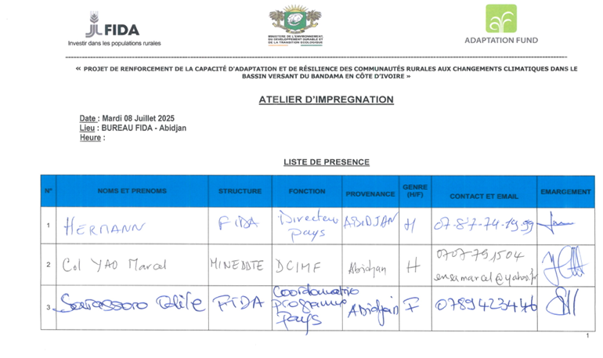

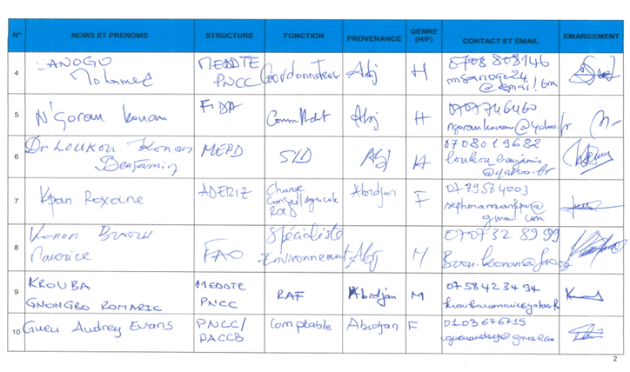
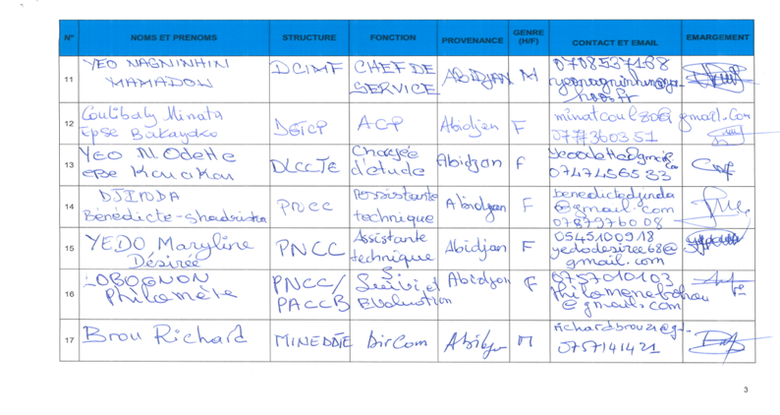

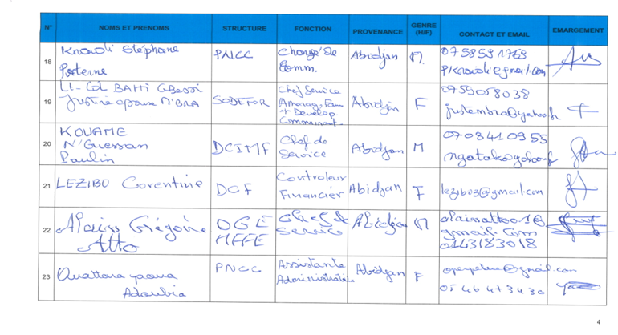

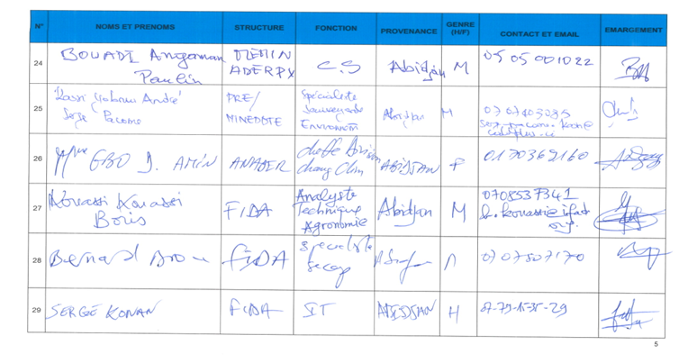

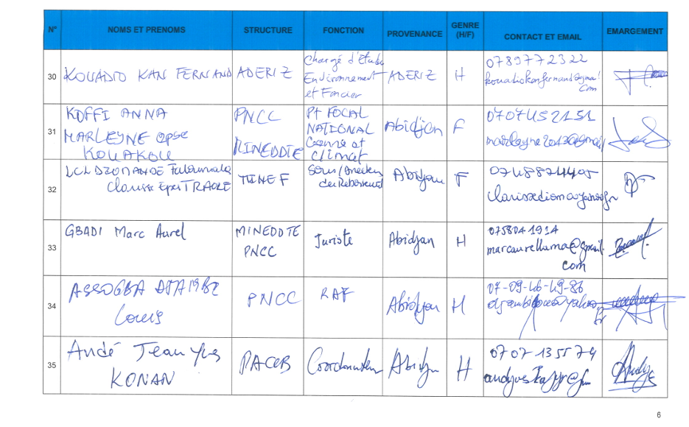
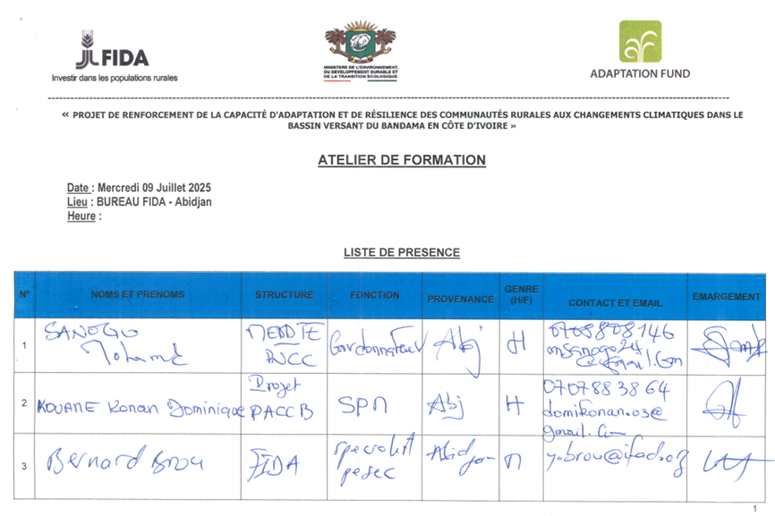
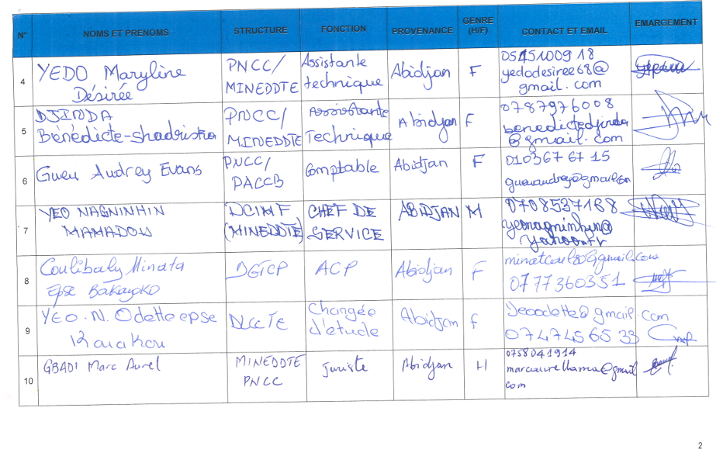
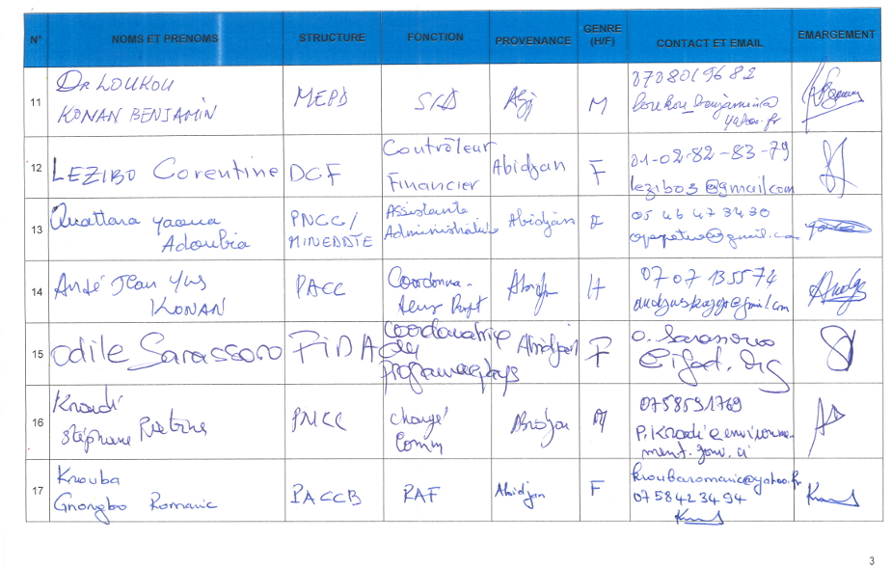
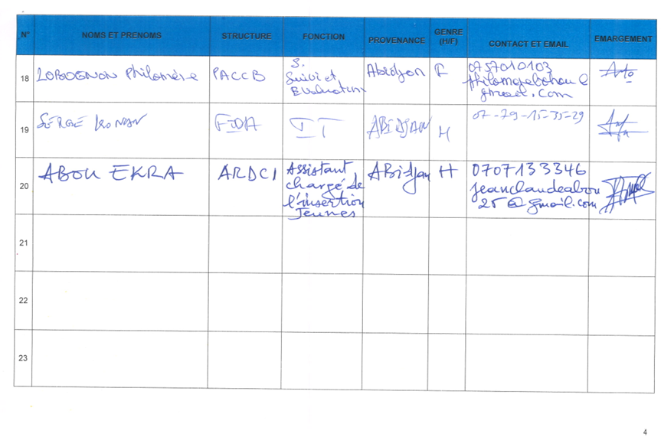

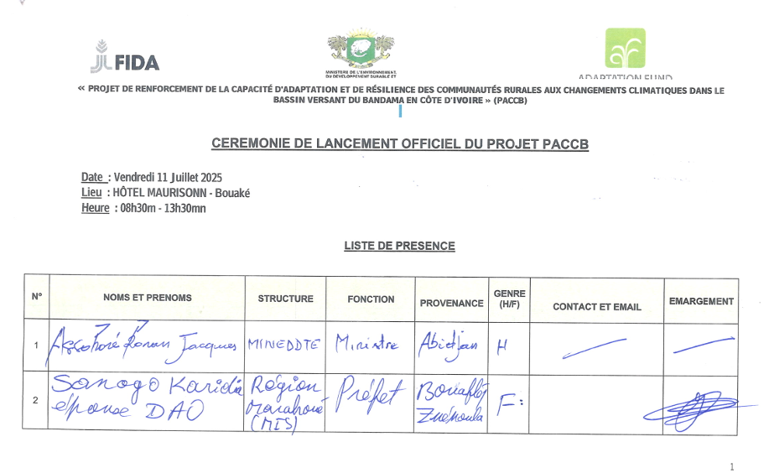
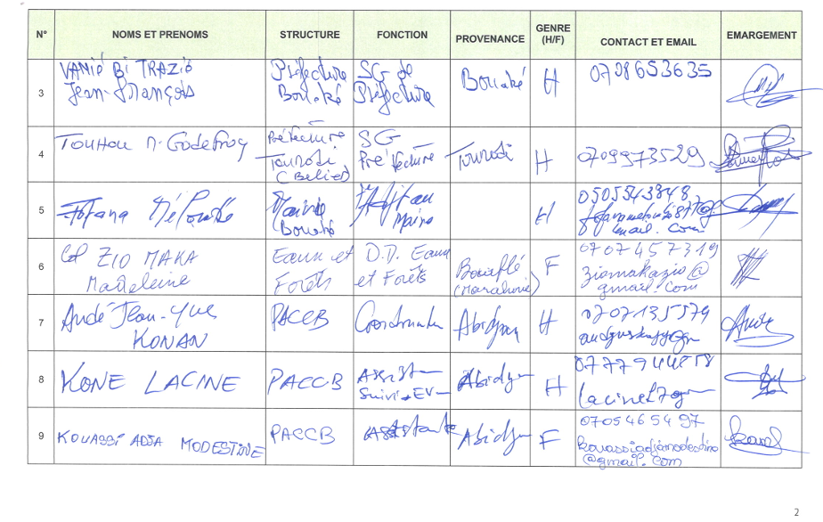
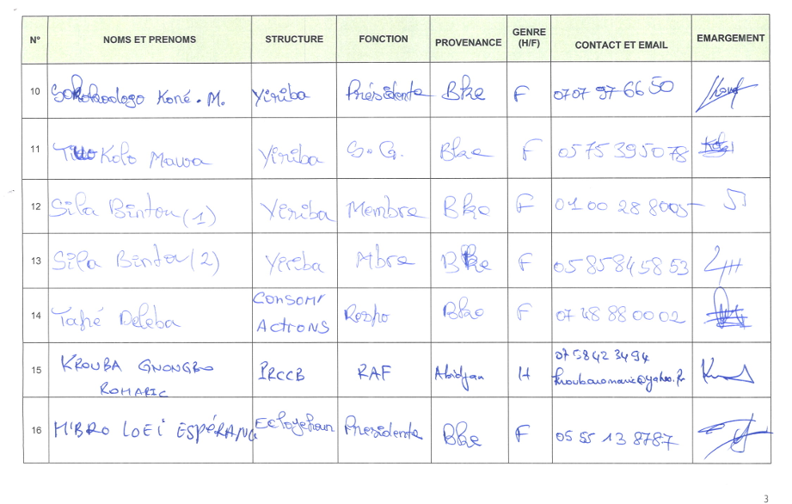
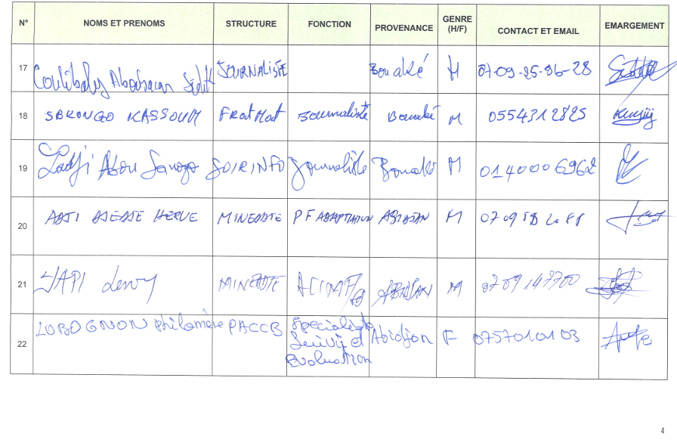
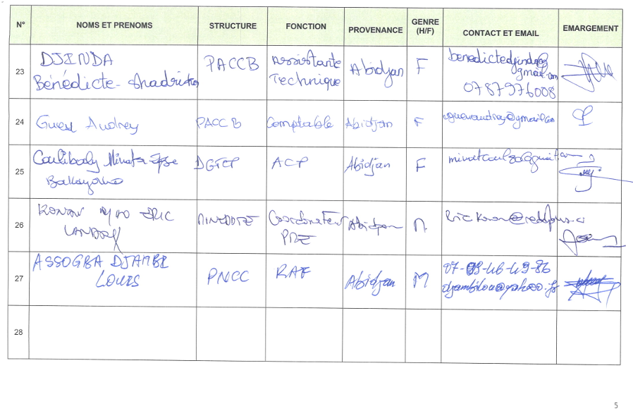
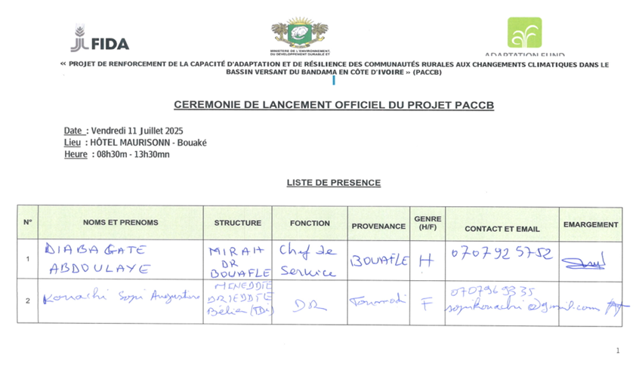

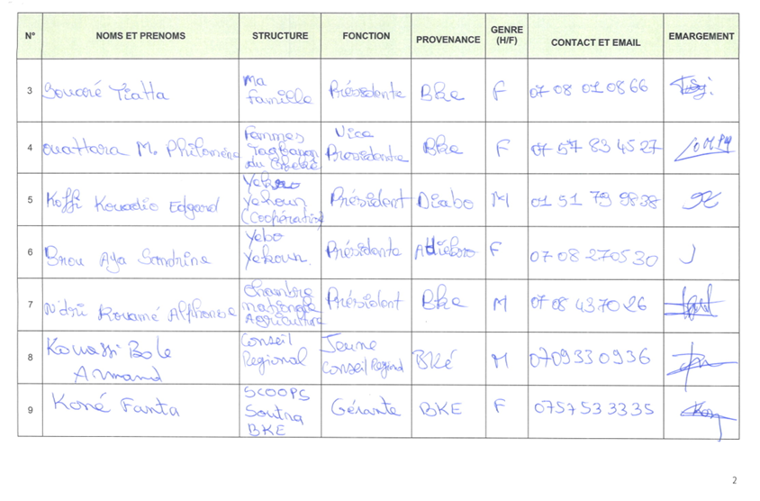
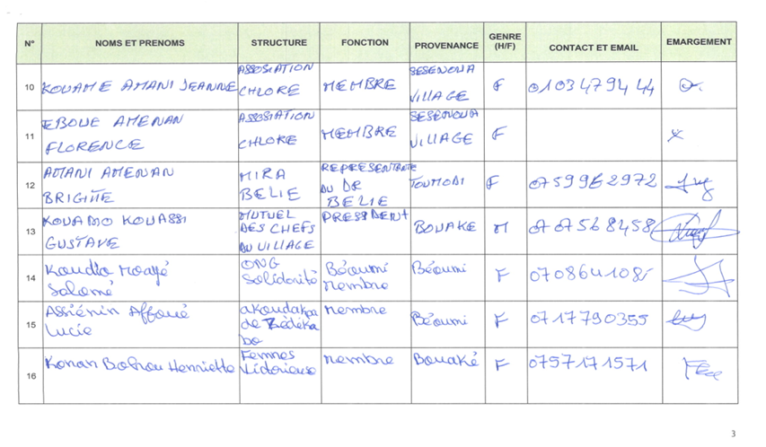

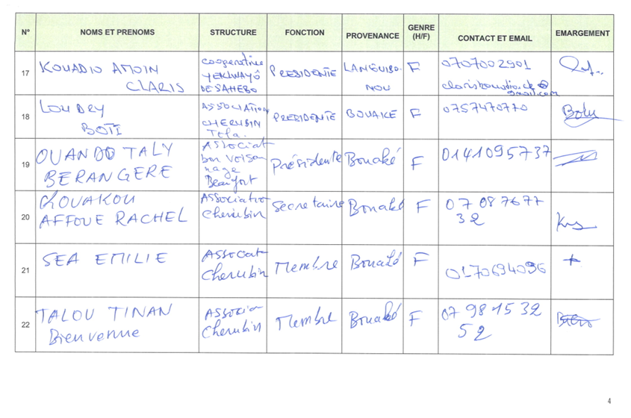

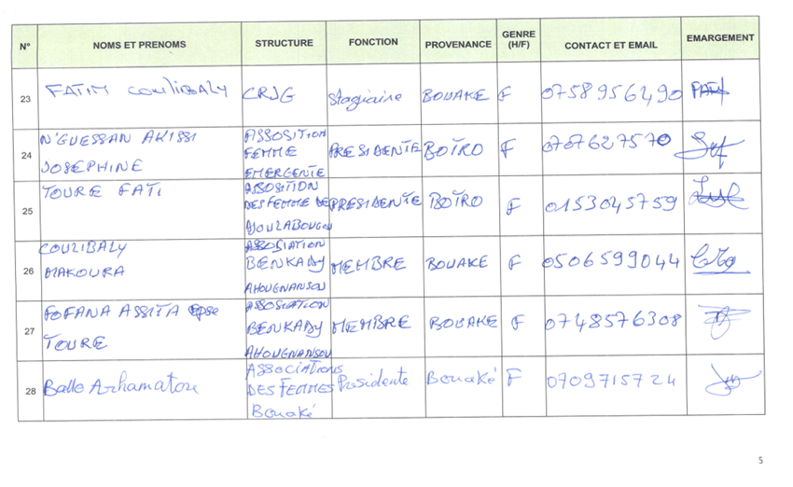

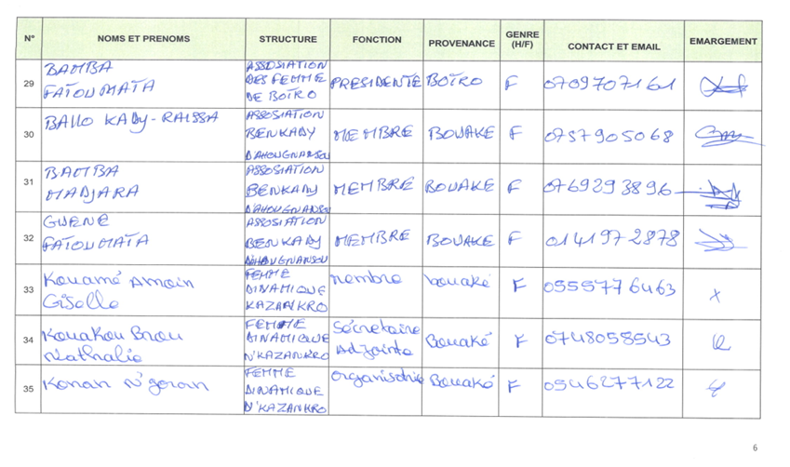

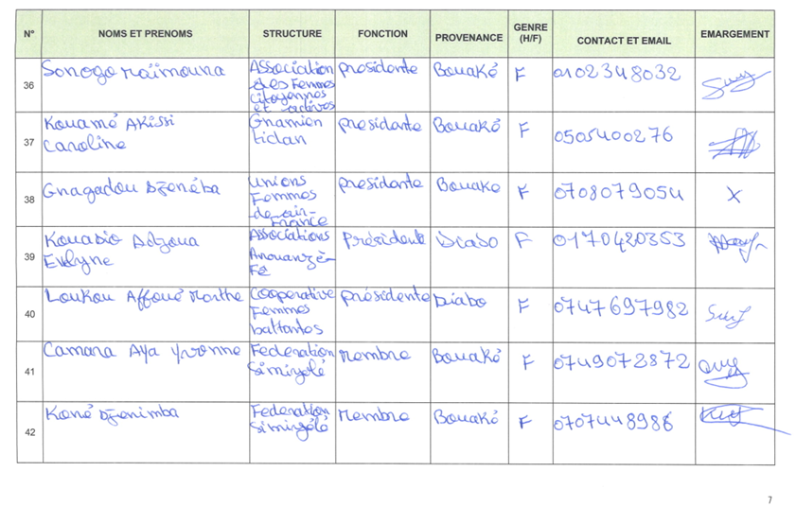

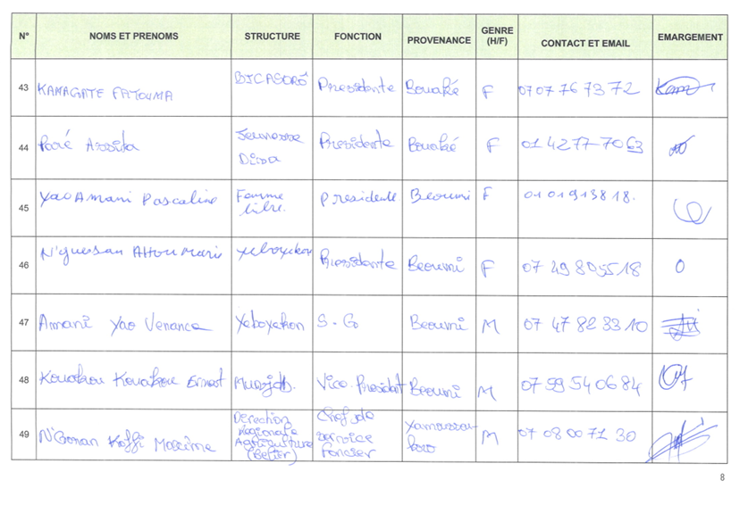

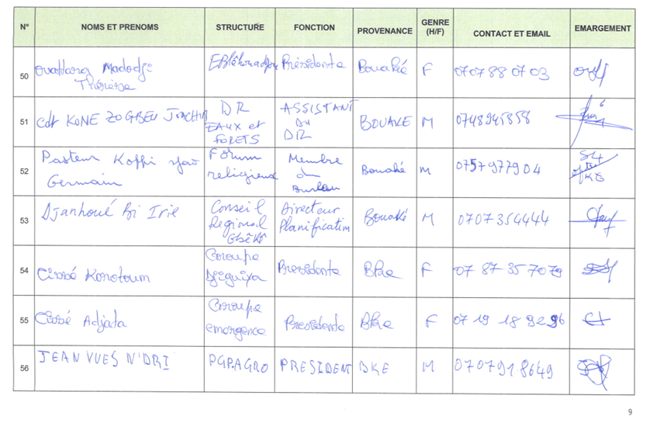

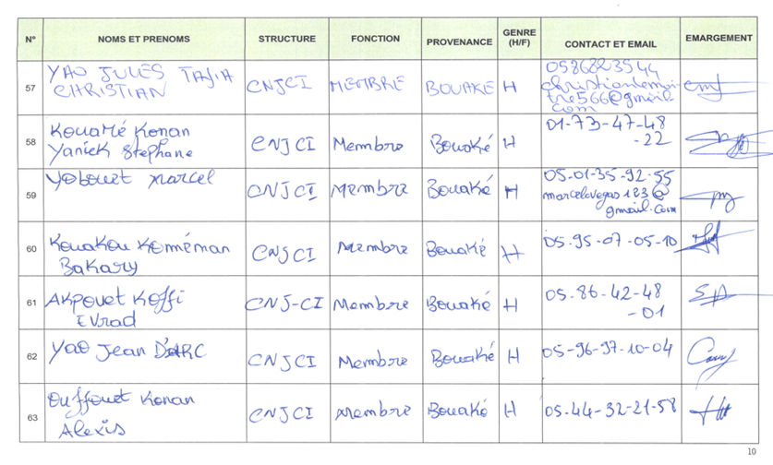

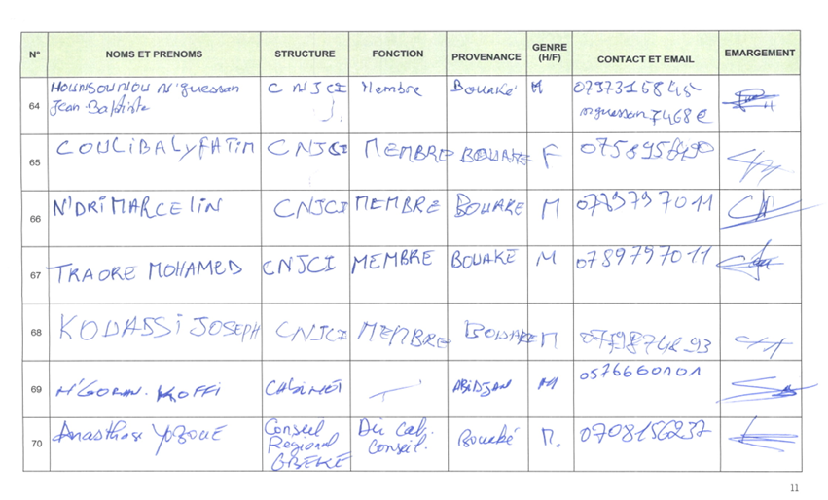

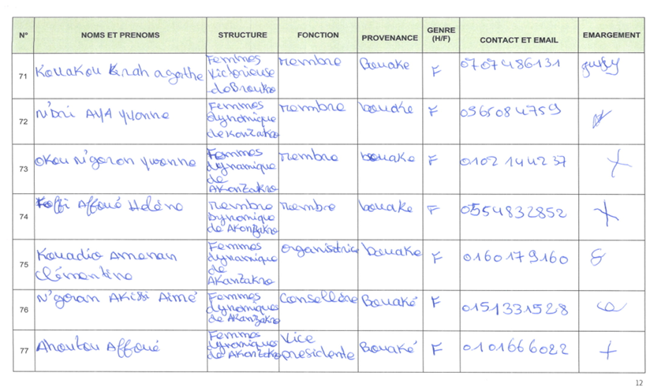

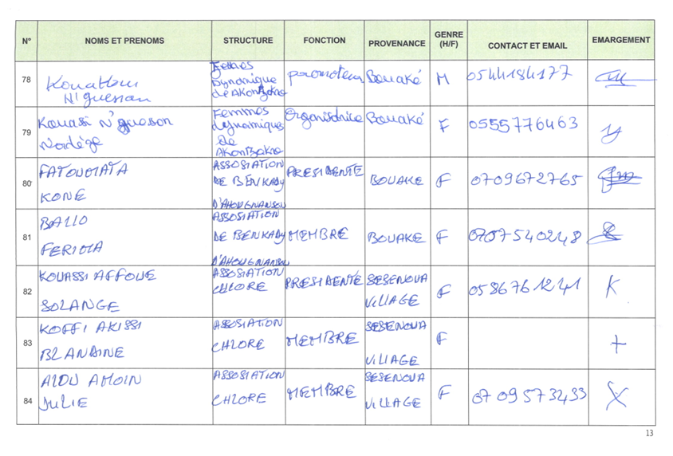
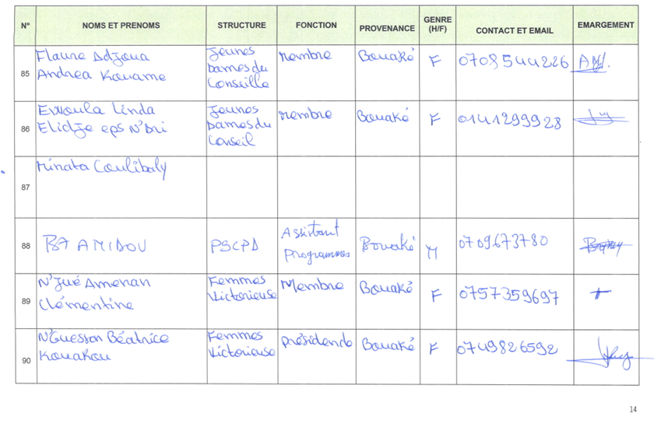

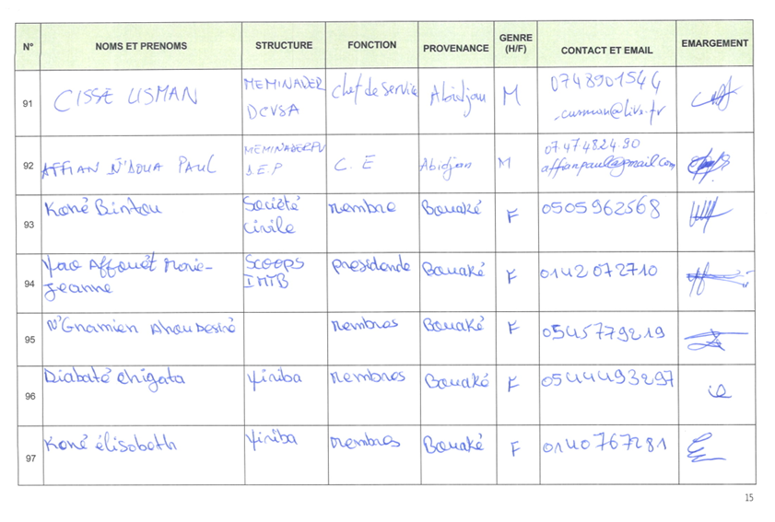

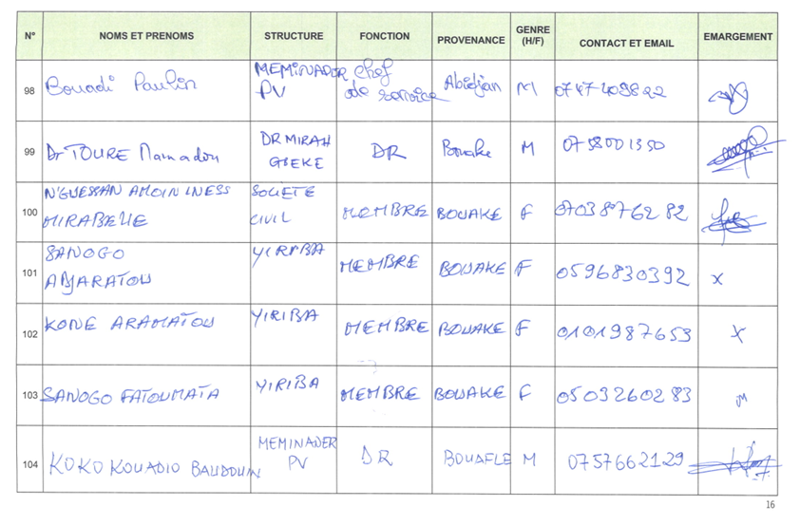

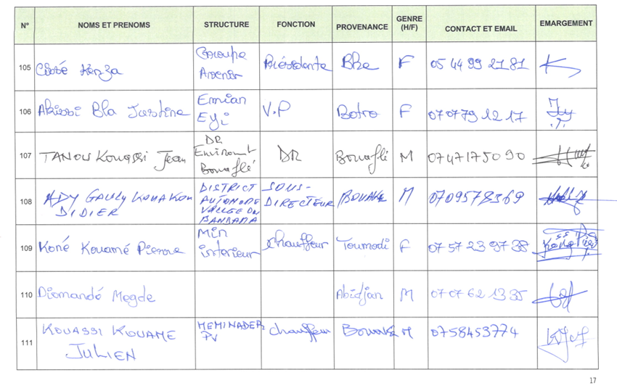

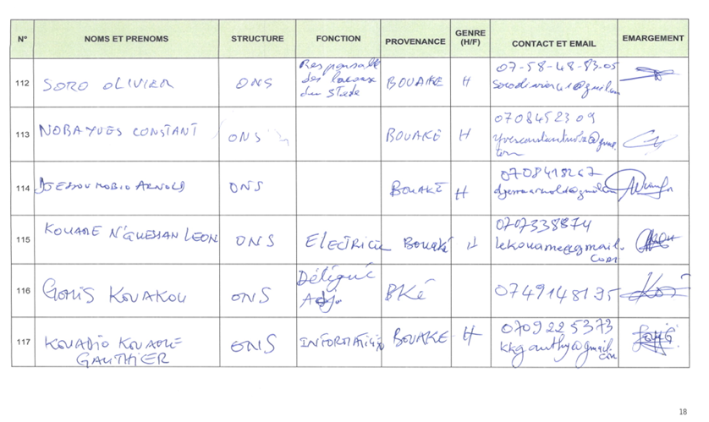

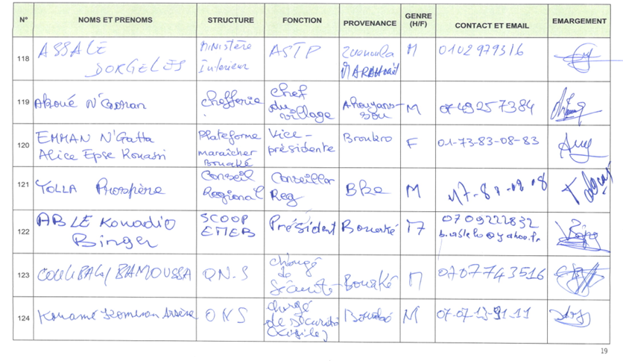

Appendix 2: Some photos of the official launch ceremony of the PACCB

Photo 11: Prefectural authorities of the targeted regions
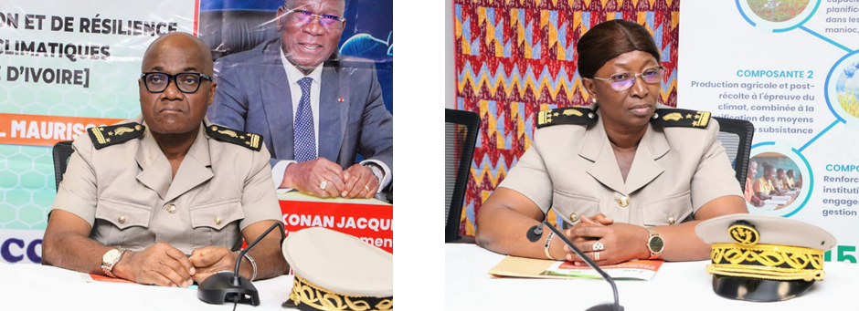
Source: Images UGP

Photo 12: beneficiary populations
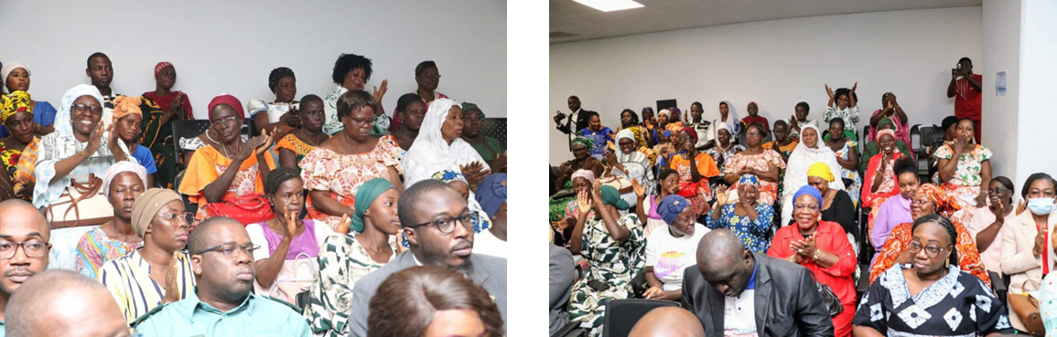
Source: Images UGP

Photo 13: Director of the Bélier Regional Council (left), coordinator of the PRE project (middle), Coordinator of the PNCC (right)
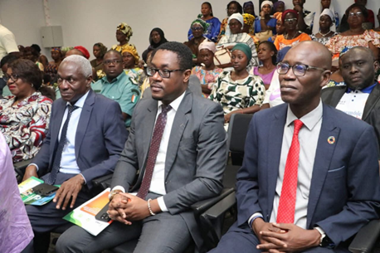

Photo 14: Mr. Minister and some authorities
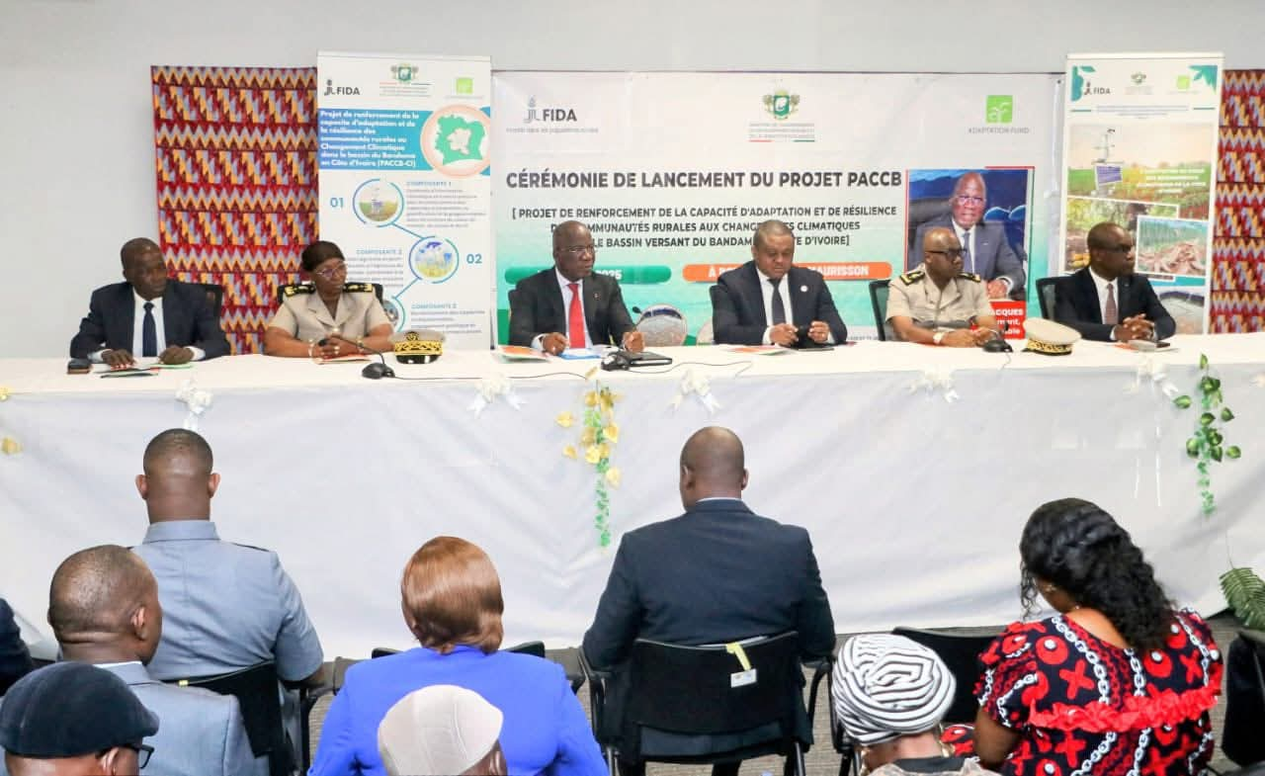
Source: Image UGP

Photo 15: Arrival of Mr. ASSAHORE Konan Jacques
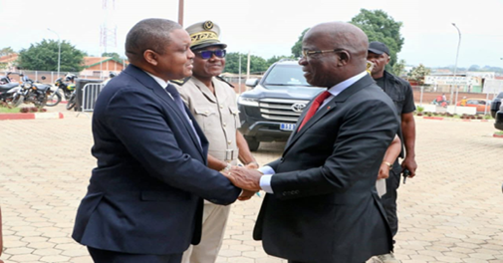
Source: Image UGP

