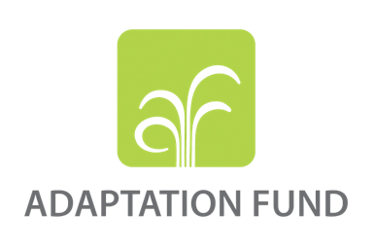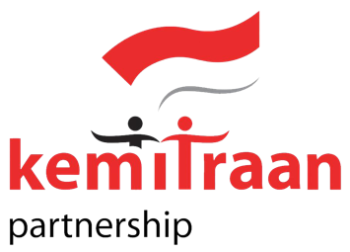

INCEPTION REPORT

ENHANCING THE ADAPTATION CAPABILITY OF COASTAL COMMUNITY IN FACING THE IMPACTS OF CLIMATE CHANGE IN NEGERI (VILLAGE) ASILULU, URENG AND LIMA OF LEIHITU DISTRICT MALUKU TENGAH REGENCY MALUKU PROVINCE
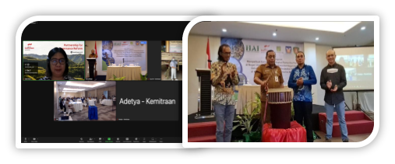

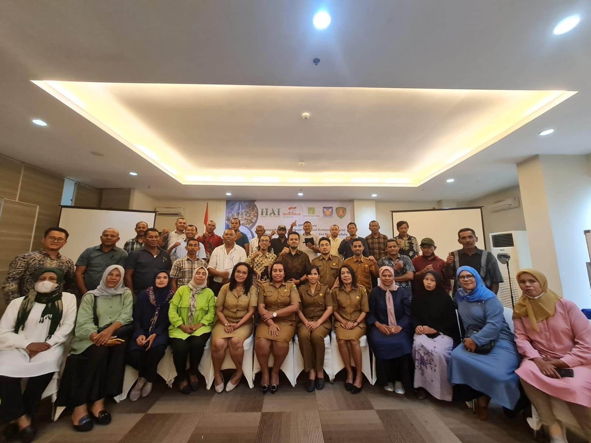

GLOSSARY

AF Adaptation Fund
BAPPEDA Regional Development Planning Agency (Badan Perencanaan Pembangunan Daerah)
BAPPELITBANGDA Regional Research, Development Planning Agency (Badan Penelitian, Perencanaan dan Pembangunan Daerah)
CN Concept Note
DKP Marine and Fisheries Office (Dinas Kelautan dan Perikanan)
DLH Environment Office (Dinas Lingkungan Hidup)
FGD Focus Group Discussion
HAI Harmony Alam Indonesia Foundation
KJA Floating Net Cage (Keramba Jaring Apung)
OPD Regional Organization of Government (Organisasi Perangkat Daerah) PUPR Public Works and Public Housing Office (Dinas Pekerjaan Umum dan
Perumahan Rakyat)
RZWP3K Zoning Plan for Water Areas and Small Islands (Rencana Zonasi Wilayah Perairan dan Pulau-Pulau Kecil)
Talut/Talit Tidal Waves (Tembok Penahan Gelombang)
Unpatti Pattimura University (Universitas Pattimura)
WPPNRI State Fisheries Management Area of the Republic Indonesia (Wilayah Pengelolaan Perikanan Negara Republik Indonesia)

TABLE OF CONTENS

GLOSSARY i
TABLE OF CONTENS ii
SUMMARY EXECUTIVE iii
- Overview 1
- Implementation Design 2
  - Reinforcing the resilience of small-scale/traditional fishermen to mitigate the effects of climate change 3
  - Coastal ecosystem restoration to strengthen communities' resilience in the coastal region and alternative fisheries and development of ecotourism potential 4
  - Developing alternative economic sectors in climate-resilient coastal regions by leveraging fisheries and marine technology 4
  - Building supporting infrastructure to anticipate the impacts of coastal floods and tidal waves 5
- Inception Phase 5
  - Communication and Coordination 5
  - Field Trip to 3 Negeri 7
  - Meeting with Experts 8
- Project Kick-Off 10
  - Kick-Off Meeting 10
  - Focus Group Discussion 14
  - Field Trip to Masohi 14
- Challenge and Opportunities 14
- Risk Management 15

SUMMARY EXECUTIVE

Maluku Province is an archipelagic province consisting of 1,412 islands, of which 92.4% is ocean and only 7.6% is land and is one of the areas in Indonesia that is most vulnerable to disasters due to the impacts of climate change.

Through financial support from the Adaptation Fund (AF), the Harmony Alam Indonesia Foundation and KEMITRAAN designed a climate change adaptation proposal entitled “Strengthening the Adaptation Capability of Coastal Communities in Facing the Impact of Climate Change in the Asilulu, Ureng and Lima Countries (villages), Leihitu District, Central Maluku Regency, Maluku Province” which aims to support climate change adaptation measures contained in the “Road Map for Mitigation and Adaptation to Climate Change and Sustainable Development in Maluku Province, adaptation to climate change in Coastal and Small Islands in Central Maluku Regency”.

The Project consists of 4 (four) Program components and has been approved by the Adaptation Fund on June 9, 2021 based on the decision of the Adaptation Fund Board No. B.36/3, namely on: (1) Strengthening adaptation of small/traditional fishermen in the impacts of climate change,
- Improvement of coastal ecosystems to strengthen community resilience in coastal areas and alternative fishing sources and development of ecotourism potential, (3) Development of alternative economies in resilient coastal areas on the climate by utilizing technology in the field of fisheries and marine areas, (4) Development/Improvement of Supporting Facilities to anticipate the Impact of coastal flooding and tidal waves.

Harmony Alam Indonesia has carried out a series of coordination and consultation with stakeholders in 3 Negeri, Regional Organizations of Government (OPD) at the Central Maluku Regency and Maluku Province, academics, and civil society organizations relevant to the implementation of the 4 (four) program components. The consultation and coordination process is carried out at the proposal preparation stage and after the proposal is approved by the Adaptation Fund. To ensure that project implementation is in line with the Road Map for Mitigation and Adaptation to Climate Change and Sustainable Development in Maluku Province, the Maluku Provincial Government and Central Maluku Regency Government have agreed on the need for an MoU on Cooperation between the Maluku Provincial Government and Harmony Alam Indonesia and a Partnership related to future project implementation.

The project kick-off was carried out on August 29, 2022 which consisted of the introduction of 4 (four) program components through a short video, opening speech from Harmony Alam Indonesia and the KEMITRAAN explaining the objectives of the climate change adaptation project with funding from the Adaptation Fund, then continued with opening speech and the

project kick-off which was inaugurated by the 1st Assistant Governor for Government Affairs and People's Welfare of the Regional Secretariat of Maluku Province.

In the FGD session, there was new information regarding the DKP Maluku Province’s plan to rehabilitate coastal vegetation (Non-Mangrove) in 3 (three) Negeri which is currently being proposed by the Maluku DKP to the Ministry of Marine Affairs and Fisheries (KKP). One of the objectives of the rehabilitation of coastal vegetation in 3 Negeri is to reduce the impact of abrasion and tidal waves that damage the talut (Tidal Waves). This is in line with the Talut rehabilitation plan in 3 (three) Negeri. Other information is related to the Revision of the Technical Material for Zoning Plan for Water Areas and Small Islands / RZWP-3-K of Maluku Province, which is already at the stage of technical consultation on the final document and the approval of the Minister. Importance alignment program with Marine Spatial Planning in the waters of 3 Negeri which are the Underwater Tourism Zone and Capture Fisheries Zone. The FGD also discussed plans for mapping fishing ground areas and the technical needs required for these activities.

On September 5, 2022, a tripartite MoU involving the Central Maluku Regency Government, Harmony Alam Indonesia and KEMITRAAN regarding the implementation of future projects was signed. On September 6, 2022, a meeting was held with the 2nd Assistant to the Governor for the Economy and Development of the Regional Secretariat of the Maluku Province with the agenda of discussing the draft MoU. A series of discussions were held with the Expert Team from Pattimura University on the implementation of activities in accordance with the prepared schedule. The discussion was followed by field visits to the target sites. .

Overview
Future projection of average temperature changes in Maluku, indicated in the downscaling statistics from IPCC Global Climate Model carried out by Gede Junnaedhi and Joko Trilaksono in 2017, shows an increase of temperature from 0,5 ºC to 1,5 ºC. The average annual projection graphic showed a minimum temperature increase in 2025, which is a sign that Maluku has undergone climate change. This influences the potential of high-risk natural disasters, such as floods in several regions of Maluku.

The results of a vulnerability study workshop in 2017 (BAPPEDA, 2017), showed that Central Maluku Regency has very high vulnerability in the capture fisheries sector. Changes in temperature will affect a decrease in the upwelling zone of fish (foraging places), a shift in fish populations to colder or warmer seas and an increase in ocean waves. Changes and variations in coastal and marine climates have an impact on the uncertainty of fishing time and area for fishermen, while most fishermen in this region still catch fish traditionally and conventionally.

Changes in fishing seasons also have an impact on fishermen's catches. Material losses also occur due to relatively high fishing costs because the fishermen have to move continuously to catch up with the time and area of fishing. Meanwhile the catch sometimes does not meet the target. The rising temperature and sea level caused by changes in coastal circulation patterns affect nutrient supply, cause coastal erosion and coral bleaching, and increase sea acidity. This condition has an impact on ecological processes that are directly related to the growth and spawning cycle of coral fish and other invertebrates.

The project Concept Note (CN) "Enhancing The Adaptation Capability Of Coastal Community In Facing The Impacts Of Climate Change In Negeri (Village) Asilulu, Ureng And Lima Of Leihitu District, Maluku Tengah Regency, Maluku Province" submitted in 2018 is aimed at assisting coastal communities in Maluku Tengah Regency to improve their resilience and reduce their vulnerability in the social, economic and ecological aspects from the threats of climate change impacts.

The improvement of the CN submitted later on and approved by Adaptation Fund (AF) in June 2021 lies in the implementation approach consisting of four components; (1) Strengthening adaptation of small/traditional fishermen in facing the impacts of climate change, (2) Improvement of coastal ecosystems to strengthen community resilience in coastal areas and alternative fishing sources, and development of ecotourism potential, (3) Alternative economic development in coastal areas that are climate-resilient by utilizing technology in fisheries and Marine areas, and (4) Development of supporting facilities to anticipate the impacts of coastal flooding and tidal waves.

Within the course of the development of the concept note and proposal, which last from 2018 until the approval in June 2021, a number of adjustments has been undertaken in consultation with the Municipal Government of Maluku Province and Maluku Tengah Regency through its

BAPPEDA in coordination with sectoral offices, such as Office of Environment, Office of Marine and Fisheries, Office of Public Housing and Settlement Area and Office of Public Works, to keep the content and the targeted outcomes in line with the Municipal Government planning for Maluku Province. Data and information included in the full proposal have been updated accordingly and respectively, still further changes and/or adjustment cannot be disclosed based on the dynamic condition of the impact and the time gap between the submission and the approval of the full proposal.

In general, there was no change between the contents of the CN and the approved proposal. The only adjustments undertaken were related to the methods and strategies used to the four program components that were to be carried out, as well as the analysis of risk management. Changes in
marine and fisheries sector policies that occurred after the issuance of Law No. 11 of 2020 on
Job Creation (Omnibus Law) would technically affect the implementation of the four program components, but wouldn’t affect or change the outcomes and outputs stated in the proposal.

Implementation Design

The four program components to be implemented offer a comprehensive approach to increase community resilience and minimize the impacts of climate change and those faced by communities in the 3 Negeri, covering economic, social, infrastructure, and ecological aspects. Most people in the 3 Negeri make a living as capture fishers, especially tuna fishers. Climate change leads to an increase in sea surface temperature, which causes the fish populations to move to colder or warmer seas and increased ocean waves. Fishermen's catches have since decreased as a result of this. The damage to the retaining walls caused the sea water to get into the land, threatening the safety of the residents living along the coast and road infrastructure. Coral reef destruction was caused by detrimental overfishing, in addition to climate change. For that matter, some fishermen in 3 Negeri depended on the availability of fish in coral reef ecosystems. Many of the wives of those fishermen started small businesses to relieve the financial burden on their families, but regrettably they had limited access to markets, funding, and innovative ideas. Moreover, young adults have trouble finding stable employment or avoiding unemployment.

Based on the aforementioned, it is necessary to carefully consider and plan the project implementation design in order to, first, provide a solution to any problems brought on by the effects of climate change and, second, effectively handle issues relating to social, economic, and environmental aspects in each targeted approach. Reinforcement and solidity of beneficiary communities in 3 Negeri were key prerequisites to independence in climate change adaptation.
The clan kinship system has a very strong influence on people in 3 Negeri. There is a tendency that residents will "listen more" to suggestions or opinions from people who still have kinship (1 Fam/Matarumah) compared to people with different clans/Matarumah. The issue of SARA

(ethnicity, religion, race and between groups) is a sensitive issue in 3 Negeri. The role of the Head of Village (King), is very important to create safe and strong social conditions. Negeri Ureng and Negeri Lima have a dark history in the form of riots between 2 villages, as well as social conflicts that have occurred between Negeri Asilulu and Negeri Ureng. Even though the incident happened 2 decades ago and has been reconciled. Still, there is the potential for riots if things occur that can provoke each other. Therefore, this program has a challenge to glue both citizen groups in 3 Negeri.

Solidarity and collaboration will be maintained throughout the project in order to strengthen social relationships between the communities in 3 Negeri. It also intended to mend the frayed ties that the community had developed over two decades of social conflict. This initiative not only addressed economic concerns, but it also improved social relations among the populations in 3 Negeri. Therefore, the relevance of the proposed approach has been carefully assessed to optimize the purpose of building community resilience in 3 Negeri while considering the needs of vulnerable groups.

Reinforcing the resilience of small-scale/traditional fishermen to mitigate the effects of climate change

This program component would strengthen fishermen's climate change adaptation capacity to deal with changes in fish migration patterns that affect the fish season calendar and fishing grounds. A technological approach will be applied to map the fishing grounds, especially fish upwelling zones. Additionally, by strengthening fishing-related groups and providing them with various forms of training, fishermen's capacity will be increased, allowing them to collaborate with other parties and to access a variety of government programs. To strengthen the practices of sustainable marine and fisheries management, Sasi Laut (a customary tradition to safeguard the sea) that will promote the traditional culture will also be put into practice. Various supporting infrastructures were developed in this component, such as fish aggregating devices and cold box procurement, to increase fishermen's income. It is important to pay close attention to the type of fish aggregating device under development and its government-approved placement line.

Coastal ecosystem restoration to strengthen communities' resilience in the coastal region and alternative fisheries and development of ecotourism potential

Climate change has degraded around 56 Ha of coral reef region in Leihitu Sub-district (Coral Bleaching). Further, the existing coral reef also suffered from unsustainable dynamite fishing, fishing boat anchors. Frequent floods have been caused by the collapse of Wai Ella dam in Negeri Lima. This component will contribute to the restoration of destroyed coral reef ecosystems (12 Ha). The artificial reef method was chosen to restore coral reefs due to its

environmentally friendly nature and quick results in the growth of coral reef fish and coral reefs, mainly because artificial concrete could become a “fish apartment”. Acropora Branching, Acro Digitate, Tabular, and Submassive were the types of coral reefs used due to their resistance to waves and are commonly found in the water around 3 Negeri.

Additionally, 3 Negeri has the potential for underwater ecotourism because the restoration of coral reefs would give ideas to the development of ecotourism. Therefore, improving the coral reef ecosystem will impact not only the availability of food for demersal fish/coral reef fish, but also alternative economic development through the ecotourism that will involve youth groups. This marine tourism concept is in line with the government's plan to develop tourism potential in a group of 3 islands (Ela Island, Hatala Island, Lain Island) located in 3 Negeri's water area. Coral reef management would be combined with a Co-Management System involving other stakeholders to protect, monitor, and expand coral reef rehabilitation in the future. The restoration of coral reefs was not the only focus. The activities to maintain and protect the coastal ecosystem will be undertaken thoroughly, one of which is waste management, which is currently in poor performance. Information and knowledge distribution on the importance of safeguarding the coastal ecosystem would target school age ranges and develop collaboration with various schools to nurture environmental awareness in younger generations.

Developing alternative economic sectors in climate-resilient coastal regions by leveraging fisheries and marine technology

The importance of alternative livelihoods for the communities in 3 Negeri was based on the condition that most people only rely on capture fisheries as the only source of income. The tidal wave and extreme weather contributed to the low fishermen's activities as they chose not to fish. Aware of that situation, many fisherwomen started fishery product-related businesses to support the household economy. The resulting products, however, can only be marketed in their respective villages due to the limited capital, market access, and other supporting infrastructure. Initiatives to cultivate seaweed have also been carried out through government programs, however they are not long-lasting. The most crucial component is technical know-how in marketing and farming.

As a result, alternative economic development approaches in the program's components include not only the supply of facilities and infrastructure but also product marketing. Furthermore, the concept of Net Floating Cages (Keramba Jaring Apung or KJA) development would be integrated with the idea of maritime tourism.

Building supporting infrastructure to anticipate the impacts of coastal floods and tidal waves

The current wave retaining wall was built entirely by the government through numerous projects. The retaining wall is known as talit or talut in the local language. The wave retaining walls can withstand sea level rise, tidal wave collisions, and tidal floods. Some of the wave retaining walls have been destroyed by being crushed or dragged away by abrasion and tidal waves. The break-in of the Wai Ella dam in 2013 also damaged several talut or retaining walls in Negeri Lima.

The restoration of several damaged retaining walls, with a ±500 M retaining wall repair target, is expected to lower the risk of tidal wave disasters in 3 Negeri. It also includes the protection of
±1.6 kilometers of Negeri roads along the coast. The Public Works and Housing (PUPR) Office will be involved in this project, starting from the consultation phase, conducting surveys, and making recommendations regarding the physical specifications of the area to be rehabilitated. The initial phase of the retaining wall improvement program will be preceded by a detailed presentation to the Environment Agency (DLH) regarding environmental impacts on the improvement to be made, and to the Regency and Province PUPR Office related to building specifications. In addition to matters related to construction techniques and specifications, and environmental impact management, it is essential to ensure community involvement in the execution of retaining wall improvement as a direct impact from the economic side.

Inception Phase

The project's initial phase began in April 2022 and concluded with a project kick-off on 29 September 2022. The following activities were carried out during the initial phase:
    - Maintain communication and coordination with the Maluku Provincial Government and the Central Maluku Regency Government
    - Visits to the project site to stay up to date on the latest developments in project conditions
    - Expert consultations and discussions
    - Project kick-off

Communication and Coordination

Because of the pandemic, online communication and coordination have been intensified since COVID-19 protocols limit travel and crowds. Coordination was immediately carried out once HAI obtained formal approval of the proposal to briefly submit the proposal approval report and discuss the project kick-off plan with the Maluku Provincial Government and the Central Maluku Regency Government. On 19 and 25 April 2022, after the Central Government loosened COVID-19 restrictions, direct (face-to-face) coordination was carried out through a series of meetings with the Regional Secretary of Maluku Province, Regional Development Planning Agency (BAPPEDA), Marine and Fisheries Office (DKP), and Environment Office (DLH). On 20 April 2022, a series of discussions with the Central Maluku Regency Government began with a meeting with the Regent of Central Maluku and was followed by meetings with the Marine and

Fisheries Office (DKP), Regional Research, Development Planning Agency (BAPPELITBANGDA), and the PUPR Office.

The meeting was intended to inform the attendees that the project is in its early stages, which means preparations for project implementation have begun. Furthermore, some stakeholders in regencies and provinces have seen changes and substitutions in officials' positions in associated agencies/offices pertinent to this program. Given that the time frame for the implementation of the FGD and coordination is quite long at the proposal preparation stage (2 years) until approval from the Adaptation Fund is obtained, this change necessitates HAI to carry out communication and re-coordination related to the program plan to be implemented. Some of the critical points of communication and coordination with the government are:

- Related to Output 1.4 and 1.5. The Central Maluku Maritime Affairs and Fisheries Agency (DKP) stated that fishing groups in 3 Negeri must be registered with the DKP to access the KUSUKA Cards (Marine and Fisheries Business Actor Card), which has become a government program through which fishermen can receive assistance such as fuel subsidies, protection insurance, and access to government programs. Fishermen do not register or have a KUSUKA Card because they are not associated with the government-registered fishermen group. The mentoring and strengthening activities for fishermen groups conducted by HAI must facilitate the registration of fishing groups to be able to receive the KUSUKA program. The fishermen mentoring and strengthening program will be carried out by coordinating with Field Assistance Personnel (TPL)/instructors at the sub-district level and involve the Fisheries Training Center and Instructors of Central Maluku Regency.
- Related to Output 1.2. Maluku Provincial Maritime Affairs and Fisheries Agency (DKP) stated that the procurement of a fish aggregating device would be difficult to realize because the water area in 3 Negeri is located in the State Fisheries Management Area of the Republic of Indonesia (WPPNRI) 714. This statement is based on the Decree of the Minister of Marine Affairs and Fisheries No. 7 of 2022 concerning the Allocation of Fish Aggregating Device on Fishing Line III at WPPNRI, which states that there is no allocation of Fish Aggregating Device at WPPNRI 714. This policy influences the decision to issue a Fish Aggregating Device Placement Permit (SIPR) for the Permanent Fish Aggregating Device category on fishing line III, if FADs are placed in fishing lane III.
- Related to Outputs 3.1 and 3.2. Currently, a revision of the Technical Materials for RZWP-3K (Coastal Zone and Small Islands Zoning Plan) is being carried out in Maluku Province, which is already at the stage of technical consultation on the final document and is awaiting the Minister's Technical Approval. The importance of aligning the program with Marine Spatial Planning in the waters of 3 Negeri which are the Underwater Tourism Zone and Capture Fisheries Zone. Cultivation activities can still be allowed for small-scale activities and must obtain a permit.

In addition, it discussed the need for an MoU between the Maluku Provincial Government and Central Maluku Regency Government with the HAI Foundation and the KEMITRAAN. This MoU is important to do, so that there is a harmony of programs and development plans in Maluku.

Field Trip to 3 Negeri

Field trip to 3 Negeri was carried out on 21-24 April 2022. Consolidation, socialization, and updating of information on the preparation of program implementation to the beneficiaries in 3 Negeri. Some of the key points in this field visit include:

- Related Outputs 1.2. The type of FADs that fishermen expect is FADs for tuna. This type of FADs is expensive. To make tuna FADs, it costs + IDR 200,000,000 (approx. USD 13,500). The types of FADs that will be provided in this program are designed for FAD types of demersal fish/reef fish and small pelagic fish which cost less (+ IDR 15,000,000 – 20,000,000, approx. USD 1,000 to USD 1,350).
- Related Outputs 3.1 and 3.2. For the placement of floating net cages (KJA) and floating rafts for seaweed, it must be adjusted to the west wind season and east wind season to avoid tidal waves. The possible time period is during the eastern transition season (April-July) and the east wind season (August-October) because the water conditions are calmer. During the western transition season (November-January), KJA and floating rafts for seaweed must be moved temporarily to avoid tidal waves. In particular, the type of KJA used must be made of HDPE which is relatively stronger and durable. Regarding seaweed, the initiative for cultivation has been carried out through government programs but is not sustainable. The main factor is poor technical knowledge in cultivation and marketing.
- Related to Component 4. Rehabilitation of talut must be integrated with the protection of fisherman's boat docks (boat mooring locations) so that they are protected from tidal waves. So far, the adaptation model carried out by fishermen is to make para-para, which is a place to store boats while not going to sea to anticipate the tidal waves that could potentially hit the boat. These para-para are used when fishermen do not go to sea for several days because of extreme weather or because other factors prevent fishermen from going to sea. Para-para is made between the talut and the shoreline, from small logs that are resistant to seawater.

Meeting with Experts

A series of meetings with Experts were held to discuss technical matters related to the implementation of the Program Components.

- The meeting was held with DR. Harold JD. Waas (marine expert from Pattimura University) to discuss the technical implementation of the study and mapping of fishing ground areas fishermen in 3 Negeri. The mapping of fishing ground areas will be carried out in a

participatory manner with fishermen in 3 Negeri. To ensure potential fishing areas, at least parameters on the presence of chlorophyll and ocean currents.. To get regular updates on the location of tuna fishing trails and map of potential fishing grounds, a collaboration with the Jembrana Bali Research and Marine Observation Center (BROL) was recommended, which can be facilitated by the DKP Maluku Province. For the technical implementation of mapping, equipment and supplies such as GPS Marines and Garmin Fish Finder 350 Plus Sonar Frequency 50/77/200 Khz are needed as well as landsat-8 satellite imagery maps with a resolution of 30 x 30 meters. Direct observation in the field by following large pelagic fishing operations using pole and line and purse seine fishing gear.

Data in the form of oceanographic conditions (sea surface temperature, distribution of chlorophyll-a and water depth) in large pelagic fishing areas in WNPRI 714 in relation to fishing productivity was analyzed to obtain a range of oceanographic parameter values. The optimum habitat for large pelagic fish is analyzed using the Generalized Additive Model. Fish migration patterns in a one-year cycle were analyzed using a combination model of fishing performance-oceanographic preferences and mapped using GIS (Geospatial Information System) techniques. The mapping is focused on locations that have been fishing routes for fishermen in 3 Negeri and combined with knowledge of the traditional fishing season calendars owned by fishermen to perform a gap analysis of factual conditions in the waters. The results of this mapping can help fishermen to set the fishing season calendar and select the type of fishing gear that is in accordance with the catch target, including the policies implemented in the context of sustainable use of fishery resources.

- Based on the results of consultations with Mr. Noke Rijoli (Coral Reef Ecosystem Expert) from Pattimura University regarding the rehabilitation of coral reefs, it is still necessary to study the location and suitability of the types of coral reefs to be rehabilitated. The artificial reef method was chosen to rehabilitate degraded coral reef because it is more environmentally friendly, has a faster impact on reef fish ecosystems and also the growth of coral reefs themselves. Artificial concrete can form a “fish housing” or fish apartment which can be made in the form of a cube with a size of 30 cm x 40 cmthat is more flexible and easier to transport. Types of coral reefs considered for the transplantation process are from the species of Acropora Branching, Acro Digitate, Tabular and Submassive, since these species are resistant to waves and are often found in waters around the 3 Negeri.
- Consultation with Dr. Mauren M. Pattinasarany from the University of Pattimura (Cultivation Fisheries Expert) resulted in a suggestion to consider the east and west monsoon seasons in the site selection for KJA and seaweed cultivation in the waters of 3 Negeri. Further, water samples are needed to ensure the salinity of the waters in the planned location where seaweed cultivation will take place. The types of fish that will be cultivated are grouper, bobara (Caranx ignobilis) and momar or shortfin scad (Decapterus macrosoma) because these species are suitable in the waters of 3 Negeri and are easy to process and market. The type of KJA that will be used is rectangular and made of HDPE for the reason

that it is more efficient and easy to assemble and maintain. To ensure the quality of fish seeds/seedlings to be cultivated, the procurement of fish seeds/seedlings must cooperate with the Center for Fisheries Seeds and Marine Cultivation in Maluku. As for seaweed cultivation, the type of seaweed to be cultivated is Eucheuma Cottonii or red seaweed.

During the field visit, preliminary observations were made to determine the location of KJA and seaweed cultivation, as well as the approximate location of FAD placement for demersal or small pelagic fish species. The determination of this initial location point is based on public information regarding the condition of the waters in 3 Negeri during the west wind season and east wind season. The exact location will be determined further through the process of mapping, testing water samples, and underwater observations to determine the location of damaged coral reefs to be rehabilitated.
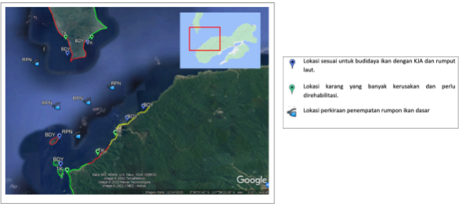

Project Kick-Off

The project kick-off was to be carried out after the Eidul-Fitr holiday. To prepare for the Kick-off, intensive communication was carried out with the Maluku Province BAPPEDA. In May 2022, the Central Government issued a Circular Letter of the Task Force for Handling Covid-19 Number 7 of 2022 concerning Health Protocols for Overseas Travel During the Corona Virus Disease 2019 (Covid-19) Pandemic. By revoking this Circular, there is flexibility in carrying out activities, one of which is flexibility in carrying out meeting activities that involve many people by ensuring health. Therefore, the implementation of the Kick-Off can be done offline (face to face).

At the initial planning stage, the Kick-Off was planned for the period between 27 and 30 June 2022. However, after further discussion with the Maluku Provincial BAPPEDA, the Kick-off schedule has been postponed to 29 August 2022 for technical reasons and to ensure further developments of the Covid-19 pandemic in Ambon City. The availability of the Governor of

Maluku was also considered, for him to be able to open the Kick-Off meeting. For the implementation of the Kick-Off, it was agreed that the Maluku Provincial BAPPEDA would make an invitation letter on behalf of the Maluku Provincial Government to the participants who would be invited to the Kick-off meeting. According to the agreement, the Kick-off participants will include all relevant OPD/Government Agencies in Maluku Province and Central Maluku Regency, community representatives of the 3 Negeri, civil society groups, and academics. Kick-off will be held in two sessions. The first session was the opening of the Kick-off as well as the ceremonial signing of the tripartite MoU of cooperation involving the Maluku Provincial Government, and HAI, followed by presentations and discussions of the 4 program components that will be implemented. The second session was a limited FGD which focused on discussing plans for mapping the fishing ground areas of fishermen in 3 Negeri.

Kick-Off Meeting

The objective of the kick-off meeting is to introduce and socialize the project and explain the implementation plan, as well as the intervention model, to all relevant key stakeholders to project implementation of 3 Negeri. Subsequently, media coverage of the project kick-off was disseminated to the people of Maluku Province. General discussion and overview of project implementation and intervention plans are part of the agenda of this meeting. As agreed with BAPPEDA, the meeting is scheduled for 09.00 EIT (East Indonesian Time) on 29 Agustus 2022.

The Governor of Maluku Province was unable to attend the kick-off because he had to attend a meeting in Jakarta regarding President Joko Widodo’s planned visit to Maluku (Tanimbar Islands Regency) on September 1, 2022. The Maluku Regional Secretary was also unable to attend, because he had to prepare the arrangement for President Joko Widodo’s visit to the Tanimbar Islands Regency. The kick-off meeting was attended by the 1st Assistant to the Governor ont he Government and People's Welfare of the Maluku Province Secretariat who officially opened the kick-off meeting. Participants from the Provincial Government attending the kick-off are among others:
- Marine and Fisheries Office of Maluku Province
- Environment Office of Maluku Province
- Public Works and Public Housing Office of Maluku Province
- BAPPEDA Maluku Province
- BAPPELITBANGDA Central Maluku Regency
- Watershed Agency (DAS) Maluku Province
- Tourism Office of Maluku Province

In addition, the kick-off meeting was also attended by representatives of civil society organizations in Maluku, journalists from various national and local media, such as community representatives in each Negeri consisting of Fishermen, Women and Youth Groups. The Kick-off meeting began with an introduction to the program components through a short video, followed

by an opening speech from the Director of Harmony Alam Indonesia. The Program Director of the KEMITRAAN, who joined the event online, delivered a speech and explained the objectives of the climate change adaptation project with funding from the Adaptation Fund, which aims to assist the government in dealing with the impacts of climate change.

The opening ceremony closed with remarks from the 1st Assistant to the Governor, addressing that the Maluku Provincial Government had integrated climate change action plan into the Maluku Province RPJMD document for 2019-2024 through the governor's flagship programs, such as the climate village program, disaster resilience village and environmental management based on local wisdom. These programs are a form of local government in response to climate change mitigation and adaptation issues. The Maluku Provincial Government expressed its appreciation and support for cooperation in implementing future activities. The 1st Assistant 1 closed his remarks by officially announcing the start of the project.

The signing of the MoU involving the Maluku Provincial Government, KEMITRAAN and HAI has not yet been implemented because it is still in the discussion stage at the Maluku Provincial Government Bureau. As for the signing of the MoU between the Central Maluku Regency Government with the KEMITRAAN and HAI, it will be held on September 5, 2022 in the capital of Central Maluku Regency in Masohi.

Introduction to Component Program

In the first session of the kick-off meeting, HAI presented the introduction to the 4 component program and explained the implementation arrangement to the attendants as described below:

PROJECT/ PROGRAMME COMPONENTS | EXPECTED OUTCOME | EXPECTED CONCRETE OUTPUT
1. Strengthening the adaptation of traditional fishermen in facing changes fish migration and circulation patterns due to climate change | A. Increasing the yield and quality of fish catches of fishermen as well as helping improving the traditional fish catching rules (Sasi Laut) | - There is a map for the new fishing ground distribution points based on the circulation pattern and fish migration pattern, as well as updated fishing season calendar  - Rumpon Procurement / Fish Aggregating Device (FAD)  - The provision of Cold Storage in each village
 | B. Enhancement of the capacity and knowledge of fishermen’ groups by adopting the climate change  adaptation strategies. | 1.3. Approximately 450 fishermen (150 fishermen in each village) have new knowledge

which is more relevant to the climate change
1.4. The establishment of fishermen’ groups which are able to cooperate with government offices, private parties, and non-governmental organizations in order to be able to access technology, group guidance and capitalization
2. Coastal ecosystems repair for the  resilience of  communities and alternate location for source fishing | A. Restoration of the function of coral reef ecosystems and expanding fishing ground zones for fishermen in nearshore waters | 2.1. Rehabilitation of ± 12 hectares of coral reefs in Asilulu and Lima villages in order to expand new fishing grounds near the beach
 | B. Increased awareness and active role of coastal communities to rehabilitate, maintain and protect coral reefs | 2.2. Approximately 90 people (30 people in each village) have the knowledge on how to do rehabilitation, transplantation, maintenance, care, and monitoring on coral reefs
3. Alternative economic development in coastal areas that are climate-resilient by utilizing technology in fisheries and Marine areas | A. Reducing dependence on livelihoods as catch fishermen | 3.1. Aquaculture farming by constructing 9 floating fish ponds for shallow water fish cultivation (3 ponds for each village) each of which is to be managed by the groups (1 group = 20  people’s)
 | B. Increasing the role of women in the family economy | - Nine floating fish net ponds for the cultivation of seaweed (3 floating fish ponds for each village) each of which will be managed by the groups (1 group = 20 people)  - 100 women in the 3 villages have the skills for processing the products of the fish and seaweed cultivation
4. Development of supporting facilities to anticipate the impacts of coastal flooding and  tidal waves | Disaster risk reduction such as damage to seaside village roads and saving of community houses on the coast, caused by tidal waves | Restoring Embankment structure that stretches (talut)  ± 500 M long across Negeri Asilulu, Negeri Ureng, and Negeri Lima

The highlighted output components 1.1.1. are the main subjects of discussion in the second session of the kick-off.

Feedback, inputs and comments
During the subsequent discussions and Q&A session, community representatives said that in the last 10 years there has been a decline in income from fishing. This is due to the increasing intensity of rainfall and tidal waves as well as shifting fish seasons. Fishermen in 3 Negeri still rely on the traditional fishing season calendar which in local terms is called tanoar. In addition, it was also stated that the damage to coral reefs was caused by fishing activities by bombing. The program, which will be implemented in 3 Negeri, is expected to overcome these problems.

DKP Maluku Province conveyed information about the rehabilitation of coastal vegetation (Non Mangroves) in 3 (three) Negeri which is currently being proposed by the DKP Maluku to the Ministry of Maritime Affairs and Fisheries (KKP). One of the objectives of rehabilitation of coastal vegetation is to reduce the impact of abrasion and tidal waves that damage the coast (tidal waves). This is in line with the talut rehabilitation plan in 3 (three) Negeri. Other information is related to the Revised Technical Material for the Zoning Plan for Water Areas and Small Islands/RZWP-3-K Maluku Province which is already in the technical consultation stage of the final document and has received the approval of the Minister. The importance of aligning the program with the Marine Spatial Plan in the Waters of 3 Negeri, namely the Underwater Tourism Zone and the Capture Fisheries Zone.

All feedback, inputs and comments were collected for the project team to utilize for evaluation against the goals and objectives of the current proposal.

Focus Group Discussion

The FGD session focused on discussing the planned fishing ground area mapping activity which was guided by DR. Harold JD. Waas (marine expert from Pattimura University). This session started with a presentation by DR. Waas about the condition of the waters in Maluku. In his presentation, he stated that tuna will continue to pass through the Makassar Strait, enter the Banda Sea, Bali Strait, Halmahera Waters, Seram Sea and head to the eastern region. Tuna moves with the ocean currents and not against the current. This oceanography and remote sensing expert also explained about fishing ground mapping, from the food chain to the use of remote sensing. DR. Waas explained that tuna can survive in one location if the food chain at that location runs regularly. But if not, of course, the fishing ground will be further away because tuna cannot survive without food supplies. To map fishing potential areas, remote sensing methods using satellites can be used to facilitate fishing by fishermen.

Participatory mapping of fishing ground areas will be carried out involving fishermen of the 3 Negeri. To ensure potential fishing areas, the least parameters needed are the presence of chlorophyll and ocean currents. The mapping is focused on locations that have been fishing routes for fishermen in 3 Negeri and combined with knowledge of the traditional fishing season calendars owned by fishermen to perform a gap analysis of factual conditions in the waters. The results of this mapping can help fishermen to set the fishing season calendar and select the type of fishing gear that is suitable to catch the target, including the policies implemented in the context of sustainable use of fishery resources.

At the end of the session, it was agreed that the time for mapping will be carried out in early October, starting with training activities on the introduction of tools for mapping at the sea (Fishing Ground Area).

Field Trip to Masohi

The visit to Masohi was carried out on 4-5 September 2022 with an audience with the Central Maluku Regent to convey the results of the kick-off meeting held previously and the plan to sign an tripartite MoU involving the Central Maluku District Government, KEMITRAAN and HAI. On September 5, 2022, the MoU was signed at the Central Maluku Regency Government Hall. While in Masohi, HAI also coordinated and consulted with the Head of the Central Maluku Marine and Fisheries Office regarding the plan to map the fishing ground area for October 2022.

Challenge and Opportunities

The project has been approved since June 2021 and HAI has immediately informed BAPPEDA, local government and communities in 3 Negeri. Indeed, the start of the project activities was postponed because the KEMITRAAN as the NIE of AF must undergo a re-accreditation process. In addition, although the COVID-19 pandemic outbreak began to decline, the government continued to enforce a policy of limiting activities throughout Indonesia. During the process, HAI continued to communicate and coordinate with the Regency’s BAPPEDA and local governments in 3 Negeri, but could not provide certainty when the project kick-off would take place.

After the NIE’s re-accreditation is finalized, on 19 and 25 April 2022, after the Central Government loosened COVID-19 restrictions, direct (face-to-face) coordination was carried out through a series of meetings with the Maluku Provincial Secretary, Development Planning Agency (BAPPEDA), Marine and Fisheries Office (DKP), and Environment Office (DLH). On 20 April 2022, a series of discussions with the Central Maluku Regency Government began with a meeting with the Regent of Central Maluku and was followed by meetings with the Regency’s Marine and Fisheries Office (DKP), Regional Research, Development Planning Agency (BAPPELITBANGDA), and the PUPR Office. The meeting was intended to inform the

attendees that the project is in its early stages, meaning that preparations for project implementation have begun. Furthermore, some stakeholders in regencies and provinces have seen changes and substitutions in officials' positions in associated agencies/offices pertinent to this program.

The DKP Maluku Province plans to rehabilitate coastal vegetation (Non-Mangrove) in 3 (three) Negeri which is currently being proposed by the Maluku DKP to the Ministry of Marine Affairs and Fisheries (KKP). One of the objectives of the rehabilitation of coastal vegetation in 3 Negeri is to reduce the impact of abrasion and tidal waves that damage the talut (Tidal Waves). This is in line with the Talut rehabilitation plan in 3 (three) Negeri outlined in the proposal. In addition, the 3 Negeri area has the potential for the development of underwater ecotourism, therefore, the coral reef rehabilitation approach will carry the concept of ecotourism. Thus, the improvement of the coral reef ecosystem will not only have an impact on the availability of food for demersal fish/reef fish, but also the development of an alternative economy through the concept of ecotourism that will be carried out by youth groups. The concept of marine tourism is in accordance with the government's plan to develop tourism potential in a group of 3 islands (Ela Island, Hatala Island, Another Island) located in 3 Negeri's water area.

Risk Management

Type of Risk | Description of Risk | Risk Category  (H/M/L) | Risk Mitigation Strategy
Political | Changes of Regional Head (Governor or Regent) | L | The provincial government has a roadmap for climate change and adaptation to sustainable development that has been set for the next 25 years. An MoU has been signed between HAI and a partnership of the Provincial Government (Finalization Phase) with the Central Maluku District Government, which will ensure support from both governments throughout the project. In addition, coordination and communication will continue to be carried out to OPD related to program implementation. However, if there is a change of Governor or Regent, coordination and communication will be carried out to the new Governor or  New Regent.
Institutional | Changes in project personnel can affect the availability of qualified  staff | L | HAI implements a recruitment system with the output of work contracts during the project. With this mechanism, personnel are  tied to the project objectives.
 | Weak commitment built  by project implementers | L | This project has a specific work component  of community strengthening for

 | with provincial/local government due to changes in government structure and lack of coordination and communication. |  | communities of the 3 Negeri that have been assisted by HAI since 2019.  The change of government structure has been anticipated by strong communication with BAPPEDA Maluku Province. To ensure project achievement will be achieved, HAI will continue to build active coordination and communication with the  provincial and Regency government.
Financial | Delays in disbursement of funds, procurement and institutional efficiency (long approval process and others) that delay project implementation. | M | Building active communication with AF/KEMITRAAN and fulfilling all forms of financial procedures in budget disbursement.
Social | Lack of community (direct beneficiaries) support to the project | L | - Building good relationships with local government (Negeri/Village Level), community and the community leaders (direct beneficiaries) before the project starts  - The formation of groups at  the Negeri level can gather all people/levels that are in target community  - Utilization of activities in the form of training/workshops/group discussions to provide understanding of the project

Annex 1

Run-down Project Kick-off 29 August 2022

Time | Activity | Fasilitator
08.30 - 09.00 | Registration | HAI
09.00 - 09.10 | Opening | MC
09.10 - 09.20 | Watched Video "Climate Change Adaptation Program" | HAI
09.20 – 10.30 | Opening and Welcoming Speech:  - Rian Hidayat – Executive Director HAI  - Dewi rizki – Program Director KEMITRAAN  - Drs. S. E. Huwae, MH - 1st Assistant Governor for Government Affairs and People's Welfare of the Regional Secretariat of Maluku Province | MC
10.30 – 10.45 | Coffee Break | HAI
10.45 – 11.00 | Presentation to introduction the 4 component program | Moderator
11.00 – 12.00 | Responds and Q&A | Moderator
12.00 - 13.30 | Break | HAI
13.30 – 15.30 | FGD | Moderator
15.30 – 15.45 | Conclusion anda Closing | Moderator

Annex 2
No | Name | Institution
1 | Muhammad Lailupa | Secretary of Negeri Government
2 | M. Tangke | Staff of Negeri Government
3 | Laila Dwitari Tuasikal | Outcome Leader HAI
4 | M. Yusuf Sangadji | Outcome Leader HAI
5 | Wirda Salong | Fasilitator Negeri HAI
6 | Rahmat Ely | Fasilitator Negeri HAI
7 | Imran Soumena | Staff of Negeri Government
8 | Rapik Soulisa | Staff of Negeri Government
9 | Fathur Sely | Fisherman/Youth Group of Negeri Lima
10 | Hamsa Soulisa | Fisherman
11 | Ridwan Tunuy | Fisherman
12 | Sale Pelu | Fisherman
13 | Aisa Laitupa | Women Group
14 | Syamsia Laitupa | Women Group
15 | La Udin | Fisherman
16 | A. Gani Kiat | Fisherman
17 | Said Hamtupa | Fisherman
18 | Iskandar Laitupa | Fisherman
19 | Mini Madero | Women Group
20 | Nya Tum Ely | Women Group
21 | Insani Soulisa | Staff of Negeri Government
22 | Maani Batjo | Women Group
23 | Abubakar Paray | Fisherman
24 | M. Saleh Kibas | Fisherman
25 | Fahri Alhamid | LSM TBM

List of Participant Kick-Off Meeting

26 | Abidin Pelaya | Bappeda

27 | Wisye Souhuwat | Bappeda
28 | Ridwan Sitiyono | Bappeda
29 | Moh. R. Fahlefi Ely | Raja
30 | Purl D. Kembauw | Bappeda
31 | Dimas | Humas
32 | A. Sahertim | Diskab UKM
33 | M. Sedek | Bappeda
34 | Abdul Rahman Marasabessy | Bappeda Province
35 | Latif Wabula | Kanwil
36 | Aditia Ega Nugraha | BPBD Province
37 | M. Fahrul Barunta | Karang Nusantara
38 | Helni Papalia | IAIN Student
39 | Y. Lopulalan | FPLK Unpatti
40 | Wahyudi Abd Ely | Staf Negeri
41 | Rahman Mahulau | Fisherman
42 | A. Karim Layn | Saniri
43 | J. Matakena | Bappeda
44 | S. Tuansikal | Bappeda Province
45 | Ronald Tetelepsu | Bappeda Province
46 | Beti Rattekanan | Bappeda Province
47 | Riko Wattimury | PUPR Office
48 | M. J. Saptenno | Unpatti
49 | Christ Belseran | Mongabay
50 | R. Gaspersz
51 | T. Pathpanas
52 | H. JD. Waas | HAI Expert
53 | Akbar Ohorella | Bappeda Province

54 | Rukia Litiloly | ITDM
55 | Rithasya T. Wemo | Environment Office
56 | Desi Patty | HAI Expert

57 | Izzati Mewa | Bappeda Province
58 | J. Saimima | Dispen
59 | Said | CNN Indonesia
60 | J. Abrahamsz | Unpatti
61 | Georgie Manuhuwa | Beta Bank Sampah
62 | Rifani Tatihay | Bappeda Province
63 | Yahya Latina | Kompas TV
64 | Rahmat H. Tutupoho | katamaluku.id
65 | H. F. Mahulette | Aspar Prov
66 | Juli Sugiarto | BWS Maluku
67 | Yanuar Agung P. | BWS Maluku
68 | Aldo S. | BAPPEDA
69 | C. E. Talahatu | DKP Maluku
70 | Eka Maryani | HAI
71 | Tajudin Buano | Ambon Ekspres
72 | Wirda Herman | Antara
73 | Edisan Was | titastory.id
74 | Nurrindi K. | HAI
75 | Semy Huwae | ASSt. 1 Prov. Maluku
76 | Jamal Riry | Fasilitator Negeri HAI
77 | Kadir Tolsuta | ITDM
78 | Maimunah Pelupessy | Fasilitator Perempuan HAI
79 | Fadly W. | KEMITRAAN
80 | Abimanyu S. Aji | KEMITRAAN

81 | Rian Hidayat | HAI
82 | Idham Gufan Nawangga | HAI
83 | Iwan Parta | HAI
84 | Justus Pattipawae | Outcome Leader HAI

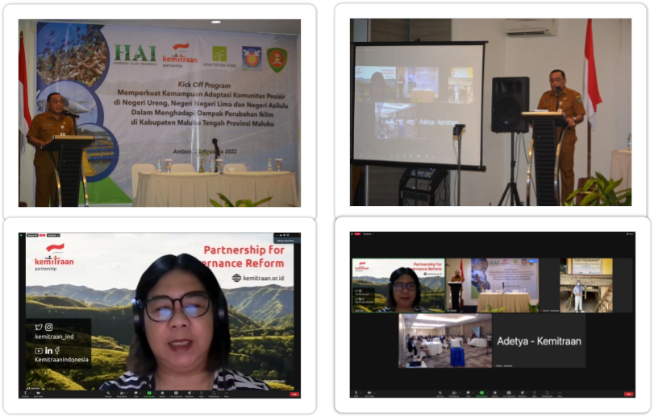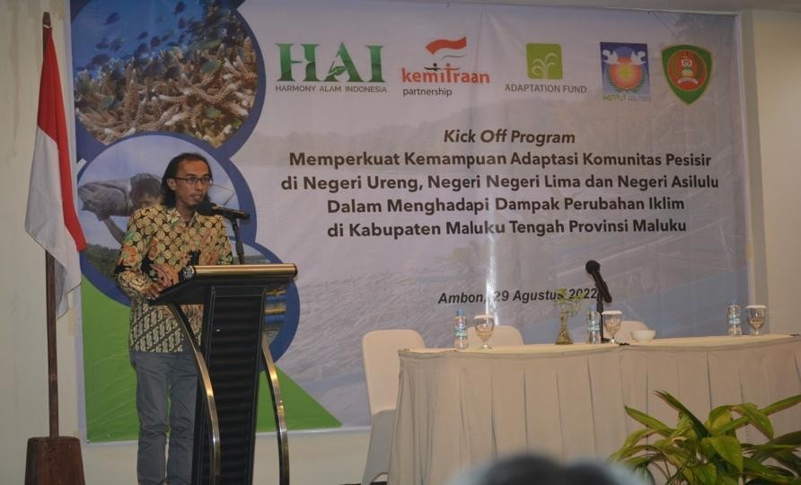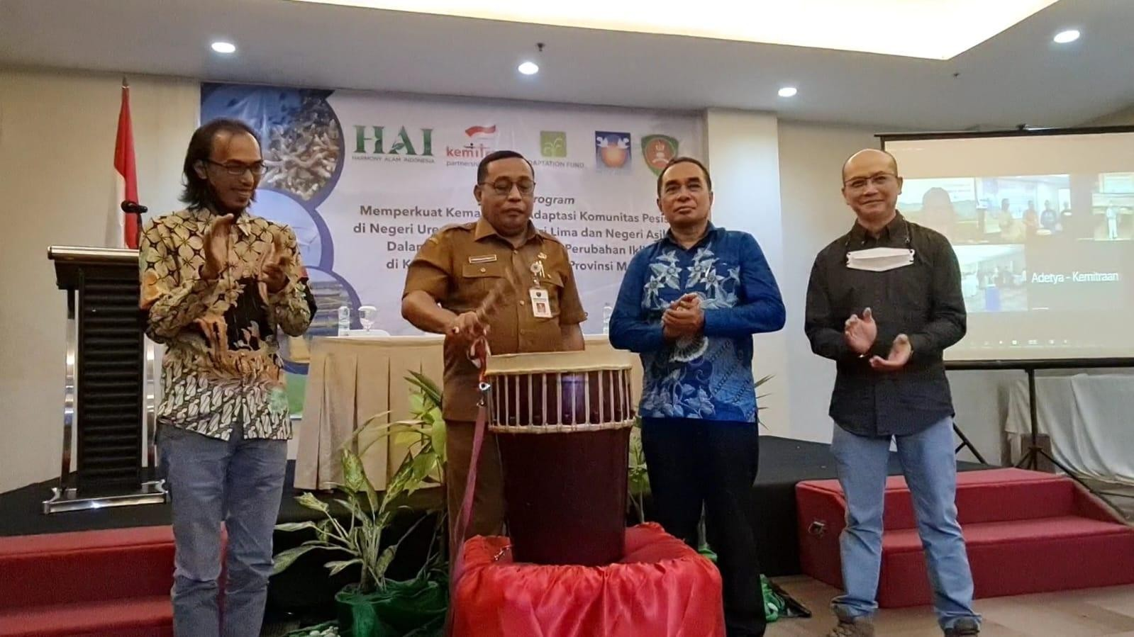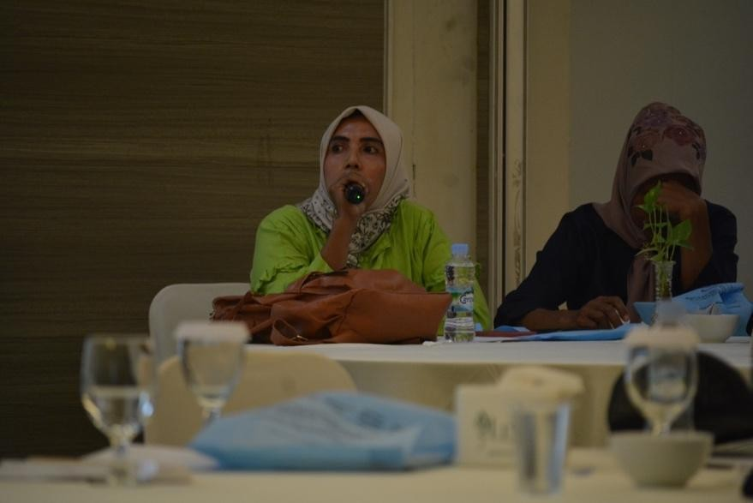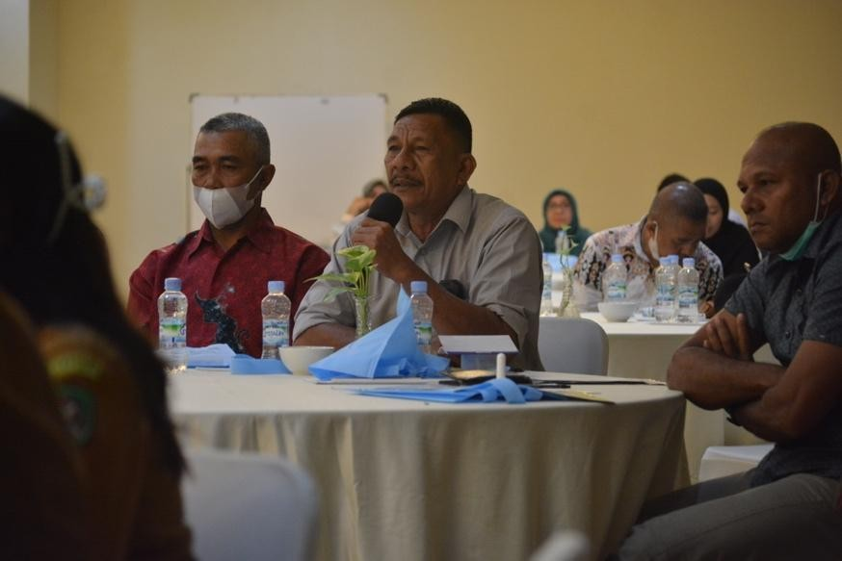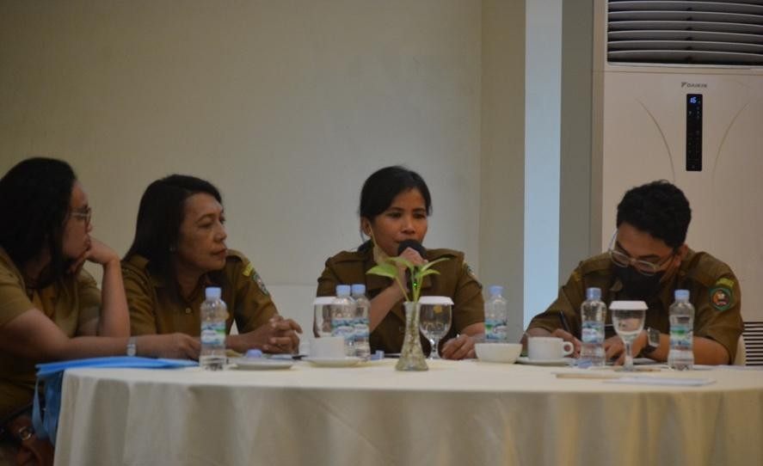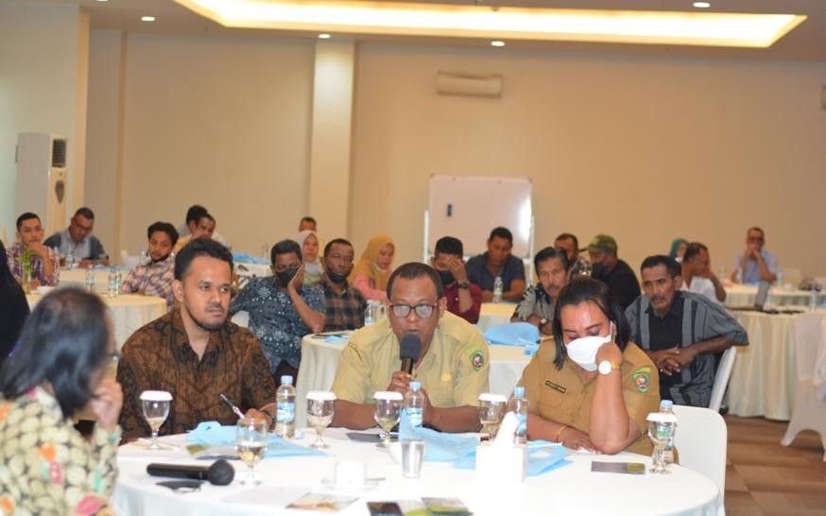
Annex 3

Documentation Kick-Off Meeting

Annex 4
List of Participant Kick-Off Meeting


DAFTAR HADIR KEGIATAN HARMONY ALAM INDONESIA

Kegiatan Lokasi Hard/Tanggal

some, *O ñ6urtui :mP*-

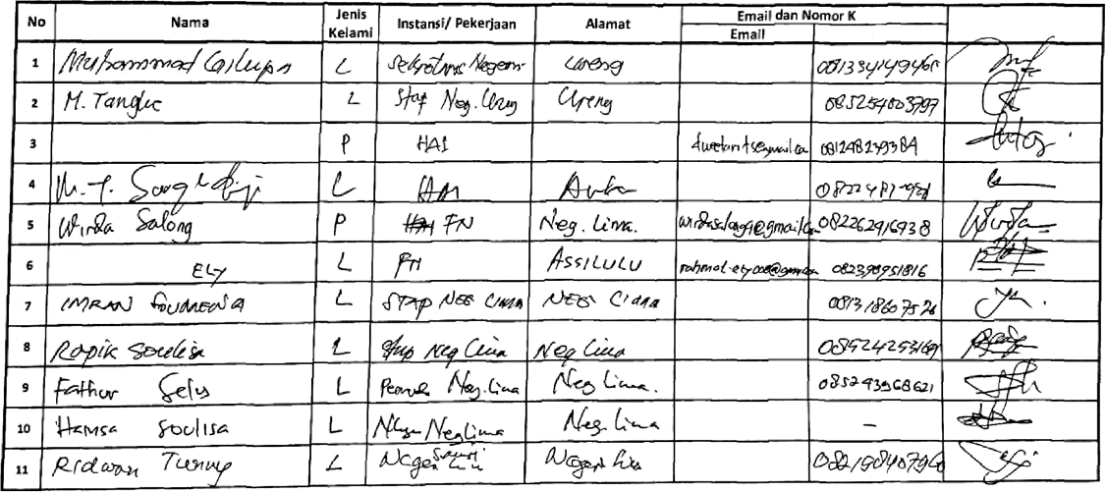
ontak HP
Tanda Tangan

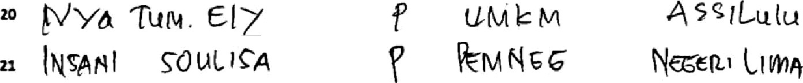





DAFTAR HADIR KEGIATAN HARMONY ALAM INDONESIA

 | Nama | Jenls  ltelami | Instansl/ Pekerjaan | Alamat | Email dan Nomor xomak |  | Taf•*• Tangan
 |  |  |  |  | Email | HP
 |  |  |  |  |  | a8isrs 986ss
• | /•/4 P/v‹ &6yd- | P | * ’^“°°* | /’4* ru
• | A aJeh /•‹&s - | * | /tY#6‹ro/ | *'/****“ ^
• | Fa,•: #Lr«d |  | usu T^u | 4 &1









DAFTAR HADIR KEGIATAN HARMONY ALAM INDONESIA

No  26 | 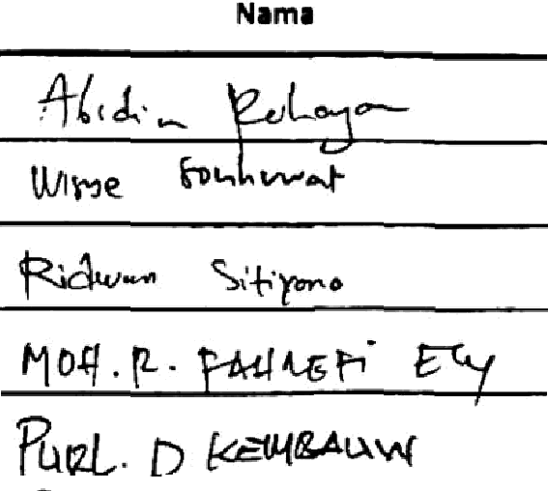 | Jenis | fnstansl/ Peker|aan |  | Ema\l dan Nomor Komak Email HP | Tanda Tangan  
No  26 |  |  |  |  | Ema\l dan Nomor Komak Email HP
No  26 |  |  |  |  | Ema\l dan Nomor Komak Email HP
 |  |  |  | 
 |  |  |  | 
 |  |  |  | 



t•IARMONY ALAI•t INDONESIA
DAFTAR HADIR KEGIATAN HARMONY ALAM INDONESIA


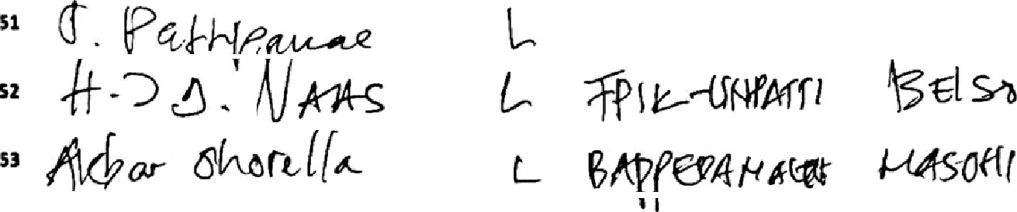
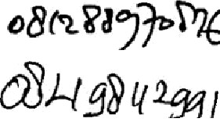


No | Name |  | Jenis  Kelami | Instansl/ Pekerjaan | Alamat | Email dan Nomor Kontal |  | Tanda Tangan
 |  |  |  |  |  | Email | HP
 |  |  | “ | 91°f  |  |  |  | 
 |  |  |  |  |  |  | 
 |  |  |  |  | 
 |  |  |  |  | 






DAFTAR HADIR KEGIATAN HARMONY ALAM INDONESIA
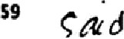
No

°
"
"
••
Nama
n°*'° °•='-°*x H*¥Y•1 -*'>« P**› ! foJ/«
lents
xeiami
P
*
P
Instansl/ Pekedaan
t”ro'vj
*’* P' *^*
Alamat
Emall dan Nomor Kontak
4 ^o>n
*•*°•
6f»
Emall
n««»,« «
HP
*»•›ee•a
Tar“- Tangan
@?
*/
<Y
*4
•*P*=c••›=8›*ysx“r»°y
^*1t*O
oci» »
” b, . 1a^>
I’
+«yya:
#'•r°«
oeit‹ t*ñ’Ya
@






H*RWOWYALAh4 IMDDMESA

DAFTAR NADIR KEGIATAN HARMONY ALAM INDONESIA



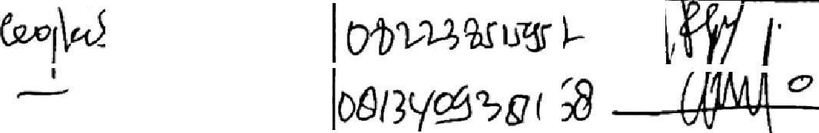

No | Nama | Jenis  Kelami | Instansl/ Peke#aan | Alamat | Emall dan Nomor Kontak  || H | Tard a Tangan
 |  |  |  |  | id | ‹&:-
 |  | P | pe «'°l*\°' | »•*°*s.t•*°** | '* ^ *oi»ia
 |  | P | H A I | L060£
 |  |  | 
 |  |  |  | 
 |  |  |  | 




HARMONY ALAS INDO IESIA

DAFTAR NADIR KEGIATAN HARMONY ALAM INDONESIA




No | Nama | Jenis | lnstansf/ Pekerjaan | y | Email dan Nomor kontak |  | anda T0ngan
 |  |  |  |  | Email | HP | anda T0ngan
• | /\on \-llrl*Yhh | L | 1&i
 |  |  |  |  |  |  | 
 |  |  |  | ^•\• • | ' -r- e«› | t› *°j | ,* f-

Annex 5

documentation of audiens with the Regent of Central Maluku and signing of the MoU

